Smart Pool Table System — Phase 3
Hub-and-Spoke Hardware, Real-Time Layer & Management Platform — Technical Specification

1. Design Intent
Phase 2 already gives every table its own network connection and its own identity through the Paybill account number, which means multiple tables can already operate independently without any shared hub. Phase 3 does not change that payment logic. It adds three things on top of it:
- A hub-and-spoke hardware option that lets several tables in one venue share a single internet/SIM connection, cutting recurring data cost per table
- A real-time layer so state changes push instantly to connected apps, instead of apps having to poll
- The Boss and Manager management applications described in the separate Management Platform Planning document, which this specification connects to the hardware layer
This document assumes the Management Platform Planning document as the source of truth for app functional requirements (roles, screens, permissions) and focuses here on the hardware and backend work needed to support it.

2. What Changes From Phase 2
Aspect | Phase 2 | Phase 3
Connectivity per table | Each unit has its own WiFi/GSM data connection | Optional: one Hub per location carries the connection; Table Nodes talk to the Hub only
Table hardware | Every unit is identical — full ESP32 with WiFi/GSM | Hub keeps WiFi/GSM; Table Nodes can be a stripped-down ESP32 with no radio cost beyond ESP-NOW
App updates | Not applicable — no app existed yet | Boss and Manager apps receive live push updates via a real-time channel
Accountability | Transaction log only | Full audit trail: manager cash entries, overrides, and maintenance flags, all tied to a user and location
Multi-location | Not addressed | Locations, tables, and managers are first-class entities in the backend
Adopting the Hub is optional per location — a small venue with one or two tables may simply keep Phase 2's standalone units, since the Hub's benefit (shared connectivity cost) only pays off once several tables are on one site.

3. Hub-and-Spoke Hardware Architecture
Within a single location, one Hub ESP32 keeps the WiFi/GSM connection to the backend. Table Nodes at that location communicate with the Hub over ESP-NOW — a lightweight, connectionless protocol built into every ESP32 — rather than each maintaining its own internet connection.
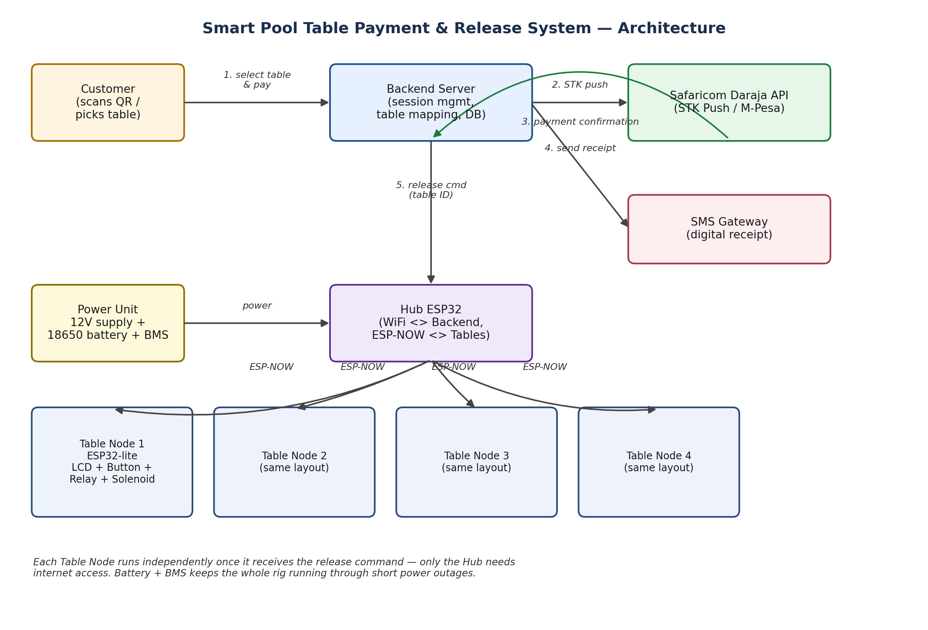
Table Nodes remain independently functional for their local duties — LCD, button, relay, solenoid, and flash-based credit cache — exactly as in Phase 1/2. Only the payment confirmation and status reporting now route through the Hub instead of directly to the backend.

4. Full Platform Architecture
The Boss App and each location's Manager App connect to the backend over two channels: the existing REST API for queries and actions, and a real-time channel that pushes every state change — a payment confirming, a button press, a manager's cash entry, a maintenance flag — the instant it happens. The Boss App subscribes to all locations; a Manager App subscribes only to its own.
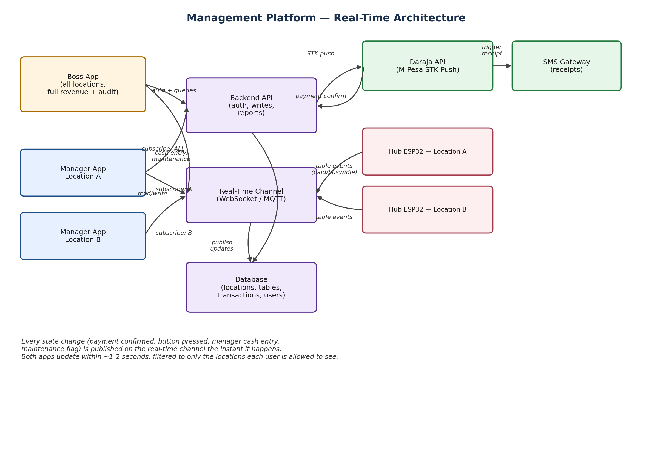

5. Hub Firmware
- Retains Phase 2's WiFi-primary / GSM-data-fallback connectivity to the backend
- Adds an ESP-NOW listener that receives status and button-press events from every Table Node at its location
- Relays each Table Node's events to the backend, tagged with that table's ID, and relays the backend's responses (credit confirmations, price updates) back down to the correct node
- Requires no payment logic of its own — it is a relay, not a decision-maker

6. Table Node Firmware
- Runs the same local logic as Phase 1/2: LCD display, debounced button, relay/solenoid pulse, flash-based credit cache
- Replaces the direct WiFi/GSM backend connection with an ESP-NOW link to its location's Hub
- Continues to serve its display and button correctly even if the Hub's internet connection is briefly down, using its local cached credit count, and reconciles with the backend once connectivity is restored
Because every unit is the same ESP32 board (see the Phase 1 specification's note on standardising the board for future upgrades), converting a Phase 2 standalone unit into a Phase 3 Table Node — or into the Hub itself — is a firmware change, not a hardware purchase.

7. Real-Time Layer
Vercel's serverless functions, used for the Phase 2 backend, do not hold long-lived connections, which is why a dedicated real-time layer is added at this phase rather than earlier. Two practical options:
- A managed real-time service (Supabase Realtime, Ably, or Pusher) that the backend publishes to on every state change, and that both apps subscribe to directly
- A small persistent process on a platform such as Fly.io or Railway, dedicated solely to holding WebSocket connections and broadcasting events, alongside the existing Vercel API
Recommendation: Supabase Realtime if the Postgres database is already hosted on Supabase, since it removes the need for a separate service.

8. Backend Additions
On top of the Phase 2 API, the backend gains the entities and endpoints needed to support multiple locations, managers, and the audit trail described in the Management Platform Planning document:
locations: id, name, address, gps_lat, gps_lng
tables: id, location_id, name, hub_id, price_per_game, status
users: id, name, phone, role (boss/manager/attendant), location_ids[]
transactions: id, table_id, amount, source (mpesa/cash/comp), user_id, txn_ref, created_at
audit_log: id, user_id, action, table_id, note, created_at
- Every cash entry, override, and maintenance flag from a Manager App writes both a transactions (or audit_log, for comps) row and publishes a real-time event
- Role-based access is enforced server-side: a Manager's queries are scoped to their assigned location_ids, never trusted from the client alone

9. Migration Path From Phase 2
- Existing Phase 2 standalone units continue operating unchanged at locations that do not need a Hub
- At a multi-table location, one existing unit is reflashed to become that location's Hub; the remaining units are reflashed as Table Nodes
- No new ESP32 hardware purchase is required for this conversion — only the Hub's continued WiFi/GSM connectivity and the Table Nodes' ESP-NOW pairing need configuring

10. Approval Points
- Confirm which locations adopt the Hub-and-Spoke model versus keeping Phase 2 standalone units
- Confirm real-time layer choice (Supabase Realtime vs. Ably/Pusher vs. a self-hosted process)
- Confirm the roll-out order: backend multi-location support first, or Hub/Table Node firmware first
- Review the Management Platform Planning document's open decisions (Attendant tier, price-change permissions, remittance cadence) alongside this specification before development begins

