Pool Table Management Platform
Boss App & Manager App — Functional Requirements & Planning Document

1. Purpose
This document defines the functional requirements for the two role-based applications that sit on top of the IoT hardware layer: the Boss (Owner) App and the Manager (Location) App. It assumes full production operation — all tables connected, all locations live — and is intended as the working reference for development, not the hardware itself.
Core principle behind every design decision in this document: all tables are locked by default, and a table can only ever unlock as the result of a logged transaction — either an M-Pesa payment or a manager-entered cash entry. There is no path that opens a table without creating a record. This is what makes remote oversight of locations the boss cannot personally visit actually trustworthy.

2. User Roles
Role | Scope | Revenue? | Unlock tables? | Manage users?
Boss / Owner | All locations | Yes — all locations | Via override only (logged as comp) | Yes — creates managers
Location Manager | Assigned location(s) only | Yes — their location(s) only | Yes — cash entry, and override | No
Attendant / Cashier (optional tier) | Assigned location only | No — cash entry only, no totals view | Yes — cash entry only | No
The Attendant tier is optional for the first release — included here so the permission model doesn't need to be redesigned if it's introduced later. Recommendation: launch with just Boss and Manager, add Attendant once real usage shows a need for it.

3. Table State Model
Every table has exactly one state at any time, driven by real events from the hardware or a manager action — never set manually to an arbitrary value.
State | Meaning | Triggered by
Locked | Default. No active session. | System default / previous game ended
Payment Pending | Payment initiated, awaiting confirmation | STK push sent
Paid / Idle | Credit available, waiting for release | M-Pesa confirmed, or manager cash entry
Occupied / Busy | Game in progress | Release button pressed
Maintenance | Taken offline by a manager | Manager flags a fault, with required note
Offline | Hardware not reporting | Hub/node connectivity loss

4. System Architecture
A real-time channel (WebSocket or MQTT) sits alongside the backend API. Every state change — a payment confirming, a button press, a manager's cash entry, a maintenance flag — is published the instant it happens. Both apps hold a live subscription filtered to what that user is allowed to see: the Boss App subscribes to all locations, a Manager App subscribes only to its own.
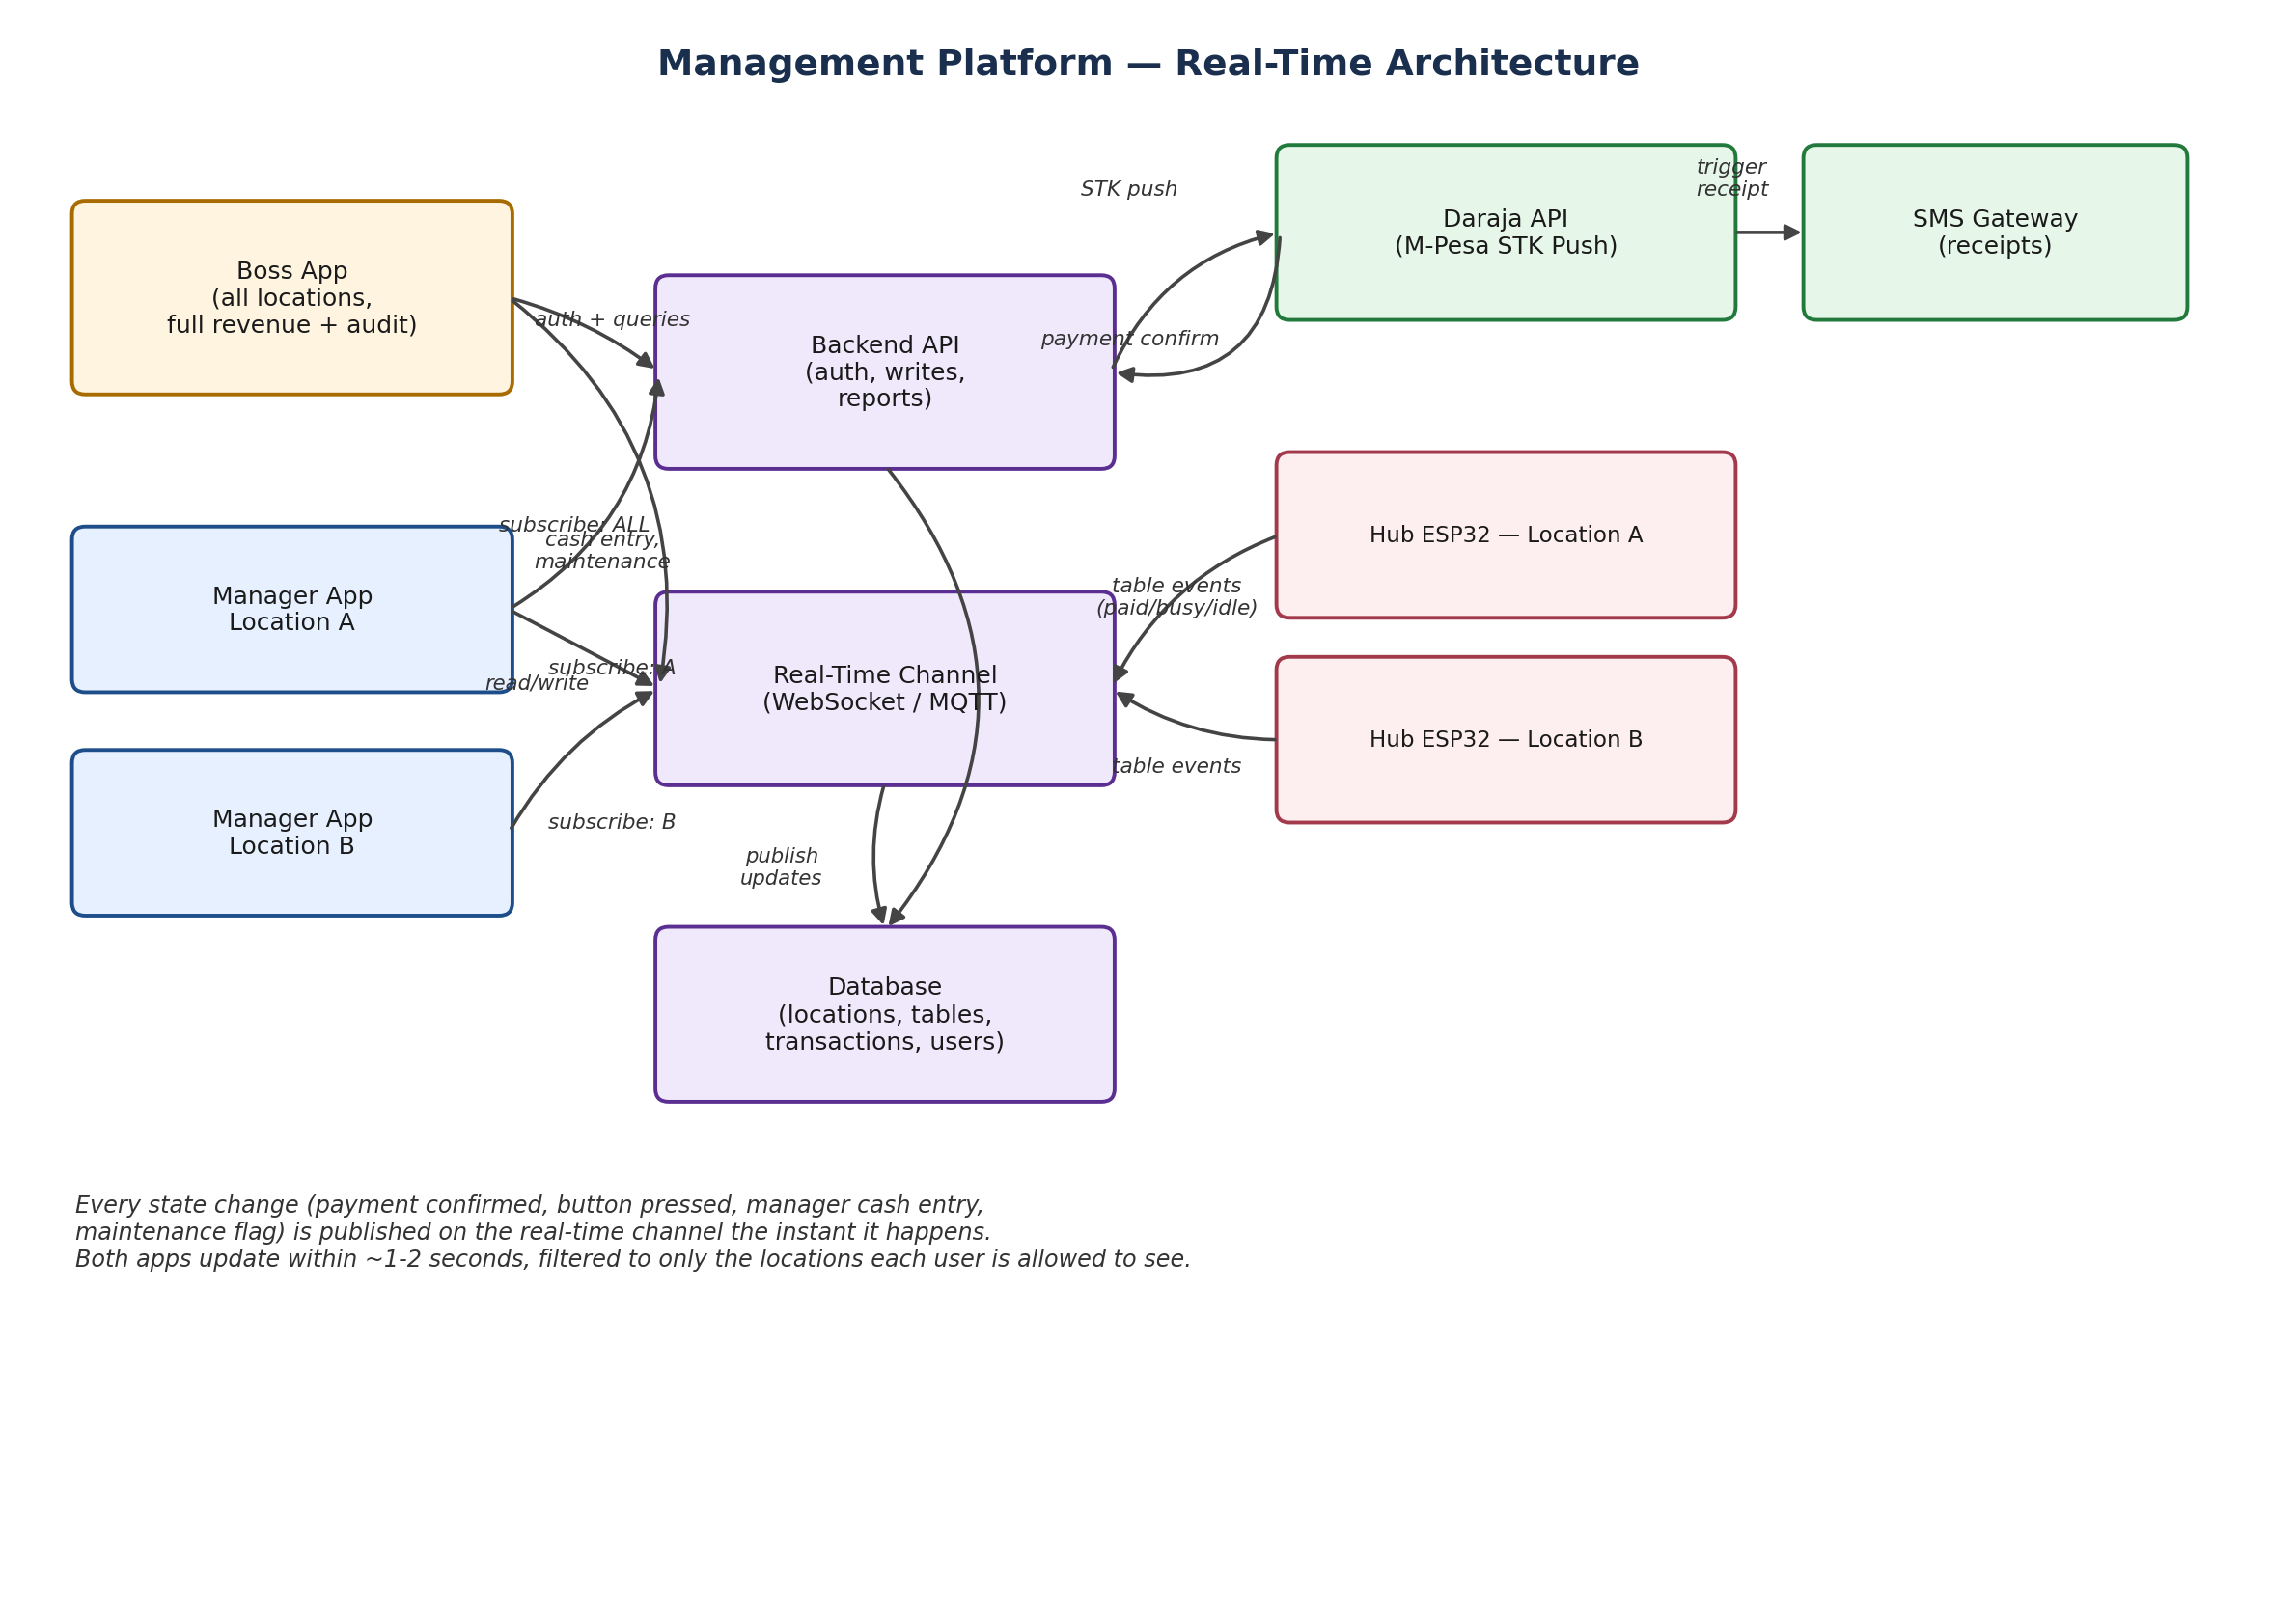

5. Boss App — Functional Requirements

5.1 Setup & Registration
- Register a location: name, address/GPS, assigned manager(s)
- Register tables per location: custom name/number, linked to a hardware unit ID
- Create and manage manager (and, if enabled, attendant) accounts, scoped to one or more locations
- Set the default price per game globally, with an option to allow or lock per-location overrides

5.2 Live Oversight
- All-locations view: table counts, how many busy/idle/locked, running revenue for today, at a glance
- Drill into any single location to see its exact table grid, identical to what that location's manager sees
- Live badge/notification counts updating in real time as table states change

5.3 Accountability & Audit
- Complete transaction ledger: every entry tagged with table, location, amount, payment method (M-Pesa or cash), manager (for cash), and timestamp
- Manager action log: every manual unlock, override, price change, or maintenance flag, immutable and timestamped
- Cash reconciliation view per manager: total cash collected vs. total remitted, so shortfalls are visible immediately
- Anomaly alerts: a release with no matching transaction, an unusual number of overrides, revenue unusually low for a location's normal pattern, a unit gone offline

5.4 Business Intelligence
- Revenue breakdowns by table, location, manager, and time period
- Best/worst performing tables and locations
- Exportable reports (CSV/Excel)

5.5 Access Control
- Boss account is the only one with full visibility and the power to create or remove manager accounts
- Two-factor authentication recommended on the Boss account specifically

6. Manager App — Functional Requirements

6.1 Cash Payment Flow (core feature)
- Select a table, enter amount received or number of games, confirm
- This creates a real transaction record — tagged “cash,” tagged with the manager's ID, timestamped — functionally identical to an M-Pesa entry aside from payment source
- Table unlocks and credit is added exactly as in the automated flow

6.2 Location Oversight
- Live table grid for their assigned location(s) only
- Today's revenue for their location, split by cash vs. M-Pesa
- Running cash-on-hand total they are expected to remit

6.3 Operational Controls
- Flag a table for maintenance, with a required short note explaining the fault
- Override/free-release for genuine faults (e.g. a jam after a legitimately paid game) — logged as a distinct “comped” event type, never folded into cash or M-Pesa totals

6.4 Explicit Restrictions
- Cannot change price per game unless the Boss grants that permission for their location
- Cannot see other locations
- Cannot delete or silently edit past transactions — only the Boss can amend, and only with a preserved edit history
- Cannot create other manager or attendant accounts

7. Non-Functional Requirements
- Real-time updates should reach both apps within 1–2 seconds of the triggering event
- The transaction ledger is append-only; corrections are new entries referencing the original, never overwrites
- Manager and Boss sessions require authentication; Boss session additionally recommended to require 2FA
- The app should clearly distinguish connectivity loss (“offline”) from an operational state (“locked”) so a manager isn't misled about why a table isn't earning

8. Recommended Approach
- Single codebase, role-based login (Boss vs Manager vs, later, Attendant) rather than separate apps — simpler to build and maintain
- Android first (Flutter or React Native), with iOS as a low-cost follow-on given a shared codebase
- Backend: REST API for writes/reports, plus a WebSocket or MQTT layer for live state — the same data model already defined for the hardware/payment platform, extended with locations, users, and roles

9. Open Decisions for Approval
- Launch with two roles (Boss, Manager) or three (add Attendant/Cashier) from day one?
- Should managers be allowed to adjust price per game at all, even with permission granted per-location?
- What cash remittance cadence is expected — daily, weekly — and should the app support marking a remittance as received by the Boss?
- Confirm whether Boss account requires two-factor authentication at launch or as a fast-follow.

