Smart Pool Table Payment & Auto-Release System
IoT + Mobile Money Project Proposal

1. Executive Summary
This project replaces the coin/token slot on a standard pool table with a smart, electronically-triggered release mechanism. Instead of dropping a coin, a customer pays via M-Pesa; once payment is confirmed, the same mechanical release the coin would normally trigger is fired electronically. The system is built in two phases: a single-table proof of concept, followed by a multi-table version that can serve several pool tables in one venue from a single control hub, each identified and billed individually.
The design goal is a professional, low-component-count build: one control hub, simple per-table nodes, mobile-money payment, digital receipts, and a battery backup so the system keeps running through short power outages.

2. Problem & Objective
- Manual coin/token operation requires physical cash handling and on-site change floats.
- Venue owners have no digital record of table usage or revenue per table.
- Objective: let customers pay via mobile money and have the table open itself automatically, with a full digital audit trail.

3. Phased Approach

Phase 1 — Single Table MVP
One ESP32 controls one table end-to-end: detects confirmed payment, accepts a button press to confirm intent, and fires a relay-driven solenoid that trips the existing coin-release lever.

Phase 2 — Multi-Table System
A hub-and-spoke architecture allows one internet-connected hub to control several table nodes (e.g., 4 tables in one club), with payments correctly routed to the right table even though all tables share a single Till Number.

4. System Architecture
The diagram below shows how a payment travels from the customer's phone through the backend and M-Pesa, and how the release command is routed to the correct table via a hub-and-spoke IoT layer.
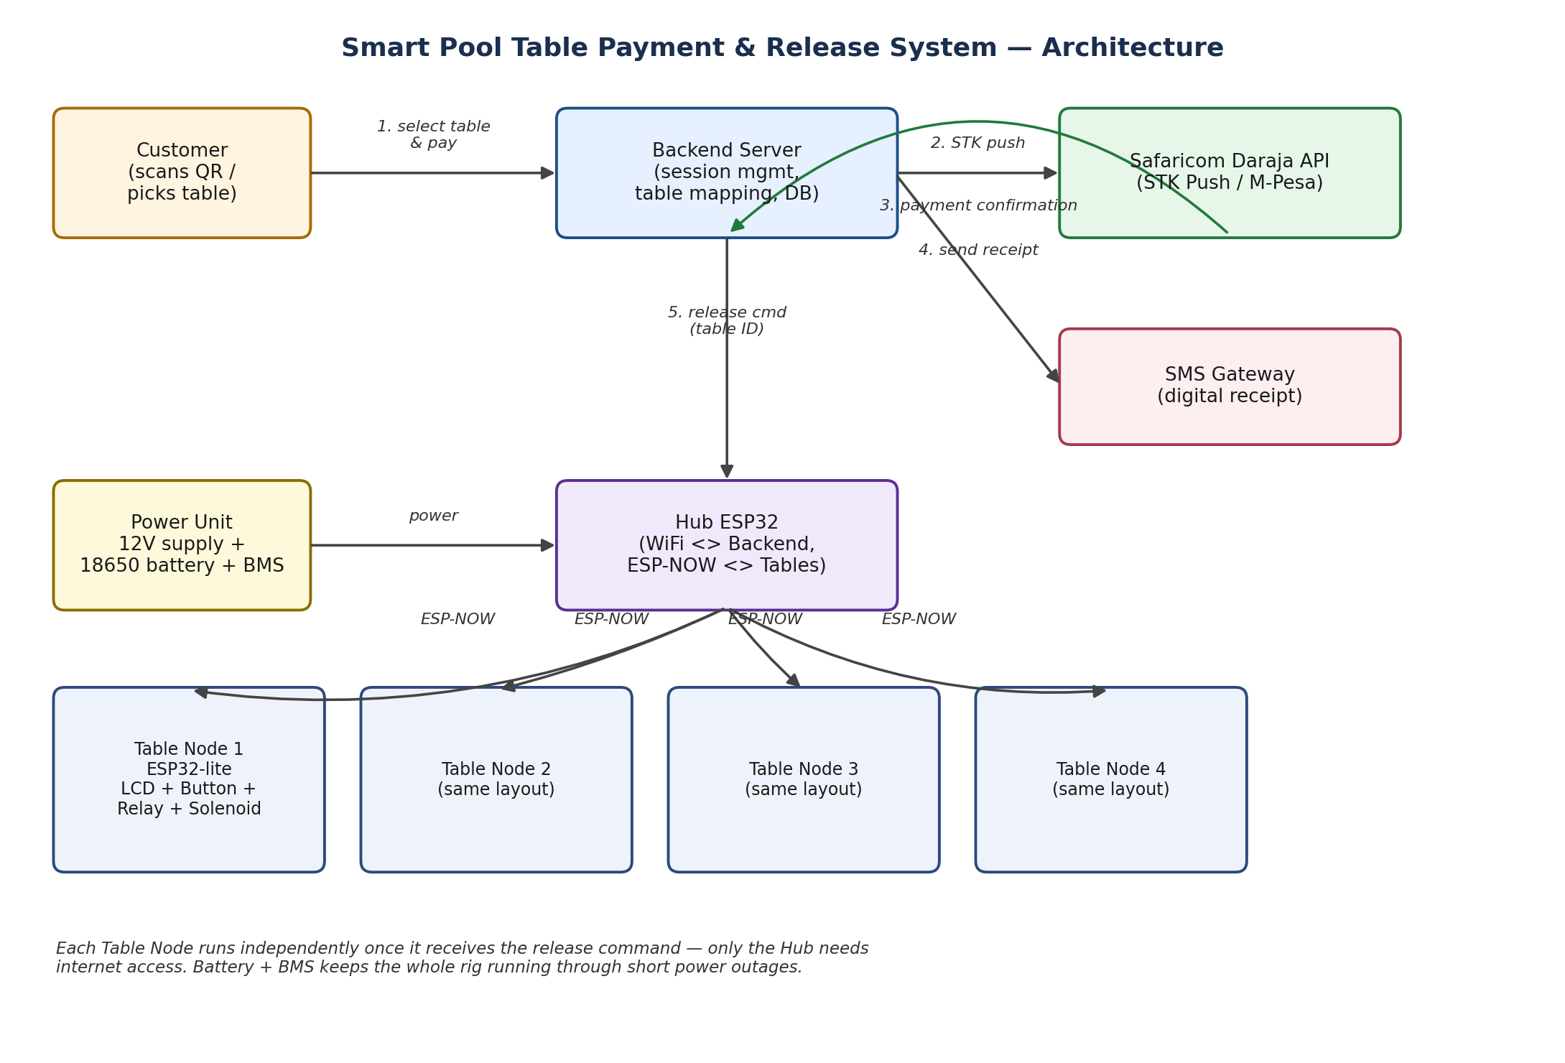

4.1 Hardware Components & Functionality
Component | Role | Why this choice
Hub ESP32 | Connects to venue WiFi, communicates with backend server, relays commands to table nodes over ESP-NOW. | Only the hub needs internet access, keeping table nodes simple and cheap.
Table Node (ESP32, one per table) | Runs the LCD, reads the button, and drives the relay/solenoid for its own table. | Independent of WiFi — receives commands directly from the hub, so a WiFi drop only affects the hub, not table logic.
16x2 I2C LCD | Displays pending games, payment status, and prompts (e.g. “Press to open”). | I2C uses only 2 signal wires, keeping wiring minimal.
Tactile push button | Customer-facing “confirm & open” trigger — a manual gate so the table does not open with nobody present. | No extra hardware beyond debounce logic in firmware.
Relay module (5V) | Switches the higher-current solenoid circuit safely from the ESP32's logic-level pins. | Isolates delicate control electronics from the actuator's power draw.
12V Solenoid (or geared DC motor) | Physically trips the existing ball-release lever/cam, exactly as a coin would. | Reuses the table's existing mechanism — no need to redesign the ball lock.
Buck converter (12V→5V) | Steps down the main 12V rail to power the ESP32 and LCD. | Lets the whole rig run off one shared power source.
18650 Li-ion cells + BMS/charge module | Battery backup — charges from mains, takes over automatically if power drops. | Acts as a self-managed UPS with no custom failover logic required.
12V power adapter | Main power source for the whole unit, also charges the battery pack. | Standard, easily sourced locally.
Master ON/OFF switch | Single physical switch to power the entire unit up or down. | One control point for the whole system, placed ahead of all other components.

4.2 Software / Cloud Components
Component | Role | Why this choice
Backend server | Manages payment sessions, maps sessions to specific tables, stores transaction history. | Central source of truth — enables reporting and multi-table routing.
Safaricom Daraja API (STK Push) | Initiates the M-Pesa payment prompt on the customer's phone and returns a confirmation callback. | Standard, trusted mobile money integration for the Kenyan market.
SMS Gateway (e.g. Africa's Talking) | Sends a branded digital receipt to the customer once payment is confirmed. | Immediate, low-cost confirmation without needing a printer.

5. Differentiating Multiple Tables on One Till Number
A standard M-Pesa Till Number (Buy Goods) does not carry a customer-entered reference, so the system cannot rely on M-Pesa alone to know which table was paid for. Two approaches were considered:

Option A — Software-side session matching (recommended)
- Customer selects a table (via QR code or a simple selection menu) before paying.
- Backend creates a pending session linking a unique session ID to that table.
- The STK Push for that session carries a unique CheckoutRequestID from Daraja.
- When Safaricom sends the payment confirmation, it references that same ID, letting the backend match the payment to the correct table.

Option B — Paybill with Account Number
- Switch from a Till Number to a Paybill, where the customer enters the table name/number as the account reference.
- M-Pesa passes this reference through directly, removing the need for session-matching logic.
- Trade-off: requires a Paybill business setup with Safaricom, which may involve additional registration.
Recommendation: proceed with Option A for the MVP, since it works with the venue's existing Till Number and scales cleanly to an in-house app later.

6. Receipt Generation
Two layers are proposed, so the system stays simple now but can grow:
- Digital receipt (Phase 1): an SMS sent automatically once payment is confirmed, e.g. “Payment confirmed: Table 3, KES 50, 14 Sep 2026 14:32. Enjoy your game!” — in addition to the standard M-Pesa SMS.
- Printed receipt (future add-on): a small 58mm thermal printer attached to the hub, available on request, for venues that want a physical slip.

7. End-to-End Workflow
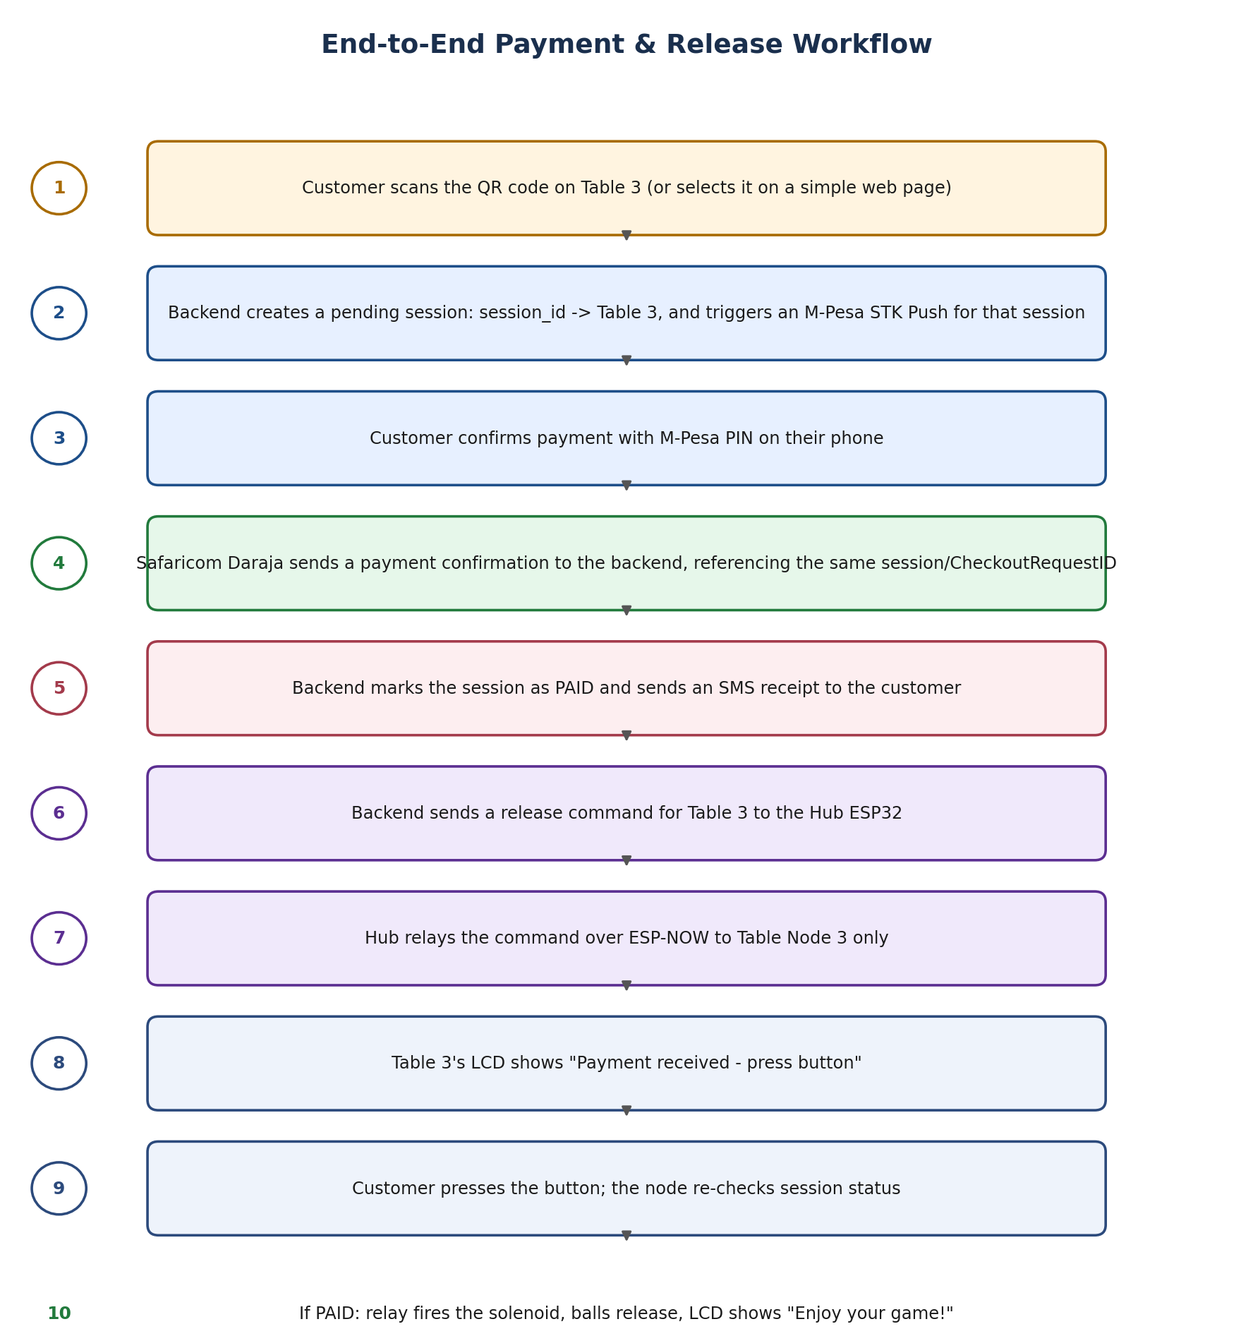

8. Power Architecture
A single 12V power adapter feeds the whole unit through a master ON/OFF switch. From there, a charge/BMS module maintains an 18650 battery pack that seamlessly takes over if mains power drops, while a buck converter independently supplies the ESP32 and LCD at 5V, and the relay/solenoid draws directly from the 12V rail. This gives the unit automatic UPS-style backup without any custom failover code.

9. Firmware Logic (Summary)
setup(): connect to WiFi/ESP-NOW, initialise LCD, arm the button interrupt, display “Ready”.
loop(): periodically poll the backend for pending-game count and update the LCD; on button press, verify payment status for this table, then either pulse the relay to release the balls and update the display, or show “Not paid yet”.

10. Recommendation & Next Steps
- Approve Phase 1 (single-table MVP) for a pilot build and mechanical test with the existing coin lever.
- Confirm choice between Option A (session-matching) and Option B (Paybill) for multi-table payment routing.
- Decide on digital-only receipts vs. adding a physical thermal printer at launch.
- On successful pilot, proceed to Phase 2 hub-and-spoke rollout across all tables in a venue.

