Appendix

Supplemental Results for

An Automated Database Case Definition for Serious Bleeding Related to Oral Anticoagulant Use

Andrew Cunningham, M.D.
C. Michael Stein, MB, ChB
Cecilia P. Chung, M.D., MPH
James R. Daugherty, M.S.
Walter E. Smalley, MD, MPH
Wayne A. Ray, Ph.D.

This document should be read in conjunction with the primary manuscript.

1 Automated Database Case Definition: Bleeding-Related Hospitalization

Endpoints were identified from hospital admissions, using a computer algorithm designed to identify hospitalizations related to bleeding.

Algorithm development began with a review of the literature. This led to the decision to base the algorithm upon the principle hospital discharge diagnosis, using as a starting point the codes identified by Arnason and colleagues (Accuracy of coding for possible warfarin complications in hospital discharge abstracts. Thrombosis Research 2006; 118:253-262). We reviewed these codes to determine if either exclusions or further inclusions were indicated. This review included consideration of our past experience with regard to bleeding complications, including studies of NSAIDs, warfarin, and clopidogrel. We also reviewed computerized records of all medical care encounters for hospitalizations with codes for which there was uncertainty. Ultimately, we included all of the codes on the list of Arnason et al.

We did add several codes to the Arnason list. These were primarily codes that are nonspecific, either with regard to presence of bleeding (e.g., peptic ulcer not otherwise specified) or as to site (e.g. anemia). We accepted these codes if there was other confirmatory evidence (e.g., a secondary diagnosis indicating bleeding or a specific site).

The algorithm also identified site of bleeding and sought to exclude bleeding obviously related to material trauma. These rules were developed on the basis of clinical plausibility, review of computerized records, and cross checking against the results of the validation study.

The final algorithm is shown in Figure 1.

Figure 1 Computer algorithm for identifying bleeding-related hospitalizations

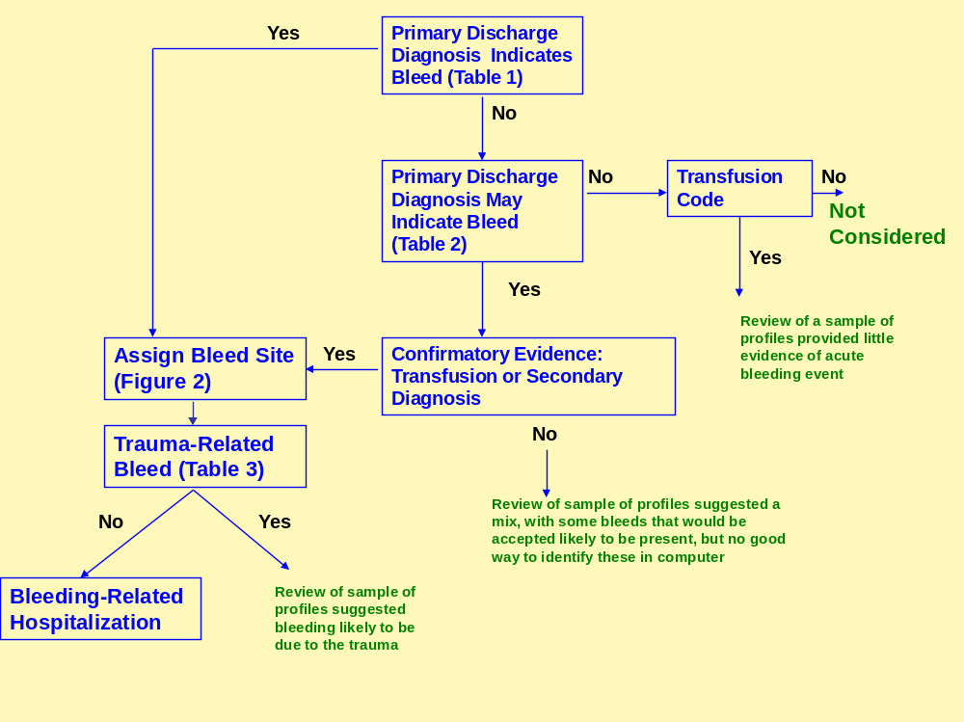

Hospitalizations with two types of primary diagnoses were considered: those indicating a bleed with no further confirmation needed (Table 1), and those indicating a bleed (Table 2) when confirmed by either a hospital revenue code indicating transfusion/cross-matching for transfusion or presence of a secondary discharge diagnosis in Table 1.

For qualifying hospital admissions, a site for the bleeding was then assigned (see §2 below). Given the site, the hospitalizations were further restricted to those for which there was no evidence of major trauma (see §3 below).

The algorithm does not consider hospitalizations in which there is no primary diagnosis associated with bleeding but there are such secondary diagnoses. The rationale was that these hospitalizations were more likely to identify bleeding that began in the hospital or was due to other causes.

Table 1 ICD9-CM diagnoses indicating bleeding of the type caused by warfarin¹, according to site

Code | Diagnosis | Code | Diagnosis
Gastroduodenal Site |  | Lower Gastrointestinal Site
 |  | 455.2 | Internal hemorrhoids with other complication
531.0x | Acute gastric ulcer with hemorrhage | 455.5 | External hemorrhoids with other complication
531.2x | Acute gastric ulcer with hemorrhage and perforation | 455.8 | Unspecified hemorrhoids with other complication
531.4x | Chronic or unspecified gastric ulcer with hemorrhage | 562.02 | Diverticulosis of small intestine with hemorrhage
531.6x | Chronic or unspecified gastric ulcer with hemorrhage and perforation | 562.03 | Diverticulitis of small intestine with hemorrhage
532.0x | Acute duodenal ulcer with hemorrhage | 562.12 | Diverticulosis of colon with hemorrhage
532.2x | Acute duodenal ulcer with hemorrhage and perforation | 562.13 | Diverticulitis of colon with hemorrhage
532.4x | Chronic or unspecified duodenal ulcer with hemorrhage | 568.81 | Hemoperitoneum
532.6x | Chronic or unspecified duodenal ulcer with hemorrhage and perforation | 569.3 | Hemorrhage of rectum and anus
533.0x | Acute peptic ulcer, site unspecified, with hemorrhage | 569.85 | Angiodysplasia of intestine with hemorrhage
533.2x | Acute peptic ulcer, site unspecified, with hemorrhage and perforation | Unspecified Gastrointestinal Site
533.4x | Chronic peptic ulcer, site unspecified, with hemorrhage | 578.1 | Blood in stool
533.6x | Chronic peptic ulcer, site unspecified, with hemorrhage and perforation | 578.9 | Hemorrhage of gastrointestinal tract, unspecified
534.0x | Acute gastrojejunal ulcer with hemorrhage
534.2x | Acute gastrojejunal ulcer w hemorrhage/perforation
534.4x | Chronic gastrojejunal ulcer with hemorrhage | Genitourinary Site
534.6x | Chronic gastrojejunal ulcer with hemorrhage and perforation | 593.81 | Vascular disorders of kidney
535.01 | Acute gastritis with hemorrhage | 599.7 | Hematuria
535.11 | Atrophic gastritis with hemorrhage | 623.8 | Other specified noninflammatory disorders of vagina
535.21 | Gastric mucosal hypertrophy with hemorrhage | 626.2 | Excessive/frequent menstruation, with secondary diagnosis indicating acute bleeding: anemia (280.0,285.1,285.9), orthostasis (458.0),syncope (780.2)
535.31 | Alcoholic gastritis with hemorrhage
535.41 | Other specified gastritis with hemorrhage | 626.6 | Metrorrhagia
535.51 | Unspecified gastritis and gastroduodenitis with hemorrhage | Cerebral Site
535.61 | Duodenitis with hemorrhage | 430 | Subarachnoid hemorrhage
537.83 | Angiodysplasia of stomach and duodenum with hemorrhage | 431 | Intracerebral hemorrhage
 |  | 432.0 | Nontraumatic extradural hemorrhage
Esophageal Site |  | 432.1 | Subdural hemorrhage | Subdural hemorrhage
456.0 | Esophageal varices with bleeding | 432.9 | Unspecified intracranial hemorrhage
456.20 | Esophageal varices in diseases classified elsewhere with bleed
530.7 | Mallory-Weiss tear (gastroesophageal laceration-hemorrhage syndrome) | Other Site
530.82 | Esophageal hemorrhage | 423.0 | Hemopericardium
 |  | 459.0 | Hemorrhage, unspecified
 |  | 568.81 | Hemoperitoneum (nontraumatic)
Upper Gastrointestinal, Unspecified |  | 719.1x | Hemarthrosis | Hemarthrosis
578.0 | Hematemesis | 784.7 | Epistaxis
 |  | 784.8 | Hemorrhage from throat
 |  | 786.3 | Hemoptysis
¹Source: Arnason et al, Accuracy of coding for possible warfarin complications in hospital discharge abstracts. Thrombosis Research 2006; 118:253-262. ‘x’ denotes that any subsequent digit is allowed. Minor changes from cited article: 1) 530.8x included, we use only 530.82; and 2) 537.8x included, we use only 537.83; 3) Arnason does not include 719.19, which we do. We considered excluding 623.8, which includes both vaginal cysts and hemorrhage; however, review of computer profiles for 5 such hospitalizations showed that 4 had evidence of bleeding and none evidence of cysts.

Table 2 Diagnosis codes indicating bleeding, when confirmed by a secondary discharge diagnosis in Table 1 or a code indicating transfusion*. Note the sites for primary and secondary diagnoses do not need to match.
Code |  | Diagnosis | Code | Diagnosis
Gastroduodenal Site |  |  | Lower Gastrointestinal Site
531.1 | Gastric ulcer acute with perforation |  | 455.x | Hemorrhoids, not incl 455.2,455.5, 455.8
531.3 | Acute gastric ulcer without mention of hemorrhage or perforation |  | 562.00 | Diverticula of small intestine without mention of hemorrhage
531.5 | Chronic or unspecified ulcer with perforation |  | 562.01 | Diverticulitis of small intestine without mention of hemorrhage
531.7 | Chronic gastric ulcer without mention of hemorrhage or perforation |  | 562.10 | Diverticula of colon without mention of hemorrhage
531.9 | Gastric ulcer, unspecified, without mention of hemorrhage or perforation |  | 562.11 | Diverticulitis of colon without mention of hemorrhage
532.1 | Duodenal ulcer acute with perforation
532.3 | Acute duodenal ulcer without mention of hemorrhage or perforation |  | Esophageal Site
532.5 | Duodenal ulcer chronic/unspecified w perforation |  | 530.1 | Esophagitis
532.7 | Duodenal ulcer chronic without mention of hemorrhage or perforation
532.9 | Unspecified as acute or chronic duodenal ulcer without mention of hemorrhage or perforation |  | Unspecified Site
533.1 | Peptic ulcer acute with perforation |  | 280.0 | Anemia due to loss of blood**
533.3 | Peptic ulcer, acute, no mention of hemorrhage |  | 285.1 | Acute posthemorrhagic anemia
533.5 | Peptic ulcer chronic/unspecified w perforation |  | 285.9 | Anemia, unspecified**
533.7 | Peptic ulcer, chronic, without mention of hemorrhage or perforation |  | 790.92 | Abnormal coagulation profile**
533.9 | Peptic ulcer, unspecified as acute or chronic without mention of hemorrhage or perforation
534.1 | Gastrojejunal ulcer acute with perforation
534.3 | Gastrojejunal ulcer acute without mention of hemorrhage or perforation
534.5 | Gastrojejunal ulcer chronic/unspecified w perforation
534.7 | Chronic gastrojejunal ulcer without mention of hemorrhage or perforation
534.9 | Gastrojejunal ulcer, unspecified acute: chronic, without mention of hemorrhage or perforation
535.00 | Acute gastritis without mention of hemorrhage
535.10 | Atrophic gastritis, no mention of hemorrhage
535.20 | Gastric mucosal hypertrophy without mention of hemorrhage
535.30 | Alcoholic gastritis, no mention of hemorrhage
535.40 | Other specified gastritis, no mention hemorrhage
535.50 | Unspecified gastritis and gastroduodenitis without mention of hemorrhage
535.60 | Duodenitis without mention of hemorrhage

*Hospital revenue codes indicating transfusion or processing of blood products for transfusion.
**These codes are only accepted if there is a secondary diagnosis for confirmation; a transfusion is not sufficient. Investigation of profiles for these codes with transfusions suggested they primarily were persons with chronic anemia and the admissions were not for an acute bleeding episode.

2. Automated Database Case Definition: Site of Bleeding

Bleeding-related hospitalizations were classified according to the probable site of the bleeding, based on the primary diagnosis code of the hospitalization (Figure 2). With two exceptions, the site is as given in Tables 3 and 4. The first exception is if the site is "Unspecified Site". In this case, the site was obtained from other diagnoses during the inpatient stay, giving priority to the hospital diagnoses. If more than a single site was so identified, the priority was as follows: gastroduodenal, lower gastrointestinal, esophageal, unspecified gastrointestinal, genitourinary, cerebral. Note codes specified to separately identify esophageal sites; however, there are few such bleeds and in most analyses these are grouped with gastroduodenal and upper unspecified as an upper GI site.

The other special case was for unspecified gastrointestinal site. In that circumstance, the site was determined from diagnoses and procedures for the period 30 days preceding the endpoint hospital admission to7 days following the hospital discharge (Figure 2). The diagnoses for upper and lower gastrointestinal sites were those specified in Tables 1 and 2 or Figure 2; the procedures are specified in Table 3.

Figure 2 When the primary diagnosis was "Unspecified Gastrointestinal Site" the site was determined as follows: Upper GI diagnoses were those in Tables 1 and 2 as well as 151.x or 152.x; lower GI diagnoses were as in Tables 1 and 2 or in the range 153.x, 154.x, 211.2, 211.3, 555-569. For diagnoses, must be 1) on inpatient encounter, 2) two different days, or 3) 2 different providers. For procedures, a single occurrence is sufficient.

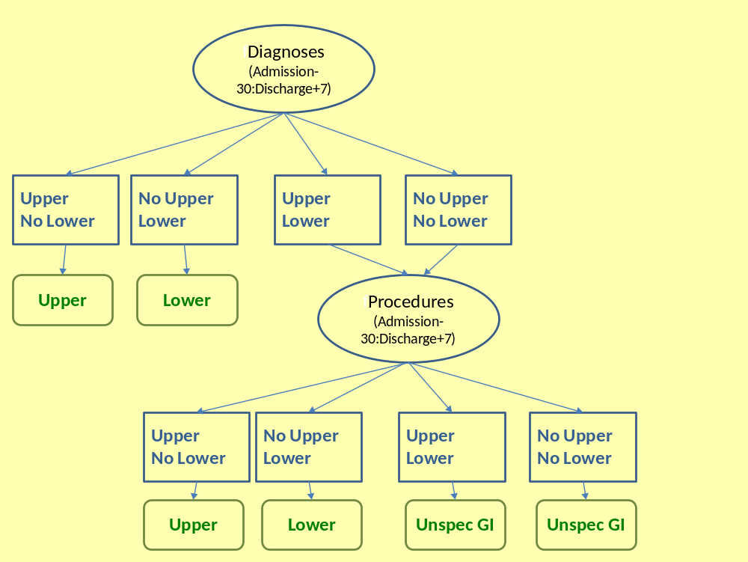
Table 3 Procedure codes consistent with upper and lower gastrointestinal sites.

Code | Diagnosis |  | Code |  |  | Diagnosis
Upper GI Site ICD9 |  |  | Lower GI Site ICD9
42.2 | Diagnostic Procedures on Esophagus |  | 45.2 |  | Diagnostic procedures on large intestine
42.33 | Control of esophageal bleeding by endoscopic approach |  | 45.7 |  | Open and other partial excision of large intestine
42.4 | Excision of esophagus |  | 45.9 |  | Intestinal anastomosis
42.82 | Suture of laceration of esophagus |  | 46.1 |  | Colostomy
42.9 | Other operations on esophagus |  | 46.2 |  | Ileostomy
44.1 | Diagnostic procedures on stomach |  | 46.3 |  | Other enterostomy
44.4 | Control of hemorrhage and suture of ulcer of stomach or duodenum |  | 46.75 |  | Suture of laceration of LI
44.61 | Suture of laceration of stomach |  | 48.23 |  | Rigid proctosigmoidoscopy
44.91 | Ligation of gastric varices |  | 48.3 |  | Local excision or destruction of lesion or tissue of rectum
45.1 | Diagnostic procedures on small intestine |  | 48.71 |  | Suture of laceration of rectum
46.71 | Suture of laceration of duodenum |  | 49.4 |  | Procedures on hemorrhoids
46.73 | Suture of laceration of SI, not duodenum |  | Lower GI CPT4
Upper GI CPT4 |  |  |  | 44140 | Colectomy, partial; with anastomosis
43200-43259 | Endoscopy upper (all except ERCP) |  | 44202-8 |  | Colectomy
43460 | Esophogastric tamponade with baloon |  | 44391 |  | Colonoscopy through stoma; with control of bleeding, any method
43501 | Gastrotomy; with suture repair of bleeding ulcer |  | 44604-5 |  | Suture of large intestine (colorrhaphy) for perforated ulcer, diverticulum, wound, injury or rupture (single or multiple perforations); without colostomy / with colostomy |  |  | Other specified noninflammatory disorders of vagina
43502 | Gastrotomy; with suture repair of pre-existing esophagogastric laceration (eg, Mallory-Weiss) |  | 45300-45392 |  | Endoscopy lower GI
43840 | Gastrorrhaphy, suture of perforated duodenal or gastric ulcer, wound, or injury |  | 46083 |  | Incision of thrombosed hemorrhoid, external
44360-44394 | Small intestinal endoscopy |  | 46221/46230/46250/  46255/46257/46258/  46260/46261/46262 |  | Hemorrhoidectomies
44602-3 | Suture of small intestine (enterorrhaphy) for perforated ulcer, diverticulum, wound, injury or rupture; single perforation/multiple perforations |  | 46600-46615 |  | Anoscopy
 |  |  | 46934-6 |  | Destruction of hemorrhoids

3. Automated Database Case Definition: Trauma Exclusion

The automated database case definition excludes trauma-related bleeding hospitalizations, defined as those potentially caused by major trauma or medical procedures. The identification of such hospitalizations is specific to the probable site of the bleeding. Table 4 shows the codes (diagnosis unless otherwise specified) used to make the determination.

The period for determining whether or not the trauma exclusion applies is the day prior to admission through the day following admission. The rationale is that trauma leading to the admission will be noted during this time period. Subsequent encounters are more likely to reflect trauma that occurred during the hospitalization. The trauma exclusion is triggered if any of the codes are present for the diagnoses (admission and all discharge) of the inpatient stay encounter (if there is a transfer, only the first hospital stay is considered). It is also triggered if there are other encounters during the time period with any diagnosis indicating trauma that occur for two distinct providers or two distinct days. Thus, a single encounter from a single provider is insufficient to trigger the exclusion.

Table 3 Trauma exclusions: For ICD9-CM codes, if only 3 digits are given, all 4th digits are accepted; if 4 digits given, all 5th digits accepted. GI = gastrointestinal, GU=genitorurinary, CNS=cerebral. Procedures indicated with *.

Code | Diagnosis/Procedure | GI | GU | CNS | Other
62000* | Elevation of depressed skull, simple #; |  |  | y
62005* | Elevation of depressed skull, compound; |  |  | y
62010* | Elevation of depressed skull, with repair of dura/debridememnt |  |  | y
800-804 | Fracture skull; |  |  | y
800-829 | Fracture, except 814-817 [metacarpal] and 825-826 [metatarsal] |  |  |  | y
806.0/2 | Fracture vertebrae w SC injury; |  |  | y | a
806.x | Fracture vertebrae w SC injury; |  | y |  | a
807.4 | Flail chest; |  | y | y | a
808 | Fracture of pelvis | y | y | y | a
812 | Fracture humerus |  | y | y | a
820 | Fracture proximal femur |  | y | y | a
821 | Fracture shaft femur; |  | y | y | a
828 | Multiple fractures, different sites | y | y | y | a
860 | Traumatic pneumothorax | y | y | y | y
862.0/862.1 | Diaphragm injury closed/open; | y | y | y | y
862.8/9 | Crushed chest closed/open; | y | y | y | y
863.0/1 | Injury stomach w/out open wound; | y |  |  | y
863.2/3x | Injury SI w/out open wound; | y |  |  | y
863.4/5 | Injury LI w/out open wound; | y |  |  | y
863.8/9 | Injury GI NOS w/out open wound; | y |  |  | y
864.1 | Injury Liver w open wound; | y |  |  | y
865.1 | Splenic Rupture; | y | y | y | y
866 | Injury to kidney; | y | y |  | y
867 | Injury to pelvic organs |  | y
873.0/1 | open wound of scalp |  |  | y
875.0/1 | open wound of chest wall |  |  |  | y
902.4 | injury to renal vessels; |  | y
902.55/56 | injury to uterine vessels; |  | y
902.81/82 | injury to ovarian vessels |  | y
925-929 | crushing injury |  |  |  | y
925 | crushing injury face/scalp/neck |  |  | y | b
926 | crushing injury ext genitalia; |  | y |  | b
926.8 | crushing of multiple sites trunk; | y | y |  | b
928 | crushing of hip/thigh; |  | y |  | b
929 | crushing of multiple sites NOS | y | y | y | b
958.4 | Traumatic shock; | y | y | y | y
958.5 | Traumatic anuria; | y | y | y | y
958.7 | Traumatic subcutaneous emphysema | y | y | y | y
996.7 | Includes hemorrhage due to devices | y | y | y | y
998.11, | postoperative bleeding | y | y | y | y
998.12 | postoperative hematoma | y | y | y | y
998.2 | accidental puncture or laceration during procedure | y | y | y | y
E805 | hit by rolling stock | y | y | y | y
E870 | Accidental cut, puncture, perforation, or hemorrhage during medical care | y | y | y | y
E881 | Fall ladder/scaffolding; | y | y | y | y
E882 | Fall from building; | y | y | y | y
E883 | Fall into hole | y | y | y | y
E922/923 | accident with firearm/explosive | y | y | y | y
E955 | Suicide/injury by firearm/explosive | y | y | y | y
E960 | Fight/rape; | y | y | y | y
E965 | Assault by firearm/explosive | y | y | y | y
E970 | Legal intervention by firearm | y | y | y | y
E985 | Injury by firearm/explosive, accidentally or purposely | y | y | y | y
 | ªIncluded in 800-829 fracture, except 814-817 [metacarpal] and 825-826 [metatarsal]
 | ^{b}Included in 925-929 crushing injury

4. Clinical Validation Study: Criteria for Bleeding

As part of the validation study, we reviewed hospital charts for the computer-identified bleeding-related hospitalizations. Each case was adjudicated to determine if the hospital records included objective evidence that the hospitalization was bleeding-related. This site-specific determination utilized the criteria in Tables 5-7 further classifying the events as definite or probable.

Table 4 Clinical Criteria for Gastrointestinal (GI) Bleeding-Related Hospitalizations

Definite GI Bleed: if at least one of the following
1) There is a documentation of a direct visualization of blood by physician/Health Care Professional (HCP): e.g.
- Hematemesis: defined as coffee ground/maroon/red emesis
- Hematochezia: defined as bright red blood per rectum
- Melena: defined as black or maroon stool

2) There is imaging and/or investigation demonstrating bleeding directly: e.g.
- Gastritis with bleed
- Gastric/duodenal ulcer with visible vessel, adherent clot or fresh blood
- Angiodysplasia with blood
- Esophageal or gastric varices / Mallory—Weiss tear with blood
- Tagged RBC scan demonstrating bleed in GI tract

3) There is imaging and /or investigation showing a potential GI bleeding source (eg gastritis, ulcer, angiodysplasia without visible evidence of bleed) AND a patient history compatible with GI bleed but bleed was undocumented/unwitnessed by HCP

Probable GI Bleed: At least one of the following :
1) A patient history compatible with GI bleed e.g. patient or family report of hematemesis hematochezia, melena but undocumented/unwitnessed by HCP with bleed unlikely to be from non-GI source AND at least one of
i. Anemia (Hgb ≤ 8 g/dL/ Hct ≤25) or anemia requiring transfusion
ii. Hypotension (SBP ≤ 90mmHg)
iii. Fall in Hgb ≥ 2g/dL / Hct ≥ 6

2) A patient presenting with findings suggestive of a bleed AND at least one of
iv. Anemia (Hgb ≤ 8 g/dL / Hct ≤ 25) or anemia requiring transfusion
v. Hypotension (SBP ≤ 90mmHg)
vi. Fall in Hgb ≥ 2g/dL / Hct ≥ 6
AND no other cause found AND physicians believe cause was a GI bleed AND a previous GI bleed or GI lesion that likely source of a bleed (eg ulcer) diagnosed by scope in the past year

3) Imaging/Investigation showing a potential GI bleeding source AND laboratory or clinical findings compatible with having bled: at least one of
i. Patient History compatible with GI bleed but undocumented or unwitnessed by HCP
ii. Anemia (Hgb ≤8 g/dL / Hct ≤25) or anemia requiring transfusion
iii. Hypotension (SBP ≤ 90mmHg)
iv. Fall in Hgb ≥ 2g/dL / Hct ≥ 6

The gastrointestinal bleeding-related hospitalizations were further classified into 5 sites, according to the criteria in Table 6.

Table 5 Specific sites for gastrointestinal bleeding-related hospitalizations.

Five categories of GI site were used:
1) Definite stomach/duodenum
Documentation of a direct visualization of blood/bleeding in the stomach/duodenum by a physician or health care professional on imaging / other investigation OR Imaging / other investigation demonstrating a potential bleeding source consistent and with clinical symptoms or signs compatible with having bled from that source as documented by a physician or health care professional or patient

2) Definite Esophageal
Documentation of a direct visualization of blood/bleeding in the esophagus by a physician or health care professional on imaging / other investigation OR Imaging / other investigation demonstrating a potential bleeding source in the esophagus and with clinical symptoms or signs compatible with having bled from that source as documented by a physician or health care professional or patient .

3) Upper GI site uncertain
Patient history = vomiting blood or altered blood but imaging/investigations inconclusive (or not performed).

Definite Lower GI
Documentation of a direct visualization of blood/bleeding in the lower gastrointestinal tract by a physician or health care professional on imaging / other investigation OR Imaging / other investigation demonstrating a potential bleeding source in the lower gastrointestinal tract and with clinical symptoms or signs compatible with having bled from that source as documented by a physician or health care professional or patient. OR Bright red blood per rectum and no upper GI bleed documented.

5) Unknown/non-specific GI Site
Unable to specify location of GI bleed, but sufficient evidence to specify bleed as gastrointestinal: examples include
- Multiple potential sites are present (coincident upper and lower gastrointestinal tract pathology consistent with potential bleed, without definite blood/bleeding present)
- Symptoms of GI bleed present without investigation to identify bleed (e.g. due to comorbidity)
- Non site-specific clinical indications for bleed of GI bleed (e.g. melena), but no evidence of source of bleed on investigation (i.e. source of acute bleed may have resolved)

Table 6 Clinical Criteria for Cerebral (CNS), Genitourinary (GU), and “Other” Bleeding-Related Hospitalizations

Definite CNS Bleed: if at least one of the following
1) There is a documentation of a direct visualization of blood by physician / HCP (i.e. intracranial or intraspinal bleeding)
2) There is radiological evidence (CT or MRI) indicating CNS bleeding
Probable CNS Bleed: if does not meet definitive CNS bleed criteria above but is consistent with the following
1) Equivocal imaging but clinical findings compatible with CNS bleed
2) In the absence of imaging and an alternative aetiology: clinical findings and clinical course consistent with CNS bleed (e.g. lumbar puncture demonstrating increased RBCs or xanthochromia)

Definite GU Bleed: if at least one of the following
1) There is a documentation of a direct visualization of blood by physician / HCP (i.e. hematuria / vaginal bleeding)
2) There is intervention/imaging documenting unequivocally GU bleeding (e.g. cystoscopy demonstrating GU tract bleed)
3) There is clinical presentation with GU tract bleeding and evidence on investigation of potential source of GU bleed (e.g. patient history of hematuria and cystoscopic evidence of intra-vesicular lesion consistent with GU bleeding source)

Probable GU Bleed: if does not meet definitive GU bleed criteria above but is consistent with the following :
1) There is clinical presentation with GU tract bleeding (i.e. unwitnessed hematuria or vaginal bleeding accompanied by clinical evidence consistent with bleed)

Definite “Other” Bleed: if at least one of the following
1) There is a documentation of a direct visualization of blood by physician / HCP (e.g. epistaxis)
2) There is intervention/imaging consistent with bleeding (e.g. CT abdomen demonstrating retro-peritoneal hematoma)
3) There is there clinical imaging of a bleeding source accompanied by signs of bleeding

Probable“Other” Bleed: if does not meet definitive Other bleed criteria above but is consistent with the following :
1) There is clinical presentation associated with bleeding (e.g. unwitnessed epistaxis accompanied by clinical evidence consistent with bleed)

The definite/probable bleeding-related hospitalizations were further classified according to severity as major or minor. The definition for a major bleed utilized the criteria from several anticoagulant clinical trials (Table 8). These required at least one of the following additional criteria to be met:
- Drop in hemoglobin of > 2g/d;
- At least 2u of packed RBC/FFP transfused;
- Critical anemia (hemoglobin < 6g/dL);
- Decline in systolic blood pressure to below 90 mm Hg;
- Bleeding was life-threatening:
  - Required surgical or angiographic intervention to stop the loss of blood;
  - Led to cardiopulmonary arrest or irreversible damage at critical site
- Bleeding was fatal, i.e., directly led to death.

Table 7 Criteria used in anticoagulant clinical trials for major bleed.

Major bleed | Minor bleed | Reference
At least one of the following criteria: fatal bleeding, clinically overt bleeding associated with a reduction in hemoglobin level of 20 g/L or more; clinically over bleeding requiring transfusion of two or more units of whole blood or erythrocytes; intracerebral bleeding and bleeding involving a critical anatomical site (intracranial [not intracerebral], intraspinal, intraocular, retroperitoneal, pericardial or atraumatic intraarticular. | Any other | Douketis et all, SPORTIF, SPORTIF III^{(1,2,3)}
Fatal bleeding bleeding in critical sites, or overt bleeding with a reduction in hemoglobin of at least 2 g/dL or leading to a transfusion of two or more units of blood or packed red cells. | Any other | Fiessinger⁽⁴⁾
Clinically overt with one or more of the following findings: involvement of a critical site (intracranial, retroperitoneal, intraocular, intraspinal, or pericardial), a bleeding index of two or more (calculated as the hemoglobin level in the baseline visit minus the post bleeding hemoglobin level, plus the number of units of packed blood cells or whole blood transfused), a need for medical or surgical intervention at the operative site, or fatal bleeding. | Any other | Francis⁽⁵⁾
Associated with death, occurred at a critical site (intracranial, intraspinal, intraocular, retroperitoneal, or pericardial), resulted in a need for transfusion of at least two units of blood, or led to a drop in hemoglobin of at least two grams/dl | Any other | Lee⁽⁶⁾

1. Douketis JD, Arneklev K, Goldhaber SZ, Spandorfer J, Halperin F, Horrow J: Comparison of bleeding in patients with nonvalvular atrial fibrillation treated with ximelagatran or warfarin: assessment of incidence, case-fatality rate, time course and sites of bleeding, and risk factors for bleeding. Arch.Intern.Med. 166(8), 853-859 (2006).
2. Olsson SB: Stroke prevention with the oral direct thrombin inhibitor ximelagatran compared with warfarin in patients with non-valvular atrial fibrillation (SPORTIF III): randomised controlled trial. Lancet. 362(9397), 1691-1698 (2003).
3. Albers GW, Diener HC, Frison L et al: Ximelagatran vs warfarin for stroke prevention in patients with nonvalvular atrial fibrillation: a randomized trial. JAMA. 293(6), 690-698 (2005).
4. Fiessinger JN, Huisman MV, Davidson BL et al: Ximelagatran vs Low-Molecular-Weight Heparin and Warfarin for the Treatment of Deep Vein Thrombosis: A Randomized Trial. JAMA 293(6), 681-689 (2005).
5. Francis CW, Berkowitz SD, Comp PC et al: Comparison of Ximelagatran with Warfarin for the Prevention of Venous Thromboembolism after Total Knee Replacement. N Engl J Med 349(18), 1703-1712 (2003).
6. Lee AYY, Levine MN, Baker RI et al: Low-Molecular-Weight Heparin versus a Coumarin for the Prevention of Recurrent Venous Thromboembolism in Patients with Cancer. N Engl J Med 349(2), 146-153 (2003).

Bleeding-related hospitalizations that did not meet the criteria for definite or probable bleeds were further classified into the following categories:
- Possible: clinical history and/or clinical course compatible with bleed but did not meet definition of definite or probable bleed.
- Prior: bleeding event had occurred but not in an emergent timeframe i.e. evidence reviewed was for elective management of a prior bleed which had resolved
- Trauma: bleed had occurred but was associated with significant trauma such that a bleed of similar magnitude would could have occurred irrespective of contribution of warfarin (e.g. head trauma with fracture, gunshot wound)
- Post admission: bleed occurred but did so after patient had been admitted to hospital.

