**Oral Presentation**

**Management of Cloacal Prolapse of Mugger Crocodile  
(*Crocodylus palustris*)** **at** **Chittagong Zoo in Bangladesh.**

DR. MD. SHAHADAT HOSSAIN SUVO1*; DR. MD. SARWAR UDDIN2

*DR. MD. SHAHADAT HOSSAIN SUVO, [drsuvo85@gmail.com](mailto:drsuvo85@gmail.com); Deputy Curator, Chittagong Zoo, Bangladesh.

DR. MD. SARWAR UDDIN, Email: sarwarvets[@gmail.com](mailto:drsuvo85@gmail.com); Education Officer cum Veterinary Surgeon, Chittagong Zoo, Bangladesh.

**ABSTRACT**

**Keywords**: Crocodile, Cloacal prolapse, Transverse suture, Treatment and prevention, Chittagong Zoo.

**BACKGROUND**

Cloacal prolapse is the eversion of the mucosa from the anus (Hedlund, C.S. and Fossum, 2007). Reptilian cloacal prolapse can be caused by trauma, traction during copulation, infection, inflammation, neurologic deficits involving or cloacal sphincter, impaction of the cloaca and sometimes during probing. (Raju and Mistry, 2021). Prolapse through the vent in reptiles were making treatment a challenge (Bennett and Mader, 2006, Clayton and Gore 2007, Hadfield and Whitaker, 2005, Martinez-Jimenez and Hernandez-Divers, 2007).

A male Crocodile (*Crocodylus palustris*) weighing about 50 kg at Chittagong Zoo revealed swollen, inflamed, oedematous prolapsed mass protruding through anus (Fig.)

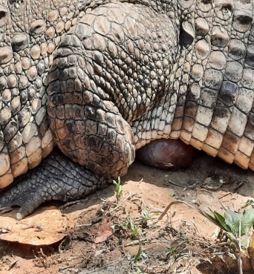 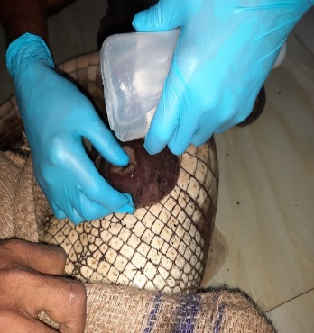 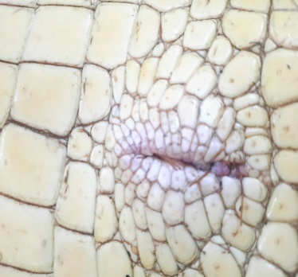 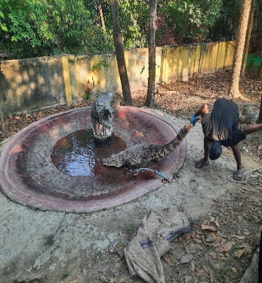

**METHODS AND RESULTS**

On dorsal recumbent position, the prolapsed tissue was gently cleaned with warmed saline. Cloacal oedema was reduced with the application of cold compresses suggested by Norton (1994) and Barten (2006) with concentrated sugar solution. Once the swelling resolved, the prolapsed tissue was reduced with the use of a lubricated gloved finger. Once the prolapse reduced, the tissue returned to its normal position by gently massaged back into the cloaca. Transverse sutures were then placed through the lateral margins of the vent to temporarily reduce the size of the vent. The centre of the vent was wide enough for urine to pass while preventing recurrence of the prolapse. These sutures were left in place for four weeks. The vent was kept well hydrated but not fed for several days to prevent defecation. Ceftazidime antibiotic, (20mg/kg body weight) and Ketoprofen (NSAID) @2mg/kg body weight were administrated intramuscularly. Five doses of Ceftazidime were administered intramuscularly at 48 hours interval.

**Conclusion**

There are many reasons that cloacal prolapses can occur, but the common are diet, dehydration and husbandry problems, or how the reptile is housed and cared for. Unfortunately, once a prolapse has occurred, there is a greater risk of another prolapse in the future.

**References**

1. Barten SL. (2006). Penile Prolapse In: Mader DR, editor, Reptile Medicine and Surgery, 2nd ed., WB Saunders Company, Philadelphia, 862–864.
2. Bennett AR and Mader D. (2006). Cloacal Prolapse. In: Reptile Medicine and Surgery, Edited by Mader D, 2nd ed. Philadelphia (PA): Elsevier Saunders Inc. p 751–755.
3. Clayton L and Gore SR. (2007). Amphibian Emergency Medicine. Vet. Clin. Exot. Anim. 10: 587 – 620.
4. Hadfield CA, Whitaker BR. (2005). Amphibian Emergency Medicine and Care. Sem. Avian and Exot. Pet. Med. 2: 79–89.
5. Hedlund, C.S. and Fossum, T.W. (2007): Surgery of the digestive system. In Small Animal Surgery, 3rd Edition. Mosby Elsevier pp. 726.
6. Martinez-Jimenez D, Hernandez-Divers S. (2007). Emergency Care of Reptiles. Vet. Clin. Exot. Anim. 10: 557–585.
7. Norton TM (1994). Chelonian Emergency and Critical Care. Semin. Avian Exot. Pet. Med. 14: 106–130.
8. Raju Vyas and Vishal Mistry, Male genital/cloacal prolapse in wild marsh crocodiles Crocodylus palustris, Gujarat, India, Herpetological Bulletin 157 (2021) Page 27
9. Sharma YK. And Raghuvanshi, PDS (2009). Surgical treatment of cloacal prolapse in a turtle. Ind. J. Vet. Surg. 30 (1): 70.)