I prefer:

□ ORAL presentation

🗹 POSTER presentation

**Unveiling Antimicrobial Resistance Genes in the Swine Cecal Microbiome Utilizing Shotgun Metagenomic Approach**

Thanaporn Eiamsam-ang1, *, Ben Pascoe2, Pakpoom Tadee1, Phongsakorn Chuammitri1, Nattinee Kittiwan3, Prapas Patchanee1

*Lead presenter

1 Faculty of Veterinary Medicine, Chiang Mai University, Muang, Chiang Mai, 50100, Thailand

2 Ineos Oxford Institute of Antimicrobial Research, Department of Biology, University of Oxford, South Parks Road, Oxford, United Kingdom

3 Veterinary Research and Development Center (Upper Northern Region), Hang Chat, Lampang, 52190, Thailand

**Abstract:**

**Background/Objective:**

The northern region of Thailand constitutes a pivotal area for swine production, facing challenges posed by antimicrobial resistance genes (ARGs). In this study, swine cecal samples from commercial farms were collected to evaluate the ARGs using shotgun metagenomic analyses, which offers a more comprehensive solution than conventional methods. This approach emphasizes the role of swine as a reservoir for ARGs and highlights its public health implications.

**Methods:**

Five swine cecal samples were collected from commercial farms located in Lampang, Chiang Mai, Chiang Rai, and Uttaradit Provinces. Tissue and contents were obtained through intestinal scraping, followed by genomic DNA extraction. Shotgun metagenomic analyses were conducted on the Illumina platform. The ARGs were identified using ABRicate against the CARD database. Visualization results utilized R packages heatmaply and ggplot2, presenting data as binary heatmap and Venn diagram, respectively.

**Results:**

The study identified tetracycline resistance as the most prevalent, followed by aminoglycoside and nucleoside resistance. Interestingly, only one gene conferring resistance to beta-lactam and lincosamide was found across all samples (Figure 1). Farm E exhibited the highest abundance of ARGs (8 ARGs), followed by Farm A (7 ARGs), and Farm D (6 ARGs). While certain ARGs were unique to each farm, others were shared among them. For instance, the *SAT-4* gene, conferring nucleoside resistance, was present in Farms A, D, and E, whereas tetracycline resistance genes, *tetQ*, were shared by Farms C and E, and *tetA(P)* was shared by Farms C and D (Figure 2).

**Conclusion:**

The prevalence of antimicrobial resistance genes in commercial swine farms is attributed to strong selective pressure caused by improper antimicrobial use. Despite efforts to regulate antimicrobial use, these genes persist within the swine cecal microbiome and circulate in the farm environment, posing challenges for eradication. These resistance genes may originate from recirculating resistant pathogens within the farm and intrinsic resistance genes within microbial genomes, facilitated by horizontal gene transfer. Swine manure is a significant route for spreading antimicrobial resistance genes to the environment, contributing to the dissemination of resistance genes from livestock to humans. These findings underscore the global public health implications of antimicrobial resistance genes in swine farms, emphasizing the importance of prudent antimicrobial use in the livestock sector.

**Keywords:** [Swine, Commercial Farms, Cecal Microbiome, Antimicrobial Resistance Genes, Shotgun Metagenomics Analyses]

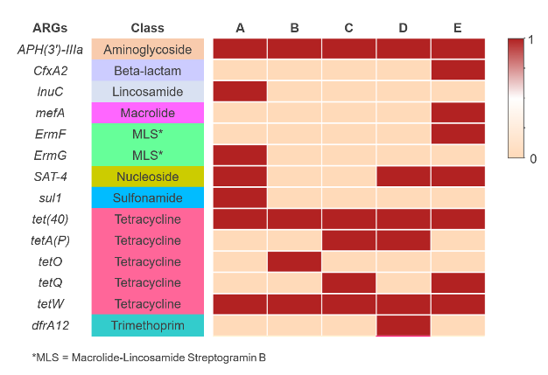

Figure 1 Binary heatmap analysis of antimicrobial resistance genes harbored in the swine cecal microbiome among five commercial farms.

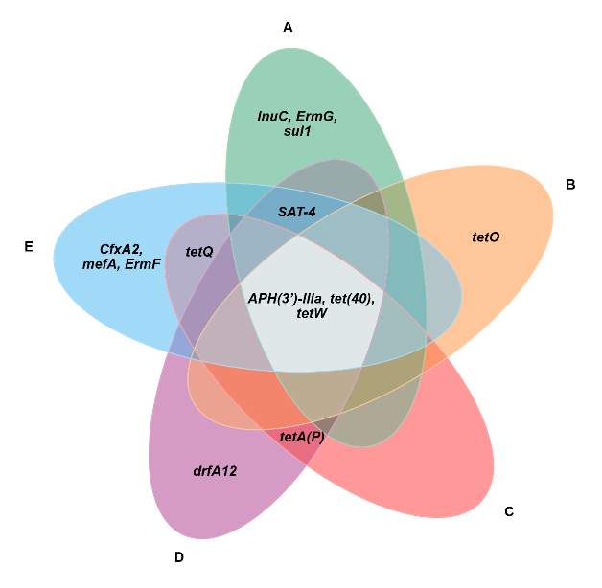

Figure 2 The Venn diagram of antimicrobial resistance genes harbored in the swine cecal microbiome among five commercial farms.