**Linear Regression**

Linear Regression is a supervised machine learning algorithm where the predicted output is continuous and has a constant slope. It's used to predict values within a continuous range rather than trying to classify them into categories.

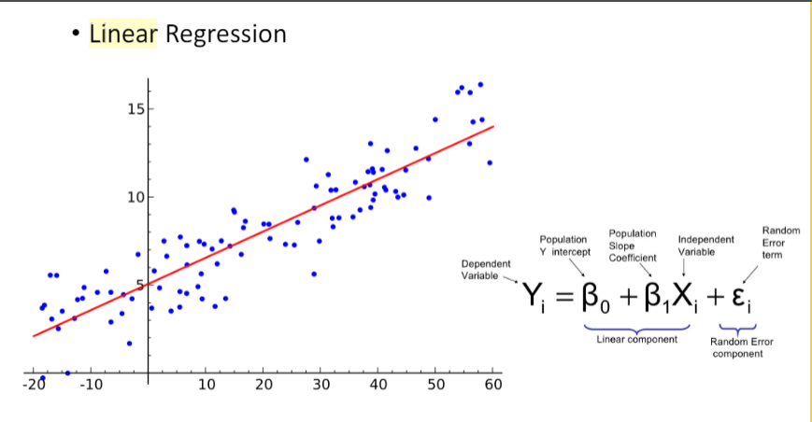

Linear regression performs the task to predict a dependent variable value (y) based on a given independent variable (x). So, this regression technique finds out a linear relationship between x (input) and y(output). Linear relationship between variables means that when the value of one or more independent variables will change (increase or decrease), the value of dependent variable will also change accordingly (increase or decrease).

 Linear regression makes predictions for continuous/real or numeric variables such as sales, salary, age, product price, etc.

Medical researchers often use linear regression to understand the relationship between drug dosage and blood pressure of patients. For example, researchers might administer various dosages of a certain drug to patients and observe how their blood pressure responds. They might fit a simple linear regression model using dosage as the predictor variable and blood pressure as the response variable.

Agricultural scientists often use linear regression to measure the effect of fertilizer and water on crop yields. scientists might use different amounts of fertilizer and water on different fields and see how it affects crop yield. They might fit a multiple linear regression model using fertilizer and water as the predictor variables and crop yield as the response variable.

**Logistic Regression**

Logistic regression is a supervised learning classification algorithm used to predict the probability of a target variable. The nature of target or dependent variable would be only two possible classes.The dependent variable is binary in nature having data coded as either 1 or 0. Mathematically, a logistic regression model predicts P(Y=1) as a function of X. It is one of the simplest ML algorithms that can be used for various classification problems such as spam detection, Diabetes prediction, cancer detection etc.

Logistic regression is suitable when the variable being predicted for is a probability on a binary range from 0 to 1.

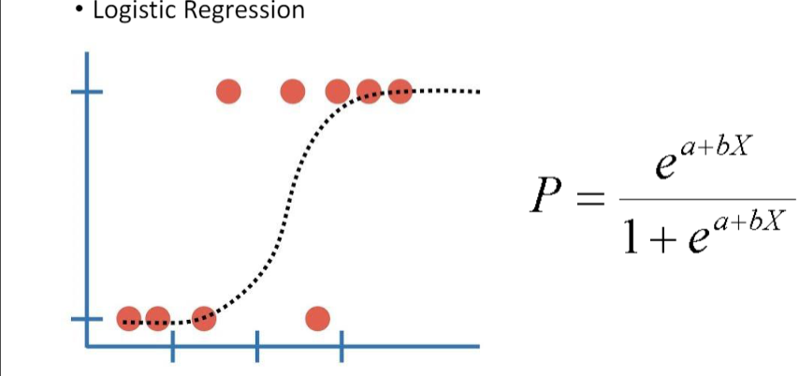

Booking.com has a lot of machine learning methods literally everywhere on the site. They try to predict users' intentions and recognize entities. Where will you go, where do you prefer to stop, what are you planning to do? Some predictions are made even if the user didn't type anything in the search line yet. But how did they start to do this? No one can build a huge and complex system with various machine learning algorithms from scratch. They have accumulated some statistics and created some simple models as the first steps.

Most of the features at such services like booking.com are rather categorical than numerical. Sometimes it becomes necessary to predict an event without specific data about the user. For example, all the data they have is where the user is from and where she wants to go. Logistic regression is ideal for such needs.