analysis

Kahiga Ndegwa

13/07/2020

Loading The dataset

advertising <- read.csv("C:/Users/user/Desktop/advertising.csv")

Checking The Data a.first columns

head(advertising)

## Daily.Time.Spent.on.Site Age Area.Income Daily.Internet.Usage  
## 1 68.95 35 61833.90 256.09  
## 2 80.23 31 68441.85 193.77  
## 3 69.47 26 59785.94 236.50  
## 4 74.15 29 54806.18 245.89  
## 5 68.37 35 73889.99 225.58  
## 6 59.99 23 59761.56 226.74  
## Ad.Topic.Line City Male Country  
## 1 Cloned 5thgeneration orchestration Wrightburgh 0 Tunisia  
## 2 Monitored national standardization West Jodi 1 Nauru  
## 3 Organic bottom-line service-desk Davidton 0 San Marino  
## 4 Triple-buffered reciprocal time-frame West Terrifurt 1 Italy  
## 5 Robust logistical utilization South Manuel 0 Iceland  
## 6 Sharable client-driven software Jamieberg 1 Norway  
## Timestamp Clicked.on.Ad  
## 1 2016-03-27 00:53:11 0  
## 2 2016-04-04 01:39:02 0  
## 3 2016-03-13 20:35:42 0  
## 4 2016-01-10 02:31:19 0  
## 5 2016-06-03 03:36:18 0  
## 6 2016-05-19 14:30:17 0

1. last columns

tail(advertising)

## Daily.Time.Spent.on.Site Age Area.Income Daily.Internet.Usage  
## 995 43.70 28 63126.96 173.01  
## 996 72.97 30 71384.57 208.58  
## 997 51.30 45 67782.17 134.42  
## 998 51.63 51 42415.72 120.37  
## 999 55.55 19 41920.79 187.95  
## 1000 45.01 26 29875.80 178.35  
## Ad.Topic.Line City Male  
## 995 Front-line bifurcated ability Nicholasland 0  
## 996 Fundamental modular algorithm Duffystad 1  
## 997 Grass-roots cohesive monitoring New Darlene 1  
## 998 Expanded intangible solution South Jessica 1  
## 999 Proactive bandwidth-monitored policy West Steven 0  
## 1000 Virtual 5thgeneration emulation Ronniemouth 0  
## Country Timestamp Clicked.on.Ad  
## 995 Mayotte 2016-04-04 03:57:48 1  
## 996 Lebanon 2016-02-11 21:49:00 1  
## 997 Bosnia and Herzegovina 2016-04-22 02:07:01 1  
## 998 Mongolia 2016-02-01 17:24:57 1  
## 999 Guatemala 2016-03-24 02:35:54 0  
## 1000 Brazil 2016-06-03 21:43:21 1

nrow(advertising)

## [1] 1000

summary

summary(advertising)

## Daily.Time.Spent.on.Site Age Area.Income Daily.Internet.Usage  
## Min. :32.60 Min. :19.00 Min. :13996 Min. :104.8   
## 1st Qu.:51.36 1st Qu.:29.00 1st Qu.:47032 1st Qu.:138.8   
## Median :68.22 Median :35.00 Median :57012 Median :183.1   
## Mean :65.00 Mean :36.01 Mean :55000 Mean :180.0   
## 3rd Qu.:78.55 3rd Qu.:42.00 3rd Qu.:65471 3rd Qu.:218.8   
## Max. :91.43 Max. :61.00 Max. :79485 Max. :270.0   
##   
## Ad.Topic.Line City   
## Adaptive 24hour Graphic Interface : 1 Lisamouth : 3   
## Adaptive asynchronous attitude : 1 Williamsport : 3   
## Adaptive context-sensitive application : 1 Benjaminchester: 2   
## Adaptive contextually-based methodology: 1 East John : 2   
## Adaptive demand-driven knowledgebase : 1 East Timothy : 2   
## Adaptive uniform capability : 1 Johnstad : 2   
## (Other) :994 (Other) :986   
## Male Country Timestamp Clicked.on.Ad  
## Min. :0.000 Czech Republic: 9 2016-01-01 02:52:10: 1 Min. :0.0   
## 1st Qu.:0.000 France : 9 2016-01-01 03:35:35: 1 1st Qu.:0.0   
## Median :0.000 Afghanistan : 8 2016-01-01 05:31:22: 1 Median :0.5   
## Mean :0.481 Australia : 8 2016-01-01 08:27:06: 1 Mean :0.5   
## 3rd Qu.:1.000 Cyprus : 8 2016-01-01 15:14:24: 1 3rd Qu.:1.0   
## Max. :1.000 Greece : 8 2016-01-01 20:17:49: 1 Max. :1.0   
## (Other) :950 (Other) :994

#Tyding The Dataset 1.looking for duplicates

duplicated(advertising)

## [1] FALSE FALSE FALSE FALSE FALSE FALSE FALSE FALSE FALSE FALSE FALSE FALSE  
## [13] FALSE FALSE FALSE FALSE FALSE FALSE FALSE FALSE FALSE FALSE FALSE FALSE  
## [25] FALSE FALSE FALSE FALSE FALSE FALSE FALSE FALSE FALSE FALSE FALSE FALSE  
## [37] FALSE FALSE FALSE FALSE FALSE FALSE FALSE FALSE FALSE FALSE FALSE FALSE  
## [49] FALSE FALSE FALSE FALSE FALSE FALSE FALSE FALSE FALSE FALSE FALSE FALSE  
## [61] FALSE FALSE FALSE FALSE FALSE FALSE FALSE FALSE FALSE FALSE FALSE FALSE  
## [73] FALSE FALSE FALSE FALSE FALSE FALSE FALSE FALSE FALSE FALSE FALSE FALSE  
## [85] FALSE FALSE FALSE FALSE FALSE FALSE FALSE FALSE FALSE FALSE FALSE FALSE  
## [97] FALSE FALSE FALSE FALSE FALSE FALSE FALSE FALSE FALSE FALSE FALSE FALSE  
## [109] FALSE FALSE FALSE FALSE FALSE FALSE FALSE FALSE FALSE FALSE FALSE FALSE  
## [121] FALSE FALSE FALSE FALSE FALSE FALSE FALSE FALSE FALSE FALSE FALSE FALSE  
## [133] FALSE FALSE FALSE FALSE FALSE FALSE FALSE FALSE FALSE FALSE FALSE FALSE  
## [145] FALSE FALSE FALSE FALSE FALSE FALSE FALSE FALSE FALSE FALSE FALSE FALSE  
## [157] FALSE FALSE FALSE FALSE FALSE FALSE FALSE FALSE FALSE FALSE FALSE FALSE  
## [169] FALSE FALSE FALSE FALSE FALSE FALSE FALSE FALSE FALSE FALSE FALSE FALSE  
## [181] FALSE FALSE FALSE FALSE FALSE FALSE FALSE FALSE FALSE FALSE FALSE FALSE  
## [193] FALSE FALSE FALSE FALSE FALSE FALSE FALSE FALSE FALSE FALSE FALSE FALSE  
## [205] FALSE FALSE FALSE FALSE FALSE FALSE FALSE FALSE FALSE FALSE FALSE FALSE  
## [217] FALSE FALSE FALSE FALSE FALSE FALSE FALSE FALSE FALSE FALSE FALSE FALSE  
## [229] FALSE FALSE FALSE FALSE FALSE FALSE FALSE FALSE FALSE FALSE FALSE FALSE  
## [241] FALSE FALSE FALSE FALSE FALSE FALSE FALSE FALSE FALSE FALSE FALSE FALSE  
## [253] FALSE FALSE FALSE FALSE FALSE FALSE FALSE FALSE FALSE FALSE FALSE FALSE  
## [265] FALSE FALSE FALSE FALSE FALSE FALSE FALSE FALSE FALSE FALSE FALSE FALSE  
## [277] FALSE FALSE FALSE FALSE FALSE FALSE FALSE FALSE FALSE FALSE FALSE FALSE  
## [289] FALSE FALSE FALSE FALSE FALSE FALSE FALSE FALSE FALSE FALSE FALSE FALSE  
## [301] FALSE FALSE FALSE FALSE FALSE FALSE FALSE FALSE FALSE FALSE FALSE FALSE  
## [313] FALSE FALSE FALSE FALSE FALSE FALSE FALSE FALSE FALSE FALSE FALSE FALSE  
## [325] FALSE FALSE FALSE FALSE FALSE FALSE FALSE FALSE FALSE FALSE FALSE FALSE  
## [337] FALSE FALSE FALSE FALSE FALSE FALSE FALSE FALSE FALSE FALSE FALSE FALSE  
## [349] FALSE FALSE FALSE FALSE FALSE FALSE FALSE FALSE FALSE FALSE FALSE FALSE  
## [361] FALSE FALSE FALSE FALSE FALSE FALSE FALSE FALSE FALSE FALSE FALSE FALSE  
## [373] FALSE FALSE FALSE FALSE FALSE FALSE FALSE FALSE FALSE FALSE FALSE FALSE  
## [385] FALSE FALSE FALSE FALSE FALSE FALSE FALSE FALSE FALSE FALSE FALSE FALSE  
## [397] FALSE FALSE FALSE FALSE FALSE FALSE FALSE FALSE FALSE FALSE FALSE FALSE  
## [409] FALSE FALSE FALSE FALSE FALSE FALSE FALSE FALSE FALSE FALSE FALSE FALSE  
## [421] FALSE FALSE FALSE FALSE FALSE FALSE FALSE FALSE FALSE FALSE FALSE FALSE  
## [433] FALSE FALSE FALSE FALSE FALSE FALSE FALSE FALSE FALSE FALSE FALSE FALSE  
## [445] FALSE FALSE FALSE FALSE FALSE FALSE FALSE FALSE FALSE FALSE FALSE FALSE  
## [457] FALSE FALSE FALSE FALSE FALSE FALSE FALSE FALSE FALSE FALSE FALSE FALSE  
## [469] FALSE FALSE FALSE FALSE FALSE FALSE FALSE FALSE FALSE FALSE FALSE FALSE  
## [481] FALSE FALSE FALSE FALSE FALSE FALSE FALSE FALSE FALSE FALSE FALSE FALSE  
## [493] FALSE FALSE FALSE FALSE FALSE FALSE FALSE FALSE FALSE FALSE FALSE FALSE  
## [505] FALSE FALSE FALSE FALSE FALSE FALSE FALSE FALSE FALSE FALSE FALSE FALSE  
## [517] FALSE FALSE FALSE FALSE FALSE FALSE FALSE FALSE FALSE FALSE FALSE FALSE  
## [529] FALSE FALSE FALSE FALSE FALSE FALSE FALSE FALSE FALSE FALSE FALSE FALSE  
## [541] FALSE FALSE FALSE FALSE FALSE FALSE FALSE FALSE FALSE FALSE FALSE FALSE  
## [553] FALSE FALSE FALSE FALSE FALSE FALSE FALSE FALSE FALSE FALSE FALSE FALSE  
## [565] FALSE FALSE FALSE FALSE FALSE FALSE FALSE FALSE FALSE FALSE FALSE FALSE  
## [577] FALSE FALSE FALSE FALSE FALSE FALSE FALSE FALSE FALSE FALSE FALSE FALSE  
## [589] FALSE FALSE FALSE FALSE FALSE FALSE FALSE FALSE FALSE FALSE FALSE FALSE  
## [601] FALSE FALSE FALSE FALSE FALSE FALSE FALSE FALSE FALSE FALSE FALSE FALSE  
## [613] FALSE FALSE FALSE FALSE FALSE FALSE FALSE FALSE FALSE FALSE FALSE FALSE  
## [625] FALSE FALSE FALSE FALSE FALSE FALSE FALSE FALSE FALSE FALSE FALSE FALSE  
## [637] FALSE FALSE FALSE FALSE FALSE FALSE FALSE FALSE FALSE FALSE FALSE FALSE  
## [649] FALSE FALSE FALSE FALSE FALSE FALSE FALSE FALSE FALSE FALSE FALSE FALSE  
## [661] FALSE FALSE FALSE FALSE FALSE FALSE FALSE FALSE FALSE FALSE FALSE FALSE  
## [673] FALSE FALSE FALSE FALSE FALSE FALSE FALSE FALSE FALSE FALSE FALSE FALSE  
## [685] FALSE FALSE FALSE FALSE FALSE FALSE FALSE FALSE FALSE FALSE FALSE FALSE  
## [697] FALSE FALSE FALSE FALSE FALSE FALSE FALSE FALSE FALSE FALSE FALSE FALSE  
## [709] FALSE FALSE FALSE FALSE FALSE FALSE FALSE FALSE FALSE FALSE FALSE FALSE  
## [721] FALSE FALSE FALSE FALSE FALSE FALSE FALSE FALSE FALSE FALSE FALSE FALSE  
## [733] FALSE FALSE FALSE FALSE FALSE FALSE FALSE FALSE FALSE FALSE FALSE FALSE  
## [745] FALSE FALSE FALSE FALSE FALSE FALSE FALSE FALSE FALSE FALSE FALSE FALSE  
## [757] FALSE FALSE FALSE FALSE FALSE FALSE FALSE FALSE FALSE FALSE FALSE FALSE  
## [769] FALSE FALSE FALSE FALSE FALSE FALSE FALSE FALSE FALSE FALSE FALSE FALSE  
## [781] FALSE FALSE FALSE FALSE FALSE FALSE FALSE FALSE FALSE FALSE FALSE FALSE  
## [793] FALSE FALSE FALSE FALSE FALSE FALSE FALSE FALSE FALSE FALSE FALSE FALSE  
## [805] FALSE FALSE FALSE FALSE FALSE FALSE FALSE FALSE FALSE FALSE FALSE FALSE  
## [817] FALSE FALSE FALSE FALSE FALSE FALSE FALSE FALSE FALSE FALSE FALSE FALSE  
## [829] FALSE FALSE FALSE FALSE FALSE FALSE FALSE FALSE FALSE FALSE FALSE FALSE  
## [841] FALSE FALSE FALSE FALSE FALSE FALSE FALSE FALSE FALSE FALSE FALSE FALSE  
## [853] FALSE FALSE FALSE FALSE FALSE FALSE FALSE FALSE FALSE FALSE FALSE FALSE  
## [865] FALSE FALSE FALSE FALSE FALSE FALSE FALSE FALSE FALSE FALSE FALSE FALSE  
## [877] FALSE FALSE FALSE FALSE FALSE FALSE FALSE FALSE FALSE FALSE FALSE FALSE  
## [889] FALSE FALSE FALSE FALSE FALSE FALSE FALSE FALSE FALSE FALSE FALSE FALSE  
## [901] FALSE FALSE FALSE FALSE FALSE FALSE FALSE FALSE FALSE FALSE FALSE FALSE  
## [913] FALSE FALSE FALSE FALSE FALSE FALSE FALSE FALSE FALSE FALSE FALSE FALSE  
## [925] FALSE FALSE FALSE FALSE FALSE FALSE FALSE FALSE FALSE FALSE FALSE FALSE  
## [937] FALSE FALSE FALSE FALSE FALSE FALSE FALSE FALSE FALSE FALSE FALSE FALSE  
## [949] FALSE FALSE FALSE FALSE FALSE FALSE FALSE FALSE FALSE FALSE FALSE FALSE  
## [961] FALSE FALSE FALSE FALSE FALSE FALSE FALSE FALSE FALSE FALSE FALSE FALSE  
## [973] FALSE FALSE FALSE FALSE FALSE FALSE FALSE FALSE FALSE FALSE FALSE FALSE  
## [985] FALSE FALSE FALSE FALSE FALSE FALSE FALSE FALSE FALSE FALSE FALSE FALSE  
## [997] FALSE FALSE FALSE FALSE

we found that the data had no duplicates

colnames(advertising)

## [1] "Daily.Time.Spent.on.Site" "Age"   
## [3] "Area.Income" "Daily.Internet.Usage"   
## [5] "Ad.Topic.Line" "City"   
## [7] "Male" "Country"   
## [9] "Timestamp" "Clicked.on.Ad"

names(advertising)[names(advertising) == "Male "] <- "Gender"

Univariate Analysis

hist(advertising$Age)

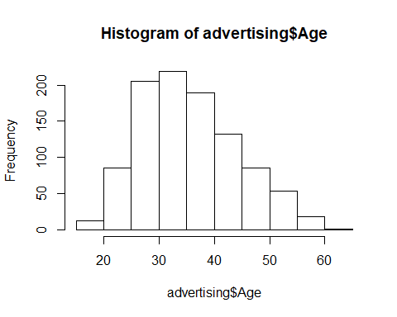 The average age is 35

plot(density(advertising$Age), main="Age Density Spread")

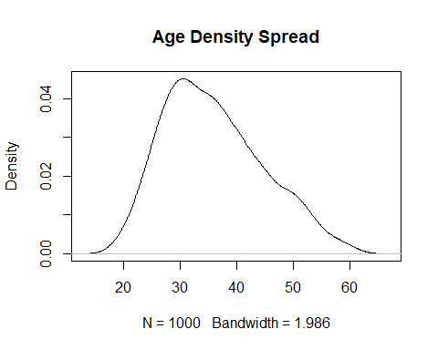

hist(advertising$Daily.Internet.Usage)

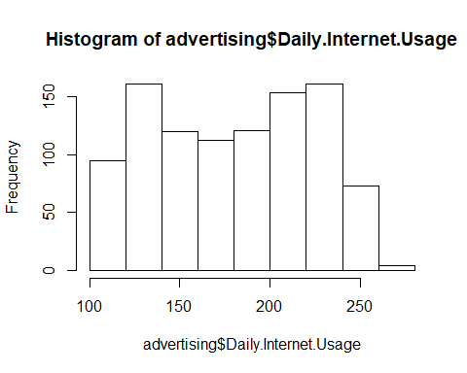

hist(advertising$Daily.Time.Spent.on.Site)

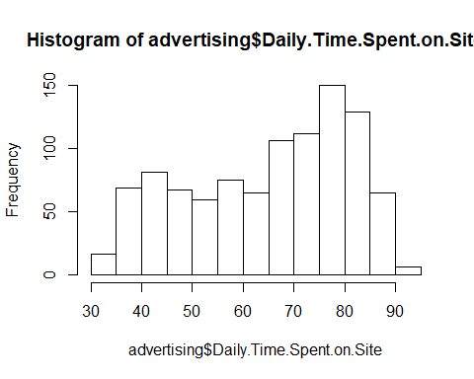 Most people use 70 to 80 hours a day on a site

pie(table(advertising$Male), main="male vs female")

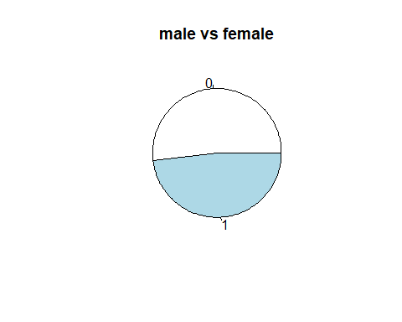 1 being male And 0 being female females spend more time than males online

pie(table(advertising$Clicked.on.Ad), main="Most likely to click on Ads")

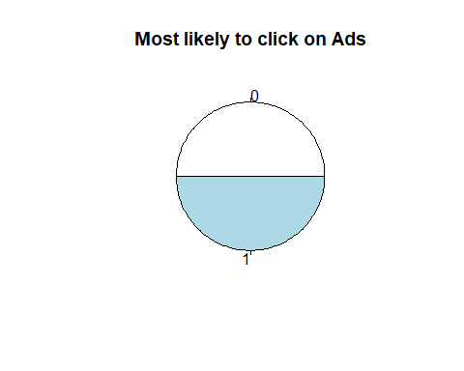 1 for Yes and 0 for No

Bivariate Analysis

boxplot(advertising$Daily.Internet.Usage-advertising$Age, notch = TRUE,col=c("grey","gold"), main="Age against internet usage")

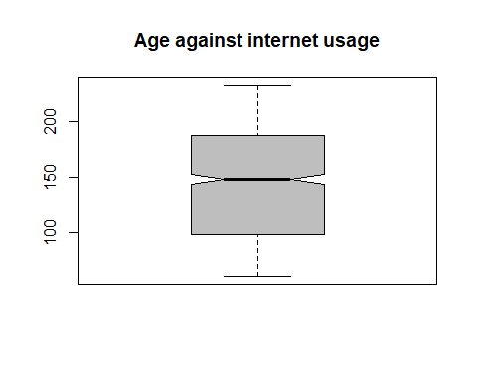

library(ggplot2)  
ggplot(advertising, aes(x = Area.Income, y = Age)) + geom_point()

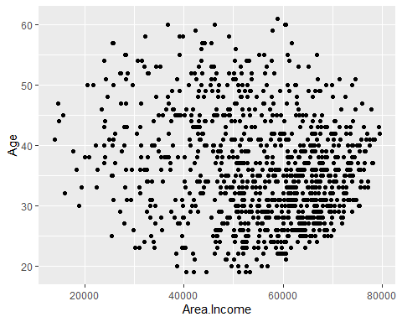

sp<-ggplot(advertising, aes(x=Area.Income, y=Daily.Internet.Usage, color=Male)) + geom_point()  
sp

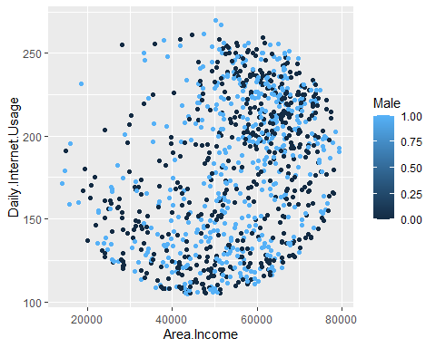

ggplot(advertising, aes(x = Daily.Time.Spent.on.Site, y = Daily.Internet.Usage)) + geom_point()

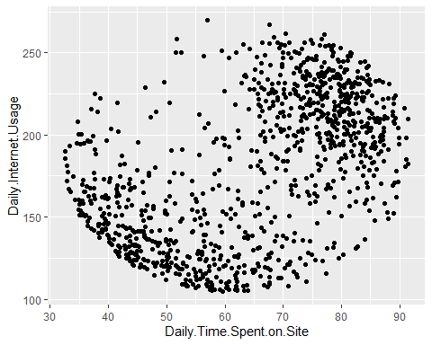

Conclusion

1. Both genders are likely to click on ads equally
2. Bore female spend more time sites compared to males
3. Males use internet more compared to ladies
4. Age bracket of 20 to 30 years are more in area.income