Product Design
Team | SSAD Team 10  Team Name : FiniteLoop  Team Members :  - Punyaslok Pattnaik  - Jaipal Singh Goud  - Umesh Kumar Singla  - Varshit Battu  - Ram Kumar Reddy

Design Model
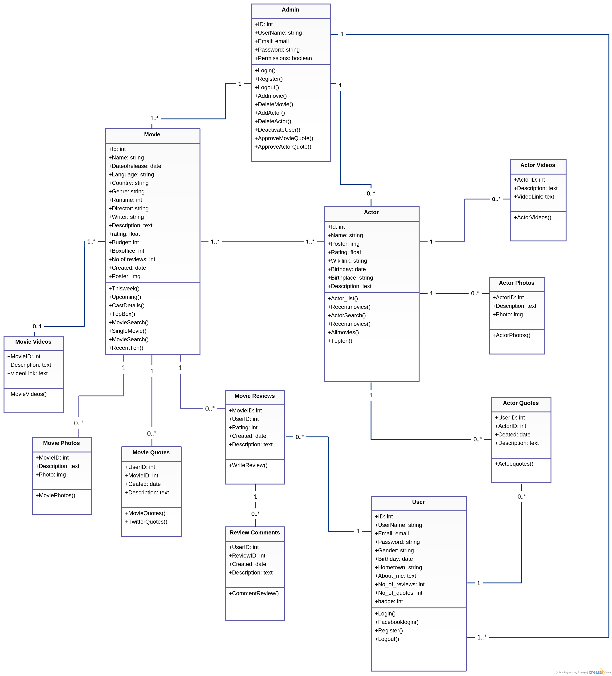

Class No. 1  Movie | Class state  - Movie ID  - Name : Name of the movie  - Date of Release : Release date of movie  - Language : Language in which the movie is to be released  - Country : Country of production  - Genre : Genre(s) of the movie  - Runtime : Durationof movie  - Director : Who directed the movie  - Writer : Who wrote the script for movie  - Description : Short description of movie  - Rating : Current User Rating  - Budget : Total Budget spent in making the movie  - Box Office : Income generated till now  - Number of Reviews : Number of reviews received  - Creation Date : Date when it was added to Movieo  - Poster : Poster of movie  Class behavior  - Thisweek() : Fetches all movies releasing in the coming week  - Upcoming() : Fetches all movies releasing in the future  - CastDetails() : Gets all the names of the people involved in making that movie  - TopBox() : Fetches the top grossing movies  - MovieSearch() : Returns Search results based on query type  - RecentTen() : Gets list of the most recently released movies (10)
Class No. 2  Movie Videos | Class state  - MovieID : The movie which the video belongs to  - Description : A short descirption of the video  - Videolink : A link for viewing the video if the video is externally hosted  Class behavior  - MovieVideos() : Gets list of all videos associated with that movie
Class No. 3  Movie Photos | Class state  - MovieID : The movie which the photo belongs to  - Description : A short descirption of the photo  - Videolink : A link for viewing the photo if the photo is externally hosted  Class behavior  - MovieVideos() : Gets list of all photos associated with that movie
Class No. 4  Movie Quotes | Class state  - UserID : The user who identified that quote  - MovieID : The movie which the quote belongs to  - Created : The date when the quote was uploaded  - Description : The content of the quote  Class behavior  - MovieQuotes() : Gets list of all quotes associated with that movie  - TwitterQuotes() : Gets a list of all popular quotes trending in Twitter
Class No. 5  Movie Reviews | Class state  - UserID : The user who wrote that review  - MovieID : The movie which the review belongs to  - Rating : The rating given to the movie by the user  - Created : The date when the review was written  - Description : The review content  Class behavior  - WriteReview() : Saves the review to the DB and updates movie rating and posts the review on the movie page
Class No. 6  Review Comments | Class state  - UserID : The user who wrote that comment  - ReviewID : The review which the comment belongs to  - Created : The date when the comment was written  - Description : The content of the comment  Class behavior  - CommentReview() : Saves the comment to the DB and posts the comment on the review page
Class No. 7  Actor | Class state  - ID  - Name : Actor's name  - Poster : Photo which appears on the Actor's page  - Rating : Current rating given by users  - Wikilink : Link to the actor's Wikipedia page  - Birthday : Actor's Birthday  - Birthplace : Place where actor was born  - Description : Short bio of actor  Class behavior  - Actor_list() : Returns list of actors based on input parameters  - Recentmovies() : Returns list of recent movies the actor has featured in  - ActorSearch() : Returns list of actors according to search results  - Allmovies() : Returns list of all movies the actor has featured in  - Topten() : Returns the top 10 highest rated Actors
Class No. 8  Actor Videos | Class state  - ActorID : ID of the actor to which the video belongs  - Description : Short description of the video  - Videolink : A link for viewing the video if the video is externally hosted  Class behavior  - ActorVideos() : Returns list of all videos of that actor
Class No. 9  Actor Photos | Class state  - ActorID : The actor which the photo belongs to  - Description : A short descirption of the photo  - Videolink : A link for viewing the photo if the photo is externally hosted  Class behavior  - ActorPhotos() : Gets list of all photos associated with that actor
Class No. 10  Actor Quotes | Class state  - UserID : The user who identified that quote  - ActorID : The actor which the quote belongs to  - Created : The date when the quote was uploaded  - Description : The content of the quote  Class behavior  - ActorQuotes() : Gets list of all quotes associated with that actor
Class No. 11  User | Class state  - ID  - UserName : Username used to login  - Email : Email address of the user  - Gender : Gender of the user  - Birthday : Date of birth of the user  - Hometown : Place where user resides  - About_me : Short description of the user written by himself  - No_of_reviews : Number of reviews written by the user  - No_of_quotes : Number of quotes identified by the user  - badge : Current badge that the user holds  Class behavior  - Login() : Checks credentials and logs in the user  - Facebooklogin() : Executes login through Facebook  - Register() : Initiates new user registration  - Logout() : Logs out the user

Sequence Diagram(s)

