**How to Change your Status on the Zulip App for Android Devices**

Often times we are unable to reply to all the texts from our friends and group members because we are either held back by another activity or we are completely unavailable to respond. This can be a huge inconvenience especially if the message needed an urgent answer not only to you but to also the group members. To mitigate this problem, Zulip has a feature that enables you to set your current status that will be accessible and visible to each and every one in your team. All they would be required to do is hover over your name and the status will appear.

**Step-by-Step Process to Setting Your Status:**

1. Once logged in on the Zulip android app, the home page will look like this;

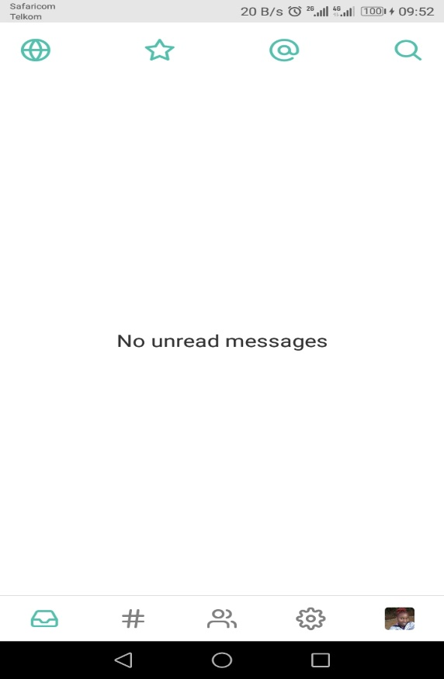

(home page)

1. Click on your profile picture icon at the bottom left of the page.
2. The new page shows your profile image at the top, your current availability, and local time and status settings.
3. By clicking the toggle button of the **Set yourself away**, your status is automatically updated to **Unavailable** by the system settings. Also you will notice that the **Active now** message changes to **Active today**, while the **green dot** that precedes your email address below your profile image is turned off an **empty colorless dot**. However, your last set status remains the same.

To change your unavailable status to available, just click the toggle button to change the setting off. Immediately you are notified that you active at the moment, and the green dot re-appears.

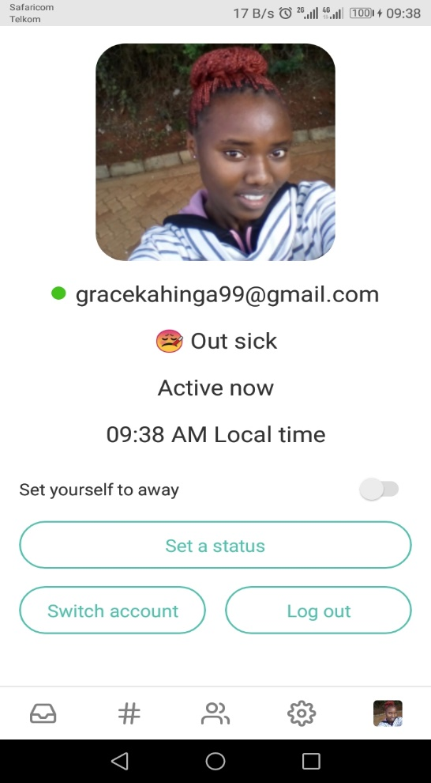 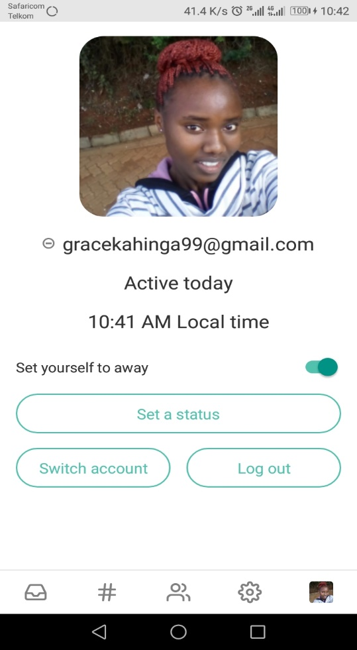

(*When the toggle button is off)* (*When the toggle button is on*)

1. To add a new status in regards to your availability, click the **Set a status** button.

There are already a number of pre-suggested statuses available for your use including the **In a meeting**, **Out Sick** and **Commuting** statuses. If you want to use one of them, just click on it and it will appear on the **edit** tab where you can modify to suit your needs.

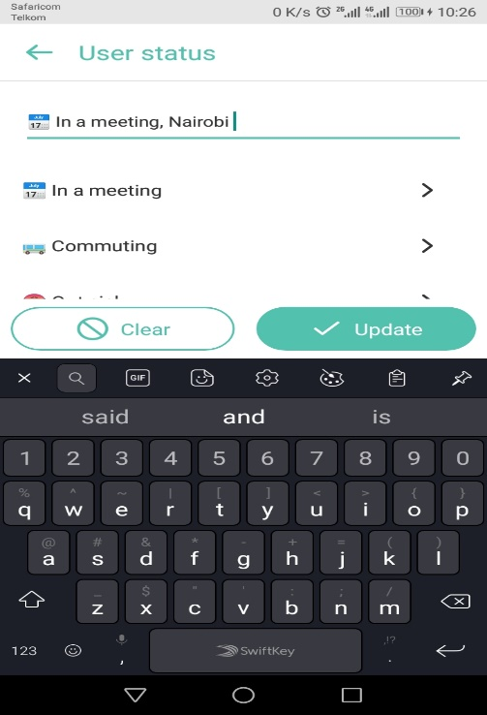

However, if none of the given statuses fits what you are looking for, you can create your own on the edit tab e.g **Exams time.**

When you have chosen or written your status, click on the **Update** button to save it in your profile.

1. To remove your status, click on the **Clear** button and the previous status will be removed.