Spike Sorting Protocol

File Organization

- Upload all files to the computer where they will be spike sorted.
- Move all data into a folder called “raw”: 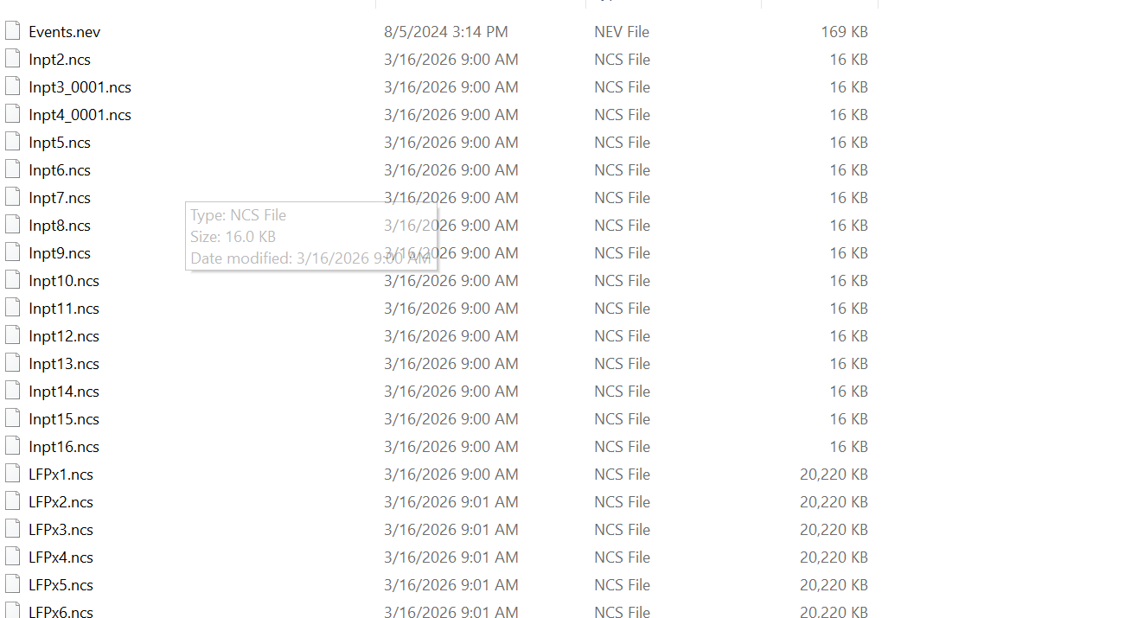
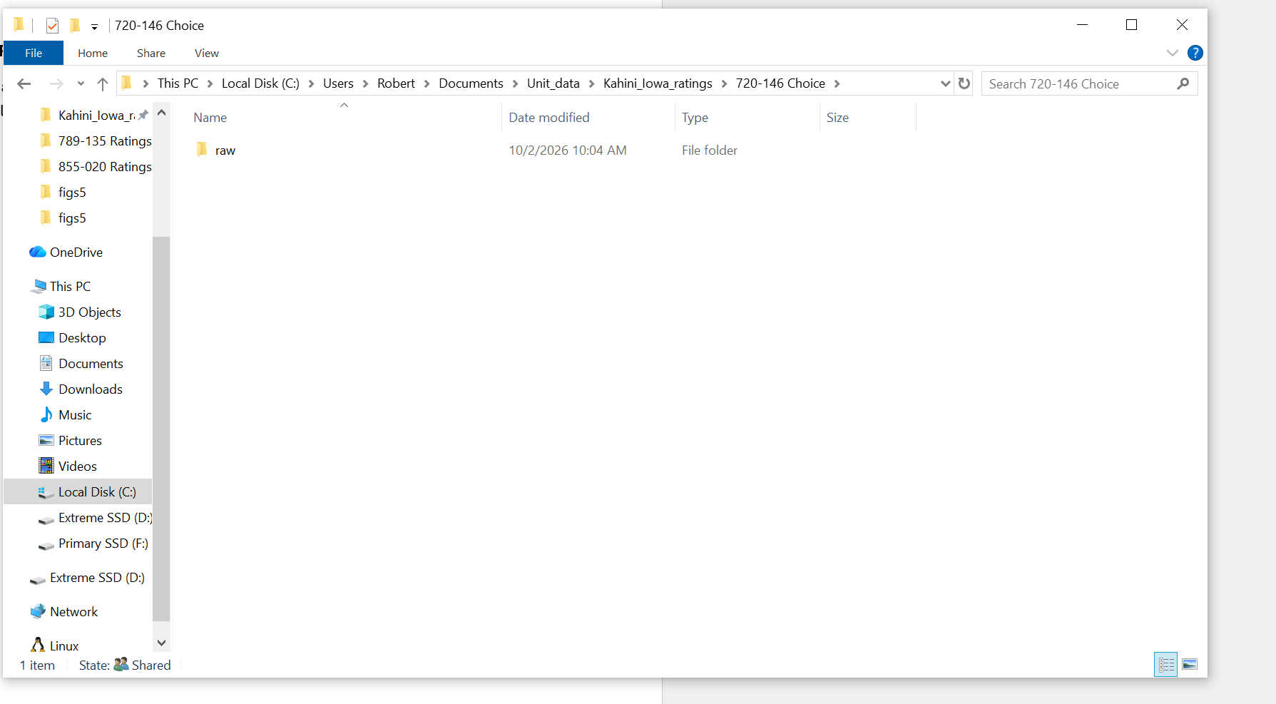
- For SUA, use only files starting with PDes
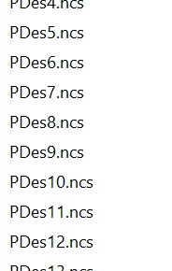

Running OSort
1. Open MATLAB
2. Go to C:\Users\Robert\Documents\bean_stalk
3. Run setpath_jd.m
4. Now go to C:\Users\Robert\Documents\bean_stalk\osort-v4-rel\code\osortTextUI
5. Edit Standalone_textGUI_atlas_IOWA.m : change the path and patient ID and channel numbers. Exclude anything with too little data eg: 16 kb.
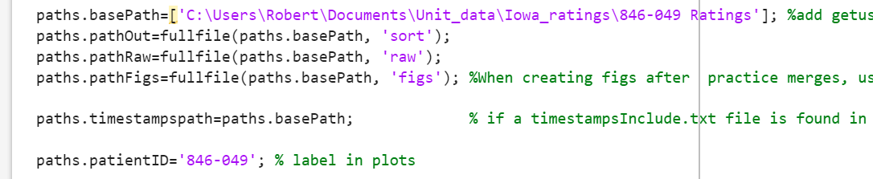
6. Run the script. This will create folders called figs 5 and sort. These will be used for manual spike sorting.
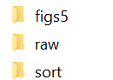

SpikeSorting

- Copy this excel file for each patient and write down cluster numbers to keep. Template: IOWA_cells_sorting_template.xlsx at C:\Users\Robert\Documents\Unit_data\Iowa_ratings\720-143 Ratings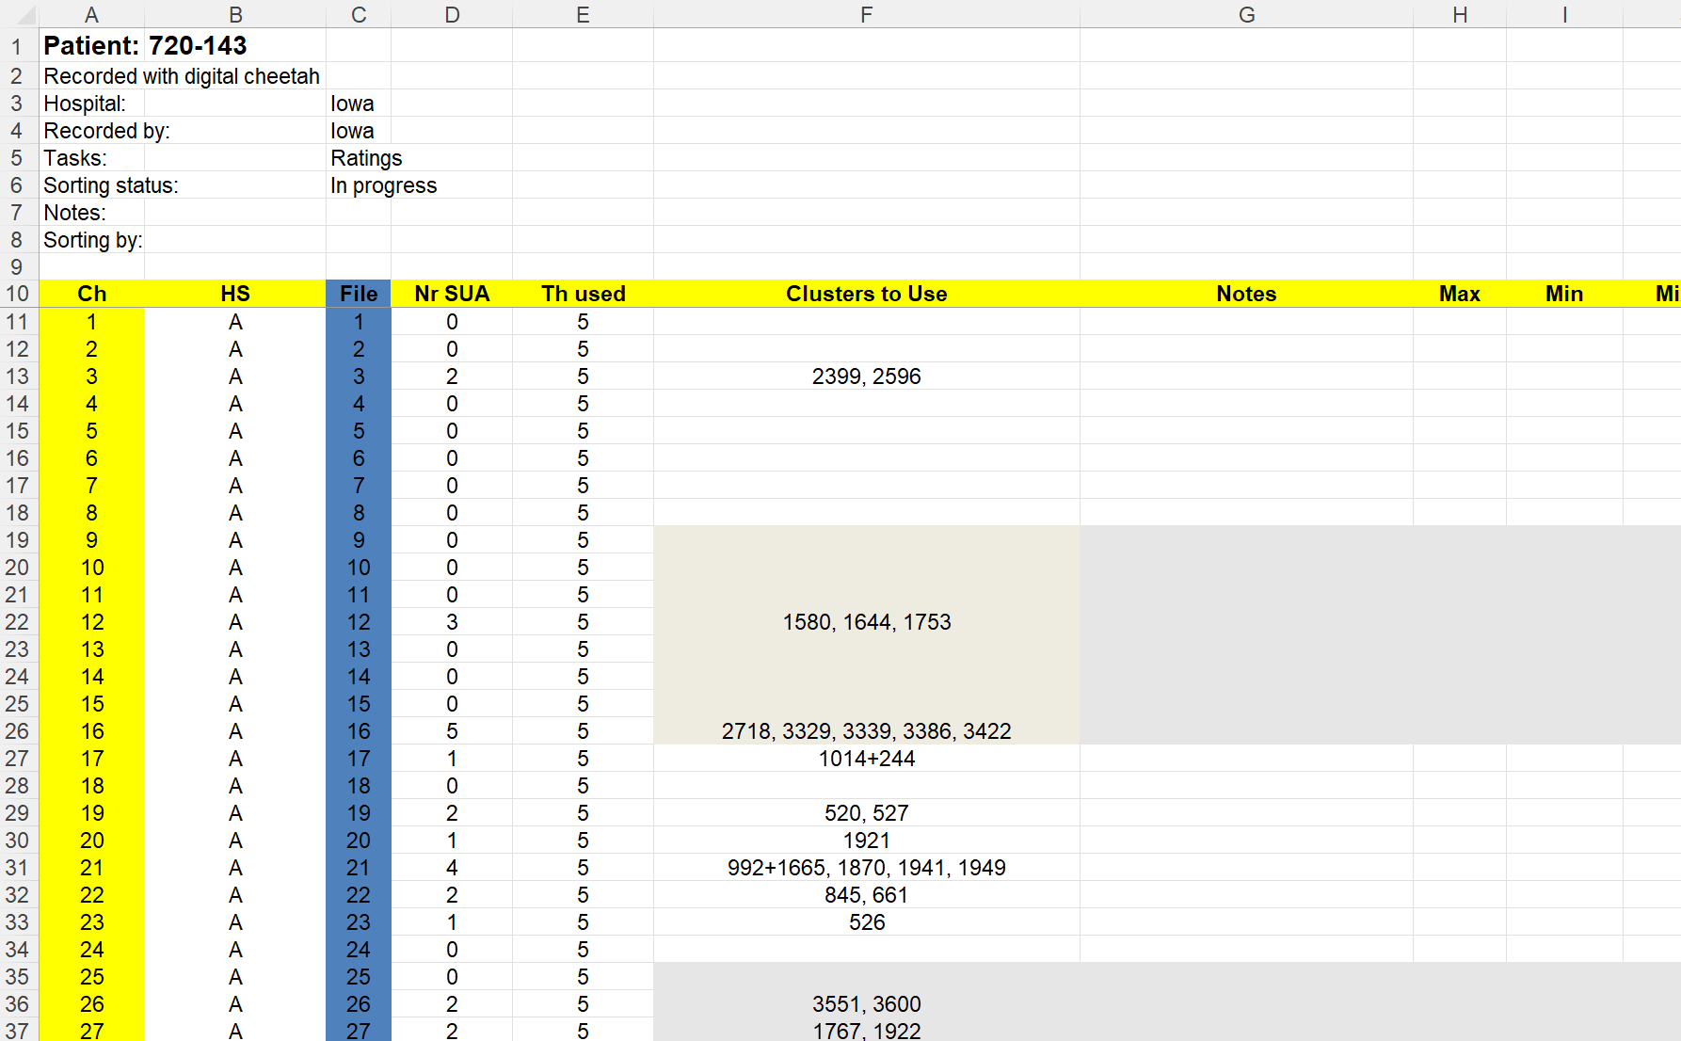
- Criteria for whether a unit is usable:

Each cluster is reviewed by eye in the figs5 figures. Kept clusters are entered in IOWA_cells_sorting_template.xlsx under Clusters to Use. Merged clusters are joined with "+" and separate units with ", " (e.g. 3874, 3945+3947).
Criteria for whether a unit is usable
A cluster is kept as a single unit only if it passes all six checks below. Each check is read from one panel of the cluster figure (A<channel>_CL_<cluster>_THM_1.png).
Check | Where on the figure | Cutoff we used | Example from our data
Firing rate | Top-left panel title, "Raw waveforms f=… Hz" | At or above 0.5 Hz (0.35-45 Hz at our discretion if otherwise good) | 868-034 A10 cluster 352: f = 0.09 Hz, not kept (Example 2)
Usable waveform | Top-left, raw waveforms with mean in blue | One clear spike shape, consistent across spikes, not too many oscillations | 868-034 A1 cluster 4561: kept (Example 1)
Density trace | Top-right, "Density of waveforms" | A dense red core that lines up with the mean waveform | 868-034 A1 cluster 4561: tight core, isolation distance 68.4 (Example 1)
ISI violations | Bottom-left panel title | First number in the title (out of ISIs up to 70 ms) below 5%. 5 to 10% accepted if the second number (out of ISIs up to 1000 ms) is 3% or less and all other checks pass. Above 10% removed. | 720-143 A82 cluster 3790: 7.06%, removed (Example 3). Also removed: 778-074 A73 cluster 9294 and 891-056 A82 cluster 2841 (second number above 3%).
ISI distribution | Bottom-middle panel | Exponential-like decay, with few intervals near 0 ms | 868-034 A1 cluster 4561 (Example 1)
Stable across the session | Bottom-right, "Spike rate & amplitude" over time | Fires for at least half of the recording | 868-034 A23 cluster 3619 fired only in the last 5.4 min of a 43 min session, removed

Example 1: usable unit. 868-034 A1 cluster 4561: f = 2.55 Hz, one clean spike shape, a tight density core, ISI under 3 ms of 1.40% / 0.05%, and a smoothly decaying ISI histogram.
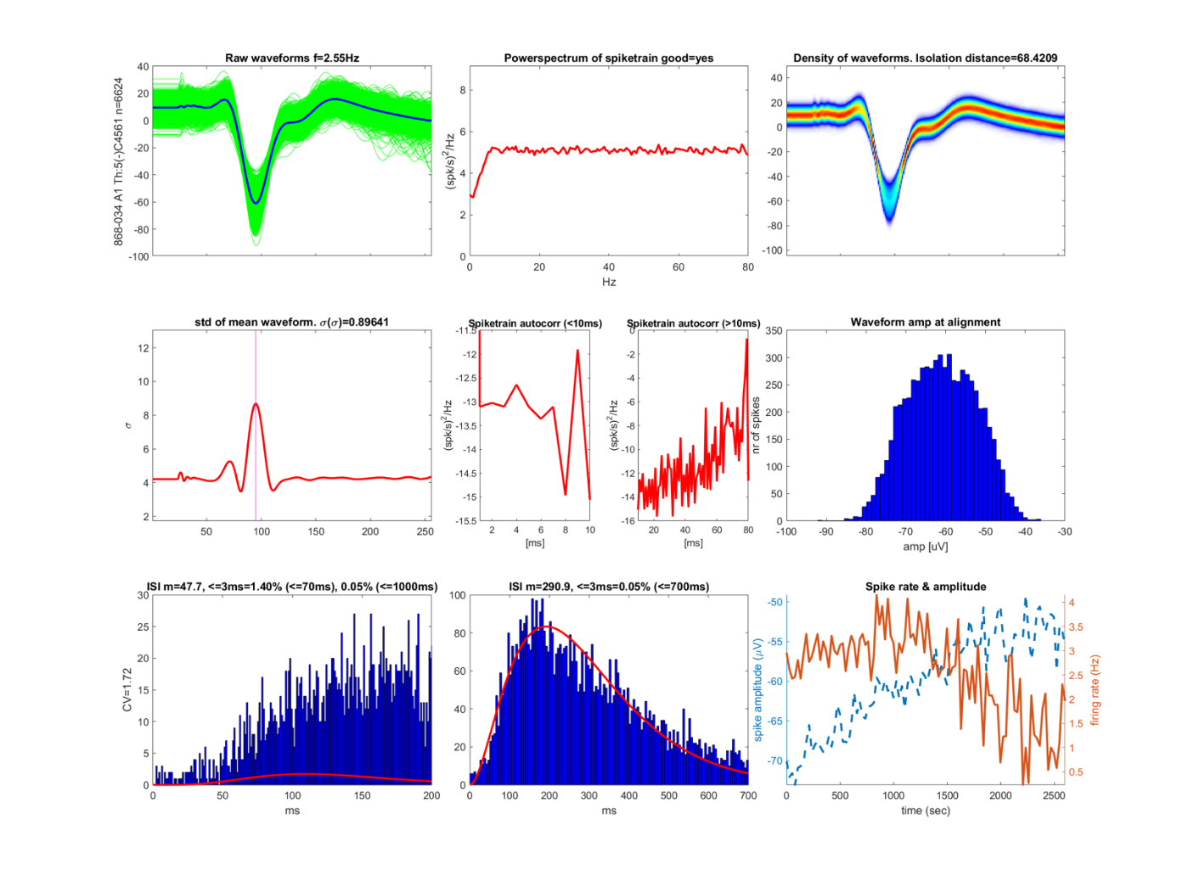
Example 1: 868-034 A1 cluster 4561, a usable unit
Example 2: firing rate too low. 868-034 A10 cluster 352: the waveform and density look clean, but f = 0.09 Hz (228 spikes in the session), so it was not kept.
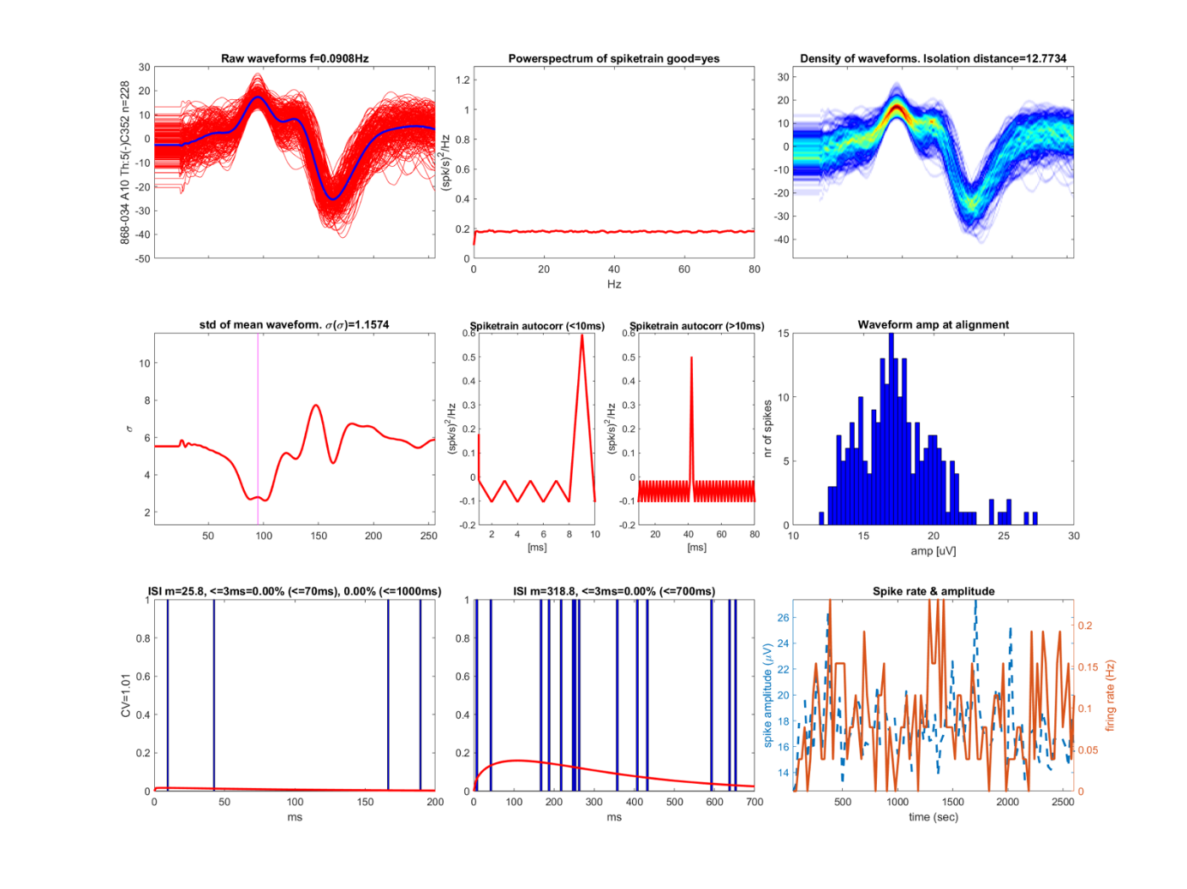
Example 2: 868-034 A10 cluster 352, firing rate too low
Example 3: too many ISI violations. 720-143 A82 cluster 3790: the ISI title reads 10.37% (of ISIs up to 70 ms) and 7.06% (of ISIs up to 1000 ms). The second number is over our 3% cutoff, so the unit was removed. Note the tall bars right at 0 ms in the bottom-left histogram.
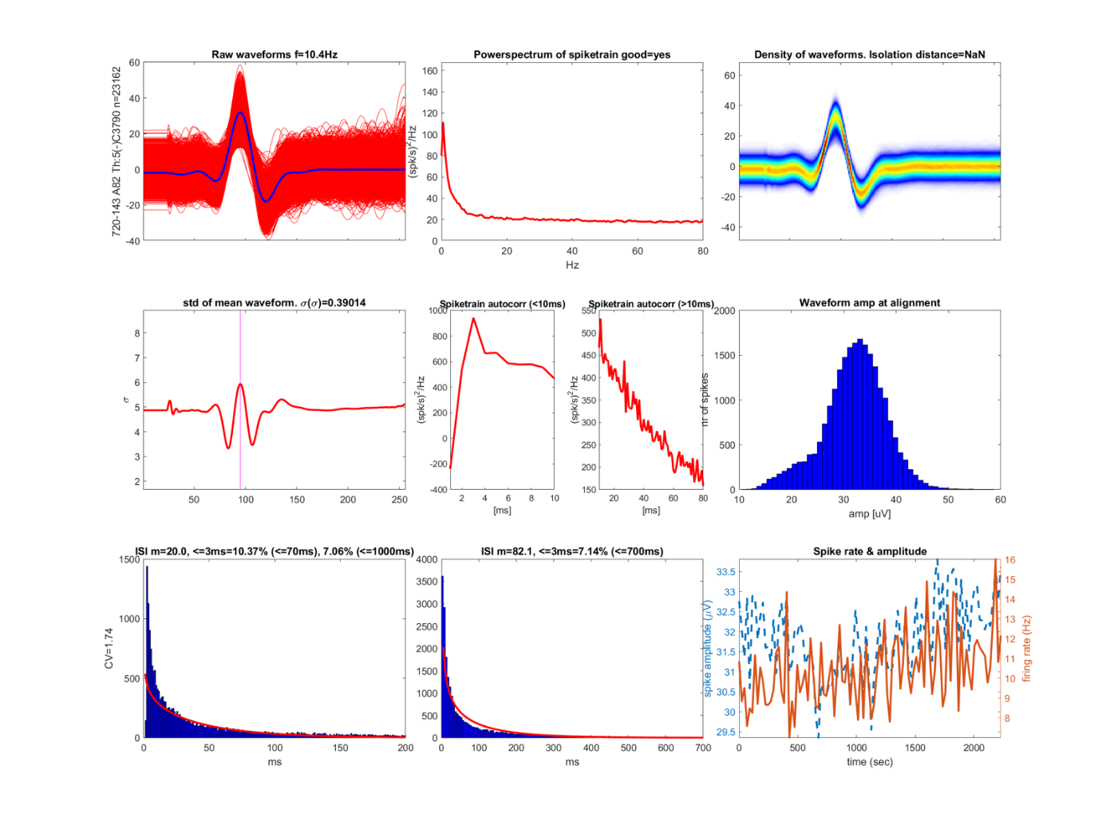
Example 3: 720-143 A82 cluster 3790, too many ISI violations
The ISI title gives two percentages, e.g. <=3ms=6.72% (<=70ms), 1.37% (<=1000ms). The first divides by only the short ISIs, so it runs high, especially for slow-firing cells. That example is 868-034 A10 cluster 3592: 6.72% on the first number but 1.37% on the second, and we kept it. The second number is close to the standard measure (percent of all ISIs).
Firing rate of the units kept with leeway: 81 of the 924 kept units fire below 0.5 Hz. They range from 0.31 to 0.498 Hz (median 0.44 Hz): 35 are between 0.45 and 0.5 Hz, 30 between 0.4 and 0.45 Hz, and 16 between 0.31 and 0.4 Hz.
Criteria for merging clusters
Two clusters on the same channel are merged when they look like the same neuron in the WAVES comparison figures (A<channel>_WAVES_<n>_THM_1.png). Each comparison in those figures shows one pair of clusters:
- Mean waveforms (top row, mean ± SD of each cluster): merge only if the shape, timing and amplitude look similar.
- Projection test (bottom row): the spikes of both clusters are projected onto the line between their mean waveforms. Overlapping histograms and a small d (distance between the cluster centres, in noise SD) suggest the same neuron.
A cluster can be merged into a kept unit even if it would not pass on its own based on firing rate alone.
Channel | Clusters | d | Decision
868-034 A2 | 3899 + 3901 | 7.8 | Merged
868-034 A41 | 3857 + 3948 | 6.8 | Merged
868-034 A10 | 3592 vs 3538 | 6.4 | Kept separate: 3538's trough is about twice as deep

Example 4: merged. 868-034 A2, second panel: cluster 3901 (blue) vs 3899 (black). The mean waveforms have the same shape, timing and depth, and the projection histograms overlap (d = 7.8). Merged as 3899+3901.
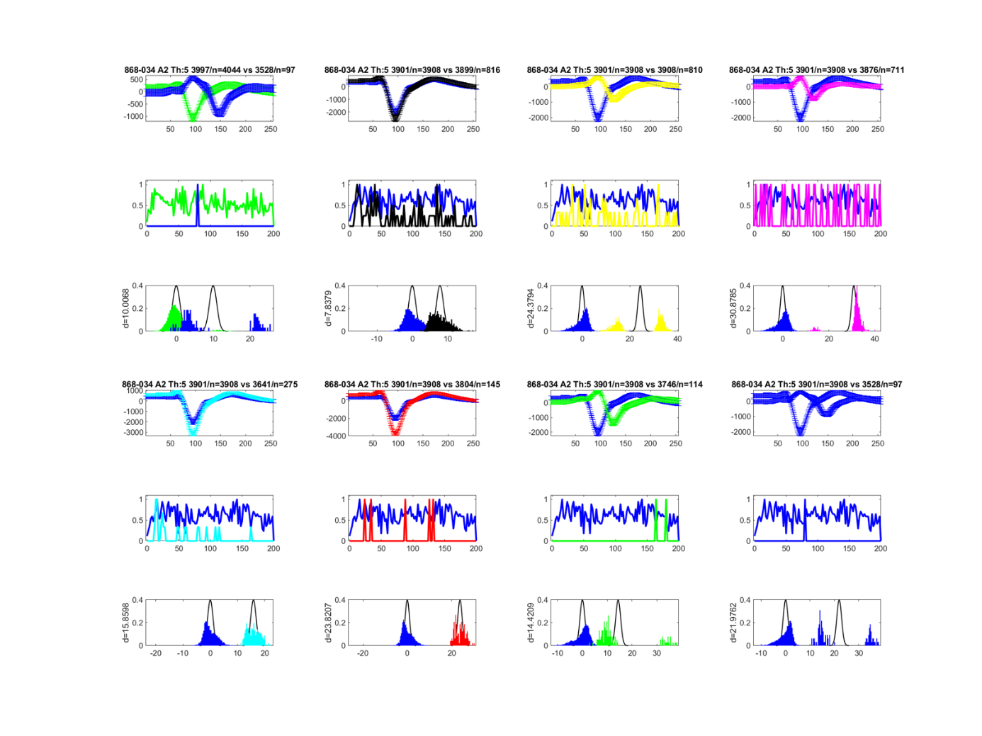
Example 4: 868-034 A2 WAVES page 3, clusters 3901 and 3899 merged

Example 5: kept separate. 868-034 A10, third panel: cluster 3592 (red) vs 3538 (black). d is similar (6.4), but 3538's trough is about twice as deep, so they were kept as two units.
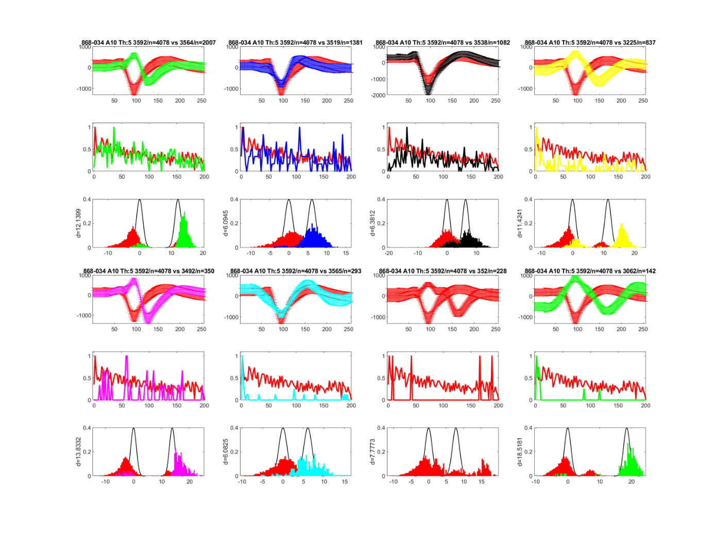
Example 5: 868-034 A10 WAVES page 1, clusters 3592 and 3538 kept separate

Defining clusters

Run C:\Users\Robert\Documents\bean_stalk\osortTextUI\defineUsableClusters_fromXlsFile.m
Iowa ratings data is stored in C:\Users\Robert\Documents\Unit_data\Iowa_ratings

