**Easy Invoice Application (Group 130)**

**Supervisor**

**Dr. Tarek Ali**

**Problem & Idea (Lecture 1 page 4):**

* The urgent need of street vendors for the existence of a system that helps them in simple accounting operations and issuance of invoices in order to keep up with the electronic tax billing.
* Their need to benefit from online sales in a specific geographical area.
* The difficulty of the current accounting programs for this group is because of the many advantages that do not benefit their activity.
* Not keeping up with the multiple payment methods such as Visa, MasterCard, Fawry, and others.
* The danger of moving them with cash amounts between alleys and alleys.

**Solution depended on MVP (skate) (Lecture 1)**

A simple application as a point of sale for itinerant sellers that offers the following solutions:

* Easy use app for various mobile devices, whether they are mobile phones, tablets, etc.
* Energy Source: You can use the mobile and a power bank only to use the application.
* Selling Online: add the feature for selling online
* Points of sale: where it makes accounting operations and issues invoices to the customer.

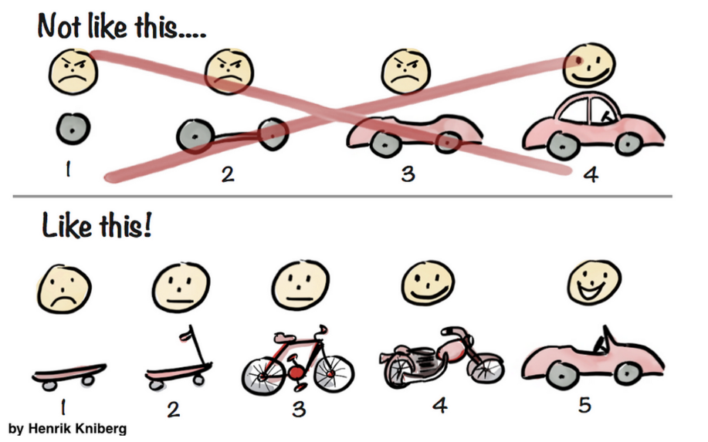

**Kick of meeting (Lecture 3 page 4)**

We scheduling a meeting through Microsoft Teams to discuss the problem and find a solution to it, define the stockholders of the project, the roles, and responsibilities of the team members, and set a timeline for the implementation of the project, and the meetings and documented on hard pager.

**Sketch (Prototype): (Lecture 3 page 22)**

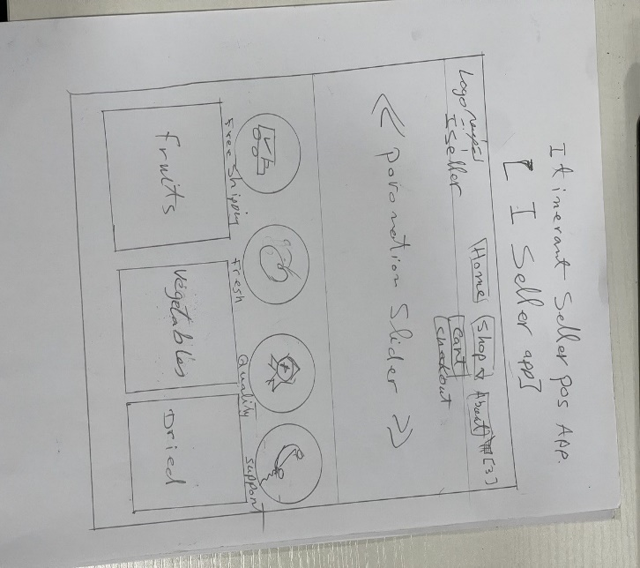

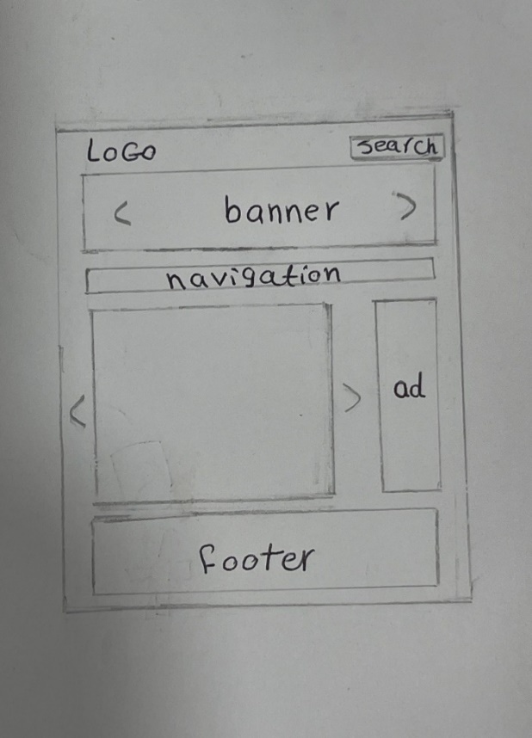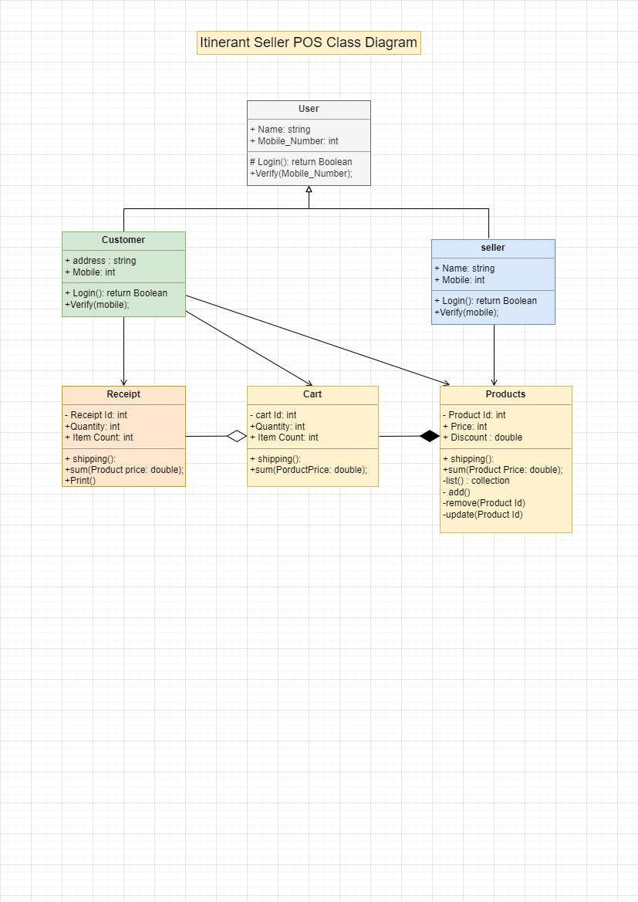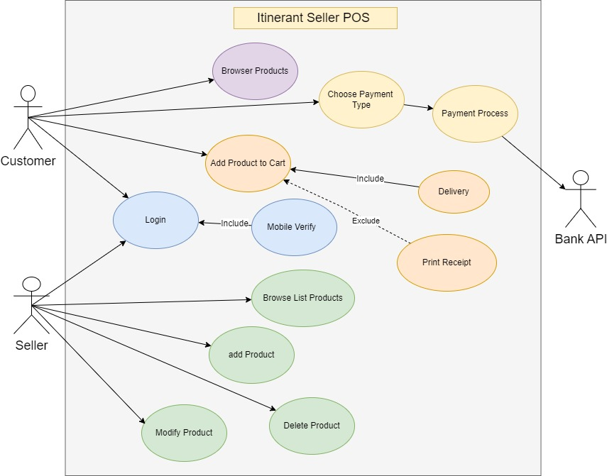

**Technologies (Lecture 5 start from page 8)**

* Frontend Technologies and Language: HTML, CSS, JavaScript.
* Backend Technologies: Asp.net core
* Backend Language: C#
* C++ Console Application for Skate purpose.

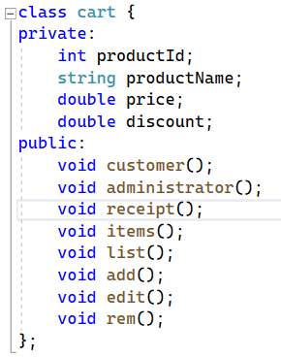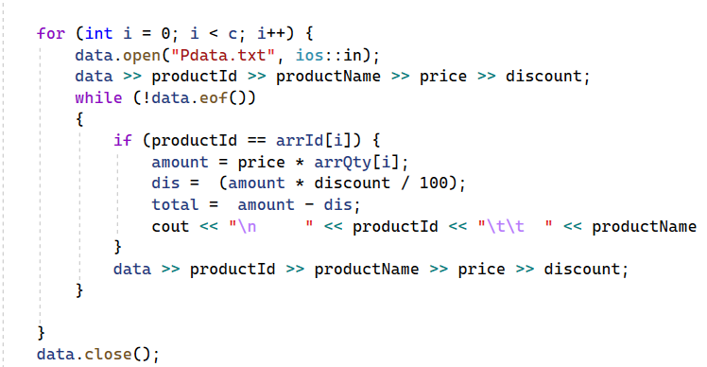

* Microsoft SQL Server

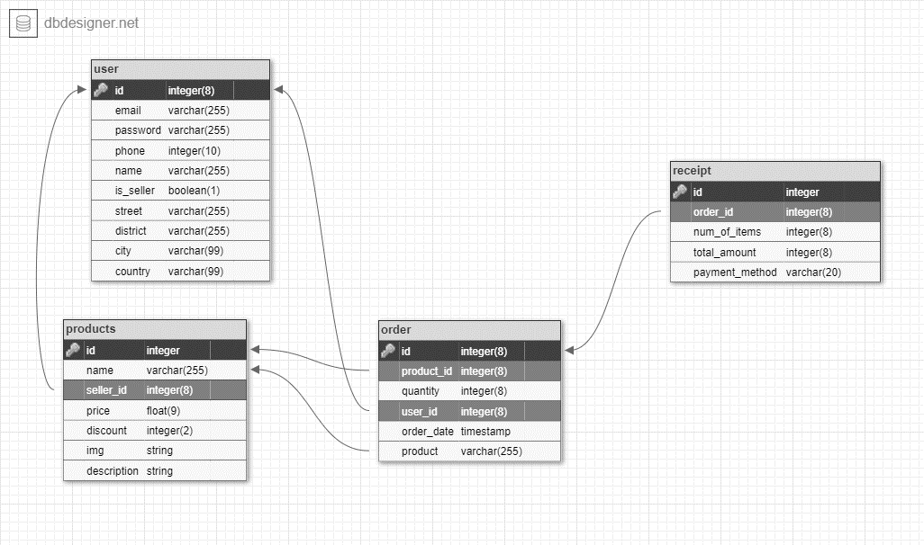

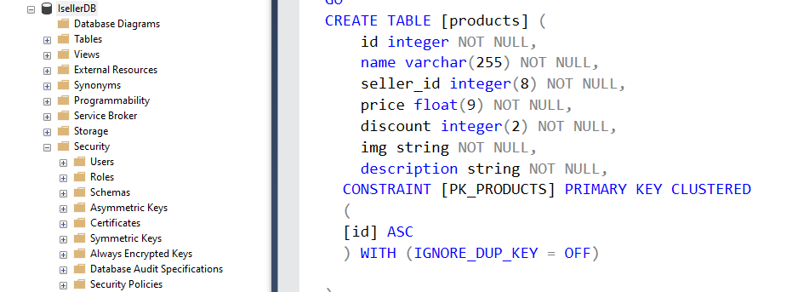

**Personas (Lecture 3 page 18)**

* Customers
* Sellers

**Methodologies (Lecture 2 page 17)**

* We use Agile – Kanban methodology

**Features of Tool I Seller App (MVP) (Lecture 3 page 12)**

A) Use Cases:

**\*System User: Admin – Customer- Seller.**

**3) Customer:**

1- As a Customer, I want to have an account (Optional)

2- As a Customer, I want to Login (Optional)

3- As a Customer, I want to add my location

4- As a Customer, I want to View available products today in my location with their price

5- As a Customer, I want to select from the available products

6- As a Customer, I want to order the selected products

7- As a Customer, I want to receive an invoice of purchased products

8- As a Customer, I want to receive my order in the identified location

9- As a Customer, I want to add review on my order.

**1) Admin:**

1- As an admin, I want to edit System user types

2- As an admin, I want to edit System products

3- As an admin, I want to edit Products price.

**2) Seller:**

1- As a seller, I want to have an account

2- As a seller, I want to Login

3- As a seller, I want to add my location

4- As a seller, I want to determine my products

5- As a seller, I want to update the products price

6- As a seller, I want to give invoice to the user

7- As a seller, I want to receive the products status after selling

8- as a seller, I want to receive a calculation on purchased products & my profit

9- As a seller, I want to view the added review on my products.

**Test Cases (Lecture 6 Page 17)**

1- Validate that the seller should have an account to login

2- Validate that the client should have an account to login

3- Validate that user can add his location

4- Validate that system saves the user location

5- Validate that System has a list of products

6- Validate that seller can update the available product per day

7- Validate that seller can update the products price

8- Validate that seller receive the products status after selling

9- Validate that seller receive a calculation on purchased products

10- Validate that seller receive a calculation of his profit

11- Validate that seller receive a calculation of his selling per month

12- Validate that seller can view the review of his products

13- Validate that System display the available products per day in the identified location with their price

14- Validate that client account can select from the available products

Per day & location

15- Validate that client order the selected products the identified location

16- Validate that client receive an invoice of purchased products

17- Validate that client can add review on his order.

18- Validate that Admin can edit System user types

19- Validate that Admin add System products

20- Validate that Admin Update System products

21- Validate that Admin determine products price limit

22- Validate that Admin can view products reviews

23-Validate that Admin can add review on seller`s accounts

**References**

1. The official ASP.NET Core documentation: <https://docs.microsoft.com/en-us/aspnet/core/>
2. The official ASP.NET Core GitHub repository: <https://github.com/aspnet/AspNetCore>
3. "Pro ASP.NET Core 3" by Adam Freeman and Andrew Lock: <https://www.apress.com/us/book/9781484255078>
4. "Building Web Applications with ASP.NET Core and MongoDB" by Rajeev Sakhuja: <https://www.packtpub.com/application-development/building-web-applications-aspnet-core-and-mongodb>
5. "Learn ASP.NET Core 3.1" by Kudvenkat: <https://www.youtube.com/playlist?list=PL6n9fhu94yhVkdrusLaQsfERmL_Jh4XmU>
6. ASP.NET Core Community on Stack Overflow: <https://stackoverflow.com/questions/tagged/asp.net-core>