Prepared By:

Tim Nishikawa  
[Comments]

1 Place Alexis Nihon, Suite 800 Montreal, QC H3Z 3B8   
Telephone: (514) 866-0001   
Fax: (514) 866-1805  
Email: info@tecsys.com

C:\Users\olivert\Downloads\TecsysTM-Logo-Red-120px.png

Copying DBs

Prepared For: Technical Services Team

BC Liquor Distribution Board  
  
  
Technical Services Team

# Table of Contents

Table of Contents 2

1. Overview 3

1.1. Introduction 3

2. Preparation 4

2.1. Planning 4

2.2. Backups 4

3. Execution Steps 6

3.1. Pre Database Steps 6

3.2. Database Steps 6

3.3. System Properties Steps 9

3.4. Launchpad Steps 12

3.5. Extra Steps 19

# Overview

## Introduction

It is relatively common to do this copy during the project and even after go live. For example to refresh Test environment with newer DBs from Production environment that has more recent sample data.

This document tries to detail the steps and options that are required to accomplish this DB copy without issues in the destination environment.

It is valuable to get the source and destination environment Instance Names beforehand, for example:

Source Instance: **ddcpwmsea1.bcliquor.com_wms**

Destination Instance: **kdci5wmsea1.bcliquor.com_wms**

# Preparation

## Planning

* + 1. You need to determine the **source** and **destination** environments.
  1. If this is happening after go-live, the **source** is typically the production environment that has the most recent sample data. If this is before go-live, the source is typically the envrionment where the production configuration has occurred.
  2. You also need to consider the **destination** environments. The destination should be on the same version as the source but if new testing or new development is happening on the destination then that test/development data will get replaced. If the destination environment has had bug patches installed or test configuration performed that is not yet promoted to the source environment then you need to consider if replacing the destination databases will have an impact.
  3. It is useful to get the source and destination environment Instance Names from the **md_app_server** view in each environment:
     1. Source Instance: **ddcpwmsea1.bcliquor.com_wms**
     2. Destination Instance: **kdci5wmsea1.bcliquor.com_wms**
     3. You also need to consider whether to include the **meta DB** in your database copy and restore: database name ends with _m (e.g. wms_m). This DB contains the metadata & iTopia objects that includes configuration such as custom expression columns, custom rules and custom criteriasets.

1. The meta DB should be included, if there is metadata configuration in the source that needs to be distributed to the destination environment.
2. Most of the steps below are required when the meta DB is part of the database copy and restore. If the meta DB is not included then many of the steps can be ignored.
   * 1. Assumes the analytics database does not need to be included. This will be cleaned out in the destination envrionment so that it can be rebuilt after the restores and steps are completed.
     2. You will likely need a DBA to do the database backups and restores.
3. There are SQL scripts involved, so the DBA may be required to run those also if they are the only IT members that are permitted to run those scripts.
4. Need to determine whether the regular backups (e.g. overnight backup, weekly backup) are sufficient from the source environment or a new set of backups are needed that are as up to date as possible.

## Backups

* + 1. Copy the database backup files from your **source** environment.

1. In this example: **INT5 wms** (META, TMS, WMS)
   * 1. wms_m
     2. wms_t
     3. wms_w
2. No need to backup the analytics DB (wms_a: will be cleaned and rebuilt) nor the ice DB (wms_c: contains test data only).
3. Optional: Reserve backups of the databases from the **destination** environment – just in case. In this example: **INT5 wms**; **int1_94x; int3_94x**

# Execution Steps

## Pre Database Steps

* + 1. BEFORE the database restore in the **destination**, Stop the EliteSeries portal on your **destination** environment. In this case: **INT5 wms**; **int1_94x; int3_94x**.

[https://kdci5wmsea1.bcliquor.com/TecsysCP2/do?actionCode=environment&environment=wms](%20https://kdci5wmsea1.bcliquor.com/TecsysCP2/do?actionCode=environment&environment=wms)

[https://kdci5wmsea2.bcliquor.com/TecsysCP2/do?actionCode=environment&environment=wms](%20https://kdci5wmsea2.bcliquor.com/TecsysCP2/do?actionCode=environment&environment=wms)

[https://kdci5wmsea3.bcliquor.com/TecsysCP2/do?actionCode=environment&environment=wms](%20https://kdci5wmsea3.bcliquor.com/TecsysCP2/do?actionCode=environment&environment=wms)

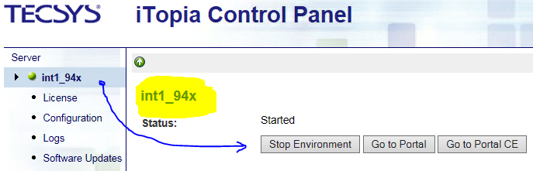

* 1. If the environment has clustered application servers, then **ALL** portals need to be stopped. For the INT5 environment portals: ALL THREE load balanced app server URLs:
  2. The URL for the load balancer (or dispatcher) will only take you to one of the app servers and it is not easy to determine which app server:

## Database Steps

* + 1. Restore the databases on the **destination** DB server **replacing** the existing databases.

1. On DEV DB server (int5): the DBs must be restored with the same name as the existing DBs:
   * 1. wms_m
     2. wms_t
     3. wms_w
2. On DEV DB server (int1_94x): the DBs must be restored with the same name as the existing DBs:
   * 1. int1_94x_m
     2. int1_94x_t
     3. int_94x_w
3. Be aware of passwords for the **tecsys** DB user. If the destination db servers have different passwords for the **tecsys** DB user than on the source db server, then that difference needs to updated in **md_environment_dbset_db** table – this will be covered in SQL Script B (step 5) below.
   * 1. Run set of SQL scripts A before starting the portal.
4. This script cleans up sessions, tasks, locks from the source environment.
5. Modified delete for tables will many records: e.g. md_task_log to delete 100,000 records at a time.
6. Likely need to shrink the database log file at the same time.
7. May need to do the same for other tables if there are lots of records.
8. Two scripts are attached: **one for int5**, **one for int1_94x**
9. Both scripts are identical with description & instructions on how to do search and replace to accommodate different environments (see image below).

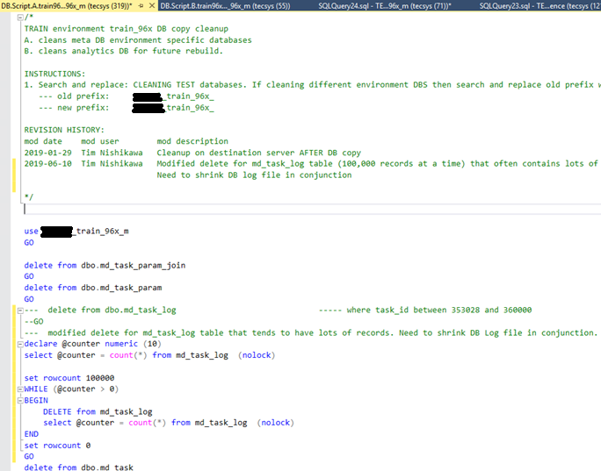

* + 1. Start the EliteSeries portal.

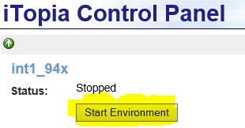

1. Records get copied from the **tecsys_default** records in various tables (e.g. md_app_server, md_app_cluster).
2. Review the start.log file if you are paranoid.

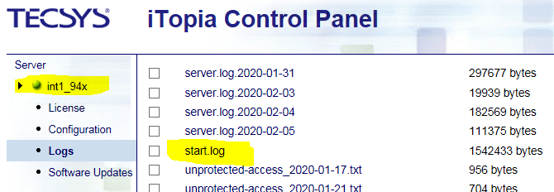

## Login Password Change Steps

* + 1. Log into EliteSeries as the **system** user. REMEMBER – if you copied the meta DB, that user’s password is the **source** environment’s password.

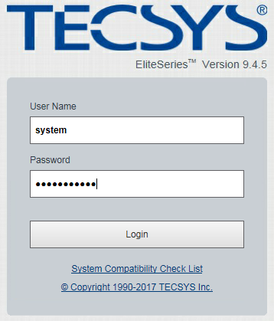

* + 1. If there are different passwords for **system** user (& **tecuser** & **tecsys**) in the different environments, then you need to update them for these users again in the **md_user** view.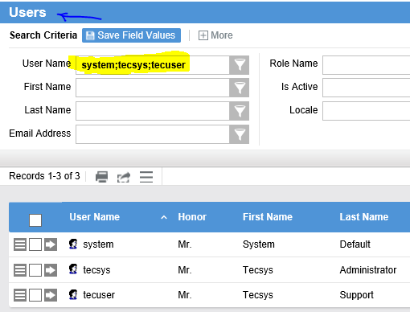

## Launchpad Steps

* + 1. To perform Launchpad steps: Log into EliteSeries as the **system** user again.

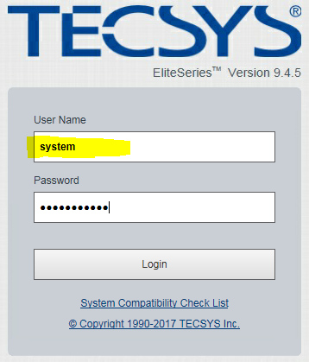

* + 1. Shut down sys_mon services (**sys_mon** = **meta_msg_sys_monitor**) Shut Down button at bottom left.

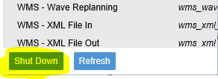

* + 1. REVIEW all queues and reset instances to **destination** environment instance. For each of the following queues:

1. REVIEW **wms_md_mq_generic**
2. REVIEW **wms_mq_warehouse_task**
3. REVIEW **tms_md_mq_generic**
4. REVIEW **meta_md_mq_generic**

For EACH of the above queues:

* copy the **destination** instance name from **md_app_server** into your clipboard (e.g. **kdci5wmsea1.bcliquor.com_wms**).
* open the message queue in Elite (above list a. to g.)

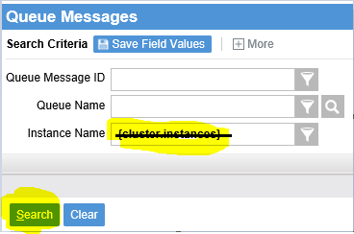

* clear out the **{cluster.instances}** value in the Instance Name criteria box (see above).
* hit Search to view any queue messages in error.
* If any rows do exist, they should have the instance name from the **Source** environment (see below). Use the Update Fields for All Records option on the results grid hamburger  to update the Instance Name field’s value with the destination instance name that is in your clipboard from the first bullet point in this list. Again, in the image below, the   
  **ddcpwmsea1.bcliquor.com_wms** instance needs to be replaced with the **kdci5wmsea1.bcliquor.com_wms** instance name.

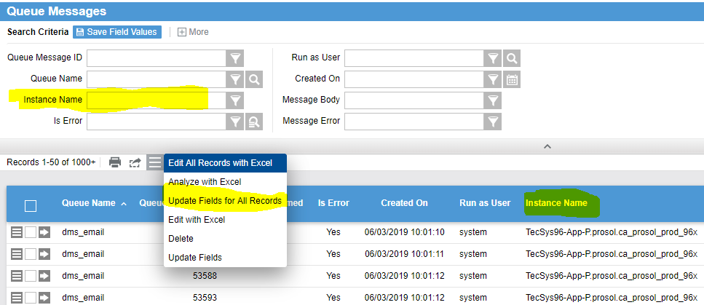

* Repeat for the queues in the following list (same as previous list)

1. REVIEW **wms_md_mq_generic**
2. REVIEW **wms_mq_warehouse_task**
3. REVIEW **tms_md_mq_generic**
4. REVIEW **meta_md_mq_generic**
   * 1. Copy Timers from the **meta_md_timer** resource.
5. Similar to the Queue messages, remove the **{cluster.instances}** value from the Instance Name criteria.
6. Use the search icon for that criteria and select the **source** environment instance from the list (in this case, **ddcpwmsea1.bcliquor.com_wms**).

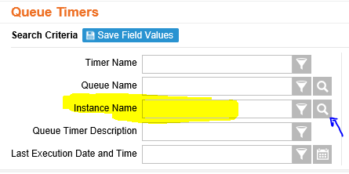

1. You should see the list of timers from the **source** environment. We are going to Copy these;   
   **Do NOT use Update Fields for All Records;   
   Do NOT use Edit with Excel.**
2. Use the **Show All** button of the results grid (top right) so all timers appear in the grid.
3. Use the select all checkbox at the top of the first column to select all of the rows. Then use the hamburger icon to select the Copy Timer option to copy the timers to the new instance.

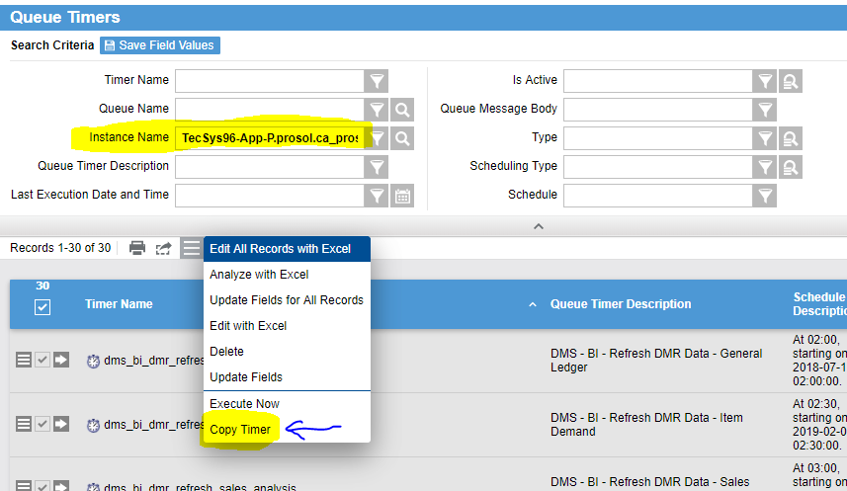

1. You can delete all of the timers for the **source** instance. They are not necessary now that we have copied them to the **destination** instance.
2. Search again using the source instance value in the Instance Name criteria.
3. Select all rows and use the Delete option in the hamburger button list.
4. If there are scheduled criteriasets (with instance names) then you may need to update them in next step (**3.4.5.**)before you can delete the associated timers.
5. There should be no remaining Timers with the **source** instance after you have copied them.
   * 1. REVIEW **meta_md_criteriaset** resource.
6. If there are any records that have an Instance Name with a **source** instance, then these MUST be fixed by SQL below (i. train_96x and ii. test_96x) to update with the **destination** instance
   1. update md_criteriaset set instance_name = (select min(instance_name) instance_name from md_app_server where environment_name = 'wms') where instance_name = 'TecSys96-App-P.ddd.ca_ddd_prod_96x'
   2. update md_criteriaset set instance_name = (select min(instance_name) instance_name from md_app_server where environment_name = 'wms') where instance_name = 'TecSys96-App-P.ddd.ca_ddd_prod_96x'
7. This must be done AFTER the timers have been copied from the GUI in previous step (**3.4.4.**).
8. If the criteriasets have no value for Instance Name as in the image below, there are no changes required.

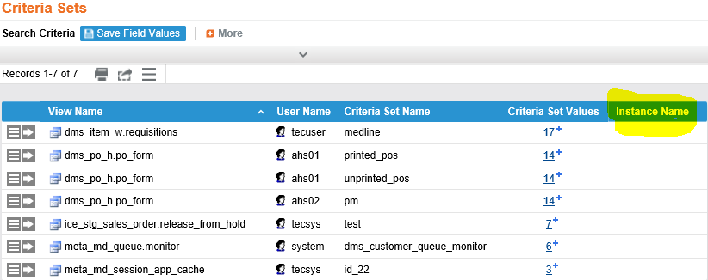

* + 1. REVIEW **meta_md_export** resource. If there are any records that have an Instance Name with a **source** instance, then replace with the **destination** instance that is in your clipboard (again, via: Update Fields for All Records). If the exports have Instance = **tecsys_default** (see below), then no changes are required.

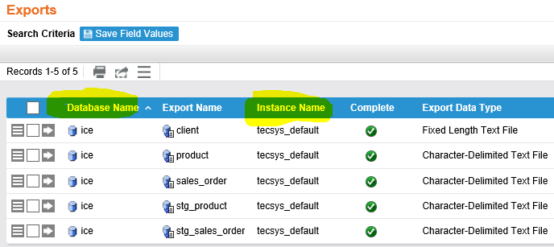

* + 1. REVIEW **meta_md_import** resource. If there are any records that have an Instance Name with a **source** instance, then replace with the **destination** instance that is in your clipboard (again, via: Update Fields for All Records). If the imports have Instance = **tecsys_default** (see below), then no changes are required.

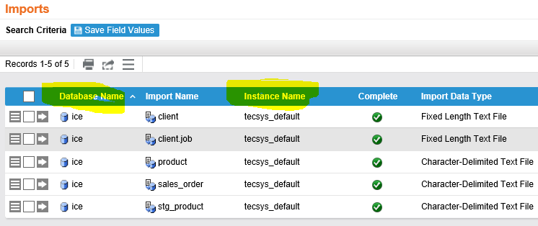

* + 1. Copy Notifications using the **meta_md_notification** resource but only those notifications with Role Name values that are not user names.

1. Similar to the Timers, remove the {cluster.instances} value from the Instance Name criteria.
2. Use the search icon for that criteria and select the **source** envrionment instance from the list (in this case, **ddcpwmsea1.bcliquor.com_wms**).
3. You will see the list of notifications from the **source** environment and there is a Copy Notification option in the hamburger icon also but in the image below none of these notifications need to be copied since all Role Name values are user names.
4. They can be Deleted instead.
5. Role Name values like ums_user; wms_user; dms_administrator can be copied first before they can be deleted also. **?? no custom notifications at BC Liquor ??**
6. There should be no remaining Notifications with the **source** instance

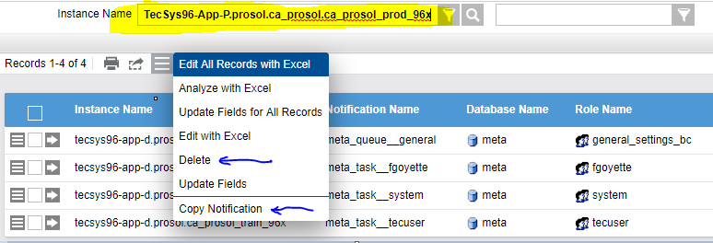

* + 1. REVIEW **wms_so_f** to optionally add an environment specific suffix to warehouse name (e.g. TRAIN96x, - TEST96x) for non-production envrionments.

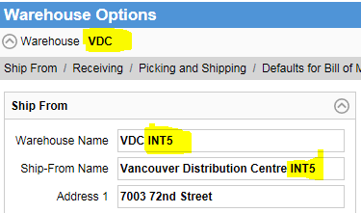

* + 1. REVIEW **meta_md_app_server**. You can now delete the **source** environment row (**PROD WMS** below). You only want to have the **destination** environment present to avoid any future confusion. Use the Delete option in the hamburger button on that row.

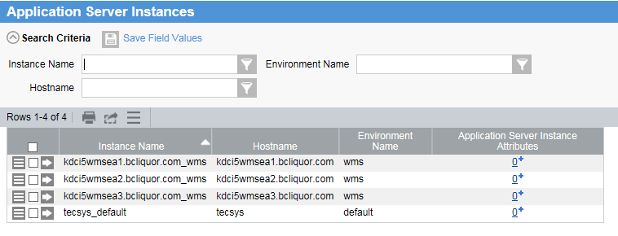

* + 1. REVIEW **meta_md_app_cluster**. The **source** cluster row (**PROD WMS** below). You only want to have the **destination** cluster present to avoid any future confusion. If there is ONLY ONE **md_app_server** record for the **destination** environment, then there will be no **md_app_cluster** row. Use the Delete option in the hamburger button on that source row.

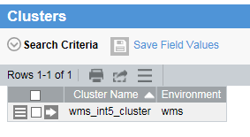

* + 1. Start up **sys_mon** services again (**meta_msg_sys_monitor**).

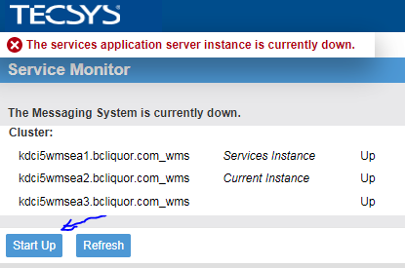

## Extra Steps

This is extra steps for **non-production** environments (e.g. test, dev, train, qa) where you may not want to emails to be sent; jasper forms to print; exports to produce files.

* + 1. Printer settings from WMS Stations:
       1. Stations (**wms_st_f**): set all jasper form printers (Report, List, Pick List, Container Packing List, Master Packing List, Bill of Lading, Manifest) to **null**, for all warehouses & all stations so no printing from **non-production** environment.

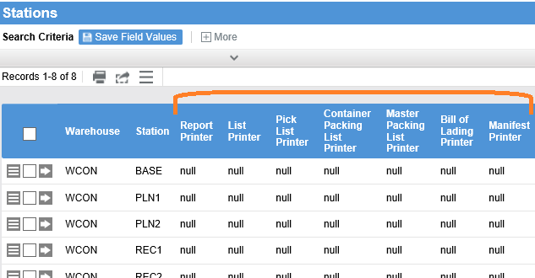

* + - 1. Station Devices (**wms_station_label_device**): set all Devices to **nulllbl** for all Warehouses, all Stations, all Document Formats & all Document Types so no printing from **non-production** environment.

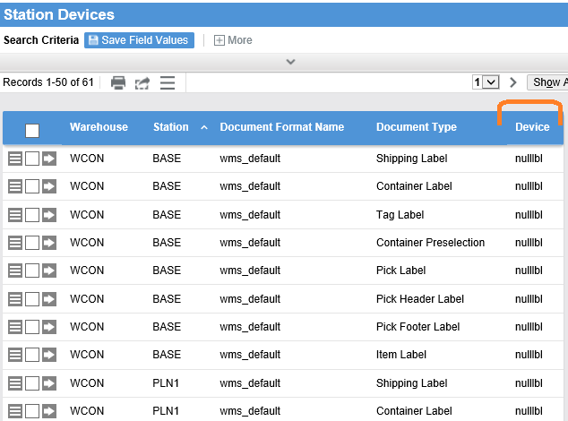

* + 1. **??does this apply to BC Liquor??**   
       Deactivate the EDI outbound 810 export: find the **dms_edi_outbound_810** timer (**meta_md_timer**) and make sure Is Active = No for the **non-production** instance.

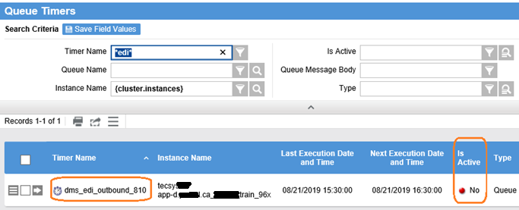

* + 1. Custom Triggers **?? does this apply to BC Liquor??** :

1. Custom DMS database trigger (**tr_md_attachment_pdf_export_ts**) on **md_attachment** table needs to be disabled  in the **non-production** environment as in image below. This will prevent invoices from the test/train/dev/etc environments from being exported to the Production folder by accident.

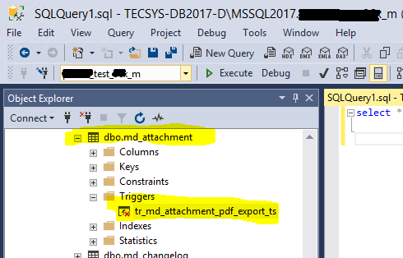

* + 1. Validate the SMTP settings in the Tecsys.properties: search for SMTP in the system_properties field and validate the **smtp.server** property does not have a valid value to ensure no emails will be sent out from this **non-production** environment.

