**Shipping Document Slowness**

Query: 01

SELECT DISTINCT "t0".cpack_id col0, "t0".cpack_order_seq col1, "t0".ob_oid col2, "t0".cont col3, "t0".line_seq col4, "t0".sku col5,

"t0".btl_cont col6, "t0".cust_oid col7, "t0".whse_code col8

FROM ( "cpack_order_line_2_ldb" "t0"

inner join ( "cpack_order_ldb" "t1"

inner join ( "cpack_ldb" "t2" inner join "mpack" "t3" ON "t2".whse_code = "t3".whse_code AND "t2".mpack_id = "t3".mpack_id )

ON "t1".whse_code = "t2".whse_code AND "t1".mpack_id = "t2".mpack_id )

ON "t0".whse_code = "t1".whse_code AND "t0".mpack_order_seq = "t1".mpack_order_seq AND "t0".mpack_id = "t1".mpack_id )

WHERE "t0".whse_code IN (N'VDC',N' ') AND "t1".whse_code = N'VDC' AND "t1".mpack_id = 91085 AND "t1".mpack_order_seq = 1 AND "t1".whse_code IN (N'VDC',N' ') AND "t2".whse_code IN (N'VDC',N' ') AND "t3".whse_code IN (N'VDC',N' ')

ORDER BY 1 asc, 2 asc, 3 asc, 4 asc, 5 asc, 6 asc, 7 asc, 8 asc

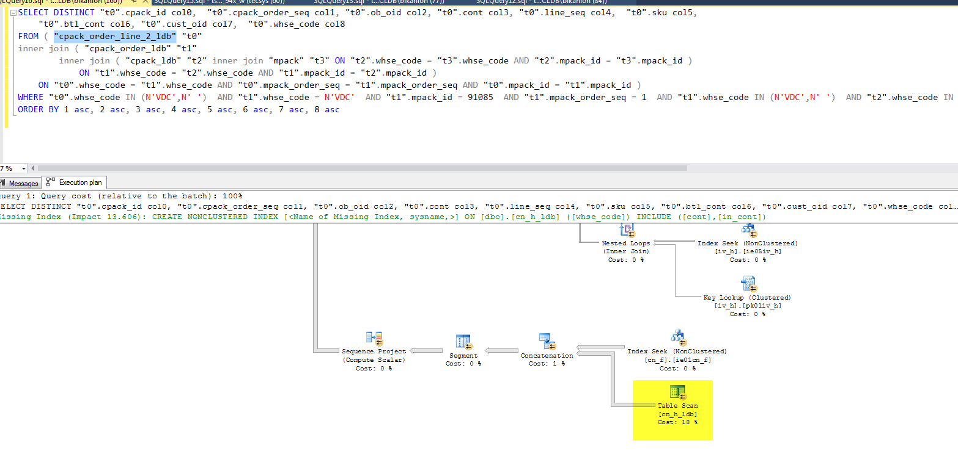

Issue:

cn_h_ldb – Cost 18% ; cpack_order – Cost 10%

Query: 02