Shipping Document Automation

# Setup Output Devices

# Setup Printing Stations

# Setup Printing Instance

update wms_system_properties_ldb

set custom_char_01 ='tswmsea.int3.bcldb.com_int3_94x'

where whse_code = 'VDC' and property_name = 'INSTANCE_NAME';

Replace high-lighted instance name above based on the environment value below

**DEV - tswmsea.dev.bcldb.com_dev_94x**

**INT3 - tswmsea.int3.bcldb.com_int3_94x**

**INT1 - tswmsea.int1.bcldb.com_int1_94x**

**INT5 - kdci5wmsea1.bcliquor.com_wms**

**PROD - ddcpwmsea1.bcliquor.com_wms**

Carrier Station Setup

# LDB Carrier Stations

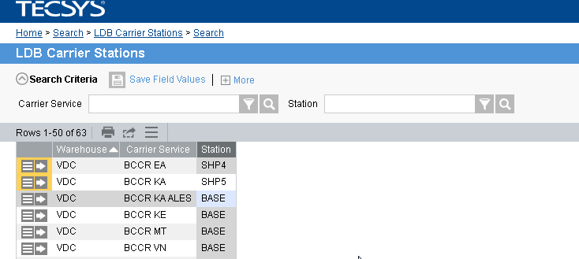

# Document Type

# Re-Printing of Master Packing List

