**Shipping Documents Automation**

## Introduction

This document details high-level technical design on the automation of Shipping documents.

## Background

Shipper prints and mail shipping documents using shipping activity view in Tecsys. Due to archiving of outbound order after ship completions if shipper fails/forget to print the shipping document, the Shipping documents cannot be printed/re-printed after ship completion.

The automation of shipping documents will ensure that shipping documents are printed and consolidated archive copy is created when outbound order last container moves to shipping dock.

## Scope

Following shipping documents are scoped for automation

1. Master Packing List
2. Floor Credit
3. Container Packing List

## Technical details

Shipper performs outbound order ship completion in Tecsys, LDB database trigger on Queue Command History (cp_h) table triggers task to created shipping documents.

Tecsys task queue create shipping documents using LDB database views and Jasper Reports. The consolidated shipping document pdf archive stored in md_attachment which can also be used for viewing and re-printing.

The Tecsys re-print Master Packing List view can be used for re-printing consolidated shipping documents.

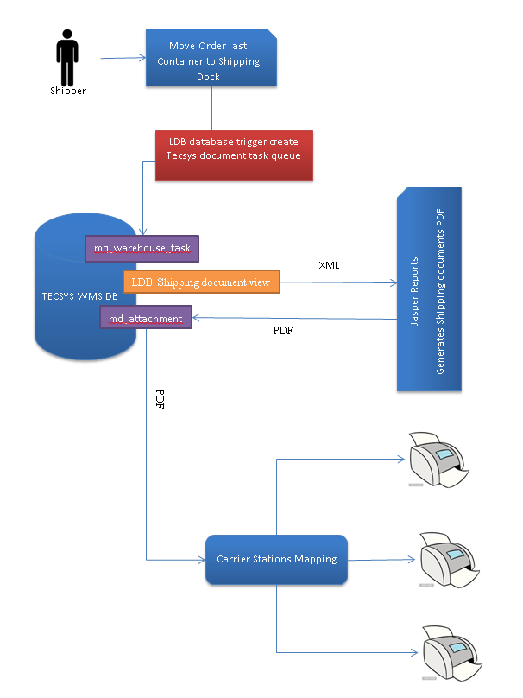

Shipping documents in scope are consolidated and enhanced for re-printing after Ship completion.

Views missing archive details.

1. Container
2. Inventory

Following objects created or modified to capture missing archive details

**Container**

Create Container history table cn_h_ldb

Create database trigger tr_ins_cn_h_ldb to copy container details from cn_f to cn_h on delete

Create database view v_u_cn_f_ldb to get container - current and history details.

**Inventory**

Create database view v_u_iv_f_ldb to get inventory - current and history details.

**Shipping Documents database views**

LDB shipping document views are used by Jasper Reports to create custom shipping documents

* Master Packing List
  + mpack_ldb – master packing header
  + mpack_order_ldb -- Master packing order (outbound)
  + mpack_order_line_ldb -- master packing order customer lines
  + mpack_order_line_2_ldb – master packing order container lines
* Floor Credit
  + fcredit_ldb – floor credit header
  + fcredit_order_ldb -- floor credit order (outbound)
  + fcredit_order_line_ldb – floor credit un-shipped order line items
* Container Packing List
  + cpack_order_line_ldb – Shipped items by containers

**Shipping Documentation database procedures**

LDB shipping documents are automated using below SQL Server procedures

ins_mq_warehouse_task_ldb – LDB procedure to create new task

get_gn_f_doc_num_ldb – LDB procedure to generate new document number

create_cpack_ldb – LDB procedure to create container packing list

create_mpack_ldb – LDB procedure to create master packing list

tr_ins_cp_h_ldb – LDB trigger on last container completion command

**Additional Configuration**

update wms_system_properties_ldb

set custom_char_01 ='tswmsea.int3.bcldb.com_int3_94x'

where whse_code = 'VDC' and property_name = 'INSTANCE_NAME';

Replace high-lighted instance name above based on the environment value below

**DEV - tswmsea.dev.bcldb.com_dev_94x**

**INT3 - tswmsea.int3.bcldb.com_int3_94x**

**INT1 - tswmsea.int1.bcldb.com_int1_94x**

**INT5 - kdci5wmsea1.bcliquor.com_wms**

**PROD - ddcpwmsea1.bcliquor.com_wms**

Setup Printers - Output Devices

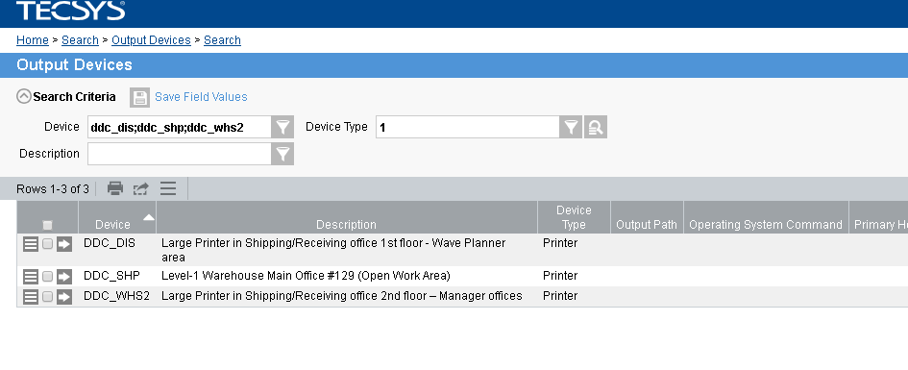

Setup Printing Stations

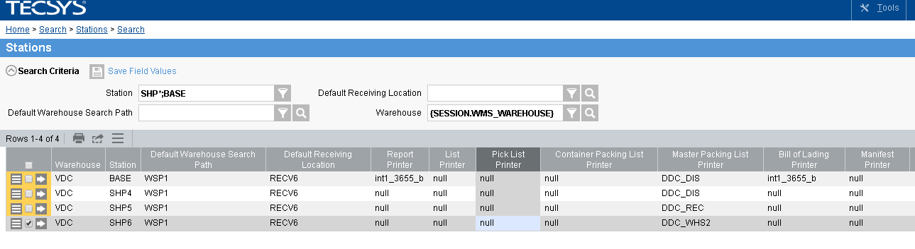

Carrier Stations Mapping

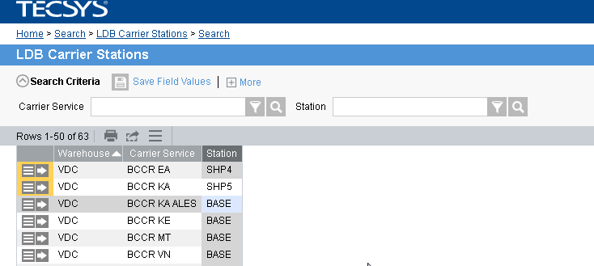

Document Type

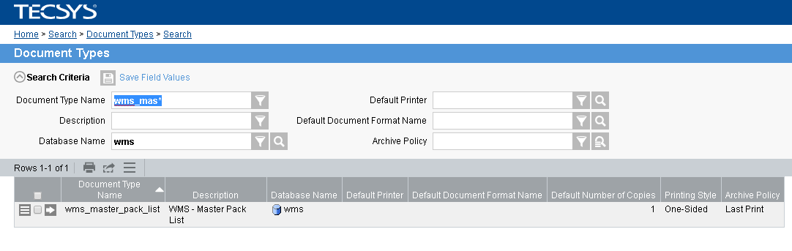

Re-Printing of Master Packing List

