
On these Crosses place the 4 below badges (Background removed) in 2x2 grid alignment
the badge size needs to be only readble so not too big not too small. See if you can add animations to those too --
Badge 1 – AZUREFANDAMENTALS
Badge2 – MicrosoftCopilot
badge 3- GoogleProjectMANAGAEMENT
Badge4 – ISO-9001
The monochrome looks pretty amazing in the profile image. See if you can add the Web site Theme Blue on the the paisley design on the tie. Also the ppaislay pattern design can be used in the web animation you gotta be creative like a creative director.

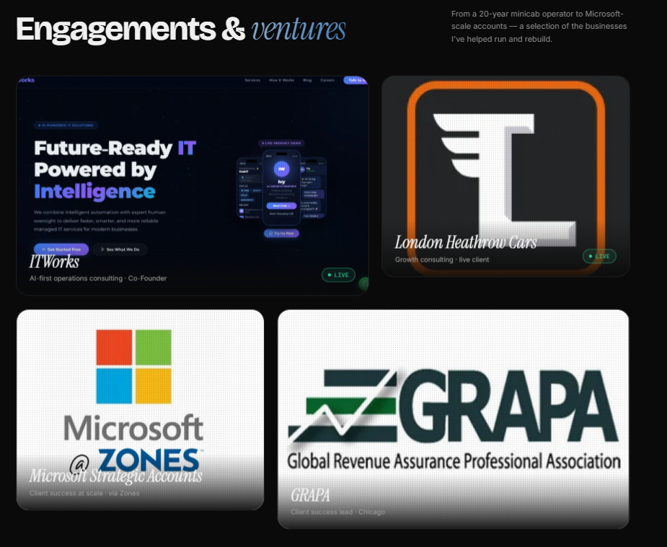
This section looks fine --
Changes needed:
The Photos on here are attached with the message-
This section allows users to deploy images which must not happen-
I will share these 4 images too-
ITWORKSIMAGE
LHC LOGO
MICROSOFTxZONESLOGO
GRAPA LOGO
ENSURE these are permamnent and not changebale anymore

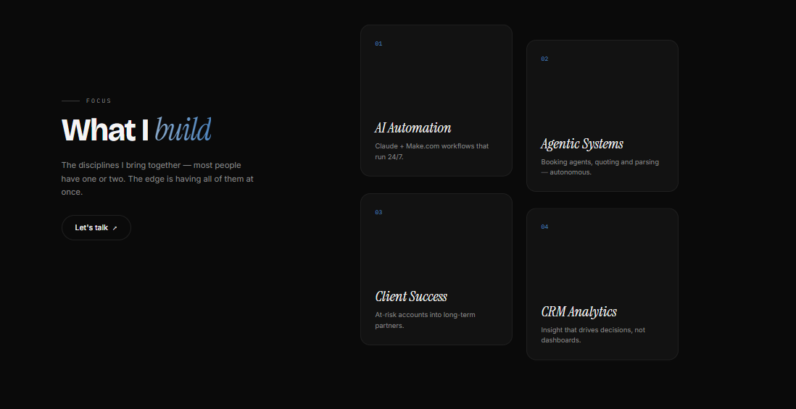

This looks amazing only need to add Icons Representing the 4 items placed on there

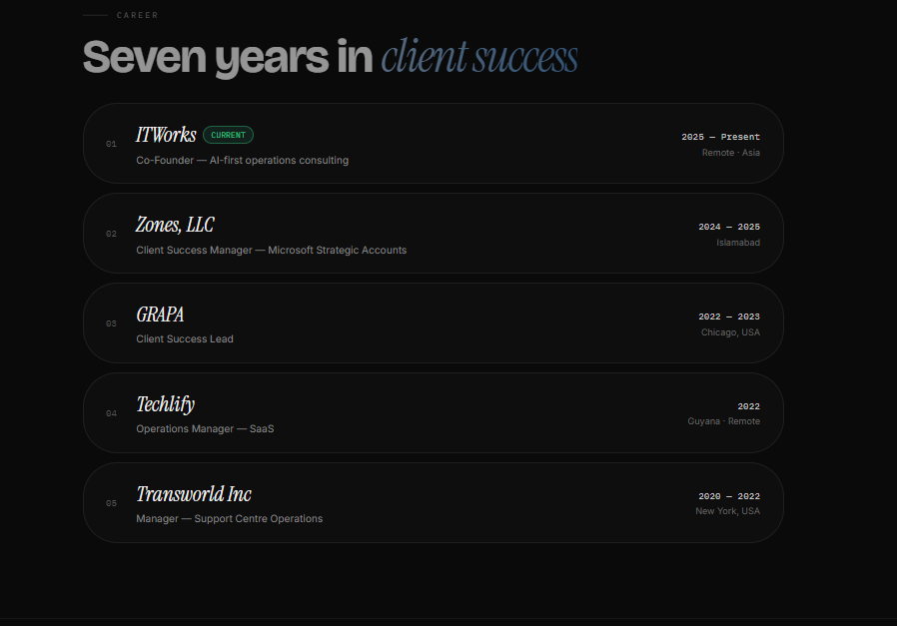

This area needs to be clickable- need a View details Button on the right side of each Role I worked in ANIMATE :if one hovers over each role it lifts up animation glowing effect.
Each Role Details- when Someone Clicks View Details ---
Zones Client Success role-
Zones is an authorized buyer for Microsoft, which is one of the company's most valued clients. As part of its strategic accounts, Zones assists Microsoft in sourcing their hardware and software needs. I am associated with the software procurement support team as a Customer Success Manager (CSM) 2. In this capacity, I help Microsoft USA CC1010 procure the necessary software for their project teams. We’d reach out to suppliers on Microsoft’s behalf and coordinate with publishers to streamline the process.
Highlighted Project: Microsoft Kaizen Software Catalog Expansion (Q2 2025)
I supported Microsoft’s Zones Catalogue expansion, which aimed at making it easier for teams to access pre-approved softwares through ProcureWeb and ServiceNow. My work includes adding new software categories, solving catalog visibility or licensing issues, and helping the project move forward on time.
Recognition:
Nominated for the Zones Five-Star Service Award following Microsoft’s acknowledgement of strong support during Fiscal YearEnd 2025 for software needs at Halo Studios.
I joined Zones Back in March 2024 as A Demand Management Specialist- It was more of a Presales Engineer role, deployed on the Microsoft front for Azure Cloud Pre-Sales function. My responsibilities at that time were:
- Qualify inbound referrals by Microsoft to understand their requirements.
- Maintain accurate and up-to-date records of customer interactions and lead progress.
- Continuously monitor and analyze data to optimize the demand management process.
- Participate in team meetings to discuss progress, challenges, and opportunities.
I stayed in this role until December of 2024 and then Moved to Client Success Manager 2- Role at Zones serving Microsoft Strategic account-

GRAPA Client Success Lead
October 2022 - October 2023 (1 year 1 month)
Chicago, Illinois, United States
- Drive client satisfaction through proactive communication .
- Lead initiatives to optimize client experience and retention strategies.
- Foster collaborative relationships across departments to achieve goals.
Techlify Operations Manager- SaaS (Remote)
May 2022 - October 2022 (6 months)
Georgetown, Demerara-Mahaica, Guyana
Prioritize Vendor Management
Formalize, Evaluate Vendors & define expectations.
Mitigate risks & keep track of renewals.
Ensure Smooth operations
Projects Delivered:
Customer Onboarding workflow Automation.
Change Management (Inhouse Scheduled work hours globally)

Transworld Inc
Manager Support Centre Operations
1 year 10 months
January 2022 - May 2022 (5 months)
New York, United States –
Manage day to day operations of the Support center, including sourcing equipment, effective resource planning and applying call center strategies and operations. - Undertake needs assessments, Trainings, performance reviews and cost/ benefit analyses - Set/meet performance targets. Evaluate, monitor & appraise. - Ensure all relevant communications and data are updated and recorded advise clients on products and services available. - Liaise with supervisors, team leaders, operatives and third parties to gather information and resolve issues. - Maintain up-to-date knowledge of industry developments and involvement in networks. - Monitor random calls to improve quality, minimize errors and track operative performance. - Coordinate staff recruitment, write job adverts and Hiring New Incumbents. - Review the performance of staff, identify training needs and plan training sessions - Prepare reports on KPIs & performance levels - Handle the most complex customer complaints or enquiries - Organize shift patterns and the number of staff required to meet demand - Coach, motivate and retain staff - Coordinate bonus, reward and incentive schemes - Forecast and analyze data against budget figures on a weekly and/or monthly basis.
Started off working with Transworld Inc, as an Assistant Manager Commercial Operations.
Assistant Manager Commercial Operations
August 2020 - January 2022 (1 year 6 months)
New York, United States
I was responsible to coordinate with all the stakeholders and making sure everyone is on the same page in terms of all Commercial Lines operations. - Pay plans & their Revisions, - Endorsements, - Audits & Recommendations, - Quotes - Renewals - Cancellations - Addressing Underwriting Issues - Binding new policies - Issue certificate of Insurance. Provide all kinds of Operational Support while maintaining good relations with the Agents Insurance carriers, Mortgagees & finance Companies.

