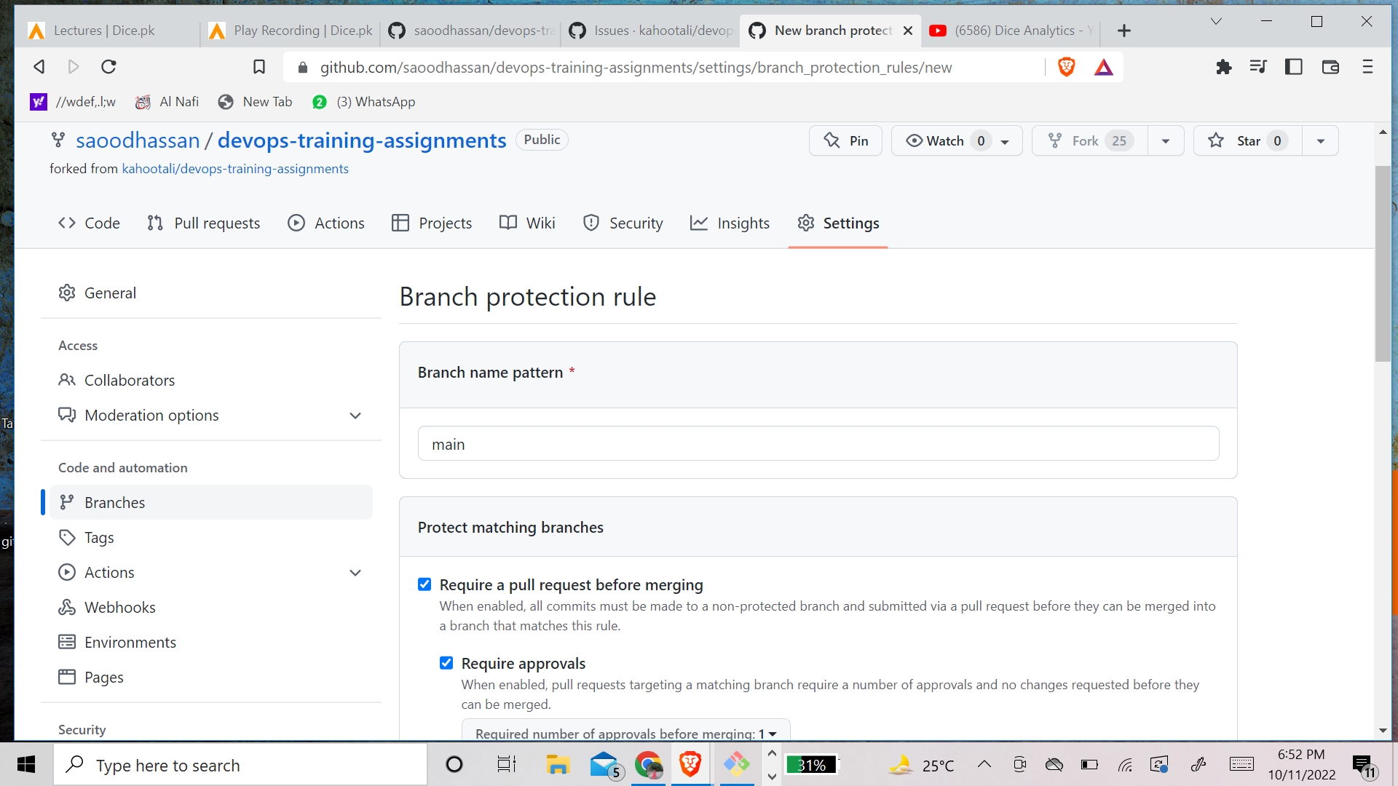

Q2. Docker containers are considered suitable to run multiple applications over a single OS kernel; whereas, virtual machines are needed if the applications or services required to run on different OS.Docker containers are generally faster and less resource-intensive than virtual machines, but full VMware virtualization still has its unique core benefits—namely, security and isolation.

Q3. Docker architecture. Docker uses a client-server architecture. The Docker client talks to the Docker daemon, which does the heavy lifting of building, running, and distributing your Docker containers. The Docker client and daemon can run on the same system, or you can connect a Docker client to a remote Docker daemon.Docker Containers allow us to separate the applications from the infrastructure so we can deploy application/software faster. Docker have main components which includes Docker Swarm, Docker Compose, Docker Images, Docker Daemon, Docker Engine.

Q4. docker container run -d --publish 9090:80 --assignment-2 nginx-container nginx

Q5. assignment-2 logs nginx-background