 | Chief Digital & Information  Application Development & Support
REQUIREMENT ANALYSIS DOCUMENT

Innovation Idea Submission and Evaluation Portal
Redevelopment
VERSION  1.0 | DATE  October 2026 | CLASSIFICATION  Internal — Confidential
Prepared for: Digital Innovation Work Unit, Digital Banking and Innovation Department

Document Control
Document Information
Title | Innovation Idea Submission and Evaluation Portal — Redevelopment
Organization | Chief Digital & Information — Application Development & Support
Version | 1.0
Date | October 2026
Prepared for | Digital Innovation Work Unit, Digital Banking and Innovation Department
Reference sources | Innovation Idea Submission Portal BRD; Software Development & Integration Request Form SDIR/01 (request dated 1 July 2026, approved 3 August 2026)
Request type | Enhancement of existing software
Requested go-live | 1 December 2026 (new idea competition starts January 2027)
Classification | Internal — Confidential

Revision History
Version | Date | Author | Summary of change
1.0 | October 2026 | Business Analysis | Initial Requirement Analysis Document

Review and Approval
Role | Name | Signature | Date
Business Owner (Digital Innovation Work Unit)
Approver (Director, Digital Banking and Innovation Department)
Portal Developer (Application Development and Support)

Table of Contents
1. Introduction 4
1.1 Purpose 4
1.2 Objectives 4
1.3 Current Challenges and Response 4
1.4 Scope 4
1.5 Stakeholders and User Roles 5
2. Business Process 6
2.1 Process Stages 6
2.2 Idea Status Lifecycle 6
2.3 Business Rules 6
3. User Requirements 7
3.1 Use Cases 7
3.2 User Stories 8
3.3 Workflow 10
4. Functional Requirements 11
4.1 Idea Submission 11
4.2 Campaign and Competition Management 11
4.3 Evaluation 12
4.4 Hackathon Support 12
4.5 Collaboration 12
4.6 Tracking and Notifications 12
4.7 Search, Dashboards and Reporting 13
4.8 Users and Access 13
5. Non-Functional Requirements 13
5.1 Non-Functional Requirements 13
5.2 Integration Requirements 14
6. Data Requirements 15
6.1 Data Model 15
6.2 Entity Description 15
6.3 Reference Data 16
6.4 Mandatory Idea Fields 16
7. Assumptions, Constraints and Open Items 17
7.1 Assumptions, Constraints and Open Items 17
7.2 Success Criteria 17
Appendix A: Acronyms and Terms 18
Appendix B: Traceability Matrix 18

1. Introduction

1.1 Purpose
The Bank's existing Innovation Idea Submission and Evaluation Portal supports only basic submission and evaluation. Much of the coordination still happens manually outside the system. This request enhances and redevelops it into a centralized, system-driven platform that supports competition-based and continuous idea submission, structured multi-level evaluation, hackathons, collaboration, notifications, dashboards and reporting.

1.2 Objectives
- Increase employee participation in innovation and encourage continuous idea generation.
- Digitize and automate submission and evaluation, and reduce manual coordination and follow-up.
- Improve transparency and real-time tracking of idea status.
- Support innovation competitions and internal and external hackathons.
- Create a centralized repository of ideas with reporting, dashboards and collaboration.

1.3 Current Challenges and Response
Challenge in the current portal | Addressed by
Limited automation of evaluation and workflow | Configurable multi-phase evaluation (FR-14 to FR-20)
Manual follow-up and communication outside the system | Automatic notifications and reminders (FR-30, FR-31)
Limited tracking and visibility of idea status | Real-time status tracking and history (FR-28, FR-29)
No collaboration or discussion features | Forums, threads and comments (FR-25 to FR-27)
Limited reporting and filtering | Dashboards, filters and exports (FR-32 to FR-34)
No structured campaign or hackathon management | Campaign and hackathon modules (FR-08 to FR-13, FR-21 to FR-24)
Some users cannot track their ideas because the portal is not linked to the latest HR system | HR system and directory integration (FR-36, INT-02)

1.4 Scope
In scope | Not stated in the request
Idea submission (competition-based and continuous), drafts, attachments | Detailed UI design (mock-up references in the BRD are conceptual)
Campaign and competition management, rules, criteria, deadlines, rewards | Payment or reward disbursement processing
Multi-level evaluation, scoring, ranking and result announcement | Choice of technical architecture (vendor proposes)
Internal and external hackathons | Migration of historical ideas from the current portal (to be confirmed)
Forums, comments, blog and post creation | —
Tracking, notifications (in-system, email, SMS), dashboards and exports | —
User management, role-based access and integrations | —

1.5 Stakeholders and User Roles
Stakeholder | Name / team | Responsibility
Business owner | Digital Innovation Work Unit | Strategic oversight and request approval
Portal developer | Application Development and Support | Develop the portal
Primary users | All internal staff | Submit, track and collaborate on ideas

Role | Responsibilities
Employee / Internal User | Create, edit, view and delete ideas; track status; discuss and collaborate; give feedback; join forums and hackathons; receive milestone notifications.
External / Public User | Hackathon only: submit ideas where permitted and receive milestone notifications.
Evaluator / Judge | Review and score assigned ideas; give feedback. Evaluation tiers: Senior Managers (phase one), Department Directors (phase two), Chiefs (final phase), and assigned judges where applicable.
Innovation Team / Admin | Create and manage campaigns, competitions, forums and hackathons; configure criteria and rules; add evaluators; push notifications; view submitted ideas; manage portal users; perform pre-screening.

2. Business Process

2.1 Process Stages
The end-to-end process runs in seven stages, from campaign setup to implementation and reporting.
# | Stage | Owner | Key activities | Output
1 | Campaign setup | Innovation Team / Admin | Define campaign type (competition, continuous, hackathon), rules, dates, criteria, rubric, phases and evaluators; publish and announce. | Published campaign
2 | Submission and intake | Employee / external user | Create idea, save draft, attach files or video, validate and submit within the open period. | Submitted idea
3 | Pre-screening | Portal admins | Check eligibility and completeness; check for duplicates or ideas already in STMS. | Approved or rejected
4 | Formal evaluation | Senior Managers, Directors, Chiefs, judges | Review, score against the rubric and comment in each phase; shortlist to the next phase. | Scored, shortlisted ideas
5 | Ranking and selection | System and Admin | Consolidate scores, produce the ranked list, select winners. | Ranked list
6 | Announcement and recognition | Innovation Team / Admin | Announce results, notify participants, apply reward and recognition. | Winners announced
7 | Implementation and reporting | Business units / Admin | Track implementation; update dashboards and reports. | Implemented ideas, reports

2.2 Idea Status Lifecycle
Phase | Statuses | Trigger
1. Submission and intake | Draft; Submitted | Idea saved; idea submitted
2. Pre-screening | Pre-screening; Approved / Rejected | Admin eligibility, duplicate and STMS check
3. Formal evaluation | Under Review; Shortlisted / Not Selected | Evaluator phases and shortlist size
4. Finalization | Ranked List; Winners Announced; Implemented | Final scoring, announcement, delivery

2.3 Business Rules
- BR-01 — Competition ideas are accepted only inside the open window; continuous ideas have no time restriction.
- BR-02 — Only complete submissions proceed; incomplete submissions are dropped.
- BR-03 — Duplicate ideas, or ideas already in STMS, are dropped at pre-screening.
- BR-04 — Evaluation follows the configured phases; only shortlisted ideas move on, and the shortlist size is set by the Admin.
- BR-05 — Evaluator roles are assigned by the portal Admin, not by another team.
- BR-06 — Ideas are scored only against the predefined criteria and rubric of the campaign.
- BR-07 — External users may take part in hackathons only.
- BR-08 — Users are notified at every status change; attachments are limited to 100 MB.

3. User Requirements

3.1 Use Cases
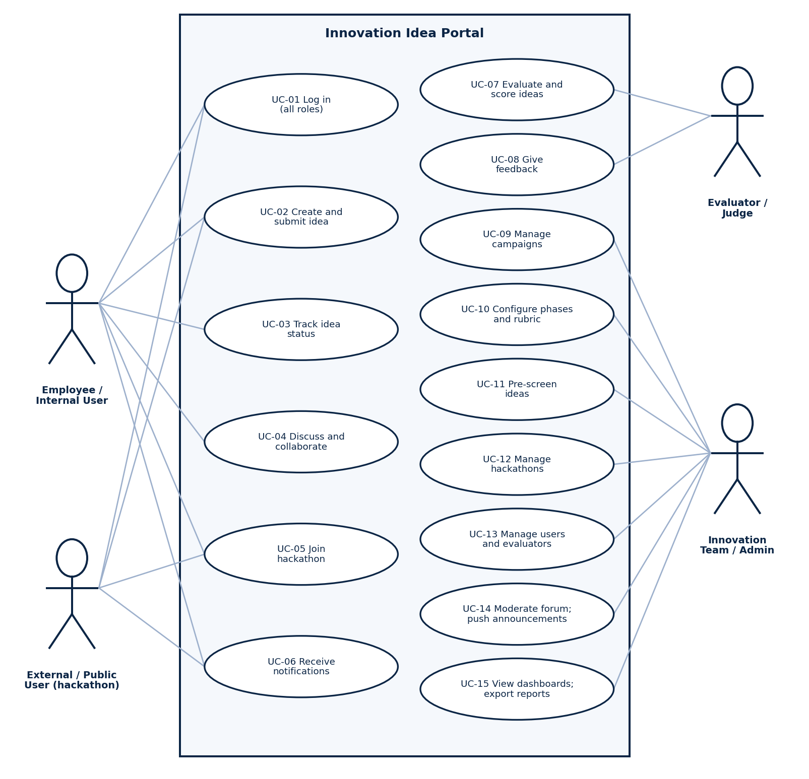
Figure 1: Use case diagram
ID | Use case | Actor | Outcome
UC-01 | Log in | All roles | Authenticated session with role-based access
UC-02 | Create and submit idea | Employee; external user (hackathon) | Idea saved as draft or submitted
UC-03 | Track idea status | Employee | Current status, history and feedback visible
UC-04 | Discuss and collaborate | Employee | Forum topics, comments and replies
UC-05 | Join hackathon | Employee; external user | Registered participant with submission
UC-06 | Receive notifications | Employee; external user | In-system, email or SMS message
UC-07 | Evaluate and score ideas | Evaluator / Judge | Scores and recommendation recorded
UC-08 | Give feedback | Evaluator / Judge | Comments visible to the submitter
UC-09 | Manage campaigns | Innovation Team / Admin | Campaign with dates, rules and rewards
UC-10 | Configure phases and rubric | Innovation Team / Admin | Phases, evaluators, screening size, criteria
UC-11 | Pre-screen ideas | Innovation Team / Admin | Approved or rejected with reason
UC-12 | Manage hackathons | Innovation Team / Admin | Event with timeline, rules and participants
UC-13 | Manage users and evaluators | Innovation Team / Admin | Accounts and roles maintained
UC-14 | Moderate forum; push announcements | Innovation Team / Admin | Moderated content, announcements sent
UC-15 | View dashboards; export reports | Innovation Team / Admin | Filtered reports in PDF, Word or Excel

UC-02 Create and Submit Idea
Actor | Employee (internal); external user for hackathons
Preconditions | User is logged in; a campaign is open or continuous submission is enabled.
Main flow | 1. User opens the Idea Submission page. 2. Enters title, problem statement, proposed solution, expected business value, category and theme, strategic pillar and remark. 3. Attaches documents, images or video (max 100 MB). 4. Selects Submit. 5. System validates mandatory fields. 6. System sets status Submitted and sends a confirmation.
Alternative flows | A. Save draft: system stores the idea as Draft without full validation. B. Validation fails: system highlights missing fields and blocks submission. C. Campaign closed: system blocks submission and shows the closing date.
Postcondition | Idea is recorded with status Submitted and enters pre-screening.

UC-07 Evaluate and Score Ideas
Actor | Evaluator / Judge
Preconditions | Evaluator role granted by Admin; ideas assigned for the current phase.
Main flow | 1. Evaluator opens the Evaluation Dashboard. 2. Selects an assigned idea. 3. Reviews content and attachments. 4. Scores each rubric criterion. 5. Adds comments and a recommendation. 6. Submits the evaluation. 7. System consolidates scores for the phase.
Alternative flows | A. Deadline approaching: system sends a pending-evaluation reminder. B. Idea already evaluated by this evaluator: score is read-only.
Postcondition | Evaluation stored; idea moves to the next phase or is marked Not Selected according to the shortlist size.

3.2 User Stories
ID | Story | Acceptance criteria
US-01 | As an employee, I want to submit an idea with its required details so that it can be evaluated. | Mandatory fields validated; status becomes Submitted; confirmation sent.
US-02 | As an employee, I want to save a draft so that I can finish the idea later. | Draft saved without full validation; editable until submitted.
US-03 | As an employee, I want to attach documents, images and short videos so that I can support my idea. | Files up to 100 MB accepted; file types listed.
US-04 | As an employee, I want to track my idea's status so that I know where it stands. | Real-time status, history and feedback shown on My Ideas.
US-05 | As an employee, I want notifications on progress so that I do not need to follow up manually. | In-system and email; SMS where applicable.
US-06 | As an employee, I want to discuss ideas in forums so that I can collaborate with colleagues. | Create topics; comment and reply.
US-07 | As an employee, I want to register for a hackathon so that I can take part. | Registration confirmed; countdown and schedule shown.
US-08 | As an external user, I want to register and submit a hackathon idea so that I can compete. | Access limited to hackathon features only.
US-09 | As an evaluator, I want to see the ideas assigned to me so that I can plan my reviews. | Assigned list with status indicators and due dates.
US-10 | As an evaluator, I want to score ideas against the rubric and comment so that evaluation is consistent. | Rubric criteria shown; total score calculated; submitted score is locked.
US-11 | As an evaluator, I want reminders of pending evaluations so that I meet deadlines. | Reminder before deadline for each pending idea.
US-12 | As an admin, I want to create a campaign with rules, dates and criteria so that submissions follow clear terms. | Opening and closing dates; deadline extension by toggle; countdown timer.
US-13 | As an admin, I want to pre-screen ideas for eligibility, duplicates and STMS so that only valid ideas are evaluated. | Approve or reject with reason; submitter notified.
US-14 | As an admin, I want to configure phases, evaluators, screening size and rubric so that evaluation matches each campaign. | Phase order, evaluators and shortlist size stored per campaign.
US-15 | As an admin, I want to grant the evaluator role so that evaluators do not depend on another team. | Role assigned and logged by the Admin.
US-16 | As an admin, I want to create and announce hackathons so that participants can join on time. | Online or in-person event; timeline, rules and announcements published.
US-17 | As an admin, I want to see the final ranking and winners so that I can announce results. | Ranking shown with winner user name and details.
US-18 | As an admin, I want filtered dashboards and exports so that I can report on innovation activity. | Filter by status; export to PDF, Word, Excel.
US-19 | As an admin, I want to moderate forums and push announcements so that discussions stay appropriate and informed. | Moderation controls; announcement sent to selected users.

3.3 Workflow
The BPMN diagram shows the competition-based idea flow across the four lanes. The hackathon flow follows below.

3.3.1 Idea Submission and Evaluation (BPMN)
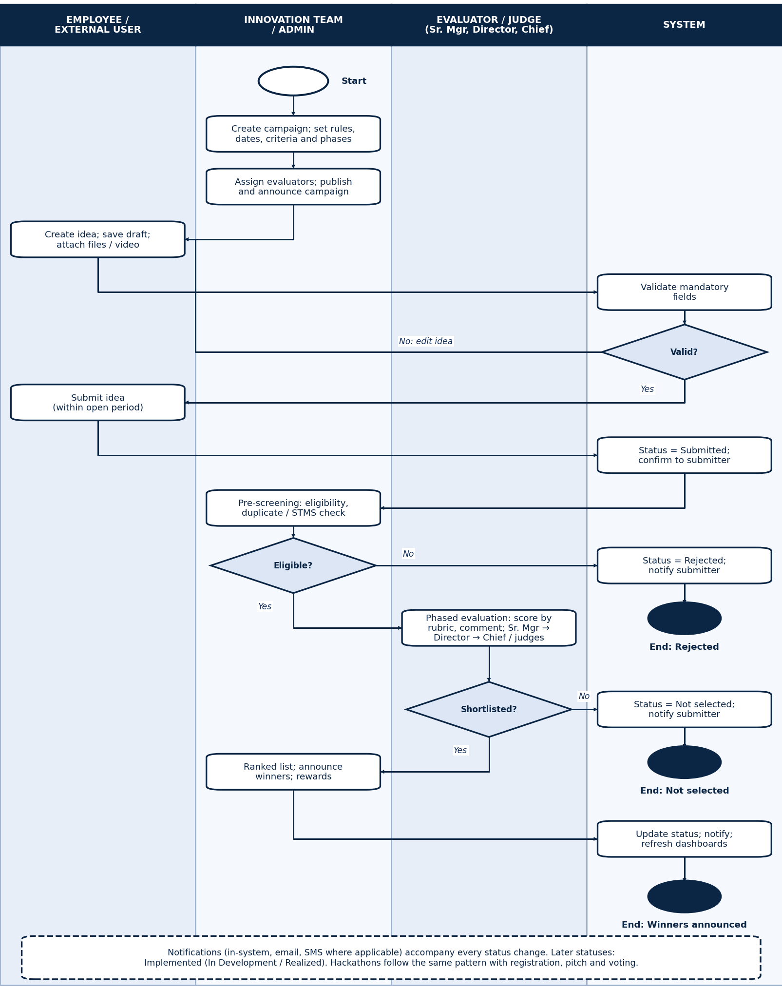
Legend: rounded boxes are tasks, diamonds are gateways, open circle is the start event, filled circles are end events.

3.3.2 Hackathon Workflow
- The Admin creates the event (internal or external; online or in-person).
- The Admin defines the timeline and rules.
- The portal displays a countdown timer.
- Participants register and submit ideas.
- The submission deadline is reached; submissions close.
- Evaluation and judging take place.
- A pitch session or online review is held; audience voting is used where applicable.
- The winner is selected.
- Results are announced and notifications are sent.
- Dashboards and reports are updated.

4. Functional Requirements
Priorities are proposed by the analyst (Must / Should) and are to be confirmed with the business owner.

4.1 Idea Submission
ID | Requirement | Priority | Source
FR-01 | Support competition-based submissions within defined timelines and continuous/open submissions with no time restriction. | Must | BRD
FR-02 | Allow internal employees to submit ideas, and external/public participants to submit ideas for hackathons where permitted. | Must | BRD
FR-03 | Save drafts and allow later editing and submission. | Must | BRD
FR-04 | Capture the mandatory fields: idea title, problem statement, proposed solution, expected business value, category and theme, strategic pillar, supporting documents and media, remark. | Must | BRD
FR-05 | Accept attachments (documents, presentations, images, short videos) up to 100 MB. | Must | BRD
FR-06 | Validate mandatory fields before submission and block incomplete submissions. | Must | BRD
FR-07 | Let owners view, edit and delete their own ideas, with edit and delete limited by idea status. | Must | Form

4.2 Campaign and Competition Management
ID | Requirement | Priority | Source
FR-08 | Create and manage innovation campaigns and competitions, including category- and theme-based competitions. | Must | BRD
FR-09 | Configure competition rules, pre-screening criteria and the evaluation rubric with points or marks. | Must | BRD
FR-10 | Manage submission opening and closing dates, extend deadlines by toggle, and show countdown timers for active competitions. | Must | BRD
FR-11 | Configure reward and recognition for a campaign. | Should | BRD
FR-12 | Create and publish announcements and push notifications to participants. | Must | BRD
FR-13 | Set the number of shortlisted ideas that move to the next stage. | Must | BRD

4.3 Evaluation
ID | Requirement | Priority | Source
FR-14 | Provide structured, configurable multi-level evaluation workflows (screening size, evaluators, phases, rubric). | Must | BRD
FR-15 | Support pre-screening by portal admins: eligibility, completeness, and duplicate or already-in-STMS checks; drop failing ideas. | Must | BRD
FR-16 | Support phase one by Senior Managers, phase two by Department Directors, final phase by Chiefs, and assigned judges where applicable. | Must | BRD
FR-17 | Allow the Admin to assign the evaluator role and assign ideas to evaluators. | Must | BRD
FR-18 | Allow evaluators to score against predefined criteria and add comments, recommendations and feedback. | Must | BRD
FR-19 | Consolidate scores, rank ideas and generate scoring summaries; show final ranking and winner details on the admin page. | Must | BRD
FR-20 | Forward ideas automatically to the relevant departments where applicable. | Should | BRD

4.4 Hackathon Support
ID | Requirement | Priority | Source
FR-21 | Create internal and external hackathons, online or in-person. | Must | BRD
FR-22 | Manage hackathon registration and submissions for internal and external participants. | Must | BRD
FR-23 | Support pitch sessions and audience voting or evaluation where applicable. | Should | BRD
FR-24 | Provide countdown and deadline notifications by toggle, and publish event schedules and updates. | Should | BRD

4.5 Collaboration
ID | Requirement | Priority | Source
FR-25 | Provide discussion forums with topics, threads, comments and replies. | Must | BRD
FR-26 | Provide feedback mechanisms and idea discussion threads between participants and reviewers. | Should | BRD
FR-27 | Support blog and post creation, with moderation controls for administrators. | Should | BRD

4.6 Tracking and Notifications
ID | Requirement | Priority | Source
FR-28 | Show idea status in real time using the lifecycle statuses in Section 2.2. | Must | BRD
FR-29 | Keep a status history for every idea. | Must | Analyst
FR-30 | Send notifications by in-system message, email and SMS where applicable for: submission confirmation, evaluation progress, feedback, pending-evaluation reminders, competition and hackathon announcements, deadline reminders and final results. | Must | BRD
FR-31 | Provide a notification page with read/unread indicators and deadline reminders. | Should | BRD

4.7 Search, Dashboards and Reporting
ID | Requirement | Priority | Source
FR-32 | Search ideas and filter by category, status, department, submission period and competition type. | Must | BRD
FR-33 | Provide dashboards: submitted ideas, evaluation progress, participation, competition performance, department-level statistics, hackathon metrics and user engagement. | Must | BRD
FR-34 | Provide reports filtered by idea status, exportable to PDF, Word and Excel. | Must | BRD

4.8 Users and Access
ID | Requirement | Priority | Source
FR-35 | Provide secure authentication, role-based authorization for the four roles, and user profile management. | Must | BRD
FR-36 | Integrate with the internal user directory and the latest HR system so employee details and idea ownership are accurate. | Must | BRD
FR-37 | Allow the Admin to manage portal users and assign roles, including the evaluator role. | Must | BRD
FR-38 | Provide a landing page with login and sign-up, news and ads for competitions and hackathons, contact and FAQ, gallery and success stories. | Should | BRD

5. Non-Functional Requirements

5.1 Non-Functional Requirements
The BRD states these qualitatively. Numeric targets are to be agreed with the business owner and developer.
ID | Category | Requirement | Target
NFR-01 | Security | Secure authentication, role-based access control, session timeout and password policies. | Per Bank security policy
NFR-02 | Data protection | Encryption in transit and at rest; secure file upload and storage; protection of confidential ideas. | Per Bank security policy
NFR-03 | Auditability | Audit trail and user activity monitoring. | All user actions logged
NFR-04 | Performance | Fast response, efficient handling of concurrent users and large uploads (up to 100 MB). | To be agreed
NFR-05 | Scalability | Support growth in users and submissions and future enhancements and integrations. | To be agreed
NFR-06 | Availability | High availability with backup, recovery and disaster recovery. | To be agreed
NFR-07 | Usability | Intuitive, simple navigation; responsive web access. | Desktop and mobile browsers
NFR-08 | Configurability | Workflows, phases, criteria and rules are configurable by the Admin without code changes. | Admin-configurable
NFR-09 | Integration | Documented APIs and integration methods, security standards and dependencies. | Vendor to specify
NFR-10 | Compliance | Bank security and regulatory compliance; vendor describes the security architecture. | Per Bank policy

5.2 Integration Requirements
ID | System | Purpose
INT-01 | Internal authentication / directory | Single sign-on and role mapping for internal users
INT-02 | HR system | Latest employee data so users can track their ideas and departments are correct
INT-03 | Email service | Notification emails
INT-04 | SMS gateway (where applicable) | SMS notifications
INT-05 | STMS | Duplicate and existing-idea check during pre-screening (method to be confirmed)
INT-06 | Possible: document management, collaboration platforms, reporting and analytics tools | Optional integrations named in the BRD

6. Data Requirements

6.1 Data Model
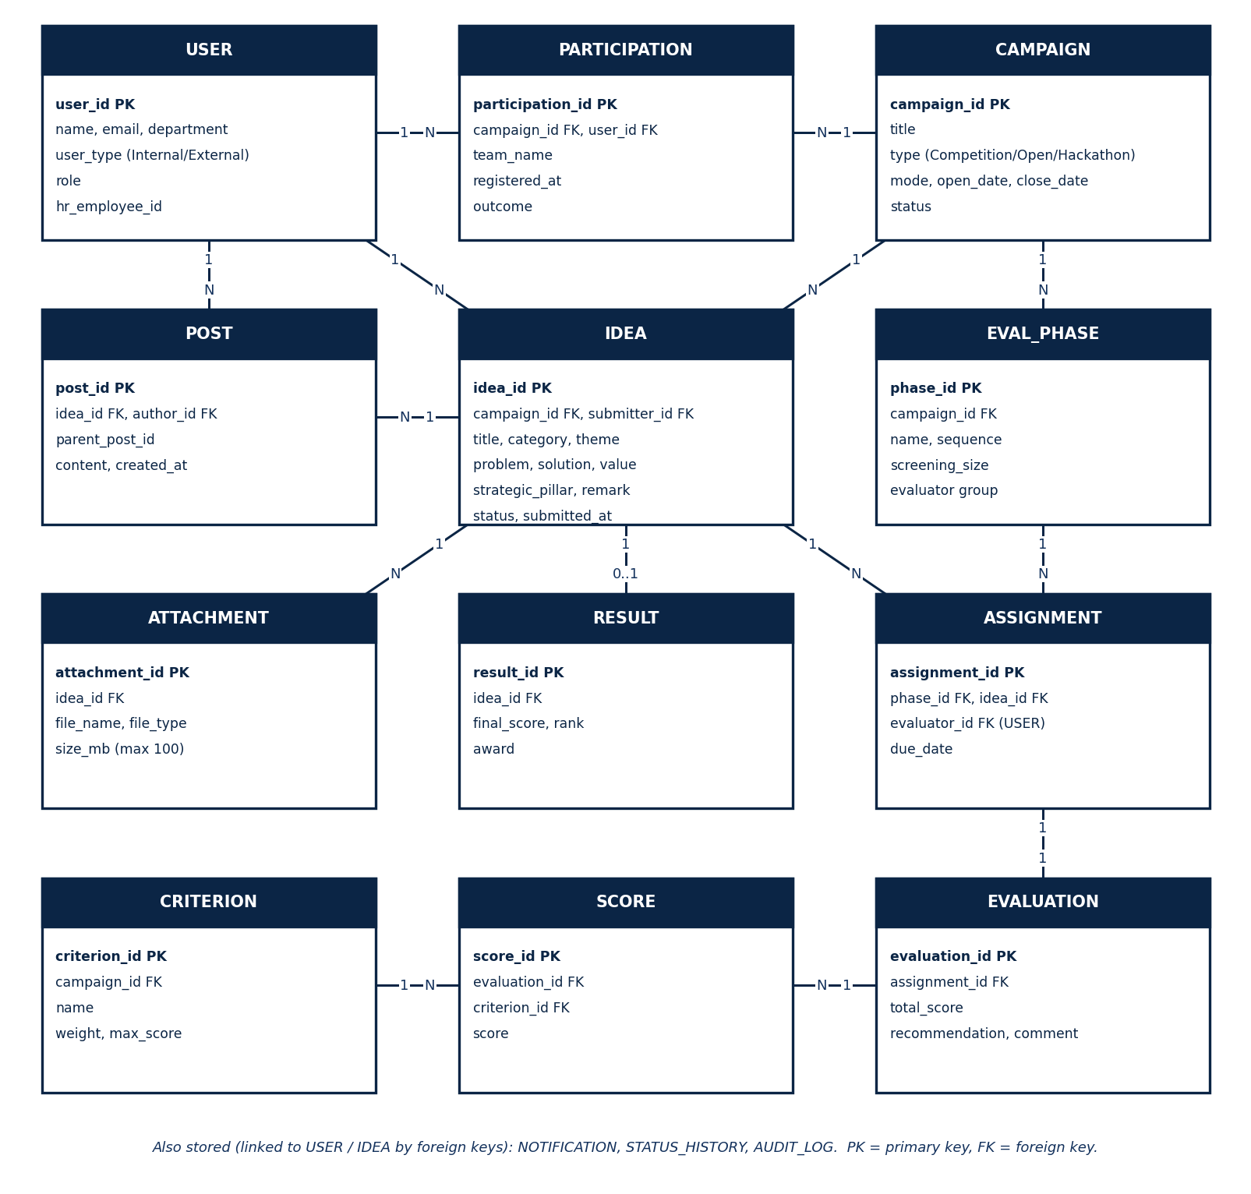
Figure 2: Conceptual data model (entity relationship)

6.2 Entity Description
Entity | Purpose | Key attributes
USER | Internal and external portal users | user_id, name, email, department, user_type, role, hr_employee_id
CAMPAIGN | Competition, continuous campaign or hackathon | campaign_id, title, type, mode, open_date, close_date, status
IDEA | Submitted idea | idea_id, campaign_id, submitter_id, title, problem, solution, value, category, theme, strategic_pillar, remark, status
ATTACHMENT | Files and video supporting an idea | attachment_id, idea_id, file_name, file_type, size_mb (max 100)
EVAL_PHASE | Evaluation phase of a campaign | phase_id, campaign_id, name, sequence, screening_size
ASSIGNMENT | Idea assigned to an evaluator for a phase | assignment_id, phase_id, idea_id, evaluator_id, due_date
EVALUATION / SCORE | Evaluator result and per-criterion scores | evaluation_id, assignment_id, total_score, recommendation, comment; score per criterion
CRITERION | Rubric criterion of a campaign | criterion_id, campaign_id, name, weight, max_score
RESULT | Final ranking and award | result_id, idea_id, final_score, rank, award
PARTICIPATION | Hackathon or campaign registration | participation_id, campaign_id, user_id, team_name, outcome
POST | Forum topic, comment, reply or blog post | post_id, idea_id, author_id, parent_post_id, content
NOTIFICATION | Message sent to a user | notification_id, user_id, channel, type, status, sent_at
STATUS_HISTORY | Status changes of an idea | history_id, idea_id, status, changed_by, changed_at
AUDIT_LOG | User activity record | log_id, user_id, action, entity, timestamp

6.3 Reference Data
List | Values
Idea category / theme | Incremental, Disruptive, Product, Process, Service, Channel and Marketing Innovation
Strategic pillar | Increase market share; Decrease cost-to-income ratio; Enhance customer satisfaction
Idea status | Draft, Submitted, Pre-screening, Approved, Rejected, Under Review, Shortlisted, Not Selected, Ranked List, Winners Announced, Implemented
Campaign type | Competition (time-bound), Continuous / open, Hackathon (online or in-person; internal or external)
User type and role | Internal or External; Employee, External User, Evaluator / Judge, Innovation Team / Admin
Notification channel | In-system, Email, SMS (where applicable)

6.4 Mandatory Idea Fields
Field | Type | Rule
Idea title | Text | Required
Problem statement | Long text | Required
Proposed solution | Long text | Required
Expected business value | Long text | Required
Category and theme | Dropdown | Required; from the reference list
Strategic pillar | Dropdown | Required; from the reference list
Supporting documents and media | File upload | Documents, presentations, images, short videos; max 100 MB
Remark | Text | Listed as a capture field in the BRD

7. Assumptions, Constraints and Open Items

7.1 Assumptions, Constraints and Open Items
Type | Item
Assumptions | Existing infrastructure and hosting are available where necessary; stakeholders take part in requirement clarification and testing; internal users have access to the required authentication systems.
Constraints | Budget limitations; timeline (go-live 1 December 2026, competition starts January 2027); integration dependencies; existing infrastructure limits; regulatory and security compliance.
Open items | Budget is not yet approved and the estimated cost is blank on the request form. HR system link method; STMS integration method; SMS gateway availability; numeric NFR targets; migration of existing ideas; edit and delete rules by status; confirmation of Must / Should priorities.

7.2 Success Criteria
- Higher employee participation in innovation competitions.
- Fewer manual processes and lower administrative workload.
- More transparent evaluation and tracking, with faster automated turnaround.
- Better user satisfaction and engagement through an interactive UI.
- Successful execution of competitions and hackathons on the platform.

Appendix A: Acronyms and Terms
Term | Meaning
BRD | Business Requirements Document
BPMN | Business Process Model and Notation
FR / NFR | Functional / Non-Functional Requirement
HR | Human Resources
RBAC | Role-Based Access Control
SMS | Short Message Service
STMS | System referenced in the BRD for checking ideas that already exist (full name to be confirmed)
UC / US | Use Case / User Story
Hackathon | Time-bound innovation event, internal or external, online or in-person

Appendix B: Traceability Matrix
Capability | Use cases | User stories | Functional requirements
Idea submission | UC-02 | US-01 to US-03 | FR-01 to FR-07
Campaign management | UC-09, UC-10 | US-12, US-14 | FR-08 to FR-13
Pre-screening and evaluation | UC-07, UC-08, UC-11 | US-09 to US-11, US-13, US-15, US-17 | FR-14 to FR-20
Hackathon | UC-05, UC-12 | US-07, US-08, US-16 | FR-21 to FR-24
Collaboration | UC-04, UC-14 | US-06, US-19 | FR-25 to FR-27
Tracking and notifications | UC-03, UC-06 | US-04, US-05 | FR-28 to FR-31
Search and reporting | UC-15 | US-18 | FR-32 to FR-34
Users and access | UC-01, UC-13 | US-15 | FR-35 to FR-38

