From Tokens to Context Vectors: A Reflection on Foundational NLP Concepts and Their Application to Browser-Based Text Analytics
Mark Emmanuel P. Sagarino
College of Computing and Information Technologies
Jose Rizal University
Mandaluyong City, Philippines
markemmanuel.sagarino@my.jru.edu

Abstract—This paper reflects on Exercise #WW-P2, a guided module on foundational Natural Language Processing (NLP) spanning tokenization, statistical term weighting with TF-IDF, and semantic embeddings. The hands-on component used two browser-based applications running Microsoft Phi-3.5-mini locally via WebGPU: a Chat Playground for generative summarization and a Language Playground for language detection and personally identifiable information (PII) extraction. Three tasks were performed—abstractive summarization of a trade review, language identification of a German hardware label, and PII detection in an invoice. The exercise established that generative and specialized analyzers are complementary rather than competing, that statistical and semantic representations encode different information, and that contextual representation separates modern language models from their predecessors.
Keywords—natural language processing, tokenization, lemmatization, TF-IDF, word embeddings, context vectors, small language models, PII redaction, transformers

INTRODUCTION
Natural Language Processing (NLP) enables computational systems to parse, interpret, and generate human language. Because language is unstructured, ambiguous, and context-dependent, it resists the tabular representations conventional machine learning pipelines require; bridging that gap demands a deliberate sequence of transformations from raw character streams to numerical structures [1].
The author's prior understanding was operational rather than theoretical: text was an obstacle to clear before applying a classifier—strip punctuation, lowercase, vectorize, proceed. The distinction between a term-weighting scheme and a learned embedding registered as a difference in library call, not in what the representation preserves.

EXPERIENTIAL AND PRACTICAL INSIGHTS
Both applications execute inference locally rather than through a cloud endpoint. The Chat Playground runs Phi-3.5-mini on the client GPU via WebGPU, degrading to WebAssembly SIMD on CPU and finally to a non-generative Basic mode [2].

Abstractive Summarization
The first task supplied a system instruction establishing the model as a text-analysis assistant, then a three-paragraph 1980s trade review of the Commodore 64 to be summarized in one paragraph. The output was genuinely abstractive: the review's evaluative structure—competitive pricing, 64K of memory, and the SID sound generator, offset against a mediocre keyboard and costly peripherals—was reconstituted in wording absent from the source (Fig. 1). An extractive summarizer concatenates salient sentences; an abstractive one must build a semantic representation and re-express it, which self-attention permits by conditioning every token on every other [3]. Output was also sensitive to the system instruction, confirming that prompt construction is a control surface rather than decoration.

Language Identification
Language detection was applied to a Schneider CPC 464 hardware label comprising article and serial numbers, electrical ratings, and a German address. The analyzer correctly returned German (Fig. 2). The instructive aspect is that the sample is not fluent prose but a fragmentary, alphanumeric-heavy artifact in which few tokens carry signal: classification rested on umlauts and on the morphology of Hergestellt and Bundesrepublik. Noise removal must therefore be selective—aggressive lowercasing would have destroyed the capitalization convention that is itself evidence of German. Identifying the language early governs routing and determines which tokenizer and stop-word list apply.

PII Detection
The third task applied the PII analyzer to a 1984 invoice. It isolated a person name, a street address, and a telephone number while correctly leaving product, price, and payment lines unflagged (Fig. 3). The documentation notes that detection combines generative inference, statistical analysis, and regular-expression matching, with false positives and missed entities expected. This clarified an engineering point: structurally regular entities such as telephone numbers are captured efficiently by deterministic patterns, whereas person names—sharing no reliable surface form and distinguished chiefly by context—require semantic modelling. A robust PII system is necessarily hybrid, with a non-zero error rate.

CORE LEARNING OUTCOMES

Tokenization Trade-offs
No tokenization scheme is neutral; each discards information in exchange for tractability. Word-level tokenization is interpretable but yields an unbounded vocabulary and fails on unseen terms; subword tokenization such as byte-pair encoding resolves the out-of-vocabulary problem at the cost of tokens that are no longer human-meaningful [4]. The stemming–lemmatization distinction repeats the pattern: suffix stripping is cheap but destructive, reducing 'studies' to 'studi' [1], whereas lemmatization returns valid forms but needs part-of-speech information and is slower. Stop-word removal is likewise conditional: beneficial for bag-of-words retrieval, harmful in sentiment analysis, where the negation in 'not good' carries the entire polarity.

Statistical Weighting Versus Semantic Embedding
TF-IDF weights each term by its frequency within a document against its rarity across the corpus, promoting terms that are locally frequent yet globally rare [5]. It is transparent, but its vector space is defined over the vocabulary itself, with one dimension per term and no relationship between dimensions, so 'laptop' and 'notebook computer' are as unrelated as 'laptop' and 'cabbage'. Embeddings resolve this by learning dense vectors from distributional evidence, positioning terms with similar contexts near one another so that semantic proximity becomes measurable geometry [6]. Table I contrasts the two; they are complementary rather than substitutes, since TF-IDF remains defensible where auditability is required.
- Statistical Weighting vs. Semantic Embedding
Property | TF-IDF | Embeddings
Vector form | Sparse, high-dim. | Dense, low-dim.
Dimension meaning | One per term | Latent feature
Synonym handling | None | Captured
Context sensitivity | None | Contextual models
Interpretability | High | Low

Context Vectors and the Transformer Bridge
The most consequential idea was the limitation of static embeddings. A classical embedding table assigns each term one vector regardless of usage, collapsing the 'bank' of a river and the 'bank' holding deposits into one averaged point. Contextual models compute a distinct vector for every token occurrence, conditioned on the surrounding sequence [7]. This is the bridge to modern LLMs: self-attention constructs, for each position, a weighted combination of all others using learned query–key compatibility [3], making meaning a function of context. Phi-3.5-mini instantiates that architecture compactly [2].

COURSE APPLICATION AND IMPACT
These concepts map onto three obligations in the author's current programme; Figs. 1–3 reproduce the supporting artefacts. First, the capstone is a tourism and cultural information management system in which visitor feedback is analyzed for sentiment. The exercise revised the intended approach: the original plan was TF-IDF feeding a conventional classifier, but such a pipeline would silently destroy negation and could not recognize that two differently worded complaints express the same grievance. A contextual representation is the defensible choice, and the reasoning is now articulable rather than conventional.
Second, the PII component carries governance implications. Any system collecting free-text feedback incidentally collects personal information, and the Philippine Data Privacy Act of 2012 imposes obligations on its handling. Fig. 3 shows that automated detection is feasible; the documented error rate shows that it is imperfect, arguing for redaction at ingestion combined with human review.
Third, for conversational systems, the exercise reframed the generative-versus-specialized distinction as an architectural decision: a generative model suits open-ended dialogue, a deterministic analyzer suits structured, auditable output, and production designs commonly compose both. The tiered fallback added a lesson on graceful degradation—of practical weight for bandwidth-limited local government deployment.
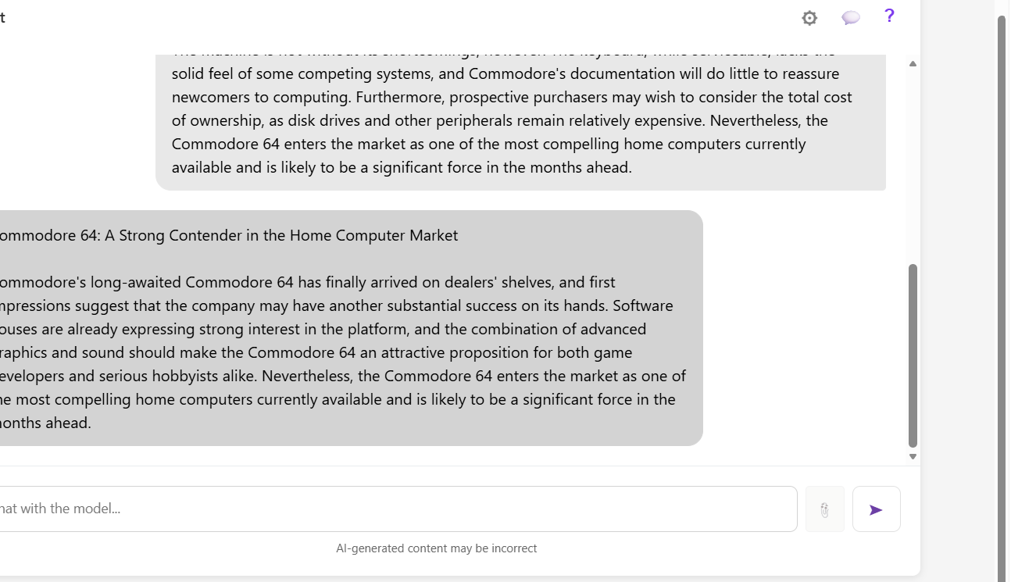
Fig. 1. Chat Playground output for the summarization task: source review (top), generated summary (bottom).
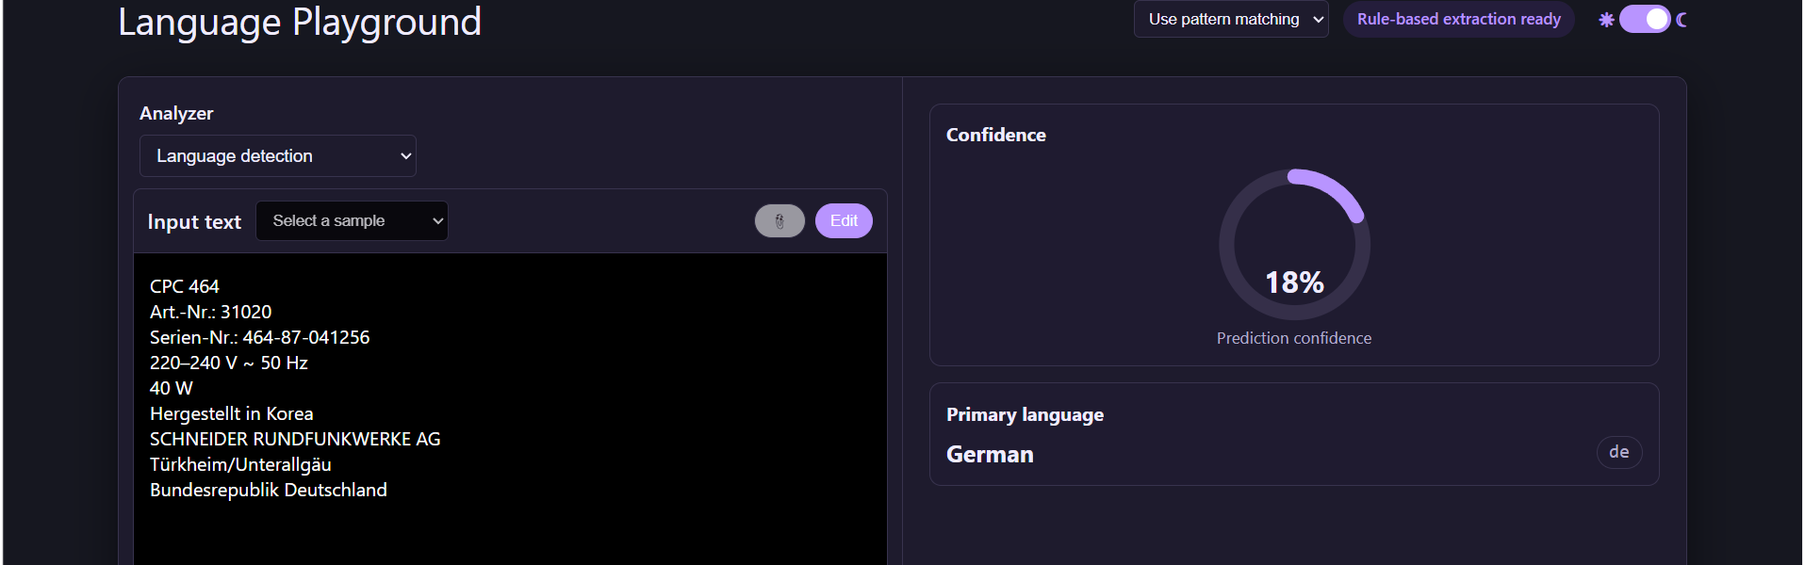
Fig. 2. Language detection on the Schneider CPC 464 label: German at 18% confidence
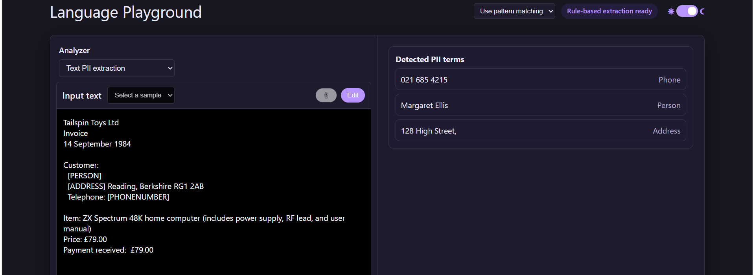
Fig. 3. PII extraction on the 1984 invoice: name, address, and telephone isolated; product and payment lines unflagged.

CONCLUSION AND FUTURE WORK
This exercise converted procedural familiarity with text preprocessing into a reasoned understanding of why each stage exists and what it costs. Three conclusions are principal: preprocessing decisions are lossy and task-conditional; statistical weighting and semantic embedding are complementary rather than successive; and contextual representation through self-attention separates modern language models from their predecessors.
Four directions follow: comparing TF-IDF against contextual embeddings on an annotated sentiment corpus; parameter-efficient fine-tuning for domain vocabulary; retrieval-augmented generation to ground output; and migration to a managed platform such as Microsoft Foundry [8].

REFERENCES
- D. Jurafsky and J. H. Martin, Speech and Language Processing, 3rd ed. Upper Saddle River, NJ, USA: Prentice Hall, 2024.
- M. Abdin et al., “Phi-3 technical report: A highly capable language model locally on your phone,” arXiv:2404.14219, Apr. 2024.
- A. Vaswani et al., “Attention is all you need,” in Proc. 31st Int. Conf. Neural Inf. Process. Syst. (NIPS), Long Beach, CA, USA, Dec. 2017, pp. 6000–6010.
- R. Sennrich, B. Haddow, and A. Birch, “Neural machine translation of rare words with subword units,” in Proc. 54th Annu. Meeting Assoc. Comput. Linguistics (ACL), Berlin, Germany, Aug. 2016, pp. 1715–1725.
- G. Salton and C. Buckley, “Term-weighting approaches in automatic text retrieval,” Inf. Process. Manage., vol. 24, no. 5, pp. 513–523, 1988.
- T. Mikolov, K. Chen, G. Corrado, and J. Dean, “Efficient estimation of word representations in vector space,” in Proc. ICLR Workshop, Scottsdale, AZ, USA, May 2013.
- J. Devlin, M.-W. Chang, K. Lee, and K. Toutanova, “BERT: Pre-training of deep bidirectional transformers for language understanding,” in Proc. NAACL-HLT, Minneapolis, MN, USA, Jun. 2019, pp. 4171–4186.
- Microsoft, “Introduction to NLP concepts,” Microsoft Learn, 2025. [Online]. Available: learn.microsoft.com/training

