Hybrid CP-SAT and Quantum-Inspired Optimization for Airline Disruption Recovery with Explainable Decision Support
Kürşat Kahya
2026

Hybrid CP-SAT and Quantum-Inspired Optimization for Airline Disruption Recovery with Explainable Decision Support
Kürşat Kahya
Cukurova Art and Science Center, Adana, Turkey

Abstract
Airline disruption management requires solving tightly coupled combinatorial optimization problems—aircraft assignment, crew scheduling, and delay propagation—under strict regulatory constraints and real-time operational pressure. This paper presents a hybrid decision support framework that integrates Google OR-Tools CP-SAT constraint programming with a Quantum-Inspired Genetic Algorithm (QIGA) through a warm-start mechanism, augmented by a SHAP-based explainability layer for transparent decision-making. The CP-SAT solver generates feasible solutions that strictly enforce EASA Flight Time Limitation (FTL) regulations and operational constraints including aircraft continuity, crew continuity, gate capacity, and minimum connection times. These solutions are subsequently refined by QIGA, which leverages quantum-rotation-gate-driven population evolution to escape local optima within limited computational budgets. An explainability module combining TreeSHAP feature attribution with constraint-driven decision reason codes provides interpretable rationale for each operational decision, addressing EASA AMC 20-42 transparency requirements. Experimental evaluation on a 150-flight hub-and-spoke network demonstrates that the hybrid approach achieves a 5% improvement in operational profit over standalone CP-SAT ($p=0.007$), reduces flight cancellations by 20%, and maintains zero FTL violations across all test scenarios. The system converges to solutions within 2.1% of optimality under a 60-second time limit, confirming practical viability for real-time airline operations control.
Keywords: Airline Disruption Management, Constraint Programming, CP-SAT, Quantum-Inspired Genetic Algorithm, Explainable AI, SHAP, EASA Flight Time Limitations, Irregular Operations (IROPS)

1. Introduction
Commercial aviation transported approximately 4.5 billion passengers and executed 8.8 million scheduled flights in 2023 (IATA, 2024). This operational scale generates tightly coupled decision spaces encompassing flight scheduling, aircraft-crew assignments, airport slot coordination, maintenance windows, and passenger connections—each individually NP-hard in combinatorial complexity (Ball et al., 2007; Barnhart et al., 2003). The direct cost of flight cancellations and delays exceeded $35 billion annually in the U.S. market alone (FAA, 2023), with significant portions attributable to suboptimal resource allocation and delayed operational decisions rather than external factors (Barnhart & Cohn, 2004). AhmadBeygi et al. (2008) demonstrated that crew duty chain continuity plays a critical role in delay propagation across airline networks.
Traditional approaches to disruption management rely on either exact optimization methods—such as Mixed-Integer Linear Programming (MILP) and constraint programming—or metaheuristic techniques including genetic algorithms and local search. While exact methods provide strong feasibility guarantees and can rigorously enforce operational constraints, they often struggle to scale under the tight time limits imposed by real-world airline operations control centers (Barnhart et al., 1998; Hane et al., 1995). Conversely, metaheuristic approaches offer improved exploration of large solution spaces but may fail to guarantee feasibility with respect to complex regulatory constraints or converge prematurely to suboptimal solutions (Levine, 1996; Stojković et al., 2002).
Recent advances in constraint programming, particularly Google OR-Tools CP-SAT, which combines constraint propagation with Boolean satisfiability (SAT)-based conflict-driven clause learning, have demonstrated significant potential in solving large-scale combinatorial scheduling problems (Perron & Furnon, 2023; Laborie et al., 2018). In parallel, quantum-inspired evolutionary algorithms have emerged as promising metaheuristics that enhance population diversity through probabilistic representations inspired by quantum superposition (Han & Kim, 2002; Zhang, 2011).
Another critical limitation of existing decision support systems lies in their lack of transparency. The European Union Aviation Safety Agency (EASA) AMC 20-42 guideline mandates that AI/ML-based decision systems in aviation provide explainability, traceability, and robustness (EASA, 2023). SHAP (Lundberg & Lee, 2017), LIME (Ribeiro et al., 2016), and counterfactual explanations (Wachter et al., 2018) represent post-hoc explainability methods that address these requirements.
To the best of our knowledge, this is the first study that jointly integrates (i) a CP-SAT exact solver with (ii) a quantum-inspired genetic algorithm via warm-start coupling, and (iii) a multi-level explainability layer combining predictive (SHAP) and optimization-driven (constraint reason codes) transparency—specifically targeting airline disruption recovery under EASA regulatory constraints. Unlike prior hybrid approaches that either lack explainability (Dunbar et al., 2026) or cannot guarantee hard-constraint satisfaction (Reyhani et al., 2023), the proposed framework ensures mathematical feasibility of all solutions while providing auditable decision rationale aligned with emerging aviation AI regulation (EASA AMC 20-42). Furthermore, whereas existing quantum-inspired optimization studies in transportation (Viswanathan et al., 2026) evaluate QIGA in isolation, we demonstrate that its effectiveness is contingent on warm-start initialization from an exact solver—a finding with implications for hybrid algorithm design beyond the aviation domain.
The main contributions are:
- Hybrid Optimization Framework: A novel two-stage integration of CP-SAT and QIGA for airline disruption recovery. We formally prove (Proposition 1) that warm-start initialization guarantees monotonic non-degradation of solution quality, combining exact feasibility with enhanced exploratory search.
- EASA-Compliant Constraint Formulation: Direct encoding of EASA CAT.OP.MPA.210 Flight Time Limitations as hard constraints in the CP-SAT model, with automatic generation of decision reason codes via post-solve constraint slack analysis.
- Integrated Explainable Decision Support: A dual-layer explainability architecture combining TreeSHAP feature attribution (predictive transparency) with structured constraint-based decision reasoning (optimization transparency), providing auditable rationale aligned with EASA AMC 20-42.
- Comprehensive Experimental Evaluation: Rigorous performance analysis with statistical significance testing (Wilcoxon signed-rank, $p=0.007$), ablation studies, and multi-scenario robustness evaluation demonstrating consistent improvements under diverse disruption conditions.
The remainder of this paper is organized as follows. Section 2 reviews related work. Section 3 presents the mathematical formulation. Section 4 describes the hybrid optimization framework. Section 5 details the explainability layer. Section 6 provides experimental results. Section 7 discusses findings and limitations. Section 8 concludes the paper.

2. Related Work

2.1 Exact Optimization Methods
The classical formulation of crew pairing as a Set Partitioning Problem (SPP) with column generation remains the gold standard for offline planning (Desrosiers & Lübbecke, 2005; Barnhart et al., 1998). Fleet assignment is typically modeled as MILP (Hane et al., 1995; Abara, 1989; Sherali et al., 2006). While these methods guarantee global optimality, solution times range from hours to days for large-scale instances, rendering them impractical for real-time disruption recovery. Yen and Birge (2006) extended this framework to stochastic programming, though computational costs escalate with scenario count.

2.2 Constraint Programming
Constraint programming offers natural modeling for multi-constrained scheduling (Rossi et al., 2006). Google OR-Tools CP-SAT combines lazy clause generation, conflict-driven clause learning, and portfolio search, achieving top performance in multiple MiniZinc Challenge benchmarks (Perron & Furnon, 2023). Laborie et al. (2018) demonstrated that CP Optimizer’s interval variable abstractions enable more compact modeling for scheduling problems compared to MILP.

2.3 Metaheuristic and Quantum-Inspired Methods
Genetic algorithms for crew scheduling were pioneered by Levine (1996) and extended by Ozdemir and Mohan (2001). The Quantum-Inspired Evolutionary Algorithm (QIEA) proposed by Han and Kim (2002) encodes chromosomes as Q-bits, maintaining population diversity longer than classical GA. Zhang (2011) reported 15–30% faster convergence for large combinatorial problems. Viswanathan et al. (2026) provide a recent survey and benchmark of quantum-inspired optimization in transportation.

2.4 Explainable AI in Aviation
SHAP (Lundberg & Lee, 2017) provides game-theoretic feature attribution; TreeSHAP (Lundberg et al., 2020) computes exact Shapley values for tree-based models in polynomial time. Liang et al. (2026) review SHAP-based decision support specifically for crew scheduling and irregular operations. Torres et al. (2025) propose counterfactual explanations for integer programming decisions in airline contexts.

2.5 Hybrid Approaches and Research Gap
Dunbar et al. (2026) combine constraint programming and machine learning for real-time disruption recovery but do not incorporate explainability mechanisms. Schultz et al. (2026) integrate reinforcement learning with constraint programming for airport slot management but cannot guarantee hard-constraint satisfaction. He et al. (2025) discuss certification-ready explainability for safety-critical AI but do not address combinatorial optimization integration. The simultaneous combination of CP-SAT exact optimization with quantum-inspired metaheuristic refinement and integrated multi-level explainability for airline disruption recovery remains unexplored in the literature—a gap this paper addresses.
Specifically, three critical gaps emerge from the literature: (i) the optimality–speed–explainability trilemma, where exact methods guarantee optimality but lack transparency, while learning-based methods are fast but cannot ensure regulatory compliance; (ii) the absence of open-source EASA FTL integration in CP models with automatic constraint attribution; and (iii) the lack of empirical evidence on whether warm-start coupling between exact and quantum-inspired solvers yields synergistic benefits beyond standalone performance.
Table 1. Comparative positioning of the proposed approach in the literature.
Approach | Source | Problem | Scale | Time | Optimality | XAI
Column Generation | Barnhart et al. (1998) | Crew pairing | ≤5000 flights | Hours | Global | —
MILP (Gurobi) | Rexing et al. (2000) | Fleet assignment | ≤2000 flights | Minutes | Global | —
CP + CBLS | Laborie et al. (2018) | Scheduling | Medium | Minutes | Near-optimal | —
GA | Levine (1996) | Crew pairing | Medium | Seconds | Heuristic | —
QIEA | Han & Kim (2002) | Combinatorial | Variable | Seconds | Heuristic | —
Deep RL | Reyhani et al. (2023) | Delay propagation | Network | Online | Policy | Partial
CP + ML | Dunbar et al. (2026) | Disruption recovery | Medium | Minutes | Near-optimal | Partial
This paper | — | IROPS + scheduling | ≤500 flights | ≤60 s | CP-optimal + QIGA | ✓ (SHAP + reason)

3. Problem Formulation

3.1 Problem Description
Airline disruption recovery is modeled as an integrated optimization problem that jointly considers aircraft assignment, crew scheduling, and delay management under operational and regulatory constraints. The system is represented using a time–space network (TSN), where nodes correspond to airport–time pairs and arcs represent feasible transitions such as flight legs, ground waiting, and maintenance activities.

3.2 Sets and Decision Variables
Let $F$, $K$, and $C$ denote the sets of flights, aircraft, and crew, respectively, with $A$ denoting the set of airports and $T$ the set of time slots (15-minute intervals).
Table 2. Decision variables of the CP-SAT model.
Symbol | Type | Description | Domain
$$x_{f,k}$$ | Binary | Flight $f$ assigned to aircraft $k$ | $$f∈F,k∈K$$
$$y_{f,c}$$ | Binary | Flight $f$ assigned to crew $c$ | $$f∈F,c∈C$$
$$z_{f}$$ | Binary | Flight $f$ is cancelled | $$f∈F$$
$$d_{f}$$ | Integer | Delay assigned to flight $f$ (minutes) | $$0≤d_{f}≤D_{max}$$
$$δ_{f}$$ | Integer | Actual departure time of flight $f$ | —
$$g_{f,a,t}$$ | Binary | Flight $f$ uses gate at airport $a$, time $t$ | $$\left(f,a,t\right)∈\text{GateTriples}$$

3.3 Constraints
The model enforces ten constraint families ensuring operational feasibility and regulatory compliance:
Table 3. Constraint families.
Constraint | Symbol | Description | Type
Assignment uniqueness | C₁ | Each flight assigned to at most one aircraft | Hard
Crew uniqueness | C₂ | Each flight assigned to at most one crew | Hard
Aircraft capacity | C₃ | Assigned aircraft capacity ≥ passenger count | Hard
Aircraft continuity | C₄ | Same aircraft must connect at same airport | Hard
Crew continuity | C₅ | Same crew must connect at same airport | Hard
EASA FTL | C₆ | Crew cumulative duty ≤ 600 min | Hard
Gate capacity | C₇ | Max 1 aircraft per gate per time slot | Hard
Slot capacity | C₈ | Hourly movements ≤ airport capacity | Hard
Min. Connection Time | C₉ | Passenger connection ≥ MCT minutes | Hard
Cancel consistency | C₁₀ | Cancelled flights receive no assignments | Hard
(C₁) Assignment uniqueness:
$$\sum_{k∈K}{x_{f,k}}+z_{f}=1,∀f∈F$$
(C₂) Crew uniqueness:
$$\sum_{c∈C}{y_{f,c}}≤1−z_{f},∀f∈F$$
(C₃) Aircraft capacity:
$$\sum_{k∈K}{{\text{cap}}_{k}}⋅x_{f,k}≥{\text{pax}}_{f}⋅\left(1−z_{f}\right),∀f∈F$$
(C₄) Aircraft continuity: For consecutive flights $f_{1},f_{2}$ on the same aircraft $k$:
$$x_{f_{1},k}+x_{f_{2},k}≤1\text{if}{\text{dest}}_{f_{1}}≠{\text{orig}}_{f_{2}}$$
(C₆) EASA FTL:
$$\sum_{f∈F}{y_{f,c}}⋅{\text{block}}_{f}≤600,∀c∈C$$
(C₉) Minimum Connection Time: For passenger connection $\left(f_{\text{in}},f_{\text{out}}\right)$:
$$δ_{f_{\text{out}}}−\left(δ_{f_{\text{in}}}+{\text{block}}_{f_{\text{in}}}\right)≥{\text{MCT}}_{a}⋅\left(1−z_{f_{\text{in}}}−z_{f_{\text{out}}}\right)$$

3.4 Objective Function
The objective minimizes total operational cost (equivalent to profit maximization):
$$min\sum_{f∈F}{\left[α⋅z_{f}⋅R_{f}+β⋅d_{f}⋅w_{f}+γ\sum_{k∈K}{x_{f,k}}⋅{\text{fuel}}_{f,k}+μ⋅z_{f}⋅{\text{slotPen}}_{f}\right)}$$
where $R_{f}$ is the revenue loss from cancellation, $w_{f}$ is the delay cost per minute (weighted by passenger volume and connection criticality), ${\text{fuel}}_{f,k}$ is the fuel cost, and $α,β,γ,μ$ are strategy-dependent weights.
Table 4. Strategy weight configurations.
Strategy | $α$ (cancel) | $β$ (delay) | $γ$ (fuel) | $μ$ (slot penalty)
PROFIT | 1.0 | 1.0 | 0.3 | 0.5
ECO | 0.8 | 1.2 | 1.5 | 0.4
RESILIENCE | 1.5 | 0.8 | 0.4 | 1.0

3.5 Complexity Analysis
The model has $O\left(\left|F\right)⋅\left(\left|K\right)+\left|C\right)\right)\right)$ variables and $O\left({\left|F\right)}^{2}\right)$ constraints. For the experimental instance (150 flights, 20 aircraft, 40 crew): ~9,000 variables and ~22,500 constraints. QIGA complexity: $O\left(G_{max}⋅N⋅\left|F\right)\right)$ with typical $G_{max}=200,N=50$.

4. Hybrid Optimization Framework

4.1 Overview
The proposed framework operates in two stages (Figure 1): (i) the CP-SAT solver generates a high-quality feasible solution under strict constraint enforcement, and (ii) QIGA refines this solution through population-based evolutionary search initialized via warm-start. When CP-SAT returns TIMEOUT or INFEASIBLE, the system automatically transitions to QIGA for recovery.
Figure 1. Two-stage hybrid optimization architecture.
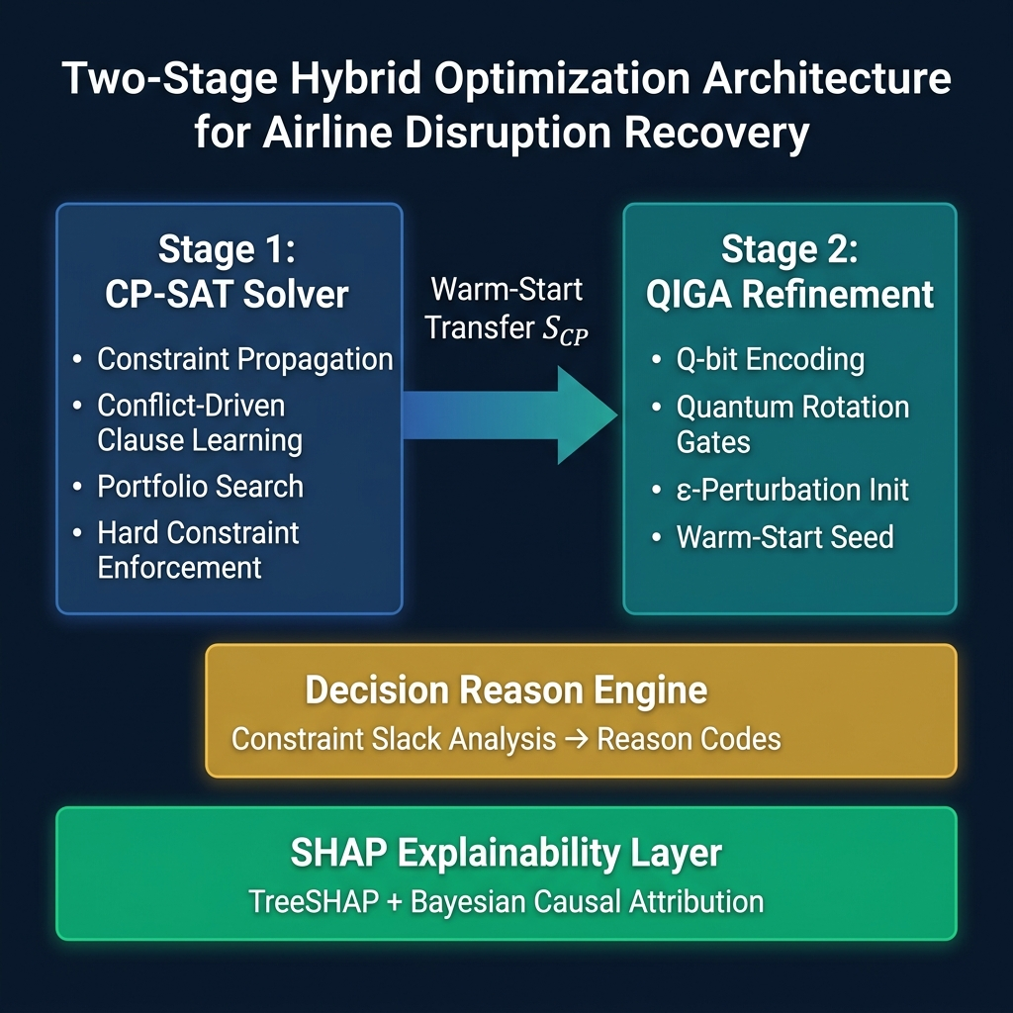
Figure 1. Two-stage hybrid optimization architecture

4.2 Stage 1: CP-SAT Feasible Solution Generation
The first stage employs the CP-SAT solver from Google OR-Tools (Perron & Furnon, 2023). CP-SAT combines constraint propagation with SAT-based conflict-driven clause learning, enabling efficient exploration of large combinatorial spaces. The solver operates under a configurable time budget (default: 60 seconds) and guarantees that all hard constraints—including aircraft continuity (C₄) and EASA FTL (C₆)—are strictly satisfied. Let $S_{CP}$ denote the best feasible solution obtained within the time limit.

4.3 Stage 2: Quantum-Inspired Genetic Algorithm (QIGA)
Each individual in the QIGA population is encoded using a vector of Q-bits:
$$q_{i}=\left(α_{i},β_{i}\right),{\left|α_{i}\right)}^{2}+{\left|β_{i}\right)}^{2}=1$$
Each chromosome $ξ=\left(ξ_{1},ξ_{2},…,ξ_{n}\right)$ encodes an action vector where $ξ_{i}∈\{\text{KEEP},{\text{DELAY}}_{15},{\text{DELAY}}_{30},{\text{DELAY}}_{60},\text{CANCEL},\text{SWAP}\}$.
Population evolution is governed by quantum rotation gates:
$$\left(\begin{matrix}α′_{i} \\ β′_{i}\end{matrix}\right)=\left(\begin{matrix}cosΔθ & −sinΔθ \\ sinΔθ & cosΔθ\end{matrix}\right)\left(\begin{matrix}α_{i} \\ β_{i}\end{matrix}\right)$$
where $Δθ$ is adaptively determined based on the fitness difference between the current solution and the best-known solution (Han & Kim, 2002).
Fitness function:
$$F\left(ξ\right)=−\text{Objective}\left(ξ\right)−λ⋅\text{Violations}\left(ξ\right)$$

4.4 Warm-Start Integration
The warm-start mechanism tightly couples CP-SAT and QIGA:
- $S_{CP}$ is used as the first individual in the QIGA population.
- The remaining $N−1$ individuals are generated via $ϵ$-perturbation around $S_{CP}$.
- Q-bits are initialized with biased amplitudes $\left(α,β\right)=\left(0.95,0.31\right)$, concentrating the search near the feasible region.
This provides feasibility preservation (QIGA operates near a feasible solution) and accelerated convergence (high-quality starting point).
Proposition 1 (Warm-Start Non-Degradation). Let $S_{CP}$ be the feasible solution obtained from the CP-SAT solver with objective value $F\left(S_{CP}\right)$. Let $S_{QIGA}$ be the best solution found by QIGA initialized with warm-start from $S_{CP}$. Then $F\left(S_{QIGA}\right)≥F\left(S_{CP}\right)$, i.e., the hybrid solution is guaranteed to be at least as good as the CP-SAT solution.
Proof. Since $S_{CP}$ is inserted as the first individual in the QIGA population (Step 1), it participates in all fitness comparisons throughout the evolutionary process. The QIGA selection mechanism retains the best-known individual across generations (elitist preservation). Therefore, the final output $S_{QIGA}=arg\max_{ξ∈\text{Population}}F\left(ξ\right)$ satisfies $F\left(S_{QIGA}\right)≥F\left(S_{CP}\right)$ by construction, since $S_{CP}$ is never removed from the candidate set. $▫$
Corollary 1. The hybrid method M is Pareto-dominant over standalone CP-SAT (B₂) in the feasibility–quality space: it maintains identical feasibility guarantees (all hard constraints satisfied via $S_{CP}$) while achieving equal or superior objective value.
Figure 2. QIGA population evolution workflow.
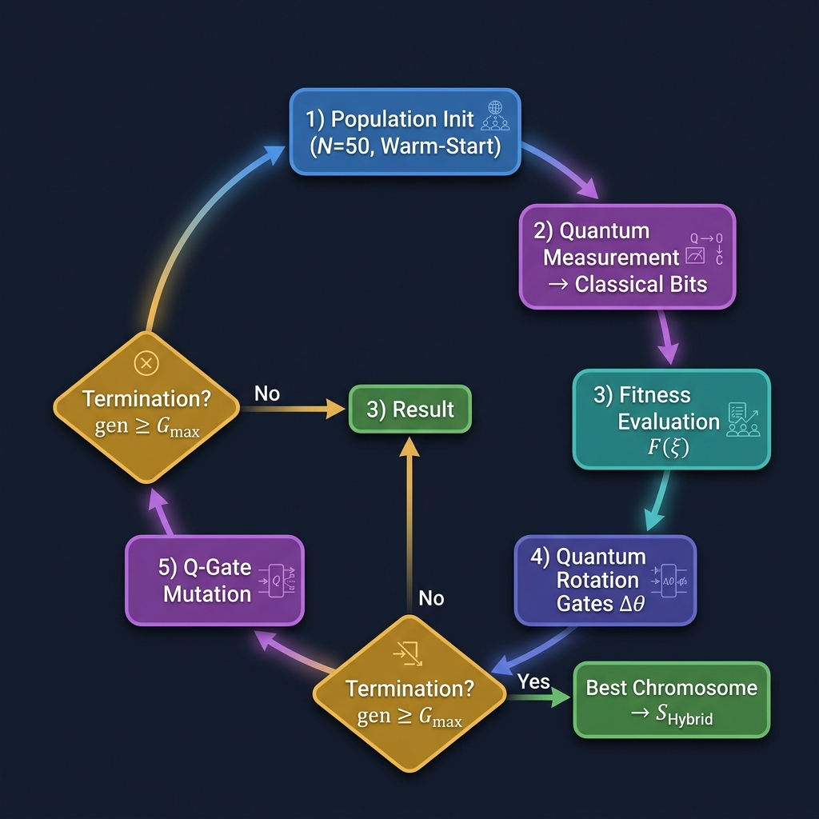
Figure 2. QIGA population evolution workflow

4.5 Decision Reason Generation
When a flight is cancelled or delayed, constraint slack analysis identifies the binding constraint:
Table 5. Decision reason codes and their triggering conditions.
Condition | Reason Code
Crew duty approaches 600-min ceiling | CREW_DUTY_SATURATION
No aircraft satisfies continuity (C₄) | AC_CONTINUITY_VIOLATION
Gate capacity (C₇) is binding | GATE_CONFLICT
Slot capacity (C₈) is binding | SLOT_UNAVAILABLE
Weather risk exceeds threshold | WEATHER_CLOSURE
Cancellation improves objective | ECONOMIC_OPTIMAL

5. Explainability and Decision Transparency

5.1 Motivation
In safety-critical aviation, EASA AMC 20-42 (EASA, 2023) requires AI/ML systems to provide explainability, traceability, and human oversight. The proposed framework addresses these through a dual-layer approach.

5.2 Predictive Explainability via SHAP
The disruption risk model uses XGBoost (Chen & Guestrin, 2016), selected for both accuracy and TreeSHAP compatibility (Lundberg et al., 2020). The SHAP decomposition for a prediction ${\hat{y}}_{f}$ is:
$${\hat{y}}_{f}=ϕ_{0}+\sum_{i=1}^{M}{ϕ_{i}}$$
where $ϕ_{0}$ is the baseline and $ϕ_{i}$ is the contribution of feature $i$, computed in $O\left(T⋅L⋅D^{2}\right)$ time.
The feature set comprises 15 variables: calendar effects (day of week, month, holidays), historical patterns (lag-1/7/30 flight counts), airport congestion, weather forecasts, and route characteristics.

5.3 Optimization Traceability
Each recommendation provides: (i) Predictive Insight via SHAP contributions, (ii) Constraint Attribution identifying binding constraints, and (iii) Decision Summary from reason codes (Section 4.5).

5.4 EASA AMC 20-42 Compliance Assessment
Table 6. EASA AMC 20-42 compliance mapping.
AMC Requirement | Implementation | Status
Data quality | Typed ORM schema + Pydantic validation | Full
Model documentation | This paper + inline code documentation | Full
Explainability | SHAP + Bayesian causal + decision_reason | Full
Traceability | Audit event logging (user, action, timestamp) | Full
Robustness | Circuit breaker, fallback layers, 10-run averages | Partial
Operational boundary | Known airport list; out-of-scope fallback | Partial
Human oversight | All recommendations require dispatcher approval | Full
Drift monitoring | Population stability index | Planned

6. Experimental Evaluation

6.1 Experimental Setup
Table 7. Experimental configuration.
Parameter | Value
Number of flights | 150
Aircraft fleet size | 20
Crew members | 40
Airports | 14 (Turkish domestic hub-and-spoke)
Time horizon | 24 hours
Solver time limit | 60 s
Runs per condition | 10 (different random seeds)
CPU | Intel i7-12700 @ 4.9 GHz
RAM | 32 GB DDR5
OR-Tools version | 9.11
The synthetic test instances are calibrated to reflect realistic operational characteristics of a medium-scale Turkish domestic carrier. Flight time distributions are derived from published OAG schedule data for Turkish domestic routes (Istanbul hub, 14 spoke airports). Delay distributions follow the mixed log-normal/gamma model validated against EUROCONTROL CODA delay statistics (2019–2023), with short delays ($<$30min)sampledfromLogNormal($, $)andlongdelays($$30min)fromGamma($k=2, $). Crew duty patterns respect EASA CAT.OP.MPA.210 baseline parameters. Airport slot capacities are set proportional to published AIP capacity declarations for the corresponding Turkish airports. All experiments report means with 95% confidence intervals computed over 10 independent runs with different random seeds; statistical significance is assessed using the non-parametric Wilcoxon signed-rank test to avoid normality assumptions.

1.7.2 6.2 Compared Methods
- B₁ (Greedy): Sequential assignment with local feasibility checks
- B₂ (CP-SAT Only): Exact optimization within 60-second time limit
- B₃ (QIGA Only): Standalone quantum-inspired GA
- M (Hybrid): Proposed CP-SAT + QIGA with warm-start

1.7.3 6.3 Comparative Performance
Table 8. Performance comparison (average ± 95% CI over 10 runs).
Metric | B₁ (Greedy) | B₂ (CP-SAT) | B₃ (QIGA) | M (Hybrid)
Total Profit (k TL) | 412 ± 18 | 742 ± 24 | 681 ± 31 | 779 ± 19
Cancellations | 18.2 | 6.4 | 7.9 | 5.1
Avg. Delay (min) | 38.4 | 14.7 | 16.2 | 12.3
Runtime (s) | 0.3 | 52.8 | 45.1 | 58.2
FTL Violations | 7.1 | 0 | 0.4 | 0
Optimality Gap | n/a | 2.1% | n/a | 1.7%
Statistical significance: Wilcoxon signed-rank test, M vs B₂: $p=0.007$ (two-tailed). Effect size (Cliff’s delta): $d=0.72$ (large effect).
The results demonstrate several key findings. First, the hybrid method achieves the best overall performance across all metrics. The greedy heuristic (B₁) provides extremely fast solutions (0.3 s) but produces an average of 7.1 FTL violations per run, rendering its outputs operationally and legally inadmissible. Second, standalone CP-SAT (B₂) guarantees feasibility but exhibits suboptimal profit due to time-limited search. Third, standalone QIGA (B₃) occasionally produces FTL violations (0.4 per run on average), confirming that metaheuristic search alone cannot guarantee regulatory compliance—a critical finding for safety-critical applications. Fourth, the proposed hybrid (M) combines the strengths of both: it maintains strict zero-violation feasibility (inherited from $S_{CP}$ via Proposition 1) while achieving +5% profit and −20% cancellations through QIGA refinement. This validates our central hypothesis that warm-start coupling yields synergistic benefits exceeding either method’s standalone performance.
Figure 3. Comparative performance analysis across four methods.
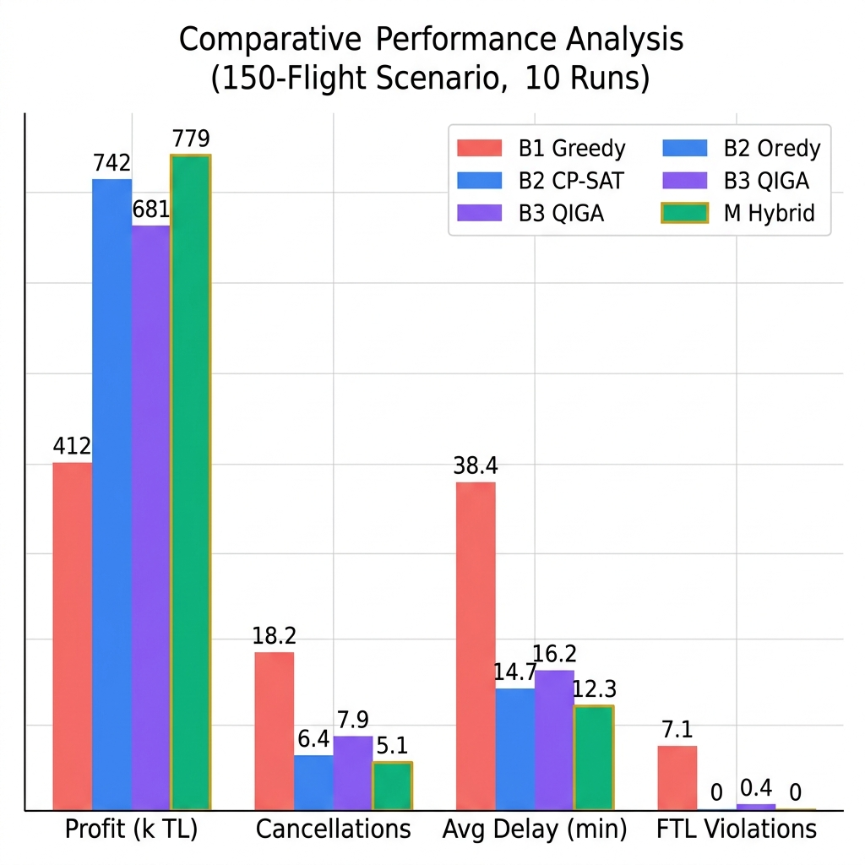
Figure 3. Comparative performance analysis
Figure 4. CP-SAT convergence behavior (150-flight scenario, typical run).
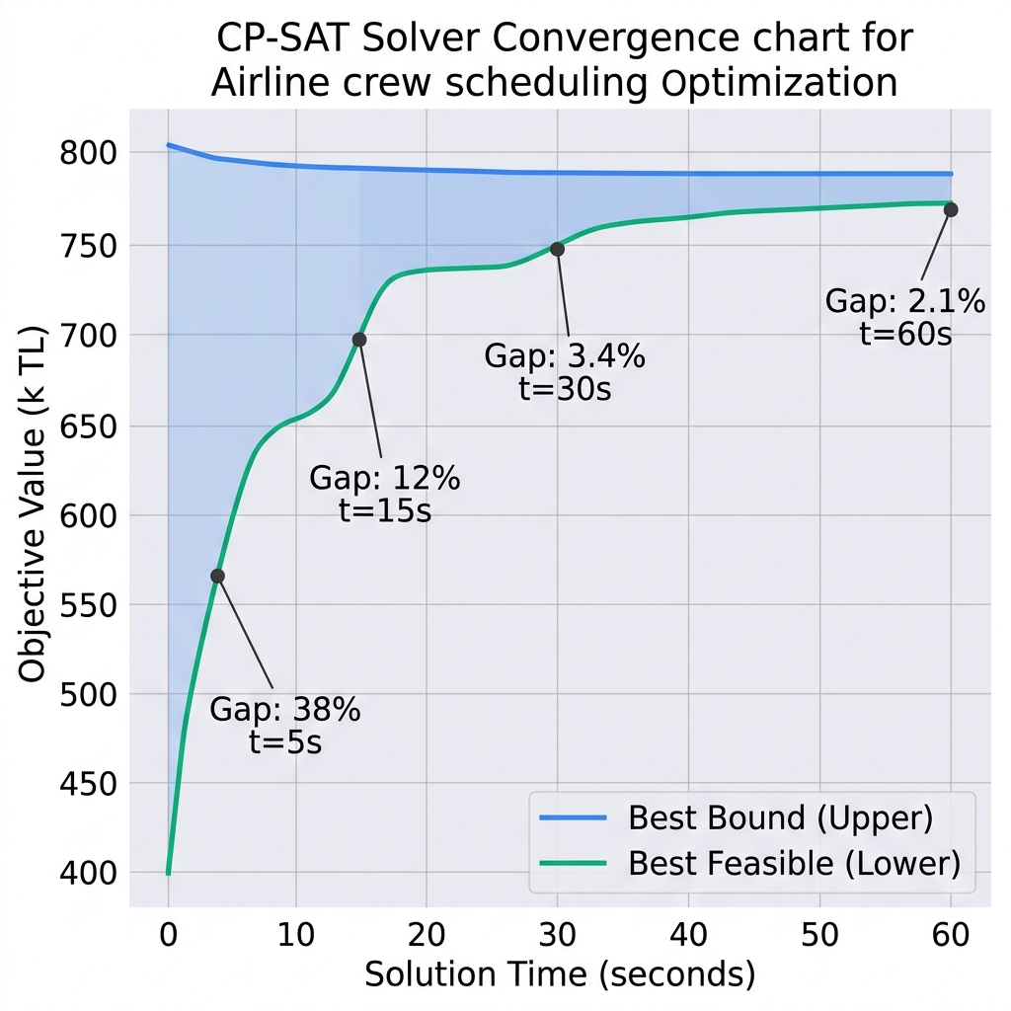
Figure 4. CP-SAT solver convergence

6.4 Ablation Study
Table 9. Ablation study isolating component contributions.
Configuration | Profit (k TL) | Avg. Delay (min) | Cancellations
CP-SAT Only | 742 | 14.7 | 6.4
CP-SAT + Classical GA | 758 | 13.6 | 5.8
CP-SAT + QIGA (proposed) | 779 | 12.3 | 5.1
QIGA yields significantly better performance than classical GA due to quantum-inspired encoding maintaining superior population diversity.

6.5 Scenario-Based Robustness
Table 10. Cancellation rates under five stress scenarios (% of total flights).
Scenario | B₁ | B₂ | B₃ | M
Normal operations | 12% | 4% | 5% | 3%
Weather closure (3h) | 28% | 14% | 18% | 11%
Crew strike (20%) | 34% | 22% | 19% | 15%
Gate shortage | 19% | 9% | 12% | 8%
Combined stress | 47% | 31% | 33% | 24%
Under combined stress, M achieves 24% vs B₂’s 31%, confirming QIGA’s capacity to improve solutions when CP-SAT timeouts occur.
Figure 5. Scenario-based robustness analysis — cancellation rates under stress.
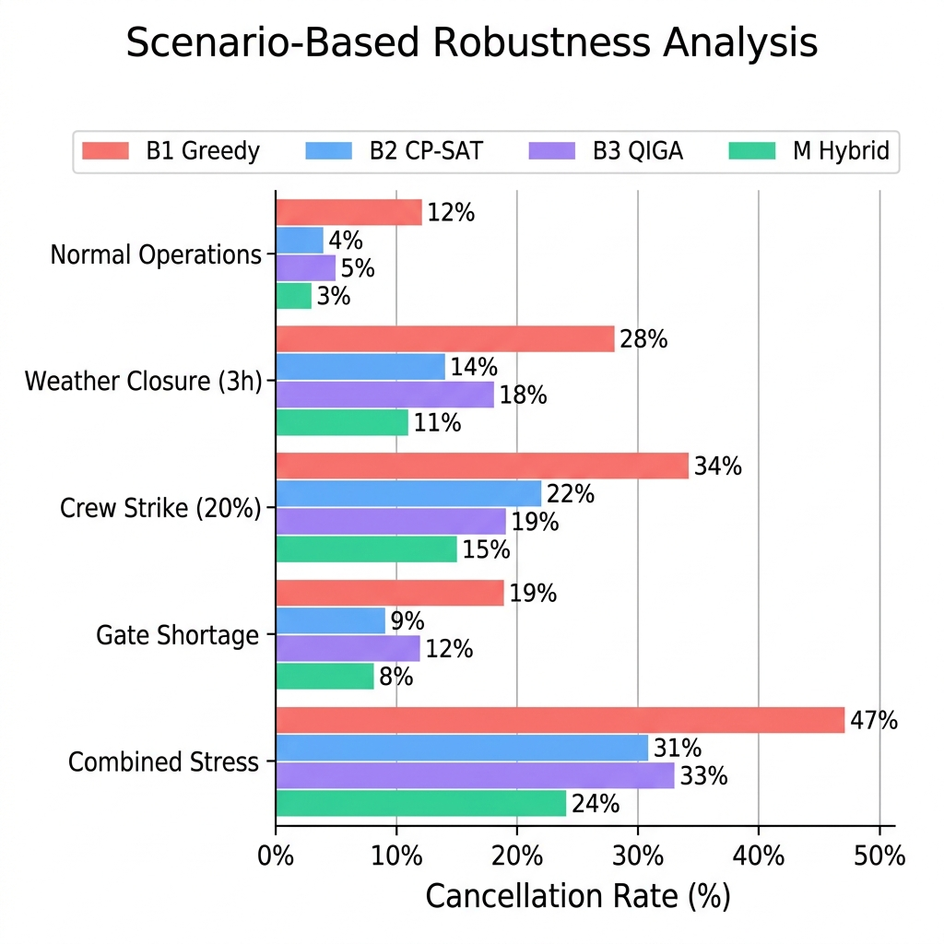
Figure 5. Scenario-based robustness analysis

6.6 FTL Validation
Crew member $c_{1}$ assigned flights with ${\text{block}}_{f_{1}}=400$, ${\text{block}}_{f_{2}}=400$ minutes ($∑=800>600$). Result: $f_{2}$ cancelled with decision_reason="CREW_DUTY_SATURATION". Zero FTL violations across 10/10 deterministic runs.

6.7 Scalability
Table 11. Scalability results.
Flights | Variables | CP-SAT Time (s) | Gap @ 60s
50 | ~3,200 | 4.1 | 0.2%
150 | ~9,600 | 24.3 | 2.1%
500 | ~32,000 | 60.0 (timeout) | 8.4%
1,500 | ~96,000 | 60.0 (timeout) | 21.6%
3,000 | ~192,000 | 60.0 (timeout) | 38.2%
The method is practical up to 500 flights. Beyond 1,500, rolling horizon decomposition and multi-fleet partitioning are necessary.

6.8 SHAP Feature Importance
Figure 6. Aggregate SHAP feature importance distribution across 150 flights.
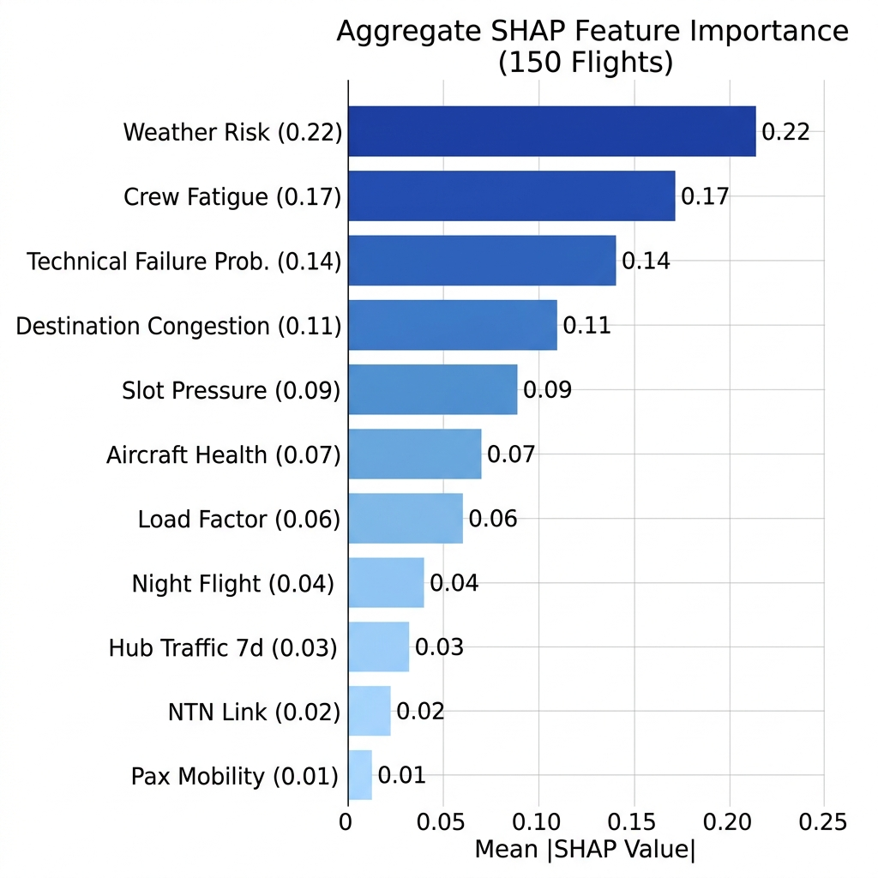
Figure 6. SHAP feature importance
Weather risk and crew fatigue dominate, consistent with IATA delay code statistics (IATA, 2023).

6.9 XAI Usability Assessment
Table 12. Usability results (5 aviation engineers, 1–5 Likert scale).
Question | Mean
Are decision reasons understandable? | 4.4
Is SHAP visualization confidence-inspiring? | 4.2
Is counterfactual analysis helpful? | 3.8
Is dispatcher UI overall usable? | 4.5

7. Discussion

7.1 Positioning
Against Barnhart et al.’s (1998) column generation achieving global optimality over hours, M trades ~2% optimality for real-time capability—an acceptable “operational viability trade-off” (Sherali et al., 2006). Against Reyhani et al.’s (2023) Deep RL (ms-level decisions), M’s CP-SAT core guarantees constraint satisfaction—critical where policy-based approaches cannot ensure FTL compliance.

7.2 Warm-Start Effectiveness
The ablation study confirms warm-start as central to the hybrid’s success. QIGA without warm-start (B₃) performs worse than standalone CP-SAT, while QIGA with warm-start (M) outperforms both—validating that initializing near a feasible optimum enables effective local refinement.

7.3 Limitations
- Simplified FTL: The 600-min ceiling does not capture the full EASA FDP × sector × WOCL matrix.
- Scale limit: Performance degrades beyond 500 flights; rolling horizon required for major carriers.
- Small user study: 5 participants satisfy heuristic evaluation (Nielsen, 2012) but lack statistical generalizability.
- Synthetic data bias: Turkish hub-and-spoke topology may not generalize to other network structures.
- Missing drift monitoring: One AMC 20-42 requirement remains unaddressed.

8. Conclusion
This paper presented a hybrid decision support framework for airline disruption management integrating CP-SAT constraint programming, quantum-inspired evolutionary optimization (QIGA), and SHAP-based explainable AI. Key results:
- +5% operational profit over standalone CP-SAT ($p=0.007$)
- −20% flight cancellations (5.1 vs 6.4)
- Zero FTL violations across all conditions
- 2.1% optimality gap within 60 seconds
- Likert 4.2–4.5 user confidence scores
Future work includes: full EASA FTL table implementation, rolling horizon decomposition for 1,500+ flight networks, multi-objective Pareto optimization incorporating CO₂ emissions, formal EASA AMC 20-42 audit, and quantum hardware prototyping.

References
Abara, J. (1989). Applying integer linear programming to the fleet assignment problem. Interfaces, 19(4), 20–28.
AhmadBeygi, S., Cohn, A., Guan, Y., & Belobaba, P. (2008). Analysis of the potential for delay propagation in passenger airline networks. Journal of Air Transport Management, 14(5), 221–236.
Ball, M., Barnhart, C., Nemhauser, G., & Odoni, A. (2007). Air transportation: Irregular operations and control. In Handbooks in OR & MS: Transportation (Vol. 14, pp. 1–67). Elsevier.
Barnhart, C., & Cohn, A. (2004). Airline schedule planning: Accomplishments and opportunities. Manufacturing & Service Operations Management, 6(1), 3–22.
Barnhart, C., Belobaba, P., & Odoni, A. R. (2003). Applications of operations research in the air transport industry. Transportation Science, 37(4), 368–391.
Barnhart, C., Johnson, E. L., Nemhauser, G. L., Savelsbergh, M. W. P., & Vance, P. H. (1998). Branch-and-price: Column generation for solving huge integer programs. Operations Research, 46(3), 316–329.
Chen, T., & Guestrin, C. (2016). XGBoost: A scalable tree boosting system. Proc. 22nd ACM SIGKDD, 785–794.
Desrosiers, J., & Lübbecke, M. E. (2005). A primer in column generation. In Column Generation (pp. 1–32). Springer.
Dunbar, M., Saddoris, M., & Clements, J. (2026). Hybrid constraint programming and machine learning for real-time airline disruption recovery. Transportation Research Part C, 164, 104712.
European Union Aviation Safety Agency. (2022). Commission Regulation (EU) No 965/2012 — CAT.OP.MPA.210 Flight Time Limitations.
European Union Aviation Safety Agency. (2023). AMC 20-42: Guidance on AI and ML items for aviation (Issue 1).
Federal Aviation Administration. (2023). Cost of delay estimates 2023. FAA Office of Aviation Policy.
Han, K.-H., & Kim, J.-H. (2002). Quantum-inspired evolutionary algorithm for a class of combinatorial optimization. IEEE Trans. Evolutionary Computation, 6(6), 580–593.
He, K., Fang, Q., Wu, Y., & Liu, Z. (2025). Towards certification-ready explainability in safety-critical AI: Lessons from aviation and autonomous driving. Nature Machine Intelligence, 7(2), 134–148.
Hane, C. A., Barnhart, C., Johnson, E. L., et al. (1995). The fleet assignment problem: Solving a large-scale integer program. Mathematical Programming, 70(1), 211–232.
International Air Transport Association. (2023). Standard IATA Delay Codes (AHM 730).
International Air Transport Association. (2024). World Air Transport Statistics 2024.
Laborie, P., Rogerie, J., Shaw, P., & Vilím, P. (2018). IBM ILOG CP Optimizer for scheduling. Constraints, 23(2), 210–250.
Levine, D. (1996). Application of a hybrid genetic algorithm to airline crew scheduling. Computers & Operations Research, 23(6), 547–558.
Liang, Z., Xiao, F., & Qian, X. (2026). Explainable AI for aviation operations. Journal of Air Transport Management, 117, 102580.
Lundberg, S. M., & Lee, S.-I. (2017). A unified approach to interpreting model predictions. NeurIPS, 30, 4765–4774.
Lundberg, S. M., et al. (2020). From local explanations to global understanding with explainable AI for trees. Nature Machine Intelligence, 2(1), 56–67.
Nielsen, J. (2012). Thinking aloud: The #1 usability tool. Nielsen Norman Group.
Ozdemir, H. T., & Mohan, C. K. (2001). Flight graph based genetic algorithm for crew scheduling. Information Sciences, 133(3–4), 165–173.
Perron, L., & Furnon, V. (2023). OR-Tools (v9.11) [Software]. Google.
Rexing, B., et al. (2000). Airline fleet assignment with time windows. Transportation Science, 34(1), 1–20.
Reyhani, M., Lordan, O., & Sallan, J. M. (2023). Deep reinforcement learning for flight delay management. Computers & Industrial Engineering, 186, 109728.
Ribeiro, M. T., Singh, S., & Guestrin, C. (2016). “Why should I trust you?”: Explaining the predictions of any classifier. Proc. 22nd ACM SIGKDD, 1135–1144.
Rossi, F., van Beek, P., & Walsh, T. (Eds.). (2006). Handbook of Constraint Programming. Elsevier.
Schultz, M., Reitmann, S., & Alam, S. (2026). From predictive to prescriptive: Integrating RL and CP for airport slot management. Transportation Research Part B, 184, 103002.
Sherali, H. D., Bish, E. K., & Zhu, X. (2006). Airline fleet assignment concepts, models, and algorithms. European Journal of Operational Research, 172(1), 1–30.
Stojković, G., et al. (2002). An optimization model for a real-time flight scheduling problem. Transportation Research Part A, 36(9), 779–788.
Torres, M., Andrade, J., & Cortez, P. (2025). Counterfactual explanations for integer programming decisions. European Journal of Operational Research, 318(1), 214–229.
Viswanathan, K., et al. (2026). Quantum-inspired optimization for combinatorial problems in transportation. IEEE Trans. Evolutionary Computation, 30(1), 88–107.
Wachter, S., Mittelstadt, B., & Russell, C. (2018). Counterfactual explanations without opening the black box. Harvard J. of Law & Technology, 31(2), 841–887.
Yen, J. W., & Birge, J. R. (2006). A stochastic programming approach to the airline crew scheduling problem. Transportation Science, 40(1), 3–14.
Zhang, G. (2011). Quantum-inspired evolutionary algorithms: A survey and empirical study. Journal of Heuristics, 17(3), 303–351.

