Code clone---- need provide id_rsa.pub for clone permission.

 repo init -u git@github.com:yonglongliu/manifests.git  
 repo sync -j4

After you get all code from gitHub, there is a folder named “tools” which have four files , you need to copy these four files out and put them at same path with “tools”.

Like below snapshot:

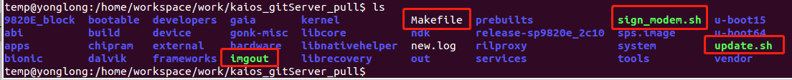

Then you can use them to compile the whole project.

update.sh

sign_modem.sh

imgout

**1： update.sh** -------- used for build all code

Build Debug version you can use below command:

**./update.sh new**



For user version:

**./update.sh user new**



If build process is ok, it's should be end like below snapshot, or else you will need to check this file "new.log" (this file records all build logs including errors) to find errors.

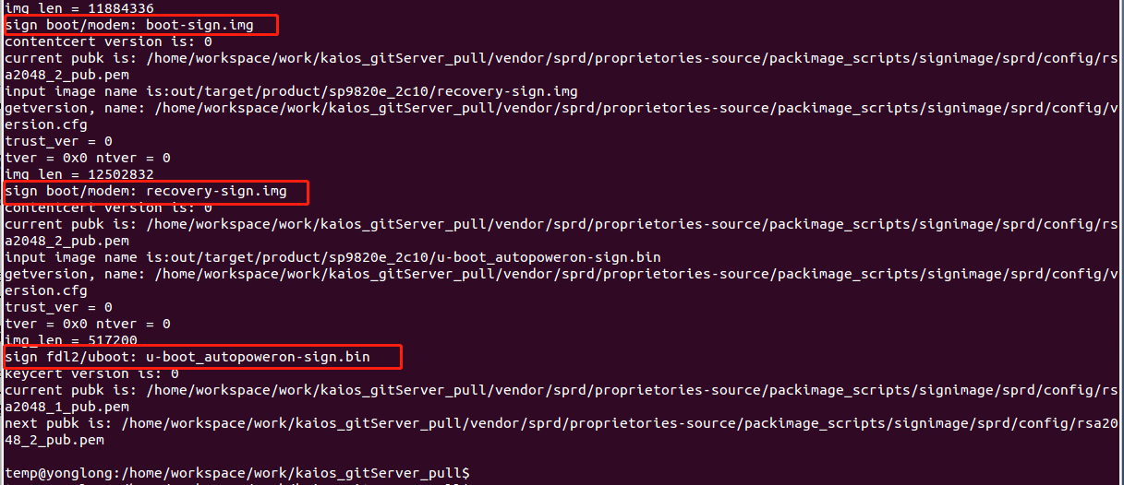

**2.** imgout --- collect all needful images to folder "release-sp9820e_2c10" from out directory



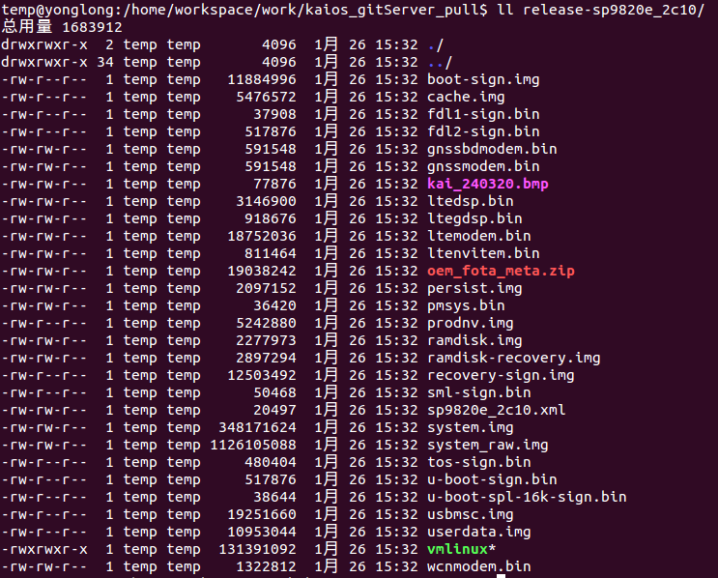

**Note:** you'd better backup this folder if it's released to Rjio , for further FOTA update will use this as source or target version.

For how to package a PAC ,please refer “Flashing_tool”document.

**3： sign_modem.sh ------**used for sign modem

you need to run this script only **if Sprd's modem files need update**, and run it before compile all code, there is no need to run this if modem files are not changed.

Sprd's modem files (7 files) are stored at below path:

(ltemodem.bin ltegdsp.bin ltedsp.bin pmsys.bin wcnmodem.bin gnssbdmodem.bin gnssmodem.bin )

/device/sprd/sharkle/sp9820e_2c10/modem_bins/

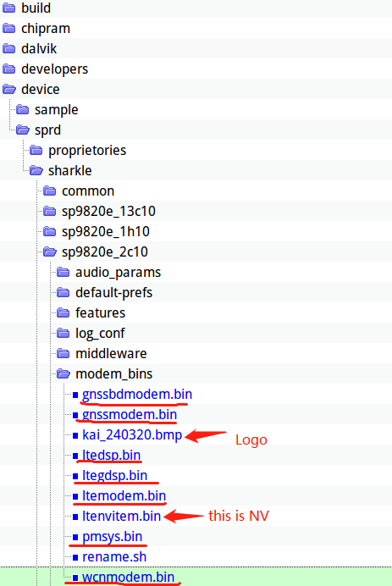

"ltenvitem.bin" also needs update if modem update.

After you get new modem files from Sprd, there are five files need to be renamed.

run below script to rename or you can manually rename as follow.

/device/sprd/sharkle/sp9820e_2c10/modem_bins/rename.sh

SC9600_sharkle_pubcp_customer_Feature_Phone_modem.dat ---rename as --- ltemodem.bin

SHARKLE1_DM_DSP.bin ---rename as --- ltegdsp.bin

SharkLE_LTEA_DSP_evs_off.bin ---rename as --- ltedsp.bin

sharkle_cm4.bin ---rename as --- pmsys.bin

PM_sharkle_cm4.bin ---rename as --- wcnmodem.bin

**Sign modem:**



after run sign_modem.sh you can find a new file with suffix "-sign" generated under path "sps.image/sp9820e_2c10-modem-sign/", like below:

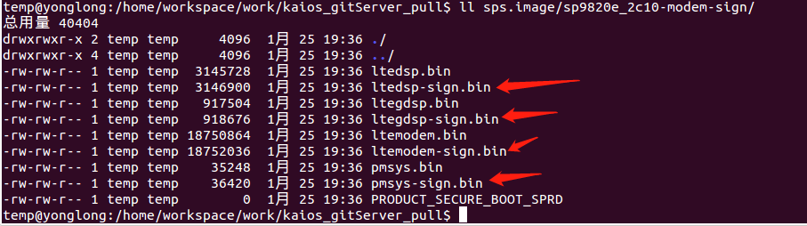

**note**:

1: only four files will be signed

2: there should be a normally compiled "out" directory when running ./sign_modem.sh.