Source code的整合意味所有展讯release的AP和MODEM,Kaios的代码,NFC的代码都整合到一起，然后可以一次编译出来。

Source code integration means that all Sprd released code (AP and MODEM), Kaios code and NFC code are integrated together and then can compiled at one time.

1. **IDH Packet Processing of SPRD. -----AP**

The decompression of the IDH package is as follows：

First, decompress idh.code.tgz to a local path with below command,after decompression, the name is idh.code.

tar zxvf idh.code.tgz

Then decompress conf-sharkle.tar.gz, and decompress it to the path of idh.code

tar zxvf conf-sharkle.tar.gz -C idh.code

After that you can find there is directory with name “device”under idh.code.

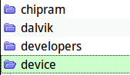

**For** below two Non-open source program and libraries:

proprietories-sp9820e_2c10_k_native-user.zip

proprietories-sp9820e_2c10_k_native-userdebug.zip

Put them to below path:

/device/sprd/proprietories

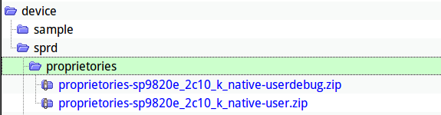

1. Sprd Modem & NV

Put all needful files at below path:

**/device/sprd/sharkle/sp9820e_2c10/modem_bins/**

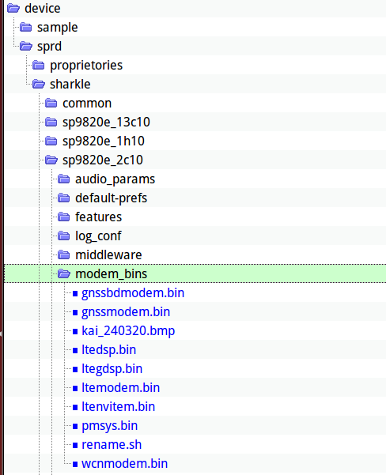

2.1----- CP0 files (4)

sharkle_pubcp_customer_Feature_Phone_builddir

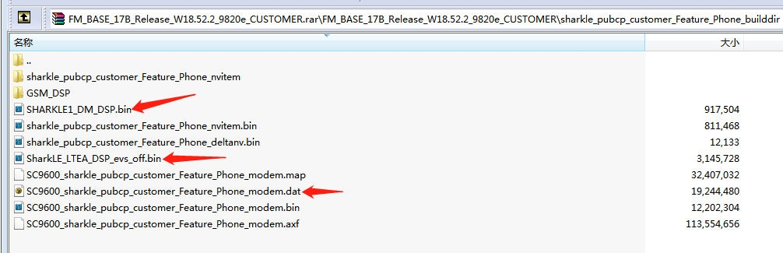

sharkle_cm4_builddir

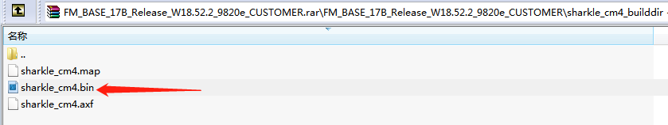

2.2 ------ CP2 (1)

sharkle_cm4_builddir

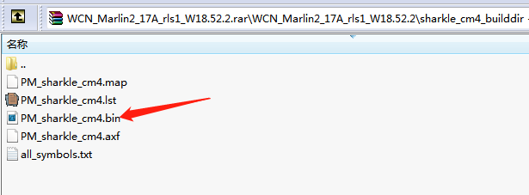

Note: above five files need to rename:

You can this below script or manully rename.

/device/sprd/sharkle/sp9820e_2c10/modem_bins/rename.sh

SC9600_sharkle_pubcp_customer_Feature_Phone_modem.dat ---rename as --- ltemodem.bin

SHARKLE1_DM_DSP.bin ---rename as --- ltegdsp.bin

SharkLE_LTEA_DSP_evs_off.bin ---rename as --- ltedsp.bin

sharkle_cm4.bin ---rename as --- pmsys.bin

PM_sharkle_cm4.bin ---rename as --- wcnmodem.bin

2.3 -----GNSS (2)

gnssbdmodem.bin

gnssmodem.bin

2.4 ltenvitem.bin ----- this is NV,including RF and Audio parameter,if modem update,this file needs update too( my side hardware colleagues will debug new a nv based on the new Modem).

3 KaiOS integration

You can get Kaios code from [https://git.kaiostech.com/](https://git.kaiostech.com/%20取各模块的压缩包) , please refer **pier.xml** when clone code from Kaios's GibLab.

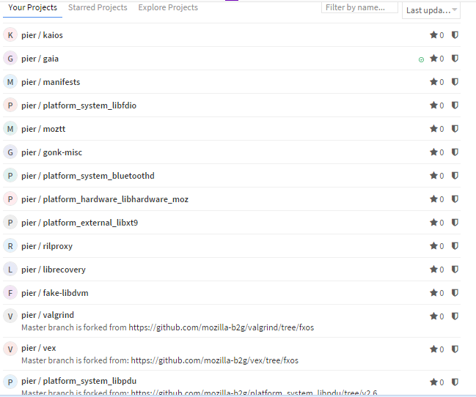

After you download Kaios code, please according to below table and put it in the right path.

If Kaios's Module have subfolder, keep it. Like below snapshot:

Idh.code/ Kaios code

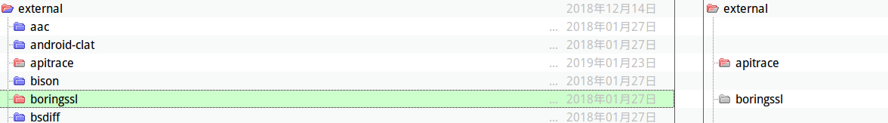

|  |  |
| --- | --- |
| Kaios Module | Integration to Sprd's idh.code/ |
| dalvik | dalvik |
| Gaia | gaia |
| gonk-misc | gonk-misc |
| Kaios | kaios-tools(No concern) |
| librecovery | librecovery |
| Manifests | (No concern) |
| external | external |
| hardware | hardware |
| prebuilts | prebuilts |
| apps | apps |
| system | system |
| services | services |
| rilproxy | rilproxy |
| .. | |
|  | |

**Note:** for apps folder, only“kaios-plus.kaiostech.com”is maintained by Kaios,other three are maintained by Sprd. So you have to keep the code of package “kaios-plus.kaiostech.com” same with code which you get from Kaios Gitlab.

Keep mmitest's code same with Sprd's mmitest code, and so engmode, logmanager.

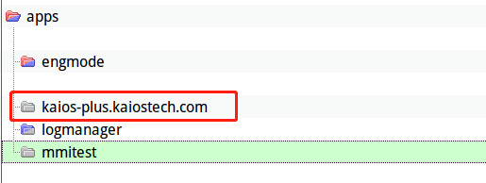

Besides you have to delete (engmode logmanager mmitest in gaia/profile_save.tar.gz )

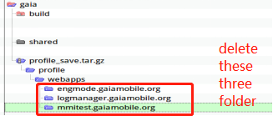

Copy profile_save.tar.gz to a temporary folder and use command “tar -zxvf profile_save.tar.gz” decompress it, there will be a folder named “profile” come out, delete above three in profile/webapps and profile_save.tar.gz , then use “tar -zcvf profile_save.tar.gz profile/” to compress a new one.

4. NFC

Nfc code is included in Kaios's system module. **(Gitlab“sec”branch).**

