Windows os: (Research Download tool only works on Windows )

Depress “RESEARCHDOWNLOAD_R21.0.0001.rar”, find “ResearchDownload.exe” and double click to run it.

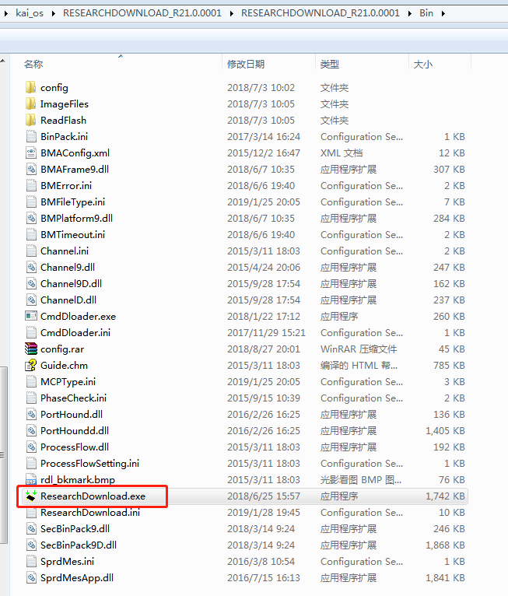

How to flashing ?

Press Icon step1 pointed ,”Download settings” will come out , do select as below two snapshot, after select all right path for all “FileID”, then press “ok” button to close “Download settings”, and press Icon step2 pointed start flashing.

Note: you need power off device and press key “*” when connect to USB line.

All needful files (*.bin *.img kai_240320.bmp) you can find in folder “release-sp9820e_2c10” , which is generated after running ./imgout (please refer “Readme.docx” from Build_script_steps ).

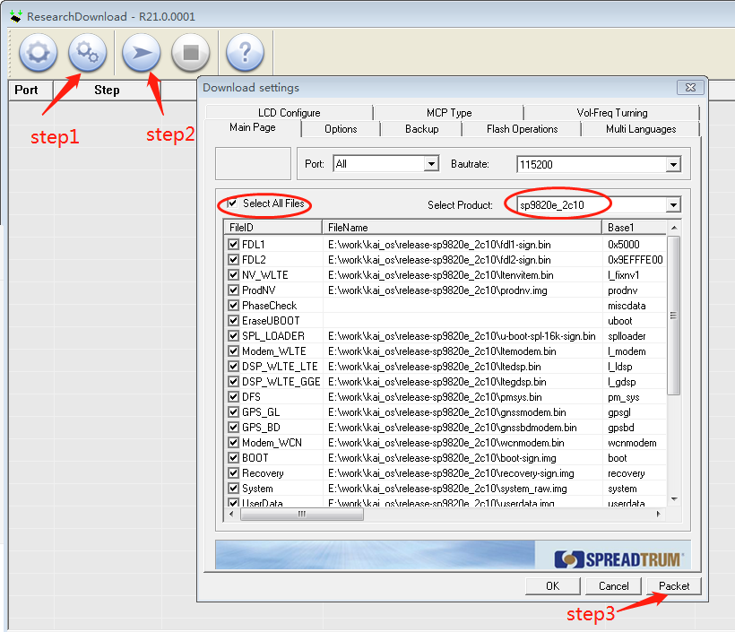

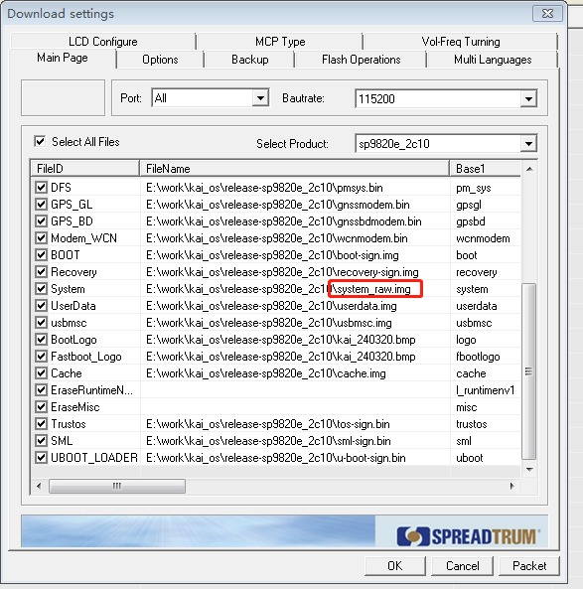

If flashing is all ok, it should be like below snapshot,then press stop to end it.

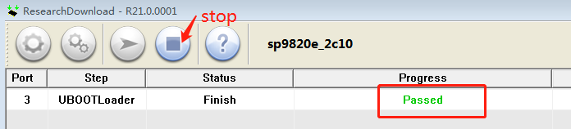

Note: there are system.img and system_raw.img under release-sp9820e_2c10.

system_raw.img -----used for package a pac

system.img -----used for Kaios fota

**How to package all files to a PAC ?**

First touch a file named like LYF_F271i-000-02-03-230119.pac under a path like “E:\tmp”

Download settings ---press Button “Packet” , a dialog popup with “Do packet operation right now?” , and select “是（Y）”

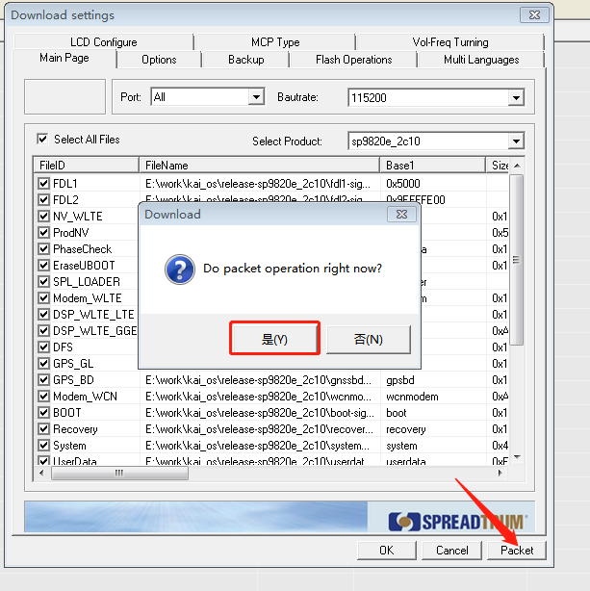

A Dialog “Packet Setting” will popup and input as follow:

Product Alias: input “sp9820e_2c10”

Product Version: input “LYF_F271i-000-02-03-230119”-- file name which just touched

Saving Path: E:\tmp\LYF_F271i-000-02-03-230119.pac ---file path which just touched

And then press Button ”ok”

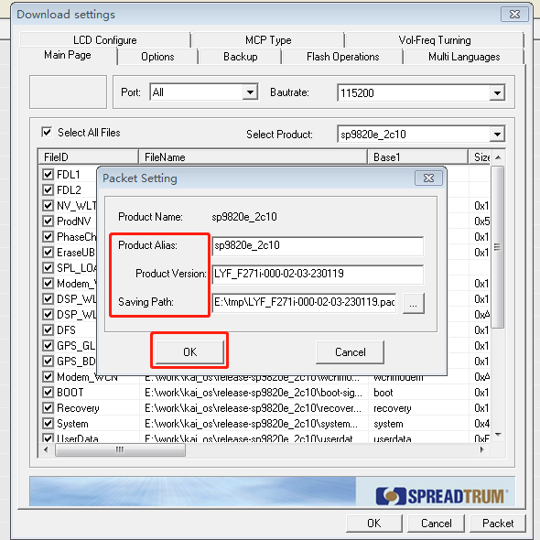

If dialog popup like below, select “是（Y）”, then wait for few seconds:

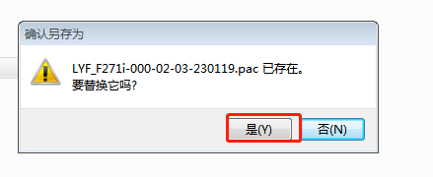

At last if packing is all ok, a dialog “Packeting complete!” will popup, and press Button “确定” as below snapshot.

That’s all for packing a PAC.

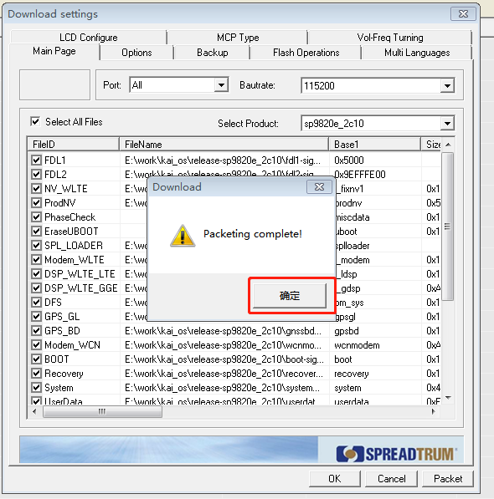

**For safety, please check time label and file size for the pac file**

**LYF_F271i-000-02-03-230119.pac**