FOTA Package creation tool:

Fota tool is under directory “9820E_block”

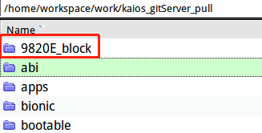

Or you can download it by below command:

git clone [git@github.com:yonglongliu/9820E_block.git](mailto:git@github.com:yonglongliu/9820E_block.git)

**Steps for make incrementOTA.zip and full FOTA package:**

**First** make two sub-folder under 9820E_block.

9820E_block/software/src/ 9820E_block/software/tgt/

Copy source images to 9820E_block/software/src/

Copy target images to 9820E_block/software/tgt/

**Note:** source and target images are all from folder “release-sp9820e_2c10“ which is generated by ./imgout after a full code compilation ,so need backup this folder always, more info please refer document of “Build_script_steps”.

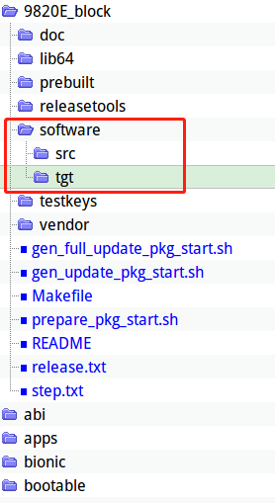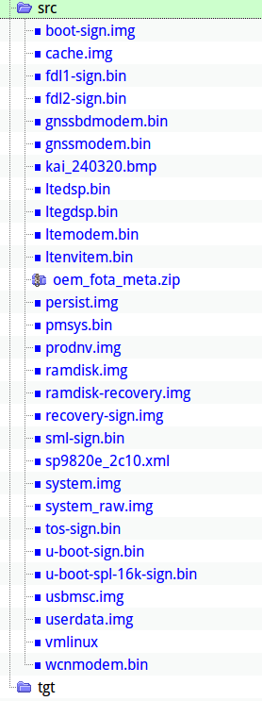

**Step1:** input “make” under 9820E_block



**step2:** input “make links”

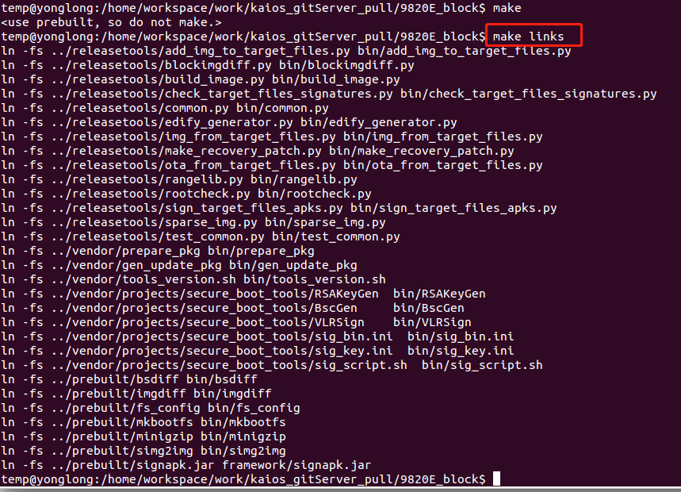

**Step3:** input ./prepare_pkg_start.sh



Wait for few seconds and it will create source.zip and target.zip under software/

**Step4:**  input ./gen_update_pkg_start.sh for increment.zip



Wait for 1-2mins and if like logs showed like below snapshot , that’s means increment is done. And you can find a “update.zip” under software.

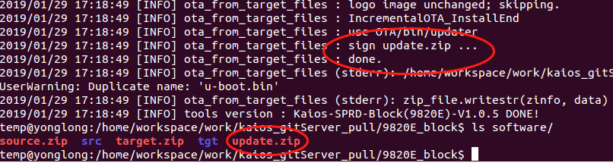

**For full Fota package use below command:**

./gen_full_update_pkg_start.sh