**1： Secure boot**

Secure boot is default on, after a full code compilation,images will be signed automatic and named with a suffix “-sign”.

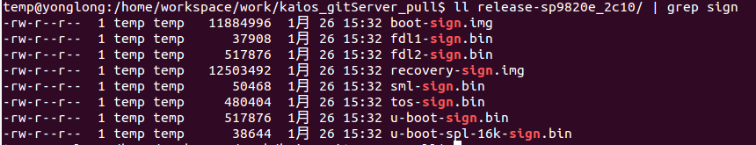

Sign keys are stored at below path and do not modify.

/vendor/sprd/proprietories-source/packimage_scripts/signimage/sprd/config/ 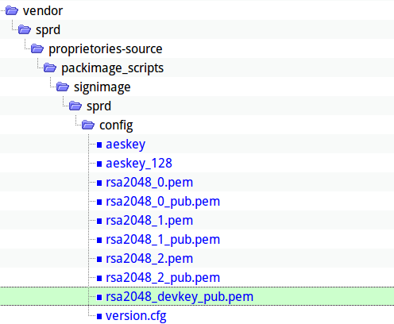

1. PLMN Lock ---