# Modify of design

## Feedback From peers

What was the original design ? What’s the new design now? how does this change

improve the design?

**Chat**

Peer：

The purpose of feedbacks is not clear

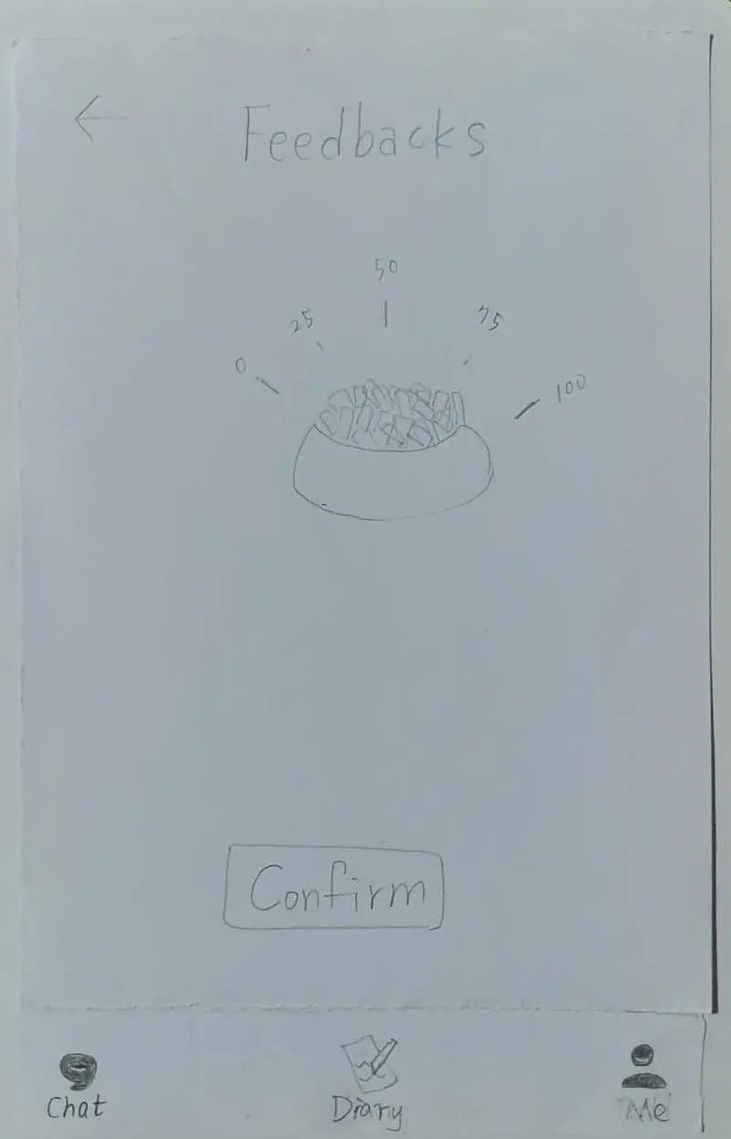 (缺圖)

Modify：  
User provide their emotion type and intensity ” before” and “after” chatting, by comparing the two, we   
 know how satisfy is the user toward the current conversation.

**Sign up**

Peer：Too many to fill in a page, and user like list more than typing

Modify：step by step filling the information, decrease the number of click in a single page,  
 more clean interface.

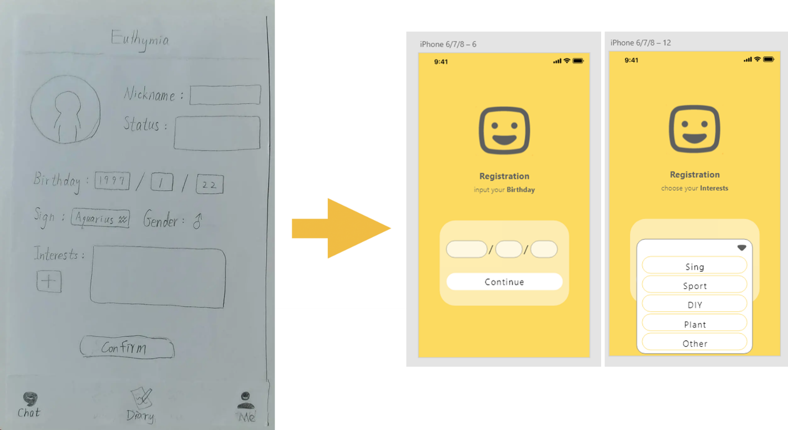

# New design

## Feedback From peers

What’s the new design? Why did you add it?

**Chat**

Peer：Will chat with people who share same negative emotion cause more negative result？

What is difference between Euthymia and other chat app？

Add：Our system will suggest “chatting target” according to the emotion difference calculated by emotion score before and after chatting, so, if people who share same negative emotion can not help the user cheer up, Euthymia will decrease the chance to recommend the people with negative emotion to the user.

At the same time, before selecting a topic to start a chat, the user will be asked to select the identity (giving the recommender / seeking help), so that the system can better match the person who seeking for help to the person who understands the topic to get the better Suggestion or relieve stress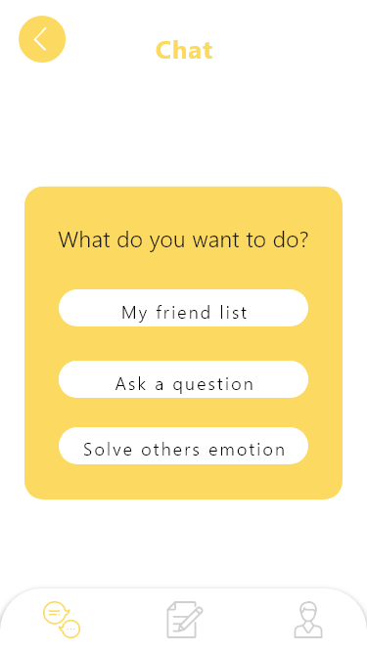

**Diary**

Peer：The diary part, some people may feel not good if their diary may be known by others.

New design：add a lock to protect privacy.

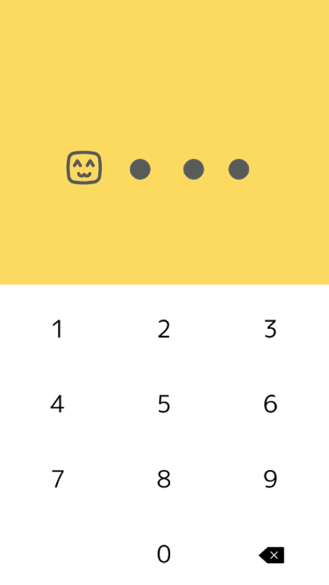

# Explanation of Back end design

Q：How to get the objective analysis of physiological information to monitor user's emotion state?

The system mainly uses a smart watch which connected to the cellphone to get the objective analysis of physiological information. It uses multiple way to calculate the stress level, such as HRV and ….

Q：So many chatting apps will end up fulling of porn information, how you block or prevent this situation?

A：By using computer filter to auto prohibit the inappropriate content

Q：If I did not renew my diary, will the data still be true？

Euthymia capture first facial expression when user open the app, and use it to aid emotion record.

# 其他(正面評價)

The animal agent seem to a good subject to talk to.

The farm that we can choose animal agent to chat is really interesting.