# highlight of the feedback

## Feedback from Lo-fi prototype

### from users

We recruit 3 college students to do the usability testing with Lo-fi prototype. After we introduce our product and the usage scenario, they are asked to finish 5 specified task. The participants are also asked to think aloud when they are interact with our product. We observe if they encounter any difficulty during the process. In the end, we do a 10-15 minutes interview according to their usage process and also get some reflection from them.

**Choose an animal to represent user himself**

Lack of signifier

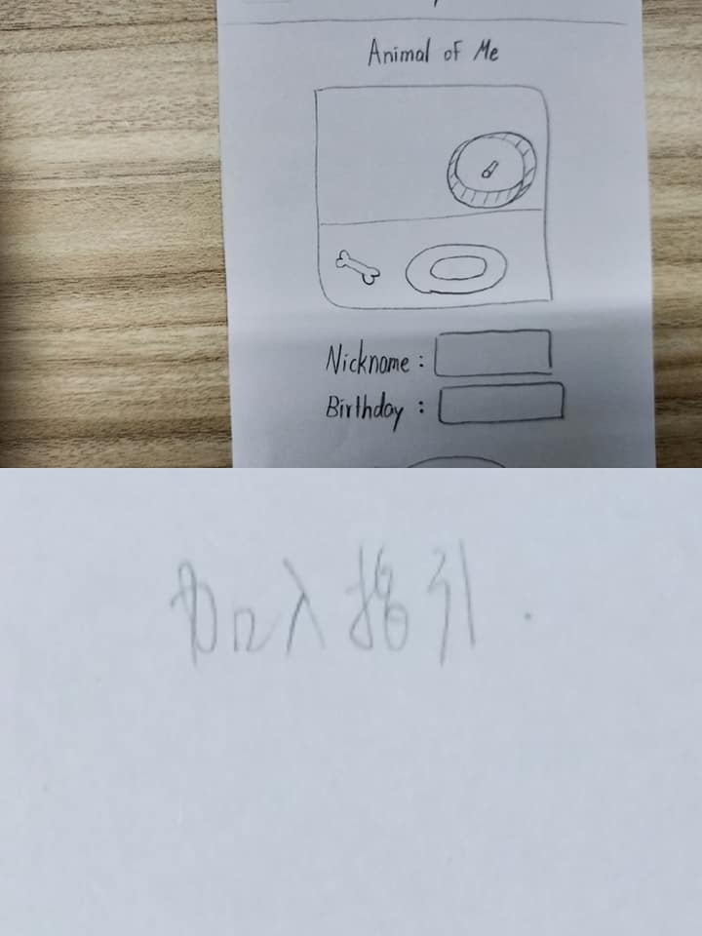

**New design (江晨**

**chat**

it is cute, but the information is not clear enough

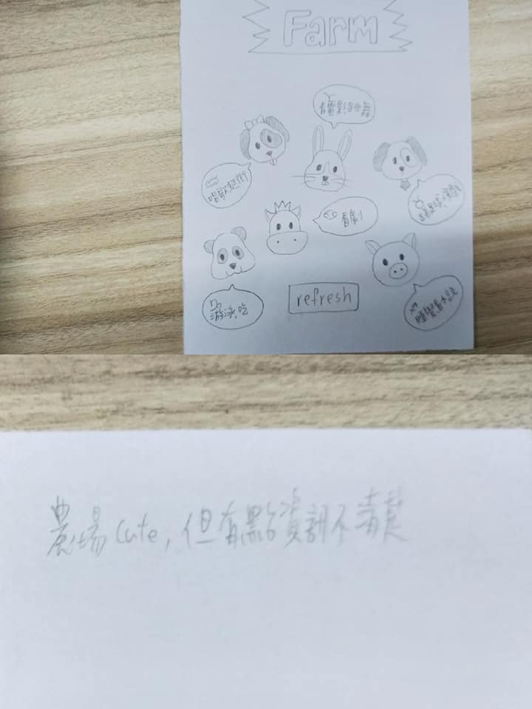

new design：decrease the information complexity on the screen

