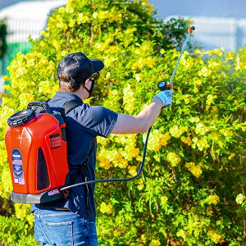
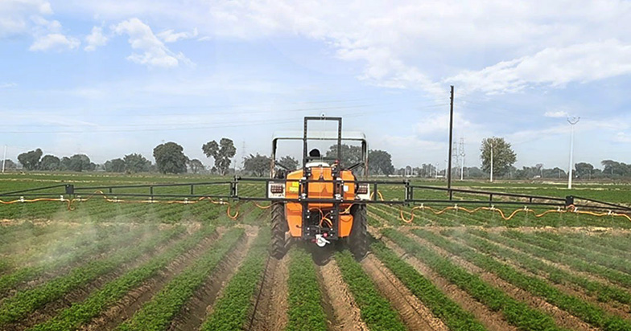
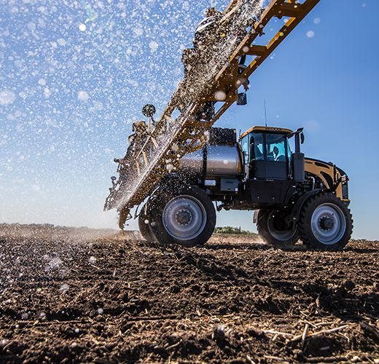
5
Below is a beginner-friendly but technically complete blueprint for building a Decision Support System (DSS) that recommends the most rational, economical, and operationally effective sprayer type and spray parameters for your region, crops, and land conditions.
I’ll start from theoretical foundations, then move to a step-by-step development methodology, introduce example (fictional) data, explain AI and offline models/tools, and finally give literature keywords.

1. Problem Restatement (Plain Language)
You manage a farm machinery factory operating in a region with:
- Mountainous + lowland terrain
- Different soil types and climates
- Different field sizes and crop types
- Existing spraying methods:
  - Knapsack sprayers (manual)
  - Newly developed automotive/mobile sprayers
  - Drone sprayers
Your goal is to recommend the best sprayer type and spray method for each situation, considering:
- Technical feasibility
- Economic efficiency
- Labor availability and cost
- Field and crop characteristics
- Equipment development and selling costs
- Long-term product lifecycle
This is a classic multi-criteria decision problem.

2. Theoretical Foundations (Why This System Works)
2.1 Multi-Criteria Decision Making (MCDM)
At its core, your problem is:
“Given many options and many conflicting factors, which option is best?”
This is studied under Multi-Criteria Decision Making (MCDM).
Key idea:
- No single factor (cost, speed, labor) is enough
- We combine weighted factors to compute a total utility score
Common theories used:
- Weighted Sum Model (WSM)
- Analytic Hierarchy Process (AHP)
- Pareto optimization
- Cost–Benefit Analysis (CBA)

2.2 Systems Engineering Theory
Your sprayer choice is not isolated. It interacts with:
- Farm operations
- Labor systems
- Crop schedules
- Equipment life cycles
So we treat the farm as a system:
- Inputs → land, crop, climate, labor
- Process → spraying
- Outputs → yield protection, cost, time

2.3 Operations Research (OR)
OR helps answer:
- How long will spraying take?
- How many workers are needed?
- What is the bottleneck?
Models used:
- Work rate models (ha/hour)
- Queueing and scheduling
- Optimization under constraints

2.4 Agricultural Engineering & Spray Physics
Important physical principles:
- Spray droplet size vs drift
- Boom width vs terrain
- Wind speed vs application accuracy
- Soil bearing capacity vs machine weight

2.5 Artificial Intelligence (Optional but Powerful)
AI is used not instead of rules, but on top of them to:
- Learn patterns from historical data
- Predict costs and performance
- Improve recommendations over time

3. Factors to Be Considered (Complete List)
Below is a structured factor taxonomy.

3.1 Land & Field Factors
Factor | Example Values
Field area | 0.2 ha – 50 ha
Field shape | Regular / Irregular
Slope | 0–5° (flat), 5–15° (hilly), >15° (mountain)
Accessibility | Road access / footpath only
Soil bearing capacity | Low / Medium / High

3.2 Soil Conditions
Factor | Example
Soil type | Clay, loam, sandy
Moisture level | Dry / normal / wet
Compaction risk | High / low
Rutting sensitivity | Yes / No

3.3 Climate & Weather
Factor | Typical Range
Wind speed | 0–8 m/s
Rain probability | % per day
Temperature | 10–35°C
Humidity | 40–90%

3.4 Crop Plan
Crop | Height | Sensitivity | Spray Frequency
Rice | Low | Medium | 6× / season
Wheat | Medium | Low | 3×
Orchard trees | High | High | 8×
Vegetables | Low | High | 10×

3.5 Sprayer Types (Decision Alternatives)
Sprayer Type | Capital Cost ($) | Area Rate (ha/h)
Knapsack | 120 | 0.3
Mobile sprayer | 12,000 | 6
Tractor boom | 25,000 | 10
Self-propelled | 90,000 | 18
Drone | 8,000 | 4

3.6 Economic Factors (Fictional Example)
Parameter | Value
Labor cost | $12/hour
Fuel cost | $1.2/liter
Electricity | $0.15/kWh
Product life | 8 years
Discount rate | 6%

3.7 Factory & Business Factors
Factor | Example
Development cost | $400,000
Annual sales volume | 300 units
Warranty cost | 3% of sale price
Maintenance cost | 5% / year

4. Step-by-Step Methodology to Build the System

STEP 1: Define Use Scenarios
Each recommendation is based on a scenario:
Scenario = {Field, Soil, Crop, Climate, Labor, Budget}
Example:
- Field size: 12 ha
- Slope: 3°
- Crop: wheat
- Labor: scarce
- Budget: medium

STEP 2: Build a Sprayer Capability Database
Each sprayer is defined as:
Sprayer = {
max_slope,
min_field_size,
spray_rate,
cost,
drift_risk,
labor_required
}

STEP 3: Mathematical Cost Model
Total Spray Cost (per season)
$$C_{total}=C_{labor}+C_{energy}+C_{depreciation}+C_{maintenance}$$
Example (Mobile Sprayer):
- Labor: 1 worker × 6 h × $12 = $72
- Fuel: 10 L × $1.2 = $12
- Depreciation: $12,000 / (8×300) = $5
- Maintenance: $8
Total = $97 / season

STEP 4: Workload & Time Model
$$T=\frac{Field Area}{Spray Rate}$$
- Knapsack (12 ha):
$$T=12/0.3=40 hours$$
- Mobile sprayer:
$$T=12/6=2 hours$$

STEP 5: Feasibility Constraints (Hard Rules)
If any rule fails → eliminate option.
Examples:
- Drone forbidden if wind > 6 m/s
- Mobile sprayer forbidden if slope > 15°
- Tractor forbidden if soil bearing is low

STEP 6: Multi-Criteria Scoring
Weighted Score Model
$$Score=∑w_{i}⋅x_{i}$$
Example weights:
- Cost: 0.35
- Time: 0.25
- Labor: 0.20
- Risk: 0.20

STEP 7: Recommendation Output
System outputs:
- Best sprayer type
- Spray speed
- Spray method
- Estimated cost
- Estimated labor
- Confidence score

STEP 8: AI Enhancement (Optional Layer)
Use historical data to:
- Predict real costs
- Adjust weights automatically
- Detect regional patterns

5. Offline / AI Tools You Can Use (About Five)
5.1 Excel + Solver (Beginner Level)
- Build cost equations
- Try different weights
- Immediate visualization
Use when:
- Early prototype
- No programming team

5.2 Python + Scikit-Learn (Offline AI)
Models:
- Random Forest → sprayer selection
- Regression → cost/time prediction
Inputs:
- Field size, slope, crop
Outputs:
- Recommended sprayer
- Expected cost

5.3 Linear Programming (OR-Tools, PuLP)
Used for:
- Regional fleet planning
- Factory production optimization

5.4 Rule-Based Expert System (Offline)
Example:
IF slope > 20° AND area < 2 ha
THEN recommend drone
Useful when:
- Data is limited
- Expert knowledge is strong

5.5 Digital Twin (Advanced, Offline)
Simulate:
- Entire farm region
- Annual spraying workload
- Machine utilization
Tools:
- AnyLogic
- SimPy (Python)

6. Validation & Continuous Improvement
- Compare predicted vs actual cost
- Collect farmer feedback
- Retrain models yearly
- Update economic parameters

7. Recommended Literature Keywords (10)
- Agricultural decision support systems
- Sprayer selection optimization
- Multi-criteria decision making agriculture
- Precision spraying technologies
- Agricultural machinery economics
- Drone spraying efficiency
- Spray drift modeling
- Farm operations optimization
- Cost–benefit analysis farm machinery
- Digital twin agriculture

8. Final Note (Beginner Perspective)
You are not building a single AI model.
You are building:
A layered decision system
- Physics + economics first
- Rules second
- AI last
If you want, next I can:
- Draw a system architecture diagram
- Create a sample Excel or Python model
- Design a user interface for farmers
- Tailor this to one specific crop or region
Just tell me where you want to go next.
system architecture diagram
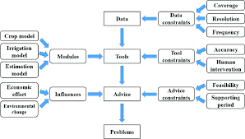
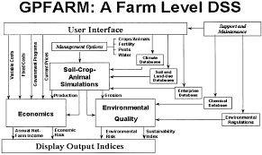
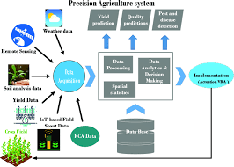
4
Below is a clear, beginner-friendly system architecture diagram explained step by step, written so you can hand it directly to engineers, researchers, or management.
I’ll first show the logical architecture (layered), then explain data flow, and finally give a text-based diagram you can copy into documents or PowerPoint.

1. High-Level Architecture Overview
Your sprayer recommendation platform is a Decision Support System (DSS) with five core layers:
┌──────────────────────────────┐
│ User Interface Layer │
└──────────────┬───────────────┘
│
┌──────────────▼───────────────┐
│ Decision Logic Layer │
└──────────────┬───────────────┘
│
┌──────────────▼───────────────┐
│ Models & Intelligence Layer │
└──────────────┬───────────────┘
│
┌──────────────▼───────────────┐
│ Data & Knowledge Layer │
└──────────────┬───────────────┘
│
┌──────────────▼───────────────┐
│ External / Offline Tools │
└──────────────────────────────┘

2. Detailed Layer-by-Layer Architecture

2.1 User Interface Layer (Who uses the system)
Purpose:
Allow factory engineers, sales staff, agronomists, or farmers to input conditions and view recommendations.
Components
- Web dashboard / PC software / tablet app
- Input forms:
  - Field size, slope
  - Soil type
  - Crop type
  - Climate data
  - Budget & labor
- Output panels:
  - Recommended sprayer type
  - Spray method (boom, airblast, drone)
  - Spray speed
  - Cost breakdown
  - Time & labor estimation
Output Example
Recommended sprayer: Mobile boom sprayer
Spray speed: 6.5 km/h
Estimated cost: $97/season
Labor required: 1 operator
Suitability score: 0.86

2.2 Decision Logic Layer (The brain coordinator)
Purpose:
Orchestrates rules, models, and constraints.
Key Modules
- Scenario Builder
  - Converts user input into structured data
- Constraint Checker
  - Eliminates impossible sprayers
- Weight Manager
  - Adjusts importance of cost, time, labor
- Ranking Engine
  - Sorts feasible options
Example Logic
IF slope > 15° → eliminate tractor sprayers
IF field < 1 ha → penalize large machines

2.3 Models & Intelligence Layer
This is where math + AI live.
Submodules
(A) Economic Model
- Cost per hectare
- Depreciation
- Maintenance
- Labor cost
$$C=C_{labor}+C_{energy}+C_{depreciation}$$

(B) Workload & Performance Model
- Spray rate (ha/h)
- Total operation time
- Operator fatigue factor

(C) Spray Suitability Model
- Drift risk
- Crop sensitivity
- Wind-speed compatibility

(D) AI / ML Models (Optional but powerful)
- Regression → cost prediction
- Classification → sprayer type
- Reinforcement learning → long-term strategy
Important:
AI does not replace rules; it refines predictions.

2.4 Data & Knowledge Layer
This layer stores everything the system knows.
Databases
1. Sprayer Database
Sprayer | Max slope | Rate | Cost
Knapsack | Any | 0.3 | $120
Mobile | 15° | 6 | $12,000

2. Crop Knowledge Base
- Spray frequency
- Sensitivity
- Growth stages

3. Soil & Land Database
- Bearing capacity
- Compaction risk
- Accessibility index

4. Climate & Weather Data
- Historical averages
- Real-time weather (optional)

5. Factory Cost Database
- Development cost
- Manufacturing cost
- Expected lifetime
- Selling price

2.5 External / Offline Tools Layer
These tools feed or validate the system.
Examples
- Excel models (early-stage validation)
- Python simulations (offline)
- Digital twin models
- Government soil maps
- Weather stations

3. Full Text-Based Architecture Diagram (Copy-Paste Ready)
+---------------------------------------------------+
| USER INTERFACE |
| - Field input |
| - Crop plan |
| - Budget & labor |
| - Recommendation display |
+---------------------------+-----------------------+
|
v
+---------------------------------------------------+
| DECISION LOGIC LAYER |
| - Scenario builder |
| - Constraint filtering |
| - Weight assignment |
| - Option ranking |
+---------------------------+-----------------------+
|
v
+---------------------------------------------------+
| MODELS & INTELLIGENCE LAYER |
| - Economic cost model |
| - Workload & time model |
| - Spray physics model |
| - AI/ML predictors (optional) |
+---------------------------+-----------------------+
|
v
+---------------------------------------------------+
| DATA & KNOWLEDGE LAYER |
| - Sprayer specs database |
| - Crop & agronomy knowledge base |
| - Soil & land database |
| - Climate data |
| - Factory cost data |
+---------------------------+-----------------------+
|
v
+---------------------------------------------------+
| EXTERNAL / OFFLINE TOOLS |
| - Excel / Solver |
| - Python models |
| - Digital twins |
| - Weather & GIS data |
+---------------------------------------------------+

4. Data Flow (Simple Explanation)
- User enters land, crop, and budget
- System builds a scenario
- Impossible sprayers are removed
- Remaining sprayers are evaluated
- Costs, time, and risks are calculated
- Options are ranked
- Best solution is presented with explanation

5. Why This Architecture Is Practical for a Beginner Team
- Can start without AI
- Excel → Python → AI (gradual growth)
- Modular (easy to upgrade)
- Transparent (engineers trust it)
- Supports both factory planning and farmer advice

If you want next:
- A visual flowchart version (for presentations)
- A UML-style architecture
- A sample database schema
- A Python pseudo-code implementation
- A factory-focused version (product strategy & sales)

