BNJetTagKai
Mulder to NRP Migration & Training Comparison
Kai Yamaguchi
June 22, 2026

1. Background: Model Architecture
The bitnet_jet_tagger is a ternary-quantized transformer jet tagger designed for the CMS Level-1 trigger. It targets FPGA synthesis via hls4ml, using BitNet-style ternary weights ({-1, 0, +1}) so that multiplications become simple additions at inference time. This is critical for meeting the L1 trigger latency budget.
Input: 10 particles per jet, each with 14 features (kinematics, impact parameters, etc.).
Pipeline: Input projection (Dense) → RMSNorm → N × BitTransformerBlock → RMSNorm → GlobalAveragePooling1D → BitLinear head → Dense(1).
Two model configurations were trained and compared:
 | Mulder | NRP
d_model | 64 | 32
n_layers | 3 | 2
ffn_dim | 128 | 64
Total parameters | 104,769 | 18,401

2. Mulder to NRP: Data Transfer
This section covers the process of migrating the training data from Mulder to the NRP Nautilus cluster. This was the primary infrastructure task.

2.1 Why the Transfer Was Needed
Mulder (mulder.t2.ucsd.edu) and NRP Nautilus are completely separate systems with separate storage. Nothing on Mulder is visible from inside an NRP pod. The training data had to be explicitly copied onto an NRP persistent volume claim (PVC), which is durable Kubernetes storage that survives pod restarts and deletions.

2.2 NRP/Nautilus Setup (Local Machine(Macbook))
- Installed kubectl via Homebrew (brew install kubectl)
- Installed kubelogin plugin for OIDC authentication (kubectl krew install oidc-login). Hit a Homebrew conflict: two different tools both named kubelogin. Resolved by using krew instead.
- Downloaded NRP kubeconfig from https://nrp.ai/config
- Switched kubectl context to nautilus, logged in via CILogon with UCSD credentials
- Russell added the account to the cms-ml namespace at https://nrp.ai/namespaces
- Created a persistent volume claim (kai-data, 100 Gi, rook-cephfs ReadWriteMany) for shared storage

2.3 Mulder Setup
- Installed kubectl and krew + oidc-login plugin directly on Mulder
- Copied kubeconfig from laptop to Mulder via scp
- Configured device-code login flow since Mulder has no browser (added --grant-type=device-code and --skip-open-browser flags to the kubeconfig)
- Authenticated by pasting a device URL into the laptop browser

2.4 The Transfer (nrpcopy)
Used the nrpcopy tool (github.com/quinnanm/nrpcopy), which wraps rsync over kubectl exec to stream files from Mulder into a pod that has the PVC mounted. It batches files, runs transfers in parallel, verifies each one, and can resume failed transfers.
Data source: Russell's directory on Mulder at /home/users/russelld/TOOLLIP_TESTS/.../L1LLPJetTag/data, containing LLP signal samples (HiddenGluGluH), QCD background, and merged train/test sets.
Critical blocker: rsync was not installed on Mulder. The first real transfer run failed completely — all 205 files failed with "krsync: exec: rsync: not found." Fixed with: micromamba install -c conda-forge rsync -y.
Result: 205 HDF5 files (~5.2 GB) transferred successfully to /data/bnjet on the kai-data PVC. Verified by file count and size comparison.

2.5 Key Problems Encountered During Transfer
- kubelogin Homebrew tap conflict: Two different tools share the name "kubelogin." Used krew to avoid the conflict.
- zsh parse errors: Angle-bracket placeholders like <namespace> triggered zsh redirect operators.
- rsync not installed on Mulder: The biggest blocker. All 205 files failed until rsync was installed via micromamba.
- nrpcopy cosmetic bug: Logged "Found 205 .root files" even though the filter was *.h5. The transfer itself worked correctly.

3. Training on NRP: Setup and Blockers

3.1 GPU Pod Setup
- Created a GPU pod using the tensorflow/tensorflow:2.11.1-gpu image with the kai-data volume mounted at /data
- Cloned the BNJetTagKai repository onto the persistent volume at /data/BNJetTagKai
- Installed Python dependencies: qkeras, matplotlib, pandas, seaborn, mplhep (with TF pinned to 2.11.1)
- Patched Python 3.10 type-hint syntax (int | None) for Python 3.8 compatibility by prepending "from __future__ import annotations"

3.2 Two Blockers During Training
Blocker 1 — Missing graphviz: train.py calls tf.keras.utils.plot_model() unconditionally at line 190, but neither pydot (pip package) nor graphviz (system binary) were installed in the container. Every run crashed immediately after printing the model summary.
Fix: apt-get install -y graphviz && pip install pydot. The system graphviz binary (the "dot" command) is required, not just the pip package.
Blocker 2 — 6-hour bare Pod deadline: The cms-ml namespace injects activeDeadlineSeconds=21600 (6 hours) onto all bare Pods. The training pod was SIGKILLed (exit 137, reason: DeadlineExceeded) at exactly 6 hours. Training had only been actively running for ~40 minutes when killed.
Fix: Switched from kind: Pod to kind: Job. Kubernetes Jobs in cms-ml are exempt from the 6-hour deadline. This is the recommended approach — the group's own zh-dino-train pods run as Jobs for days. The Job also bakes all dependency installation into its startup command, eliminating manual setup.

4. Mulder vs NRP: Training Comparison
The Mulder run used the larger model configuration (d64/l3/ffn128) with many more training epochs, while the NRP run used a smaller model (d32/l2/ffn64) as an initial validation of the pipeline.
 | Mulder | NRP (Nautilus)
Machine | mulder.t2.ucsd.edu | NRP Nautilus (K8s)
GPU | CPU | RTX 3090 (24 GB)
Python | 3.10 | 3.8
TensorFlow | 2.11.1 | 2.11.1
Model config | d64, 3 layers, ffn128 | d32, 2 layers, ffn64
Parameters | 104,769 | 18,401
Stage 1 epochs | 10 | 1
Stage 2 epochs | 40 (early stop at 45) | 5
Stage 2.5 epochs | 2 | 1
Stage 3 epochs | 10 | 2
Total runtime | ~1d 19h | ~7h 29m
Stage 1 val AUC | 0.759 | 0.754
Stage 2.5 val AUC | 0.762 | 0.735
Stage 3 val AUC | 0.782 | 0.665
Stage 3 TPR@1e-2 | 0.126 | 0.095
Test mean AUC | 0.770 | 0.658
Test mean TPR@1e-2 | 0.117 | 0.095
Test mean TPR@1e-3 | 0.014 | 0.007

5. Test Results by Category: Side by Side
Final model performance evaluated on 9 physics categories (3 mass points × 3 quark flavors), testing against QCD background.
Category | Mulder AUC | NRP AUC | Mulder TPR@1e-2 | NRP TPR@1e-2
phi15_bbbb | 0.796 | 0.659 | 0.164 | 0.132
phi15_cccc | 0.794 | 0.680 | 0.155 | 0.126
phi15_uuuu | 0.809 | 0.691 | 0.148 | 0.115
phi30_bbbb | 0.709 | 0.601 | 0.050 | 0.049
phi30_cccc | 0.782 | 0.674 | 0.140 | 0.103
phi30_uuuu | 0.787 | 0.667 | 0.110 | 0.078
phi60_bbbb | 0.685 | 0.599 | 0.041 | 0.043
phi60_cccc | 0.797 | 0.685 | 0.147 | 0.126
phi60_uuuu | 0.775 | 0.662 | 0.100 | 0.083
Mean | 0.770 | 0.658 | 0.117 | 0.095

6. Key Observations
- The Mulder model (104k params) outperforms the NRP model (18k params) across all categories. This is expected given it is ~5.7x larger and trained for significantly more epochs.
- Both models show the same physics pattern: phi15 (low-mass) categories are easiest, phi60_bbbb (high-mass b-jets) is hardest.
- cccc (charm) is consistently the best-performing signal type across all mass points in both models.
- The NRP smaller model achieves ~85% of the Mulder model's AUC despite having only ~18% of the parameters — the ternary quantization is effective even at reduced model size.
- phi30_bbbb TPR@FPR=1e-2 is nearly identical between the two models (0.050 vs 0.049) — the smaller model loses almost nothing on this category at low FPR.
- The NRP infrastructure is now fully operational: data transferred, training pipeline validated, blockers documented and resolved.
- Future NRP runs can use the larger model config (d64/l3/ffn128) now that the Job-based setup eliminates the 6-hour cap.
  - model.png — Keras model architecture diagram
  - weights.png — Weight histogram confirming ternary quantization
- logs/ — Three log files showing all three training attempts (graphviz crash, 6h deadline kill, successful run)
- nrp/ — Setup documentation: data transfer runbook, GPU training runbook, Nautilus setup notes

• Mulder: 10+40+2+10 = 62 epochs in ~43h → ~42 min/epoch (on CPU, 105k params)
• NRP: 1+5+1+2 = 9 epochs in ~7.5h → ~50 min/epoch (on RTX 3090, 18k params)

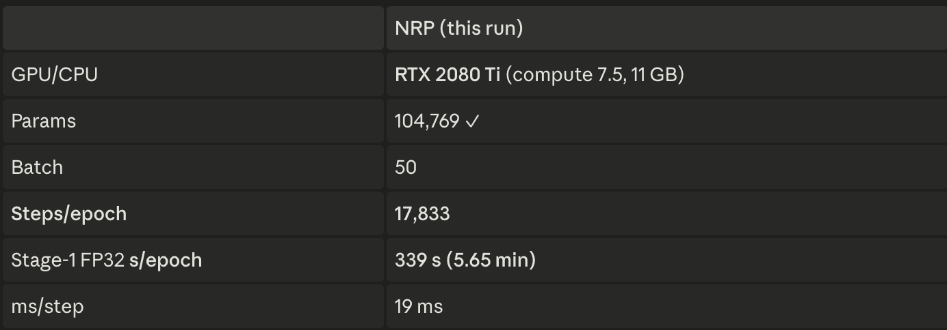

64 model has 5.7× the parameters of the d32 run (104,769 vs 18,401), yet its Stage-1 epoch is 339 s vs the d32 run's 375 s
basically the same

