BNJetTag
A 1-bit BitNet {-1,+1} transformer jet tagger for the CMS Level-1 trigger
Binary weights -> FPGA LUT/logic instead of DSPs (0 DSP on the binary core)

Progress update — figures only · talking points in the companion speaker-notes file
Kai Yamaguchi · UC San Diego · 2026-06-29

1. The model — a binary BitLinear transformer jet tagger
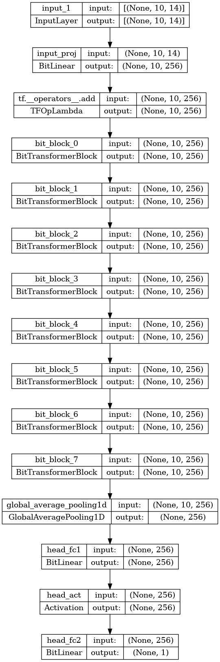

2. The data — jet-level kinematics (signal vs background)
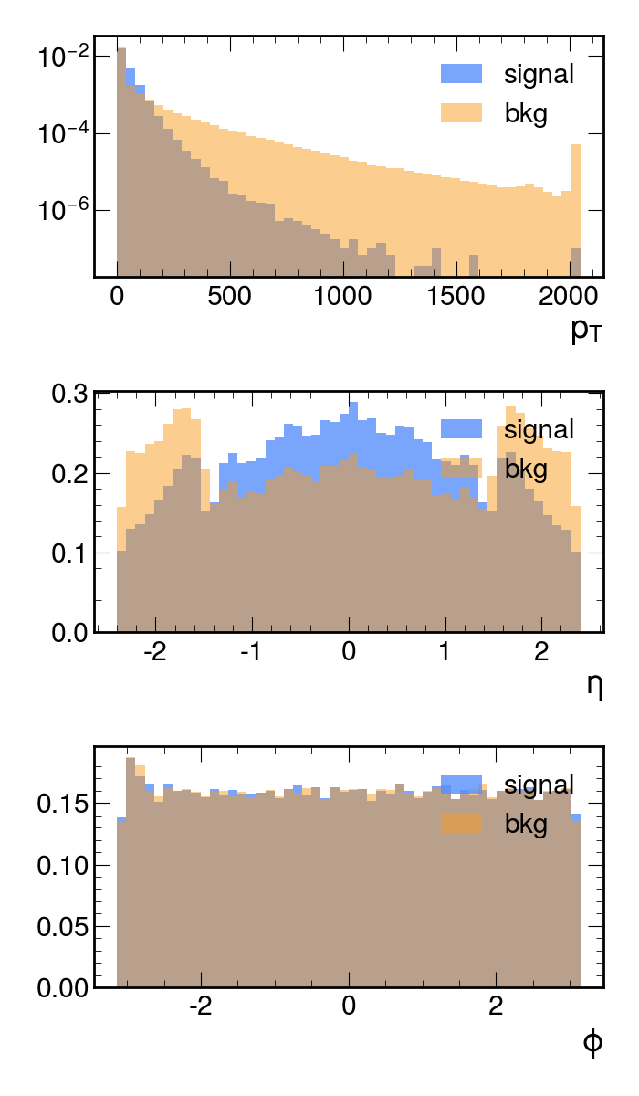

3. The inputs — 14 per-constituent features
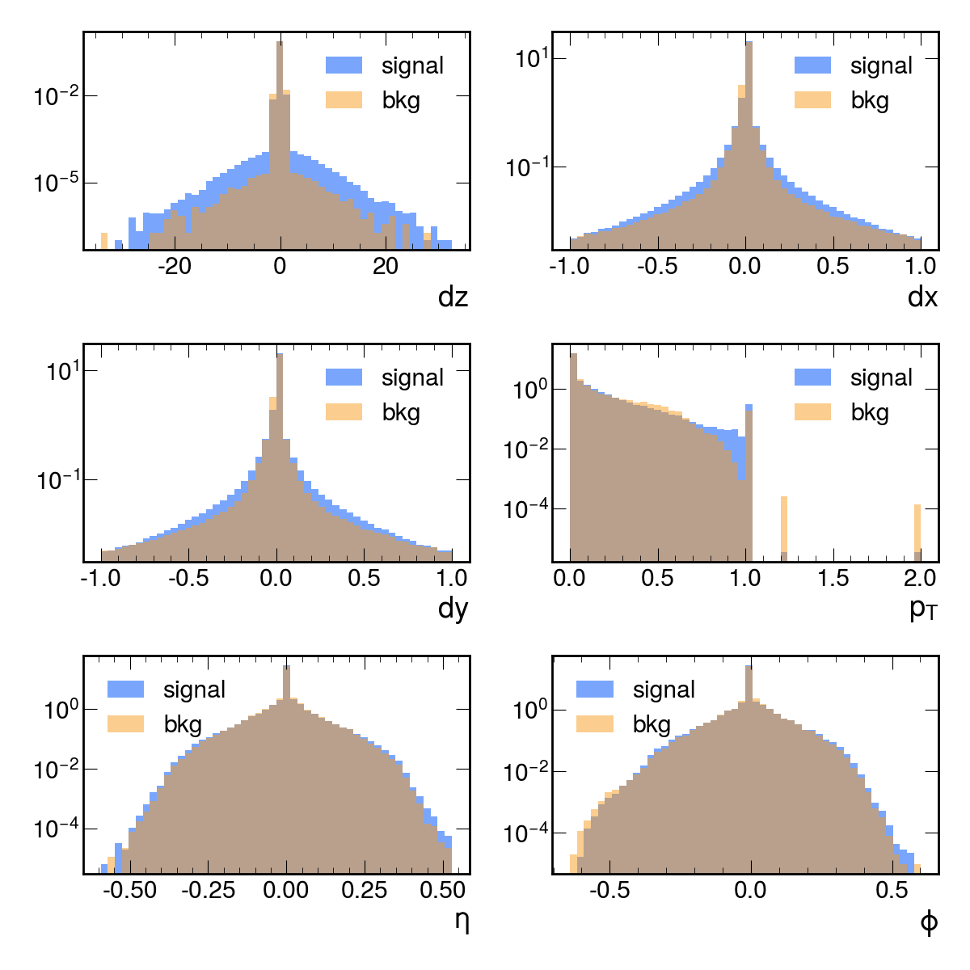

4. Preprocessing — pT reweighting
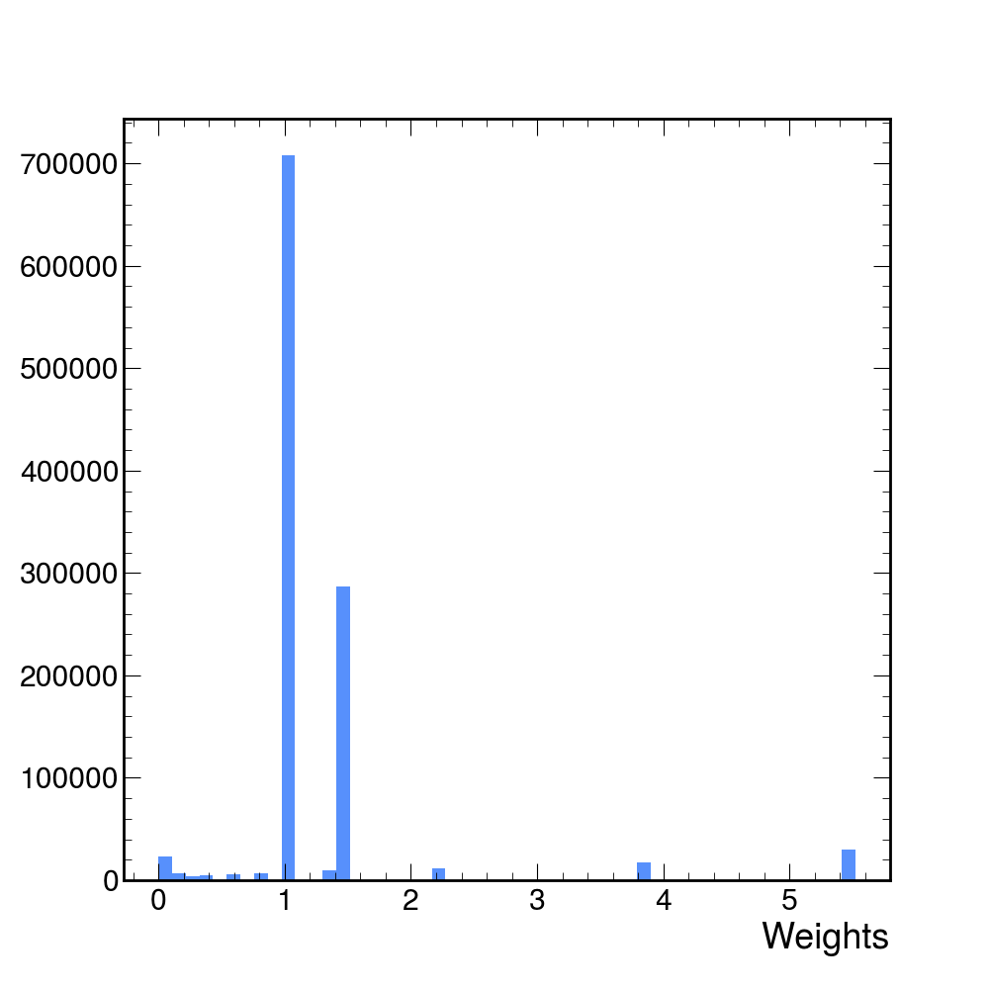

5. System & code map — what we built and edited
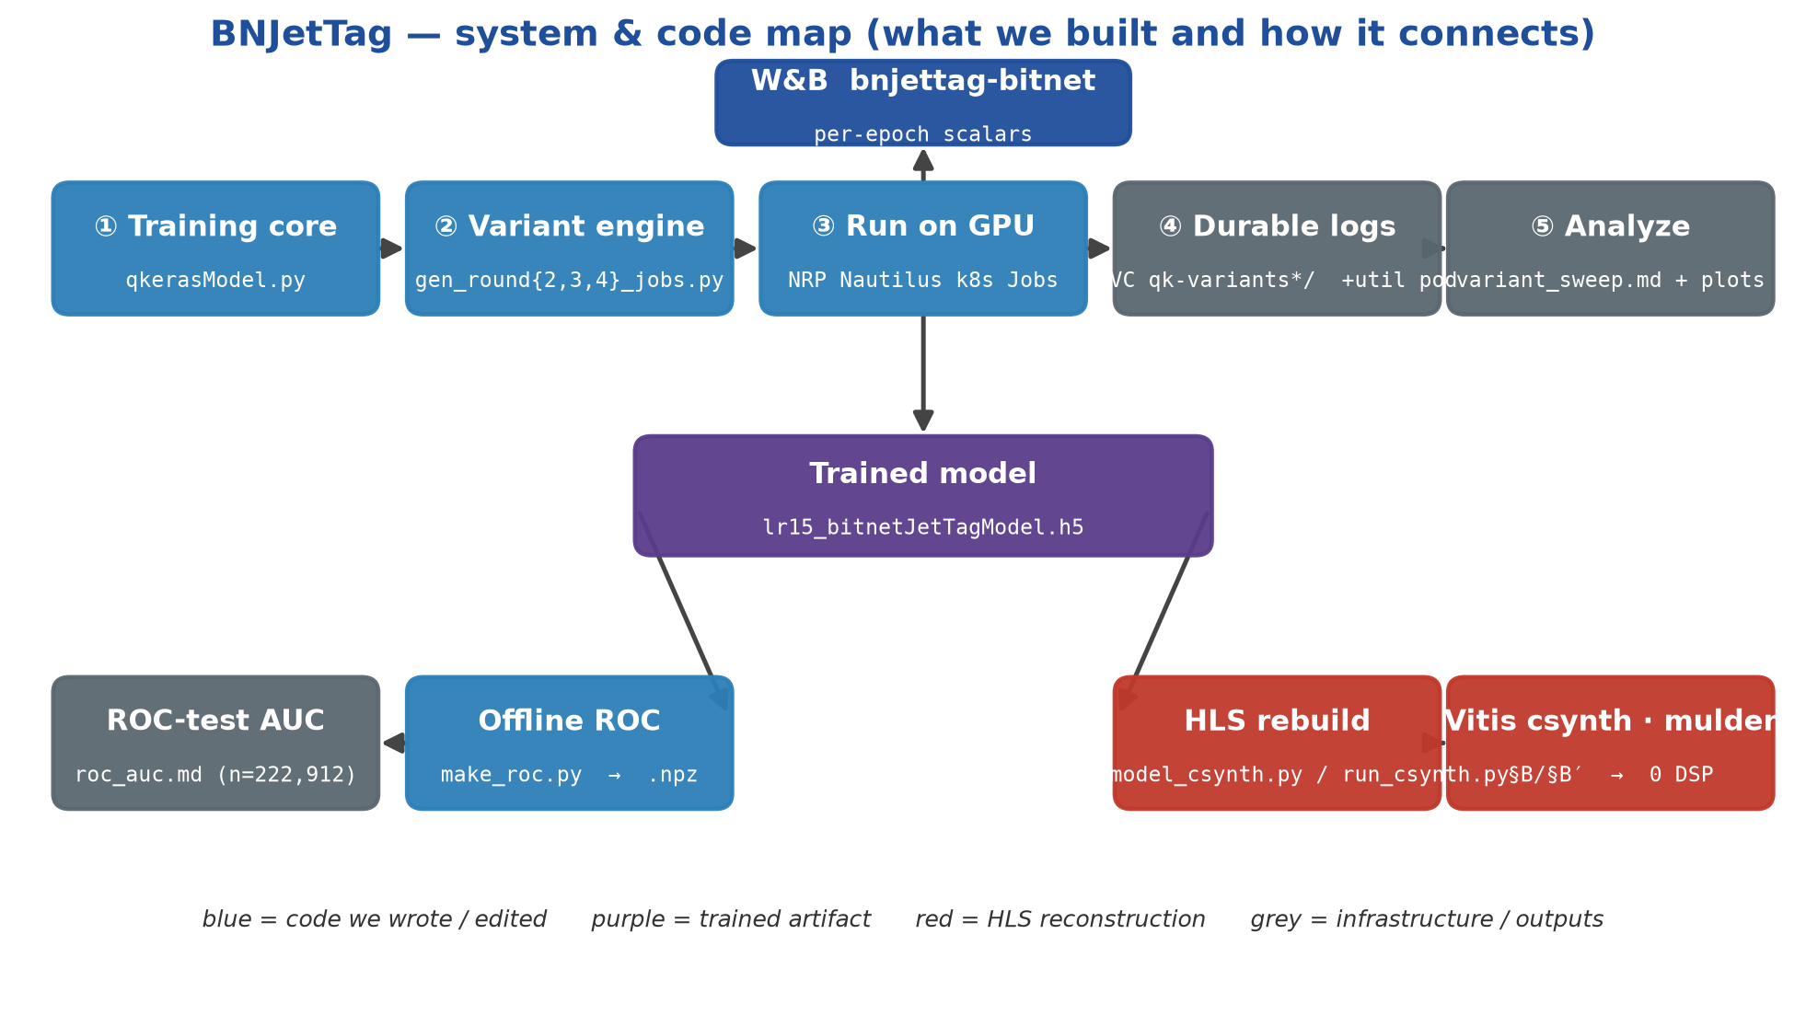

6. Headline result — DSP = 0 in real Vitis C-synthesis
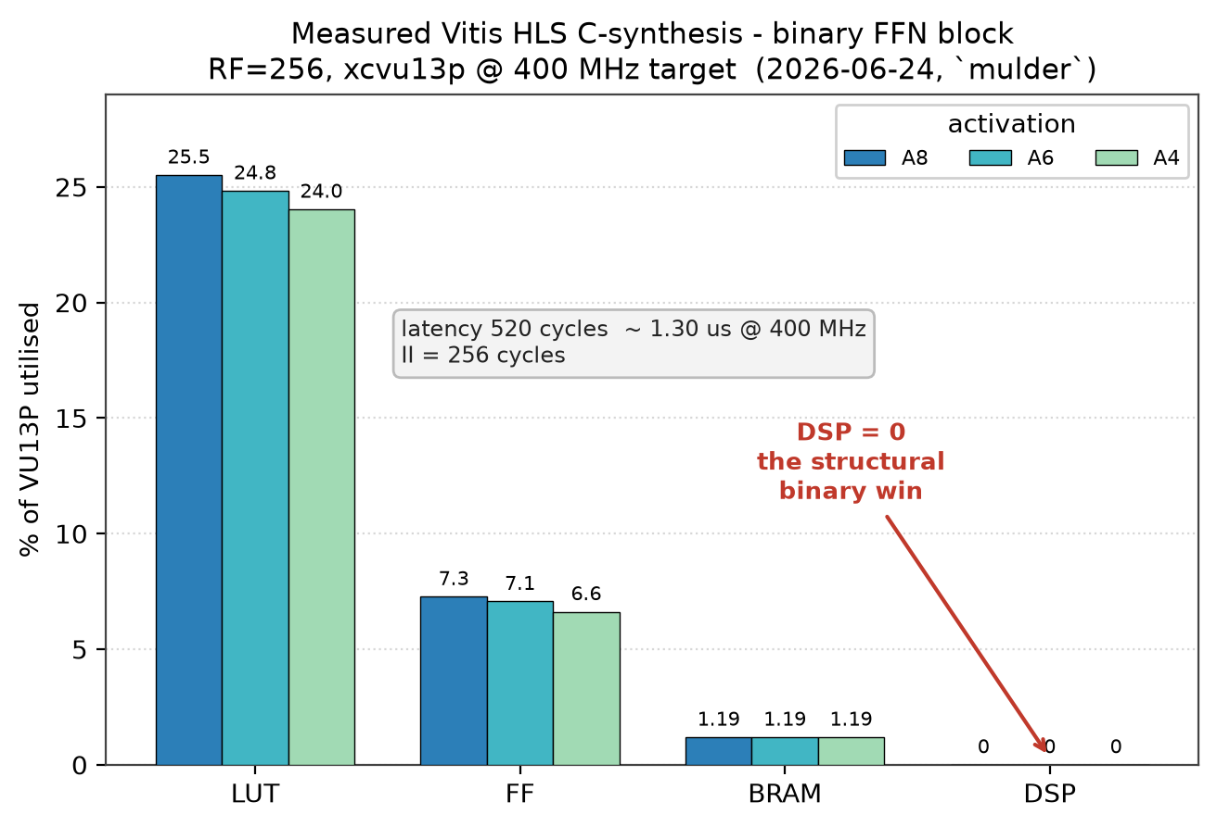

7. Two axes — efficiency vs FPGA resources (A8 -> A4)
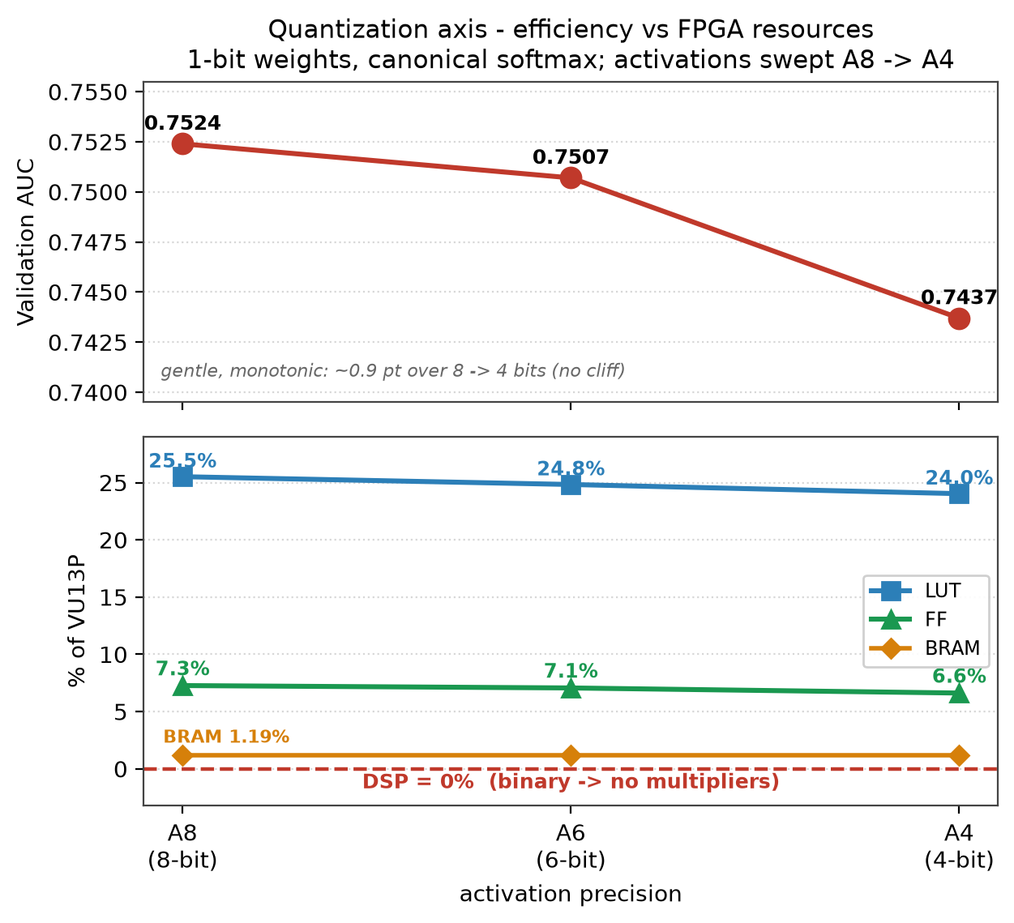

8. The FULL transformer in silicon — 100% of DSP is LayerNorm
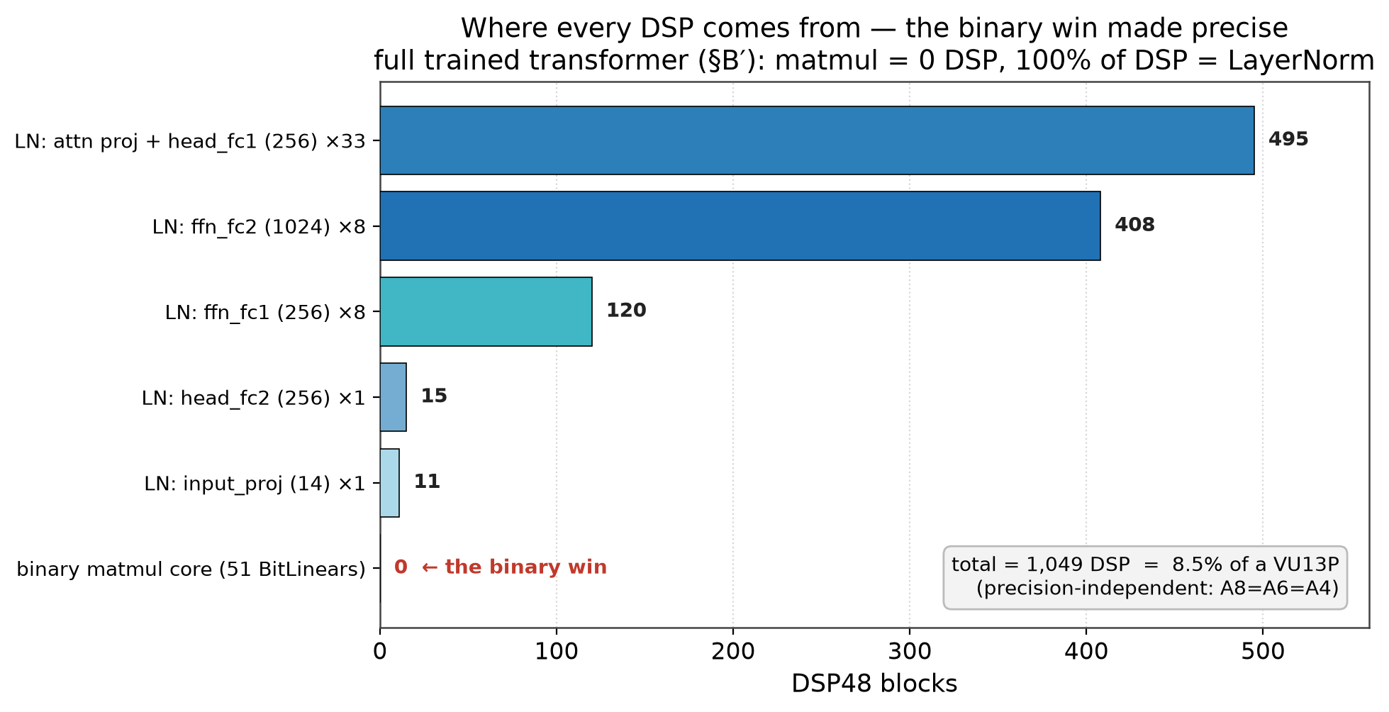

9. Tagging efficiency — cost of going 1-bit ~ -1.7 points
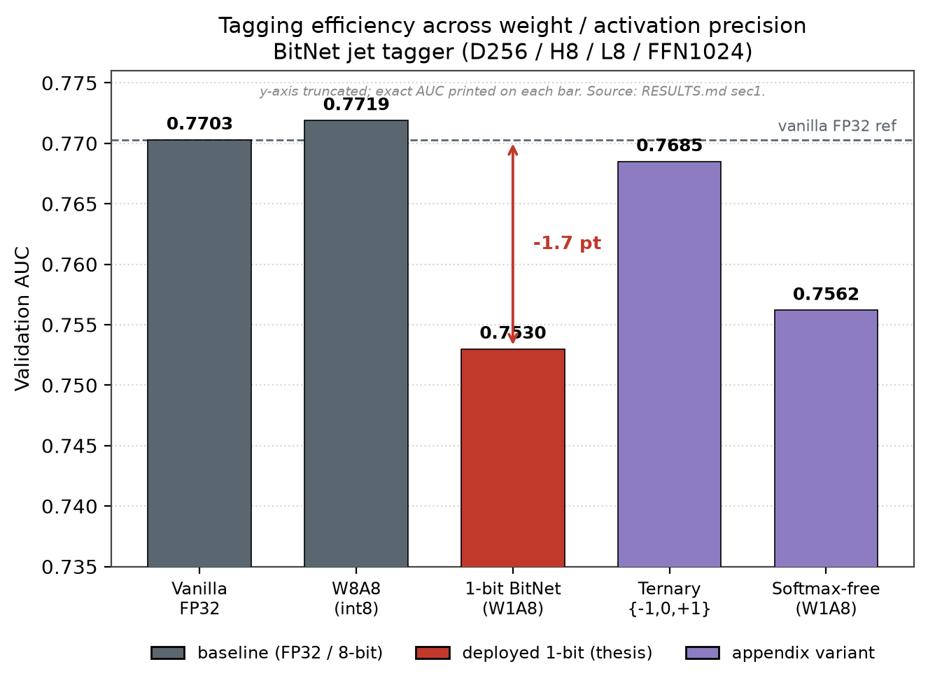

10. ROC on the held-out test set (n = 222,912)
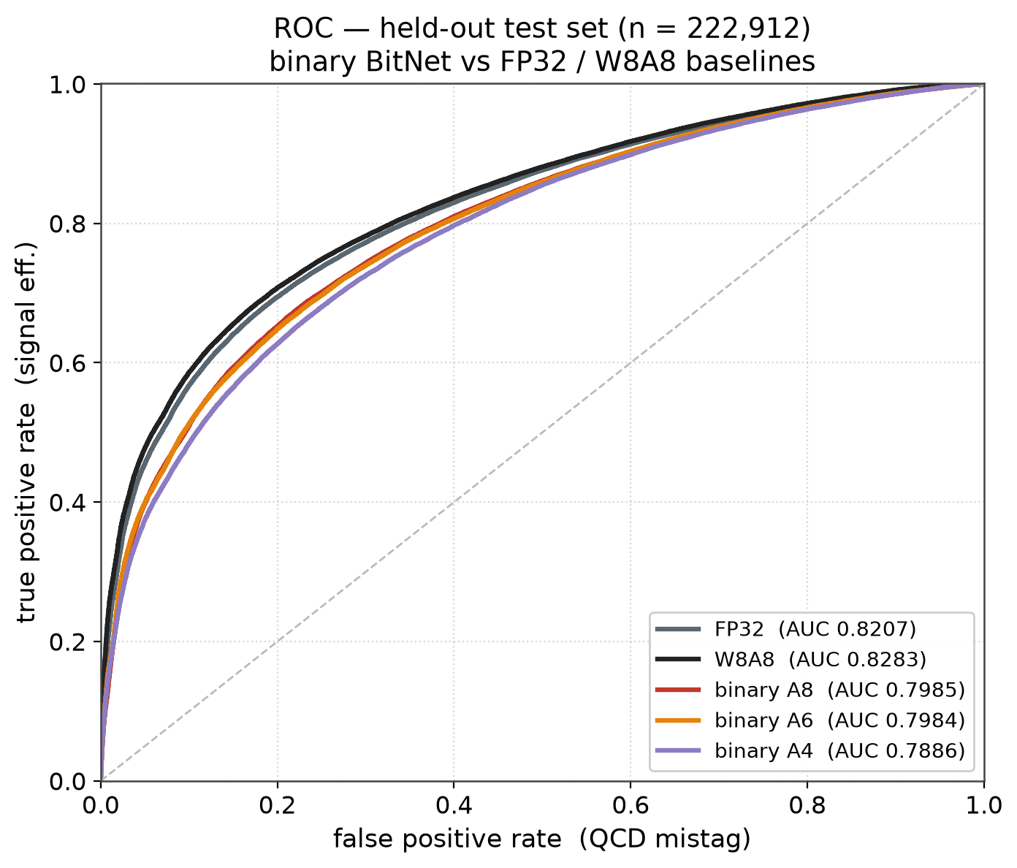

11. GPU sweep — once the LR is tuned, bigger wins
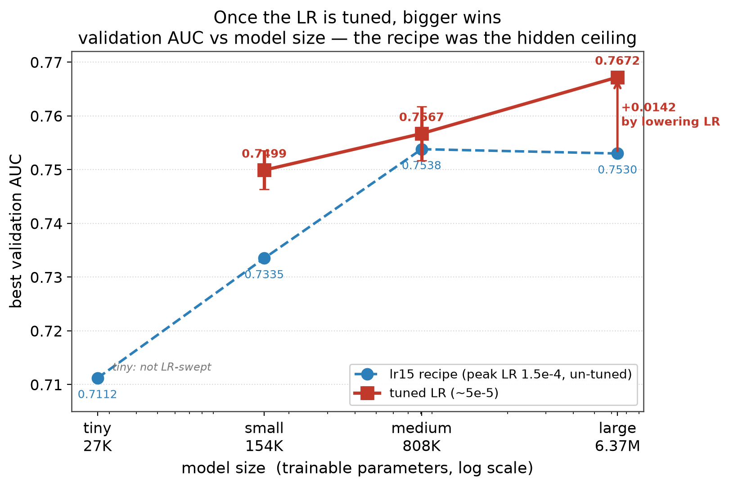

12. The recipe was the ceiling — lower LR fixes the collapse
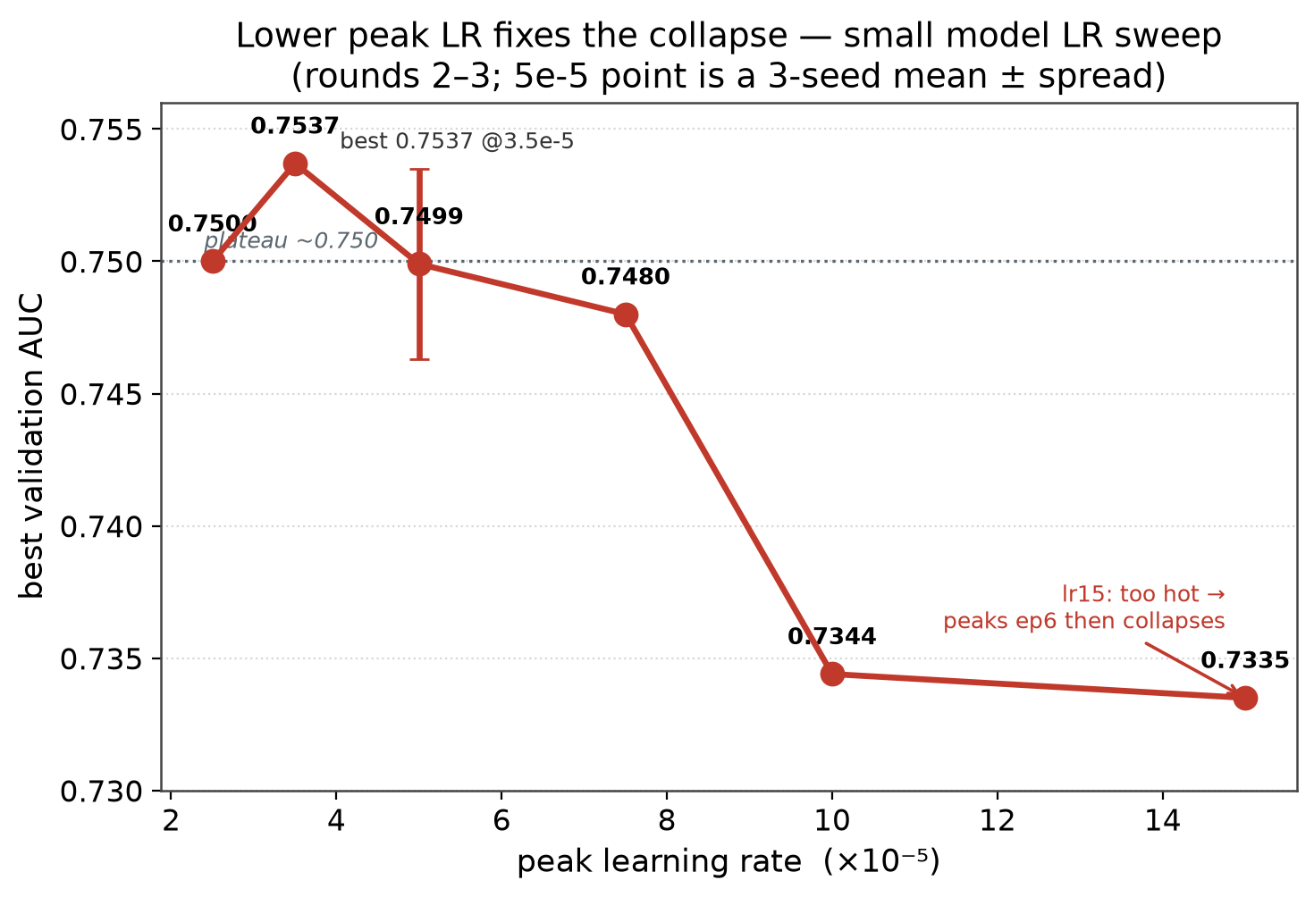

13. Rigor — seed repeats show the 'architecture wins' were noise
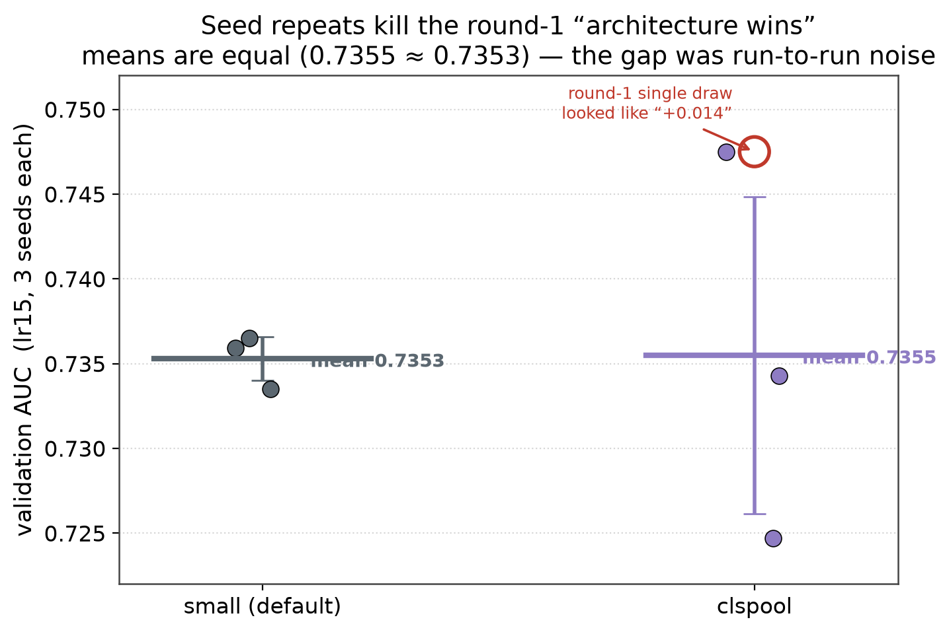

14. Efficiency frontier & recommendation
