

Prepared for: MTConnect Institute

Prepared by: William Sobel

Prepared on: March 12, 2010

MTConnect® Standard

Part 1 - Overview and Protocol

Version 1.1.0 – Draft F

MTConnect® Specification

AMT - The Association For Manufacturing Technology (“AMT”) owns the copyright in this MTConnect® Specification. AMT grants to you a non-exclusive, non- transferable, revocable, non-sublicensable, fully-paid-up copyright license to reproduce, copy and redistribute the MTConnect® Specification, provided that you may only copy or redistribute the MTConnect® Specification in the form in which you received it, without modifications, and with all copyright notices and other notices and disclaimers contained in the MTConnect® Specification.

If you intend to adopt or implement this MTConnect® Specification in a product, whether hardware, software or firmware, which complies with the MTConnect® Specification, you must agree to the MTConnect® Specification Implementer License Agreement (“Implementer License”) or to the MTConnect® Intellectual Property Policy and Agreement (“IP Policy”). The Implementer License and IP Policy each sets forth the license terms and other terms of use for MTConnect® Implementers to adopt or implement the MTConnect® Specifications, including certain license rights covering necessary patent claims for that purpose. These materials can be found at www.MTConnect.org, or by contacting Paul Warndorf at <mailto:pwarndorf@mtconnect.hyperoffice.com>.

MTConnect® Institute and AMT have no responsibility to identify patents, patent claims or patent applications which may relate to or be required to implement a Specification, or to determine the legal validity or scope of any such patent claims brought to their attention. Each MTConnect® Implementer is responsible for securing its own licenses or rights to any patent or other intellectual property rights that may be necessary for such use, and neither AMT nor MTConnect® Institute have any obligation to secure any such rights.

The MTConnect® Specification is provided “as is” and MTConnect® Institute and AMT, and each of their respective members, officers, affiliates, sponsors and agents, make no representation or warranty of any kind relating to these materials or to any implementation of the MTConnect® Specification in any product, including, without limitation, any express or implied warranty of noninfringement, merchantability, or fitness for particular purpose, or of the accuracy, reliability, or completeness of information contained herein. In no event shall MTConnect® Institute or AMT be liable to any user or implementer of the MTConnect® Specification for the cost of procuring substitute goods or services, lost profits, loss of use, loss of data or any incidental, consequential, indirect, special or punitive damages or other direct damages, whether under contract, tort, warranty or otherwise, arising in any way out of access, use or inability to use the MTConnect® Specification or other MTConnect® Materials, whether or not they had advance notice of the possibility of such damages.

Table of Contents

1 Overview 1

1.1 MTConnect® Document Structure 1

2 Purpose of This Document 2

2.1 Terminology 2

2.2 XML Terminology 4

2.3 Markup Conventions 6

2.4 Document Conventions 7

2.5 Units 7

2.6 Referenced Standards and Specifications 8

3 Architectural Overview 9

3.1 Request Structure 9

3.2 Process Workflow 9

3.2.1 Agent Initialization 9

3.2.2 Application Communication 11

4 Reply XML Document Structure 13

4.1 MTConnectDevices 13

4.1.1 MTConnectDevices Elements 14

4.2 MTConnectStreams 14

4.2.1 MTConnectStreams Elements 15

4.3 MTConnectError 15

4.3.1 MTConnectError Elements 16

4.4 Header 16

4.4.1 Header Attributes 17

5 Protocol 20

5.1 Standard Request Sequence 20

5.2 Probe Requests 22

5.3 Sample Request 24

5.3.1 Parameters 26

5.4 Current Request 27

5.4.1 Parameters 27

5.4.2 Getting the State at a Sequence Number 27

5.5 Streaming 28

5.6 HTTP Response Codes and Error 31

5.6.1 MTConnectError 31

5.6.2 Errors 32

5.6.3 Error 32

5.7 Protocol Details 33

5.8 Request without Filtering 34

5.9 Request with Path Parameter 38

5.10 Fault Tolerance and Recovery 40

5.10.1 Application Failure 40

5.10.2 Agent Failure 42

5.10.3 Data Persistence and Recovery 43

5.11 Unavailability of Data 43

5.11.1 Examples 44

5.11.2 Constant valued data items 46

Appendices 47

A. Bibliography 47

B. Discovery 49

B.1. Physical Architecture 49

Table of Figures

Figure 1: Agent Initialization 10

Figure 2: Application Communication 11

Figure 3: MTConnectDevices structure 13

Figure 4: MTConnectStreams structure 14

Figure 5: MTConnectError structure 15

Figure 6: Header Schema Diagram 17

Figure 7: Application and Agent Conversation 21

Figure 8: Sample Device Organization 25

Figure 9: Sample Data in an Agent 34

Figure 10: Example #1 for Sample from Sequence #103 35

Figure 11: Example #1 for Sample from Sequence #114 36

Figure 12: Example #1 for Sample from Sequence #124 37

Figure 13: Example #2 for Sample from Sequence #103 with Path 38

Figure 14: Example #2 for Sample from Sequence #114 with Path 39

Figure 15: Example #2 for Sample from Sequence #124 with Path 40

Figure 16: Application Failure and Recovery 41

Figure 17: Agent Failure and Recovery 42

Figure 18: Unavailable Data from Machine 44

Figure 19: Shop Illustration 49

# Overview

MTConnect is a standard based on an open protocol for data integration. MTConnect® is not intended to replace the functionality of existing products, but it strives to enhance the data acquisition capabilities of devices and applications and move toward a plug-and-play environment to reduce the cost of integration.

MTConnect® is built upon the most prevalent standards in the manufacturing and software industry, maximizing the number of tools available for its implementation and providing the highest level of interoperability with other standards and tools in these industries.

To facilitate this level of interoperability, a number of objectives are being met. Foremost is the ability to transfer data via a standard protocol which includes:

* + A device identity (i.e. model number, serial number, calibration data, etc.).
  + The identity of all the independent components of the device.
  + Possibly a device’s design characteristics (i.e. axis length, maximum speeds, device thresholds, etc.).
  + Most importantly, data captured in real or near-real-time (i.e. current speed, position data, temperature data, program block, etc.) by a device that can be utilized by other devices or applications (e.g. utilized by maintenance diagnostic systems, management production information systems, CAM products, etc.).

The types of data that may need to be addressed in MTConnect® could include:

* + Physical and actual device design data
  + Measurement or calibration data
  + Near-real-time data from the device

To accommodate the vast amount of different types of devices and information that may come into play, MTConnect® will provide a common high-level vocabulary and structure.

## MTConnect® Document Structure

The MTConnect® specification is subdivided using the following scheme:

Part 1: Overview and Protocol – Version 1.1.0 Draft F

Part 2: Components and Data Items – Version 1.1.0 Draft F

Part 3: Streams, Events and Samples – Version 1.1.0 Draft F

Extensions to the standard will be made according to this scheme and new sections will be added as new areas are addressed. Documents will be named as follows: MTC_Part_<Number>_<Description>.doc. All documents will be developed in Microsoft® Word format and released in Adobe® PDF format. For example, this document is MTC_Part_1_Overview.doc.

# Purpose of This Document

This document is intended to::

* define the MTConnect® standard;
* specify the requirements for compliance with the MTConnect® standard;
* provide engineers with sufficient information to implement Agents for their devices;
* provide developers with the necessary guidelines to use the standard to develop applications.

Part 1 of the MTConnect Standard provides an overview of the MTConnect Structure and Overview of the Protocol; including the communication between devices, fault tolerance, connectivity handling, and error handling.

The document is organized as follows:

* Section 3 discusses the architecture and the MTConnect® standard in relation to the other devices and processes. A brief discussion of the high level data flow is also given to frame the scope of the standard.
* Section 4 provides the structure of the protocol header which will be discussed in detail in section 5.
* Section 5 provides detailed information on the MTConnect® protocol and how processes will communicate and recover from failure.

## Terminology

**Adapter** An optional software component that connects the Agent to the Device.

**Agent** A process that implements the MTConnect® HTTP protocol, XML generation, and MTConnect protocol.

**Alarm** An alarm indicates an event that requires attention and indicates a deviation from normal operation.

**Application** A process or set of processes that access the MTConnect® Agent to perform some task.

**Attribute** A part of an element that provides additional information about that element. For example, the name element of the Device is given as <Device **name=”mill-1”**>...</Device>

**CDATA** The text in a simple content element. For example, *This is some text*, in <mt:Alarm ...>This is some text</mt:Alarm>.

**Component** A part of a device that can have sub-components and data items. A component is a basic building block of a device.

**Controlled Vocabulary** The value of an element or attribute is limited to a restricted set of possibilities. Examples of controlled vocabularies are country codes: US, JP, CA, FR, DE, etc…

**Current** A snapshot request to the Agent to retrieve the current values of all the data items specified in the path parameter. If no path parameter is given, then the values for all components are provided.

**Data Item** A data item provides the descriptive information regarding something that can be collected by the Agent.

**Device** A piece of equipment capable of performing an operation. A device is composed of a set of components that provide data to the application. The device is a separate entity with at least one Controller managing its operation.

**Discovery** Discovery is a service that allows the application to locate Agents for devices in the manufacturing environment. The discovery service is also referred to as the *Name Service.*

**Element** An XML element is the central building block of any XML Document. For example, in MTConnect® the Device element is specified as <**Device** >...</**Device**>

**Event** An event represents a change in state that occurs at a point in time. Note: An event does not occur at predefined frequencies.

**HTTP** Hyper-Text Transport Protocol. The protocol used by all web browsers and web applications.

**Instance** When used in software engineering, the word *instance* is used to define a single physical example of that type. In object-oriented models, there is the class that describes the thing and the instance that is an example of that thing.

**LDAP** Lightweight Directory Access Protocol, better known as Active Directory in Microsoft Windows. This protocol provides resource location and contact information in a hierarchal structure.

**MIME** Multipurpose Internet Mail Extensions. A format used for encoding multipart mail and http content with separate sections separated by a fixed boundary.

**Probe** A request to determine the configuration and reporting capabilities of the device.

**REST** REpresentational State Transfer. A software architecture where the client and server move through a series of state transitions based solely on the request from the client and the response from the server.

**Results** A general term for the Samples, Events, and Condition contained in a ComponentStream as a response from a sample or current request.

**Sample** A sample is a data point from within a continuous series of data points. An example of a Sample is the position of an axis.

**Socket** When used concerning interprocess communication, it refers to a connection between two end-points (usually processes). Socket communication most often uses TCP/IP as the underlying protocol.

**Stream** A collection of events and samples organized by devices and components.

**Service** An application that provides necessary functionality.

**Tag** Used to reference an instance of an XML element.

**TCP/IP** TCP/IP is the most prevalent stream-based protocol for interprocess communication. It is based on the IP stack (Internet Protocol) and provides the flow-control and reliable transmission layer on top of the IP routing infrastructure.

**URI** Universal Resource Identifier. This is the official name for a web address as seen in the address bar of a browser.

**UUID** Universally unique identifier.

**XPath** XPath is a language for addressing parts of an XML Document. See the XPath specification for more information. <http://www.w3.org/TR/xpath>

**XML** Extensible Markup Language. <http://www.w3.org/XML/>

**XML Schema** The definition of the XML structure and vocabularies used in the XML Document.

**XML Document** An instance of an XML Schema which has a single root element and conforms to the XML specification and schema.

**XML NMTOKEN** The data type for XML identifiers. It must start with a letter, an underscore “_” or a colon “:” and then it **MUST** be followed by a letter, a number, or one of the following “.”, ”-“, ”_”, “:”. An NMTOKEN cannot have any spaces or special characters.

## XML Terminology

In the document there will be references to XML constructs, including elements, attributes, CDATA, and more. XML consists of a hierarchy of elements. The elements can contain sub-elements, CDATA, or both. For this specification, however, an element never contains mixed content or both sub-elements and CDATA. Attributes are additional information associated with an *element*. The textual representation of an element is referred to as a *tag*. In the example:

1. <Foo name=”bob”>Ack!</Foo>

an *element* consists of a named opening and closing tag. In the above example, <Foo...> is referred to as the opening tag and </Foo> is referred to as the closing tag. The text Ack! in between the opening and closing tags is called the CDATA. CDATA can be restricted to certain formats, patterns, or words. In the document when it refers to an element having CDATA, it indicates that the element has no sub-elements and only contains data.

When one looks at an XML Document there are two parts. The first part is typically referred to as an XML declaration and is only a single line. It looks something like this:

1. <?xml version="1.0" encoding="UTF-8"?>

This line indicates the XML version being used and the character encoding. Though it is possible to leave this line off, it is usually considered good form to include this line in the beginning of the document. The second part contains the XML document and consists of the rest of the document.

Every XML Document contains one and only one root element. In the case of MTConnect, it is the MTConnectDevices, MTConnectStreams, or MTConnectError element. When these root elements are used in the examples, you will sometimes notice that it is prefixed with mt: as in mt:MTConnectDevices. The mt: is what is referred to as a namespace. In XML, to allow for multiple XML Schemas to be used within the same XML Document, a namespace will indicate which XML Schema is in effect for this section of the document. This convention allows for multiple XML Schemas to be used within the same XML Document, even if they have the same element names. The namespace is optional and is only required if multiple schemas are required.

An *attribute* is additional data that can be included in each XML element. For example, in the following MTConnect® DataItem, there are several attributes describing the data item:

1. <DataItem name=”Xpos” type=”POSITION” subType=”ACTUAL” category=”SAMPLE” />

The name, type, subType, and category are attributes of the element. Each attribute can only occur once within an element declaration, and it can either be required or optional.

An element can have any number of sub-elements. The XML Schema specifies which sub-elements and how many times a given sub-element can occur. Here’s an example:

1. <TopLevel>
2. <FirstLevel>
3. <SecondLevel>
4. <ThirdLevel name=”first”></ThirdLevel>
5. <ThirdLevel name=”second”></ThirdLevel>
6. </SecondLevel>
7. </FirstLevel>
8. </TopLevel>

In the above example, the FirstLevel has a sub-element SecondLevel which in turn has two sub-elements, ThirdLevel, with different names. Each level is an element and its children are its sub-elements and so forth.

In XML we sometimes use elements to organize parts of the document. A few examples in MTConnect® are Streams, DataItems, and Components. These elements have no attributes or data of their own; they only provide structure to the document and allow for various parts to be addressed easily.

1. …
2. <Device id=”d” name=”Device”>
3. <DataItems>
4. <DataItem …/>
5. …
6. </DataItems>
7. <Components>
8. <Axes … >…</Axes>
9. </Components>
10. </Device>

In the previous example DataItems and Components are only used to contain certain types of elements and provide structure to the documents. These elements will be referred to as *Containters* in the standard.

An XML Document can be validated. The most basic check is to make sure it is well-formed, meaning that each element has a closing tag, as in <foo>...</foo> and the document does not contain any illegal characters (<>) when not specifying a tag. If the closing </foo> was left off or an extra > was in the document, the document would not be well-formed and may be rejected by the receiver. The document can also be validated against a schema to ensure it is valid. This second level of analysis checks to make sure that required elements and attributes are present and only occur the correct number of times. A valid document must be well-formed.

All MTConnect® documents must be valid and conform to the XML Schema provided along with this specification. The schema will be versioned along with this specification. The greatest possible care will be taken to make sure that the schema is backward compatible.

For more information, visit the w3c website for the XML Standards documentation: <http://www.w3.org/XML/>

## Markup Conventions

MTConnect® follows industry conventions on tag format and notations when developing the XML schema. The general guidelines are as follows:

1. All tag names will be specified in Pascal case (first letter of each word is capitalized). For example: <ComponentEvents />
2. Attribute names will also be camel case, similar to Pascal case, but the first letter will be lower case. For example: <MyElement attributeName=”bob”/>
3. All values that are part of a limited or controlled vocabulary will be in upper case with an _ (underscore) separating words. For example: ON, OFF, ACTUAL, COUNTER_CLOCKWISE, etc…
4. Dates and times will follow the W3C ISO 8601 format with arbitrary fractions of a second allowed. Refer to the following specification for details: <http://www.w3.org/TR/NOTE-datetime> The format will be YYYY-MM-DDThh:mm:ss.ffff, for example 2007-09-13T13:01.213415. The accuracy and number of fractional digits of the timestamp is determined by the capabilities of the device collecting the data. All times will be given in UTC (GMT).
5. Element names will be spelled-out and abbreviations will be avoided. The one exception is the word identifier that will be abbreviated Id. For example: SequenceNumber will be used instead of SeqNum.

## Document Conventions

The following documentation conventions will be used in the text:

* The word **MUST** is used to indicate provisions that are mandatory. Any deviation from those provisions will not be permitted.
* The word **SHOULD** is used to indicate a provision that is recommended but the exclusion of which will not invalidate the implementation.
* The word **MAY** will be used to indicate provisions that are optional and are up to the implementer to decide if they are relevant to their device.
* The word **NOT** will be added to any of the previous words to emphasize the negation of this provision.

In the tables where elements are described, the Occurrence column indicates if the attribute or sub-elements are required by the specification.

For attributes:

1. If the Occurrence is 1, the attribute **MUST** be provided.
2. If the Occurrence is 0..1, the attribute **MAY** be provided, and at most one occurrence of the attribute may be given.

For elements:

1. If the Occurrence is 1, the element **MUST** be provided.
2. If the Occurrence is 0..1, the element **MAY** be provided, and at most one occurrence of the element may be given.
3. If the Occurrence is 1..INF, one or more elements **MUST** be provided.
4. If the Occurrence is a number, e.g. 2, exactly that number of elements **MUST** be provided.

Font styles used:

Code samples as well as any XML elements or attributes will always be given in fixed width fonts. References to other *Documents* or *Sections* will be presented in italics.

## Units

MTConnect® will adopt the units common to most standards specifications for exchanging data items. These units have been selected by the working group as giving the greatest interoperability and common acceptance.

| **Property** | **Symbol** | **Unit** |
| --- | --- | --- |
| Angle |  | decimal degree |
| Angular Acceleration | /s2 | degree per second squared |
| Angular Velocity | /s | degrees per second |
| Elapsed time | s | seconds with fractions |
| Force | N | newtons |
| Length | mm | millimeters |
| Linear Acceleration | mm/s2 | millimeter per second squared |
| Linear Velocity | mm/s | millimeter per second |
| Mass | kg | kilogram |
| Rotary Velocity | rev/min | revolution per minute |
| Spindle Speed | rev/min | revolution per minute |
| Temperature | C | degree Celsius |
| Time | Sec | second |
| Torque | N m | newton meter |

## Referenced Standards and Specifications

A large number of specifications are being used to normalize and harmonize the schema and the vocabulary (names of tags and attributes) specified in MTConnect® *(See Appendix A: Bibliography for complete references).*

# Architectural Overview

MTConnect® is built upon the most prevalent standards in the industry. This maximizes the number of tools available for implementation and provides the highest level of interoperability with other standards and protocols.

MTConnect® **MUST** use the HTTP protocol as the underlying transport for all messaging. The data **MUST** be sent back in valid XML, according to this standard. Each MTConnect® Agent **MUST** represent at least one device. The Agent **MAY** represent more than one device if desired.

MTConnect® is composed of a few basic conceptual parts. They are as follows:

**Header** Protocol related information. (*See Header in Part 1 Section 4)*

**Components** The building blocks of the device. *(See Components in Part 2 Section 3)*

**DataItems** The description of the data available from the device. *(See DataItems in Part 2 Section 4 )*

**Streams** A set of samples or events for components and devices. *(See Streams in Part 3)*

**Samples** A point-in-time measurement of a data item that is continuously changing. *(See Samples in Part 3)*

**Events** Discrete changes in state that can have no intermediate value. They indicate the state of a specific attribute of a component. *(See Events in Part 3)*

**Condition** A piece of information the device provides as an indicator of its health and ability to function. A condition can be one of Normal, Warning, Fault, or Unavailable. A single condition type can have multiple Faults or Warnings at any given time, unlike Events and Samples where a data time of a given type may only have a single value at a given time. *(See Condition in Part 3).*

## Request Structure

An MTConnect® request **SHOULD NOT** include any body in the HTTP request. If the Agent receives any additional data, the Agent **MAY** ignore it. There will be no cookies or additional information considered; the only information the Agent **MUST** consider is the URI in the HTTP GET (Type a URI into the browser’s address bar, hit return, and a GET is sent to the server. In fact, with MTConnect® one can do just that. To test the Agent, one can type the Agent’s URI into the browser’s address bar and view the results.)

## Process Workflow

What follows is the typical interaction between four entities in the MTConnect® architecture: the *Name Service* (an LDAP server that translates device names to the Agent’s URI), the *Application* (a user application that makes special use of the device’s data), the *Agent* (the process collecting data from the device and delivering it to the applications), and the *Device* (the physical piece of equipment).

*Note: Refer to Appendix B for more information on LDAP and the requirements for its use.*

### Agent Initialization

For this example, the agent first authenticates itself with the Name Server (if used). In the second part of the example, it shows how the entities interrelate in an architecture.

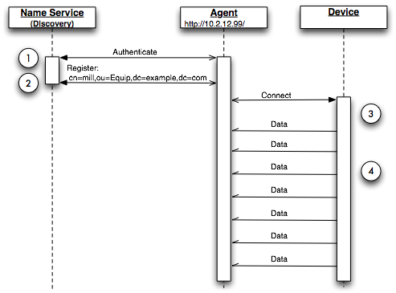

Figure 1: Agent Initialization

The diagram above illustrates the initialization of the Agent and communication with the device. *Implementors Note:* This is the recommended architecture and implementations **SHOULD** refer to this when developing their MTConnect® Agents.

**Step 1** The Agent connects and authenticates itself with the Name Service (LDAP server).

**Step 2** The Agent registers its URI with the Name Service so it can be located.

**Step 3** The Agent connects to the Device using the device’s API or another specialized process.

**Step 4** The device sends data to the Agent or the Agent polls the device for data.

### Application Communication

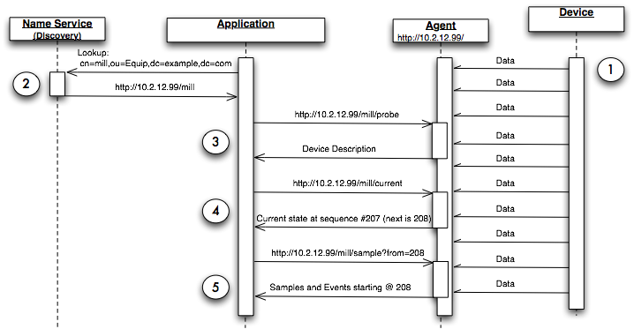 Figure 2: Application Communication

The preceding diagram shows how all major components of an MTConnect® architecture inter-relate and how the four basic operations are used to locate and communicate with the Agent regarding the device.

**Step 1** The device is continually sending information to the Agent. The Agent is collecting the information and saving it based on its ability to store information. The data flow from the device to the agent is implementation dependant. The data flow can begin once a request has been issued from a client application at the discretion of the agent.

**Step 2** The Application locates the device using the *Name Service* with the standard LDAP syntax that is interpreted as follows: the mill is in the organizational unit of Equip which is in the example.com domain. The LDAP record for this device will contain a URI that the Application can use to contact the Agent.

**Step 3** The Application has the URI to contact the Agent for the mill device. The first step is a request for the device’s descriptive information using the probe request. The probe will return the component composition of the device as well as all the data items available.

**Step 4** The Application requests the current state for the device. The results will contain the device stream and all the component streams for this device. Each of the data items will report their values as samples or events. The application will receive the nextSequence number from the Agent to use in the subsequent sample request.

**Step 5** The Application uses the nextSequence number to sample the data from the Agent starting at sequence number 208. The results will be events and samples; and the count is not specified, so it defaults to 100.

This will be discussed in more detail in the *Protocol* section of the document. The remainder of this document will assume the *Name Service* discovery has already been completed.

# Reply XML Document Structure

At the top level of all MTConnect® XML Documents there **MUST** be one of the following elements: MTConnectDevices, MTConnectStreams, or MTConnectError. This element will be the root for all MTConnect® responses and contains all sub-elements for the protocol.

All MTConnect® XML Documents are broken down into two parts. The first element is the Header that provides protocol related information like next sequence number and creation date and the second section the content for Devices, Streams, or Errors.

The top level elements **MUST** contain references to the XML schema URN and the schema location. This is the standard XML schema attributes:

1. <MTConnectStreams xmlns:m="urn:mtconnect.com:MTConnectStreams:1.1"
2. xmlns:xsi="http://www.w3.org/2001/XMLSchema-instance"
3. xmlns="urn:mtconnect.com:MTConnectStreams:1.1"
4. xsi:schemaLocation="urn:mtconnect.com:MTConnectStreams:1.1 http://www.mtconnect.org/schemas/MTConnectStreams.xsd"> …

## MTConnectDevices

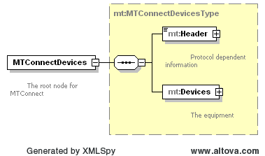

Figure : MTConnectDevices structure

MTConnectDevices provides the descriptive information about each device served by this Agent and specifies the data items that are available. In an MTConnectDevices XML Document, there **MUST** be a Header and it **MUST** be followed by Devices section. An MTConnectDevices XML Document **MUST** have the following structure (the details have been eliminated for illustrative purposes):

1. <MTConnectDevices xmlns:m="urn:mtconnect.com:MTConnectDevices:1.1"
2. xmlns:xsi="http://www.w3.org/2001/XMLSchema-instance"
3. xmlns="urn:mtconnect.com:MTConnectDevices:1.1"
4. xsi:schemaLocation="urn:mtconnect.com:MTConnectDevices:1.1   
    http://www.mtconnect.org/schemas/MTConnectDevices_1.1.xsd">
5. <Header> … </Header>
6. <Devices> … </Devices>
7. </MTConnectDevices>

### MTConnectDevices Elements

An MTConnectDevices element **MUST** include the Header for all documents and the Devices element.

| **Element** | **Description** | **Occurrence** |
| --- | --- | --- |
| Header | A simple header with next sequence and creation time | 1 |
| Devices | The root of the descriptive data | 1 |

For the above elements of the XML Document, please refer to Part 1 section 4.4 for Header and Part 2 section 3 Components and Devices.

## MTConnectStreams

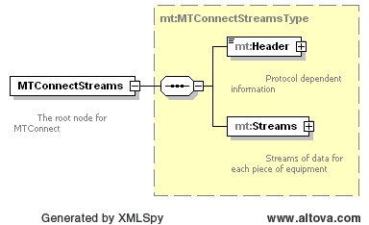

Figure : MTConnectStreams structure

MTConnectStreams contains a timeseries of Samples, Events, and Condition from devices and their components. In an MTConnectStreams XML Document, there **MUST** be a Header and it **MUST** be followed by a Streams section. An MTConnectStreams XML Document will have the following structure (the details have been eliminated for illustrative purposes):

1. <MTConnectStreams xmlns:m="urn:mtconnect.com:MTConnectStreams:1.1"
2. xmlns:xsi="http://www.w3.org/2001/XMLSchema-instance"
3. xmlns="urn:mtconnect.com:MTConnectStreams:1.1"
4. xsi:schemaLocation="urn:mtconnect.com:MTConnectStreams:1.1 http://www.mtconnect.org/schemas/MTConnectStreams.xsd">
5. <Header> … </Header>
6. <Streams> … </Streams>
7. </MTConnectStreams>

### MTConnectStreams Elements

An MTConnectStreams document **MUST** include a Header and a Streams element.

| **Element** | **Description** | **Occurrence** |
| --- | --- | --- |
| Header | A simple header with next sequence and creation time | 1 |
| Streams | The root of the sample and event data | 1 |

For the above elements of the XML Document, please refer to Part 1 section 4.4 for Header and Part 3 section 3 for Streams.

## MTConnectError

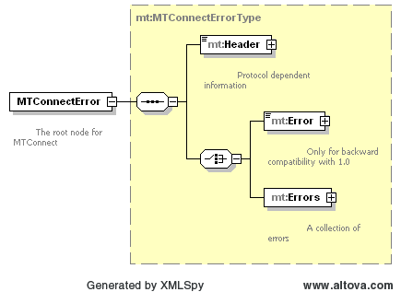

Figure : MTConnectError structure

An MTConnectError document contains information about an error that occurred in processing the request. In an MTConnectError XML Document, there **MUST** be a Header and it must be followed by an Errors container that can contain a series of Error elements:

1. <?xml version="1.0" encoding="UTF-8"?>
2. <MTConnectError xmlns="urn:mtconnect.org:MTConnectError:1.1" xmlns:xsi="http://www.w3.org/2001/XMLSchema-instance" xsi:schemaLocation="urn:mtconnect.org:MTConnectError:1.1 http://www.mtconnect.org/schemas/MTConnectError_1.1.xsd">
3. <Header creationTime="2010-03-12T12:33:01" sender="localhost" version="1.1" bufferSize="131072" instanceId="1268463594" />
4. <Errors>
5. <Error errorCode="OUT_OF_RANGE" >Argument was out of range</Error>
6. <Error errorCode="INVALID_PATH" >Bad path</Error>
7. </Errors>
8. </MTConnectError>

For purposes of backward compatibility, a single error can have a single Error element.

1. <?xml version="1.0" encoding="UTF-8"?>
2. <MTConnectError xmlns="urn:mtconnect.org:MTConnectError:1.1" xmlns:xsi="http://www.w3.org/2001/XMLSchema-instance" xsi:schemaLocation="urn:mtconnect.org:MTConnectError:1.1 http://www.mtconnect.org/schemas/MTConnectError_1.1.xsd">
3. <Header creationTime="2010-03-12T12:33:01" sender="localhost" version="1.1" bufferSize="131072" instanceId="1268463594" />
4. <Error errorCode="OUT_OF_RANGE" >Argument was out of range</Error>
5. </MTConnectError>

### MTConnectError Elements

An MTConnect® document **MUST** include the Header for all documents and one Error element.

| **Element** | **Description** | **Occurrence** |
| --- | --- | --- |
| Header | A simple header with next sequence and creation time | 1 |
| Errors | A collection of Error elements. | 1 |

For the above elements of the XML Document, please refer to section 4.4 for Header and section 5.5 for Error.

## Header

Every MTConnect® response **MUST** contain a header as the first element below the root element of any MTConnect® XML Document sent back to an application. The following information **MUST** be provided in the header: creationTime, instanceId, sender, bufferSize, and version. If the document is an MTConnectStreams document it **MUST** also contain the nextSequence, firstSequence, and lastSequence attributes as well.

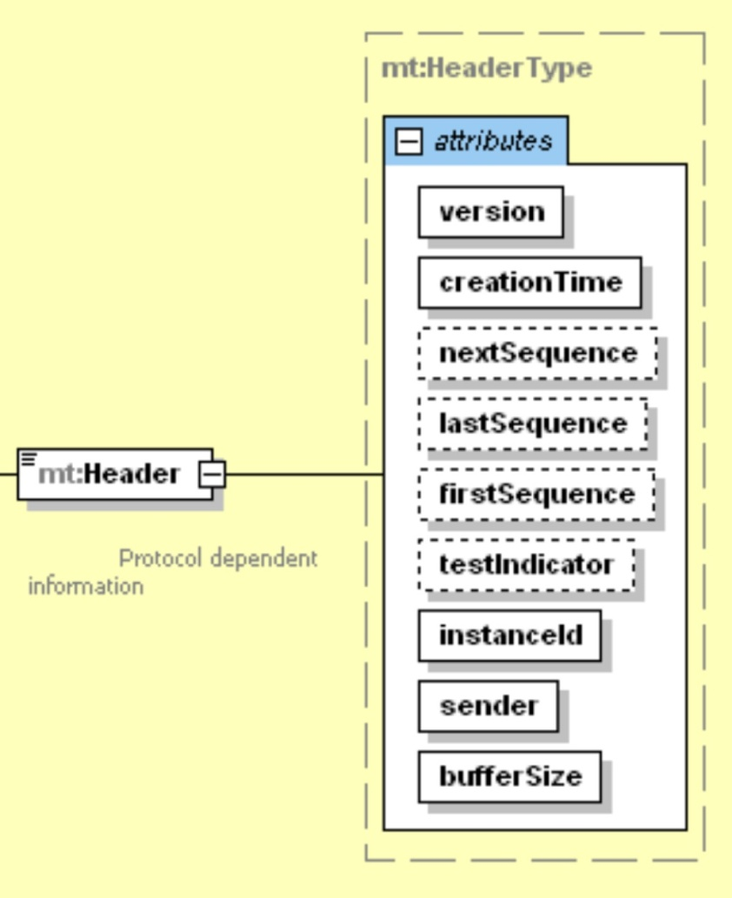

Figure 6: Header Schema Diagram

<Header creationTime="2010-03-13T07:59:11+00:00" sender="localhost"   
 instanceId="1268463594" bufferSize="131072" version="1.1"  
 nextSequence="154" firstSequence="1" lastSequence="153" />

### Header Attributes

| **Attribute** | **Description** | **Occurrence** |
| --- | --- | --- |
| creationTime | The time the response was created. | 1 |
| nextSequence | The sequence number to use for the next request. Used for sample and current requests. Not used in probe request. This value **MUST** have a maximum value of 2^63-1 and **MUST** be stored in an signed 64 bit integer. | 0..1 |
| instanceId | A number indicating which invocation of the Agent. This is used to differentiate between separate instances of the Agent. This value **MUST** have a maximum value of 2^63-1 and **MUST** be stored in an signed 64 bit integer. | 1 |
| testIndicator | Optional flag that indicates the system is operating in test mode. This data is only for testing and indicates that the data is simulated. | 0..1 |
| sender | The Agent identification information. | 1 |
| bufferSize | The number of Samples, Events, and Condition that will be retained by the Agent. The buffersize **MUST** be a positive integer value with a maximum value of 2^31-1. | 1 |
| firstSequence | The sequence number of the first sample or event available. This value **MUST** have a maximum value of 2^63-1 and **MUST** be stored in an signed 64 bit integer. | 0..1 |
| lastSequence | The sequence number of the last sample or event available. This value **MUST** have a maximum value of 2^63-1 and **MUST** be stored in an signed 64 bit integer. | 0..1 |
| version | The protocol version number. This is the major and minor version number of the MTConnect standard being used. For example if the version number is current 10.21.33, the version will be 10.21. | 1 |

The nextSequence, firstSequence, and lastSequence number **MUST** be included in sample and current responses. These values **MAY** be used by the client application to determine if the sequence values are within range.The testIndicator **MAY** be provided as needed.

Details on the meaning of various fields and how they relate to the protocol are described in detail in the next section on *Protocol (section 5)*. The standard specifies how the protocol **MUST** be implemented to provide consistent MTConnect® Agent behavior.

The instanceId **MAY** be implemented using any unique information that will be guaranteed to be different each time the sequence number counter is reset. This will usually happen when the MTConnect® Agent is restarted. If the Agent is implemented with the ability to recover the event stream and the next sequence number when it is restarted, then it **MUST** use the same instanceId when it restarts.

The instanceId allows the MTConnect® Agents to forgo persistence of events and samples and restart clean each time. Persistence is a decision for each implementation to be determined. This will be discussed further in the section on *Fault Tolerance (in section 5.10).*

The sender **MUST** be included in the header to indicate the identity of the Agent sending the response. The sender **MUST** be in the following format: http://<address>[:port]/. The port **MUST** only be specified if it is **NOT** the default HTTP port 80.

The bufferSize **MUST** contain the maximum number of results that can be stored in the Agent at any one instant. This number can be used by the application to determine how frequently it needs to sample and if it can recover in case of failure. It is the decision of the implementer to determine how large the buffer should be.

As a general rule, the buffer **SHOULD** be sufficiently large to contain at least five minutes’ worth of events and samples. Larger buffers are more desirable since they allow longer application recovery cycles. If the buffer is too small, data can be lost. The Agent **SHOULD** **NOT** be designed so it becomes burdensome to the device and could cause any interruption to normal operation.

# Protocol

The MTConnect® Agent collects and distributes data from the components of a device to other devices and applications. The standard requires that the protocol **MUST** function as described in this section; the tools used to implement the protocol are the decision of the developer.

MTConnect® provides a RESTful interface. The term REST is short for ***RE****presentational* ***S****tate* ***T****ransfer* and provides an architectural framework that defines how state will be managed within the application and Agent. REST dictates that the server is unaware of the clients state and it is the responsibility of the client application to maintain the current read position or next operation. This removes the server’s burden of keeping track of client sessions. The underlying protocol is HTTP, the same protocol as used in all web browsers.

The MTConnect® *Agent* **MUST** support HTTP version 1.0 or greater. The only requirement for an MTConnect® Agent is that it **MUST** support the HTTP GET verb. The response to an MTConnect® request **MUST** always be in XML. The HTTP request **SHOULD NOT** include a body. If the Agent receives a body, the Agent **MAY** ignore it. The *Agent* **MAY** ignore any cookies or additional information. The only information the Agent **MUST** consider is the URI in the HTTP GET.

If the HTTP GET verb is not used, the *Agent* must respond with a HTTP 400 Bad Request indicating that the client issued a bad request. See section 5.6 for further discussion on error handling.

## Standard Request Sequence

MTConnect® Agent **MUST** support three types of requests:

* probe – to retrieve the components and the data items for the device. Returns a MTConnectDevices XML document.
* current – to retrieve a snapshot of the data item’s most recent values or the state of the device at a point in time. Returns an MTConnectStreams XML document.
* sample – to retrieve the Samples, Events, and Condition in time series. Returns an MTConnectStreams XML document.

The sequence of requests for a standard MTConnect® conversation will typically begin with the application issuing a probe to determine the capabilities of the device. The result of the probe will provide the component structure of the device and all the available data items for each component.

Once the application determines the necessary data items are available from the Agent, it can issue a current request to acquire the latest values of all the data items and the next sequence number for subsequent sample requests. The application **SHOULD** also record the instanceId to know when to reset the sequence number in the eventuality of Agent failure. *(See Fault Tolerance (Section 5.10) for a complete discussion of the use of instanceId).*

Once the current state has been retrieved, the Agent can be sampled at a rate determined by the needs of the application. After each request, the application **SHOULD** save the nextSequencenumber for the next request. This allows the application to receive all results without missing a single sample or event and removes the need for the application to compute the value of the from parameter for the next request.

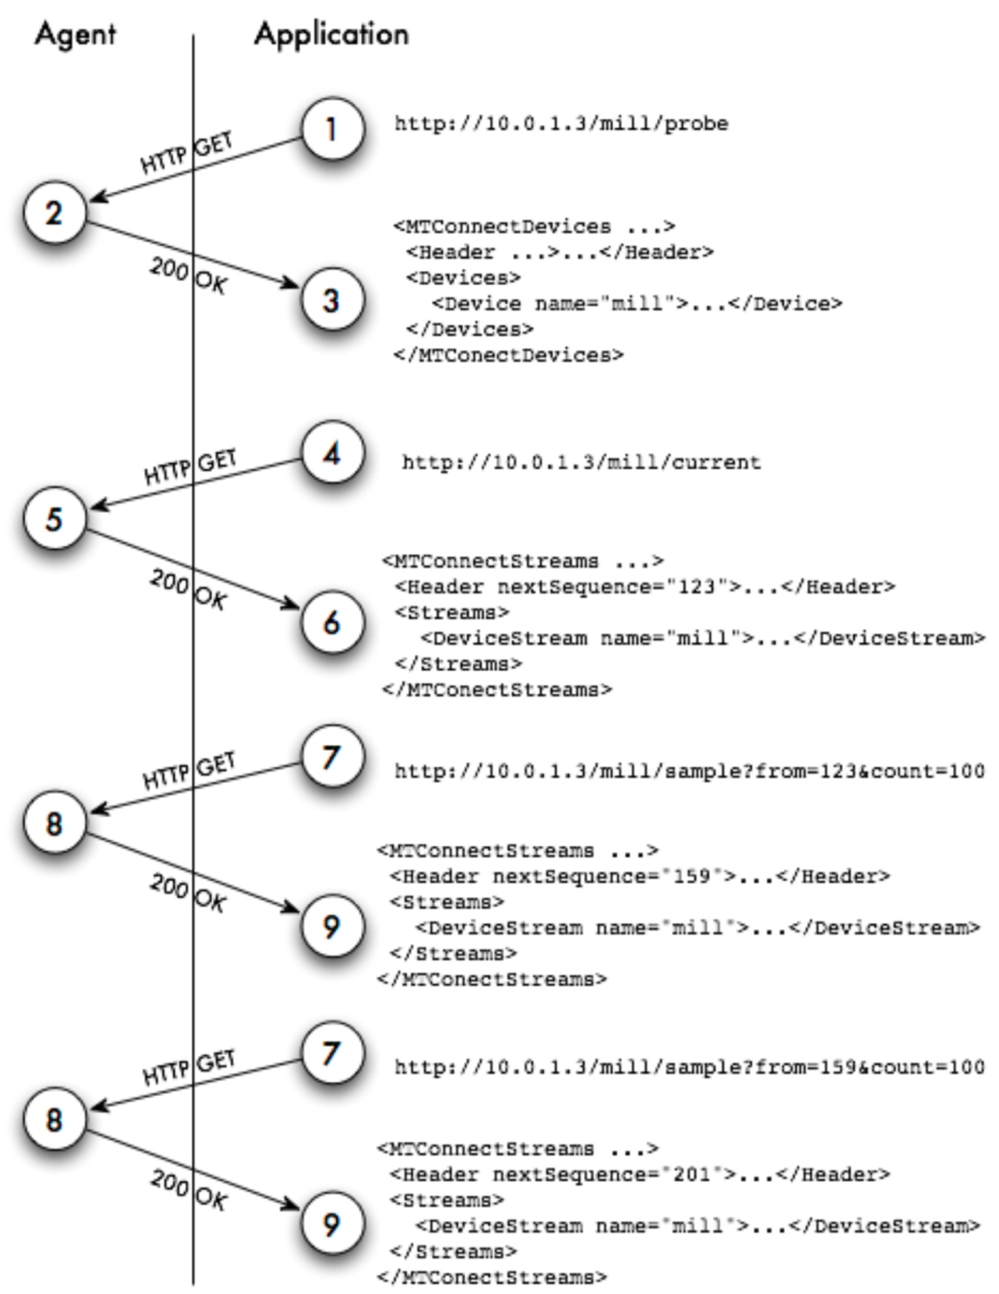

Figure 7: Application and Agent Conversation

The above diagram illustrates a standard conversation between an application and an MTConnect® Agent. The sequence is very simple because the entire protocol is an HTTP request/response. The next sequence number handling is shown as a guideline for capturing the stream of Samples, Events, and Condition.

## Probe Requests

The MTConnect® Agent **MUST** provide a probe response that describes this Agent’s devices and all the devices’ components and data items being collected. The response to the probe **MUST** always provide the most recent information available. A probe request **MUST NOT** supply any parameters. If any are supplied, they **MUST** be ignored. The response from the probe will be static as long as the machine physical composition and capabilities do not change, therefore it is acceptable to probe very infrequently. In many cases, once a week may be sufficient.

The probe request **MUST** support two variations:

* The first provides information on only one device. The device’s name **MUST** be specified in the first part of the path. This example will only retrieve components and data items for the mill-1 device.

1. http://10.0.1.23/mill-1/probe

* The second does not specify the device and therefore retrieves information for all devices:

1. http://10.0.1.23/probe

#### Example

The following is an example probe response for 4 Axis Simulator:

1. <?xml version="1.0" encoding="UTF-8"?>
2. <MTConnectDevices xmlns:m="urn:mtconnect.org:MTConnectDevices:1.1" xmlns:xsi="http://www.w3.org/2001/XMLSchema-instance" xmlns="urn:mtconnect.org:MTConnectDevices:1.1" xsi:schemaLocation="urn:mtconnect.org:MTConnectDevices:1.1 http://www.mtconnect.org/schemas/MTConnectDevices_1.1.xsd">
3. <Header creationTime="2010-03-13T08:02:38+00:00" sender="localhost" instanceId="1268463594" bufferSize="131072" version="1.1" />
4. <Devices>
5. <Device id="dev" name="VMC-4Axis" uuid="XXX111">
6. <DataItems>
7. <DataItem category="EVENT" id="avail" type="AVAILABILITY" />
8. </DataItems>
9. <Components>
10. <Axes id="axes" name="axes">
11. <Components>
12. <Linear id="x" name="X">
13. <DataItems>
14. <DataItem category="SAMPLE" id="Xact" nativeUnits="MILLIMETER" subType="ACTUAL" type="POSITION" units="MILLIMETER" />
15. <DataItem category="SAMPLE" id="Xload" nativeUnits="PERCENT" type="LOAD" units="PERCENT" />
16. <DataItem category="CONDITION" id="Xtravel" type="POSITION" />
17. <DataItem category="CONDITION" id="Xovertemp" type="TEMPERATURE" />
18. <DataItem category="CONDITION" id="Xservo" type="ACTUATOR" />
19. </DataItems>
20. </Linear>
21. <Linear id="y" name="Y">
22. <DataItems>
23. <DataItem category="SAMPLE" id="Yact" nativeUnits="MILLIMETER" subType="ACTUAL" type="POSITION" units="MILLIMETER" />
24. <DataItem category="SAMPLE" id="Yload" nativeUnits="PERCENT" type="LOAD" units="PERCENT" />
25. <DataItem category="CONDITION" id="Ytravel" type="POSITION" />
26. <DataItem category="CONDITION" id="Yovertemp" type="TEMPERATURE" />
27. <DataItem category="CONDITION" id="Yservo" type="ACTUATOR" />
28. </DataItems>
29. </Linear>
30. <Linear id="z" name="Z">
31. <DataItems>
32. <DataItem category="SAMPLE" id="Zact" nativeUnits="MILLIMETER" subType="ACTUAL" type="POSITION" units="MILLIMETER" />
33. <DataItem category="SAMPLE" id="Zload" nativeUnits="PERCENT" type="LOAD" units="PERCENT" />
34. <DataItem category="CONDITION" id="Ztravel" type="POSITION" />
35. <DataItem category="CONDITION" id="Zovertemp" type="TEMPERATURE" />
36. <DataItem category="CONDITION" id="Zservo" type="ACTUATOR" />
37. </DataItems>
38. </Linear>
39. <Rotary id="a" name="A">
40. <DataItems>
41. <DataItem category="SAMPLE" id="Aact" nativeUnits="DEGREE" subType="ACTUAL" type="ANGLE" units="DEGREE" />
42. <DataItem category="SAMPLE" id="Aload" nativeUnits="PERCENT" type="LOAD" units="PERCENT" />
43. <DataItem category="CONDITION" id="Atravel" type="POSITION" />
44. <DataItem category="CONDITION" id="Aovertemp" type="TEMPERATURE" />
45. <DataItem category="CONDITION" id="Aservo" type="ACTUATOR" />
46. </DataItems>
47. </Rotary>
48. <Rotary id="c" name="C" nativeName="S1">
49. <DataItems>
50. <DataItem category="SAMPLE" id="S1speed" nativeUnits="REVOLUTION/MINUTE" type="SPINDLE_SPEED" units="REVOLUTION/MINUTE" />
51. <DataItem category="EVENT" id="S1mode" type="ROTARY_MODE">
52. <Constraints>
53. <Value>SPINDLE</Value>
54. </Constraints>
55. </DataItem>
56. <DataItem category="SAMPLE" id="S1load" nativeUnits="PERCENT" type="LOAD" units="PERCENT" />
57. <DataItem category="CONDITION" id="spindle" type="SYSTEM" />
58. </DataItems>
59. </Rotary>
60. </Components>
61. </Axes>
62. <Controller id="cont" name="controller">
63. <DataItems>
64. <DataItem category="CONDITION" id="logic" type="LOGIC_PROGRAM" />
65. <DataItem category="EVENT" id="estop" type="EMERGENCY_STOP" />
66. <DataItem category="CONDITION" id="servo" type="ACTUATOR" />
67. <DataItem category="EVENT" id="message" type="MESSAGE" />
68. <DataItem category="CONDITION" id="comms" type="COMMUNICATIONS" />
69. </DataItems>
70. <Components>
71. <Path id="path" name="path">
72. <DataItems>
73. <DataItem category="SAMPLE" id="SspeedOvr" nativeUnits="PERCENT" subType="OVERRIDE" type="SPINDLE_SPEED" units="PERCENT" />
74. <DataItem category="EVENT" id="block" type="BLOCK" />
75. <DataItem category="EVENT" id="execution" type="EXECUTION" />
76. <DataItem category="EVENT" id="program" type="PROGRAM" />
77. <DataItem category="SAMPLE" id="path_feedrate" nativeUnits="MILLIMETER/SECOND" type="PATH_FEEDRATE" units="MILLIMETER/SECOND" />
78. <DataItem category="EVENT" id="mode" type="CONTROLLER_MODE" />
79. <DataItem category="EVENT" id="line" type="LINE" />
80. <DataItem category="SAMPLE" id="path_pos" nativeUnits="MILLIMETER_3D" subType="ACTUAL" type="PATH_POSITION" units="MILLIMETER_3D" />
81. <DataItem category="SAMPLE" id="probe" nativeUnits="MILLIMETER_3D" subType="PROBE" type="PATH_POSITION" units="MILLIMETER_3D" />
82. <DataItem category="EVENT" id="part" type="PART_ID" />
83. <DataItem category="CONDITION" id="motion" type="MOTION_PROGRAM" />
84. <DataItem category="CONDITION" id="system" type="SYSTEM" />
85. </DataItems>
86. </Path>
87. </Components>
88. </Controller>
89. </Components>
90. </Device>
91. </Devices>
92. </MTConnectDevices>

## Sample Request

The sample request retrieves the values for the component’s data items. The reponse to a sample request **MUST** be a valid MTConnectStreams XML Document.

The diagram below is an example of all the components and data items in relation to one another. The device has one Controller with a single Path, three linear and one rotary axis and two data items for each axis. The Controller’s Path is capable of providing the execution status and the current block of code. The device has a data item, Availability, that indicates the device is available to communicate.

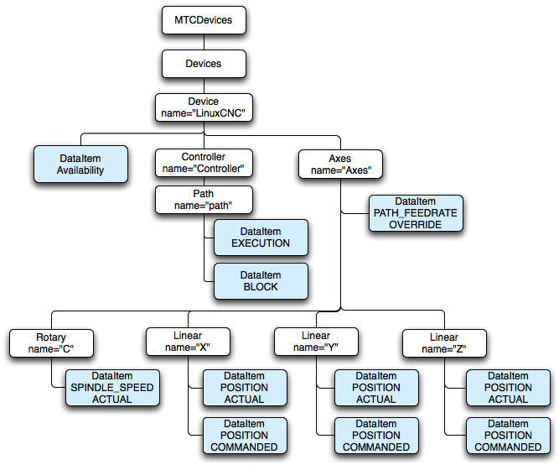

Figure 8: Sample Device Organization

The following path will request the data items for all components in mill-1 with regards to the example above (note that the path parameter refers to the XML Document structure from the probe request, not the XML Document structure of the sample):

1. http://10.0.1.23:3000/mill-1/sample

This is equivalent to providing a path-based filter for the device named mill-1:

1. http://10.0.1.23:3000/sample?path=//Device[@name=”mill-1”]

To request all the axes’ data items the following path expression is used:

1. http://10.0.1.23:3000/mill-1/sample?path=//Axes

To specify only certain data items to be included (e.g. the positions from the axes), use this form:

1. http://10.0.1.23:3000/mill-1/sample?path=//Axes//DataItem[@type=”POSITION”]

To retrieve only actual positions instead of both the actual and commanded, the following path syntax can be used:

1. http://10.0.1.23:3000/mill-1/sample?path=//Axes//DataItem[@type=”POSITION” and @subType=”ACTUAL”]

or:

1. [http://10.0.1.23:3000/mill-1/sample?path=](http://10.0.1.23:3000/mill-1/sample.xml)//Axes//DataItem[@type=”POSITION” and @subType=”ACTUAL”]&from=50&count=100

The above example will retrieve all the axes’ positions from sample 50 to sample 150. The actual number of items returned will depend on the contents of the data in the Agent and the number of results that are actual position samples.

A more complete discussion of the protocol can be found in the section on *Protocol Details.*

### Parameters

All parameters **MUST** only be given once and the order of the parameters is not important. The MTConnect® Agent **MUST** accept the following parameters for the sample request:

path - This is an xpath expression specifying the components and/or data items to include in the sample. If the path specifies a component, all data items for that component and any of its sub-components **MUST** be included. For example, if the application specifies the path=//Axes, then all the data items for the Axes component as well as the Linear and Rotary sub-components **MUST** be included as well.

from - This parameter requests events and samples starting at this sequence number. The sequence number can be obtained from a prior current or sample request. The response **MUST** provide the nextSequence number. If the value is 0 the first available sample or event **MUST** be used. If the value is less than 0 (< 0) an INVALID_REQUEST error **MUST** be returned.

count - The maximum number of events and samples to consider, see detailed explanation below. Events and samples will be considered between from and from + count, where the latter is the lesser of from + count and the last sequence number stored in the agent. The Agent **MUST NOT** send back more than this number of events and samples (in aggregate), but fewer events and samples **MAY** be returned. If the value is less than 1 (< 1) an INVALID_REQUEST error **MUST** be returned.

frequency – The *Agent* **MUST** stream Samples, Events, and Condition to the client application pausing for frequency milliseconds between each part. Each part will contain a maximum of count events or samples and from will be used to indicate the beginning of the stream.

The nextSequence number in the header **MUST** be set to the sequence number following the largest sequence number (highest sequence number + 1) of all the events and samples considered when collecting the results.

If no parameters are given, the following defaults **MUST** be used:

The path **MUST** default to all components in the device or devices if no device is specified.

The count **MUST** default to 100 if it is not specified.

The from **MUST** default to 0 and return the first available event or sample. If the latest state is desired, see current.

## Current Request

The current request retrieves the values for the components’ data items at the point the request is received. The response to the request **MUST** contain the most current values for all data items specified in the request path. If the path is not given, it **MUST** respond with all data items for the device(s), in the same way as the sample request.

current **MUST** return the nextSequence number for the event or sample directly following the point at which the snapshot was taken. This **MUST** be determined by finding the sequence number of the last event or sample in the Agent and adding one (+1) to that value. The nextSequence number **MAY** be used for subsequent samples.

The Samples, Events, and Condition returned from the current request **MUST** have the time-stamp and the sequence number that was assigned at the time the data was collected. The Agent **MUST NOT** alter the original time, sequence, or values that were assigned when the data was collected.

http://10.0.1.23:3000/mill-1/current?path=//Axes//DataItem[@type=”POSITION” and @subType=”ACTUAL”]

This example will retrieve the current actual positions for all the axes, as with a sample, except with current, there will always be a sample or event for each data item if at least one piece of data was retrieved from the device.

http://10.0.1.23:3000/mill-1/current?path=//Axes//DataItem[@type=”POSITION” and @subType=”ACTUAL”]&at=1232

The previous example retrieves the axes actual position at the *Agent* sequence number 1232 in the history.

### Parameters

The MTConnect® Agent **MUST** accept the following parameter for the current request:

path - same requirements as sample.

freqency - same requirements as sample. **MUST NOT** be used with at.

at - an optional argument specifying the MTConnect protocol sequence number. If supplied, the most current values on or before the sequence number **MUST** be provided. If at is not provided, the latest values **MUST** be provided. at **MUST NOT** be used with the frequency as this will just return the same data set repeatedly.

If no parameters are provided for the current request, all data items **MUST** be retrieved with their latest values.

### Getting the State at a Sequence Number

The current at allows an application to monitor real-time conditions and then perform causal analysis by requesting the current values for all the data items at the sequence number of interest. This removes the requirement that the application continually poll for all state and burden the server and the network with unneeded information associated with faults or other abnormal conditions.

## Streaming

When the frequency parameter is provided, the MTConnect® *Agent* **MUST** find all available events and sample that match the current filter criteria specified by the path at the frequency given or at its maximum possible scan rate. The frequency indicates the delay between data deliveries. A frequency of zero indicates the *Agent* deliver data at its highest possible frequency.

The frequency **MUST** be given in milliseconds. If there are no available events or samples, the *Agent* **MAY** delay sending an update for **AT MOST** ten (10) seconds. The *Agent* **MUST** send updates at least once every ten (10) seconds to ensure the receiver that the *Agent* is functioning correctly. The content of the streams **MUST** be empty if no data is available for a given interval.

The format of the response **MUST** use a MIMEencoded message with each section separated by a MIMEboundary. Each section of the response **MUST** contain an entire MTConnectStreams document.

For more information on MIME see rfc1521 and rfc822. This format is in use with most streaming web media protocols.

Request:

http://localhost/sample?frequency=1000&path=//DataItem[@type=”AVAILABILITY”]

Sample response:

1. HTTP/1.1 200 OK
2. Connection: close
3. Date: Sat, 13 Mar 2010 08:33:37 UTC
4. Status: 200 OK
5. Content-Disposition: inline
6. X-Runtime: 144ms
7. Content-Type: multipart/x-mixed-replace;boundary=a8e12eced4fb871ac096a99bf9728425

Lines 1-12 are a standard header for a MIME multipart message. The boundary is a separator for each section of the stream. The content length is set to some arbitrarily large number or omitted. Line 10 indicates this is a multipart MIME message and the boundary between sections.

1. --a8e12eced4fb871ac096a99bf9728425
2. Content-type: text/xml
3. Content-length: 887
4. <?xml version="1.0" encoding="UTF-8"?>
5. <MTConnectStreams xmlns:m="urn:mtconnect.org:MTConnectStreams:1.1" xmlns:xsi="http://www.w3.org/2001/XMLSchema-instance" xmlns="urn:mtconnect.org:MTConnectStreams:1.1" xsi:schemaLocation="urn:mtconnect.org:MTConnectStreams:1.1 http://www.mtconnect.org/schemas/MTConnectStreams_1.1.xsd">
6. <Header creationTime="2010-03-13T08:33:37+00:00" sender="localhost" instanceId="1268469210" bufferSize="131072" version="1.1" nextSequence="43" firstSequence="1" lastSequence="42" />
7. <Streams>
8. <DeviceStream name="VMC-4Axis" uuid="XXX111">
9. <ComponentStream component="Device" name="VMC-4Axis" componentId="dev">
10. <Events>
11. <Availability dataItemId="avail" sequence="25" timestamp="2010-03-13T08:33:30.555235">UNAVAILABLE</Availability>
12. </Events>
13. </ComponentStream>
14. </DeviceStream>
15. </Streams>
16. </MTConnectStreams>

Lines 13-28 are the first section of the stream. Since there was no activity in this time period there are no component streams included. Each section presents the content type and the length of the section. The boundary is chosen to be a string of characters that will not appear in the message.

1. --a8e12eced4fb871ac096a99bf9728425
2. Content-type: text/xml
3. Content-length: 545
4. <?xml version="1.0" encoding="UTF-8"?>
5. <MTConnectStreams xmlns:m="urn:mtconnect.org:MTConnectStreams:1.1" xmlns:xsi="http://www.w3.org/2001/XMLSchema-instance" xmlns="urn:mtconnect.org:MTConnectStreams:1.1" xsi:schemaLocation="urn:mtconnect.org:MTConnectStreams:1.1 http://www.mtconnect.org/schemas/MTConnectStreams_1.1.xsd">
6. <Header creationTime="2010-03-13T08:33:38+00:00" sender="localhost" instanceId="1268469210" bufferSize="131072" version="1.1" nextSequence="43" firstSequence="1" lastSequence="42" />
7. <Streams />
8. </MTConnectStreams>

Lines 29-50: After a period of time, the power gets turned off and a new mime part is sent with the new status.

1. --a8e12eced4fb871ac096a99bf9728425
2. Content-type: text/xml
3. Content-length: 883
4. <?xml version="1.0" encoding="UTF-8"?>
5. <MTConnectStreams xmlns:m="urn:mtconnect.org:MTConnectStreams:1.1" xmlns:xsi="http://www.w3.org/2001/XMLSchema-instance" xmlns="urn:mtconnect.org:MTConnectStreams:1.1" xsi:schemaLocation="urn:mtconnect.org:MTConnectStreams:1.1 http://www.mtconnect.org/schemas/MTConnectStreams_1.1.xsd">
6. <Header creationTime="2010-03-13T08:34:18+00:00" sender="localhost" instanceId="1268469210" bufferSize="131072" version="1.1" nextSequence="98" firstSequence="1" lastSequence="97" />
7. <Streams>
8. <DeviceStream name="VMC-4Axis" uuid="XXX111">
9. <ComponentStream component="Device" name="VMC-4Axis" componentId="dev">
10. <Events>
11. <Availability dataItemId="avail" sequence="65" timestamp="2010-03-13T08:34:16.0312">AVAILABLE</Availability>
12. </Events>
13. </ComponentStream>
14. </DeviceStream>
15. </Streams>
16. </MTConnectStreams>

Lines 51-72: Approximately six seconds later the machine is turned back on and a new message is generated. Even though we have a scan frequency of one second, the *Agent* waited for ten seconds to send a new message.

1. --a8e12eced4fb871ac096a99bf9728425
2. Content-type: text/xml
3. Content-length: 545
4. <?xml version="1.0" encoding="UTF-8"?>
5. <MTConnectStreams xmlns:m="urn:mtconnect.org:MTConnectStreams:1.1" xmlns:xsi="http://www.w3.org/2001/XMLSchema-instance" xmlns="urn:mtconnect.org:MTConnectStreams:1.1" xsi:schemaLocation="urn:mtconnect.org:MTConnectStreams:1.1 http://www.mtconnect.org/schemas/MTConnectStreams_1.1.xsd">
6. <Header creationTime="2010-03-13T08:34:27+00:00" sender="localhost" instanceId="1268469210" bufferSize="131072" version="1.1" nextSequence="98" firstSequence="1" lastSequence="97" />
7. <Streams />
8. </MTConnectStreams>

Lines 73-89 demonstrate a heartbeat sent out 10 seconds after the previous message. Since there is no activity there is no content in the device streams element.

The *Agent* **MUST** continue to stream results until the client closes the connection. All update will be handled asynchronously and **MUST** not impede the other requests both synchronous and asynchronous.

## HTTP Response Codes and Error

MTConnect® uses the HTTP response codes to indicate errors where no XML document is returned because the request was malformed and could not be handled by the *Agent.* These errors are serious and indicate the client application is sending malformed requests or the *Agent* has an unrecoverable error. The error code **MAY** also be used for HTTP authentication with the 401 request for authorization. The HTTP protocol has a large number of codes defined[1]; only the following mapping **MUST** be supported by the MTConnect® Agent:

| **HTTP  Status** | **Name** | **Description** |
| --- | --- | --- |
| 200 | OK | The request was handled successfully. |
| 400 | Bad Request | The request could not be interpreted. |
| 500 | Internal Error | There was an internal error in processing the request. This will require technical support to resolve. |
| 501 | Not Implemented | The request cannot be handled on the server because the specified functionality is not implemented. |

### MTConnectError

The MTConnectError document **MUST** be returned if the *Agent* cannot handle the request. The Error contains an errorCode and the CDATA of the element is the complete error text. The classification for errors is expected to expand as the standard matures.

For backward compatibility, MTConnectError can contain a single Error element. If there are more than one error to report, it is up to the implementation of the *Agent* to determine the most important error to include.

### Errors

The MTConnectError element **MUST** contain all relevant errors for the given request. The Errors element **MUST** contain at least one Error element. There are no attributes for this element.

### Error

The Error contains an errorCode and the CDATA of the element is the complete error text. The classification for errors is expected to expand as the standard matures.

|  |  |  |
| --- | --- | --- |
| **Attributes** | **Description** | **Occurrence** |
| errorCode | An error code | 1 |

The CDATA of the Error element is the textual description of the error and any additional information the Agent wants to send. The Error element **MUST** contain one of the following error codes:

| **Error Code** | **Description** |
| --- | --- |
| UNAUTHORIZED | The request did not have sufficient permissions to perform the request. |
| NO_DEVICE | The device specified in the URI could not be found. |
| OUT_OF_RANGE | The sequence number was beyond the end of the buffer. |
| TOO_MANY | The count given is too large. |
| INVALID_URI | The URI provided was incorrect. |
| INVALID_REQUEST | The request was not one of the three specified requests. |
| INTERNAL_ERROR | Contact the software provider, the Agent did not behave correctly. |
| INVALID_PATH | The xpath could not be parsed. Invalid syntax. |
| UNSUPPORTED | A valid request was provided, but the *Agent* does not support the feature or request type*.* |

Here is an example of an HTTP error:

1. HTTP/1.1 200 Success
2. Content-Type: text/xml; charset=UTF-8
3. Server: Agent
4. Date: Sun, 23 Dec 2007 21:10:19 GMT
5. <?xml version="1.0" encoding="UTF-8"?>
6. <MTConnectError xmlns="urn:mtconnect.org:MTConnectError:1.1" xmlns:xsi="http://www.w3.org/2001/XMLSchema-instance" xsi:schemaLocation="urn:mtconnect.org:MTConnectError:1.1 http://www.mtconnect.org/schemas/MTConnectError_1.1.xsd">
7. <Header creationTime="2010-03-12T12:33:01" sender="localhost" version="1.1" bufferSize="131000" instanceId="1" />
8. <Errors>
9. <Error errorCode="OUT_OF_RANGE" >Argument was out of range</Error>
10. <Error errorCode="INVALID_PATH" >Bad path</Error>
11. </Errors>
12. </MTConnectError>

## Protocol Details

When an MTConnect® Agent collects information from the device, it assigns each piece of information a unique sequence number. The sequence number **MUST** be assigned in monotonically increasing numbers in the order they arrive at the Agent. Each DataItem **SHOULD** provide a time-stamp indicating when the information was collect from the component. If no time-stamp is provided, the Agent **MUST** provide a time-stamp of its own. The time-stamps recorded by the application **MUST** be use as the means for the ordering of the messages as opposed to using the sequence number for this purpose.

Note: It is assumed the time-stamp is the best available estimate of when the data was recorded.

If two data items are sampled at the same exact time, they **MUST** be given the same time stamp. It is assumed that all events or samples with the same timestamp occurred at the same moment. A sample is considered to be valid until the time of the next sample for the same data item. If no new samples are present for a data item, the last value is maintained for the entire period between the samples. **Important:** MTConnect® only records data when it changes. If the value remains the same, MTConnect **MUST** record a duplicate value with a new sequence number and time stamp. There **MUST** **NEVER** be two identical adjacent values for the same data item in the same component.

For example, if the Xact is 0 at 12:00.0000 and Yact is 1 at 12:00.0000, these two samples were collected at the same moment. If Yact is 2 at 12:01.0000 and there is no value at this point for Xact, it is assumed that Xact is still 0 and has not moved.

The sequence number **MUST** be unique for this instance of the MTConnect® Agent, regardless of the device or component the data came from. The MTConnect® Agent provides the sequence numbers in series for all devices using the same counter. This allows for multi-device responses without sequence number collisions and unnecessary protocol complexity.

The information in MTConnect® can be thought of as a four column table of data where the first column is a sequence number increasing by increments of one, the second column is the time, the third column is the data item it is associated with, and the fourth column is the value. The storage, internal representation, and implementation is not part of this standard. The implementer can choose to store as much or as little information as they want, as long as they can support the requirements of the standard. They can also decide if it is necessary to locally persist the data.

The following table is an example of a small window of data collected from a device:

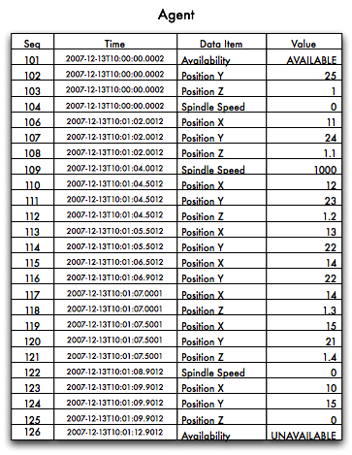

Figure 9: Sample Data in an Agent

This is a table of 25 data values and a duration of around 12 seconds. The data captures the availability of the device and the position of its axes: the linear axes X, Y, and Z, and the rotary axis C. The only data items collected in this example are the Position (for the sake of this data, we have the actual position) and the rotary axis C Spindle Speed. We are also collecting the device’s power state that can be either ON or OFF. The device is OFF when the sample starts.

For the remainder of the examples we will be excluding the time column to save space.

## Request without Filtering

In the example above, the application made a request for a sample starting at sequence #103 and retrieves the next eleven items. The response will include all the Samples, Events, and Condition in the mill device from 103 to 113. The nextSequence number in the header will tell the application it should begin the next request at 114. (The response is abbreviated and for illustration purpose only.)

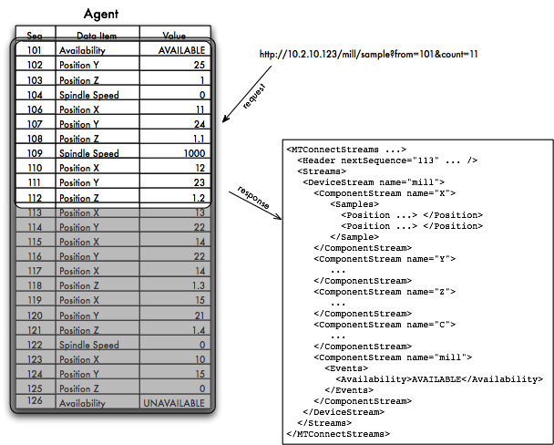

Figure 10: Example #1 for Sample from Sequence #101

In the following illustration, the next request starts at 114 and gets the next ten samples. The response will include the X, Y, Z, and C samples and since there are no Availablity events, this component will not be included:

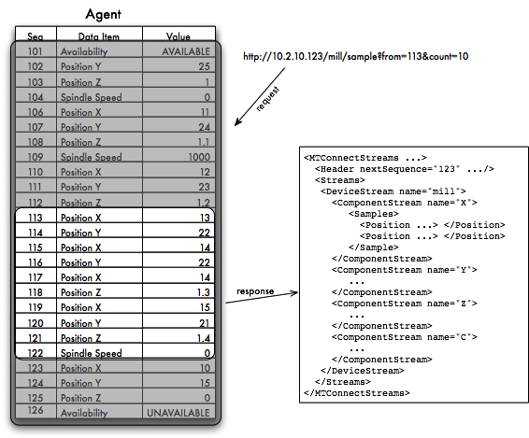

Figure 11: Example #1 for Sample from Sequence #113

In the above illustration, only the four axis components have samples. One will only get samples or events if they occur in the window being requested. In the next illustration, the application will request the next ten items starting at sequence number 124.

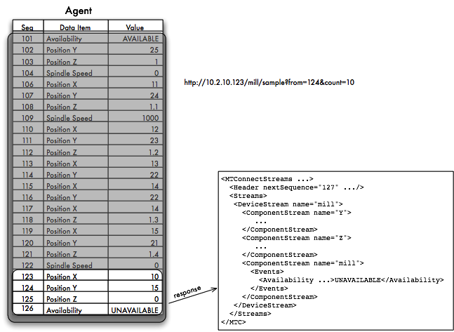

Figure 12: Example #1 for Sample from Sequence #124

In the above illustration, there are only three items available. The first two are axis samples and the third is a power event. The next sequence will indicate that the application must request Samples, Events, and Condition starting at 127 for the next group. If the application were to do this, it would receive an empty response with the nextSequence of 127 indicating that no data was available.

The next sequence number **MUST** always be the largest sequence number of available items in the selection window plus one. If the request indicated a from of 10 and a count of 10, the MTConnect® **MUST** consider at most 10 items if available. If the value for from is larger than the last item’s sequence number + 1, an OUT_OF_RANGE error **MUST** be returned from the Agent.

The same rule will be applied to the current request as well. In the instance of the current request, the next sequence **MUST** be set to the one greater than the last item’s sequence number in the table of data values. Since current always considers all events and samples, it **MUST** always be one greater than the maximum sequence number assigned.

## Request with Path Parameter

The next set of examples will show the behavior when a path parameter is provided.

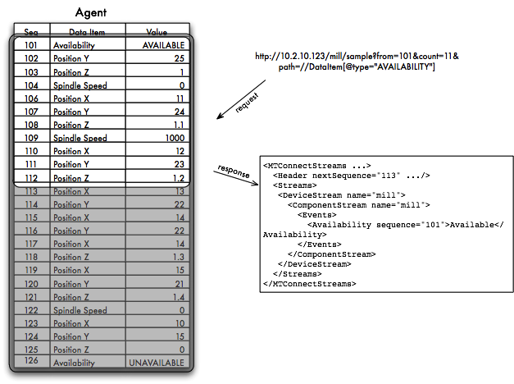

Figure 13: Example #2 for Sample from Sequence #103 with Path

Figure 12 shows that when events are filtered for only the Power component, the Power ON event will be delivered and nothing else. The Availability AVAILABLE event is sequence number 105, but since the other Samples, Events, and Condition are considered, the next sequence number is still 114. The MTConnect® Agent **MUST** set the next sequence number to one greater (+1) than the last event or sample in the window of items being considered. The Agent **MUST** consider all the events and samples evaluated in the process of formulating the response to the application.

In the next illustration the request is sent as before but now only including Power components:

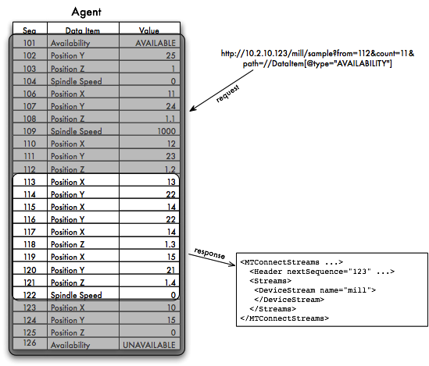

Figure 14: Example #2 for Sample from Sequence #114 with Path

An empty element representing the device **MUST** be returned to indicate that the request was valid and no data was found since there were no AVAILABILITY events in the given range. The nextSequence in the case **MUST** be set to 124 even though no results were returned. If this was not done, the application would continue to request sequence starting at 114 indefinitely.

To continue this example, the last request will start at 124 as before and will now request only Power components:

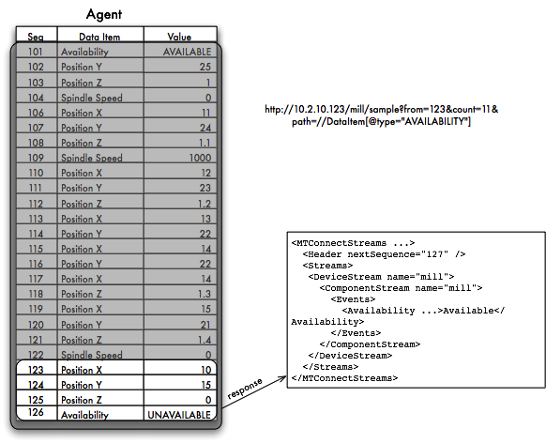

Figure 15: Example #2 for Sample from Sequence #123 with Path

As can be seen, the one Power event is returned and the next sequence is now 127. This will indicate that the application must request from 127 on for the next set of events. If no events are available, the nextSequence will again be set to 127 and an empty DeviceStream will be returned.

## Fault Tolerance and Recovery

MTConnect® does not provide a guaranteed delivery mechanism. The protocol places the responsibility for recovery on the application.

### Application Failure

The application failure scenario is easy to manage if the application persists the next sequence number after it processes each response. The MTConnect® protocol provides a simple recovery strategy that only involves reissuing the previous request with the recovered next sequence number.

There is the risk of missing some events or samples if the time between requests exceeds the capacity of the Agent’s buffer. In this case, there is no record of the missing information and it is lost. If the application automatically restarts after failure, the intervening data can be quickly recovered

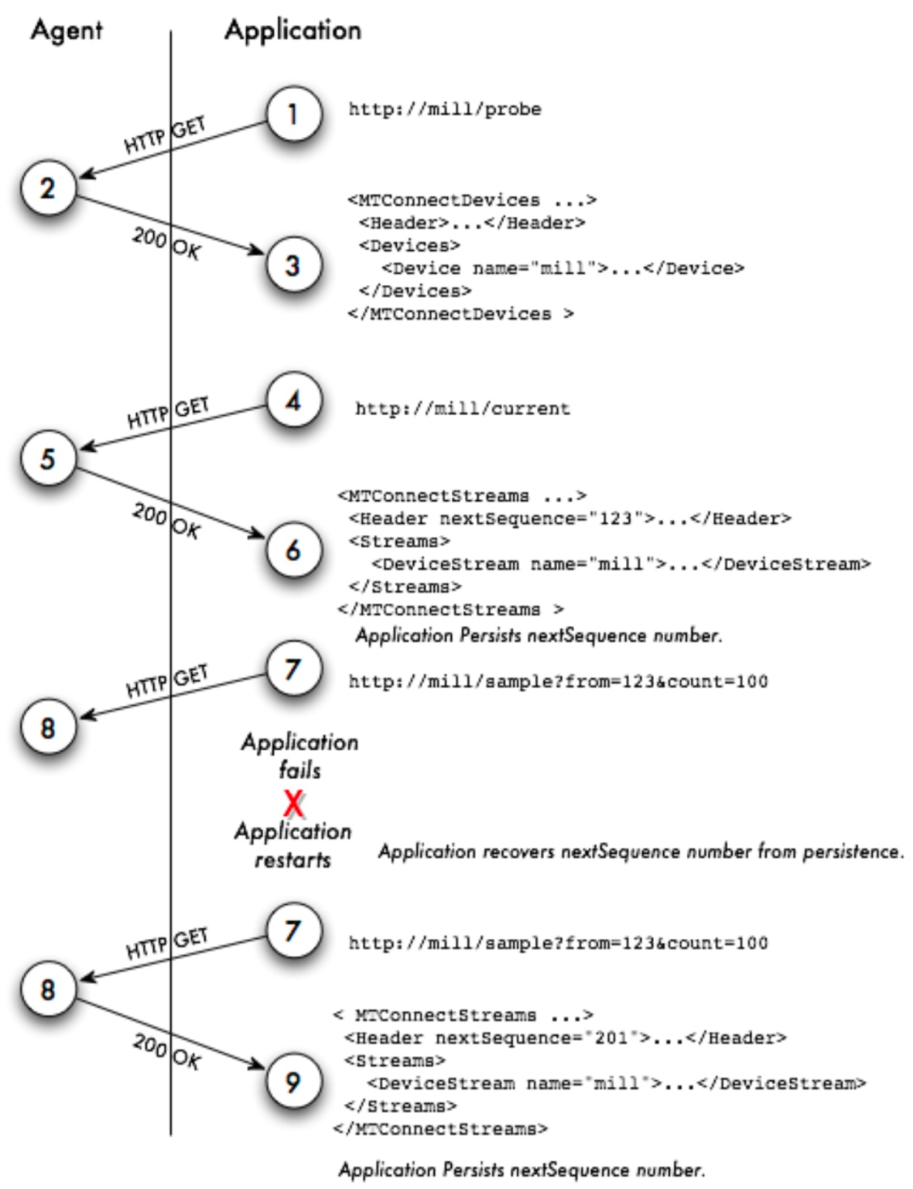

Figure 16: Application Failure and Recovery

If this cannot be done, the current state of the device can be retrieved and the application can continue from that point onward.

### Agent Failure

Agent failure is the more complex scenario and requires the use of the instanceId. The instanceId was created to facilitate recovery when the Agent fails and the application is unaware. Since HTTP is a connectionless protocol, there is no way for the application to easily detect that the Agent has restarted, the buffer has been lost, and the sequence number has been reset.

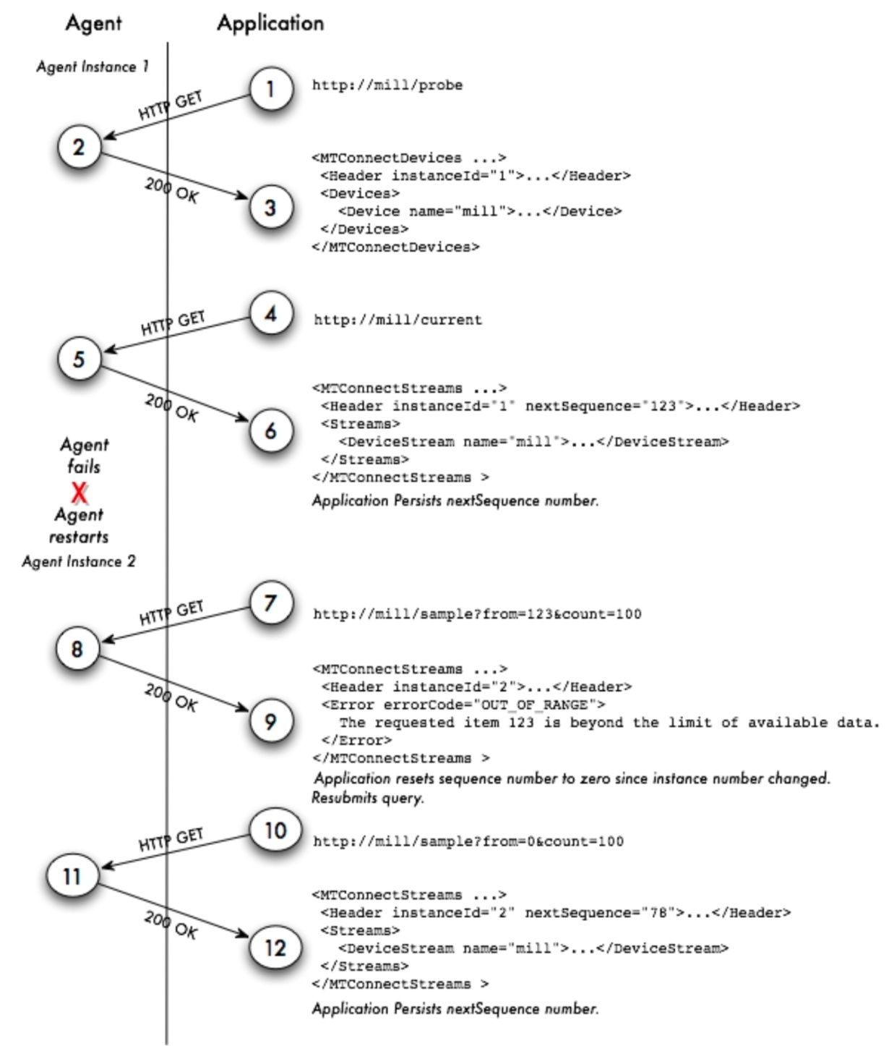

Figure 17: Agent Failure and Recovery

In the above example, the instanceId is increased from 1 to 2 indicating that there was a discontinuity in the sequence numbers. When the application detects the change in instanceId, it **MUST** reset its next sequence number and retry its request from sequence number 0. The next request will retrieve all data starting from the first available event or sample.

### Data Persistence and Recovery

The implementer of the Agent can decide on the strategy regarding the storage of events and samples. In the simplest form, the Agent can persist no data and hold all the results in volatile memory. If the Agent has a method of persisting the data fast enough and has sufficient storage, it **MAY** save as much or as little data as is practical in a recoverable storage system.

If the Agent can recover data and sequence numbers from a storage system, it **MUST NOT** change the instanceId when it restarts. This will indicate to the application that it need not reset the next sequence number when it requests the next set of data from the Agent.

If the Agent persists no data, then it **MUST** change the instanceId to a different value when it restarts. This will ensure that every application receiving information from the Agent will know to reset the next sequence number.

The instanceId can be any unique number that will be guaranteed to change every time the Agent restarts. If the Agent will take longer than one second to start, the UNIX time **MAY** be used for identification of the MTConnect® Agent in the instanceId.

## Unavailability of Data

In the event no data is available, the value for the data item in the stream **MUST** be UNAVAILABLE. This value indicates that the value is currently indeterminate and no assumptions are possible. MTConnect® supports multiple data sources per devices and for that reason, every data item **MUST** be considered independent and **MUST** maintain its own connection status.

In the following example, the data source for a temperature sensor becomes temporarily disconnected from the *Agent*. At this point the value changes from the current temperature to UNAVAILABLE since the temperature can no longer be determined.

In figure 17, the temperatures range around 100 until it becomes disconnected and then in the future it reconnects and the temperature is 30. Between these two points assumptions **SHOULD NOT** be made as to the temperature since no information was available.

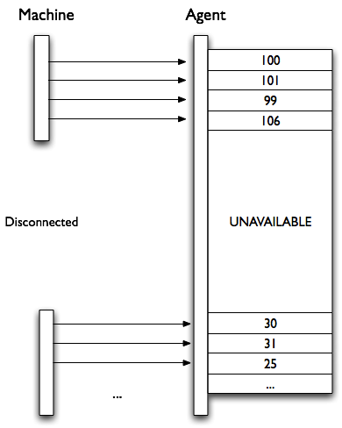

Figure : Unavailable Data from Machine

If data for multiple data items are delivered from one source and that source becomes unavailable, all data items associated with that source **MUST** have the value UNAVAILABLE. This **MUST** be a synchronous operation where all related data items will get that value with the same time stamp. The value will remain UNAVAILABLE until the data source has reconnected.

### Examples

1. <Linear name=”X” id=”x”>
2. <DataItems>
3. <DataItem type=”POSITION” category=”SAMPLE” id=”Xpos” … />
4. <DataItem type=”TEMPERATURE” category=”SAMPLE” id=”Ctemp” … />
5. </DataItems>
6. </Linear>

When the *Agent* is started and has no initial information about the device, all data item value **MUST** have the value UNAVAILABLE. The will produce the following results to a current reques:

<ComponentStream component="Linear" componentId="x" name="X">

<Samples>

<Position timestamp="2010-03-01T11:59:09.001" dataItemId="Xpos" sequence="99" >**UNAVAILABLE**</Position>

<Temperature timestamp="2010-03-01T11:59:09.001" dataItemId="Xpos" sequence="100" >**UNAVAILABLE**</Temperature>

</Samples>

</ComponentStream>

Once the adapters are connected, the values will no longer be UNAVAILABLE. The results from the current once again:

<ComponentStream component="Linear" componentId="x" name="X">

<Samples>

<Position timestamp="2010-03-01T12:09:31.021" dataItemId="Xpos" sequence="122" >**13.0003**</Position>

<Temperature timestamp="2010-03-01T12:07:22.031" dataItemId="Xpos" sequence="113" >**102**</Temperature>

</Samples>

</ComponentStream>

If the temperature sensor should lose power and become disconnected, as shown in figure 17, the following response will be given by current.

<ComponentStream component="Linear" componentId="x" name="X">

<Samples>

<Position timestamp="2010-03-01T12:12:19.311" dataItemId="Xpos" sequence="212" >**1.0003**</Position>

<Temperature timestamp="2010-03-01T12:15:41.121" dataItemId="Xpos" sequence="199" >**UNAVAILABLE**</Temperature>

</Samples>

</ComponentStream>

The X position has a valid value and only the Temperature is unknown. When a sample is requested, the value UNAVAILABLE will be treated the same as any other value for the data item.

<ComponentStream component="Linear" componentId="x" name="X">

<Samples>

<Position timestamp="2010-03-01T11:59:09" dataItemId="Xpos" sequence="212" >**1.0003**</Position>

<Position timestamp="2010-03-01T11:59:09" dataItemId="Xpos" sequence="212" >**2.2103**</Position>

<Position timestamp="2010-03-01T11:59:09" dataItemId="Xpos" sequence="212" >**4.3303**</Position>

<Temperature timestamp="2010-03-01T11:59:09" dataItemId="Xpos" sequence="199" >**101**</Temperature>

<Temperature timestamp="2010-03-01T11:59:09" dataItemId="Xpos" sequence="199" >**103**</Temperature>

<Temperature timestamp="2010-03-01T11:59:09" dataItemId="Xpos" sequence="199" >**UNAVAILABLE**</Temperature>

</Samples>

</ComponentStream>

### Constant valued data items

If the data item is constrained to one value, the initial value for this data item **MUST** be that value. For example:

1. <Rotary name=”C” id=”C” nativeName=”S”>
2. <DataItems>
3. <DataItem type=”ROTARY_MODE” category=”EVENT” id=”Cmode”>
4. <Constraints><Value>**SPINDLE**</Value></Constraints>
5. </DataItem>
6. <DataItem type=”SPINDLE_SPEED” category=”SAMPLE” id=”Cspeed”/>
7. </DataItems>
8. </Rotary>

In this example, the RotaryMode **MUST** be initialized to SPINDLE. If an application was to request data from this device before the adapter was connect, the result **MUST** be the following:

<ComponentStream component="Rotary" componentId="c" name="C">

<Events>

<RotaryMode timestamp="2010-03-01T11:58:09" dataItemId="Cmode" sequence="1" >**SPINDLE**</Position>

<Events>

<Samples>

<SpindleSpeed timestamp="2010-03-01T11:59:09" dataItemId="Cspeed" sequence="113" >**UNAVAILABLE**</Temperature>

</Samples>

</ComponentStream>

The SpindleSpeed shows UNAVAILABLE as described above, but the RotaryMode is assigned the constant value SPINDLE since it can only have one value. The value for RotaryMode **MAY** **NOT** be delivered by the *Adapter* and if it is, it **MUST** be SPINDLE.

For more information on Constraints, see *MTConnect Part 2, Section 4.1 – Data Item Element.*

Appendices

1. Bibliography
2. Engineering Industries Association. *EIA Standard - EIA-274-D*, Interchangeable Variable, Block Data Format for Positioning, Contouring, and Contouring/Positioning Numerically Controlled Machines. Washington, D.C. 1979.
3. ISO TC 184/SC4/WG3 N1089. *ISO/DIS 10303-238*: Industrial automation systems and integration Product data representation and exchange Part 238: Application Protocols: Application interpreted model for computerized numerical controllers. Geneva, Switzerland, 2004.
4. International Organization for Standardization. *ISO 14649*: Industrial automation systems and integration – Physical device control – Data model for computerized numerical controllers – Part 10: General process data. Geneva, Switzerland, 2004.
5. International Organization for Standardization. *ISO 14649*: Industrial automation systems and integration – Physical device control – Data model for computerized numerical controllers – Part 11: Process data for milling. Geneva, Switzerland, 2000.
6. International Organization for Standardization. *ISO 6983/1* – Numerical Control of machines – Program format and definition of address words – Part 1: Data format for positioning, line and contouring control systems. Geneva, Switzerland, 1982.
7. Electronic Industries Association. *ANSI/EIA-494-B-1992*, 32 Bit Binary CL (BCL) and 7 Bit ASCII CL (ACL) Exchange Input Format for Numerically Controlled Machines. Washington, D.C. 1992.
8. National Aerospace Standard. *Uniform Cutting Tests* - NAS Series: Metal Cutting Equipment Specifications. Washington, D.C. 1969.
9. International Organization for Standardization. *ISO 10303-11*: 1994, Industrial automation systems and integration Product data representation and exchange Part 11: Description methods: The EXPRESS language reference manual. Geneva, Switzerland, 1994.
10. International Organization for Standardization. *ISO 10303-21*: 1996, Industrial automation systems and integration -- Product data representation and exchange -- Part 21: Implementation methods: Clear text encoding of the exchange structure. Geneva, Switzerland, 1996.
11. H.L. Horton, F.D. Jones, and E. Oberg. *Machinery's handbook*. Industrial Press, Inc. New York, 1984.
12. International Organization for Standardization. *ISO 841-2001: Industrial automation systems and integration - Numerical control of machines - Coordinate systems and motion nomenclature.* Geneva, Switzerland, 2001.
13. *ASME B5.59-2 Version 9c: Data Specification for Properties of Machine Tools for Milling and Turning. 2005.*
14. *ASME/ANSI B5.54: Methods for Performance Evaluation of Computer Numerically Controlled Lathes and Turning Centers. 2005.*
15. OPC Foundation. *OPC Unified Architecture Specification, Part 1: Concepts Version 1.00. July 28, 2006.*
16. Discovery

The deployment of MTConnect® **SHOULD** use a separate service to aid applications in locating and communicating with devices. If discovery is employed, the MTConnect® Agent **MUST** register all the devices in an LDAP server so each device’s Agent can be located on the network with an HTTP URI. The device entry in LDAP **MUST** include a labeledURIObject and **MUST** specify the labeledURI field. Other information **MAY** be added to the LDAP device record depending on the needs of the application and the organization.

Applications **MAY** require the ability to locate devices and it is best handled by the discovery service. The implementation **SHOULD NOT** assume that one Agent will be providing data for all the devices. If one wants to find all the devices available for data collection using the MTConnect® protocol, they **SHOULD** use an LDAP server to organize their equipment and resolve the machine names into valid URIs.

If discovery is not provided or used, the application **MUST** know the URI for the device’s Agent and address it directly.

* 1. Physical Architecture

The diagram below is an example of a shop floor with three devices, one management application, and one *Name Service*. There are two MTConnect® Agents in this deployment. One of the MTConnect® Agents is serving two pieces of equipment (lathe-1 and lathe-2) and the other Agent is embedded in the controller of the mill. The management application is monitoring all three pieces of equipment.

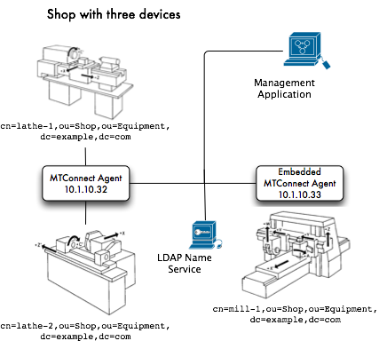

Figure : Shop Illustration

One can look up the three devices using the *Name Service*. The application would search for all devices in the Equipment organization unit (ou=Equipment,dc=example,dc=com). The application would get back three device names: lathe-1, lathe-2, and mill-1. These would be have the following URIs: http://10.1.10.32/lathe-1, http://10.1.10.32/lathe-2, and http://10.1.10.33/mill-1.

The application can thereafter use the URIs to query the devices for the components and the data they can supply.

1. For a full list of HTTP response codes see the following document: <http://www.w3.org/Protocols/rfc2616/rfc2616-sec10.html>