

MTConnect® Standard

Part 4 – Assets  
Version 1.2.0 – Draft E

Prepared for: MTConnect Institute

Prepared by: William Sobel

Prepared on: March 18, 2011

MTConnect® Specification

AMT - The Association For Manufacturing Technology (“AMT”) owns the copyright in this MTConnect® Specification. AMT grants to you a non-exclusive, non- transferable, revocable, non-sublicensable, fully-paid-up copyright license to reproduce, copy and redistribute the MTConnect® Specification, provided that you may only copy or redistribute the MTConnect® Specification in the form in which you received it, without modifications, and with all copyright notices and other notices and disclaimers contained in the MTConnect® Specification.

If you intend to adopt or implement this MTConnect® Specification in a product, whether hardware, software or firmware, which complies with the MTConnect® Specification, you must agree to the MTConnect® Specification Implementer License Agreement (“Implementer License”) or to the MTConnect® Intellectual Property Policy and Agreement (“IP Policy”). The Implementer License and IP Policy each sets forth the license terms and other terms of use for MTConnect® Implementers to adopt or implement the MTConnect® Specifications, including certain license rights covering necessary patent claims for that purpose. These materials can be found at www.MTConnect.org, or by contacting Paul Warndorf at <mailto:pwarndorf@mtconnect.hyperoffice.com>.

MTConnect® Institute and AMT have no responsibility to identify patents, patent claims or patent applications which may relate to or be required to implement a Specification, or to determine the legal validity or scope of any such patent claims brought to their attention. Each MTConnect® Implementer is responsible for securing its own licenses or rights to any patent or other intellectual property rights that may be necessary for such use, and neither AMT nor MTConnect® Institute have any obligation to secure any such rights.

The MTConnect® Specification is provided “as is” and MTConnect® Institute and AMT, and each of their respective members, officers, affiliates, sponsors and agents, make no representation or warranty of any kind relating to these materials or to any implementation of the MTConnect® Specification in any product, including, without limitation, any express or implied warranty of noninfringement, merchantability, or fitness for particular purpose, or of the accuracy, reliability, or completeness of information contained herein. In no event shall MTConnect® Institute or AMT be liable to any user or implementer of the MTConnect® Specification for the cost of procuring substitute goods or services, lost profits, loss of use, loss of data or any incidental, consequential, indirect, special or punitive damages or other direct damages, whether under contract, tort, warranty or otherwise, arising in any way out of access, use or inability to use the MTConnect® Specification or other MTConnect® Materials, whether or not they had advance notice of the possibility of such damage.

Table of Contents

1 Overview 1

1.1 MTConnect® Document Structure 1

2 Purpose of This Document 2

2.1 Terminology 2

2.2 Terminology and Conventions 4

3 Extension to Part 1, Overview and Protocol 5

4 Extensions to Part 2, Commonents and Data Items 5

4.1 Data Item Types for EVENT Category 5

5 Extensions to Part 3, Streams 5

5.1 Extension to Events section 5

6 Assets 6

6.1 Cutting Tools 6

6.1.1 CuttingTool attributes: 10

6.1.2 deviceUuid 10

6.1.3 CuttingTool Elements 11

6.1.4 Description 11

6.1.5 CuttingToolDefinition 11

6.1.6 CuttingToolDefinition attributes: 11

6.1.6.1 format 11

6.1.7 CuttingToolDefinition Elements 12

6.1.8 ISO 13399 12

6.1.9 CuttingToolLifeCycle 12

6.1.10 CuttingToolLifeCycle Elements 13

6.1.11 CutterStatus 14

6.1.12 LocationNumber 14

6.1.12.1 LocationNumber attributes: 15

6.1.12.2 size 15

6.1.12.3 direction 15

6.1.13 ProgramNumber 15

6.1.14 ReconditionCount 15

6.1.14.1 ReconditionCount attributes 15

6.1.15 ProgramSpindleSpeed 16

6.1.15.1 ProgramSpindleSpeed attributes 16

6.1.16 Measurements 16

6.1.17 Measurement 17

6.1.17.1 Measurement attributes 17

6.1.18 CommonMeasurement subtypes 18

6.1.19 AssemblyMeasurement subtypes 18

6.1.20 CuttingItems 20

6.1.20.1 CuttingItems attributes 20

6.1.21 CuttingItem 20

6.1.21.1 CuttingItem attributes 20

6.1.22 A CuttingItem contains the following elements. 21

6.1.23 ItemLife: 21

6.1.23.1 ItemLife attributes: 21

6.1.24 CuttingItemMeasurement subtypes 22

Appendices 25

A. Bibliography 25

B. Cutting Tool Example 27

Table of Figures

Figure 1: Assets Schema 6

Figure 2: Cutting Tool Parts 7

Figure 3: Cutting Tool Composition 7

Figure 4: Cutting Tool Measurements 8

Figure 5: Cutting Tool Asset Structure 9

Figure 6: Cutting Tool Schema 10

Figure 7: Cutting Tool Definition 11

Figure 8: Cutting Tool Life Cycle 13

Figure 9: Location Number 14

Figure 10: Cutting Tool Life Cycle 15

Figure 11: Program Spindle Speed 16

Figure 12: Measurement 17

Figure 13: Cutting Tool Measurement Diagram 1 18

Figure 14: Cutting Tool Measurement Diagram 2 19

Figure 15: Cutting Items 20

Figure 16: Item Life 21

Figure 17: Cutting Tool Item Measurement Diagram 1 23

Figure 18: Cutting Tool Item Measurement Diagram 2 24

# Overview

MTConnect® is a standard based on an open protocol for data integration. MTConnect® is not intended to replace the functionality of existing products, but it strives to enhance the data acquisition capabilities of devices and applications and move toward a plug-and-play environment to reduce the cost of integration.

MTConnect® is built upon the most prevalent standards in the manufacturing and software industry, maximizing the number of tools available for its implementation and providing the highest level of interoperability with other standards and tools in these industries.

To facilitate this level of interoperability, a number of objectives are being met. Foremost is the ability to transfer data via a standard protocol which includes:

* + A device identity (i.e. model number, serial number, calibration data, etc.).
  + The identity of all the independent components of the device.
  + Possibly a device’s design characteristics (i.e. axis length, maximum speeds, device thresholds, etc.).
  + Most importantly, data captured in real or near-real-time (i.e. current speed, position data, temperature data, program block, etc.) by a device that can be utilized by other devices or applications (e.g. utilized by maintenance diagnostic systems, management production information systems, CAM products, etc.).

The types of data that may need to be addressed in MTConnect® could include:

* + Physical and actual device design data
  + Measurement or calibration data
  + Near-real-time data from the device

To accommodate the vast amount of different types of devices and information that may come into play, MTConnect® will provide a common high-level vocabulary and structure.

The first version of MTConnect® will focus on a limited set of the characteristics mentioned above that were selected based on the fact that they can have an immediate affect on the efficiency of operations.

## MTConnect® Document Structure

The MTConnect® specification is subdivided using the following scheme:

Part 1: Overview and Protocol – Version 1.2.0, Draft

Part 2: Components and Data Items – Version 1.2.0, Draft

Part 3: Streams, Events, Samples, and Condition – Version 1.2.0, Draft

Part 4: Assets – Version 1.2.0, Draft

Extensions to the standard will be made according to this scheme and new sections will be added as new areas are addressed. Documents will be named as follows: MTC_Part_<Number>_<Description>.doc. All documents will be developed in Microsoft® Word format and released in Adobe® PDF format. For example, this document is MTC_Part_1_Overview.doc.

# Purpose of This Document

The four MTConnect® documents are intended to:

* define the MTConnect® standard;
* specify the requirements for compliance with the MTConnect® standard;
* provide engineers with sufficient information to implement Agents for their devices;
* provide developers with the necessary guidelines to use the standard to develop applications.

Part 2 of the MTConnect® standard focuses on structure and description of what information is available from the device. The actual device state is not provided in this section, but is covered in Part 3 covering Streams, Samples, Events, and Condition. The descriptive data is similar to the schema of the data, it describes the components available in a device and what data items are provided by each component.

This part also covers instructions on how a piece of equipment should be modeled, the structure of the component hierarchy, the names for each component (if restricted), and allowable data items for each of the component. Some components, like Linear axis, use the naming conventions as laid out in this document. This allows for a consistent meaning across devices.

## Terminology

**Adapter** An optional software component that connects the Agent to the Device.

**Agent** A process that implements the MTConnect® HTTP protocol, XML generation, and MTConnect protocol.

**Alarm** An alarm indicates an event that requires attention and indicates a deviation from normal operation.

**Application** A process or set of processes that access the MTConnect® Agent to perform some task.

**Attribute** A part of an element that provides additional information about that element. For example, the name element of the Device is given as <Device **name=“mill-1”**>...</Device>

**CDATA** The text in a simple content element. For example, *This is some text*, in <mt:Alarm ...>This is some text</mt:Alarm>.

**Component** A part of a device that can have sub-components and data items. A component is a basic building block of a device.

**Controlled Vocabulary** The value of an element or attribute is limited to a restricted set of possibilities. Examples of controlled vocabularies are country codes: US, JP, CA, FR, DE, etc…

**Current** A snapshot request to the Agent to retrieve the current values of all the data items specified in the path parameter. If no path parameter is given, then the values for all components are provided.

**Data Item** A data item provides the descriptive information regarding something that can be collected by the Agent.

**Device** A piece of equipment capable of performing an operation. A device is composed of a set of components that provide data to the application. The device is a separate entity with at least one Controller managing its operation.

**Discovery** Discovery is a service that allows the application to locate Agents for devices in the manufacturing environment. The discovery service is also referred to as the *Name Service.*

**Element** An XML element is the central building block of any XML Document. For example, in MTConnect® the Device element is specified as <**Device** >...</**Device**>

**Event** An event represents a change in state that occurs at a point in time. Note: An event does not occur at predefined frequencies.

**HTTP** Hyper-Text Transport Protocol. The protocol used by all web browsers and web applications.

**Instance** When used in software engineering, the word *instance* is used to define a single physical example of that type. In object-oriented models, there is the class that describes the thing and the instance that is an example of that thing.

**LDAP** Lightweight Directory Access Protocol, better known as Active Directory in Microsoft Windows. This protocol provides resource location and contact information in a hierarchal structure.

**MIME** Multipurpose Internet Mail Extensions. A format used for encoding multipart mail and http content with separate sections separated by a fixed boundary.

**Probe** A request to determine the configuration and reporting capabilities of the device.

**REST** REpresentational State Transfer. A software architecture where the client and server move through a series of state transitions based solely on the request from the client and the response from the server.

**Results** A general term for the Samples, Events, and Condition contained in a ComponentStream as a response from a sample or current request.

**Sample** A sample is a data point from within a continuous series of data points. An example of a Sample is the position of an axis.

**Socket** When used concerning interprocess communication, it refers to a connection between two end-points (usually processes). Socket communication most often uses TCP/IP as the underlying protocol.

**Stream** A collection of Events and Samples organized by devices and components.

**Service** An application that provides necessary functionality.

**Tag** Used to reference an instance of an XML element.

**TCP/IP** TCP/IP is the most prevalent stream-based protocol for interprocess communication. It is based on the IP stack (Internet Protocol) and provides the flow-control and reliable transmission layer on top of the IP routing infrastructure.

**URI** Universal Resource Identifier. This is the official name for a web address as seen in the address bar of a browser.

**UUID** Universally unique identifier.

**XPath** XPath is a language for addressing parts of an XML Document. See the XPath specification for more information. <http://www.w3.org/TR/xpath>

**XML** Extensible Markup Language. <http://www.w3.org/XML/>

**XML Schema** The definition of the XML structure and vocabularies used in the XML Document.

**XML Document** An instance of an XML Schema which has a single root element and conforms to the XML specification and schema.

**XML NMTOKEN** The data type for XML identifiers. It must start with a letter, an underscore “_” or a colon “:” and then it **MUST** be followed by a letter, a number, or one of the following “.”, ”-“, ”_”, “:”. An NMTOKEN cannot have any spaces or special characters.

## Terminology and Conventions

Please refer to Part 1 “Overview and Protocol” Section 2 for XML Terminology and Documentation conventions.

# Extension to Part 1, Overview and Protocol

As documented in Part 1, additional queries will be added to the *Agent* to support the storage and retrieval of assets. There is more detail in Part 1; what follows is a summary of the protocol additions:

Asset protocol:

* Request an asset by id:
  + url: http://example.com/asset/hh1
  + Returns the MTConnectAssets document for asset hh1
* Request multiple assets by id:
  + url: http://example.com/asset/hh1;cc;123;g5
  + Returns the MTConnectAssets document for asset hh1, cc, 123, and g5.

# Extensions to Part 2, Commonents and Data Items

This document will add the following data item types to support change notification when an asset is added or updated. The data item **MUST** be placed in the DataItems collection of the top level device. The device **MUST** be the device that is supplying the asset data.

## Data Item Types for EVENT Category

| **Data Item type/subtype** | **Description** |
| --- | --- |
| **ASSET_CHANGED** | The value of the **CDATA** for the event **MUST** be the assetId of the asset that has been added or changed. There will not be a separate message for new assets. |

# Extensions to Part 3, Streams

The associated modifications **MUST** be added to Part 3 to add the following event to the events in the streams.

## Extension to Events section

**AssetChanged** An asset has been added or modified. The **CDATA** for the AssetChangeed element **MUST** be the assetId of the asset that has been modified.

# Assets

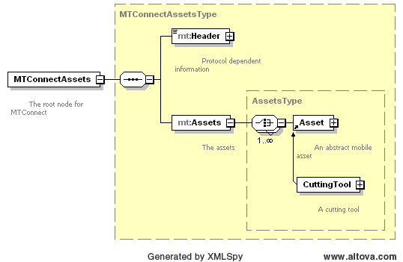

Figure 1: Assets Schema

An Asset is something that is associated with the manufacturing process that is not a component of a device, can be removed without detriment to the function of the device, and can be associated with other devices during their lifecycle. An asset does not have computational capabilities, but may carry information in some media physically attached to the asset.

Concrete examples of Assets are things like Cutting Tools, Workholding Systems, and Fixtures. Part 4 of the MTConnect standard will concern itself with the modeling of these assets and the management and communication of asset data using MTConnect.

At the top level of the MTConnectAssets document we have a standard header as documented in Part 1: Overview and Protocol and one or more assets. Each asset is required to have an assetId that serves as a unique identifier of that asset. The id allows the application to request the asset data from the agent, as prescribed in Part 1.

In the remaining document, we will be discussing Cutting Tools as the first asset type covered by the standard. The cutting tool must have an assetId that differs from all the other assets tracked by this agent. There **MUST** never be more than one asset provided by MTConnect with the same asset Id in the same agent.

## Cutting Tools

MTConnect will adopt the ISO 13399 structure when formulating the vocabulary for cutting tools. MTConnect will focus on the use phase of application of the cutting tool and cutting items. At this time we are only concerned with two aspects of the cutting tool, the Cutting Tool and the Cutting Item. We will not be including the Tool Item, Adaptive Item, or the Assembly Items, as they are component parts of the cutting tool do not have a large impact on the use phase of the tool and will be sufficiently defined in the ISO 13399 portion of the document.

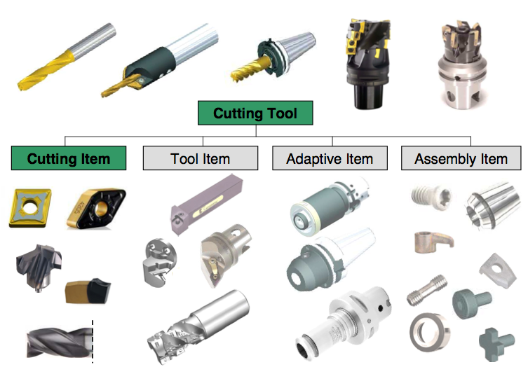

Figure : Cutting Tool Parts

The previous diagram illustrates the parts of a cutting tool. The cutting tool is the aggregate of all the components and the cutting item is the part of the tool that removes the material from the workpiece. These are the primary focus of MTConnect.

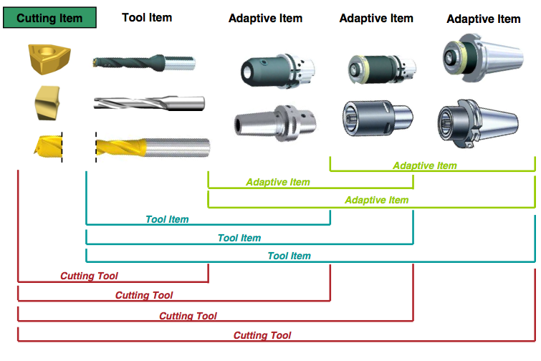

Figure : Cutting Tool Composition

Figure 3 provides another view of the cutting tool composition model. The adaptive items and tool items will be used for measurements, but will not be modeled as separate entities. The definitions will assume when referencing the cutting tool we are referring to the entirety of the asset and when we provide data regarding the cutting item we are referencing each individual component as illustrated on the left of the previous diagram.

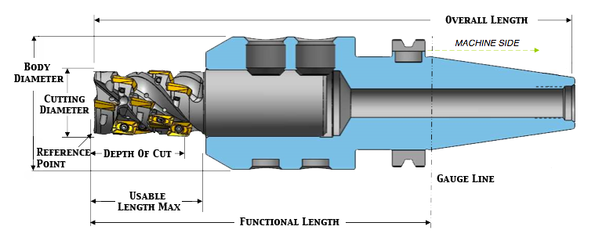

Figure : Cutting Tool Measurements

A cutting tool, or cutter, is a type of asset that is used to remove material from a workpiece. A cutting tool may have one or more edges which provide a shear deformation of the material. The MTConnect standard will not define the entire geometry of the cutting tool, but will provide the information necessary to use the tool in the manufacturing process. Additional information can be added to the definition of the cutting tool by means of schema extensions.

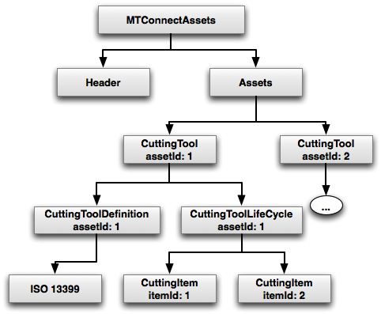

Figure : Cutting Tool Asset Structure

The structure of the MTConnectAssets document contains the standard MTConnectHeader as defined in *Part 1: Overview and Protocol* of the standard. A finite number of assets will be stored in the MTConnect agent. This finite number will be implementation specific and will depend on memory and storage constraints. The standard will not prescribe the number or capacity requirements for an implementation.

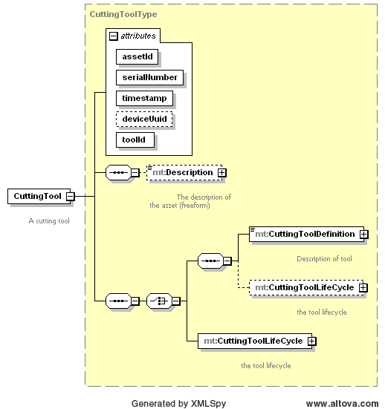

Figure 6: Cutting Tool Schema

### CuttingTool attributes:

| **Attribute** | **Description** | **Occurrence** |
| --- | --- | --- |
| timestamp | The time this asset was last modified. Always given in UTC. | 1 |
| assetId | The unique identifier of the instance of this tool. This will be the same as the serial number in most cases. The suggested format is the combination of the toolId and the serialNumber. One example would be toolId.serialNumber | 1 |
| serialNumber | It **MUST** be an NMTOKEN XML type. | 1 |
| toolId | The identifier for class of cutting tool. | 1 |
| deviceUuid | The device’s uuid that supplied this data. | 1 |

### deviceUuid

This optional element References to the UUID atribute given in the device element. This can be any series of numbers and letters as defined by the XML type NMTOKEN.

### CuttingTool Elements

The elements associated with this cutting tool are given below. Each element will be described in more detail below and any possible values will be presented with full definitions. The elements **MUST** be provided in the following order as prescribed by XML. At least one of CuttingToolDefinition or CuttingToolLifeCycle **MUST** be supplied.

| **Element** | **Description** | **Occurrence** |
| --- | --- | --- |
| Description | An element that can contain any descriptive content. This can contain configuration information and manufacturer specific details. This element is defined to contain mixed content and XML elements can be added to extend the descriptive semantics of MTConnect. | 0..1 |
| CuttingToolDefinition | Reference to a ISO 13399 | 0..1 |
| CuttingToolLifeCycle | MTConnect data regarding the use phase of this tool. | 0..1 |

### Description

The description **MAY** contain mixed content, meaning that an additional XML element or plain text may be provided as part of the content of the description tag. Currently the description contains no additional attributes.

### CuttingToolDefinition

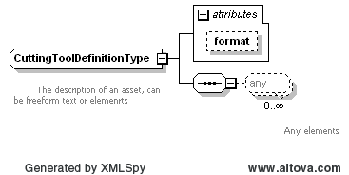

Figure 7: Cutting Tool Definition

The tool definition contains the ISO 13399 standard tool information.

### CuttingToolDefinition attributes:

| **Attribute** | **Description** | **Occurrence** |
| --- | --- | --- |
| format | Format – EXPRESS, XML, TEXT, or UNDEFINED. Default: XML | 0..1 |

#### format

The format attribute describes the expected representation of the enclosed data. If no value is given, the assumed format will be XML.

| **Value** | **Description** |
| --- | --- |
| XML | The default value for the definition. The content will be an XML document. |
| EXPRESS | The document will confirm to the ISO 10303 standard. STEP-NC part 21 file formats. |
| TEXT | The document will be a text representation of the tool data. |
| UNDEFINED | The document will be provided in an undefined format. |

### CuttingToolDefinition Elements

The elements associated with this cutting tool are given below. Each element will be described in more detail below and any possible values will be presented with full definitions. The elements **MUST** be provided in the following order as prescribed by XML.

| **Element** | **Description** | **Occurrence** |
| --- | --- | --- |
| ISO13399 | Not sure what this will be… | 1 |

### ISO 13399

The ISO 13399 data either in XML or EXPRESS format. An XML schema will be preferred. This is still an open issue.

### CuttingToolLifeCycle

The life cycle refers to the data pertaining the the application or the use of the tool. This data is provided by various devices, machine tool, presetters, and statistical process control applications. Life cycle data will not remain static, but will change periodically when a tool is used or measured. The life cycle has three conceptual parts; tool and cutting item identity, properties, and measurements. A measurement is defined as a constrained value that is reported in defined units and as a W3C floating point format.

The CuttingToolLifeCycle contains data for the entire tool assembly. The specific cutting items that are part of the CuttingToolLifeCycle are contained in the CuttingItems element. Each cutting item has similar properties as the assembly; identity, properties, and measurements.

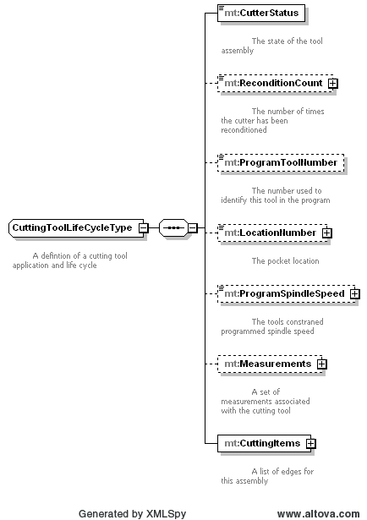

Figure 8: Cutting Tool Life Cycle

### CuttingToolLifeCycle Elements

The elements associated with this cutting tool are given below. Each element will be described in more detail below and any possible values will be presented with full definitions. The elements **MUST** be provided in the following order as prescribed by XML.

| **Element** | **Description** | **Occurrence** |
| --- | --- | --- |
| CutterStatus | The status of the this assembly. Possible values are: NEW, RECONDITIONED, NOT_REGISTERED, USED, EXPIRED, TAGGED_OUT, BROKEN, or UNKNOWN. | 1 |
| ReconditionCount | The number of times this cutter has been reconditioned. | 0..1 |
| LocationNumber | The pot identifier this tool now resides in. | 0..1 |
| ProgramToolNumber | The number of the tool as referenced in the part program. | 0..1 |
| ProgramSpindleSpeed | The constrained programmed spindle speed for this tool | 0..1 |
| Measurements | A collection of measurements for the tool assembly. | 0..1 |
| CuttingItems | A set of individual cutting items. | 1 |

### CutterStatus

The value of the ToolStatus element can be one of the following or can be extended using the extended “x:[VALUE]” pattern where [VALUE] can be any uppercase word. The extended syntax MAY not be supported by applications, adhering to the following vocabulary is greatly encouraged. The default value is UNKNOWN.

| **Value** | **Description** |
| --- | --- |
| NEW | A new tool that has not been used or first use. Marks the start of the tool history. |
| RECONDITIONED | The cutting tool has been reconditioned. See ReconditionCount for the number of times this cutter has been reconditioned. |
| USED | The tool is in process and has remaining tool life. |
| EXPIRED | The cutting tool has reached the end of its useful life. |
| BROKEN | Premature tool failure. |
| TAGGED_OUT | Removed from service of the machine. |
| NOT_REGISTERED | This cutting tool cannot be used until it is entered into the system. |
| UNKNOWN | The cutting tool is an indeterminate state. This is the default value. |

### LocationNumber

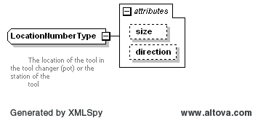

Figure 9: Location Number

This is the optional device specific pocket id providing the current pocket number this tool resides in. This can be any series of numbers and letters as defined by the XML type NMTOKEN.

#### LocationNumber attributes:

| **Attribute** | **Description** | **Occurrence** |
| --- | --- | --- |
| size | The number of locations this tool assembly occupies. | 0..1 |
| direction | The direction of the pocket overlap defined as the positive or negative progression of the overlapping pots. | 0..1 |

#### size

Number of Pot tool pocket locations that the assembly occupies due to interference. The value **MUST** be an integer.

#### direction

The indexed direction for the additional pockets.

| **Value** | **Description** |
| --- | --- |
| POSITIVE | The additional locations required for this tool are higher indexed positioned. |
| NEGATIVE | The additional locations required for this tool are lower indexed positioned. |

### ProgramNumber

The tool number that is assigned in the part program. The value **MUST** be an integer.

### ReconditionCount

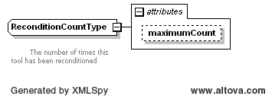

Figure : Cutting Tool Life Cycle

This element **MUST** contain an integer value as the CDATA that represents the number of times the cutter has been reconditioned.

#### ReconditionCount attributes

| **Attribute** | **Description** | **Occurrence** |
| --- | --- | --- |
| maximumCount | The maximum number of times this tool may be reconditioned | 0..1 |

### ProgramSpindleSpeed

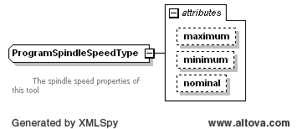

Figure 11: Program Spindle Speed

Tool Spindle Speed **MUST** be specified in revolutions/minute (RPM). The CDATA **MAY** contain the programmed tool speed if available. The maximum and minimum speeds **MAY** be provided as attributes. At least one value **MUST** be provided.

#### ProgramSpindleSpeed attributes

| **Attribute** | **Description** | **Occurrence** |
| --- | --- | --- |
| maximum | The upper bound for the tool’s programmed spindle speed | 0..1 |
| minimum | The lower bound for the tools spindle speed. | 0..1 |
| nominal | The nominal speed the tool is designed to operate at. | 0..1 |

### Measurements

The Measurements element is a collection of one or more constrained scalar values associated with this cutting tool. The contents **MUST** be a subtype of CommonMeasurement or AssemblyMeasurement. The following section will define the abstract Measurement type used in both CuttingToolLifeCycle and CuttingItem. This section will then describe the AssemblyMeasurement types. The CuttingItemMeasurement types will be described at the end of the CuttingItem section.

A measurement is specific to a process and a machine tool at a particular shop. The tool zero reference point or gauge line will be different depending on the particular implementation and will be assumed to be self-consistent within the shop. MTConnect does not standardized the manufacturing process or the definition of the zero point in all cases. MTConnect is developing a common language to describe the different properties and measurements and the meaning of those measurements with respect to the established practices at a particular location.

### Measurement

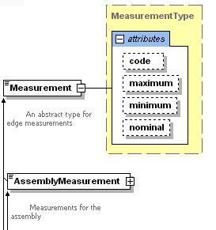

Figure : Measurement

A measurement **MUST** be a scalar floating point value that **MAY** be constrained to a maximum and minimum value. Since the CuttingToolLifeCycle’s main responsibility is to track aspects of the tool that change over it’s use in the shop, MTConnect represents the current value of the measurement **MUST** be in the CDATA (text between the start and end element) as the most current valid value.

The minimum and maximum **MAY** be supplied if they are known or relevant to the measurement. A nominal value **MAY** be provided to show the reference value for this measurement.

There are three subtypes of Measurement: CommonMeasurement, AssemblyMeasurement, and CuttingItemMeasurement. These abstract types **MUST NOT** appear in an MTConnectAssets document, but are used in the schema as a way to separate which measurements **MAY** appear in the different sections of the document. Only subtypes that have extended these types **MAY** appear in the MTConnectAssets XML.

Measurements in the CuttingToolLifeCycle section **MUST** refer to the entire assembly and not to an individual cutting item. Cutting item measurements **MUST** be located in the measurements associated with the individual Cutting Item.

#### Measurement attributes

| **Attribute** | **Description** | **Occurrence** |
| --- | --- | --- |
| code | A shop specific code for this measurement. ISO 13399 codes **MAY** be used to for these codes as well. | 0..1 |
| maximum | The maximum value for this measurement. Exceeding this value would indicate the tool is not usable. | 0..1 |
| minimum | The minimum value for this measurement. Exceeding this value would indicate the tool is not usable. | 0..1 |
| nominal | The as advertised value for this measurement. | 0..1 |

### CommonMeasurement subtypes

We will be referring to the following diagrams when discussing measurements.

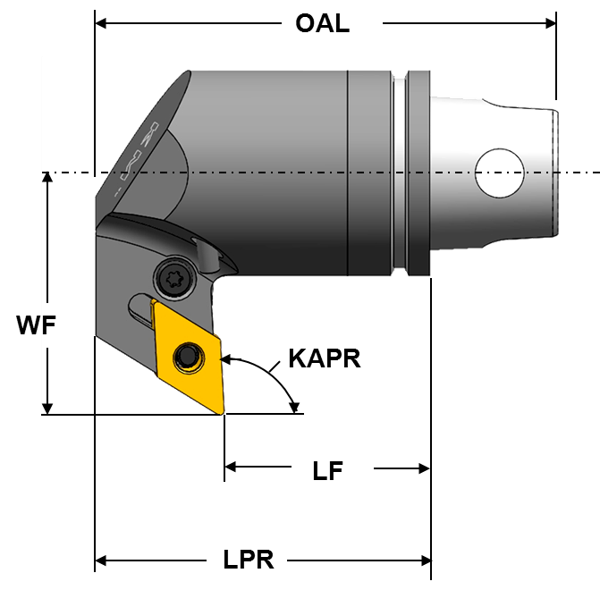

Figure 13: Cutting Tool Measurement Diagram 1

The Code in the following table will refer to the acronym in the diagram. We will be referring to many diagrams to disambiguate all measurements of the cutting tools and items.

| **Measurement** | **Code** | **Description** | **Units** |
| --- | --- | --- | --- |
| ProtrudingLength | LPR | The dimension from the yz-plane to the furthest point of the tool item or adaptive item measured in the -X direction. | mm |
| Mass |  | The weight of the tool or cutting item in grams. | grams |

### AssemblyMeasurement subtypes

These measurements are specific to the entire assembly and **MUST** **NOT** be used for the measurement pertaining to a CuttingItem. The following diagram will be used to for reference for the assembly specific measurements.

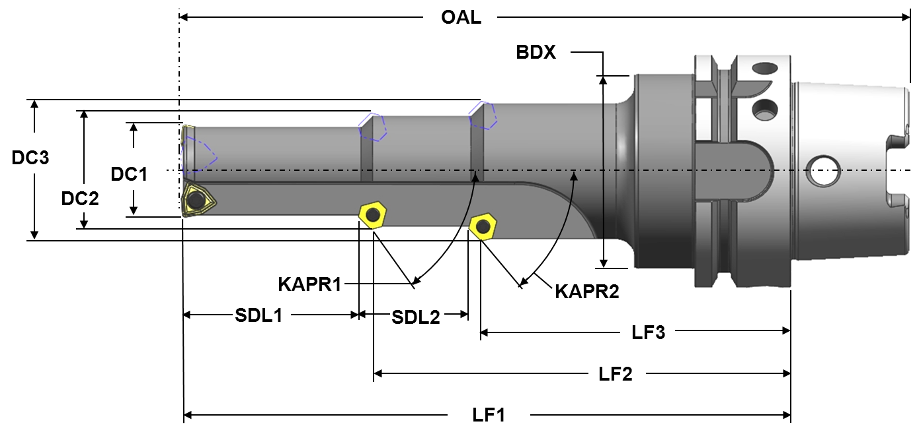

Figure 14: Cutting Tool Measurement Diagram 2

The Code in the following table will refer to the acronym in the diagram. We will be referring to many diagrams to disambiguate all measurements of the cutting tools and items.

| **Measurement** | **Code** | **Description** | **Units** |
| --- | --- | --- | --- |
| BodyDiameterMax | BDX | The largest diameter of the body of a tool item. | mm |
| BodyLengthMax | LBX | The distance measured along the X axis from that point of the item closest to the workpiece, including the cutting item for a tool item but excluding a protruding locking mechanism for an adaptive item, to either the front of the flange on a flanged body or the beginning of the connection interface feature on the machine side for cylindrical or prismatic shanks. | mm |
| DepthOfCutMaximum | ATMX | The maximum engagement of the cutting edge or edges with the workpiece measured perpendicular to the feed motion. | mm |
| OverallToolLength | OAL | The largest length dimension of the tool item including the master insert where applicable. | mm |
| ShankDiameter | DMM | The dimension of the diameter of a cylindrical portion of a tool item or an adaptive item that can participate in a connection. | mm |
| ShankHeight | H | The dimension of the height of the shank. | mm |
| ShankLength | LS | The dimension of the length of the shank. | mm |
| UsableLengthMax | LUX | maximum length of a cutting tool that can be used in a particular cutting operation including the non-cutting portions of the tool. | mm |

### CuttingItems

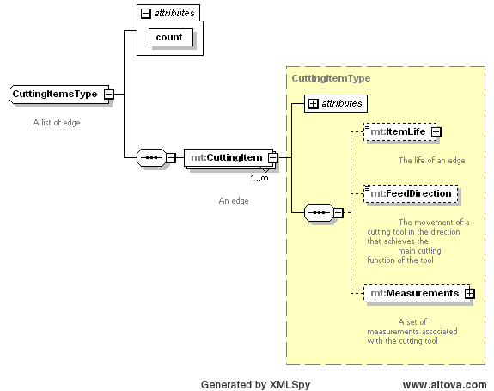

Figure 15: Cutting Items

The collection of cutting items.

#### CuttingItems attributes

| **Attribute** | **Description** | **Occurrence** |
| --- | --- | --- |
| count | The number of cutting items. | 1 |

### CuttingItem

A cutting item is the portion of the tool that physically removes the material from the workpiece by shear deformation. The cutting item can be either a single piece of material attached to the tool item or it can be one or more separate pieces of material attached to the tool item using a permanent or removable attachment. A cutting item can be comprised of one or more cutting edges. Cutting items include: replaceable inserts, brazed tips and the cutting portions of solid cutting tools.

#### CuttingItem attributes

| **Attribute** | **Description** | **Occurrence** |
| --- | --- | --- |
| itemId | The unique identifier of this cutting item within this assembly | 1 |

### A CuttingItem contains the following elements.

| **Element** | **Description** | **Occurrence** |
| --- | --- | --- |
| ItemLife | The life of this cutting item. | 0..3 |
| Measurements | A collection of measurements relating to this cutting item. | 0..1 |

### ItemLife:

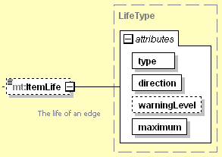

Figure 16: Item Life

The value is the current value for the tool life. The value **MUST** be a number. Tool life is an option element which can have three types, either minutes for time based, part count for parts based, or wear based using a distance measure. One tool life can appear for each type, but there cannot be two entries of the same type. Additional types can be added in the future.

#### ItemLife attributes:

These is an optional attribute that can be used to further classify the operation type.

| **Attribute** | **Description** | **Occurrence** |
| --- | --- | --- |
| type | The type of tool life being accumulated. MINUTES, PART_COUNT, or WEAR | 1 |
| countDirection | Indicates if the tool life counts from zero to maximum or maximum to zero, | 1 |
| warningLevel | The point at which a tool life warning will be raised. | 0..1 |
| life | The end of life limit for this tool. If the countDirection is DOWN, the point at which this tool should be expired, usually zero. If the countDirection is UP, this is the upper limit for which this tool should be expired. | 0..1 |
| initialLife | The initial life of the tool when it is new. | 0..1 |

##### ItemLife type attribute:

The value of type must be one of the following:

| **Value** | **Description** |
| --- | --- |
| MINUTES | The tool life measured in minutes. All units for minimum, maximum, and warningLevel **MUST** be provided in minutes. |
| PART_COUNT | The tool life measured in parts. All units for minimum, maximum, and warningLevel **MUST** be provided supplied as the number of parts. |
| WEAR | The tool life measured in tool wear. Wear **MUST** be provided in millimeters as an offset to nominal. All units for minimum, maximum, and warningLevel **MUST** be given as millimeter offsets as well. |

##### ItemLife direction attribute:

The value of type must be one of the following:

| **Value** | **Description** |
| --- | --- |
| DOWN | The tool life counts down from the maximum to zero. |
| UP | The tool life counts up from zero to the maximum. |

### CuttingItemMeasurement subtypes

These measurements are specific to an individual cutting item and **MUST** **NOT** be used for the measurement pertaining to an assembly. The following diagram will be used to for reference for the cutting item specific measurements.



Figure 17: Cutting Tool Item Measurement Diagram 1

The Code in the following table will refer to the acronym in the diagram. We will be referring to many diagrams to disambiguate all measurements of the cutting tools and items.

| **Measurement** | **Code** | **Description** | **Units** |
| --- | --- | --- | --- |
| FunctionalLength | LFx | distance from the gauge plane or from the end of the shank, if a gauge plane does not exist, to the cutting reference point determined by the main function of the tool | mm |
| StepDiameterLength | SDLx | The length of a portion of a stepped tool that is related to a corresponding cutting diameter measured from the cutting reference point of that cutting diameter to the point on the next cutting edge at which the diameter starts to change. | mm |
| StepIncludedAngle | STA | The angle between a major edge on a step of a stepped tool and the same cutting edge rotated 180 degrees about its tool axis. | degree |
| CuttingDiameter | DCx | The nominal radius of a rounded corner measured in the XY-plane. | mm |
| CuttingHeight | H1 | The distance from the basal plane of the tool item to the cutting point. | mm |

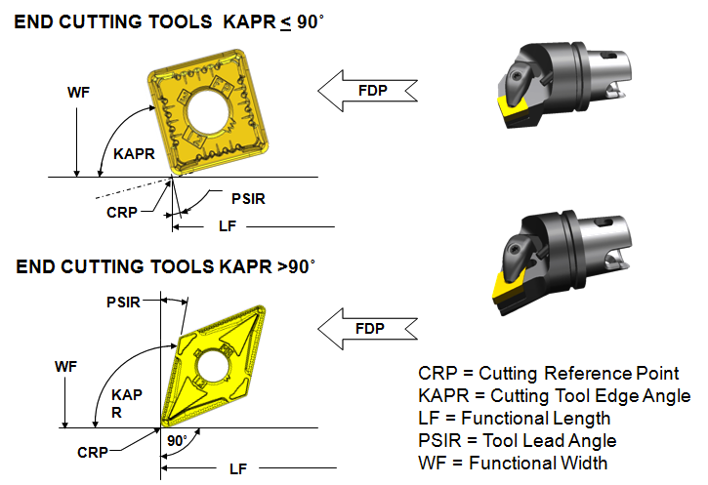

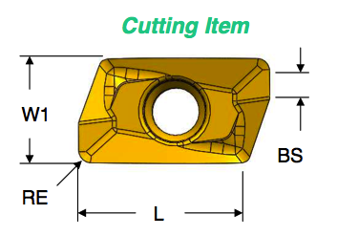

Figure 18: Cutting Tool Item Measurement Diagram 2

The following CuttingItemMeasurements will refer the diagram above.

| **Measurement** | **Code** | **Description** | **Units** |
| --- | --- | --- | --- |
| CuttingReferncePoint | CRP | The theoretical sharp point of the cutting tool from which the major functional dimensions are taken. | ? |
| CuttingEdgeLength | L | The theoretical length of the cutting edge of a cutting item over sharp corners. | mm |
| FlangeDiameter | DF | The dimension between two parallel tangents on the outside edge of a flange. | mm |
| FunctionalWidth | WF | The distance between the cutting reference point and the rear backing surface of a turning tool or the axis of a boring bar. | mm |
| InclinationAngle | LAMS | The angle between the tool rake plane and a plane parallel to the xy-plane measured in the tool cutting edge plane. | mm |
| IncribedCircleDiameter | IC | The diameter of a circle to which all edges of a equilateral and round regular insert are tangential. | mm |
| PointAngle | SIG | The angle between the major cutting edge and the same cutting edge rotated by 180 degrees about the tool axis. | degree |
| ToolCuttingEdgeAngle | KAPR | The angle between the tool cutting edge plane and the tool feed plane measured in a plane parallel the xy-plane. | degree |
| ToolLeadAngle | PSIR | The angle between the tool cutting edge plane and a plane perpendicular to the tool feed plane measured in a plane parallel the xy-plane. | degree |
| WiperEdgeLength | BS | The measure of the length of a wiper edge of a cutting item. | mm |

Appendices

1. Bibliography
2. Engineering Industries Association. *EIA Standard - EIA-274-D*, Interchangeable Variable, Block Data Format for Positioning, Contouring, and Contouring/Positioning Numerically Controlled Machines. Washington, D.C. 1979.
3. ISO TC 184/SC4/WG3 N1089. *ISO/DIS 10303-238*: Industrial automation systems and integration Product data representation and exchange Part 238: Application Protocols: Application interpreted model for computerized numerical controllers. Geneva, Switzerland, 2004.
4. International Organization for Standardization. *ISO 14649*: Industrial automation systems and integration – Physical device control – Data model for computerized numerical controllers – Part 10: General process data. Geneva, Switzerland, 2004.
5. International Organization for Standardization. *ISO 14649*: Industrial automation systems and integration – Physical device control – Data model for computerized numerical controllers – Part 11: Process data for milling. Geneva, Switzerland, 2000.
6. International Organization for Standardization. *ISO 6983/1* – Numerical Control of machines – Program format and definition of address words – Part 1: Data format for positioning, line and contouring control systems. Geneva, Switzerland, 1982.
7. Electronic Industries Association. *ANSI/EIA-494-B-1992*, 32 Bit Binary CL (BCL) and 7 Bit ASCII CL (ACL) Exchange Input Format for Numerically Controlled Machines. Washington, D.C. 1992.
8. National Aerospace Standard. *Uniform Cutting Tests* - NAS Series: Metal Cutting Equipment Specifications. Washington, D.C. 1969.
9. International Organization for Standardization. *ISO 10303-11*: 1994, Industrial automation systems and integration Product data representation and exchange Part 11: Description methods: The EXPRESS language reference manual. Geneva, Switzerland, 1994.
10. International Organization for Standardization. *ISO 10303-21*: 1996, Industrial automation systems and integration -- Product data representation and exchange -- Part 21: Implementation methods: Clear text encoding of the exchange structure. Geneva, Switzerland, 1996.
11. H.L. Horton, F.D. Jones, and E. Oberg. *Machinery's handbook*. Industrial Press, Inc. New York, 1984.
12. International Organization for Standardization. *ISO 841-2001: Industrial automation systems and integration - Numerical control of machines - Coordinate systems and motion nomenclature.* Geneva, Switzerland, 2001.
13. *ASME B5.59-2 Version 9c: Data Specification for Properties of Machine Tools for Milling and Turning. 2005.*
14. *ASME/ANSI B5.54: Methods for Performance Evaluation of Computer Numerically Controlled Lathes and Turning Centers. 2005.*
15. OPC Foundation. *OPC Unified Architecture Specification, Part 1: Concepts Version 1.00. July 28, 2006.*
16. International Organization for Standardization. *ISO 13399*: *Cutting tool data representation and exchange*. Geneva, Switzerland, 2000.
17. Cutting Tool Example