Homework 1 Report b04501127 凌于凱

Enviroment
OS: Archlinux
Compiler: g++ (GCC) 8.2.1
how to execute
make to compile cpp file and generate execute file(train, test, cal_acc).
./train iteration model_init.txt seq_model_0x.txt model_0x.txt to train model_0x.
./test modellist.txt testing_data.txt result.txt to classify the testing data.
./cal_acc result1.txt testing_answer.txt acc.txt to calculate accuracy.

Summary
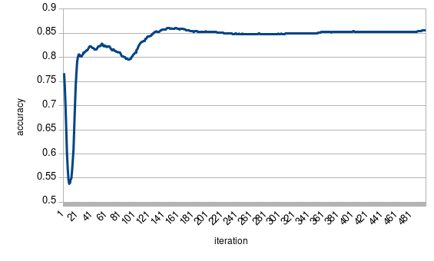
可以發現正確率隨著iteration的上升也跟著上升，直到大概執行150次時達到收斂

