Sobeys Hackathon – Working With the Data

The Sobeys Data Model

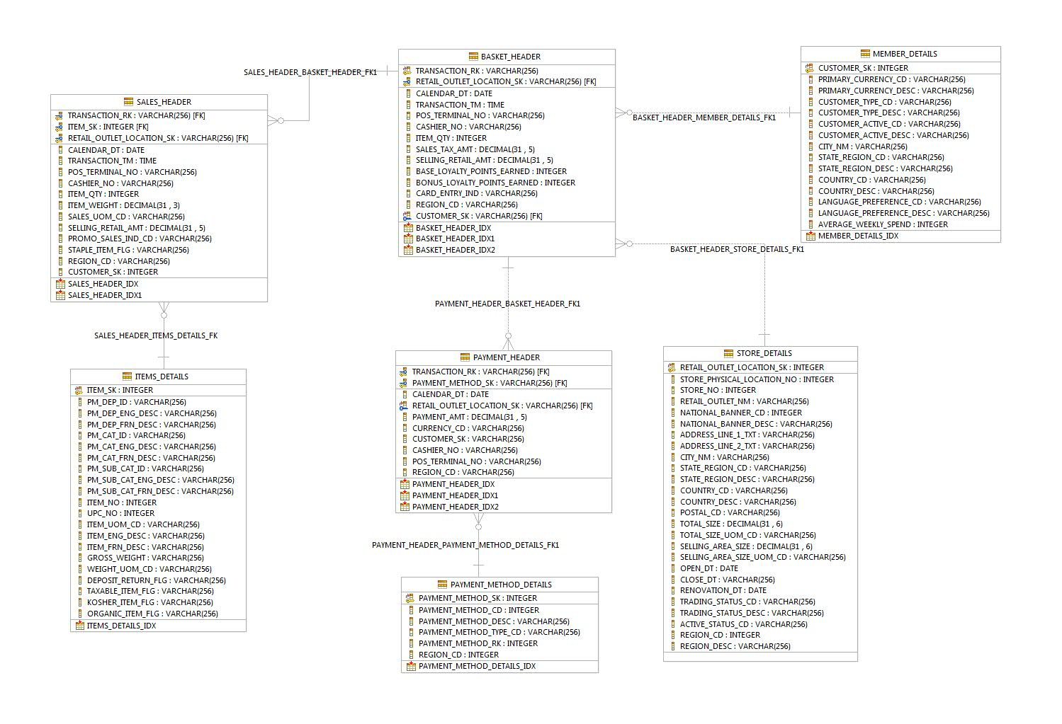

Connecting to the Sobeys Database in Bluemix
You are welcome to use whatever means you are comfortable with to access the data for the hackathon. These instructions will detail how to connect to the database using the SQuirreL SQL client tool which is free open source.
Step 1: Download SQuirreL SQL v3.7 from http://squirrel-sql.sourceforge.net/ Installation instructions can be found at this URL as well.
Step2: Download the DB2 10.5 Database Drivers for your environment (Windows or Linux) from:
http://www-01.ibm.com/support/docview.wss?uid=swg24040536
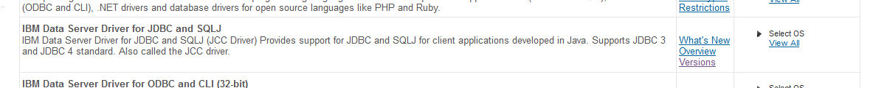

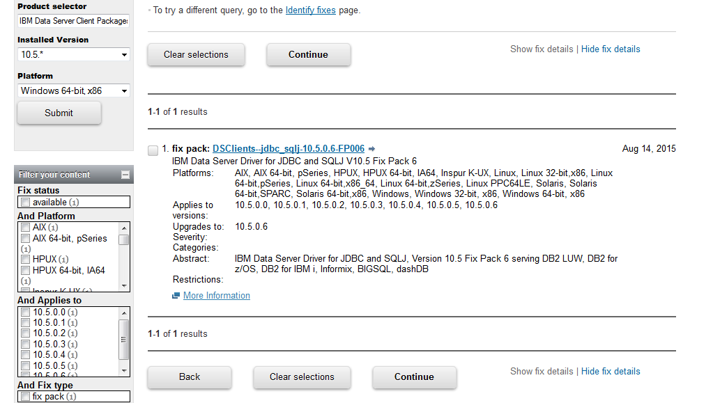

The downloaded file should look like this:
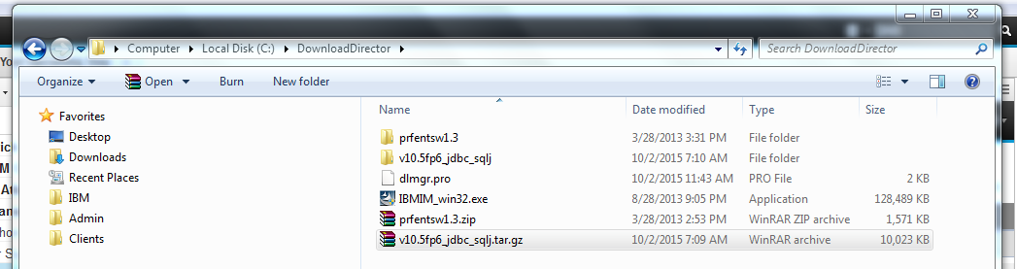
Unzip the file and note where the unzipped folder is as you will need to point to that within SQuirreL SQL later.
Step 3: Connect your DB2 DB Drivers from Step 2
Open the SQuirreL SQL Client and click on the Drivers tab. Click on the IBM DB2 Net Driver Item and a popup will appear. You need to click on the Extra Class Path tab
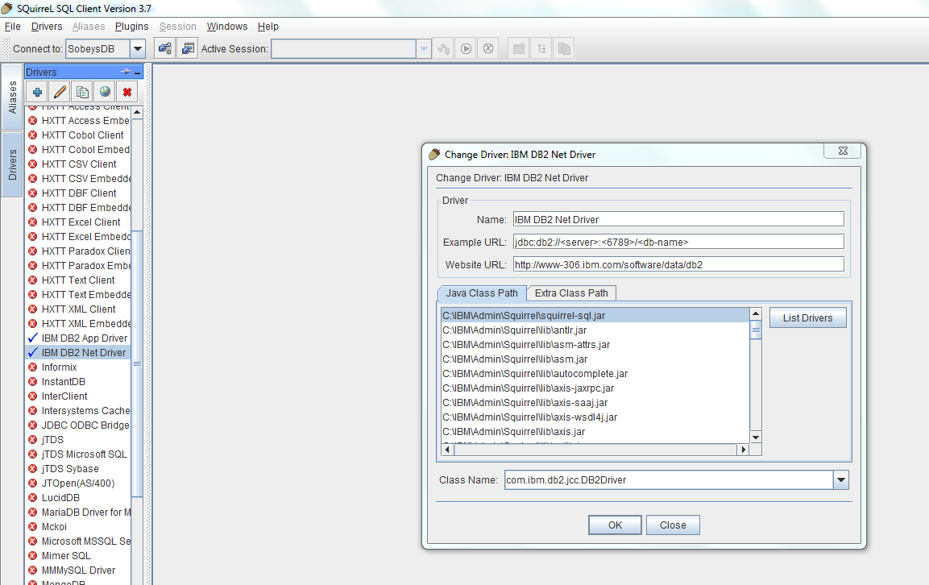
The Extra Class Path tab will appear and needs to be pointed to your driver files you downloaded in step 1.
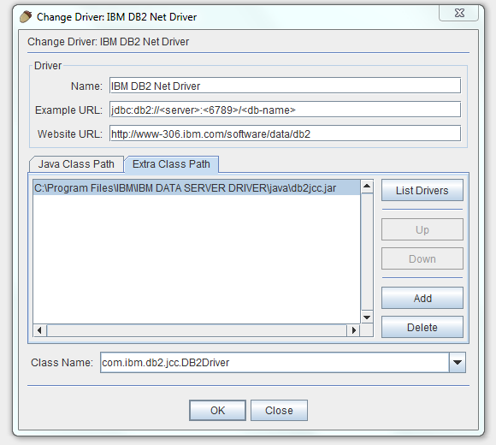
Click the “Add” button and a file dialog will appear. Open the location where your driver files are stored and click on the following file: db2jcc.jar. It should look like this:
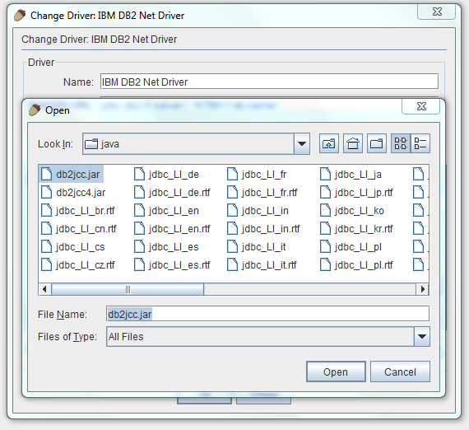
Hit Open and then Ok and you are done.
Repeat these steps for the IBM DB2 App Driver as shown below.
Step 4: Create Database Connection in SQuirreL SQL client
Open the SQuirreL SQL Client and click on the Aliases tab
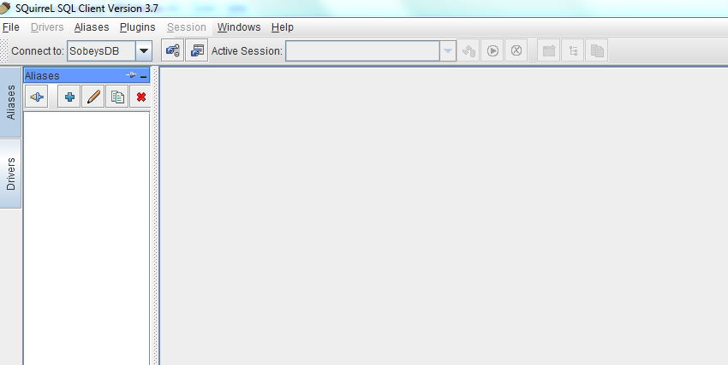
Hit the + sign to create a new alias:
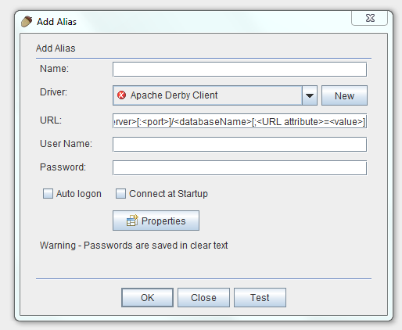
Use the following data to fill out this form:
Name: SobeysDB
Driver: IBM DB2 Net Driver
URL: jdbc:db2://192.155.240.174:50000/I6832924
User Name: :piqgpyyd
Password: zttx5bvvgvfc
The filled out form should look like:
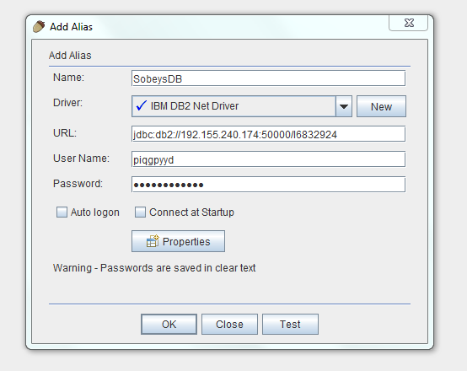
Click Ok and you should connect successfully!

Write Queries and Extract to CSV Files
Here are the steps to write a query and extract the output to a CSV file if desired:
Write your SQL statement and run it and then right mouse click on the results and select the “Export to CSV/ MS Excel / XML option”. The screens should look like this.
