Name: Richie Tess Lourdes B. Narval

Activity No. 7

1. Create a Java program that will compute the following arithmetic operations: addition, subtraction, multiplication, division, modulo : given x = 100, y = 50. Display all results. Display the string “ Hello “ into Uppercase and Lowercase and the length of the string . Display your lastName and firstname using + operator.

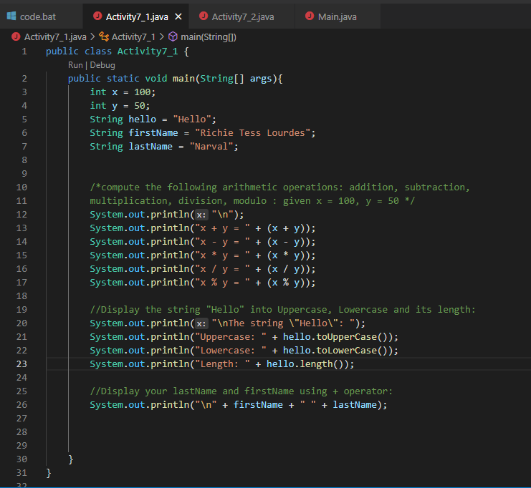Program:

Output:

