LEARNER’S PERMANENT ACADEMIC RECORD MANAGEMENT SYSTEM FOR NEW MABUHAY ELEMENTARY SCHOOL

A Capstone Project presented to the
Faculty of New Mabuhay Elementary School, General Santos City

In partial fulfilment of the Requirements for the degree
Bachelor of Science in Information Technology

Presented by:

Abellanosa, John Marcel T.
Aquino, Tarah P.
Sacro, Analyn L.
Tiu, John Jacob A.
Ayuso, Gabriel E.
Magbanua, Jose Eduardo
Lanzaderas, Princess Jhanine
Labustro, Desiree L.
Magsipoc, Genevieve M.
Deleon, Jero Clint B.
Lapasa, James
Jabat, Jasper

Presented to:

ELMER M. BALOYO JR., MIT
Capstone Adviser

Feb 21, 2026

APPROVAL SHEET

This Capstone Project hereto entitled:
LEARNER’S PERMANENT ACADEMIC RECORD MANAGEMENT SYSTEM FOR NEW MABUHAY ELEMENTARY SCHOOL
developed and submitted by John Marcel T. Abellanosa, Tarah P. Aquino, John Jacob A. Tiu, Analyn L. Sacro, Gabriel E. Ayuso, Jose Eduardo Magbanua, Princess Jhanine P. Lanzaderas, Desiree L. Labustro, Genevieve M. Magsipoc, Jero Clint B. Deleon, James Lapasa, Jasper Jabat has been examined and is recommended for acceptance and approval for ORAL EXAMINATION.

ELMER M. BALOYO JR., MIT
Capstone Adviser

APPROVED by the committee on Oral Examination with a Grade of XXXX on February 28, 2026.

PAOLO LUIGI ASIS, MIT ROMAN M. GATBONTON, MIT
Chairman Member

RAYNEE B. MEDINA
Member

ACCEPTED and APPROVED in partial fulfilment of the requirements for the degree of Bachelor of Science in Information Technology (BSIT).

ELMER M. BALOYO JR., MIT Program Head
College of Information Technology Education

Date: ______________________________

DEDICATION

This capstone project is dedicated to the faculty and staff of New Mabuhay Elementary School, whose unwavering commitment to academic excellence has inspired the pursuit of innovation. Their dedication to providing quality education has motivated the development of this system to enhance record management efficiency. Their passion for nurturing young minds has fueled the researchers’ determination to create a solution that improves the handling of student academic records.

Furthermore, gratitude is extended to the families and loved ones of the researchers, whose continuous support, encouragement, and understanding have been invaluable throughout the project's completion. Their unwavering belief in the researchers’ abilities provided the strength to overcome challenges and see the project through to its successful completion. Without their patience and moral support, this endeavor would not have been possible.

Lastly, this project is dedicated to future learners, ensuring a streamlined and secure system that upholds the integrity of academic records for generations to come. It is the researchers’ hope that this project will serve as a stepping stone toward technological advancements in educational

institutions, improving efficiency and accuracy in managing student records while alleviating administrative burdens.

ACKNOWLEDGEMENT

The researchers extend their deepest appreciation to everyone who contributed to the successful completion of this capstone project. This work would not have been possible without the guidance, support, and encouragement of various individuals and institutions who played crucial roles throughout the research and development process.

Foremost, sincere gratitude is given to the Almighty for providing wisdom, strength, and perseverance throughout this endeavor. His guidance has served as a beacon of hope, enabling the researchers to navigate through the challenges encountered during the development of the system.

Special recognition is extended to Mr. Elmer M. Baloyo Jr., MIT, the Capstone Adviser, for his invaluable guidance, constructive feedback, and unwavering support in refining the project's vision. His expertise and mentorship have significantly contributed to the successful realization of this research.

The researchers also express their sincere thanks to the faculty and administration of Goldenstate College, particularly the College of Information Technology Education, for their continuous encouragement and the opportunity to undertake this study. Their trust and support

provided the necessary resources and knowledge that greatly influenced the outcome of this project.

Heartfelt appreciation is conveyed to the administrators, teachers, and staff of New Mabuhay Elementary School for their time, cooperation, and willingness to share insights, which played a crucial role in shaping the project to meet the institution's needs. Their valuable input and willingness to assist in system evaluation have helped refine the features and functionality of the system.

Finally, deepest gratitude is extended to the researchers' families and friends for their encouragement, patience, and unwavering support throughout this journey. Their belief in this endeavor has been a constant source of motivation, providing the strength to persist despite obstacles. Their words of encouragement, sacrifices, and steadfast support have been instrumental in the completion of this capstone project.

ABSTRACT

The Learner’s Permanent Academic Record Management System for New Mabuhay Elementary School is designed to enhance the efficiency, security, and accessibility of student academic records, specifically the SF10 (Form 137). The manual record-keeping process poses challenges such as inefficiency, data loss, and security risks. This study aims to address these issues by developing an offline digital system that allows streamlined input, management, and retrieval of student records while ensuring data integrity and security. The system employs role-based access, granting administrators full control over student data while restricting teachers to specific grade levels and quarters. A quarter-based lock mechanism is implemented to ensure timely data input while preserving record integrity. Additionally, automated change logs enhance accountability and data security by recording every modification made to the records, providing an auditable history of changes. The research follows the Software Development Life Cycle (SDLC) methodology, ensuring a structured approach to planning, designing, developing, and testing the system. This methodology enables a step-by-step approach, ensuring that all aspects of system development are well-executed. Technologies used in development include Visual Studio 2015, Microsoft Excel and MySQL, operating in an offline environment for improved accessibility and security. The system's offline functionality ensures that users can access and

manage records without internet dependency, mitigating risks associated with connectivity issues.

Testing results demonstrate that the system effectively optimizes record management processes, reducing administrative workload while ensuring data accuracy and protection. The study's findings indicate that digitalizing student records minimizes errors and increases efficiency in record retrieval, benefitting both teachers and administrators. The project concludes that an automated academic record management system significantly improves efficiency, security, and reliability

in handling student records, particularly in educational institutions relying on manual processes.

Future recommendations include potential online integration for broader accessibility, automated backup functionalities to enhance data security, and additional features such as data analytics for better tracking of student performance. These improvements would further enhance the system’s capabilities, ensuring its sustainability and adaptability in the ever-evolving educational landscape.

TABLE OF CONTENTS

CHAPTER I 14
BACKGROUND OF THE STUDY 14
Introduction 14
GENERAL OBJECTIVE OF THE PROJECT 16
SPECIFIC OBJECTIVES OF THE PROJECT 16
SCOPE AND LIMITATION 18
Scope 18
Limitation 19
CHAPTER II 21
REVIEW OF RELATED LITERATURE AND STUDIES/SYSTEM 21
Related Literature 21
WHAT IS THE STUDENT RECORD MANAGEMENT SYSTEM? 21
RECORDS MANAGEMENT IN THE EDUCATION SECTOR 22
A COMPUTERIZED STUDENTS' RECORDS MANAGEMENT SYSTEM 24
A CASE STUDY OF FACULTY OF SCIENCE AND TECHNOLOGY 24
KAMPALA INTERNATIONAL UNIVERSITY WESTERN CAMPUS 24
DESIGNING AN ELECTRONIC STUDENT’S RECORDS MANAGEMENT 26
SYSTEM: A CASE STUDY OF ST FRANCIS SCHOOLS OF HEALTH 26
SCIENCES NAMATABA MUKONO (SFRASH) 26
CREATING AND IMPLEMENTING AN E-SCHOOL RECORDS MANAGEMENT SYSTEM: A CASE STUDY OF MUSHONA PRIMARY SCHOOL IN ZAMBEZI DISTRICT 28
DESIGN AND IMPLEMENTATION OF BAGGAO NORTH CENTRAL 29
SCHOOL COMPUTER-BASED RECORD MANAGEMENT SYSTEM 29
DEVELOPMENT OF STUDENT RECORDS MANAGEMENT SYSTEM OF MAGALALAG NATIONAL HIGH SCHOOL 30
CENTRAL TAYTAY SENIOR HIGH SCHOOL - STAND ALONE COMPUTERIZED RECORD MANAGEMENT SYSTEM 31
MANAGEMENT INFORMATION SYSTEM OF PUBLIC SECONDARY SCHOOLS IN SAGBAYAN DISTRICT: A PROPOSED IMPLEMENTATION 32

TABLE OF CONTENTS

DESIGNING AND IMPLEMENTING E-SCHOOL SYSTEMS: AN INFORMATION SYSTEMS APPROACH TO SCHOOL MANAGEMENT OF A COMMUNITY COLLEGE IN NORTHERN MINDANAO, PHILIPPINES 33
Related Systems 34
DEPED LEARNER INFORMATION SYSTEM (LIS) V3.0 34
WELA SCHOOL SYSTEM 35
MANDALUYONG CITY SDO E-SCHOOL SYSTEM 36
STI STUDENT LIFECYCLE MANAGEMENT SYSTEM 37
CAGAYAN STATE UNIVERSITY - PROCUREMENT & RECORDS SYSTEM 38
POWERSCHOOL SIS 39
ELLUCIAN BANNER SAAS 40
WORKDAY STUDENT 41
INFINITE CAMPUS 42
FEDENA 3.0 43
CHAPTER III 44
TECHNICAL BACKGROUND 44
TECHNICALITY OF THE PROJECT 44
DETAILS OF THE TECHNOLOGIES TO BE USED 44
HOW THE PROJECT WILL WORK 47
CHAPTER IV 48
METHODOLOGY 48
ENVIRONMENT AND LOCALE 51
POPULATION OF THE STUDY 54
OPERATIONAL FEASIBILITY 55
FUNCTIONAL DECOMPOSITION DIAGRAM Error! Bookmark not defined.
TECHNICAL FEASIBILITY 57
HARDWARE 57
SOFTWARE 58
SCHEDULE FEASIBILITY 59

TABLE OF CONTENTS

REQUIREMENTS MODELLING (SCREEN LAY-OUT) 60
DATA AND PROCESS MODELLING 64
DATA FLOW DIAGRAM 65
SYSTEM FLOWCHART 67
PROGRAM FLOW CHART Error! Bookmark not defined.
SYSTEM DESIGN 89
INPUT DESIGN AND USER INTERFACE 115
LOGIN FORM 117
ADD/EDIT STUDENT FORM 118
ADD CLASS FORM 120
ADD SCHOOL YEAR FORM 121
GRADE ENTRY INPUT 122
OUTPUT DESIGN 124
SF10 FORM (LEARNER'S PERMANENT ACADEMIC RECORD) 124
HONOR ROLL REPORT 127
ACTIVITY LOGS (AUDIT TRAIL) 128
DASHBOARD ANALYTICS 129
FORMS 131
ENTITY RELATIONSHIP DIAGRAM 138
DEPLOYMENT DIAGRAM 141
COMPONENT DESCRIPTION: 142
CONCLUSION 143
RECOMMENDATIONS 143
PROJECT IMPLEMENTATION PLAN 143
PROJECT IMPLEMENTATION CHECKLIST 145
PROJECT IMPLEMENTATION CONTINGENCY 146
BIBLIOGRAPHY 147

LIST OF FIGURES

Figure 1: How the project will work ………………………………………………
Figure 2: Organization Chart ………………………………………………………

LIST OF TABLES

Table 1: Gantt Chart …………………………………………………………………………
Table 2: Performance Review Evaluation Technique ………………………….

CHAPTER I

BACKGROUND OF THE STUDY

Introduction

Educational institutions rely heavily on the accurate and efficient management of student records to ensure academic integrity, compliance with regulations, and seamless administrative processes. Traditionally, record-keeping has been done manually, leading to various challenges such as misplaced documents, inefficiencies in retrieval, and the risk of data loss due to unforeseen circumstances. The Learner’s Permanent Academic Record Management System for New Mabuhay Elementary School was conceptualized to address these issues by providing a secure, digital, and automated solution tailored to the school's needs.

The SF10 (Form 137) serves as a critical document that records a learner’s academic history, including grades and other essential student information. Given the importance of this document, it is imperative to implement a structured and secure system that simplifies data entry, storage, and retrieval while ensuring that academic records remain accurate, confidential, and tamper-proof.

This system is designed to operate offline, eliminating dependence on internet connectivity while still ensuring a robust and reliable database for managing student records. It introduces a role-based access model, granting administrators full control over student data while allowing teachers to input and manage records specific to their assigned grade levels.

A quarter-based locking mechanism is implemented to enforce deadlines for grade submission, preventing unauthorized modifications after a set period. Additionally,

automated change logs record every action performed within the system, ensuring full accountability and transparency.

By integrating modern technologies such as Visual Studio 2015, MySQL and Microsoft Excel, this system streamlines the process of managing academic records, reducing administrative workload and minimizing errors associated with manual record-keeping. The system is expected to enhance data security, accessibility, and operational efficiency, ensuring that students’ academic records are maintained accurately and retrieved promptly when needed.

The Learner’s Permanent Academic Record Management System will significantly improve the way New Mabuhay Elementary School handles student records. It will eliminate common pain points associated with manual documentation, provide a user-friendly interface, and establish a structured workflow that optimizes the record-keeping process. With its implementation, the institution can ensure a higher level of accuracy, efficiency, and data protection, ultimately benefiting students, educators, and school administrators alike.

GENERAL OBJECTIVE OF THE PROJECT

The primary objective of this project is to develop a Learner’s Permanent Academic Record Management System for New Mabuhay Elementary School to streamline the storage, retrieval, and management of student academic records, specifically the SF10 (Form 137). The system aims to replace the traditional manual record-keeping process with a secure, efficient, and digital solution that enhances data accuracy, accessibility, and security while reducing administrative workload.

This system is designed to function in an offline environment, ensuring uninterrupted access to academic records without dependence on internet connectivity. Additionally, it seeks to implement a role-based access control system, where administrators and teachers have designated privileges to maintain data integrity and confidentiality. By integrating automation, structured workflows, and digital storage, this project aspires to modernize the way student records are handled, ensuring that they are maintained accurately, securely, and efficiently.

SPECIFIC OBJECTIVES OF THE PROJECT

To accomplish the general objective, the project specifically aims to:
  - Develop a digital platform for SF10 (Form 137) record management, replacing manual processes with a centralized, structured, and efficient system.
  - Implement role-based access control, ensuring data security by limiting administrative privileges to authorized users while allowing teachers to input and update records within their assigned grade levels.
  - Enhance data security and transparency through automated change logs, tracking modifications to student records, including timestamps and user details.
  - Introduce a quarter-based locking mechanism to prevent unauthorized modifications after designated periods, ensuring data integrity and accuracy.

  - Ensure uninterrupted access through offline functionality, allowing users to retrieve and update records even in areas with limited or no internet connectivity.
  - Facilitate seamless retrieval and printing of student records, enabling authorized users to generate and print official copies of SF10 (Form 137) efficiently.
  - Reduce administrative workload and processing time by automating data entry, retrieval, and verification, allowing educators and staff to focus on essential academic responsibilities.
  - Integrate data backup and recovery features, preventing data loss due to accidental deletions or system failures, ensuring record availability at all times.
  - Enhance user experience through an intuitive interface, making navigation simple and reducing the need for extensive training.
  - By achieving these objectives, the system will improve efficiency, security, and reliability in managing student academic records at New Mabuhay Elementary School.

SCOPE AND LIMITATION

Scope

The Learner’s Permanent Academic Record Management System is designed to digitize and enhance the management of SF10 (Form 137) records at New Mabuhay Elementary School by providing a structured and efficient approach to academic record-keeping. The system features user roles and access control, where administrators have full editing permissions across all grade levels, while teachers can update records only within their assigned grade levels and designated timeframes. A quarter-based locking mechanism ensures data integrity by restricting modifications beyond deadlines unless authorized by administrators. To strengthen data security, the system records all modifications, including user details and timestamps, with change logs accessible only to administrators for auditing purposes. The system operates offline, ensuring continuous access without internet dependency, while local storage and backup features safeguard data and allow recovery in case of accidental deletions or system failures. For record management and reporting, the system enables users to input, update, retrieve, and print student records efficiently, allowing authorized personnel to generate reports and official SF10 (Form 137) documents seamlessly. Designed with a user-friendly interface, the system minimizes training requirements for teachers and administrators while optimizing efficiency and reducing

workloads associated with manual record-keeping. By integrating these features, the system significantly enhances data security, accessibility, and operational efficiency, ensuring a structured and reliable academic record management process at New Mabuhay Elementary School.

Limitation

Despite its many advantages, the proposed system has some limitations that must be considered. The system is limited solely to the management of SF10 (Form 137) records and does not support the handling of other student-related data such as disciplinary records, extracurricular activities, medical records, or attendance tracking. Manual record-keeping outside the system is also not integrated, which may require additional efforts from school staff for non-digital documentation.

Another limitation is that the system is strictly offline-based, which means it does not support real-time online access, remote access, or cloud storage integration. Users must be physically present at the institution to access and update records, which may pose challenges if administrators or teachers require access to student data outside school premises. Additionally, data synchronization across multiple devices or external institutions is not available, limiting the system’s scalability beyond New Mabuhay Elementary School.

The quarter-based locking mechanism, while beneficial for maintaining record integrity, also introduces constraints. Once records are locked after the designated period, teachers must request administrative approval for any modifications, which may lead to delays in corrections or adjustments.

Moreover, automated grading computations and analytics are not included in the current system, requiring users to manually calculate grades and track student performance.

Furthermore, the system is customized specifically for New Mabuhay Elementary School, meaning it may require extensive modifications for use in other institutions with different grading structures, curriculum frameworks, or administrative policies.

Any attempt to deploy the system outside the school would necessitate major adjustments in its configuration and functionalities.

Lastly, while the system includes local backup and recovery features, it does not support automated remote backups or real-time data restoration, making it susceptible to potential data loss in cases of hardware failure or accidental deletions if backups are not consistently maintained. Future enhancements may address these limitations by integrating online access, cloud storage, automated backup solutions, and additional academic tracking tools to improve usability and efficiency.

CHAPTER II

REVIEW OF RELATED LITERATURE AND STUDIES/SYSTEM

Related Literature

WHAT IS THE STUDENT RECORD MANAGEMENT SYSTEM?
Astria Learning. (2022)
The Student Record Management System (SRMS) is a digital solution designed to streamline the storage, retrieval, and management of student academic records in educational institutions. Traditional paper-based and manual systems often lead to inefficiencies, data loss, and security concerns. This study explores the evolution of SRMS, focusing on its transition from on-premise installations to cloud-based solutions that offer enhanced security, cost-effectiveness, and accessibility. Key functionalities of SRMS include academic activity tracking, admissions processing, financial transactions, and inter-departmental communication. Through automation and data analytics, SRMS improves administrative efficiency, reduces operational costs, and enhances decision-making processes. Recent advancements in cloud computing have further enhanced the scalability and security of SRMS, making it a vital tool for modern educational institutions. This research reviews existing literature on SRMS, analyzing its impact on student record management, data security, and institutional efficiency. Findings indicate that implementing a well-designed SRMS significantly improves administrative productivity, student engagement, and overall institutional performance.

RECORDS MANAGEMENT IN THE EDUCATION SECTOR
Retrieve from Archive One. (2023)
Records management plays a vital role in the efficient operation of educational institutions by ensuring the systematic organization, storage, and retrieval of essential documents. Schools and universities handle extensive records, including student information, financial transactions, human resource files, and compliance-related documents. Traditionally, these records have been maintained in paper formats, leading to challenges in accessibility, security, and overall efficiency. Even with electronic storage, poor management practices can still pose risks such as data loss and breaches. This study explores the significance of structured records management in education and its impact on institutional efficiency. Proper records management promotes accountability by maintaining accurate documentation of financial transactions, stock inventories, and administrative activities. Additionally, well-organized records facilitate informed decision-making by providing administrators with reliable data for staff evaluations, student performance monitoring, and institutional planning. Effective human resource management also benefits from comprehensive employee records, which aid in workforce planning, promotions, and performance assessments. Moreover, maintaining detailed student records supports personalized academic guidance and counseling, ensuring that students receive necessary interventions based on their academic progress and behavior. To address the challenges associated with traditional records management; educational institutions are increasingly adopting Document Management Systems (DMS). A DMS provides a centralized and secure platform for storing and retrieving records, reducing reliance on physical documents and minimizing risks related to misplacement, unauthorized access, and inefficiency. The implementation of digital records management solutions enhances document security, facilitates quick retrieval, and streamlines administrative processes, ultimately improving institutional effectiveness. This study concludes that transitioning from manual to

digital records management significantly enhances operational efficiency, compliance with regulatory requirements, and overall administrative effectiveness in educational institutions. As digital transformation continues to reshape the education sector, adopting modern records management systems is essential for institutions striving to maintain accuracy, security, and accessibility in handling educational records.

A COMPUTERIZED STUDENTS' RECORDS MANAGEMENT SYSTEM

A CASE STUDY OF FACULTY OF SCIENCE AND TECHNOLOGY

KAMPALA INTERNATIONAL UNIVERSITY WESTERN CAMPUS
Retrieve from afribary.com by Bob John. (2024)
A computerized students' records management system (CSRMS) is a computer program designed to capture, store, manage the creation and maintenance of students' records in an organization. Records management (RM) is the practice of controlling records of an organization from the time they are created to the time of disposal, which includes identifying, creating, classifying, using, storing, securing, retrieving, and destroying or permanently preserving records. Records management system (RMS) is a collection of elements in an organization managing records. The activities in this management include the systematic and efficient control of the creation, maintenance, and destruction of the records, along with the business transaction associated with them, for this case, which is students' records management system. The major objective of the study was to design a Computerized Students' Records Management System that would help the Faculty of Science and Technology, KIU-WC, to efficiently and effectively manage students. The specific objectives of this study were to investigate the current system of students' record management, gather requirements for designing a computerized students' records management system, design and develop a computerized record management system, test, implement, and validate the system. Data was gathered using interviews, observations, and questionnaires. The collected data was sorted and analyzed using Microsoft Excel software, and it was found out that the current manual system is inefficient, time- and space-consuming, in addition to being insecure, hence judged not good for the management of records. After gathering the requirements, entity relation diagrams and data flow diagrams were used to design the computerized system. Microsoft Visual Basic was used to create the user interface, while MS Access was used to create the database. The computerized system developed enables electronic capturing of students' data, storing of this data in an electronic database,

which eases the retrieval of the same data any time by only authorized people. The developed computerized system also allows the backup of data on movable devices like flash disks, memory cards, and external hard drives, which increases the capacity of backup. The computerized system reduces a burden of over-compiling of papers and the need for more shelves, which reduce congestion in the Faculty of Science and Technology.

DESIGNING AN ELECTRONIC STUDENT’S RECORDS MANAGEMENT

SYSTEM: A CASE STUDY OF ST FRANCIS SCHOOLS OF HEALTH

SCIENCES NAMATABA MUKONO (SFRASH)
Retrieve from dissertations.mak.ac.ug by Kwapi Benard, Fatima Adam, Ejang Patricia Ewang & Nakandi Latifah. (2022)
The Electronic Students Record Management System as designed to provide efficient and accurate recording of records, to maintain and secure the student's records, and easy retrieval of student records, to lessen the workload of the staffs. The study aimed at designing an Electronic Students Records Management System at SFRASH Namataba Mukono to handles the storage, maintenance, and retrieval of information of students. This manual system is associated with a number of challenges such as misfiling, difficulty in retrieval, loss of files, and consumption of office space, and hence delay in service delivery. The study was guided by the following objectives as: general objective to design an electronic system that would ease the management of the students' records effectively and efficiently, to enable timely decision-making in St. Francis Schools of Health Sciences (SFRASH) and specific objectives: To find out the various types of records kept, to investigate the current system of student’s record management, to gather requirements for designing an electronic student’s records management system, to design and implement an electronic student records management system, and to test and validate the system at SFRASH. The study was also carried out under the following research questions: What are the different types of records kept, how are students
records currently kept, what are some of the requirements and the tools used for gathering information for the requirements needed for designing an electronic student’s records management system, how will the system be designed and implemented, and what are the methods for testing and validating the system. Data was gathered using interviews, observation, and document review. The collected data was sorted and analyzed using tables, and it was found out that the current manual system is inefficient, time and space-consuming, in addition to being insecure, hence

judged not good for the management of records. The system was designed using Visual Studio 2019 and Microsoft Access Database 2013. An electronic system developed enables electronic capturing of students' data, storing of this data in an electronic database, which eases the retrieval of the same data, any time by only authorized people. The developed computerized system also allows the backup of data on movable devices like flash disks, memory cards, and external hard drives, which increases the capacity of backup.

CREATING AND IMPLEMENTING AN E-SCHOOL RECORDS MANAGEMENT SYSTEM: A CASE STUDY OF MUSHONA PRIMARY SCHOOL IN ZAMBEZI DISTRICT
Retrieve from researchgate.net by Preston Mwiinga. (2023)
In the bygone era, prior to the rise of cutting-edge technology, organizations including schools heavily depended on manual, paper-based systems to oversee their record-keeping processes. However, the relentless evolution of technology has ushered in an opportune moment to address this long-standing challenge. Our project is a dedicated endeavor aimed at surmounting the hurdles intertwined with archaic paper-based record management systems. Our undertaking encompasses the development of a robust online school management system, adept at securely housing a wealth of information concerning schools, educators, and students within a digital repository. The design and development phases of the project are underpinned by the substantial use of sophisticated computer software and automated tools, ensuring seamless data storage for future reference. Our paramount
consideration during system design is user-friendliness, as we endeavor to make the system easily navigable, sparing users from redundant data entry tasks. Once the foundational modules are established, an extensive testing regimen is executed to warrant the seamless and effective functionality of the project. The system is designed with security and efficiency in mind, allowing for comprehensive data management in a secure online database. Following the creation of the essential modules, a rigorous testing process was conducted to guarantee the successful functionality of the project.

DESIGN AND IMPLEMENTATION OF BAGGAO NORTH CENTRAL

SCHOOL COMPUTER-BASED RECORD MANAGEMENT SYSTEM
Retrieve from ijfmr.com by Ursola G. Uy, Michelle A. Cabrera, Michael J. Pinero, Conrado P. Vizcarra. (2023)
This study aims to design and develop a computer-based student record management system for Baggao North Central School. The system is expected to streamline the administrative tasks of the school, from keeping track of student records to generating reports. Its user-friendly interface makes it easy for staff to navigate through the system, reducing the chance of human error during record-keeping. Additionally, the quick access feature enables staff to locate student records within seconds, making it an invaluable tool for effective academic management. The system incorporates security features to maintain the privacy of sensitive student information, ensuring that only authorized individuals have access to the data. Moreover, the system ensures that data is always up-to-date and accurate, minimizing the risk of issues arising from inconsistencies in record keeping. The system allows selected staff members to input, edit, and view student-related information, promoting seamless information flow within Baggao North Central School (BNCS). This enhances efficiency in managing student records and enables timely decision-making when necessary.

DEVELOPMENT OF STUDENT RECORDS MANAGEMENT SYSTEM OF MAGALALAG NATIONAL HIGH SCHOOL
Retrieve from journal.aide-inc.net by Rene A. Duruin and Generino P. Siddayao. (2024)
This study aimed to design, develop, and implement a School Records Management System (SRMS) for Magalalag National High School. The Descriptive and Developmental research design was employed in this study. Interviews and surveys were used as data and requirement-gathering techniques. Data gathered were analyzed using descriptive statistics. For the Developmental Research Design, the Software Development Life Cycle (SDLC) and the Sashimi Model approach were utilized. The findings of the study revealed that one of the major difficulties with the manual system is the lack of document storage, as the amount of paper used grows yearly, which had the highest mean value. This indicates a need for an efficient way to manage these documents. It was also revealed that one of the most highly recommended solutions for this issue is to monitor the record management program and keep it up to date. It was suggested that there should be a staff member responsible for maintaining this program. Moreover, the assessment of the SRMS further showed that it has an extremely high degree of compliance with ISO 25010 Software Quality Standards. The study also found that the SRMS is useful for storing and retrieving student records. The research shows that the SRMS is considered effective based on evaluation using ISO 25010 Software Quality Standards. This study will serve as the foundation for its potential adaptation and implementation in MNHS.

CENTRAL TAYTAY SENIOR HIGH SCHOOL - STAND ALONE COMPUTERIZED RECORD MANAGEMENT SYSTEM
Retrieve from scribd.com by Lorry Ann Elorde, Almelyn Q. Latube, Cyryl O. Nonong, Shirley A. Quilloy. (2021)
This study aims to investigate the efficiency and effectiveness of having an integrated system of electronic records for the students of Central Taytay Senior High
School. The researchers noticed some problems experienced by the registrar when obtaining student records. This prompted the researchers to propose this study to address the current problem. To gather data for the study, a survey was created containing questions about how the software would benefit the registrars and how convenient it would be compared to manually writing and searching for student records. The system aims to make it easier for the registrar to generate and retrieve student records efficiently. The researchers conducted an interview with the registrar of the school. After analyzing the interview responses, the researchers found that the interviewee was in favor of the proposed system. The results suggest that the proposed study should be accepted, utilized, and integrated into the school's system. The study was conducted to assess the methods and processes used by the Registrar’s Office in maintaining student records. It also identified the problems encountered by registrar personnel and instructors, particularly regarding the security of student records against alteration or loss. Additionally, it examined the need for developing a Student Record Management System. A Student Record Management System that is accurate, fast, and accessible for the registrar’s office will facilitate record-keeping. It will also improve operational efficiency, ensuring a smoother workflow and better service.

MANAGEMENT INFORMATION SYSTEM OF PUBLIC SECONDARY SCHOOLS IN SAGBAYAN DISTRICT: A PROPOSED IMPLEMENTATION
Retrieve from philpapers.org by Fernando Enad & Nestor Balicoco. (2023)
This research addressed the challenges faced by public secondary schools in Sagbayan District, Bohol, regarding records management. The study employed a mixed research design, combining both descriptive-qualitative and descriptive-quantitative methods. The qualitative phase involved conducting in-depth interviews and focus group discussions with relevant stakeholders involved in records management. Meanwhile, the quantitative phase utilized survey questionnaires to gather data from stakeholders to determine the acceptability of the proposed Management Information System (MIS) among end users. The findings from the first phase revealed various challenges in records management, such as inefficient manual record-keeping systems, difficulties in data retrieval, and the risk of data loss due to inadequate backup procedures. These challenges underscored the need for a comprehensive, technology-driven solution to streamline records management processes and ensure data security. The evaluation results from the second phase showed that the developed MIS was well-accepted among end users. The absence of any significant difference in the level of acceptability among participants further validated the system’s suitability for addressing their specific needs. The successful implementation of the MIS proved to be an effective solution to the records management challenges faced by public secondary schools in Sagbayan District, Bohol.

DESIGNING AND IMPLEMENTING E-SCHOOL SYSTEMS: AN INFORMATION SYSTEMS APPROACH TO SCHOOL MANAGEMENT OF A COMMUNITY COLLEGE IN NORTHERN MINDANAO, PHILIPPINES
Retrieve from stepacademic.net by Niño T. Baran, Kenn Migan Vincent C. Gumonan, Aldwin Lester M. Martinez & Mona Liel E. Lacsa. (2021)
Colleges and universities have been established to provide educational services to the people. Like any other organization, the school has processes and procedures similar to business or industry that involve admissions, processing of data, and generation of reports. Those processes are made possible through a centralized system for storing, processing, and retrieving data and information. The majority of schools in the country are already adopting computer-based systems to address their needs, especially for student and school-related transactions. The absence of a computer system and the complexity of the transactions within the college, which results in personnel being overloaded with paperwork in storing and keeping student records and information, is the motivating factor for designing and developing the School Management Information System for a community college in the northern part of Mindanao.

Related Systems

DEPED LEARNER INFORMATION SYSTEM (LIS) V3.0
https://lis.deped.gov.ph (2024)
The Learner Information System (LIS) stands as the Department of Education's centralized, web-based national registry, mandating the maintenance of a unique Learner Reference Number (LRN) for every student in basic education. It is the primary mechanism for tracking enrollment, monitoring learner promotion, and generating standardized school forms (SF1-SF10) across all public and private institutions.
- Strengths: Its most significant advantage is the standardization of learner data on a national scale, ensuring a "single source of truth" for student enrollment and preventing duplicate entries across different schools. The 2024 update improved data validation protocols, reducing common encoding errors.
- Weaknesses: The system's heavy reliance on stable internet connectivity creates a major operational bottleneck. During critical reporting periods (End of School Year), server congestion often leads to downtime, delaying the submission of urgent reports. Crucially, while it tracks current status, it lacks the functionality for schools to easily rectify, reconstruct, or print detailed historical records (Form 137/SF10) offline, forcing registrars to rely on manual methods for historical data.
- Gap Addressed: The proposed system fills this critical void by providing an offline-first, localized solution specifically designed for New Mabuhay Elementary School. It allows for the immediate generation and printing of SF10 forms without internet dependency, ensuring that record management continues seamlessly even during LIS downtimes.

WELA SCHOOL SYSTEM
https://wela.online/en/ (2023)
Wela is a robust, cloud-based school management platform tailored for Philippine private schools, integrating modules for grading, attendance, accounts receivable, and library management. Its 2023 update introduced a mobile application for parents, enabling real-time monitoring of student grades and financial statements, alongside a "Teacher Portal" for direct grade entry.
- Strengths: The system's automated grade consolidation is a major asset, eliminating the prone-to-error manual computation of grades. The parent mobile app fosters transparency and improves home-school communication.
- Weaknesses: As a commercial product, Wela operates on a subscription-based "Software as a Service" (SaaS) model, presenting a significant financial barrier for non-funded public schools. Its feature set, designed for private institutions (billing, online payments), is often too complex and irrelevant for the simpler, non-commercial workflows of public elementary schools.
- Gap Addressed: The proposed project addresses this financial and functional mismatch by offering a cost-effective, custom-built system that delivers the essential automation of grade consolidation and report generation found in premium software, but specifically engineered for the public-school context without recurring licensing fees.

MANDALUYONG CITY SDO E-SCHOOL SYSTEM
https://depedmandaluyong.org (2024)
The Mandaluyong City Schools Division Office (SDO) e-School System is a division-wide initiative aimed at digitizing student records and automating the submission of school forms from the school level to the division office. It streamlines data transfer, reducing the manual workload of checking forms and enabling centralized city-wide statistical reporting for decision-making.
- Strengths: It effectively centralizes data for an entire city division, allowing for rapid generation of aggregate statistics (e.g., total enrollees, dropout rates). It simplifies the compliance process for school heads submitting reports to the division.
- Weaknesses: While excellent for compliance, the system focuses on aggregate data reporting rather than the detailed, day-to-day management of individual student permanent records (SF10) within the school. It lacks granular tools for school registrars to edit, update, or reconstruct historical grades for transferees or correct past errors in a student's permanent record.
- Gap Addressed: The proposed system complements this by focusing entirely on the school-level management of the Permanent Record. It provides the specific, granular tools needed by registrars to manage historical grades and print individual SF10s, functionality that division-level systems typically overlook.

STI STUDENT LIFECYCLE MANAGEMENT SYSTEM
https://elms.sti.edu (Updated 2022)
The STI Student Lifecycle Management System (SLMS) is an end-to-end solution that manages the entire academic journey of a student, from initial admission inquiry to graduation and alumni tracking.
- Strengths: Its core strength lies in its "One-Student, One-Record" policy, which ensures that a student's data remains consistent and accessible across all STI campuses nationwide, facilitating seamless transfer and record retrieval.
- Weaknesses: Designed for a large network of tertiary institutions, the system's enterprise-level complexity and scale make it impractical for a single elementary school. The infrastructure required to deploy and maintain such a system is beyond the technical and financial capacity of a typical public elementary school.
- Gap Addressed: The proposed system adapts the valuable "Lifecycle" concept —tracking a student continuously from Grade 1 to Grade 6—but simplifies the implementation into a lightweight, user-friendly interface. This makes advanced lifecycle tracking accessible to elementary school staff with basic technical skills, bridging the gap between complex enterprise systems and manual paper records.

CAGAYAN STATE UNIVERSITY - PROCUREMENT & RECORDS SYSTEM
https://journal.aide-inc.net/index.php/aide-irj/article/view/112 (2024)
This integrated system combines student academic records with university procurement, asset management, and human resources. Cited in recent studies for its "holistic" approach, it allows administrators to link student fees directly to facility usage and resource allocation.
- Strengths: It provides a comprehensive view of school operations, linking academic data with administrative and financial logistics.
- Weaknesses: The broad integration leads to "feature bloat," where the sheer number of modules makes the system slow and confusing to navigate. Simple, frequent tasks like printing a student's Form 137 can become buried under layers of unrelated menus (e.g., procurement, assets), creating a steep learning curve for non-technical staff.
- Gap Addressed: The proposed system avoids this pitfall by being highly specialized and streamlined, focusing solely on Academic Records Management. This "lean" design ensures that teachers and registrars can perform their specific tasks—entering grades and printing records—with maximum efficiency and minimal training.

POWERSCHOOL SIS
https://www.powerschool.com/ (USA, 2025 Update)
PowerSchool SIS is the premier K-12 student information system in North America, renowned for its scalability and advanced analytics. Its 2025 roadmap emphasizes "AI-Driven Insights," introducing features that predict student failure risks based on attendance and grade trends, and integrating diverse data points like health and special education plans.
- Strengths: It sets the global standard for data-driven decision-making , offering predictive analytics that help educators intervene early for at-risk students. Its interoperability allows it to connect with hundreds of third-party educational apps.
- Weaknesses: The system's vast feature set and high cost make it completely inaccessible for smaller, resource-constrained schools in the Philippines. The complexity of its setup requires dedicated IT staff, which most public elementary schools do not have.
- Gap Addressed: The proposed system democratizes digital record-keeping by providing essential functions —secure grade storage and automated report generation—without the overwhelming complexity or prohibitive cost of enterprise-level analytics, making modern record management accessible to New Mabuhay Elementary School.

ELLUCIAN BANNER SAAS
https://www.ellucian.com/products/student (Global, 2024)
Ellucian Banner is a dominant higher-education ERP used globally to manage massive student databases. Its recent pivot to a "SaaS" (Software as a Service) model highlights the industry shift toward cloud-based accessibility and security.
- Strengths: It proves that web-based technologies (specifically PHP and SQL-based structures) are the gold standard for secure, high-volume record keeping. Its "Self-Service" portals empower students and faculty to manage their own data, reducing administrative bottlenecks.
- Weaknesses: As a university-centric system, it includes extensive modules for "Financial Aid," "Dormitory Management," and "Course Prerequisite Checking" that are completely irrelevant to the elementary school context.
- Gap Addressed: The proposed system adopts the robust web-based architecture (PHP/MySQL) of Banner to ensure scalability and security but strips away the university-level features. It delivers a solution that is technically modern yet functionally tailored specifically to the K-12 education sector.

WORKDAY STUDENT
https://www.workday.com/en-us/products/student/overview.html (Global, 2023)
Workday Student is a modern, mobile-first system that unifies student academic records with university finance and human resources. It is celebrated for its "Role-Based Security Model," which offers granular control over data access.
- Strengths: Its security model is best-in-class, ensuring that sensitive data (like grades or financial status) is visible only to authorized users. The mobile-first design caters to the modern, on-the-go user.
- Weaknesses: The implementation cost is extremely high, and the system requires significant hardware resources to run effectively, making it unsuitable for schools with older computer hardware.
- Gap Addressed: The proposed system implements a similar Role-Based Security (Admin vs. Teacher) model to strictly protect data integrity but is optimized to run on standard, low-spec school hardware (e.g., existing desktop PCs). This ensures that the school benefits from enterprise-grade security concepts without the enterprise-grade price tag or hardware requirements.

INFINITE CAMPUS
https://www.infinitecampus.com/ (USA, 2023)
Infinite Campus is widely used in the US for its unique "Statewide" data collection capabilities. Unlike legacy systems that create a new database for each school year, Infinite Campus utilizes a "Single Database" design to track students across multiple years and schools.
- Strengths: This design enables longitudinal data analysis, allowing educators to view a student's complete academic trajectory from kindergarten through 12th grade in a single, unified view.
- Weaknesses: Its centralized nature raises data privacy concerns and creates a single point of failure if the central server is breached. The setup is complex and requires state-level coordination.
- Gap Addressed: The proposed system adopts the "Single Database" concept for tracking historical grades (Grade 1-6) but implements it as a local, offline database. This ensures that sensitive student data remains within the school's physical control and privacy jurisdiction while still allowing for the powerful analysis of a student's academic history.

FEDENA 3.0
https://fedena.com/ (India/Global, 2022)
Fedena is an open-source school management software built on the Ruby on Rails framework, popular in developing nations for its cost-effectiveness. It features a modular "Plugin System," allowing schools to customize their installation by adding only the features they need.
- Strengths: It is highly affordable and adaptable, demonstrating that community-driven software can rival expensive commercial products. The plugin architecture keeps the core system lightweight.
- Weaknesses: While the software is free, it requires significant technical expertise to install, maintain, and customize plugins to match specific local reporting formats (like DepEd forms). A school without a dedicated programmer would struggle to make it compliant.
- Gap Addressed: The proposed system addresses this gap by being pre-configured with the specific DepEd SF10 format and workflow. It offers a "turnkey" solution that requires no complex customization or programming knowledge from the school staff, ensuring immediate usability upon installation.

CHAPTER III

TECHNICAL BACKGROUND

This chapter discusses the technical aspects of the Learners' Permanent Academic Record Management System for New Mabuhay Elementary School, including the system’s specifications, operational framework, and implementation details.

TECHNICALITY OF THE PROJECT

The Learners' Permanent Academic Record Management System for New Mabuhay Elementary School is designed to streamline student academic record management by replacing manual processes with a secure, digital solution. The system will function in an offline environment, ensuring accessibility and security without dependence on internet connectivity.

DETAILS OF THE TECHNOLOGIES TO BE USED
- SOFTWARE – FRONT END
- HTML5 (Hyper Text Markup Language)
- Used for the semantic structure of all web pages, forms, and the SF10 report layout.
- CSS3 (Cascading Style Sheets)
- Used for custom styling, printing layouts for Form 137, and ensuring the interface is user-friendly.
- Bootstrap 5.3.0 Framework
- A powerful responsive framework used for the system's grid system, navigation bars, modals, and mobile-ready design.

- JavaScript (ES6+)
- Handles dynamic interactivity such as the "Loading..." spinners, sidebar toggles, and client-side form validation.
- Bootstrap Icons 1.10.5
- Provides the vector icons used throughout the dashboard (e.g., user, print, and trash icons).

- SOFTWARE – BACK END
- PHP (Hypertext Preprocessor) 8.x
- The core server-side language that processes login logic, grade calculations, and database connections.
- MySQL Database
- The relational database used to store student profiles, grades, school years, and user accounts.
- Apache HTTP Server (via XAMPP)
- The local web server software that hosts the PHP application and serves it to the browser.
- XAMPP Control Panel
- The integrated development environment used to manage the Apache server and MySQL database offline.

- OPERATING SYSTEM REQUIREMENTS
- Windows 10 or Windows 11 (64-bit)
- Required to run the XAMPP server environment and modern web browsers (Chrome/Edge) efficiently

- HARDWARE REQUIREMENTS
- Processor: Intel Core i3 / AMD Ryzen 3 or higher
- Necessary to run the local web server (Apache) and database (MySQL) simultaneously without lag.
- RAM: 8GB or higher
- Recommended to ensure smooth performance when multiple browser tabs and the server are running.

- Storage: 250GB HDD or SSD
- Required for storing the XAMPP installation, database files, and daily backups.
- Printer: Standard Inkjet or Laser Printer
- Must support Long/Legal Size Paper (8.5" x 13") for printing the official DepEd School Form 10 (Form 137).

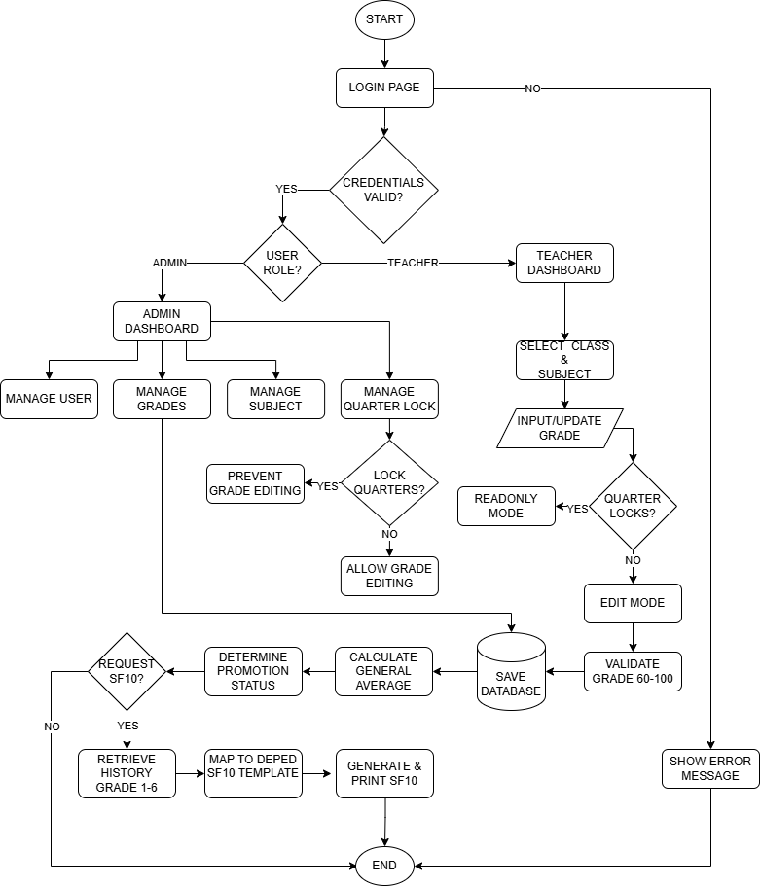
HOW THE PROJECT WILL WORK

Figure 1.0 – How the Project will work

CHAPTER IV

METHODOLOGY

This chapter presents an analysis of the proposed system. It outlines the planning, design, and practical value of the system, emphasizing its relevance to the administration of New Mabuhay Elementary School in enhancing their understanding of the proposal. Furthermore, the chapter discusses the operational and technical dimensions of the project, including implementation schedules, as part of the development and deployment of the Learner's Permanent Academic Records Management System.

The researchers adopted the Software Development Life Cycle (SDLC) as the guiding framework for this study. This approach is characterized by its structured phases, wherein the output of each phase serves as the input for the subsequent stage. The model is recognized for its clarity and ease of application, making it accessible to both practitioners and reviewers. Its framework ensures that each phase is accompanied by well-defined deliverables and a systematic review process, thereby facilitating effective project management and orderly progression.

- Planning
The researchers convened as a group to exchange ideas and collaboratively organize their efforts. By structuring the team effectively, they sought to maximize the strengths and capabilities of each member, ensuring that everyone contributed meaningfully to the research process. Together, they formulated plans for the system’s functionality—specifically the digitization of SF10 forms, grade entry, and student data management—while also considering strategies for the successful implementation of the project at New Mabuhay Elementary School.

- Analyzing
The researchers collaboratively examined a wide range of data, including existing DepEd Orders regarding the SF10 form (Learner's Permanent Academic Record), to serve as references for the project. Following the collection process, the team systematically organized and analyzed the information to anticipate potential challenges, such as data accuracy in grade computation and historical record migration. Designated members then conducted a thorough evaluation to develop feasible and well-structured solutions aimed at addressing these identified problems.

- Designing
The system was intentionally designed with simplicity and data integrity as its guiding principles. To achieve this, the researchers selected a web-based architecture that could be readily accessed via the school's local network. The resulting design emphasizes clarity and accessibility, ensuring that the system is both comprehensible and easy to operate for teachers and the school registrar.

- Coding
For the development of the system’s software, the researchers selected programming languages and tools that were widely standard for web development. Specifically, they utilized PHP for server-side logic and MySQL/MariaDB for database management, as these enabled rapid and efficient application generation on the XAMPP environment. This choice reflected both practicality and effectiveness, ensuring that the programming process aligned with the project’s objectives for timely and reliable implementation.

- Testing
Upon completing the key stages of the project, the researchers invited prospective users—specifically the teachers and the school registrar of New Mabuhay Elementary School —to engage directly with the system. These individuals were encouraged to interact with the application firsthand, testing features such as grade encoding, quarter locking, and SF10 report generation. Through this participatory evaluation, the researchers were able to identify logical errors and gain valuable insights, which informed further refinements and enhancements to the system’s development.

- Implementation
Following the refinement of the system, the researchers compiled all necessary documentation to accompany the final product for client presentation. These materials included comprehensive records, the database schema, and instructional guides detailing the system’s functionality and operation. In collaboration with the administration of New Mabuhay Elementary School, the researchers ensured that the project was completed successfully and prepared for practical use within the school's local infrastructure.

- Maintenance
After the system had been implemented and deployed, the researchers ensured that a maintenance plan was in place to keep the Learner's Permanent Academic Records Management System running smoothly. This included procedures for regular database backups, security updates, and troubleshooting of both the software and the XAMPP server environment. The system would be periodically checked for errors or performance issues, and corrective actions would be taken

promptly to prevent disruptions. Instructional guides and support materials were also provided to the client to facilitate routine maintenance and problem resolution, ensuring the system remained functional, secure, and efficient for long-term use.

ENVIRONMENT AND LOCALE
This study was carried out in partnership with New Mabuhay Elementary School (NMES), located in Barangay Mabuhay, General Santos City. NMES traces its origins to the early 1980s, officially established around 1980 to provide local access to primary education. It grew from an annex of Lagao National High School (LNHS) into an independent elementary school serving the surrounding community and has celebrated milestone anniversaries, including its 45th anniversary in late 2025.
Key milestones and local context:
- 1980s: Community demand for a local elementary school in Barangay Mabuhay led to the creation of a local annex and the vision for NMES.
- 1990s: Lagao National High School operated an extension in Barangay Mabuhay to serve growing enrollment; local records and secondary sources document this phase.
- 1995: The extension arrangements matured and nearby institutions reorganized; NMES consolidated its presence as an independent elementary school.
- Present: NMES continues to serve primary education needs in the locality, maintaining partnerships with municipal education offices and celebrating notable anniversaries.
Data and access: the partner school provided sample datasets (student records, enrollment lists and historical grade sheets) for testing and UAT. Site visits and stakeholder meetings were conducted at the school to validate workflows and to gather qualitative feedback from teachers and administrators

Google Maps embed showing the school's location, and photographs of the school's façade and facilities
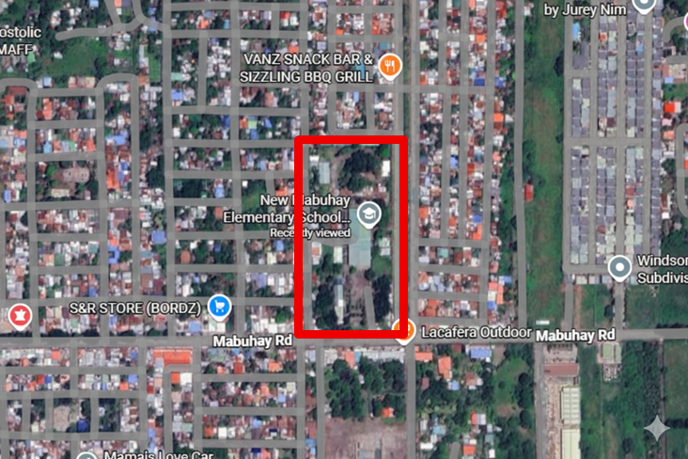

Figure 2.0 – The Environment and Locale

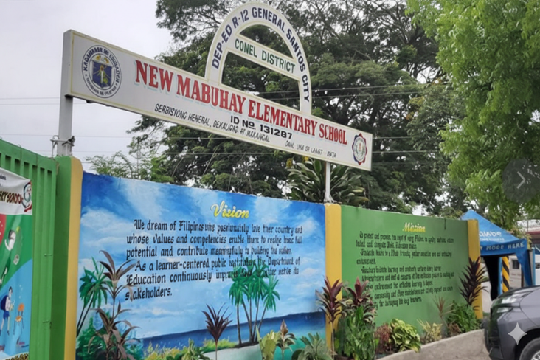
Figure 2.0 – The Environment and Locale

Figure 2.1 – Entrance Gate Front Side of the school

Figure 2.1 – Front Gate of the school

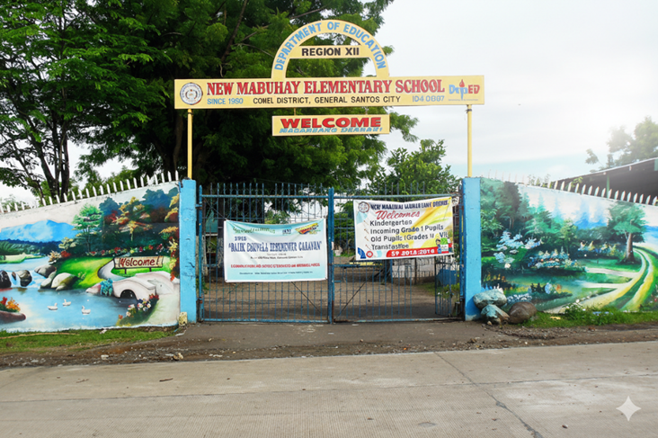

Figure 2.2 – Exit Gate East Side of the school
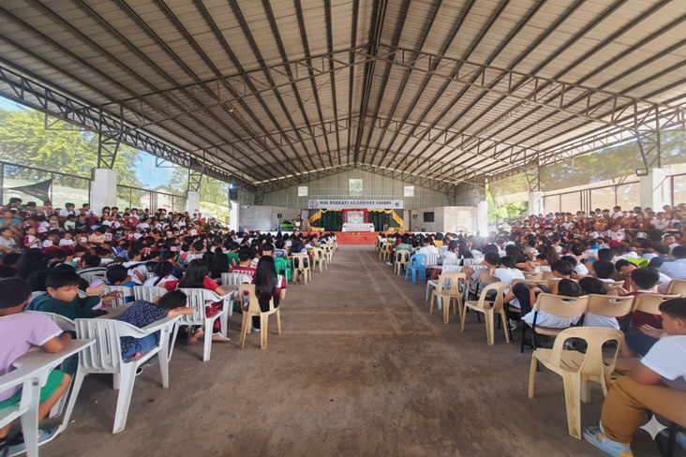

Figure 2.3 – School Gymnasium

POPULATION OF THE STUDY
In this section details the number of employees or number of workforce. What are their positions and present the organizational structure. Attach an organizational structure. Cite the organizational structure as ‘FIGURE 3.0” to be included in your List of Figures.

OPERATIONAL FEASIBILITY
This section includes the cause-and-effect diagrams. The fishbone diagrams will help identify the possible causes to problems and sorting ideas into useful categories. The proposed system should be user-friendly and satisfies the end-user requirements.

- People
inadequate training; high staff workload; unclear role responsibilities; staff turnover.
- Machine (Technology)
Intermittent internet; old PCs or incompatible browsers; unreliable printers/scanners.
- Measurement / Monitoring
No verification/check steps; missing QA metrics; no pre‑submission checks.
- Material (Data)
Missing or invalid LRN; legacy grade formats; incomplete enrollment or subject mappings.
- Environment
Shared workstations; limited printing/backup resources; intermittent power/connectivity.
- Management
No standard operating procedures; inconsistent grading policies; insufficient staffing and support.

Top 3 root causes: process & data gaps (paper/legacy data), lack of staff training/role clarity, technology/connectivity
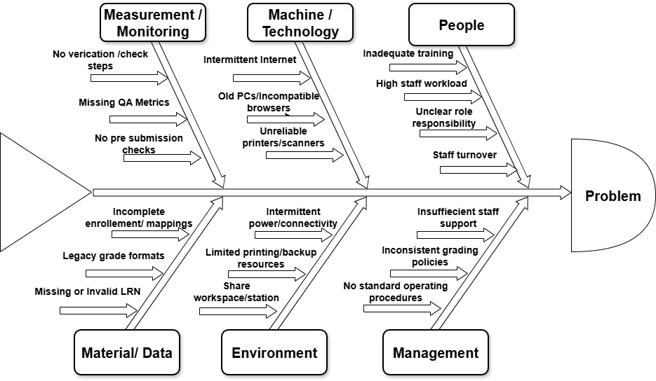

Figure 4.0 – Operational Feasibility (Fishbone Diagram)

TECHNICAL FEASIBILITY
In considering whether the proposed system is technically feasible, the researchers survey the area and checked the necessary technologies. The following are the needed resources in the proposed system:

HARDWARE
These are the requirements for hardware to fully operate the proposed system.

  - CPU Specification
    - Minimum: Intel Core i3 (8th Gen)
    - Recommended: 2.5 GHz or higher, dual-core
  - RAM Memory Specification
    - Minimum: 4 GB RAM
    - Recommended: 8 GB RAM for better multitasking
  - HDD Specification
    - Minimum: 256 GB HDD or SSD
    - Recommended: 512 GB SSD for faster system performance and data access
  - Brand/ Model / Description of Monitor
    - Brand / Model: Dell E190i
    - Description: 18.9-inch (1280 x 1024) LED-backlit monitor
  - Brand/ Model / Description of Keyboard
    - Brand / Model: A4TECH KRS-85
    - Description: Standard wired USB keyboard
  - Brand/ Model / Description of Mouse
    - Brand / Model: Logitech MX300
    - Description: Standard wired optical USB mouse
  - Others such as Printer / Scanner / Speaker
    - Printer: Brother HL-L2350DW

SOFTWARE
These are the requirements for hardware to fully operate the proposed system.

- OS Specification

    - Operating System: Windows 10 or Windows 11 (64-bit)
    - Browser: Google Chrome (Recommended), Mozilla Firefox, or Microsoft Edge

- Front-end Specification

    - Languages: HTML5, CSS3, JavaScript
    - Frameworks/Libraries: Bootstrap (for responsive design/dashboard UI), jQuery (for interactive elements)
    - Development Tool: Visual Studio Code (or Visual Studio 2015 as per your previous note)

- . Back-end Specification

    - Server Environment: XAMPP (Apache HTTP Server)
    - Server-Side Language: PHP 7.4 or higher
    - Database: MySQL / MariaDB (via phpMyAdmin)

SCHEDULE FEASIBILITY
The schedule feasibility is an estimation of the timetable of system development and if it can be completed in a given time period. It is the measurement of how reasonable the timetable of the project is.

Table 1.0 – The Gantt Chart
Task Name | July |  |  |  | August |  |  |  | September |  |  |  | October |  |  |  | November |  |  |  | December
PLANNING
ANALYSIS
DESIGN
CODING
IMPLEMENTING
TESTING
MAINTENANCE

The table 1.0 shows how the study is developing by the researchers illustrated through the time frame versus tasks using the Gantt Chart.

REQUIREMENTS MODELLING (SCREEN LAY-OUT)
During the requirement analysis phase, the researchers must have to identify and describe all system requirements. The System Requirement Checklist presents the input, process, outputs, performance and controls.

- INPUT – is the data collected that is being stored in the database
- PROCESS – is the processes done in a particular sub-system
- OUTPUT – is the result of all inputted data
- PERFORMANCE – is the remark that the output is working properly and error-free
- CONTROL – is the order to limit the operation

Table 2.0 – Student Management
INPUT | LRN, Last Name, First Name, Middle Name, Suffix, Gender, Birthdate, Credential Presented (Kinder Progress Report, PEPT, etc.), Eligibility School Name, School ID, Address, PEPT Rating/Date/Center (if applicable)
PROCESS | Validate for duplicate LRN or Name, convert names to uppercase, Insert student record into database, Log activity (Audit Trail)
OUTPUT | New Student Record stored in database, Student ID generated, Redirection to Grade Progression page
PERFORMANCE | Immediate validation of duplicates, Real-time data insertion
CONTROL | Required fields check (LRN, Name, etc.), Duplicate LRN prevention, Session-based access control (Login required)

The Table 2.0 shows the data and input-process-out, performance and control for Student Management

Table 3.0 – Grade Management
INPUT | Student ID, School Attended ID, Subject ID, Quarter Grades (Q1, Q2, Q3, Q4), Final Rating, Remarks
PROCESS | Retrieve student and subject data, check for existing grades, Input/Update grades per quarter, Calculate Final Rating (Average), Determine Promotion/Retention status
OUTPUT | Stored Grades for each subject/quarter, Calculated General Average, Updated Student Academic Record
PERFORMANCE | Automatic calculation of averages, Fast retrieval of grade history
CONTROL | Quarter locking mechanism (prevent editing past quarters), Role-based access (Teachers/Admins)

The Table 3.0 shows the data and input-process-out, performance and control for Grade Management

Table 4.0 – SF10 Report Generation
INPUT | Student ID, Selected School Year range, Template choice (DepEd SF10 Standard)
PROCESS | Fetch complete academic history (Grades 1-6), Map grades to SF10 layout, Format data for printing
OUTPUT | Printable SF10 Form (HTML/PDF preview), Official Academic Record Document
PERFORMANCE | High-fidelity print layout, Accurate historical data compilation
CONTROL | Read-only output (cannot edit grades on the form directly), Access restricted to authorized personnel

The Table 4.0 shows the data and input-process-out, performance and control for SF10 Report Generation

Table 5.0 – User Management (Security)
INPUT | Username, Password, Full Name, Role (Administrator/Teacher)
PROCESS | Verify credentials against database, Hash passwords (if registration), Create/Update user session
OUTPUT | Access to Dashboard (Admin or Teacher view), Login Success/Failure message
PERFORMANCE | Secure login processing, Session management
CONTROL | Password hashing, Role-based restrictions (Admins can manage users, Teachers can only manage grades), Session timeout/logout

The Table 5.0 shows the data and input-process-out, performance and control for User Management (Security)

DATA AND PROCESS MODELLING
In this section, it shows the whole flow of the system. This includes the Context Diagram, the Entity Relationship Diagram and the Data Flow Diagram used to describe the flow of the data.

- The System Context Diagram
It is a diagram that defines the boundary between the system, or part of a system and its environment showing the entities that interact with it.

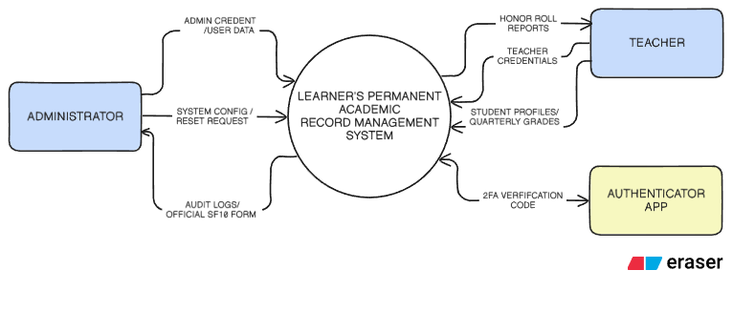

Figure 5.0 The System Context Diagram of the learner’s permanent academic record management system for new mabuhay elementary school.

DATA FLOW DIAGRAM
The Data Flow Diagram is a graphical representation of the flow of the data through an information system. It enables you to represent the processes in your information system from the viewpoint of data.
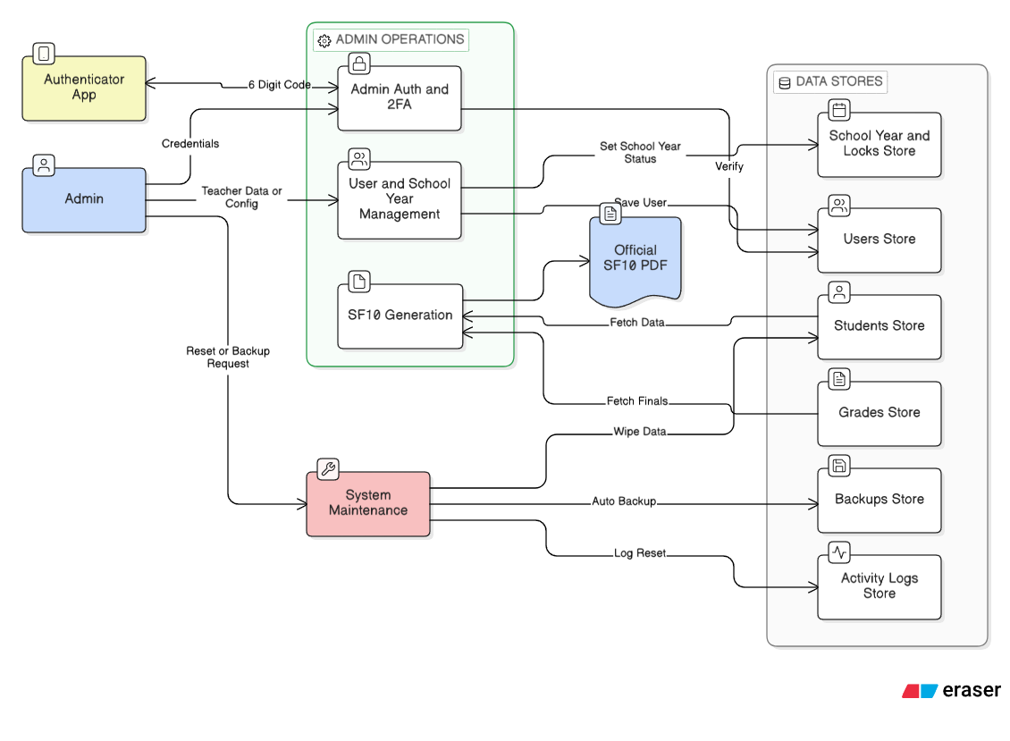

Figure 5.1 Data Flow Diagram of Admin User

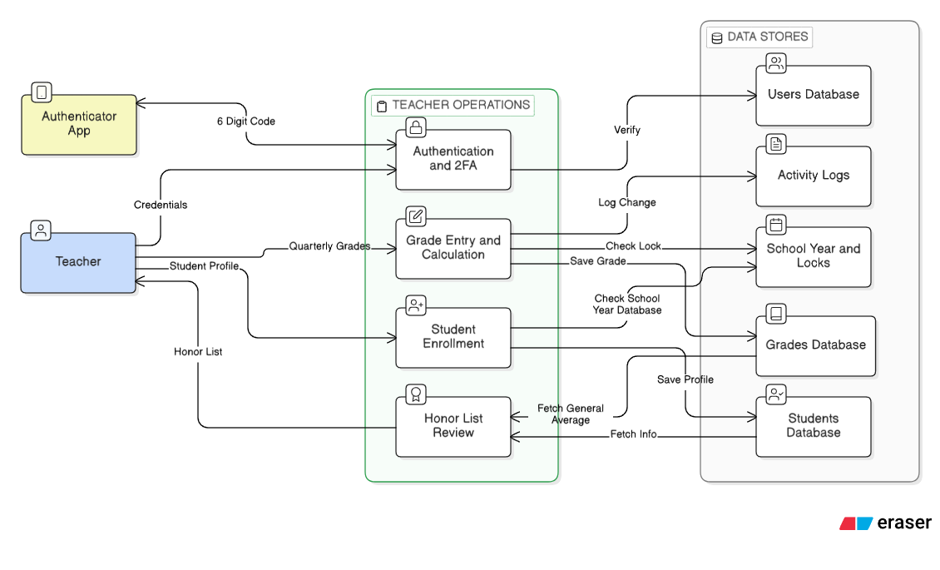

Figure 5.2 Data Flow Diagram of Teacher User

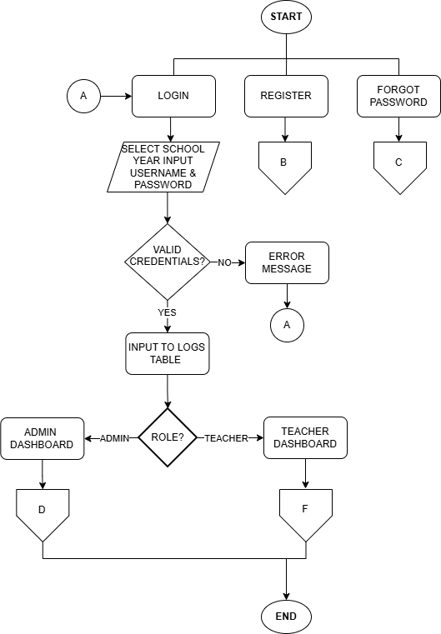
SYSTEM FLOWCHART

Figure 5.2 The Proposed System Flowchart of the Learner’s Permanent Academic Record Management System for New Mabuhay Elementary School

PROGRAM FLOW CHART

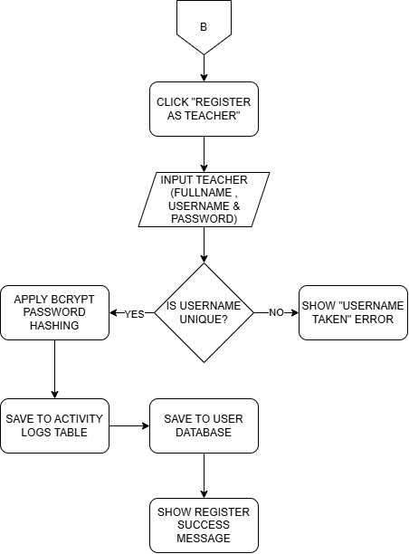

Figure 5.3 The program flowchart of Register Page

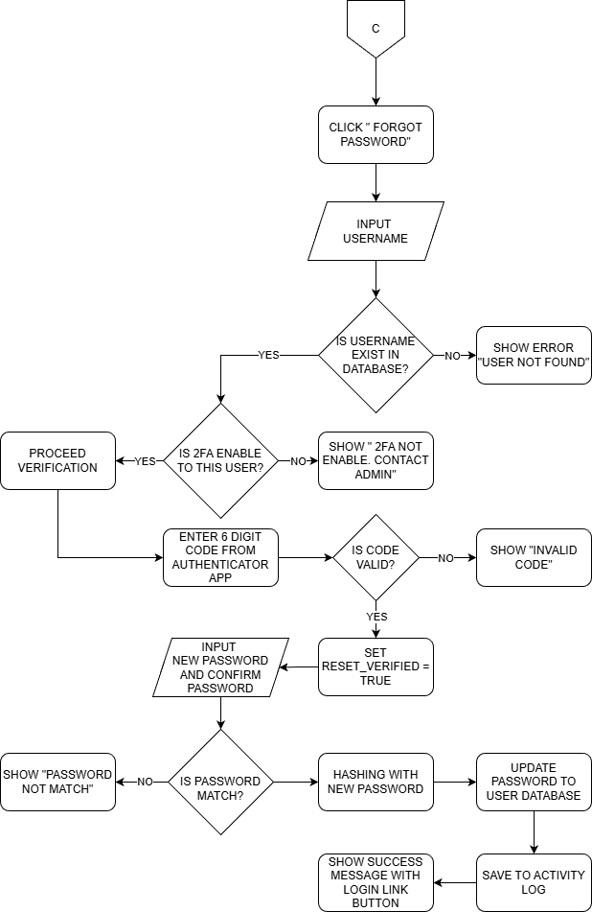

Figure 5.4 The Program Flowchart of Forgot Password Page

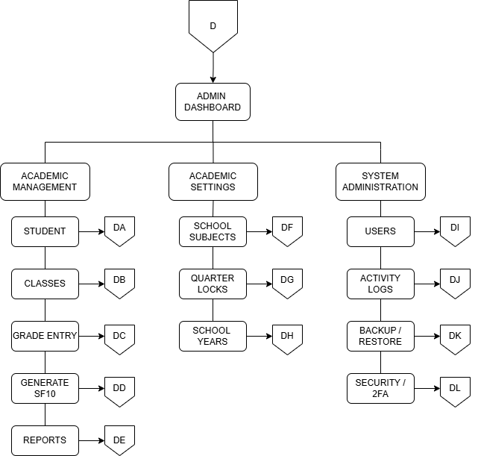

Figure 5.5 The Program Flowchart of Admin Dashboard

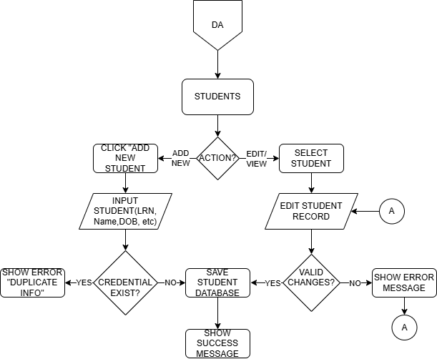
SSS

Figure 5.6 The Program Flowchart of Student Menu for Admin User

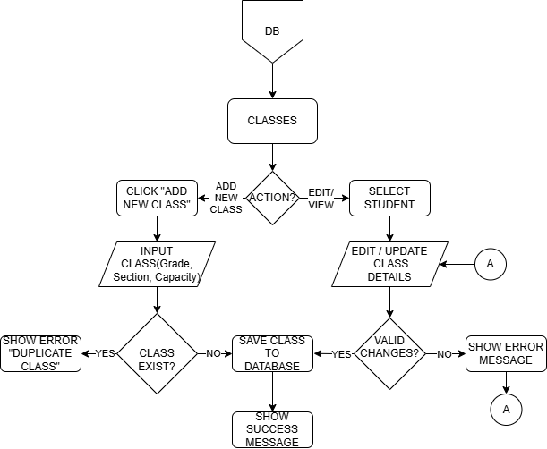

Figure 5.7 The Program Flowchart of Class Menu for Admin User

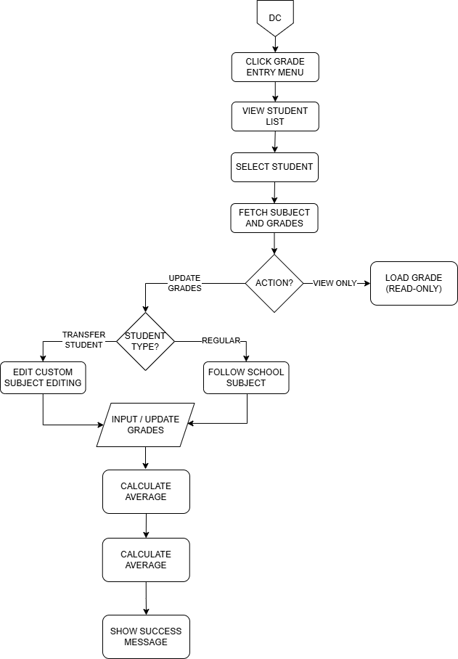

Figure 5.8 The Program Flowchart of Grade Entry Menu for Admin User

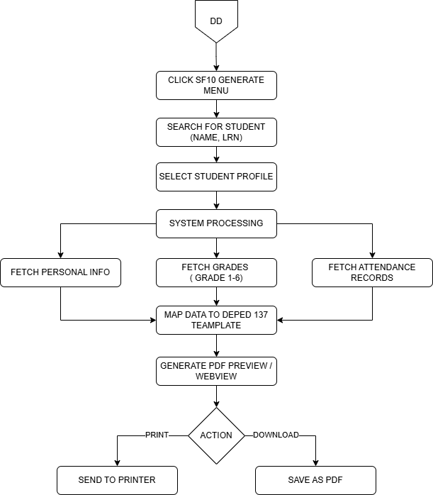

Figure 5.9 The Program Flowchart of Generate SF10 Menu for Admin User

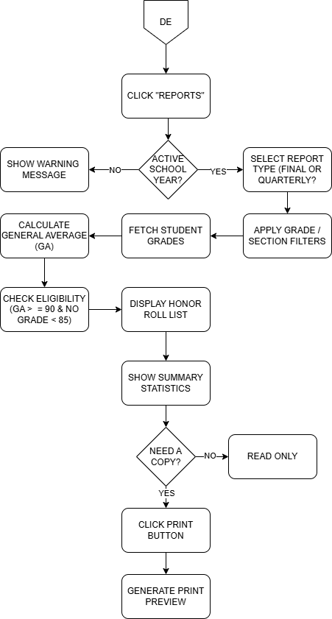

Figure 5.10 The Program Flowchart of Reports Menu for Admin User

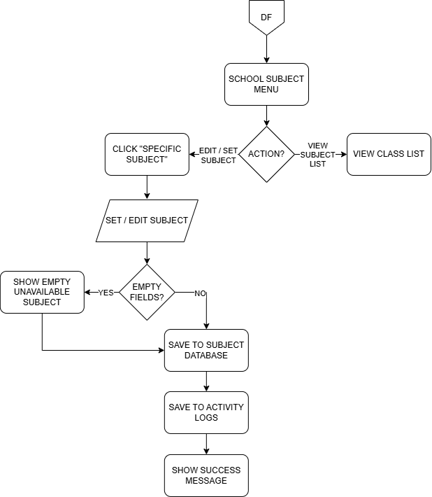

Figure 5.11 The Program Flowchart of Reports Menu for Admin User

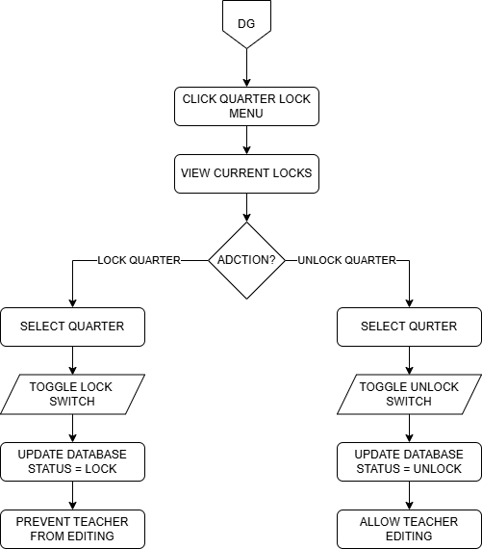

Figure 5.12 The Program Flowchart of Quarter Lock Menu for Admin User

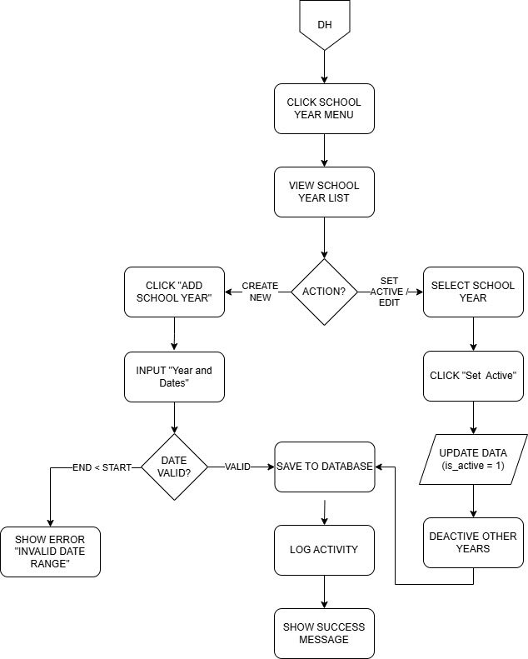

Figure 5.13 The Program Flowchart of School Year Menu for Admin User

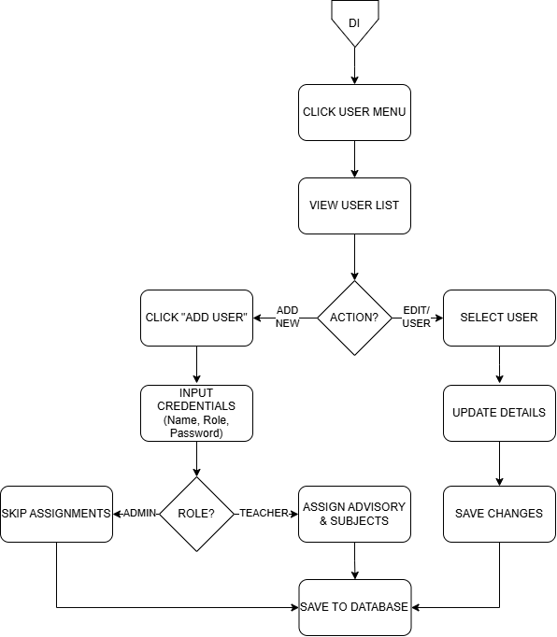

Figure 5.14 The Program Flowchart of User Menu for Admin User

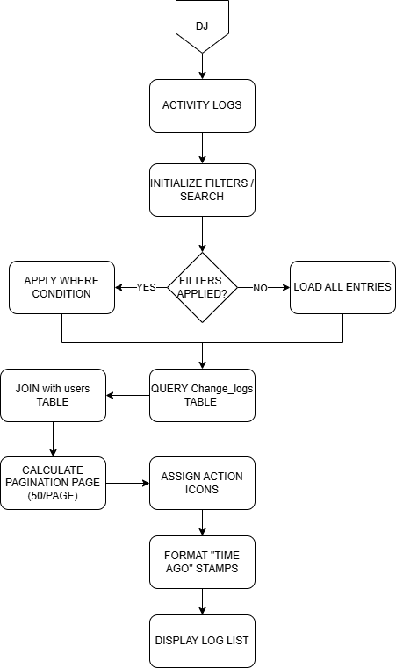

Figure 5.15 The Program Flowchart of Activity Logs Menu for Admin User

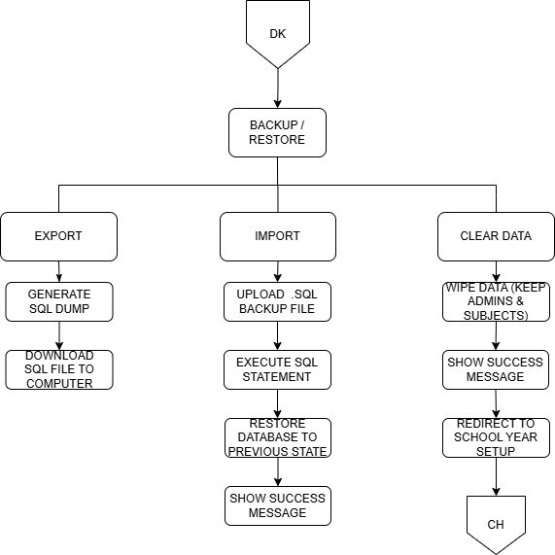

Figure 5.16 The Program Flowchart of Backup / Restore Menu for Admin User

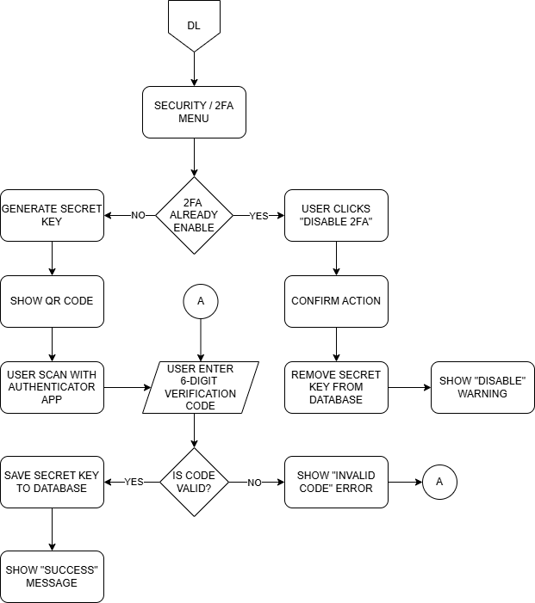

Figure 5.17 The Program Flowchart of Security / 2FA Menu for Admin User

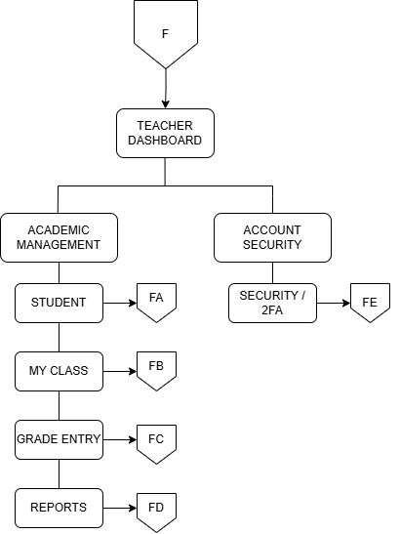

Figure 5.18 The Program Flowchart of Teacher Dashboard

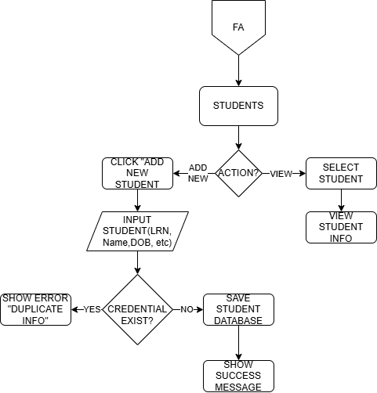

Figure 5.19 The Program Flowchart of Student Menu for Teacher User

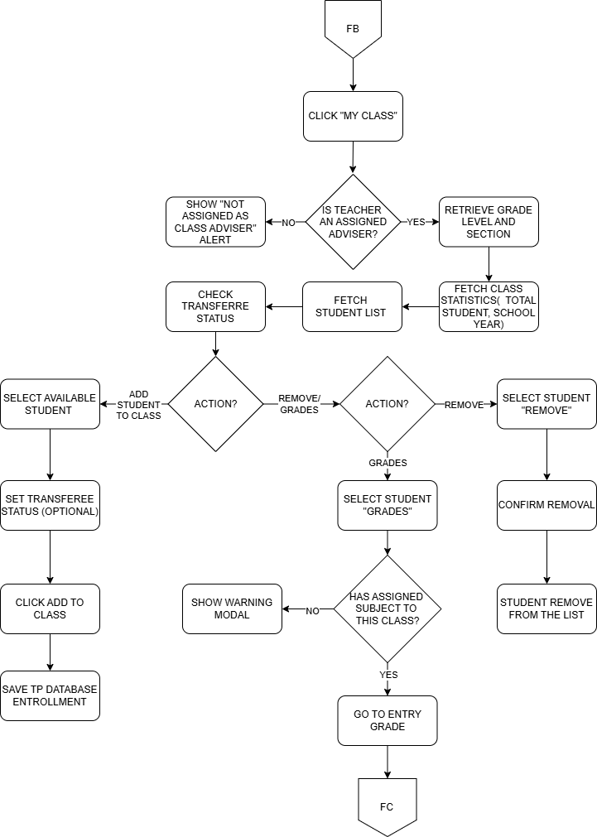

Figure 5.20 The Program Flowchart of My Class Menu for Teacher User

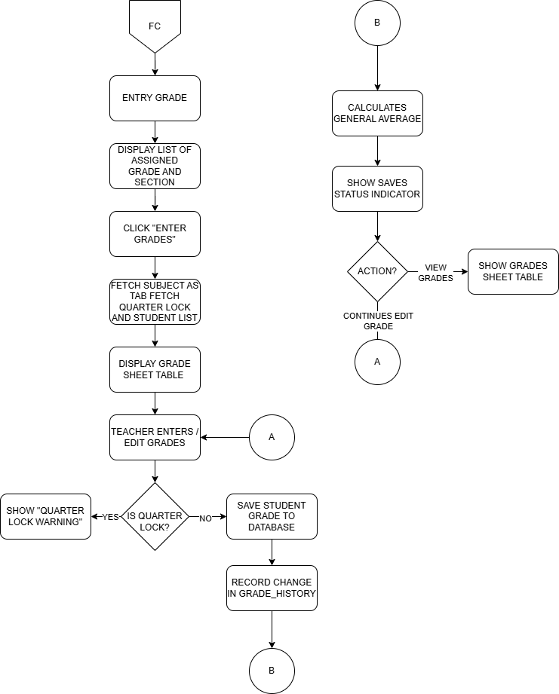

Figure 5.21 The Program Flowchart of Grade Entry Menu for Teacher User

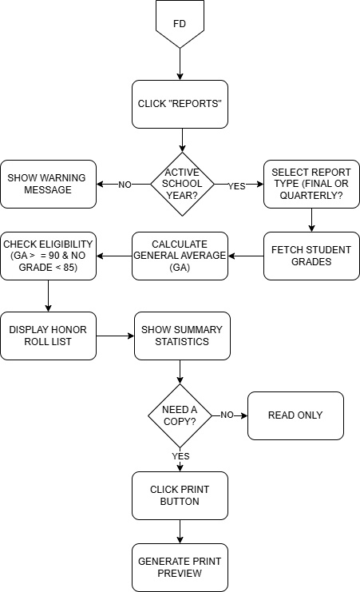

Figure 5.22 The Program Flowchart of Reports Menu for Teacher User

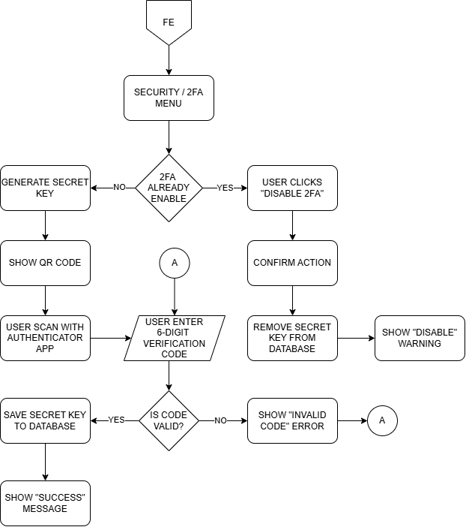

Figure 5.23 The Program Security / 2FA Menu for Teacher User

SYSTEM DESIGN
In this chapter, it shows the screenshots or Graphical User Interface (GUI) of the system that serves as a manual guide that aims to help the user to familiarize the system and for them to understand the flow of the system.

1. LOGIN AND SECURITY
This section covers how to access the system and how to register as a new teacher if needed.

Steps:
1.1 Select the School Year from the dropdown menu (e.g., 2025-2026 (Current)).
1.2 Enter your designated Username in the first field.
1.3 Enter your Password in the second field.
1.4 (Optional) Click the Eye Icon (Show Password) to view the characters you typed.
1.5 Click the Login button to access the main Dashboard.
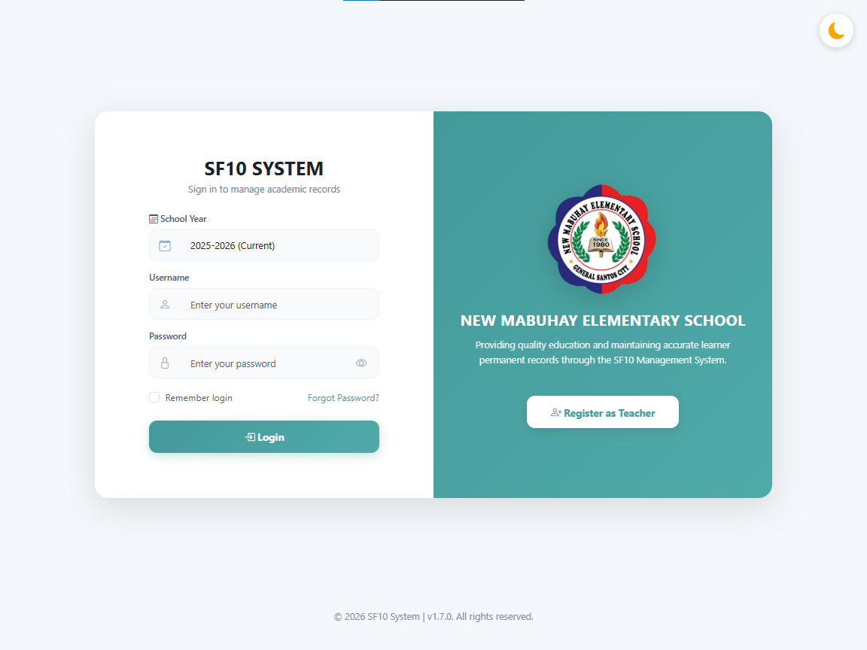

Figure 6.0 The System Design of Login and Security

2. REGISTRATION
This section covers how a new teacher can create an account in the system.

Steps:
2.1 On the Login page, click the Register as Teacher button on the right panel (or "Register as Teacher" link on mobile devices). The panel will slide to show the registration form.
2.2 Enter your Full Name (e.g., Juan Dela Cruz).
2.3 Choose a unique Username .
2.4 Enter a strong Password (minimum 6 characters).
2.5 Re-enter your Password in the Confirm Password field to verify.
2.6 Click the Register button to submit your information.
2.7 Upon successful registration, a success message will appear. Wait for an admin to approve your account and assign your advisory class before logging in.
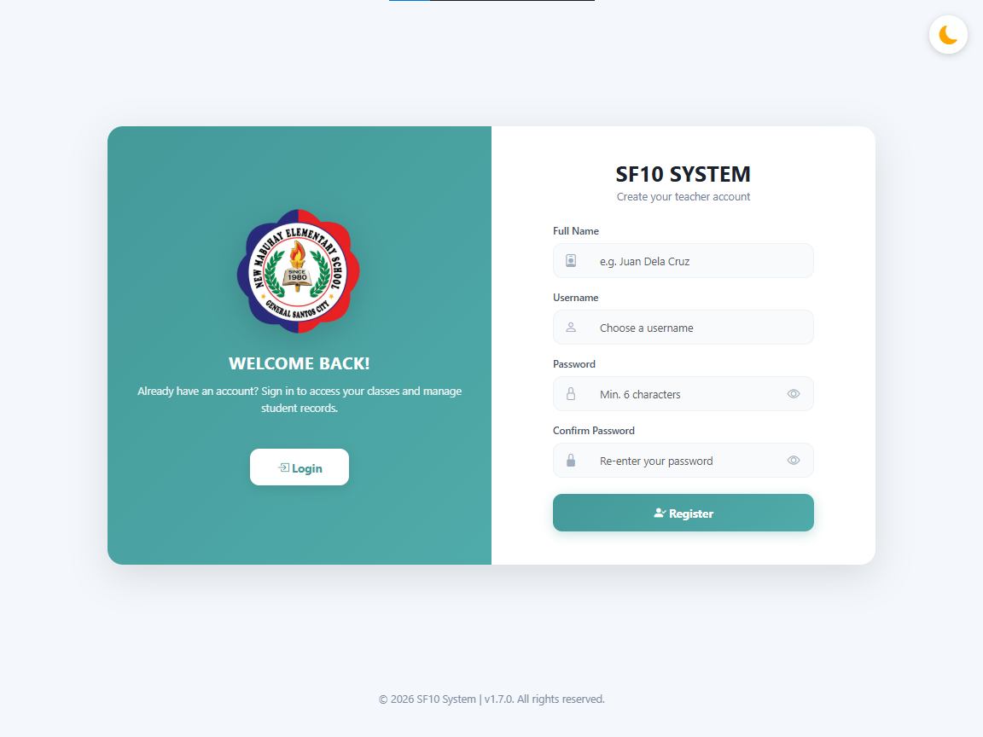

Figure 6.1 The System Design of Registration

3. DASHBOARD OVERVIEW
The dashboard is the system's home screen, providing a summary of key metrics and academic records status.

Steps:
3.1 View Total Students. Shows the total number of enrolled students (e.g., 13).
3.2 View Total Teachers. Shows the number of registered teachers (e.g., 7).
3.3 View Active Classes. Shows the number of currently active classes (e.g., 6).
3.4 View SF10 Records. Shows the total count of SF10 permanent records in the system (e.g., 29).
3.5 Analyze Student Distribution. Review the donut chart for a visual breakdown of students per grade level.
3.6 Monitor Enrollment Statistics. Checks for average per grade, highest enrollment, and lowest enrollment data.
3.7 Track Recent Activity. Shows a chronological log of recent system actions like grade entries or new enrollments.
3.8 Use Navigation. Access system modules via the Sidebar or manage profile settings from the top bar.

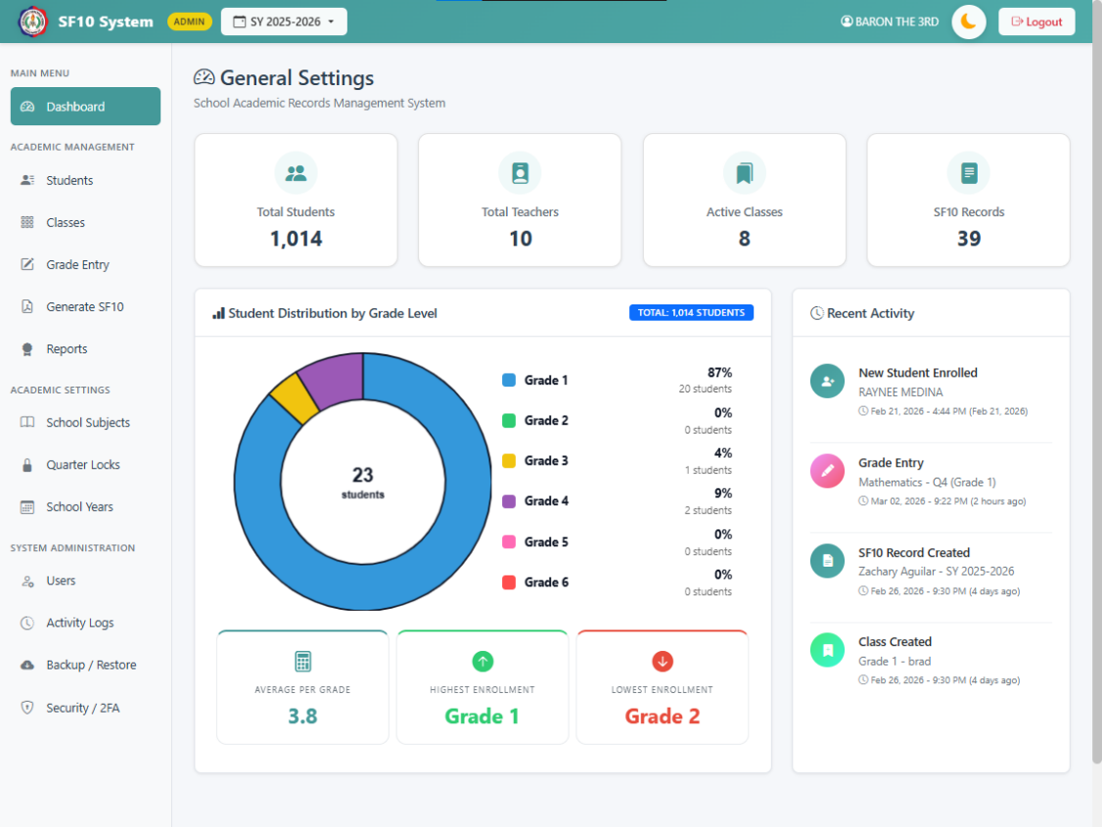

Figure 6.2 The System Design of Admin Dashboard

4. CHANGE SCHOOL YEAR (ADMIN ONLY)
This section details how administrators can switch between different school years using the header toggle.

Steps:
4.1 Locate the School Year Toggle in the top header (e.g., SY 2025-2026).
4.2 Click the button to open the dropdown menu.
4.3 Select the desired School Year from the list of available academic years.
4.4 Confirm the action in the Popup dialog to switch the active school year.
4.5 The system will reload and display data relevant to the selected School year.
4.6 (Optional) Click Manage School Years within the dropdown to add or edit academic years.

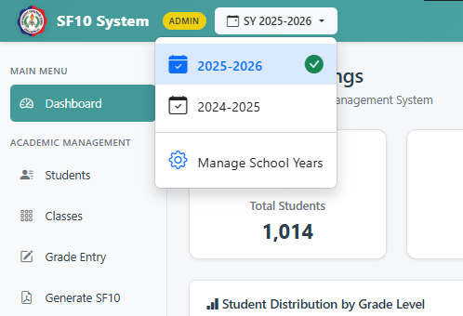

Figure 6.3 The System Design of School Year Header Toggle (Admin Only)

5. THEME CUSTOMIZATION (LIGHT/DARK MODE)
This section explains how to toggle between Light Mode and Dark Mode for visual comfort.

Steps:
5.1 Locate the Theme Toggle button (Sun/Moon icon) in the top header, next to the user profile.
5.2 Check the current icon. A Moon icon indicates Light Mode is active; a Sun icon indicates Dark Mode is active
5.3 Click the button to Switch the theme.
5.4 Observe the immediate color scheme change across the entire application.
5.5 The system automatically saves your preference for future sessions.

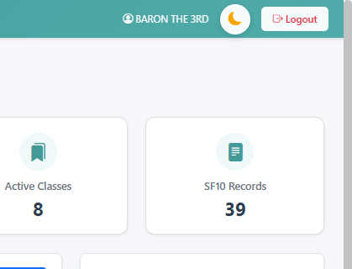

Figure 6.4 The System Design of Theme Header Toggle

6. ADD USER (TEACHER/ADMIN)
This section details how administrators can add new users to the system, assigning them roles and specific responsibilities.

Steps:
6.1 Navigate to the Users module from the sidebar.
6.2 Click the Add New User button to open the user creation form.
6.3 Enter the Full Name of the user (e.g., Maria Clara).
6.4 Specify a unique Username for login.
6.5 Create a secure Password for the account
6.6 Select the appropriate Role from the dropdown:
- Admin: Full access to system settings and all data.
- Teacher: Restricted access to assigned classes and subjects.

6.7 (Optional) Fill in School Information fields like School Name, ID, District, Division, and Region if applicable.
6.8 For Teacher Role Only:
- Check Class Adviser if the teacher manages a specific section. Select the Grade and Section from the dropdown.
- Check Subject Assignments to assign specific subjects. Click Add Subject, then select the Grade Level, Subject, and applicable Sections.
6.9 Review all entered information.
6.10 Click the Add User button to save the new account.
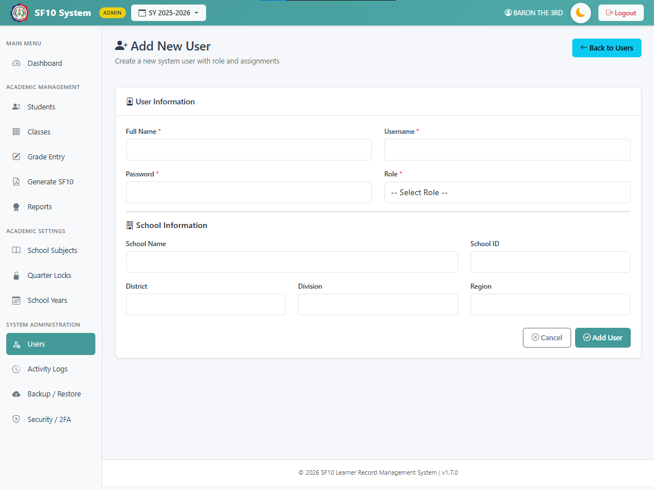

Figure 6.5 The System Design of Add New User

7. ADD STUDENT
This section explains how to enroll a new student into the system by entering their personal and academic background information.

Steps:

7.1 Navigate to the Students module from the sidebar.
7.2 Click the Add New Student button to open the enrollment form.
7.3 Enter the Basic Information:
- LRN: The Learner Reference Number (must be unique).
- Gender: Select Male or Female.
- Birthdate: Enter the student's date of birth. Name: Enter Last Name, First Name, Middle Name, and Suffix (if applicable).
7.4 Select the Credential Presented for Grade 1 eligibility (e.g., Kinder Progress Report, ECCD Checklist)

7.5 Fill in Eligibility Information:
- School Name: Name of the school where the credential was obtained.
- School ID: The ID of the previous school.
- School Address: Address of the previous school.
7.6 (Optional) If the student is a PEPT passer, check the PEPT Passer box and provide details like Rating, Exam Date, and Testing Center.
7.7 Review all entered information for accuracy.
7.8 Click the Save Student button to create the record.
7.9 Upon success, you will be redirected to the Grade Progression page to set up the student's academic history.

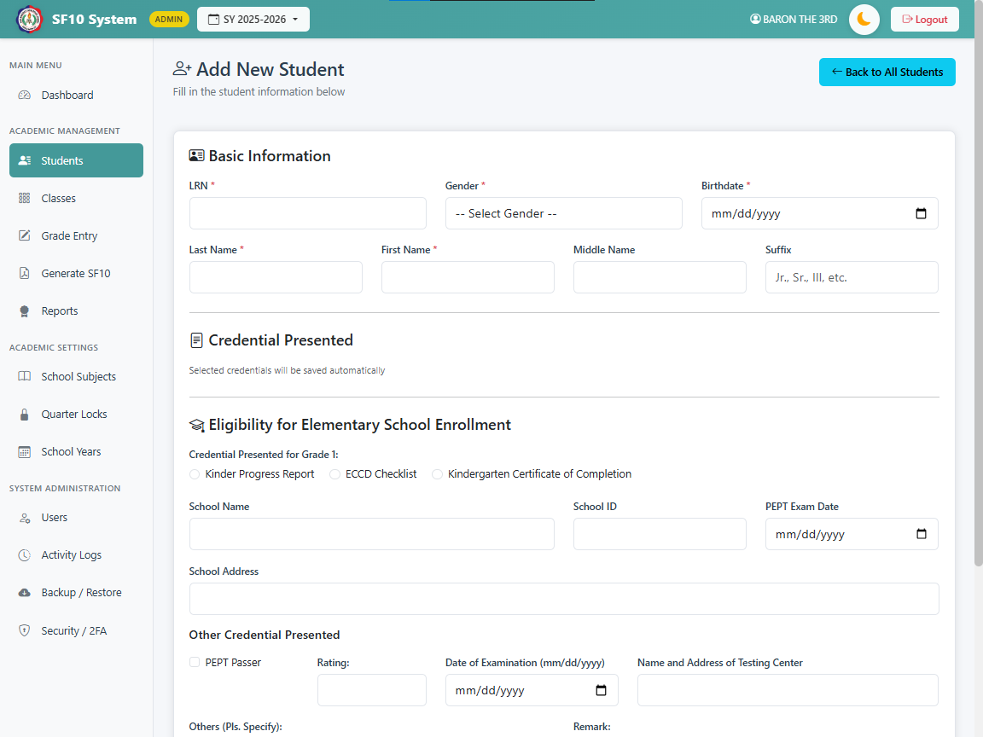

Figure 6.6 The System Design of Add New Student

8. ADD CLASS
This section details how to create a new class section for a specific grade level and school year.

Steps:
8.1 Navigate to the Classes module from the sidebar.
8.2 Click the Add New Class button to open the class creation form.
8.3 Select the Grade Level (Grade 1 to 6) from the dropdown menu.
8.4 Enter the Section Name (e.g., Diamond, Einstein, A).
8.5 Verify or edit the School Year (defaults to the current active school year, e.g., 2025-2026)
8.6 Set the Maximum Capacity for the class (default is 40 students).
8.7 Review the entered information to ensure uniqueness (Grade + Section + School Year combination must be unique).
8.8 Click the Add Class button to create the new section.

8.9 The new class will appear in the active classes list and be available for student enrollment.
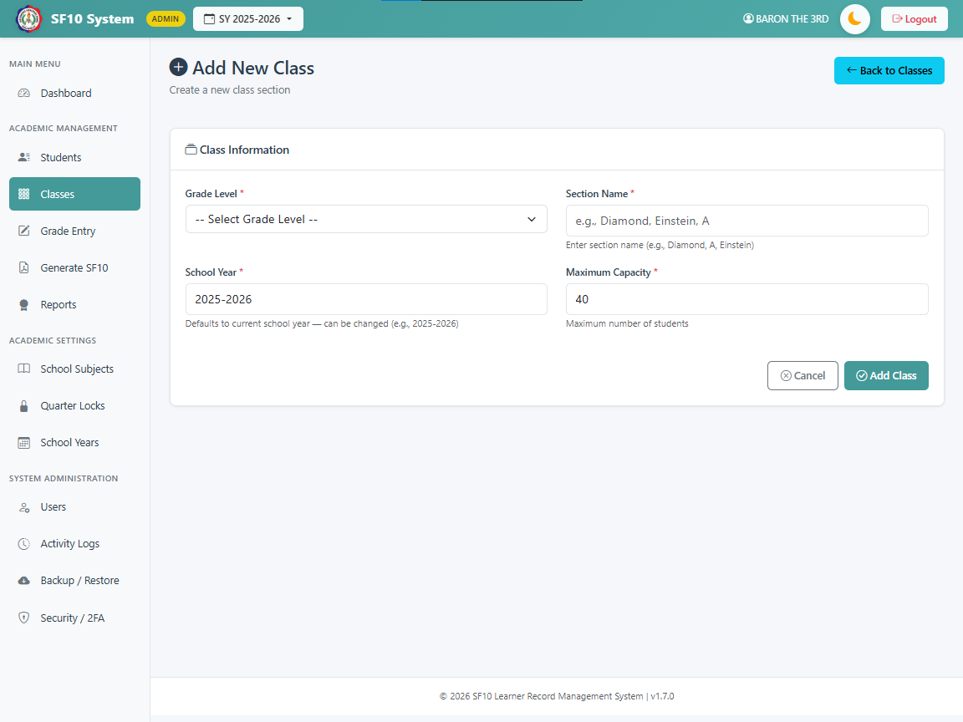

Figure 6.7 The System Design of Add New Class

9. MANAGE SCHOOL SUBJECT FORMAT
This section covers how to configure the default subject names for each grade level. This ensures that subjects are displayed correctly for students based on their grade.

Steps:
9.1 Navigate to the School Subjects module from the sidebar.
9.2 You will see a tabbed interface for Grades 1-6. Select the tab for the grade level you want to configure (e.g., Grade 1)
9.3 The list displays the global subject names on the left.
9.4 In the input field on the right, enter the Display Name for the Subject specific to that grade level.
- Example: If the global subject is "Mathematics", you might want it to display as "Math 1" for Grade 1.

- Leave the field blank or matching the original name if no change is needed.
9.5 Repeat this process for other subjects and other grade levels as necessary
9.6 Click the Save Changes button at the bottom right to apply the new subject names.
9.7 A confirmation message will appear, and the page will reload with the updated configuration.
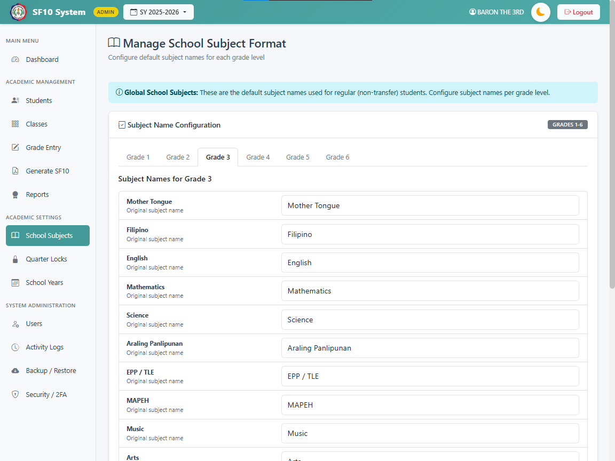

Figure 6.8 The System Design of Manage School Subject

10. TEACHER GRADE ENTRY
This section details how teachers can input grades for their assigned subjects and sections.

Steps:
10.1 Navigate to the Grade Entry module from the sidebar.
10.2 Select the Grade Level and Section you want to input grades for.
10.3 The system will verify your subject assignments for the selected class.
- Note: If you have no subjects assigned to this class, an error message will appear.
10.4 Once inside the grade entry form, you will see tabs for each Subject assigned to you.

- Click on a subject tab to enter grades for that specific subject.
10.5 The list of students in the section will be displayed.
10.6 Enter the numerical grade for the current Quarter.
10.7 Grades are validated to ensure they are within the valid range (0-100).
10.8 If a quarter is Locked by the administrator, you will not be able to edit the grades for that quarter.
10.9 The system automatically calculates the Final Rating and Remarks (Passed/Failed) once all four quarters are graded.
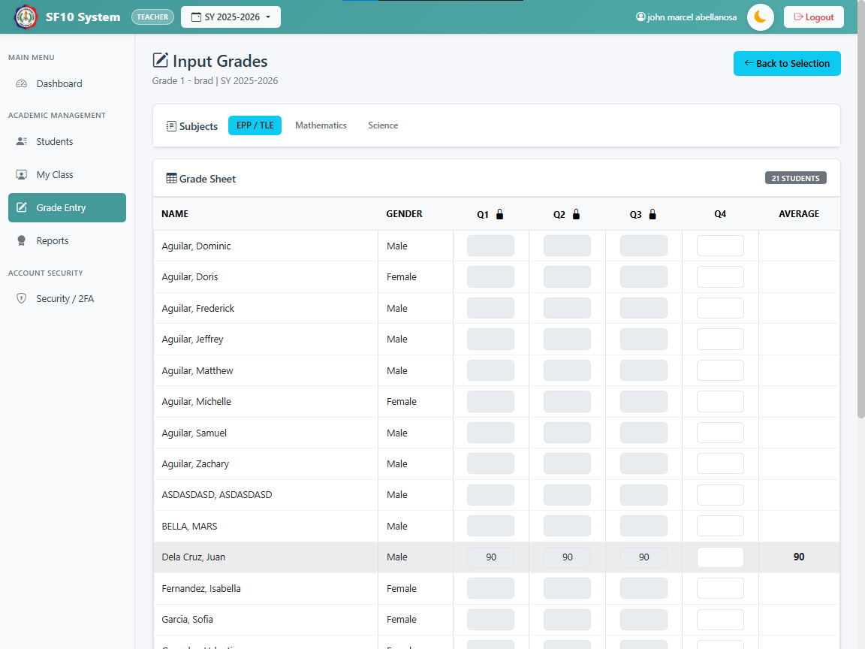

Figure 6.9 The System Design of Grade Entry for Teacher User

11. ADMIN GRADE MANAGEMENT
This section covers how administrators can manage grades for any student, including editing locked quarters and handling transferee records.

Steps:
11.1 Navigate to the Grade Entry module for Admin User from the sidebar.

11.2 Use the search bar or filters to find a specific student.
11.3 Click on the student's name to open their Grade Management page.
11.4 Select the School Year and Grade Level record you wish to manage.
- The system supports both regular and transferee records.
11.5 You can view and edit grades for All Subjects and All Quarters, even if they are locked for teachers
11.6 For Transferee Students, you can:
- Enter custom subject names if they differ from the standard curriculum.
- Manually input grades obtained from their previous school.
11.7 Remedial Classes:
- Scroll down to the Remedial Classes section.
- Enter details for students who took remedial classes, including Learning Area, Final Rating, and Remedial Class Mark.
- The system will automatically calculate the Recomputed Final Grade and Remarks.
11.8 Click the Save Grades button to persist any changes made to the grades or remedial information.
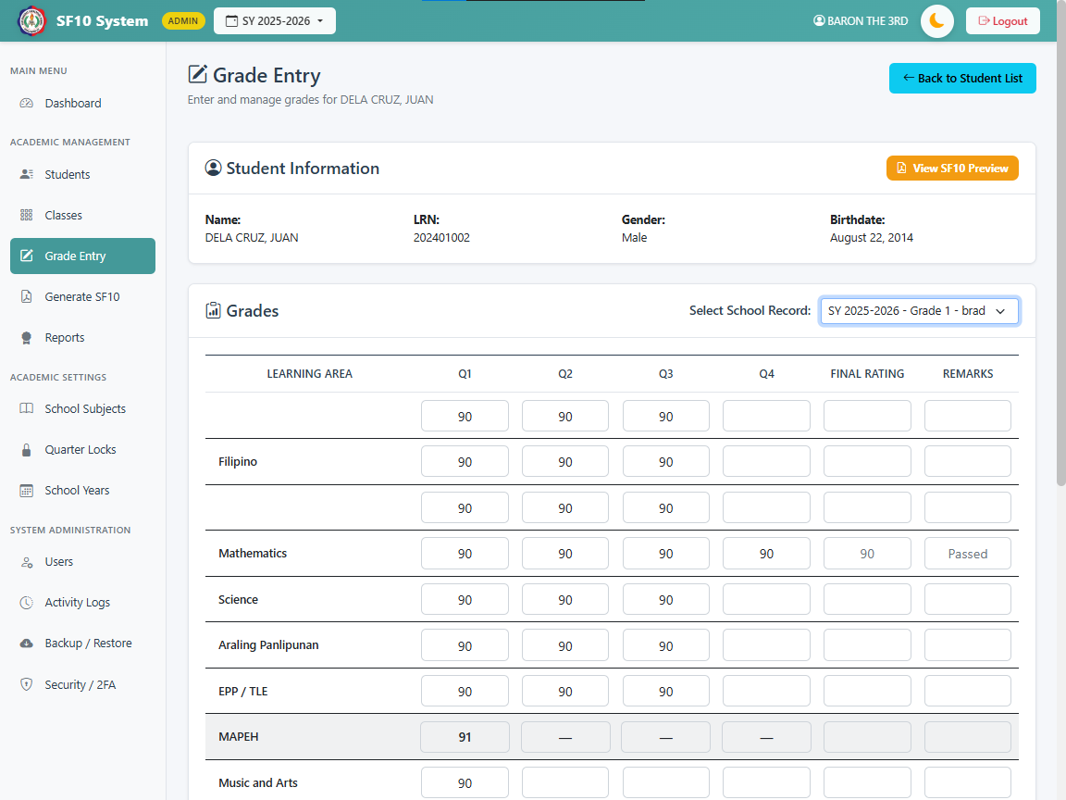

Figure 6.10 The System Design of Grade Entry for Admin User

12. MANAGE QUARTER LOCKS
This section explains how administrators can control grade editing permissions by locking or unlocking specific quarters for the active school year.

Steps:
12.1 Navigate to the Manage Quarter Locks module from the sidebar.
- Note: This feature is only available to “administrators”.
12.2 The page displays the lock status for all four quarters (Q1, Q2, Q3, Q4) for the Current School Year.
12.3 Manual Lock/Unlock:
- Toggle the switch next to a quarter to change its status.
- Locked: Teachers cannot edit grades for this quarter.
- Unlocked: Teachers can input and edit grades.
- A confirmation modal will appear to verify the action.
12.4 Auto-Lock Scheduler:

- Set a specific date and time for the system to automatically Lock a quarter.
- Click the Save button to apply the schedule.
- Use the Clear button to remove a scheduled auto-lock.
12.5 Auto-Unlock Scheduler:
- Set a specific date and time for the system to automatically Unlock a quarter.
- Click the Save button to apply the schedule.
- Use the Clear button to remove a scheduled auto-unlock.
12.6 System notifications will confirm when locks or schedules are successfully updated.

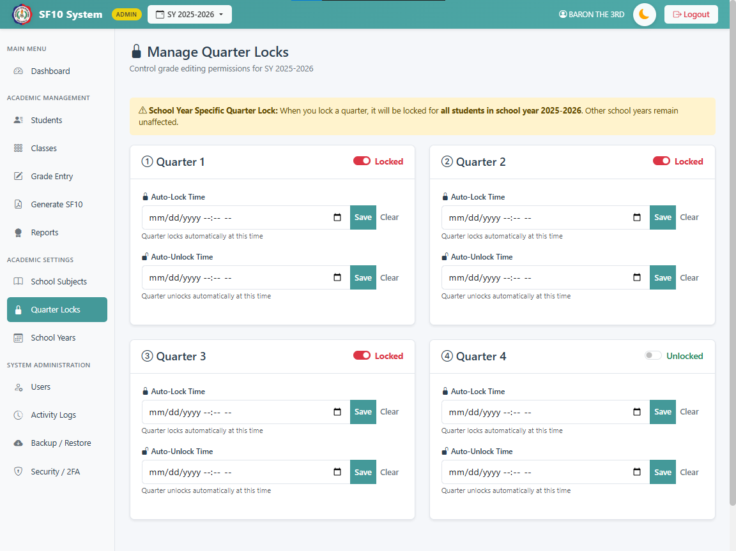

Figure 6.11 The System Design of Quarter Lock Menu

13. MANAGE SCHOOL YEARS
This section outlines how administrators can create, update, and manage academic school years.

Steps:
13.1 Navigate to the School Years module from the sidebar.
13.2 View School Years List:
- The main page displays a table of all registered school years.
- Columns include: School Year, Start Date, End Date, Status, and Current Active status.
13.3 Add New School Year:
- Click the Add School Year button.
- Fill in the required fields:
- School Year: Format as YYYY-YYYY (e.g., 2025-2026).
- Status: Select 'Active' to allow enrollment/grading or 'Inactive'.
- Start Date and End Date: Define the academic calendar duration.

- Set as current school year: Check this box to make it the default year for the system.
- Click Create School Year to save.
13.4 Edit School Year:
- Click the Actions (three dots) button for a specific row.
- Select Edit School Year.
- Update details as needed and save.
13.5 Delete School Year:
- Click the Actions button and select Delete School Year.
- A confirmation modal will appear. Note that you cannot delete a school year that has existing class data.
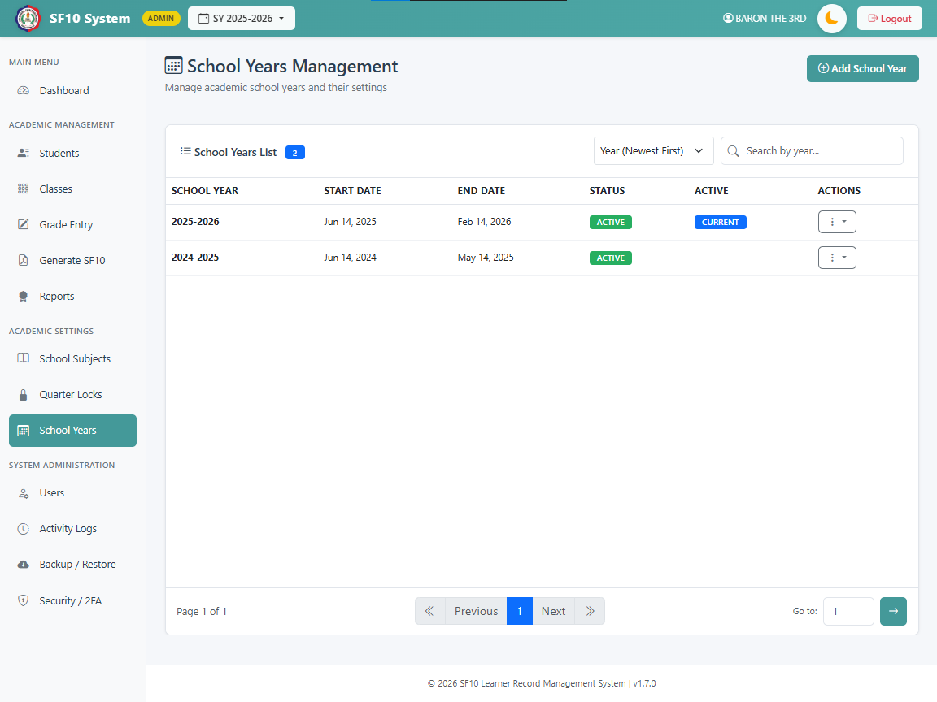

Figure 6.12 The System Design of School Year Menu

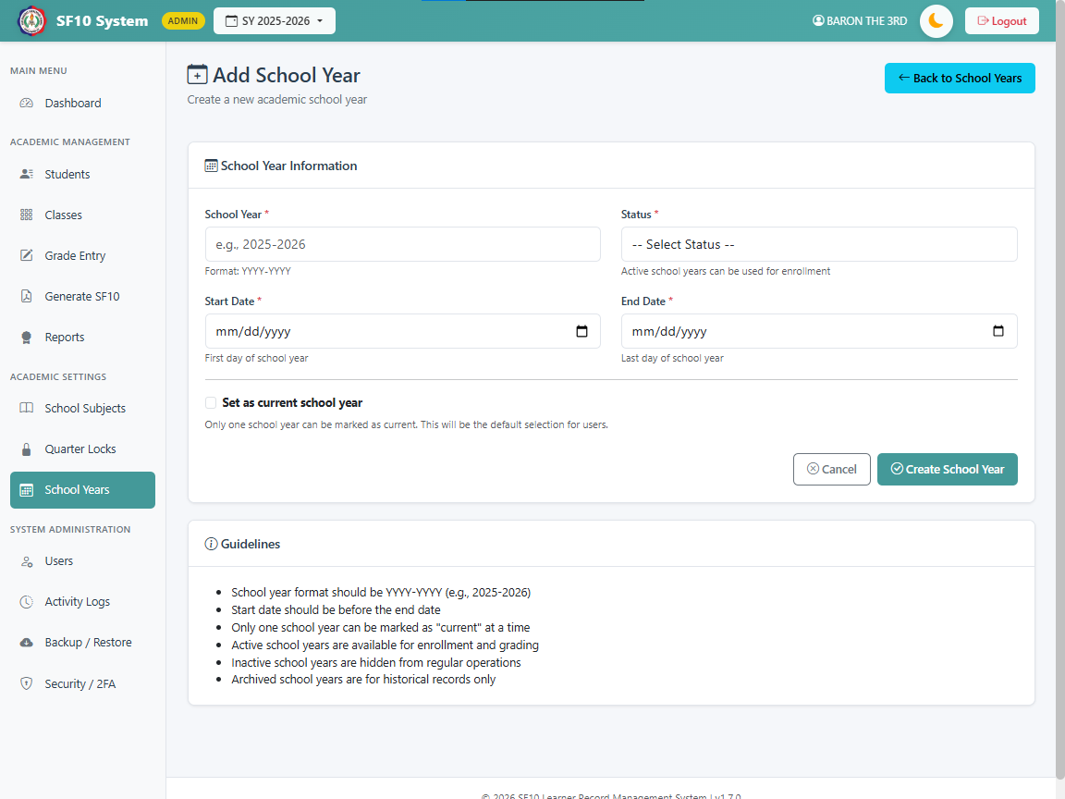

Figure 6.13 The System Design of Add New School Year

14. GENERATE SF10 FORM
This section details how to generate, preview, and print the official DepEd SF10 (Student Permanent Record) form.

Steps:
14.1 Navigate to the Generate SF10 Form module from the sidebar.
- Note: This feature is strictly for “administrators”.
- 14.2 Select a student:
- The main page lists all students with their LRN, Name, Gender, Birthdate, and current Grade/Section.
- Use the Search Bar to find a student by Name or LRN.
- Use the Sort/Filter dropdown to organize the list (e.g., Name A-Z, Grade Level, Gender).
- Click on a student's row to open their record.
14.3 SF10 Preview Page:

- The system displays a comprehensive preview of the student's academic history.
- Student Information: Verify personal details like LRN, Name, and Birthdate.
- Academic Records: Scroll through cards representing each Grade Level and School Year attended.
- Each card shows the School Name, ID, Section, Adviser, and a table of grades.
- General Average is automatically calculated based on the grades present.
14.4 Edit Records (If needed):
- Edit Information: Click this button on a specific grade level card to update school details (e.g., School Name, Adviser).
- Edit Grades: Click this button to modify the grades for that specific school year.
14.5 Print/Download Official Form:
- View Front Sheet: Opens the front page of the SF10 form (Personal Info + Scholastic Record) in a new tab, formatted for printing.
- View Back Sheet: Opens the back page of the SF10 form (continuation of records) in a new tab.
- Use your browser's print function (Ctrl+P) to save as PDF or print to paper.
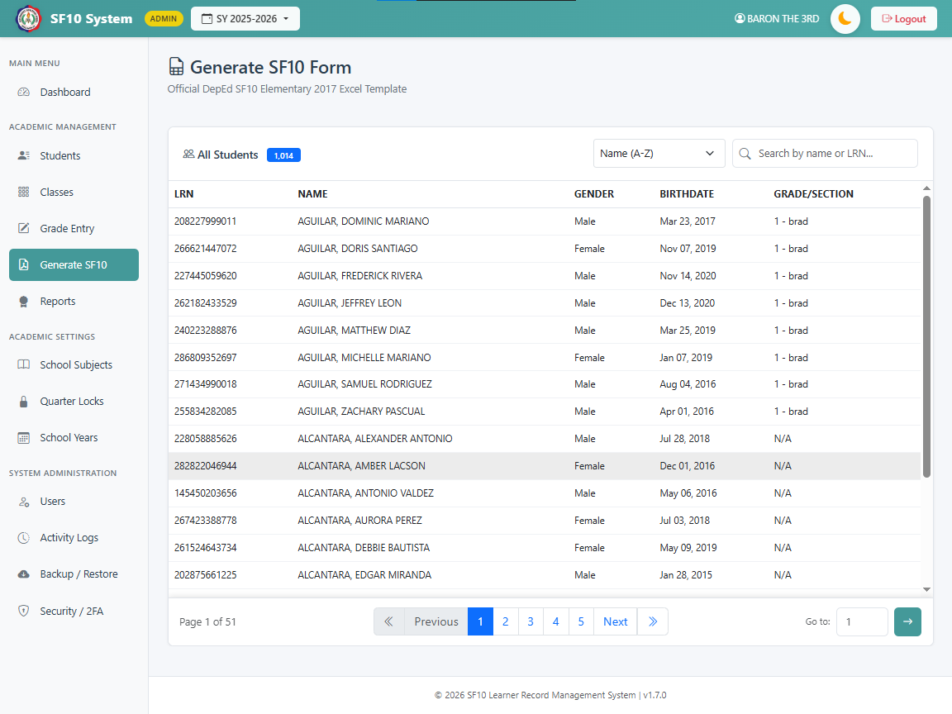

Figure 6.14 The System Design of SF10 Preview Student List

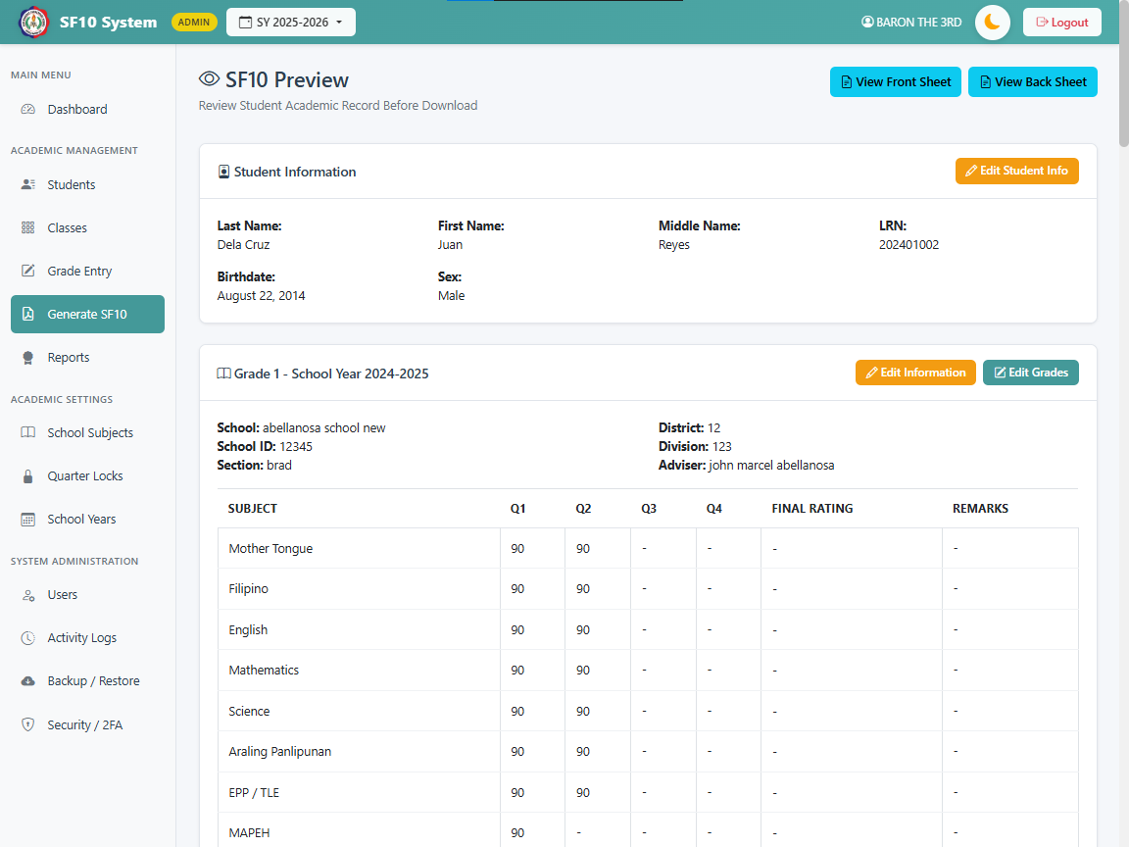

Figure 6.15 The System Design of SF10 Preview

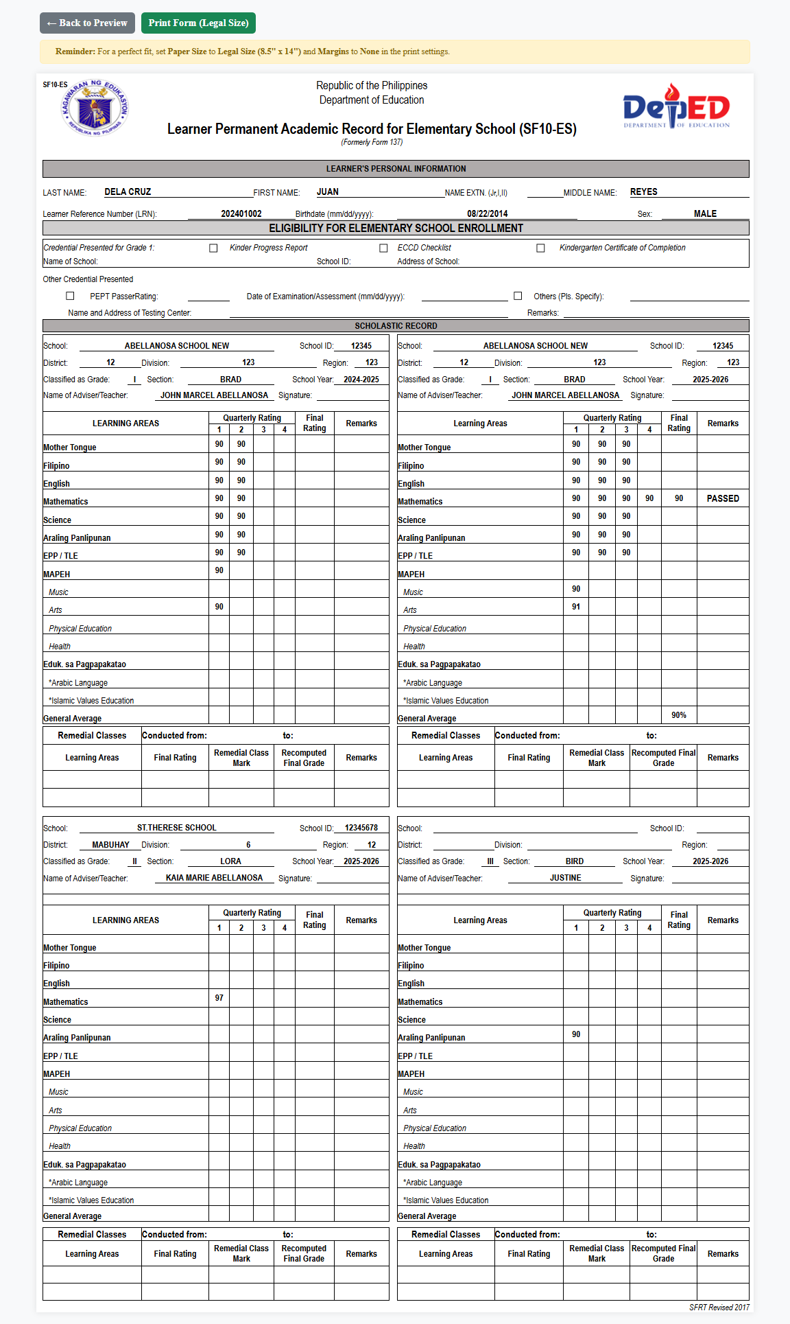

Figure 6.16 The System Design of SF10 Preview Form Front Page
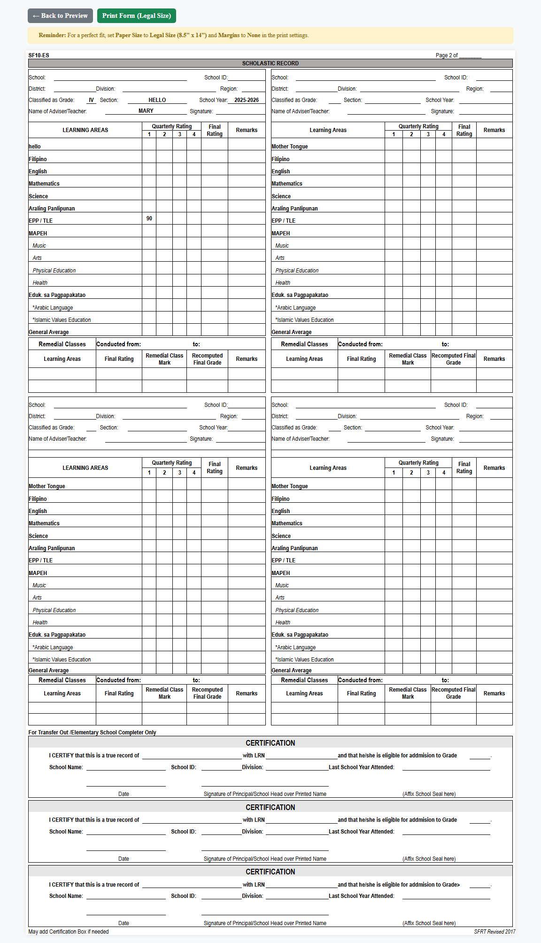

Figure 6.17 The System Design of SF10 Preview Form Back Page

15. REPORTS (HONOR ROLL)
The Reports module provides automated Honor Roll generation based on DepEd Order No. 36, s. 2016. It calculates student awards based on their General Average (GA) and lowest subject grade.
Steps:
15.1 Report Types
- Final Honor Roll: Calculates the General Average based on the average of all four quarters.
- Quarterly Honor Rolls (Q1-Q4): Calculates awards based on grades for a specific quarter.
- Switching Views: Click the tabs (Final, Quarter 1, Quarter 2, etc.) to switch between report types. The summary statistics at the top will update automatically.
15.2 Award Criteria The system automatically assigns awards if a student meets the following criteria:
- With Highest Honors: GA of 98-100 (No grade below 85)
- With High Honors: GA of 95-97 (No grade below 85)
- With Honors: GA of 90-94 (No grade below 85)
15.3 Admin Features
- Global View: Admins can view honor students from all grade levels and sections.
- Filtering:
- Use the Filter Bar to select a specific Grade Level and Section.
- Click Apply to filter the list.
- Click Clear to reset to the full list.
- Summary Stats: Displays total counts for Students, Subjects, and Grade Records at the bottom of the page.
15.4 Teacher Features
- Class-Specific View: Teachers only see honor students from their assigned classes.
- Header Info: The report header displays the teacher's assigned Grade and Section(s).
  - Printing
- Click the Print button in the top-right corner.
- The system generates a clean, printer-friendly version of the report, hiding the sidebar, filters, and navigation buttons.
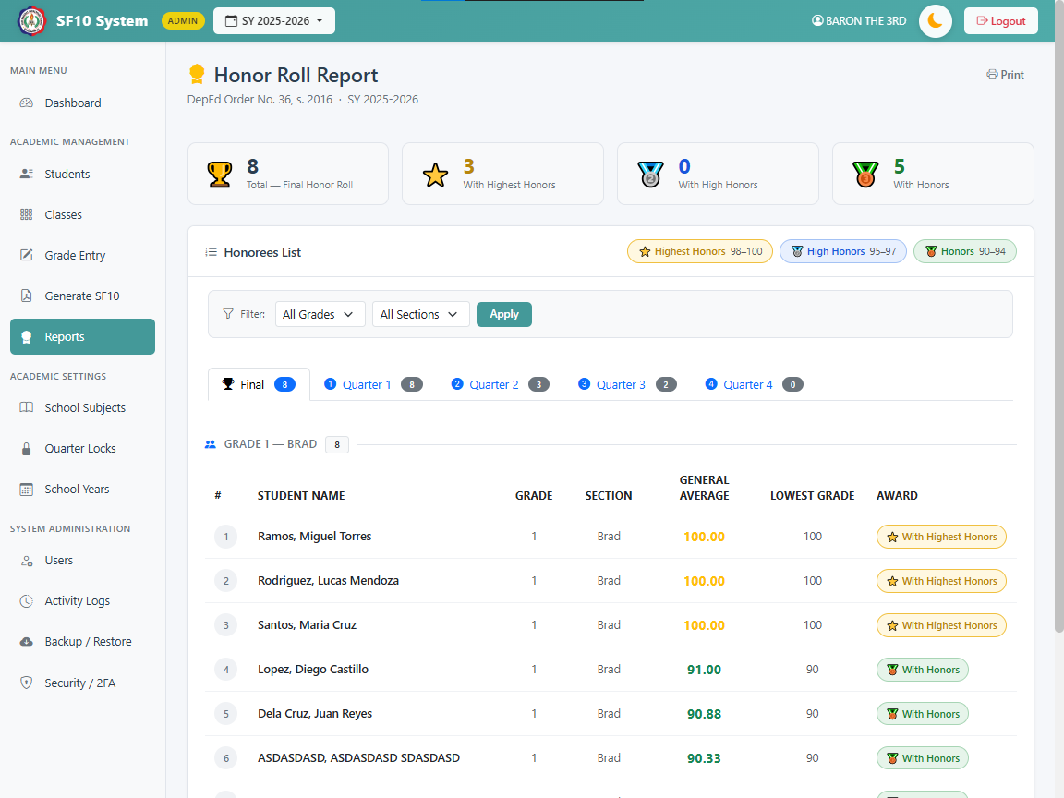

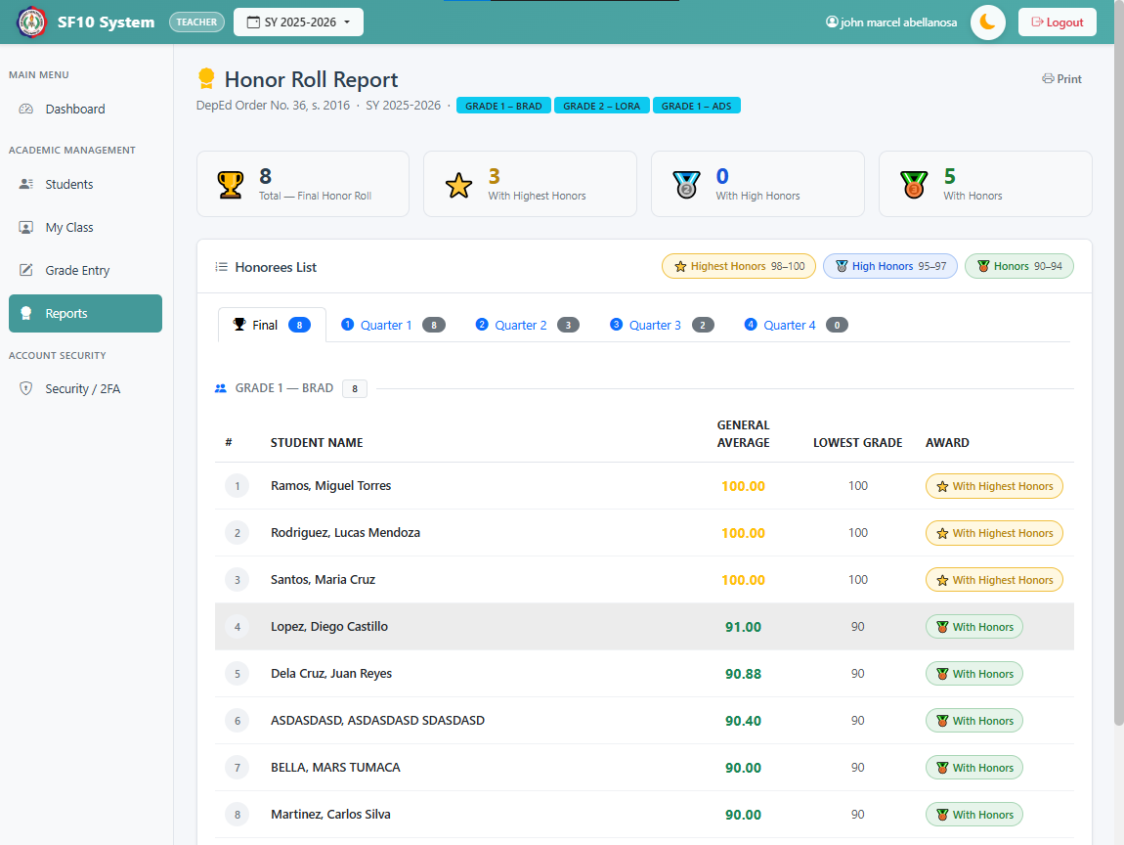
Figure 6.18 The System Design of Report (Honor Roll) Admin User

Figure 6.19 The System Design of Report (Honor Roll) Teacher User

16. ACTIVITY LOGS MANAGEMENT
This module provides administrators with a comprehensive audit trail of all system activities, ensuring security and accountability.

Features:
16.1 Viewing Logs
- Navigate to Activity Logs from the sidebar.
- The system displays a chronological list of activities, showing:
- Date & Time: Exact timestamp of the action.
- User: The name and role of the user who performed the action.
- Action Type: The type of operation (e.g., INSERT, UPDATE, DELETE, LOGIN, LOGOUT).
- Table: The database table affected by the change.
- Details: Specific information about the change (e.g., "Updated grade for Student X").
16.2 Filtering Logs
- Click the Filters button at the top right to open the filter modal.
- You can filter logs by:
- Action Type: Select specific actions like 'LOGIN' or 'GRADE_ENTRY'.
- User: View activities performed by a specific user.
- Date Range: Specify a 'Date From' and 'Date To' to narrow down the timeline.
- Click Apply Filters to update the list.
16.3 Pagination
- The system displays 50 logs per page to maintain performance.
- Use the pagination controls at the bottom to navigate through history.
- Use the Go to box to jump to a specific page number.

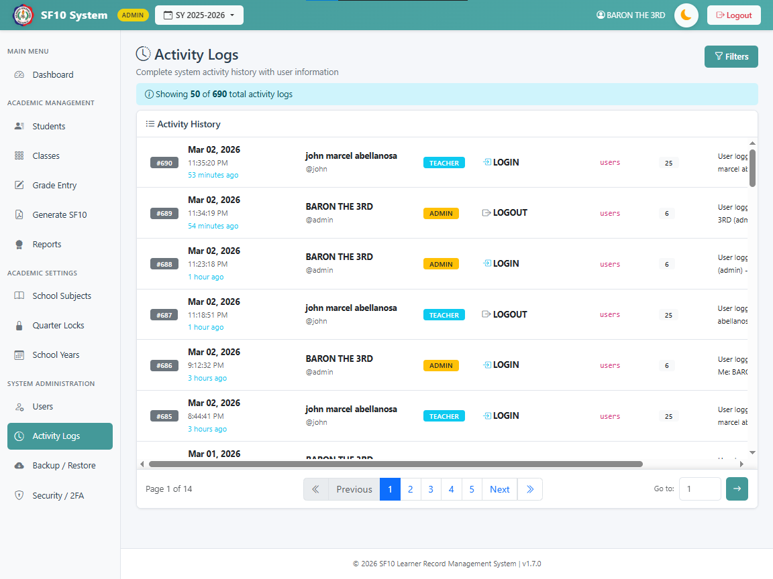

Figure 6.20 The System Design of Activity Logs (Admin Only)

17. BACKUP & RESTORE
This module allows administrators to secure the system data and perform disaster recovery.

Steps:
17.1 Export Database (Backup)
- Navigate to Backup & Restore from the sidebar.
- Click the Export SQL Dump button.
- The system will generate a .sql file containing the entire database structure and data.
- The file will be automatically downloaded to your local computer.
- Recommendation: Perform this regularly (e.g., weekly or before major updates).
17.2 Import Database (Restore)
- Warning: This action will overwrite existing data.
- Navigate to Backup & Restore.

- In the "Import SQL" section, click Choose File and select a valid .sql backup file.
- Click Import SQL.
- A confirmation modal will appear. Verify the filename and click Yes, Import.
- The system will restore the database and update the active school year session.
17.3 Clear Database (Reset)
- Warning: This action is irreversible. It is intended for resetting the system for a new deployment or cleaning up test data.
- Navigate to Backup & Restore.
- Locate the Clear Database section at the bottom.
- Click Clear Database.
- A confirmation modal will appear requiring two levels of verification:
- Password Verification: You must enter your current Admin Password.
- Automatic Safety Backup: The system will automatically create a full backup of your current data before wiping it. This backup is stored in the backups/ folder.
- Once verified, all student records, grades, classes, and teacher accounts will be deleted (Admin accounts and Subjects are preserved).
- You will be redirected to the School Years management page to set up a new academic year.
17.4 Managing Auto-Backups
- The system maintains a "Safety Net" of your previous database states.
- Locate the Auto-Backups History section.
- Accessing History: For security, you must enter your Admin Password and click View History to reveal the list.
- Recovery:
- The system stores the 10 most recent safety backups.
- Each backup filename includes the Admin's Name and the Manila Timestamp of when the clear happened.
- Click the Import button next to any file to immediately restore the system to that specific point in time.
- Security: These files are protected and cannot be accessed by non-admins or through a direct web link.

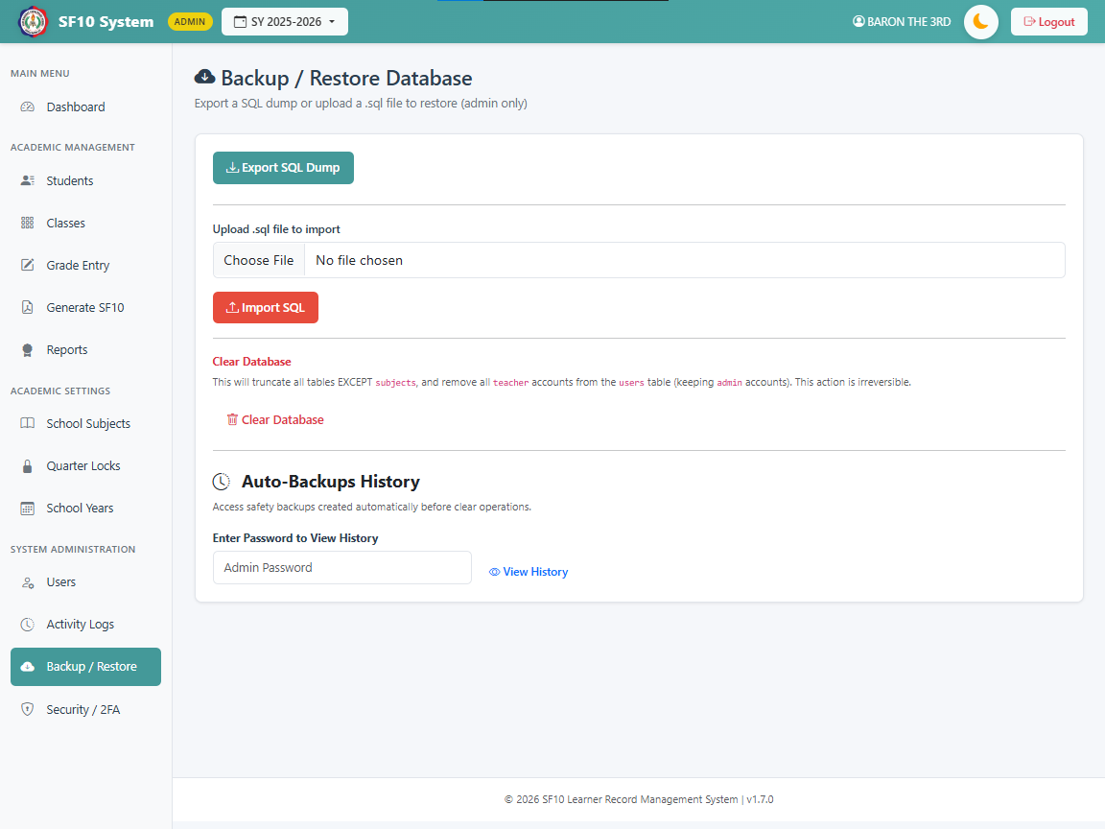

Figure 6.21 The System Design of Backup / Restore Menu

18. FORGOT PASSWORD (Account Recovery)
This section covers how a teacher can securely recover their account using the Two-Factor Authentication (2FA) feature.
Steps:
18.1 On the Login page, click the Forgot Password? link located below the login button.
18.2 Enter your registered Username in the identification field and click Next.
18.3 The system will verify if your account has Two-Factor Authentication (2FA) enabled.
18.4 If 2FA is active, open your Authenticator App (e.g., Google Authenticator) on your mobile device.
18.5 Enter the 6-digit Verification Code currently displayed in your app and click Verify.
18.6 Upon successful verification, enter your New Password (minimum 6 characters).
18.7 Re-enter your password in the Confirm New Password field.
18.8 Click the Reset Password button to update your credentials.
18.9 A success message will appear once the password is changed. Click the link to return to the login screen.
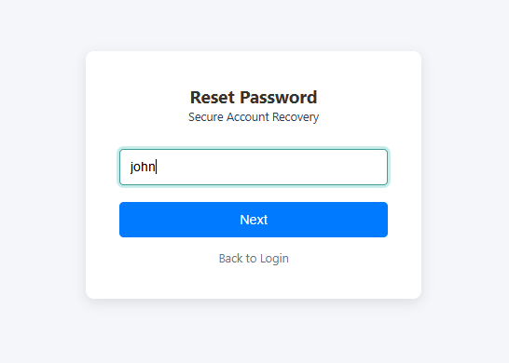

Figure 6.22 The System Design of Forgot Password Enter Username
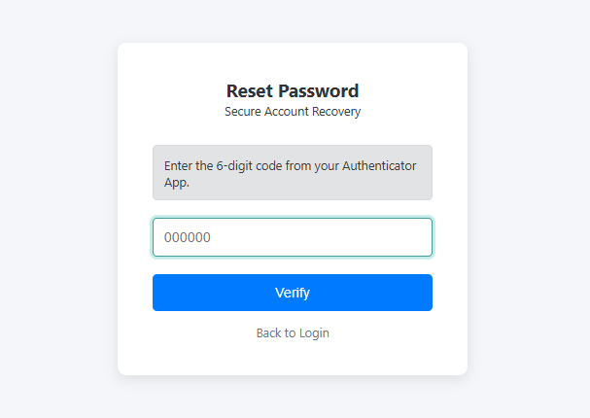

Figure 6.23 The System Design of Forgot Password Enter 6-Digit Code

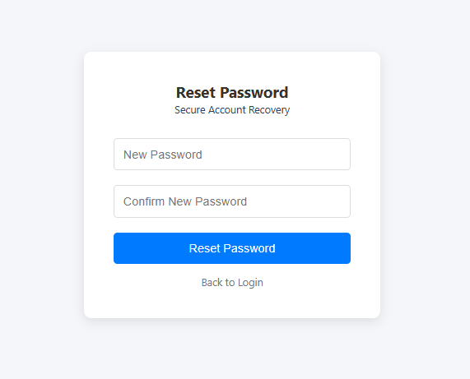

Figure 6.24 The System Design of Forgot Password Enter New Password and
Confirm New Password

INPUT DESIGN AND USER INTERFACE
This refers to the space where interaction between humans and machines happened. It is where the users are allowed to manipulate the system or the system to indicate the effects of the user’s manipulation.

1.LOGIN FORM

- Fields:
- Username: Text (Required).
- Password: Password (Required, masked).
- School Year: Dropdown (Required, defaults to active year).
- Validation:
- Credentials must match an active account in the user’s table.

- School year must be active and not archived.


Figure 7.0 Login Form

2. ADD/EDIT STUDENT FORM

- Personal Information:
- LRN: Text (Required, Unique, 12 digits).
- Last Name: Text (Required, auto-converted to Uppercase).
- First Name: Text (Required, auto-converted to Uppercase).
- Middle Name: Text (Optional, auto-converted to Uppercase).
- Suffix: Text (Optional, e.g., Jr., III).
- Birthdate: Date (Required).
- Gender: Dropdown (Male/Female, Required).
- Eligibility Information:
- Credential Presented: Radio Button (Kinder Progress Report, ECCD Checklist, Kindergarten Certificate).

- School Name: Text (Optional).
- School ID: Text (Optional).
- School Address: Text (Optional).
- PEPT Rating: Number/Text (Optional).
- PEPT Exam Date: Date (Optional).
- PEPT Testing Center: Text (Optional).
- Validation:
- LRN must be unique in the system.
- Combination of First Name + Last Name + Middle Name is checked for duplicates.


Figure 7.1 Add Student Form

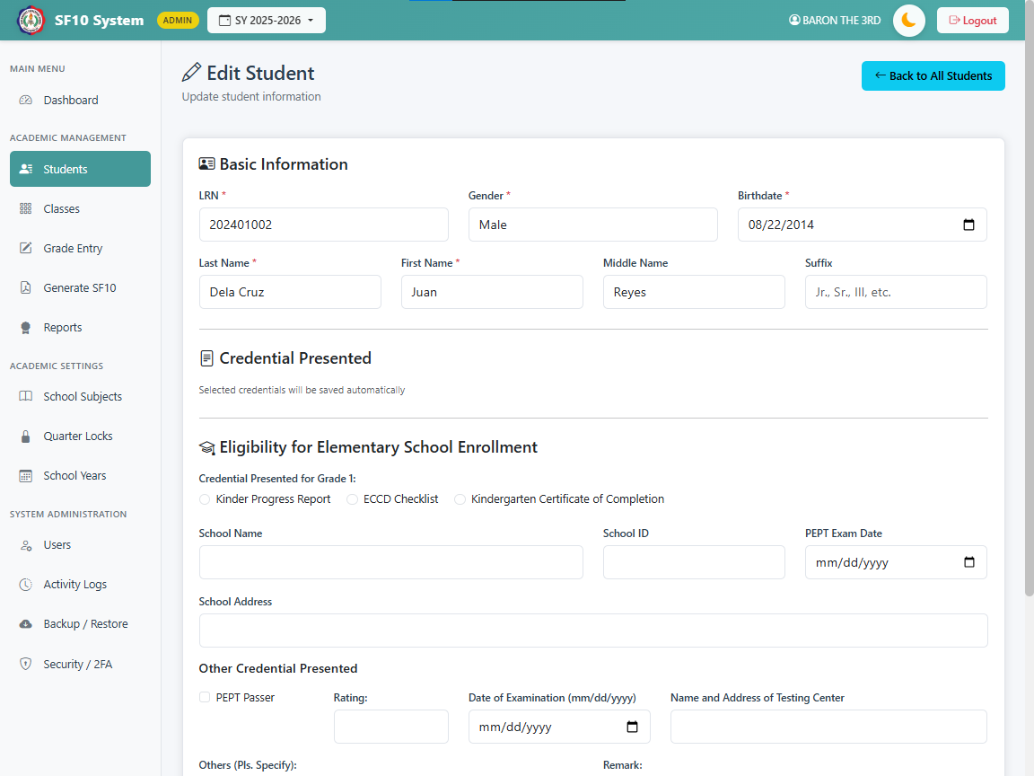

Figure 7.2 Edit Student Form

3.ADD CLASS FORM

- Fields:
- Grade Level: Dropdown (Grade 1 - 6, Required).
- Section: Text (Required).
- School Year: Text (Required, defaults to current session year).
- Capacity: Number (Required, default 50).
- Validation:
- Combination of Grade + Section + School Year must be unique.

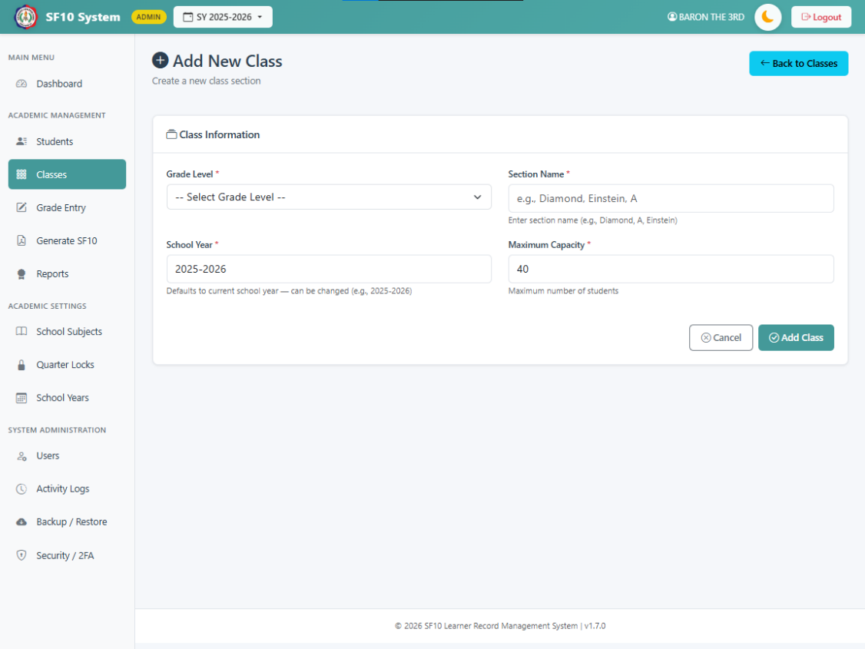

Figure 7.3 Add Class Form

4.ADD SCHOOL YEAR FORM

- Fields:
- School Year: Text (e.g., "2023-2024", Required).
- Start Date: Date (Required).

- End Date: Date (Required).
- Status: Dropdown (Active/Inactive, Required).
- Set as Active: Checkbox.
- Validation:
- End Date must be after Start Date.
- Setting a year as "Active" automatically deactivates other years.



Figure 7.4 Add School Year Form

5.GRADE ENTRY INPUT

- Fields:
- Quarter 1-4: Number (Input range 60-100 or null).
- Final Rating: System-calculated (Average).
- Remarks: System-calculated (Passed/Failed).
- Validation:
- Grades can be entered via AJAX auto-save.
- Input is restricted if the specific Quarter is locked by Admin.
- Numeric values are rounded to nearest integer for display but stored precisely.

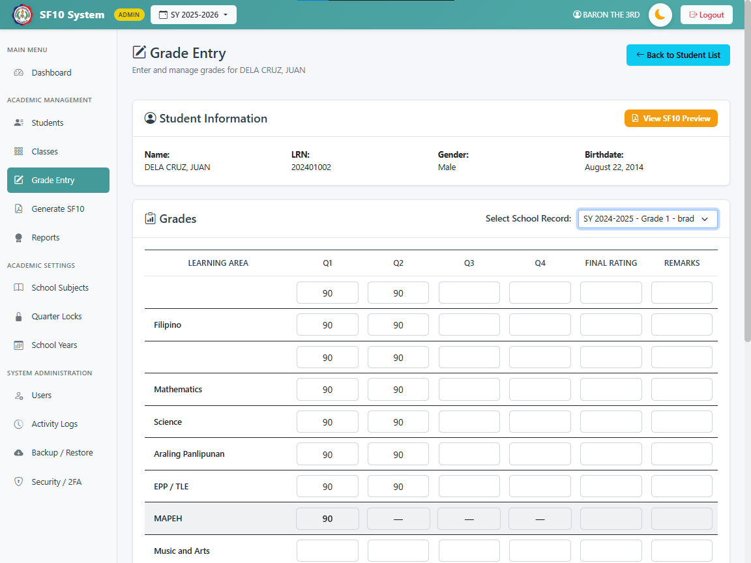

Figure 7.5 Entry Grade Form Admin User
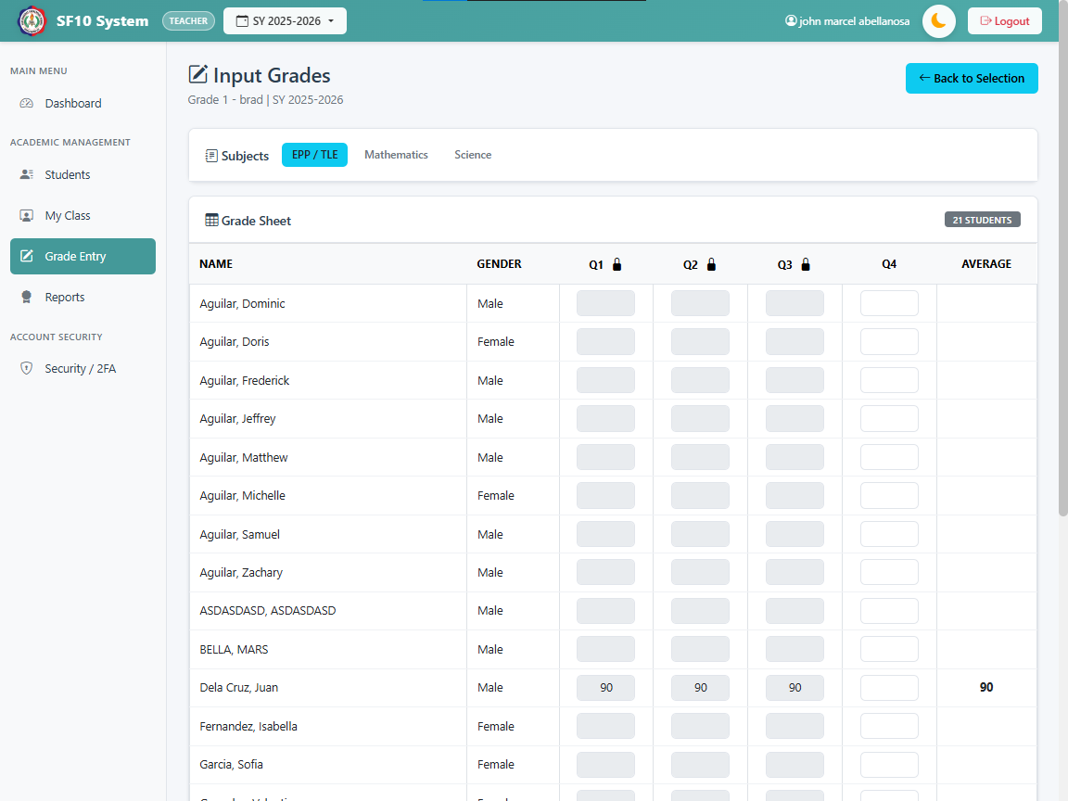

Figure 7.6 Grade Entry Form Teacher User

OUTPUT DESIGN
This refers to the finish product of the system that can usually be printed on paper such as reports that can be displayed in the screen.

1.SF10 FORM (LEARNER'S PERMANENT ACADEMIC RECORD)

- Format:
- Printable HTML Document (Standard A4/Long Bond Paper layout).
- Header:
- Republic of the Philippines
- Department of Education
- Region, Division, District
- School Name and School I
- Student Information Section:
- Name (Last, First, Middle)
- LRN (Learner Reference Number)
- Sex, Date of Birth
- Scholastic Record Section (Iterative):
- Grouped by School Year and Grade Level.
- Table Columns:
- Subject: Name of the learning area.
- Quarter 1-4: Quarterly grades.
- Final Rating: Average of quarters.
- Remarks: Passed / Failed.
- General Average: Calculated row at the bottom of the table.
- Remedial Classes: Separate table if applicable (Subject, Final Grade, Remedial Class Mark, Recomputed Final Grade, Remarks).
- Certification Section:
- Signature lines for the Adviser and School Head.

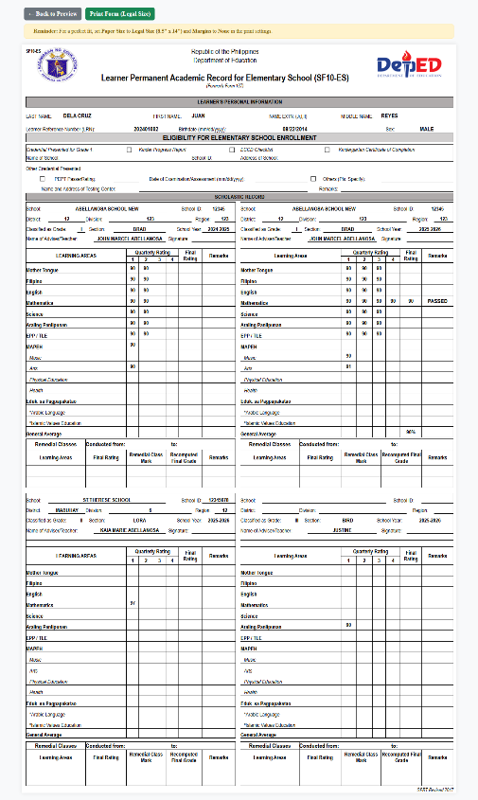

Figure 8.0 SF10 Form Front Printable Output


Figure 8.1 SF10 Form Back Printable Output

2.HONOR ROLL REPORT

- Format:
- Printable List (HTML).
- Types:
- Quarterly Honor Roll, Final Honor Roll.
- Content:
- Header: School Year, Quarter Label.
- Table Columns:
- Student Name: Full name.
- Grade & Section: Current placement.
- General Average: Calculated to 2 decimal places (or whole number per policy).
- Award:
- "With Highest Honors" (98-100)
- "With High Honors" (95-97)
- "With Honors" (90-94)
- Logic:
- Students are only included if their General Average meets the threshold AND no single subject grade is below 85.



Figure 8.2 Honor Roll Report Output

3.ACTIVITY LOGS (AUDIT TRAIL)

- Format: Paginated HTML Table (50 rows per page).
- Columns:
- Date & Time: Timestamp of the event.
- User: Who performed the action (Admin/Teacher Name).
- Action: Type (INSERT, UPDATE, DELETE, LOGIN, LOGOUT).
- Table: Affected database table.
- Details: Descriptive text of the change (e.g., "Updated grade for Student X in Math").

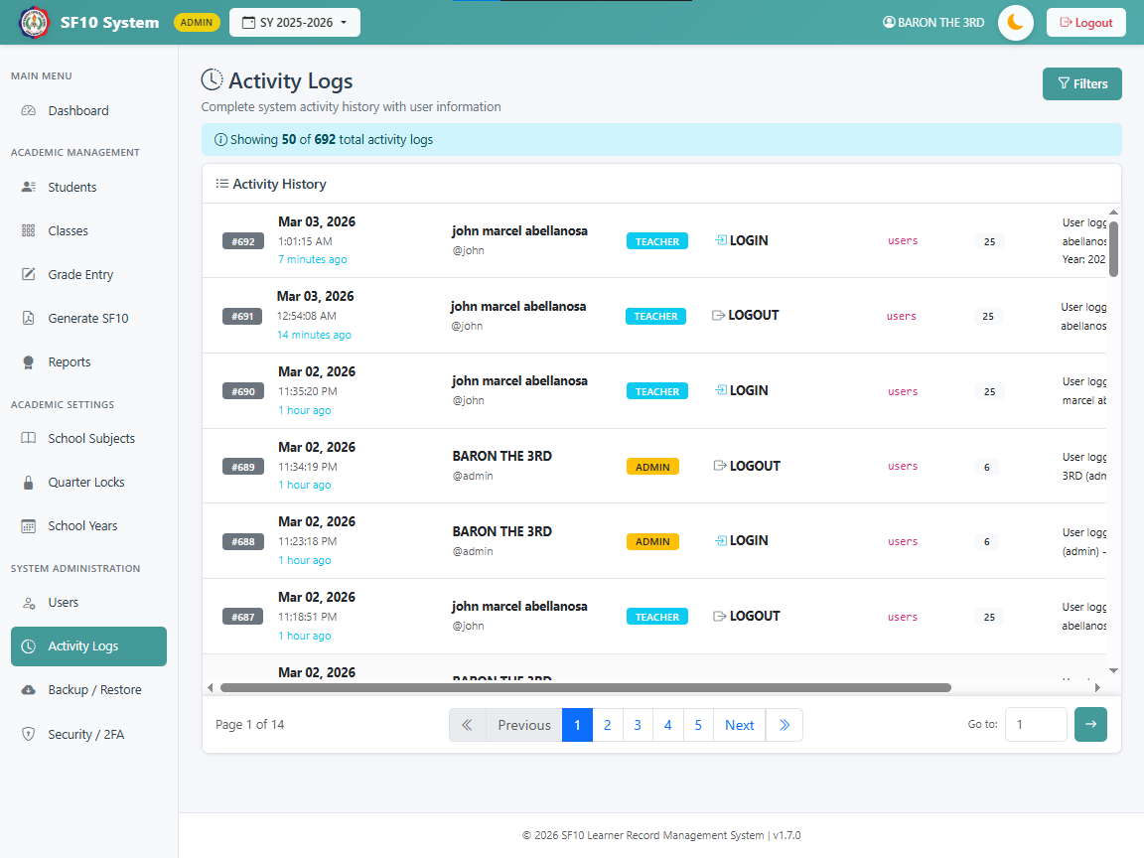

Figure 8.3 Activity Logs Output

4.DASHBOARD ANALYTICS

- Format: Visual Widgets / Cards.
- Content:
- Total Students: Count of currently enrolled active students.
- Total Teachers: Count of active teacher accounts.
- Active Classes: Count of class sections for the current school year.
- System Status: Current Active School Year and Quarter status.

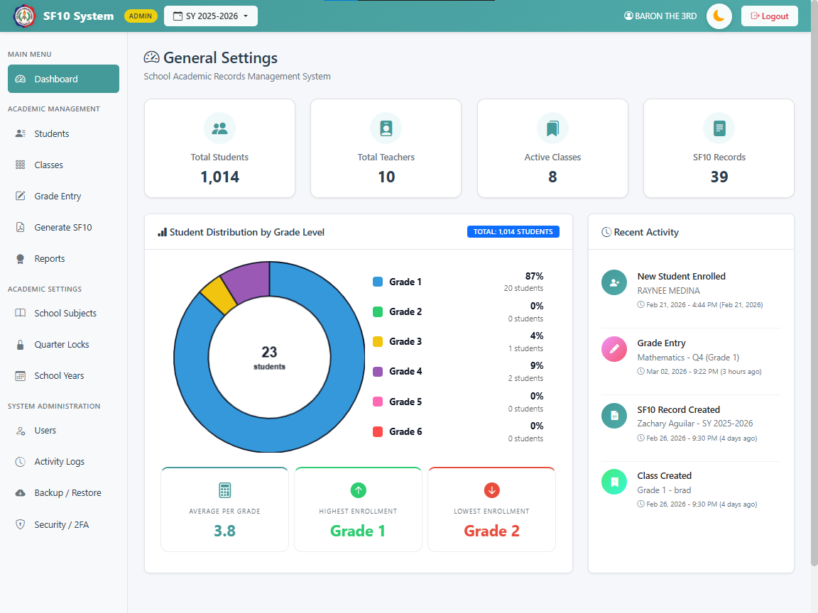

Figure 8.4 Dashboard Analytics Output

FORMS
This section lists the primary User Interface (UI) screens and Data Entry Forms used in the system, detailing their layout and interaction model.



Figure 9.0 Login Form

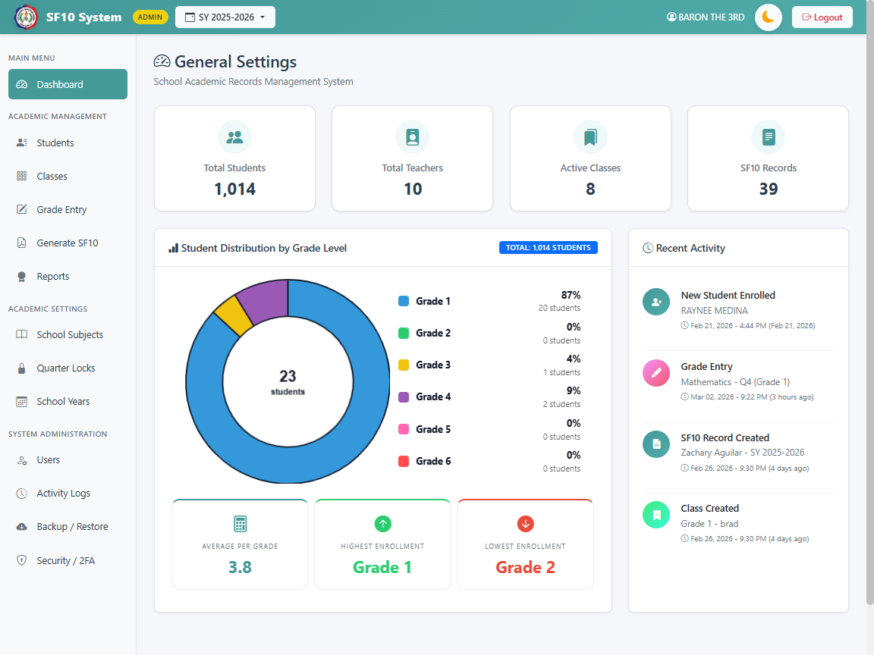


Figure 9.1 Main Dashboard

Figure 9.2 Student Registration Form
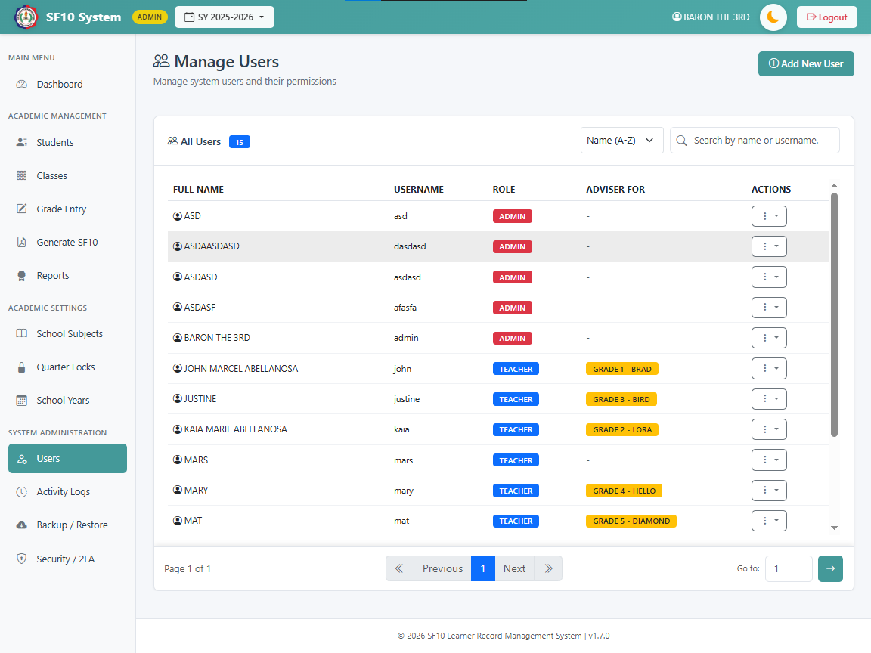

Figure 9.3 User Management Form
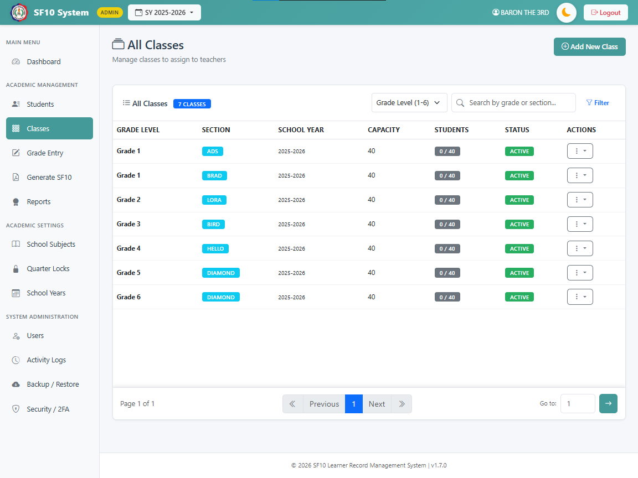

Figure 9.4 Class/Section Form


Figure 9.5 School Year Form
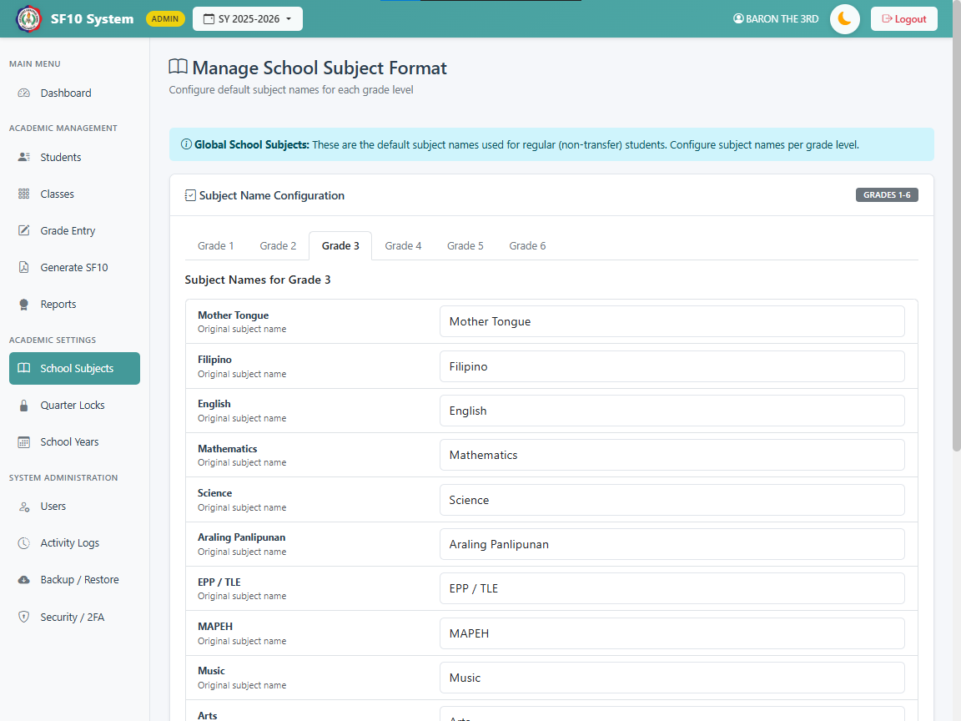

Figure 9.6 Subject Management Form
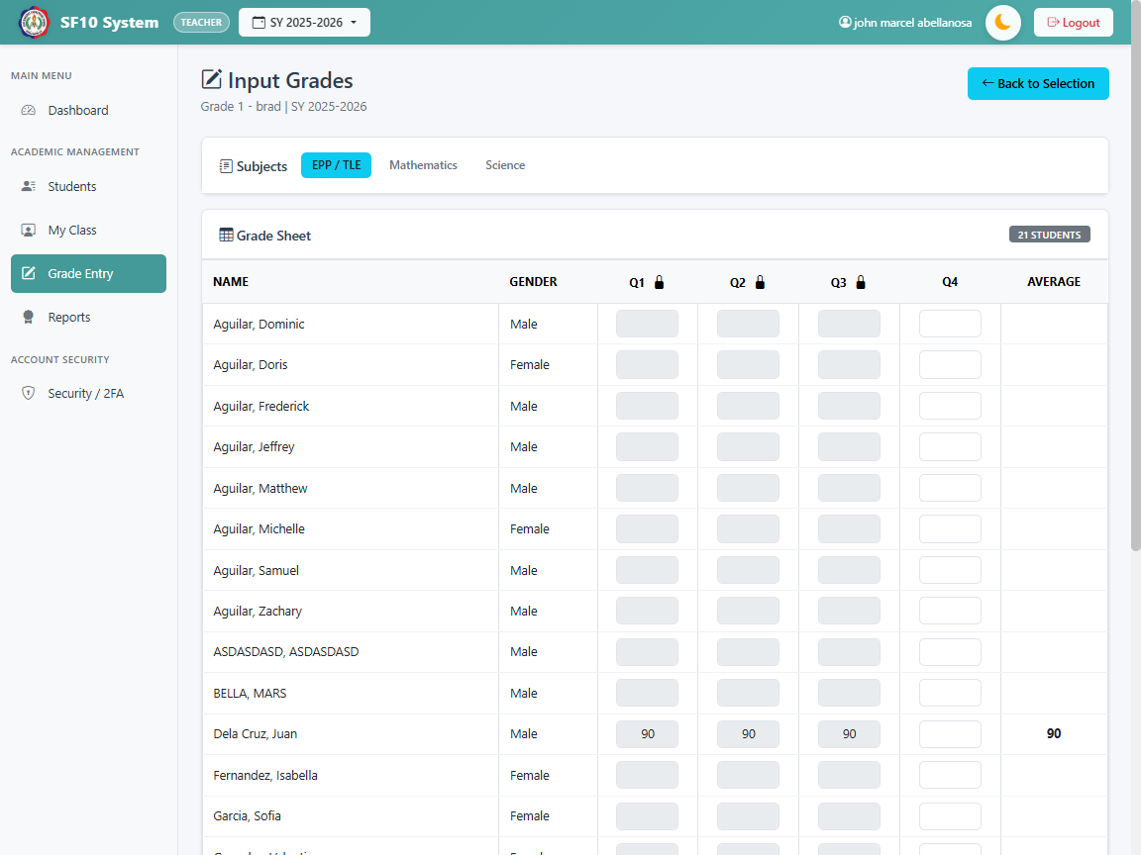

Figure 9.7 Teacher Grade Entry Form
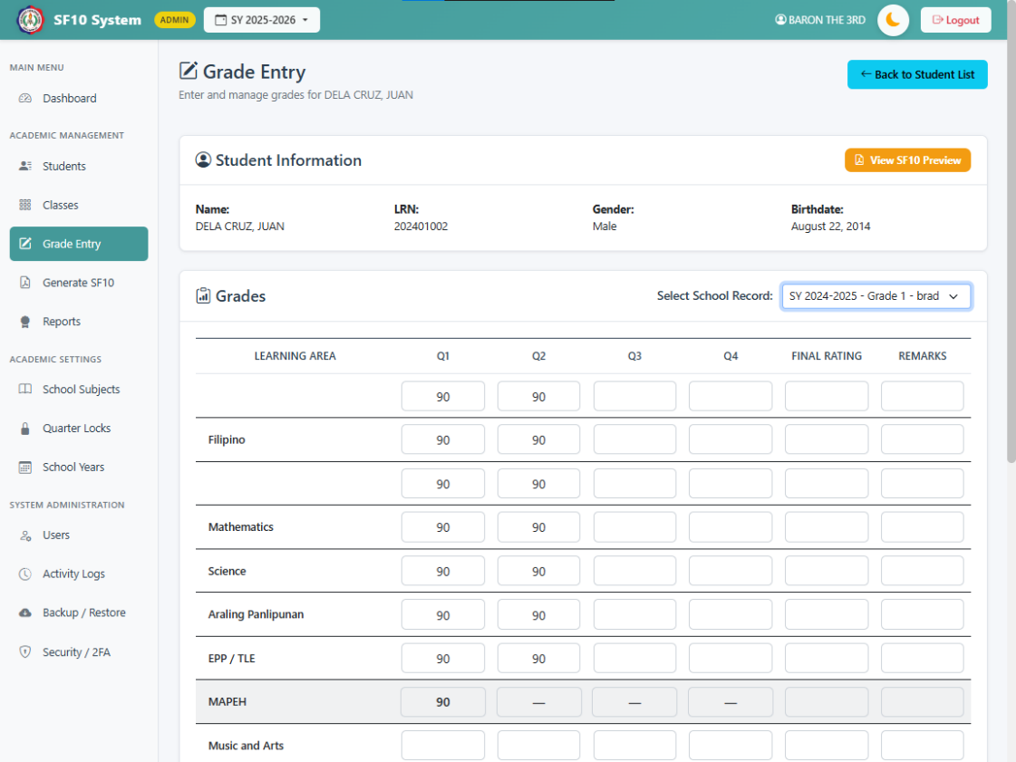

Figure 9.8 Admin Grade Management Form


Figure 9.9 Quarter Lock Management
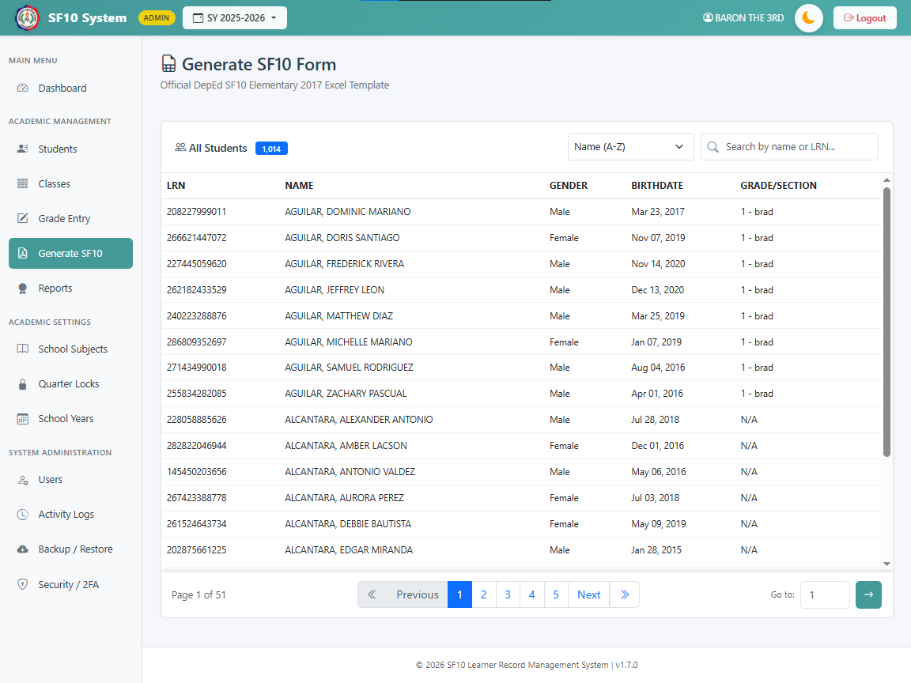

Figure 9.10 SF10 Generation Interface



Figure 9.11 Honor Roll Filter Form

ENTITY RELATIONSHIP DIAGRAM

In a definition from smartdraw.com, an Entity Relationship Diagram (ERD) shows the relationship of entity sets stored in the database. This illustrates how entities such as people, objects or concepts relate to each other within a system.

To maintain clarity and readability in the system documentation, the Entity Relationship Diagram (ERD) is presented using a Modular Approach.

Module 1: Student Enrollment & Academic Structure
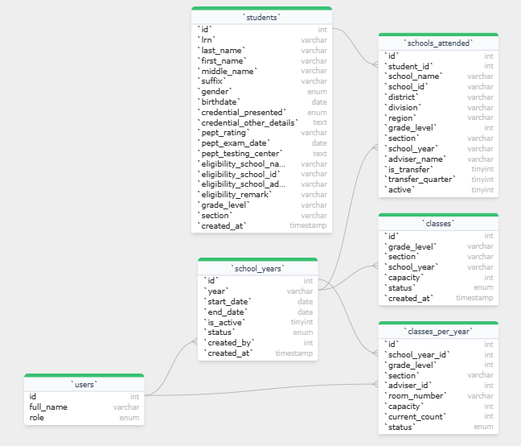

Figure 10.0 Show Student Enrollment & Academic Structure ERD in modular approach

Module 2: Grading & Assessment System

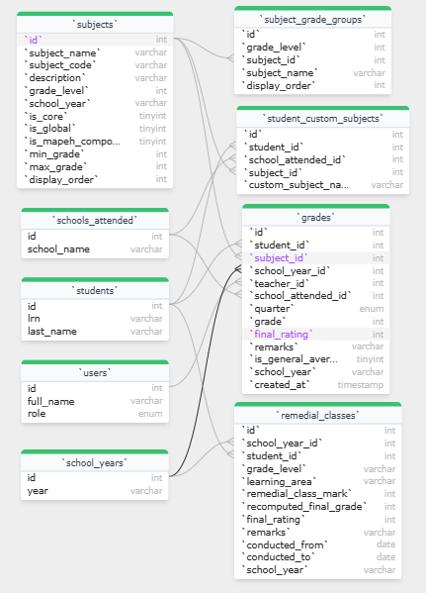

Figure 10.1 Show Grading & Assessment System ERD in modular approach

Module 3: Faculty & System Administration

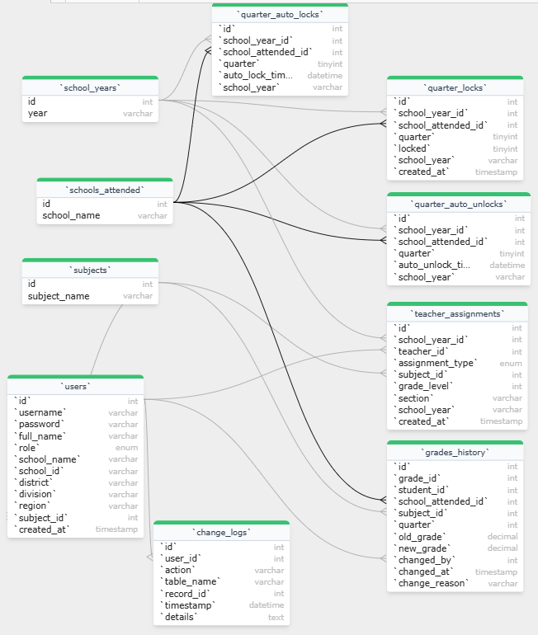

INSERT THE ENTITY RELATIONSHIP DIAGRAM
After the diagram, please write a Figure XX.X: Entity Relationship Diagram
There is only 1 Entity Relationship Diagram.

Figure 10.2 Show Faculty & System Administration ERD in modular approach

DEPLOYMENT DIAGRAM
The Deployment Diagram is used to visualize the topology of the physical components of a system, where software and hardware components are being deployed.
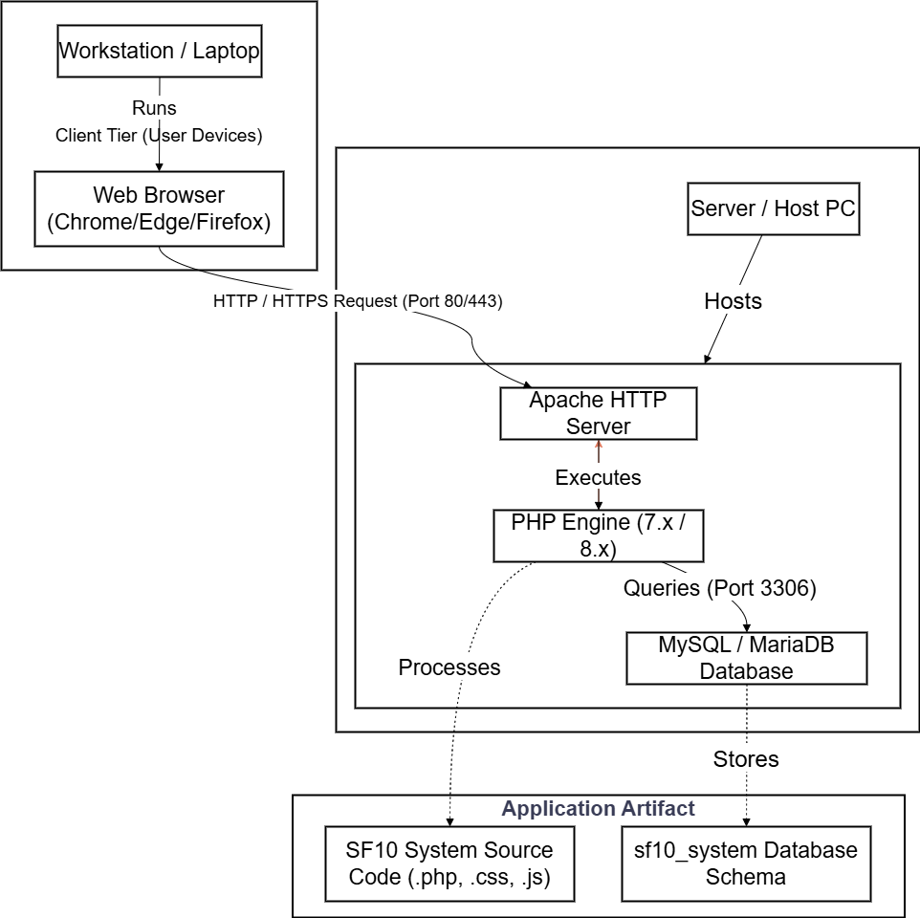

Figure 11.0 Show Deployment Architecture and Diagram

COMPONENT DESCRIPTION:

- Client Tier:
- Hardware: User's Desktop PC, Laptop, or Tablet.
- Software: Any modern web browser (Google Chrome, Mozilla Firefox, Microsoft Edge).
- Function: Provides the user interface (UI) for interacting with the SF10 System.
- Server Tier:
- Hardware: The central computer hosting the application (can be a local server or cloud instance).
- Software (XAMPP Stack):
- Apache HTTP Server: Handles incoming web requests from clients.
- PHP Engine: Processes the server-side logic and dynamic content.
- MariaDB / MySQL: Manages the relational database storage.
- Function: Processes requests, executes business logic, and manages data persistence.
- Communication:
- HTTP/HTTPS: The protocol used for communication between the Client and Server over the network (LAN or Internet).

CONCLUSION

The development and implementation of the Learner's Permanent Academic Record Management System of New Mabuhay Elementary School successfully addressed the inefficiencies of the previous manual record-keeping process. By automating data processing and centralizing academic records, the system eliminated redundancy, minimized human error, and significantly improved operational efficiency. Furthermore, the integration of role-based security and a modular architecture ensured that sensitive learner data remained secure while allowing for future scalability. Ultimately, the system transformed the school's academic management into a streamlined, accurate, and highly productive operation.

RECOMMENDATIONS

To maximize the benefits of the Learner's Permanent Academic Record Management System of New Mabuhay Elementary School, the following strategic actions were recommended:

- Phased Implementation and Training: It was advised to roll out the system in phases, accompanied by comprehensive training workshops to ensure faculty and staff proficiency.
- Infrastructure and Policy Enforcement: The establishment of robust server maintenance protocols and clear administrative policies regarding data entry timelines was deemed essential for system sustainability.
- Future Expansion: Consideration for future enhancements, such as integration with DepEd systems or a stakeholder portal, was proposed to further elevate the school's technological capabilities.

PROJECT IMPLEMENTATION PLAN

An implementation plan is a management tool designed to illustrate in detail, the critical steps in developing and starting a project. It is a guide that helps program staff to be

proactive rather than reactive in developing their program and identifying any challenges in the implementation.
As the system developer, the following chronological activities were conducted before the full deployment of the system:

- System Environment Preparation: The necessary hardware and software components, including the XAMPP server stack (Apache, MySQL, PHP), were installed and configured on the school's designated server. The network infrastructure was tested to ensure stable connectivity between the server and client workstations.

- Data Migration and Integrity Check: Existing manual records were reviewed and digitized. Initial data, such as the list of students, subjects, and faculty members, was migrated into the database. A verification process was performed to ensure that the digitized data matched the physical records accurately.

- User Orientation and Role Assignment: A general orientation session was organized for the school administration and faculty. During this session, the system's purpose and benefits were presented. User accounts were created, and specific roles (Administrator, Adviser, Subject Teacher) were assigned based on the school's organizational structure.

- Module-Specific Training Workshops: Targeted training sessions were conducted. Administrators were trained on system maintenance and user management. Faculty members were trained on the grading module, specifically on encoding grades and generating reports. Hands-on exercises were provided to ensure user proficiency.

- Pilot Testing: A pilot test was executed involving a selected grade level (e.g., Grade 7). The system was used in parallel with the manual process for one grading quarter. Feedback was collected from the pilot users to identify any usability issues or bugs.

- System Refinement and Final Deployment: Based on the feedback from the pilot test, necessary adjustments and optimizations were made to the system code. Once the system

- was deemed stable and fully functional, the official full-scale deployment to all grade levels was authorized.

PROJECT IMPLEMENTATION CHECKLIST

The implementation checklist will be given to the staff and the owner who will use the system. They will be the one to determine if the proposed system can be acceptable in their establishment.

Table 6.0 The Implementation Checklist
CRITERIA | YES | NO
- Are the staff who will use the system are computer literate? | ✔
- Is the project team conducted a user’s orientation to the staff? | ✔
- Is the project team conducted short trainings in hardware manipulation? |  | ✔
- Is the project team conducted short trainings in software / system manipulation? | ✔
- Is the establishment has computer units? | ✔
- Are the computer units compatible to the system requirements? | ✔
- Is the design of the system met the user’s expectation? | ✔
- Are the contents/menu in the system met the user’s need? | ✔
- Is the system capable to produce reports? | ✔
- Is the system acceptable to the management? | ✔

PROJECT IMPLEMENTATION CONTINGENCY

The following contingency measures were implemented to address the gaps identified during the assessment of the Project Implementation Checklist, specifically targeting items that were initially unfulfilled or posed potential risks:

- Addressing Hardware Limitations: In instances where existing faculty workstations did not meet the recommended system specifications, browser optimizations were applied to ensure smooth operation. Additionally, a request for phased hardware upgrades was submitted to the school administration to resolve long-term performance bottlenecks.

- Bridging Technical Literacy Gaps: For staff members who demonstrated limited proficiency with computerized systems, peer-assisted learning sessions were organized. Tech-savvy faculty members were designated as "System Champions" to provide on-the-spot assistance to their colleagues, and printed quick-reference guides were distributed to supplement formal training.

- Mitigating Network Instability: To counter the risk of unstable internet connectivity, the system was configured to operate primarily on the local area network (LAN). This configuration ensured that the system remained fully functional and accessible within the school premises, independent of external internet fluctuations.

- Resolving Data Discrepancies: When inconsistencies were detected between the initial digital migration and physical records, a dedicated "Data Validation Period" was established. During this time, advisers were granted temporary edit access to manually verify and correct student profiles before the grading period was officially locked.

- Compensating for Lack of Dedicated IT Staff: Due to the absence of a full-time IT officer, a "System Focal Person" was appointed from the teaching staff to handle basic
troubleshooting and user account management. For complex technical issues, a remote support agreement was established with the system developer to ensure continuity of operations.

BIBLIOGRAPHY

Astrialearning. (2022). What bis the student record management system? astrialearning.com
https://astrialearning.com/blogs/blog/what-is-the-student-record-management-system/
archive-one. (2023). Records management in the education sector. archive-one.net
https://archive-one.net/blogs/records-management-in-the-education-sector
afribary. (2024). A computerized students' records management system a case study of faculty of science and technology Kampala international university western campus. afribary.com
https://afribary.com/works/bob-john-computer-science-bushenyi-a-computerised-students-records-management-system/read
Designing an electronic students records management system: a case study of st francis schools of health Sciences namataba mukono (sfrash)
https://dissertations.mak.ac.ug/bitstream/handle/20.500.12281/15901/Kwapi%20Benad-CoCIS-BRAM.pdf?sequence=3&isAllowed=y

APPENDIX A – RELEVANT SOURCE CODE

(Insert the relevant source code of the system/app, use 8 as font size and Courier New as font style)

APPENDIX B - LETTER OF APPROVAL

(Insert the scanned copy of Letter of Approval signed/received by the proponents, project instructor and client)

APPENDIX C - GRAMMARIAN’S CERTIFICATE

(Insert the scanned copy of Grammarian’s certificate signed by the grammarian and project manager)

APPENDIX D – PROJECT WORKING TITLE FORM

(Insert the scanned copy of Project Working Title Form)

APPENDIX E – PANEL RECOMMENDATION FORM

(Insert the scanned copy of Panel Recommendation Form)

APPENDIX F - PROPONENTS’ BACKGROUND

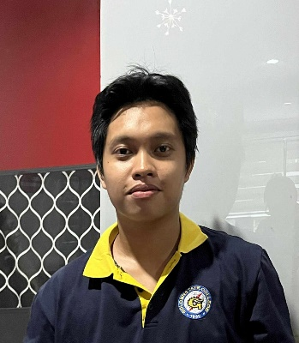
JOHN MARCEL T. ABELLANOSA
Purok : Nopol A Barangay Conel General Santos City
koysabellanosa@gmail.com
0961 013 8322

PERSONAL INFORMATION
Birthday: September 14, 2002
Birth Place: General santos City
Civil Status: Single
Religion: Roman Catholic

Name of Father: Excel Maca Abellanosa
Name of Mother: Mary Grace T. Abellanosa

EDUCATIONAL BACKGROUND
Elementary: Don Manuel H. Guttierez Sr.
Year Graduated: 2009 - 2015

High School: Engracia Valdomar National High School
Year Graduated: 2020 - 2021

College: Golden State College
Course: BS SCIENCE IN INFORMATION
TECHNOLOGY

APPENDIX F - PROPONENTS’ BACKGROUND

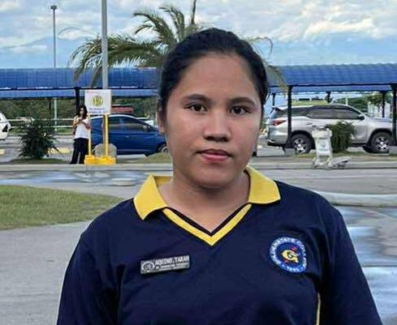
TARAH P. AQUINO
Purok Nopol A Barangay Conel General Santos City
Aquinorahpadios120603@gmail.com
0993 6780 213

PERSONAL INFORMATION
Birthday: June 12, 2003
Birth Place: Bagumbayan Sultan Kudarat
Civil Status: Single
Religion: Roman Catholic

Name of Father: Godfrey A. Aquino
Name of Mother: Rolinda P. Aquino

EDUCATIONAL BACKGROUND
Elementary: Malandag Central Elementary School
Year Graduated: 2015 - 2016

High School: Malandag National High School
Year Graduated: 2021 – 2022

College: Golden State College
Course: BS SCIENCE IN INFORMATION
TECHNOLOGY

APPENDIX F - PROPONENTS’ BACKGROUND


JERO CLINT B. DELEON
Barangay Fatima General Santos City
Jerodeleon2612@gmail.com
0970 0582 910

PERSONAL INFORMATION
Birthday: March 22, 2004
Birth Place: General santos City
Civil Status: Single
Religion: Roman Catholic

Name of Father: Jemer B. Deleon
Name of Mother: Rosalie F. Bantillo

EDUCATIONAL BACKGROUND
Elementary: Upper Tambler Elementary School
Year Graduated: 2015 - 2016
High School: G.S.C National High School
Year Graduated: 2022 - 2023

College: Golden State College
Course: BS SCIENCE IN INFORMATION
TECHNOLOGY

APPENDIX F - PROPONENTS’ BACKGROUND


Baranggay Kawas Alabel Sarangani Province
desireelabustro@gmail.com
0905 7261 445

PERSONAL INFORMATION
Birthday: December 17, 2002
Birth Place: Kawas Alabel
Civil Status: Single
Religion: Cristian

Name of Father: Primo Rosaot Labustro
Name of Mother: Nissa Laurel Labustro

EDUCATIONAL BACKGROUND
Elementary: Kawas Elementary School
Year Graduated: 2015 - 2016

High School: Alabel National High School
Year Graduated: 2022 - 2023

College: Golden State College
Course: BS SCIENCE IN INFORMATION
TECHNOLOGY

