Ohsung Steel ERP 2.0 · Production Floor Tools
Leveling Production Report
Thursday, September 3, 2026 - Based on leveling-line PLC telemetry (LEVELING_DATA) - How equipment settings, box handling, and uncoiler tension behave as each coil's length progresses

1. Overview
Two leveling jobs were completed on the leveling line on Thursday, September 3, 2026. The table below combines the GreenERP job order (erp_data) with leveling-line PLC telemetry (LEVELING_DATA, MariaDB osungsteel.servehttp.com). Total length and sheet count are not read from a direct counter - they are derived by detecting the moment the in-stroke position value (MOVELENSV) resets back toward zero after each sheet, then accumulating that sheet's cut-length setting (CUTLENSET). See Section 7 for methodology and caveats.
Coil ID | Customer | Spec | Weight (kg) | Work window (KST) | Est. total length | Est. sheets
EPD2871C01 | Daehan Gangjae  ((주)대한강재) | 0.76X4XC | 10,410 | 17:34-19:27  (1h 53m) | 863.4 m | 289
59A2078B | Yuchang  ((주)유창) | 1.15X1200XC | 10,700 | 20:37-00:30 (+1d)  (3h 53m) | 992.4 m | 332

Both jobs used essentially the same cut length per sheet (~2.99 m). Coil 1 ran in the early evening (started 17:34, just before the normal 17:40 shift close, and finished 19:27); Coil 2 ran later that evening into the next day, from 20:37 to 00:30. On this date the leveling line was in operation well past normal day-shift hours, into the evening and past midnight.

2. Job 1 - EPD2871C01 (Daehan Gangjae, 0.76mm)

2.1 Equipment settings (fixed for the entire length)
Settings were finalized once at 08:48:02 - about 14 minutes after the PLC log for this job begins at 08:34:03 - and never changed again through the 10:27:06 finish (a 1mm wobble in CUTLENSET between 2994 and 2995mm at 09:01-09:03 is sensor rounding noise, not a real change).
Setting | Value | Notes
CUTLENSET (cut-length setting) | 2,994 mm (~2.994 m) | Fixed from 08:48:02 to end
SPEEDSET (speed setting) | 25 | Fixed for the entire run, never changed
ACCTM (acceleration time) | 10.0 sec | Fixed
DECTM (deceleration time) | 1.0 sec | Fixed
SLOWLENSET (slow-down length setting) | 50 mm | Fixed
INVERTERSPEEDCOEFF (inverter speed coefficient) | 23.7 - 24.0 | Measurement-noise level only, effectively fixed

2.2 Measured performance vs. coil length
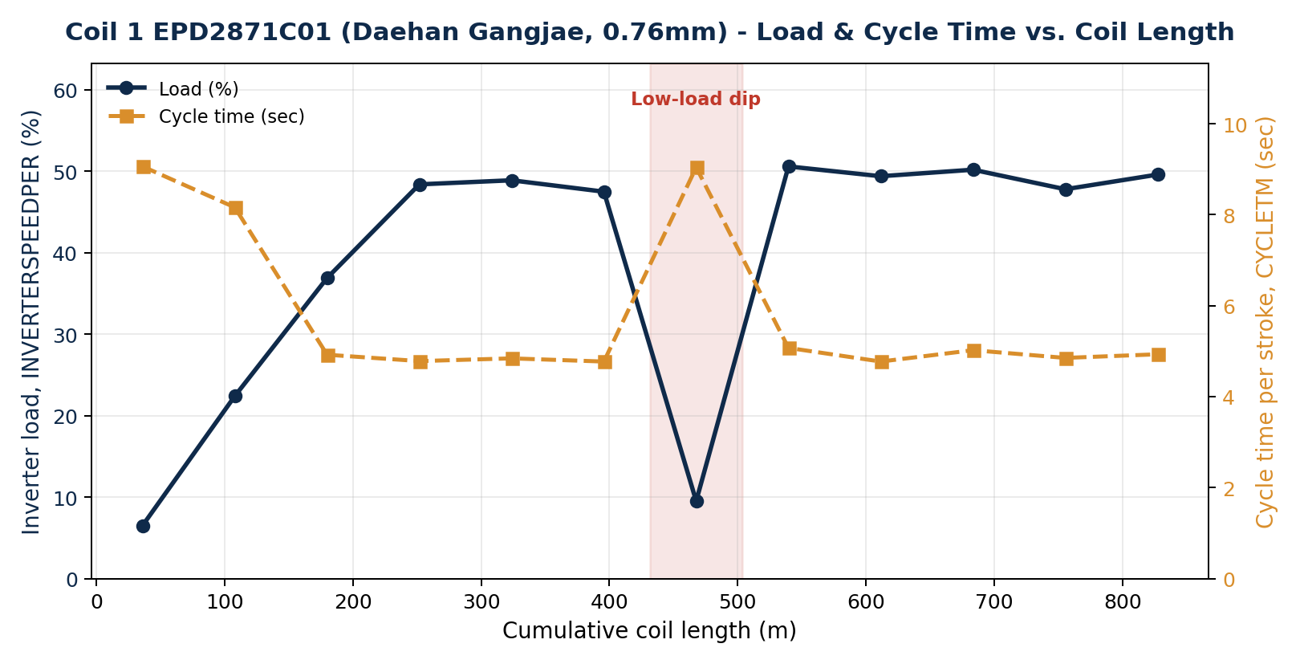
Figure 1. EPD2871C01 - inverter load (%) and cycle time per stroke (sec) vs. cumulative coil length (m)
- Warm-up phase (0-220m, roughly the first 25% of the coil): load climbs 6.5% -> 22.4% -> 36.9% -> ~48%, while cycle time shortens from 9.06 sec to ~4.8 sec. Settings did not change at all in this phase, so this is a real warm-up in the machine's realized performance, not a settings adjustment.
- Steady-state phases (220-432m and 504-863m): load holds at 47-51%, cycle time at 4.8-5.1 sec.
- Low-load dip (431.7-503.65m, 18:39-19:07 KST, ~28 minutes): load falls to as low as 9.5% and cycle time returns to a warm-up-like 9.04 sec. Since no setting changed during this window, this looks like a temporary stop or slow-down on the floor (e.g. checking material) rather than a control-parameter change.
- Box handling: per LEVELING_DATA's BOXIDX field, this entire coil was processed as a single box - there was no box change during this run.
- Because this coil has only one box, the 28-minute dip above is NOT explained by a box change (unlike Coil 2's pattern in Section 3). Its cause is not visible in the PLC settings and would need to be confirmed with the floor team - e.g. a splice/material check or an unlogged stoppage.

2b. Uncoiler Tension (PR-DTC-3100)
The uncoiler ahead of the leveling line has its own legacy tension-controller display (no data port), read by camera + OCR (Groq/Qwen vision) into the ai_tension_readings table roughly every 5 minutes while the monitoring script is running. Per the project's own data model notes, a reading has no coil ID or length of its own - it must be attributed to whichever coil had RUN=1 in LEVELING_DATA at that reading's captured_at timestamp.
Applying that rule to September 3: the OCR monitor was only active from 09:01:20 to 15:40:29 KST that day (64 readings, see table below). Coil 1 did not start until 17:34 KST and Coil 2 not until 20:37 KST - both begin after the monitor's last reading that day. So none of the day's 64 uncoiler-tension readings fall inside either job's run window; none can be attributed to EPD2871C01 or 59A2078B.
Field | Value | Note
Reading window (KST) | 09:01:20 - 15:40:29 | Ends ~2h before Coil 1 starts (17:34)
Readings that day | 64 | connected=64/64, parse_ok=63/64
Avg. output % | 70.3 %
Avg. output voltage | 16.9 V
Avg. thickness (OCR) | 958.1 um (~0.96mm) | Matches neither coil's spec (0.76mm / 1.15mm)
Avg. start diameter | 1,204.0 mm | Constant all morning
Avg. tension_set | 70.3 | Same value as output %, as expected from the panel layout
Avg. tension_rate | 0.00 | Known OCR field limitation - this field always reads 0 (documented issue)

- The morning readings' average thickness (~0.96mm) matches neither of today's two coils (0.76mm and 1.15mm), consistent with them belonging to an earlier or untagged coil that was on the uncoiler before either of today's report jobs, or to an idle/last-known-value state.
- Practical takeaway: today's two leveling jobs both ran in the evening/night, outside the OCR monitor's current operating hours, so there is currently no uncoiler-tension telemetry for evening-shift jobs like these. If tension data is wanted for jobs like these two, the monitoring script's operating hours would need to be extended into the evening (see Section 7).

3. Job 2 - 59A2078B (Yuchang, 1.15mm)

3.1 Equipment settings
The previous job's (Coil 1, 0.76mm) SPEEDSET=25 was still in effect when Coil 2 began, then was corrected to 15 at the 3m mark (11:55:58) - consistent with Yuchang's thicker spec (1.15mm) calling for a lower speed. It did not change again for the rest of the 992m run. CUTLENSET was also nudged from 2994 to 2993.5mm at the 15m mark, then held fixed.
Setting | Value | Notes
CUTLENSET (cut-length setting) | 2,993.5 mm (~2.994 m) | Fixed after the 15m mark
SPEEDSET (speed setting) | 15 | Corrected from 25 to 15 at the 3m mark, then fixed (reflects thicker spec vs. Coil 1)
ACCTM / DECTM | 10.0 sec / 1.0 sec | Fixed
SLOWLENSET (slow-down length setting) | 50 mm | Fixed
INVERTERSPEEDCOEFF (inverter speed coefficient) | 24.2 - 24.5 | Fixed

3.2 Measured performance vs. coil length
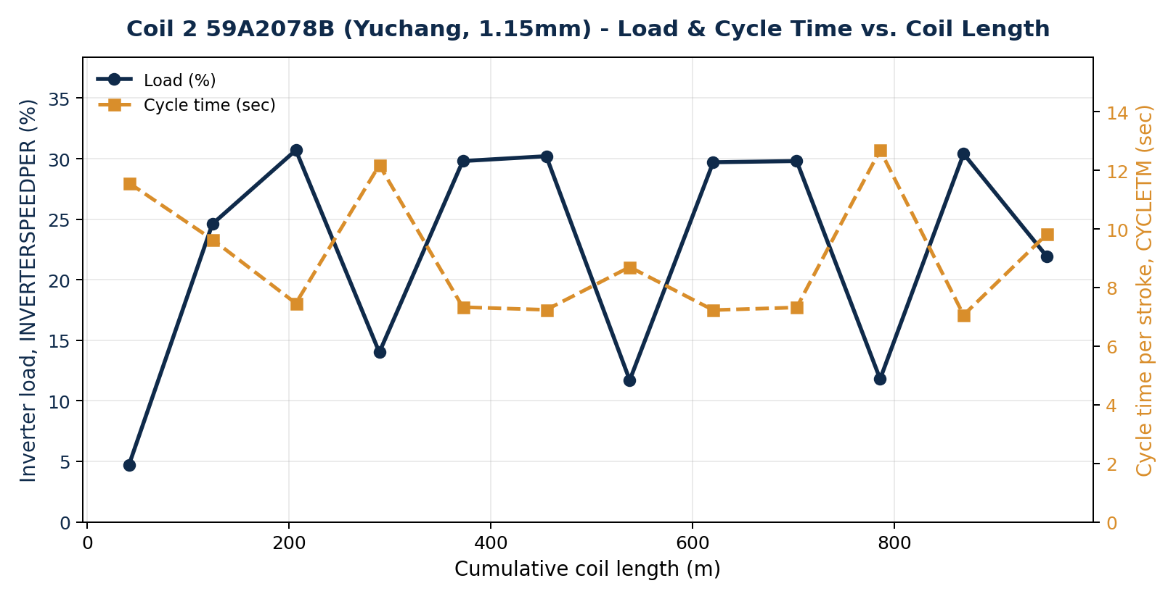
Figure 2. 59A2078B - inverter load (%) and cycle time per stroke (sec) vs. cumulative coil length (m)
- Unlike Coil 1's single warm-up curve, this coil shows a repeating sawtooth: low-load segments (5-14%, cycle time 8.7-12.7 sec) alternate with high-load segments (24-31%, cycle time 7.0-7.5 sec) about every 80-90m, 6+ times over the run.
- Settings never changed again after the 3m mark - so the repeated rise and fall in load is a real, measured effect, not the operator re-tuning the machine.

3b. Box breakdown - Coil 2
Coil 2 was processed as 4 separate boxes (BOXIDX 1-4). The table and chart below show each box's production time and the gap between boxes (i.e. the box-change pause).
Box | Start (KST) | End (KST) | Duration | Gap before next box | Avg. load %
1 | 20:36:58 | 22:37:06 | 2h 00m | - | 7.7 %
 |  |  |  | 11m 58s (box change)
2 | 22:49:04 | 23:28:44 | 39m 40s |  | 17.0 %
 |  |  |  | 4m 36s (box change)
3 | 23:33:20 | 00:07:17 (+1d) | 33m 57s |  | 19.2 %
 |  |  |  | 2 sec (negligible)
4 | 00:07:19 (+1d) | 00:30:00 (+1d) | 22m 41s | - | 24.7 %

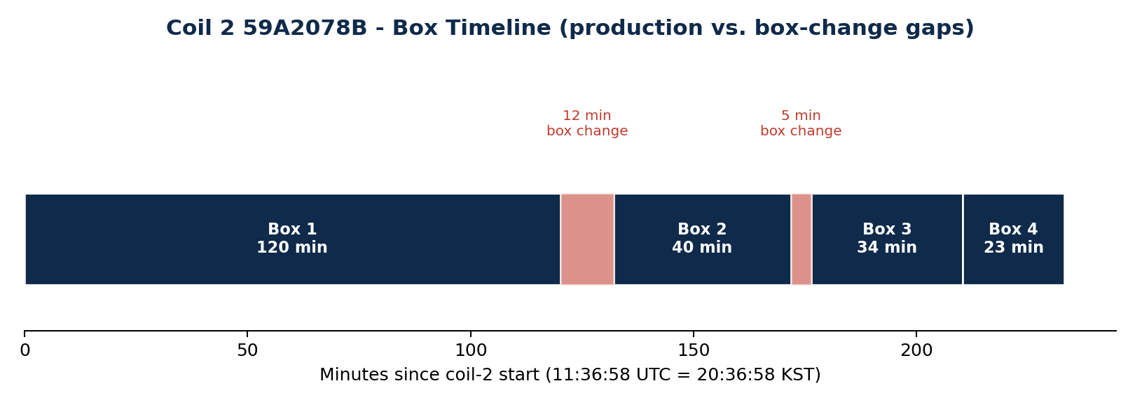
Figure 3. Coil 2 59A2078B - box production spans and the gaps between them
- This confirms the operator's own explanation: leveling packs finished sheets into boxes underneath each coil, and the brief pauses seen in the load/cycle-time chart correspond to stopping to swap out a full box. The two clearest gaps (12 minutes after Box 1, ~4.6 minutes after Box 2) line up with the low-load dips visible in Figure 2.
- Box-average load rises from box to box (7.7% -> 17.0% -> 19.2% -> 24.7%), which matches the same warm-up-then-plateau behavior seen in Coil 1, just interrupted by 3 box changes instead of running as one continuous block.
- Note the asymmetry with Coil 1 (Section 2): Coil 1's own 28-minute dip is not a box change, since it was processed as a single box throughout. So box changes explain Coil 2's repeating pattern well, but do not explain Coil 1's one dip - that one still needs a floor-side explanation.

4. Comparing the two jobs
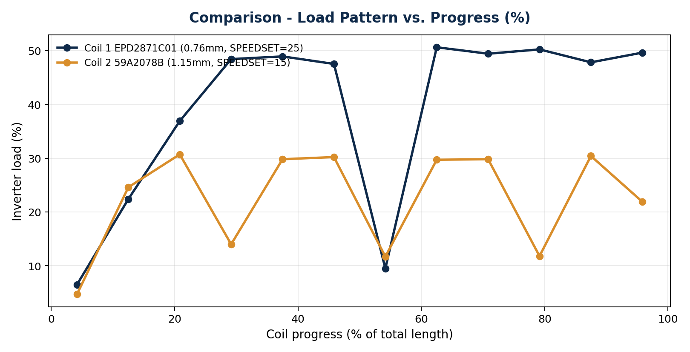
Figure 4. Load (%) vs. progress through the coil (%) - both jobs
- Common pattern: both jobs show the same operating model - settings are locked in once at the start and held for the whole run, while only the measured values (load %, cycle time) move with length. The leveling line is not being re-tuned in real time as a coil progresses; it is set once to match the job spec and then left alone.
- Thickness vs. SPEEDSET: the 0.76mm coil ran at SPEEDSET 25, the thicker 1.15mm coil at SPEEDSET 15 - thicker material set to run slower (only 2 data points here, so this should be confirmed against more coils before treating it as a rule).
- Difference: Coil 1 only shows a warm-up in its first ~25% of length and is stable for the remaining 75%; Coil 2 never reaches a single stable plateau, instead repeating the rise-and-fall pattern tied to its 4 box changes. Coil 1 being a single box vs. Coil 2's four boxes is the most likely reason for that difference.

5. Key insights
- (1) Leveling-line settings (CUTLENSET, SPEEDSET, ACCTM, DECTM, SLOWLENSET, INVERTERSPEEDCOEFF) are not adjusted gradually as a coil's length progresses - they are locked in once at job start to match the spec, then held fixed to the end. Operators are not re-tuning the line in real time during a run.
- (2) What does change with length is measured performance (load % / cycle time), and that change is explained almost entirely by two things: (a) machine warm-up early in a run, and (b) box-change pauses - confirmed directly for Coil 2 (Section 3b), and matching the pattern seen in Coil 1's own warm-up, even though Coil 1's mid-run dip is not itself a box change.
- (3) Finding (1) supports the case for the already-planned 'Leveler AI Helper / length-based control guide' (planned 2026-09-03, architecture.md Section 11): since operators are not currently adjusting settings by length, an automated length-based recommendation tool would add real, new value rather than just reproducing what operators already do.
- (4) Sheet-count method check: this report's MOVELENSV-reset method gives 289 sheets for Coil 1 and 332 for Coil 2. The existing leveling-detail screen's method (span-time / average cycle time) gives 861 and 1,359 - about 3.0x and 4.1x too high. This directly reconfirms, with fresh data, the known issue already documented in architecture.md that CYCLETM is an in-stroke counter and over-counts sheets 3-4x.
- (5) Uncoiler tension telemetry currently has a coverage gap for evening/night jobs: the OCR monitor only ran 09:01-15:40 KST on 09/03, while both of that day's leveling jobs ran later (17:34-19:27 and 20:37-00:30). Extending the monitor's operating hours would let future reports like this one include real tension data alongside the settings/load data.

6. Data and methodology
Data sources: the leveler-explore Supabase Edge Function (new leveling_length_profile mode, added 2026-09-04) against LEVELING_DATA (leveling PLC telemetry, MariaDB osungsteel.servehttp.com) and erp_data (job orders); ai_tension_readings (Supabase Postgres) for uncoiler tension.
- Deriving cumulative length: LEVELING_DATA has no column for a coil's total accumulated length - only MOVELENSV, which rises from 0 toward CUTLENSET within each stroke and resets for the next sheet. This analysis flags a reset whenever MOVELENSV drops more than 100mm from the previous reading, and accumulates each completed sheet's CUTLENSET to back into a cumulative length.
- Cross-check: Coil 2 (59A2078B, 1.15mm x 1,200mm, 10,700kg) converts to an estimated ~987.7m via steel density (7,850 kg/m3), within 0.5% of this report's PLC-derived 992.4m - supporting the method's reliability. Coil 1's spec string (0.76X4XC) doesn't clearly encode a width, so the same cross-check wasn't possible for it.
- Limitations: cumulative length and sheet counts are estimates, not direct counter readings. Improving accuracy would need (a) a real cut counter tag in the PLC, (b) the OCR/production tooling to record COIL_ID and sheet count at capture time, and (c) enforcing COIL_ID tagging across all runs - all already listed as follow-ups in the existing plan (레벨러_AI헬퍼_개발기획_정리.md).
- Uncoiler tension readings (ai_tension_readings) carry no coil ID or length of their own; per the project's documented data model, each reading should be attributed to whichever coil has RUN=1 in LEVELING_DATA at that reading's timestamp. For 09/03 this attribution yields no matches for either job in this report (Section 2b).

7. Recommendations
- Prioritize the planned length-based control guide (including cycle-rhythm prediction and box-change alerts), since this report confirms its core premise: operators fix settings at job start and do not adjust them by length.
- Add automatic detection of 'measured values drop with no setting change' windows - like Coil 1's 28-minute dip and Coil 2's repeating box-change dips - to the live dashboards, so unusual stops can be traced after the fact.
- Extend the uncoiler-tension OCR monitor's operating hours to cover evening/night leveling jobs, so future reports like this one can include real tension data for jobs that run outside normal day-shift hours.
- Work with the floor team to add a real cut-counter PLC tag, to remove the 3-4x sheet-count discrepancy documented in Section 5(4).
Prepared by: Ohsung Steel ERP 2.0 - Automated analysis report - 2026-09-04

