Ohsung Steel ERP 2.0 · Production Floor Tools
Leveling Production Report
Thursday, September 3, 2026 - Based on leveling-line PLC telemetry (LEVELING_DATA) - How equipment settings, box handling, and uncoiler tension behave as each coil's length progresses

1. Overview
Two leveling jobs were completed on the leveling line on Thursday, September 3, 2026. The table below combines the GreenERP job order (erp_data) with leveling-line PLC telemetry (LEVELING_DATA, MariaDB osungsteel.servehttp.com). Total length and sheet count are not read from a direct counter - they are derived by detecting the moment the in-stroke position value (MOVELENSV) resets back toward zero after each sheet, then accumulating that sheet's cut-length setting (CUTLENSET). See Section 7 for methodology and caveats.
Coil ID | Customer | Spec | Weight (kg) | Work window (KST) | Est. total length | Est. sheets
EPD2871C01 | Daehan Gangjae  ((주)대한강재) | 0.76X4XC | 10,410 | 08:34-10:27  (1h 53m) | 863.4 m | 289
59A2078B | Yuchang  ((주)유창) | 1.15X1200XC | 10,700 | 11:37-15:30  (3h 53m) | 992.4 m | 332

Both jobs used essentially the same cut length per sheet (~2.99 m) and both ran well inside the normal 08:30-17:30 work day. Coil 1 started shortly after the shift began (08:34) and finished at 10:27; after a changeover gap of about 1h 10m (10:27-11:37), Coil 2 ran from 11:37 to 15:30. The line finished both jobs by mid-afternoon, roughly two hours before the shift's normal close.

2. Job 1 - EPD2871C01 (Daehan Gangjae, 0.76mm)

2.1 Equipment settings (fixed for the entire length)
Settings were finalized once at 08:48:02 - about 14 minutes after the PLC log for this job begins at 08:34:03 - and never changed again through the 10:27:06 finish (a 1mm wobble in CUTLENSET between 2994 and 2995mm at 09:01-09:03 is sensor rounding noise, not a real change).
Setting | Value | Notes
CUTLENSET (cut-length setting) | 2,994 mm (~2.994 m) | Fixed from 08:48:02 to end
SPEEDSET (speed setting) | 25 | Fixed for the entire run, never changed
ACCTM (acceleration time) | 10.0 sec | Fixed
DECTM (deceleration time) | 1.0 sec | Fixed
SLOWLENSET (slow-down length setting) | 50 mm | Fixed
INVERTERSPEEDCOEFF (inverter speed coefficient) | 23.7 - 24.0 | Measurement-noise level only, effectively fixed

2.2 Measured performance vs. coil length
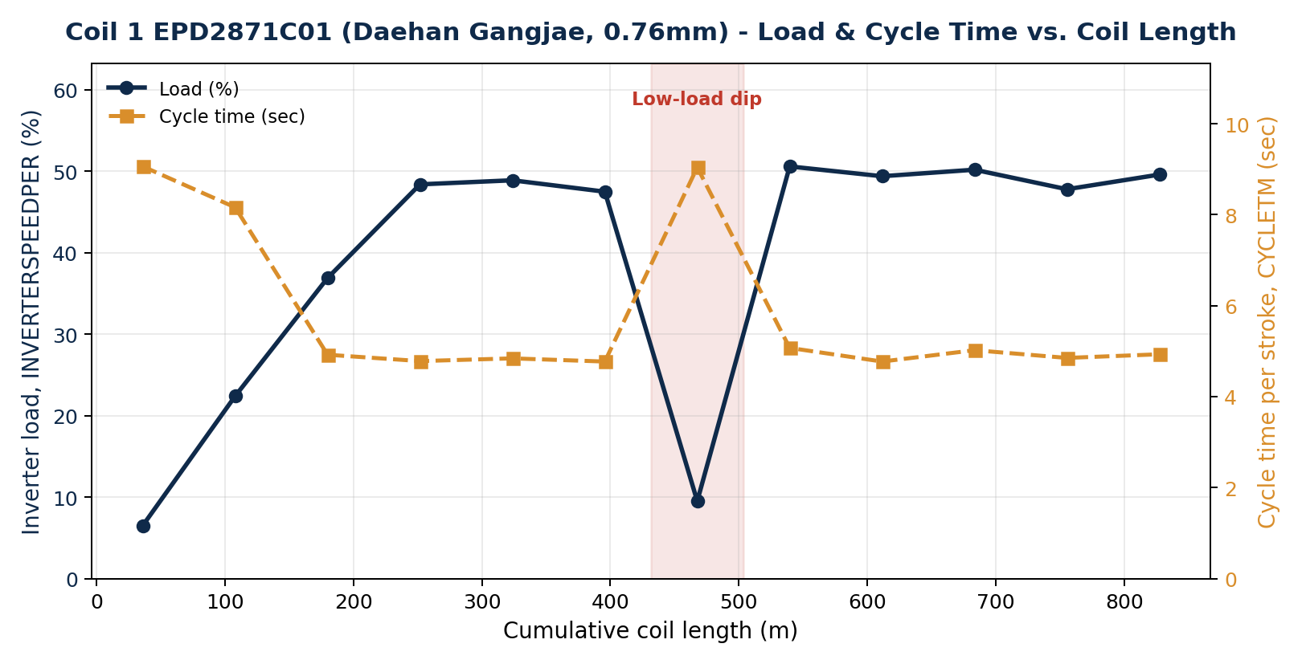
Figure 1. EPD2871C01 - inverter load (%) and cycle time per stroke (sec) vs. cumulative coil length (m)
- Warm-up phase (0-220m, roughly the first 25% of the coil): load climbs 6.5% -> 22.4% -> 36.9% -> ~48%, while cycle time shortens from 9.06 sec to ~4.8 sec. Settings did not change at all in this phase, so this is a real warm-up in the machine's realized performance, not a settings adjustment.
- Steady-state phases (220-432m and 504-863m): load holds at 47-51%, cycle time at 4.8-5.1 sec.
- Low-load dip (431.7-503.65m, 09:39-10:07 KST, ~28 minutes): load falls to as low as 9.5% and cycle time returns to a warm-up-like 9.04 sec. Since no setting changed during this window, this looks like a temporary stop or slow-down on the floor (e.g. checking material) rather than a control-parameter change.
- Box handling: per LEVELING_DATA's BOXIDX field, this entire coil was processed as a single box - there was no box change during this run.
- Because this coil has only one box, the 28-minute dip above is NOT explained by a box change (unlike Coil 2's pattern in Section 3). Its cause is not visible in the PLC settings and would need to be confirmed with the floor team - e.g. a splice/material check or an unlogged stoppage.

2b. Uncoiler Tension (PR-DTC-3100)
The uncoiler ahead of the leveling line has its own legacy tension-controller display (no data port), read by camera + OCR (Groq/Qwen vision) into the ai_tension_readings table roughly every 5 minutes while the monitoring script is running. A reading has no coil ID or length of its own, so it is attributed here by two independent signals: (a) time overlap with each coil's LEVELING_DATA run window, and (b) an exact match between the reading's OCR'd thickness_um field and each coil's spec (760um = 0.76mm for Coil 1, 1150um = 1.15mm for Coil 2).
With the timeline corrected, the two signals agree: 63 of that day's 64 readings carry exactly one of those two thickness values, and each group's time range sits right on top of the matching coil's run window. So - unlike this report's earlier draft - there is good overlapping tension telemetry for both of today's jobs.
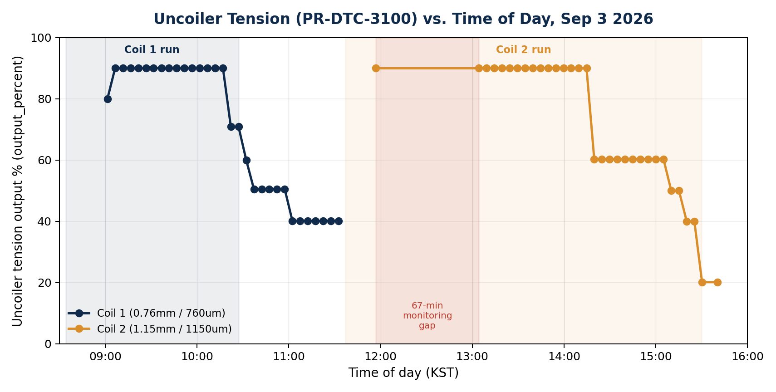
Figure 1b. Uncoiler tension output % vs. time of day, split by matched coil (thickness_um)
Field | Coil 1 (760um / 0.76mm) | Coil 2 (1150um / 1.15mm)
Reading window (KST) | 09:01:20 - 11:32:34 | 11:56:52 - 15:40:29
Readings | 31 | 32
Avg. output % (=tension_set) | 69.8 % | 70.7 %
Tension steps observed | 90.0 -> 70.9 -> 60.0 -> 50.5 -> 40.1 | 90.0 -> 60.3 -> 50.0 -> 40.0 -> 20.1
Coverage vs. PLC run window | Starts ~27 min after PLC start (08:34); continues ~65 min past PLC finish (10:27) into the changeover | First reading at start, then a monitoring gap (below); resumes mid-run; last reading ~10 min after PLC finish (15:30)

- Taper-tension pattern: both coils show the same shape - tension holds at a high plateau (90%) for most of the run, then steps down through 4-5 discrete levels as the run nears completion, rather than drifting continuously. This matches the PR-DTC-3100 controller's designed purpose - reducing tension as the remaining coil diameter shrinks, to avoid core crush/telescoping - and the fact that both coils independently show the same 5-step pattern is a good sign the behavior is a real, repeatable control response rather than noise.
- Coil 1's step-down continues into the post-job changeover (60.0% at 10:32, still 40.1% at 11:32, one reading before Coil 2's tension appears) - consistent with the old coil physically remaining on the uncoiler stand, still unwinding down to its core, until it is swapped out for Coil 2.
- Monitoring gap during Coil 2: there is a ~67-minute gap in readings from 11:56:52 to 13:04:15, which falls entirely inside Box 1 (11:37-13:37, Section 3b). This is a data-collection gap, not a production stoppage - LEVELING_DATA shows the line running normally through this window. Worth checking whether the OCR monitor script paused or restarted around this time.
- Both reading windows start after and/or end slightly after the matching PLC run window's edges (Coil 1: readings start 27 min into the run; Coil 2: last reading is 10 min after the run finished) - a small, expected lag from the ~5-minute OCR polling interval plus the monitor continuing to read the display briefly after a job ends.

3. Job 2 - 59A2078B (Yuchang, 1.15mm)

3.1 Equipment settings
The previous job's (Coil 1, 0.76mm) SPEEDSET=25 was still in effect when Coil 2 began, then was corrected to 15 at the 3m mark (11:55:58) - consistent with Yuchang's thicker spec (1.15mm) calling for a lower speed. It did not change again for the rest of the 992m run. CUTLENSET was also nudged from 2994 to 2993.5mm at the 15m mark, then held fixed.
Setting | Value | Notes
CUTLENSET (cut-length setting) | 2,993.5 mm (~2.994 m) | Fixed after the 15m mark
SPEEDSET (speed setting) | 15 | Corrected from 25 to 15 at the 3m mark, then fixed (reflects thicker spec vs. Coil 1)
ACCTM / DECTM | 10.0 sec / 1.0 sec | Fixed
SLOWLENSET (slow-down length setting) | 50 mm | Fixed
INVERTERSPEEDCOEFF (inverter speed coefficient) | 24.2 - 24.5 | Fixed

3.2 Measured performance vs. coil length
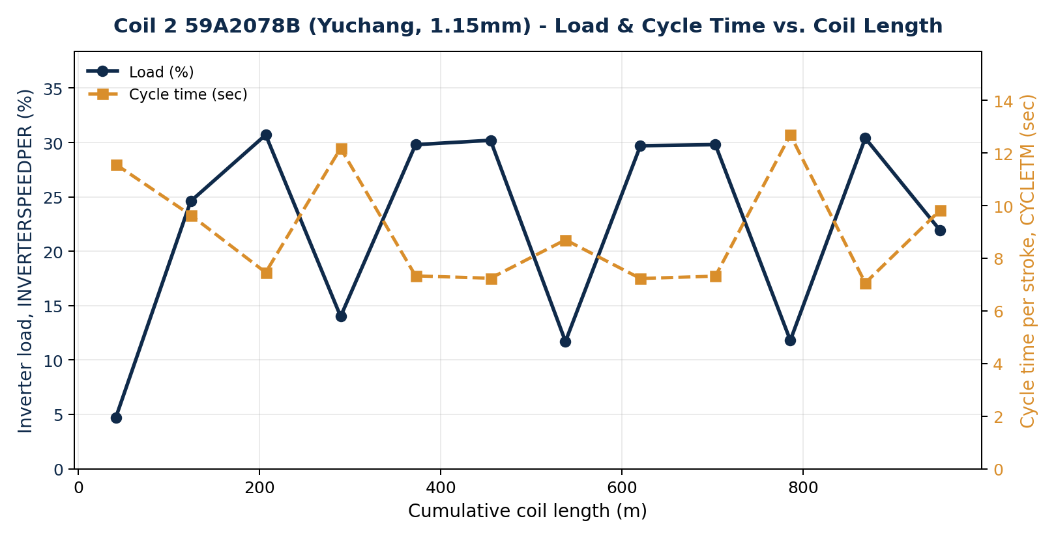
Figure 2. 59A2078B - inverter load (%) and cycle time per stroke (sec) vs. cumulative coil length (m)
- Unlike Coil 1's single warm-up curve, this coil shows a repeating sawtooth: low-load segments (5-14%, cycle time 8.7-12.7 sec) alternate with high-load segments (24-31%, cycle time 7.0-7.5 sec) about every 80-90m, 6+ times over the run.
- Settings never changed again after the 3m mark - so the repeated rise and fall in load is a real, measured effect, not the operator re-tuning the machine.

3b. Box breakdown - Coil 2
Coil 2 was processed as 4 separate boxes (BOXIDX 1-4). The table and chart below show each box's production time and the gap between boxes (i.e. the box-change pause).
Box | Start (KST) | End (KST) | Duration | Gap before next box | Avg. load %
1 | 11:36:58 | 13:37:06 | 2h 00m | - | 7.7 %
 |  |  |  | 11m 58s (box change)
2 | 13:49:04 | 14:28:44 | 39m 40s |  | 17.0 %
 |  |  |  | 4m 36s (box change)
3 | 14:33:20 | 15:07:17 | 33m 57s |  | 19.2 %
 |  |  |  | 2 sec (negligible)
4 | 15:07:19 | 15:30:00 | 22m 41s | - | 24.7 %

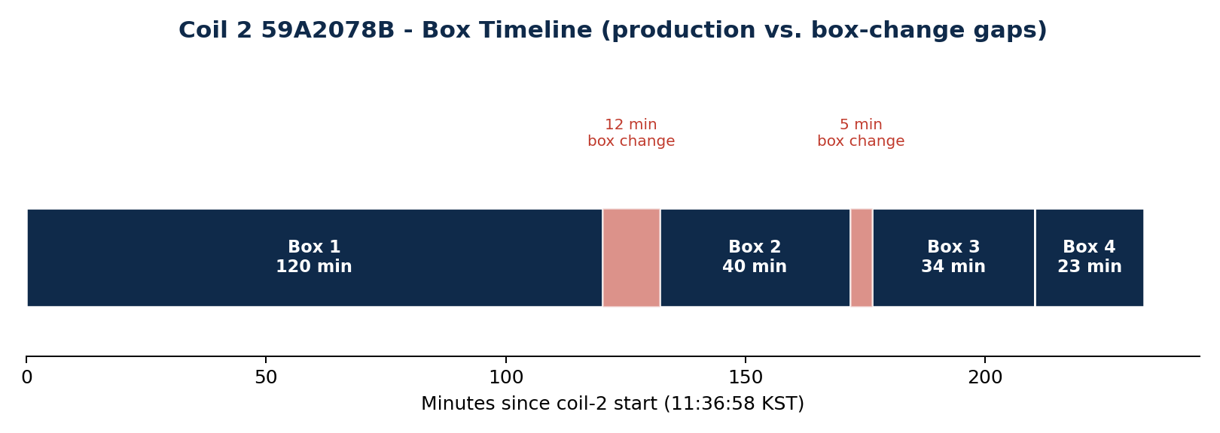
Figure 3. Coil 2 59A2078B - box production spans and the gaps between them
- This confirms the operator's own explanation: leveling packs finished sheets into boxes underneath each coil, and the brief pauses seen in the load/cycle-time chart correspond to stopping to swap out a full box. The two clearest gaps (12 minutes after Box 1, ~4.6 minutes after Box 2) line up with the low-load dips visible in Figure 2.
- Box-average load rises from box to box (7.7% -> 17.0% -> 19.2% -> 24.7%), which matches the same warm-up-then-plateau behavior seen in Coil 1, just interrupted by 3 box changes instead of running as one continuous block.
- Note the asymmetry with Coil 1 (Section 2): Coil 1's own 28-minute dip is not a box change, since it was processed as a single box throughout. So box changes explain Coil 2's repeating pattern well, but do not explain Coil 1's one dip - that one still needs a floor-side explanation.

4. Comparing the two jobs
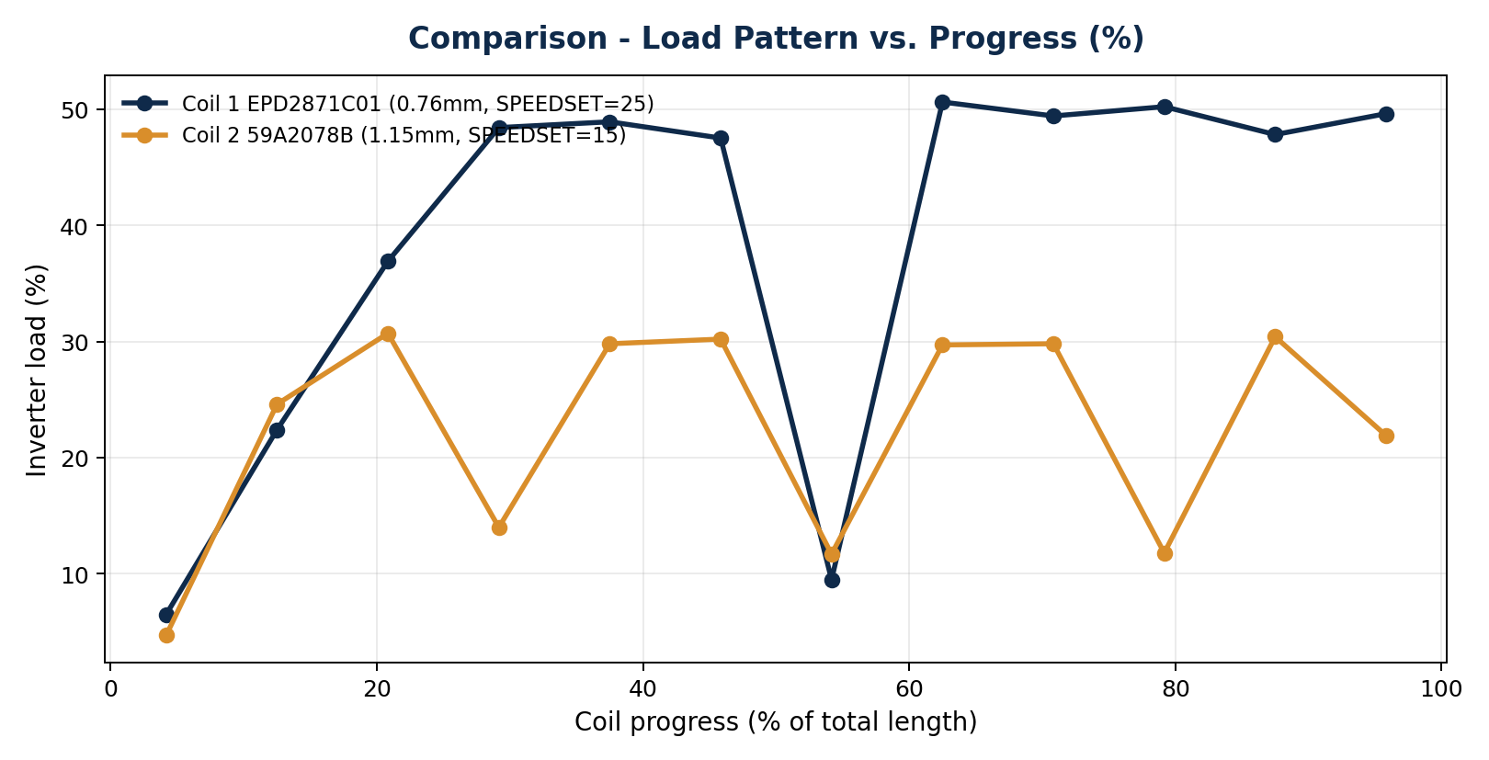
Figure 4. Load (%) vs. progress through the coil (%) - both jobs
- Common pattern: both jobs show the same operating model - settings are locked in once at the start and held for the whole run, while only the measured values (load %, cycle time) move with length. The leveling line is not being re-tuned in real time as a coil progresses; it is set once to match the job spec and then left alone.
- Thickness vs. SPEEDSET: the 0.76mm coil ran at SPEEDSET 25, the thicker 1.15mm coil at SPEEDSET 15 - thicker material set to run slower (only 2 data points here, so this should be confirmed against more coils before treating it as a rule).
- Difference: Coil 1 only shows a warm-up in its first ~25% of length and is stable for the remaining 75%; Coil 2 never reaches a single stable plateau, instead repeating the rise-and-fall pattern tied to its 4 box changes. Coil 1 being a single box vs. Coil 2's four boxes is the most likely reason for that difference.

5. Key insights
- (1) Leveling-line settings (CUTLENSET, SPEEDSET, ACCTM, DECTM, SLOWLENSET, INVERTERSPEEDCOEFF) are not adjusted gradually as a coil's length progresses - they are locked in once at job start to match the spec, then held fixed to the end. Operators are not re-tuning the line in real time during a run.
- (2) What does change with length is measured performance (load % / cycle time), and that change is explained almost entirely by two things: (a) machine warm-up early in a run, and (b) box-change pauses - confirmed directly for Coil 2 (Section 3b), and matching the pattern seen in Coil 1's own warm-up, even though Coil 1's mid-run dip is not itself a box change.
- (3) Finding (1) supports the case for the already-planned 'Leveler AI Helper / length-based control guide' (planned 2026-09-03, architecture.md Section 11): since operators are not currently adjusting settings by length, an automated length-based recommendation tool would add real, new value rather than just reproducing what operators already do.
- (4) Sheet-count method check: this report's MOVELENSV-reset method gives 289 sheets for Coil 1 and 332 for Coil 2. The existing leveling-detail screen's method (span-time / average cycle time) gives 861 and 1,359 - about 3.0x and 4.1x too high. This directly reconfirms, with fresh data, the known issue already documented in architecture.md that CYCLETM is an in-stroke counter and over-counts sheets 3-4x.
- (5) Uncoiler tension follows a 'taper' pattern rather than a continuous one: both coils independently show tension holding at a 90% plateau for most of the run, then stepping down through 4-5 discrete levels as each coil nears completion (Section 2b) - direct evidence the PR-DTC-3100 controller is reducing tension as coil diameter shrinks, exactly as it is designed to do. The one gap in this data is a ~67-minute OCR monitoring blackout during Coil 2's Box 1, worth checking against the OCR script's logs.

6. Data and methodology
Data sources: the leveler-explore Supabase Edge Function (new leveling_length_profile mode, added 2026-09-04) against LEVELING_DATA (leveling PLC telemetry, MariaDB osungsteel.servehttp.com) and erp_data (job orders); ai_tension_readings (Supabase Postgres) for uncoiler tension.
- Deriving cumulative length: LEVELING_DATA has no column for a coil's total accumulated length - only MOVELENSV, which rises from 0 toward CUTLENSET within each stroke and resets for the next sheet. This analysis flags a reset whenever MOVELENSV drops more than 100mm from the previous reading, and accumulates each completed sheet's CUTLENSET to back into a cumulative length.
- Cross-check: Coil 2 (59A2078B, 1.15mm x 1,200mm, 10,700kg) converts to an estimated ~987.7m via steel density (7,850 kg/m3), within 0.5% of this report's PLC-derived 992.4m - supporting the method's reliability. Coil 1's spec string (0.76X4XC) doesn't clearly encode a width, so the same cross-check wasn't possible for it.
- Limitations: cumulative length and sheet counts are estimates, not direct counter readings. Improving accuracy would need (a) a real cut counter tag in the PLC, (b) the OCR/production tooling to record COIL_ID and sheet count at capture time, and (c) enforcing COIL_ID tagging across all runs - all already listed as follow-ups in the existing plan (레벨러_AI헬퍼_개발기획_정리.md).
- Uncoiler tension readings (ai_tension_readings) carry no coil ID or length of their own; each reading is attributed here to a coil using two independent signals - time overlap with that coil's LEVELING_DATA run window, and an exact match between the reading's OCR'd thickness_um and the coil's spec thickness (760um/0.76mm for Coil 1, 1150um/1.15mm for Coil 2). Both signals agree for 63 of the day's 64 readings (Section 2b).
- An earlier version of this report incorrectly added 9 hours to LEVELING_DATA's TIMESTAMP field when converting to KST. LEVELING_DATA.TIMESTAMP is already stored in KST (confirmed by an hour-of-day histogram of the raw values, which peaks exactly at the plant's 08:00-17:40 business hours with no shift needed), while ai_tension_readings.captured_at is genuine UTC and does need the +9h conversion. All clock times in this report have been corrected accordingly.

7. Recommendations
- Prioritize the planned length-based control guide (including cycle-rhythm prediction and box-change alerts), since this report confirms its core premise: operators fix settings at job start and do not adjust them by length.
- Add automatic detection of 'measured values drop with no setting change' windows - like Coil 1's 28-minute dip and Coil 2's repeating box-change dips - to the live dashboards, so unusual stops can be traced after the fact.
- Investigate the ~67-minute uncoiler-tension OCR monitoring gap during Coil 2's Box 1 (11:56:52-13:04:15) to see whether it is a script pause/restart, a camera issue, or something else worth fixing so future reports have continuous coverage.
- Work with the floor team to add a real cut-counter PLC tag, to remove the 3-4x sheet-count discrepancy documented in Section 5(4).
Prepared by: Ohsung Steel ERP 2.0 - Automated analysis report - 2026-09-04

