7.3 Analysis of the Impact of New Olympic Events on Host Country Performance

In most Olympic Games, new events are introduced either to promote the development of a specific sport or at the discretion of the host country to encourage the popularity of certain activities. The objective of this analysis is to evaluate the impact of these new events on the performance of athletes from the host country, by comparing the per capita performance of host country athletes with that of all athletes.

Step 1: Quantification of Performance

To account for the incomplete nature of early Olympic Games, which introduced many new events, we focus on data from the Games held after 1964. The performance of athletes is quantified as follows:

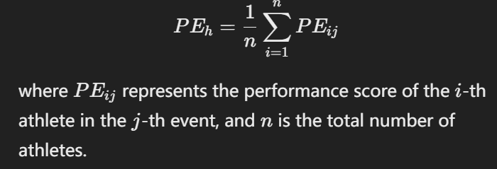

- PEh: Per capita performance score of host country athletes. The formula is:

\[

PE_h = \frac{1}{n} \sum_{i=1}^{n} PE_{ij}

\]

where \(PE_{ij}\) represents the performance score of the \(i\)-th athlete in the \(j\)-th event, and \(n\) is the total number of athletes.

PEo: Per capita performance score of all athletes, calculated in the same way as for the host country.

As shown in Figure X, the differences in performance between the host countries and all athletes vary across different Olympic Games.

#### Step 2: Mann-Whitney U Test

To evaluate whether there is a significant difference between the performance of host country athletes in new events and that of all athletes, we applied the **Mann-Whitney U Test**, also known as the **Wilcoxon Rank-Sum Test**. 【】This non-parametric test is suitable for small sample sizes and non-normally distributed data, and it has been shown to be effective (K. V. Mardia).【】

Hypotheses:

- **Null hypothesis (H₀)**: The per capita performance of host country athletes is equal to that of all athletes, i.e., \(PE_{host} = PE_{all}\).

- **Alternative hypothesis (H₁)**: The per capita performance of host country athletes is not equal to that of all athletes, i.e., \(PE_{host} \neq PE_{all}\).

#### U Test Statistic Formula:

The Mann-Whitney U test statistic is computed as follows:

\[

U = n_1n_2 + \frac{n_1(n_1+1)}{2} - R_1

\]

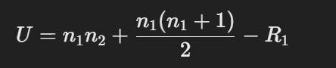

where \(n_1\) and \(n_2\) represent the sample sizes of the two groups, and \(R_1\) is the sum of ranks for the host country athletes.

Using Python, the Mann-Whitney U test statistic was computed to be **47.0**, with a p-value of **0.596**.

#### Result Analysis:

Given that the p-value is greater than 0.05, we fail to reject the null hypothesis. This suggests that there is **no statistically significant difference** between the per capita performance of host country athletes and that of all athletes in the new events. This finding aligns with the conclusions of Gergely Csurilla, who reported no significant effect of hosting on athlete performance.

---

McKnight, P. E., & Najab, J. (2010). Mann‐Whitney U Test. *The Corsini encyclopedia of psychology*, 1-1.

K. V. Mardia. "Small Sample Power of a Non-Parametric Test for the Bivariate Two-Sample Location Problem in the Normal Case." Journal of the Royal Statistical Society Series B: Statistical Methodology 1(2018).

Csurilla, G., Fertő, I. The less obvious effect of hosting the Olympics on sporting performance. *Sci Rep* **13**, 819 (2023). https://doi.org/10.1038/s41598-022-27259-8