6.2 **The Importance of Sports Projects for a Country**

A country's investment and emphasis on sports significantly influence the number of athletes and their overall performance. To identify the most important Olympic sports for a country, we must analyze both the number of athletes participating and the country's achievements in each sport.

**1.Data Normalization and Proportional Analysis:**

However, the inherent differences between sports， the number of participants and the total number of medals available，must be taken into account. For example, in 2024, the athletics event had 1810 participants and 144 medals, while table tennis had only 172 participants and 15 medals.

To eliminate the influence of these differences between sports, we process the data as follows:

For each country, we calculate the proportion of participation and medal achievements in each sport. Specifically, the participation ratio for each event is defined as:



where PAi,jrepresents the total number of athletes from country iii in sport jjj

Similarly, we compute the PE for each sport in each country using the previously mentioned Fibonacci Weighted Point System.

The **performance ratio** for each event is: 

**2.Entropy Weight Method (EWM)**  
To determine the relative importance of participation ratio and performance ratio, we use the **EWM**. This method allows us to quantify the relative importance of each feature (participation and performance) in assessing the importance of each sport. **Hj:** The entropy for feature jjj is computed as follows:

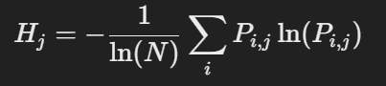

where where Pi,j is the normalized value of feature j, and N is the number of countries.

The weight for each feature jjj is then derived using the following formula: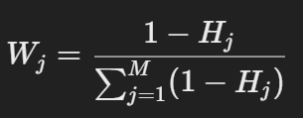

Where M is the number of features.

**3.TOPSIS Method**:  
Once the weights for the participation ratio and performance ratio are determined, we apply the TOPSIS method to calculate the overall importance score for each sport. The steps of the TOPSIS method are as follows:

**Step 1: Construct and Normalized Decision Matrix:**

We construct a decision matrix where each row represents a country and each column represents a specific sport. Each element xij in this matrix corresponds to the combined value of participation and performance ratios for country iii in sport jjj.

In order to eliminate the influence of different dimensions of indices, we standardize the matrix.The standardization formula is as follows:

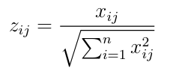

Use 𝑍𝑖𝑗 as the element to construct the normalized matrix 𝑍𝑛×𝑚 = [𝑍𝑖𝑗],𝑖 = 1,…,𝑛;𝑗 = 1,…,𝑚;

**Step 2: determine the best and worst solutions.**

For each column (representing a sport), we determine the best and worst solutions:

The **best solution** Z+ is the maximum value for each column

𝑍^+ = (𝑚𝑎𝑥𝑍𝑖1,𝑚𝑎𝑥𝑍𝑖2,…,𝑚𝑎𝑥𝑍𝑖𝑚)

The **worst solution** Z− is the minimum value for each column:

𝑍^− = (𝑚𝑖𝑛𝑍𝑖1,𝑚𝑖𝑛𝑍𝑖2,…,𝑚𝑖𝑛𝑍𝑖m)

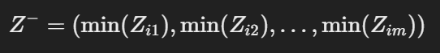

Calculate the distance between 𝑍+ and 𝐷𝑖 + and the distance between 𝑍− and 𝐷𝑖 − for each evaluation object. The calculation of the distance here needs to use the weight calculated by the EWM method in the previous section.

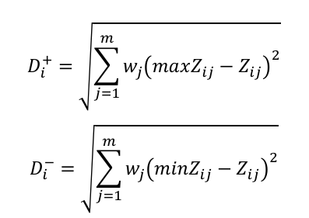

Step3：Calculate the Closeness Index：

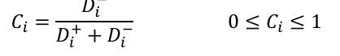

The closer Ci is to 1, the more important sport jjj is for country iii. A higher Civalue indicates that sport jjj is a more important sport for that country.

4. Results

To illustrate the application of our model, we focused on China (CHN) and input the normalized participation and performance ratios for each sport into the model. These ratios, derived from China’s historical athlete participation and medal achievements, were processed using the **EWM-TOPSIS Model** to calculate the Closeness Index for each sport. This index represents the proximity of each sport’s performance to the optimal solution, with higher values indicating greater importance.

As shown in the figure below, the Closeness Index for **table tennis(Closeness = 0.90)** is the highest among all sports, underscoring its paramount importance to China in the Olympic context. Following closely are badminton,trampolining, and diving, all of which have Closeness values exceeding **0.5**. These sports are also critical to China’s Olympic strategy, highlighting their significant role in the country’s athletic achievements.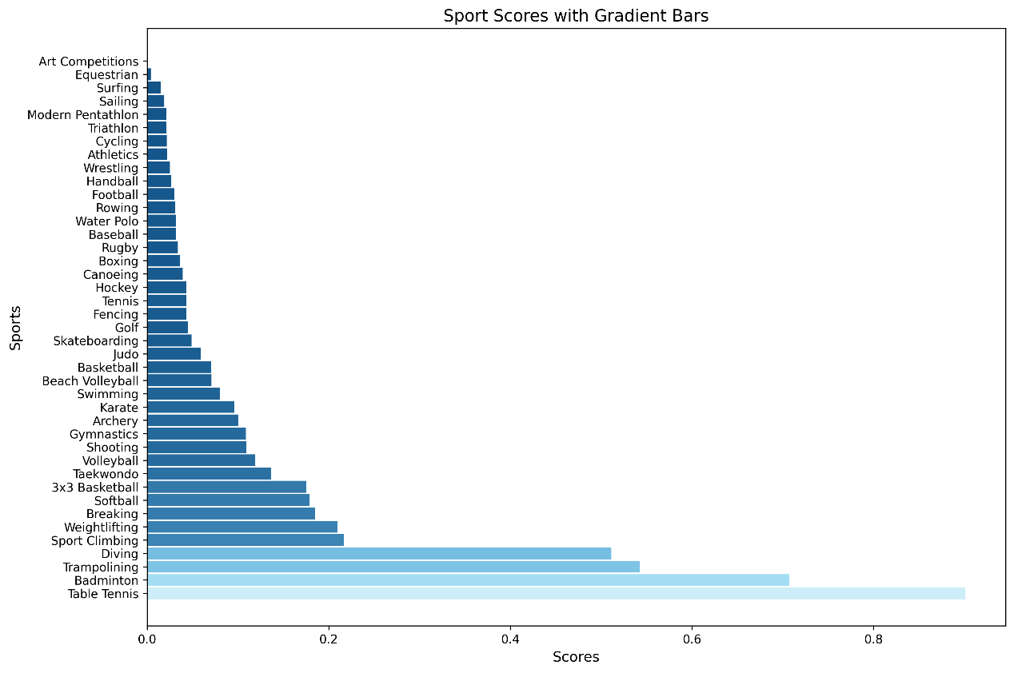

**Sport closeness for China with Gradient Bars**