**Homework #3 - Bonus Report**

Hoaxing Wang

#932359049

*Part 1 – 10 Homography matrices H(0)*

**10 points for two planes in each pair of images selected manually:**

Image 1:

|  |  |  |  |  |  |  |  |
| --- | --- | --- | --- | --- | --- | --- | --- |
| Plane 1 | | | | Plane 2 | | | |
| Image 1 | | Image 2 | | Image 1 | | Image 2 | |
| x | y | x | y | x | y | x | y |
| 510 | 89 | 519 | 90 | 241 | 7 | 275 | 16 |
| 388 | 150 | 405 | 153 | 305 | 26 | 339 | 33 |
| 308 | 188 | 329 | 190 | 350 | 40 | 387 | 45 |
| 257 | 214 | 283 | 215 | 218 | 53 | 253 | 62 |
| 220 | 230 | 248 | 233 | 263 | 65 | 297 | 72 |
| 701 | 462 | 702 | 464 | 139 | 61 | 178 | 70 |
| 520 | 425 | 528 | 428 | 174 | 138 | 214 | 146 |
| 402 | 396 | 415 | 396 | 118 | 148 | 159 | 154 |
| 318 | 381 | 339 | 381 | 147 | 16 | 187 | 26 |
| 378 | 618 | 392 | 617 | 111 | 99 | 154 | 106 |

Image 2:

|  |  |  |  |  |  |  |  |
| --- | --- | --- | --- | --- | --- | --- | --- |
| Plane 1 | | | | Plane 2 | | | |
| Image 1 | | Image 2 | | Image 1 | | Image 2 | |
| x | y | x | y | x | y | x | y |
| 113 | 399 | 117 | 399 | 606 | 439 | 623 | 440 |
| 151 | 392 | 155 | 391 | 684 | 377 | 706 | 376 |
| 201 | 387 | 207 | 386 | 424 | 363 | 448 | 362 |
| 203 | 366 | 211 | 365 | 340 | 329 | 362 | 329 |
| 127 | 361 | 137 | 360 | 593 | 309 | 619 | 308 |
| 87 | 358 | 99 | 357 | 426 | 276 | 455 | 275 |
| 41 | 359 | 52 | 358 | 617 | 243 | 647 | 242 |
| 11 | 389 | 16 | 388 | 215 | 459 | 231 | 459 |
| 113 | 410 | 114 | 410 | 476 | 392 | 496 | 391 |
| 119 | 378 | 125 | 377 | 293 | 226 | 323 | 225 |

Image 3:

|  |  |  |  |  |  |  |  |
| --- | --- | --- | --- | --- | --- | --- | --- |
| Plane 1 | | | | Plane 2 | | | |
| Image 1 | | Image 2 | | Image 1 | | Image 2 | |
| x | y | x | y | x | y | x | y |
| 166 | 170 | 161 | 169 | 83 | 169 | 78 | 170 |
| 193 | 156 | 186 | 157 | 59 | 156 | 52 | 157 |
| 165 | 217 | 160 | 216 | 37 | 144 | 28 | 146 |
| 157 | 281 | 152 | 280 | 84 | 216 | 79 | 217 |
| 201 | 187 | 194 | 186 | 60 | 199 | 53 | 202 |
| 219 | 145 | 211 | 144 | 38 | 184 | 28 | 187 |
| 230 | 192 | 220 | 192 | 82 | 255 | 77 | 257 |
| 204 | 246 | 196 | 245 | 61 | 247 | 53 | 250 |
| 184 | 304 | 177 | 304 | 41 | 231 | 32 | 234 |
| 238 | 187 | 229 | 186 | 45 | 279 | 35 | 283 |

Image 4:

|  |  |  |  |  |  |  |  |
| --- | --- | --- | --- | --- | --- | --- | --- |
| Plane 1 | | | | Plane 2 | | | |
| Image 1 | | Image 2 | | Image 1 | | Image 2 | |
| x | y | x | y | x | y | x | y |
| 11 | 7 | 7 | 7 | 158 | 204 | 162 | 203 |
| 36 | 10 | 32 | 10 | 150 | 182 | 153 | 180 |
| 14 | 16 | 10 | 16 | 108 | 199 | 112 | 198 |
| 32 | 18 | 29 | 18 | 235 | 162 | 236 | 160 |
| 14 | 39 | 11 | 39 | 184 | 170 | 186 | 168 |
| 32 | 40 | 29 | 40 | 106 | 215 | 111 | 215 |
| 41 | 64 | 37 | 64 | 277 | 159 | 276 | 157 |
| 22 | 40 | 18 | 40 | 198 | 150 | 196 | 149 |
| 42 | 81 | 38 | 81 | 123 | 158 | 124 | 157 |
| 22 | 60 | 19 | 60 | 20 | 182 | 23 | 183 |

Image 5:

|  |  |  |  |  |  |  |  |
| --- | --- | --- | --- | --- | --- | --- | --- |
| Plane 1 | | | | Plane 2 | | | |
| Image 1 | | Image 2 | | Image 1 | | Image 2 | |
| x | y | x | y | x | y | x | y |
| 321 | 75 | 287 | 75 | 192 | 199 | 185 | 196 |
| 288 | 78 | 255 | 79 | 208 | 202 | 202 | 200 |
| 347 | 72 | 312 | 72 | 224 | 195 | 216 | 194 |
| 387 | 68 | 351 | 68 | 205 | 154 | 199 | 153 |
| 323 | 36 | 290 | 36 | 205 | 187 | 199 | 186 |
| 171 | 48 | 137 | 48 | 165 | 183 | 157 | 181 |
| 381 | 159 | 347 | 159 | 208 | 119 | 203 | 118 |
| 408 | 192 | 374 | 192 | 193 | 142 | 189 | 139 |
| 425 | 121 | 390 | 121 | 246 | 160 | 240 | 159 |
| 293 | 96 | 260 | 96 | 205 | 89 | 203 | 86 |

**10 Homography matrices:**

Image 1 – Plane 1: Image 1 – Plane 2:

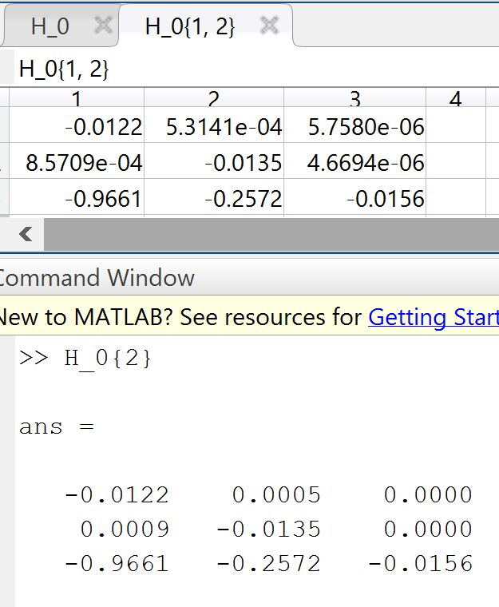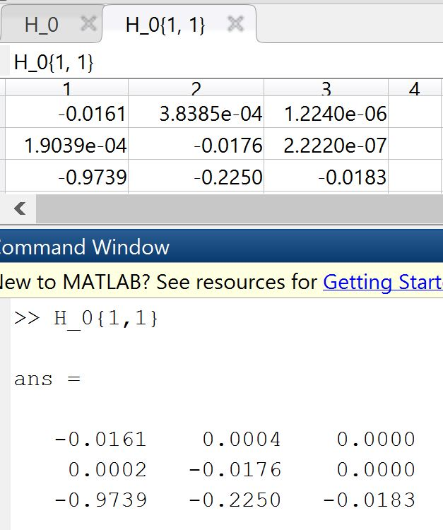

Image 2 – Plane 1: Image 2 – Plane 2:

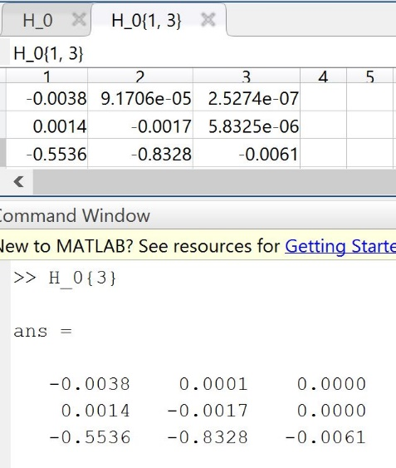 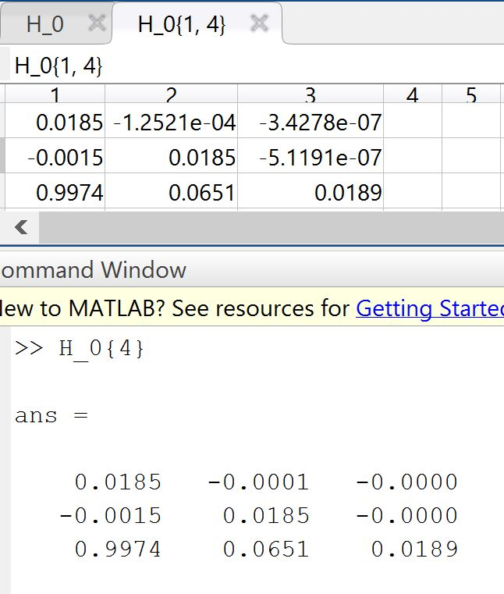

Image 3 – Plane 1: Image 3 – Plane 2:

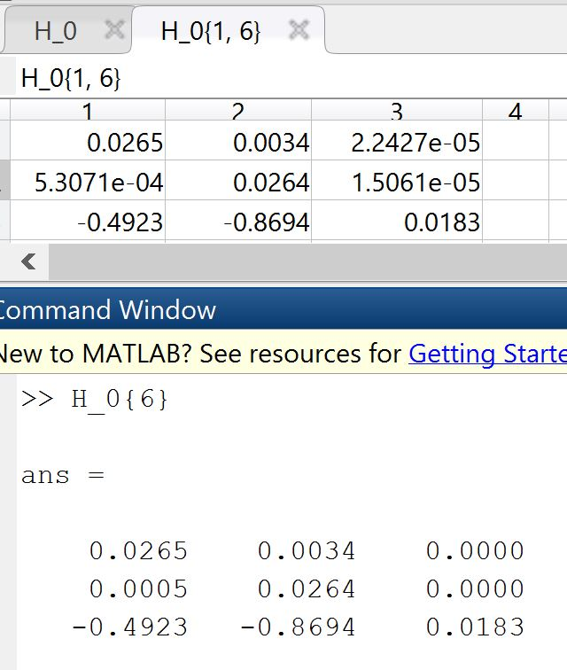

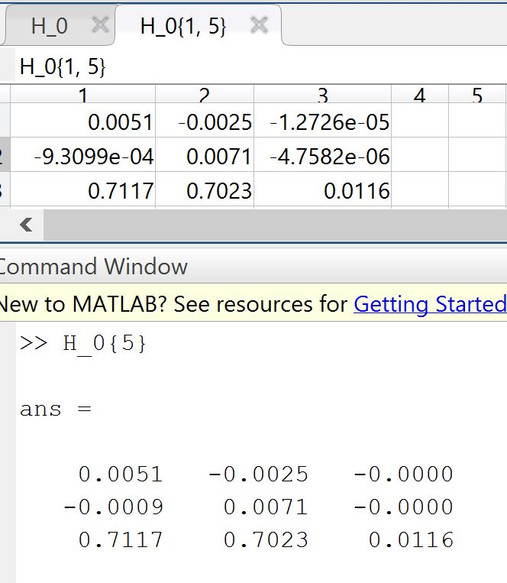

Image 4 – Plane 1: Image 4 – Plane 2:

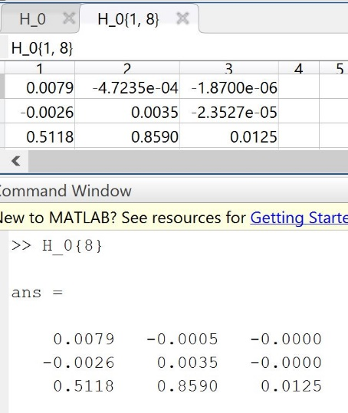

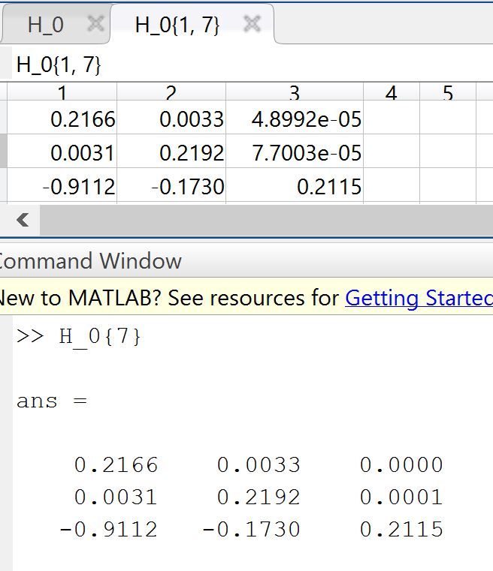

Image 5 – Plane 1: Image 5 – Plane 2:

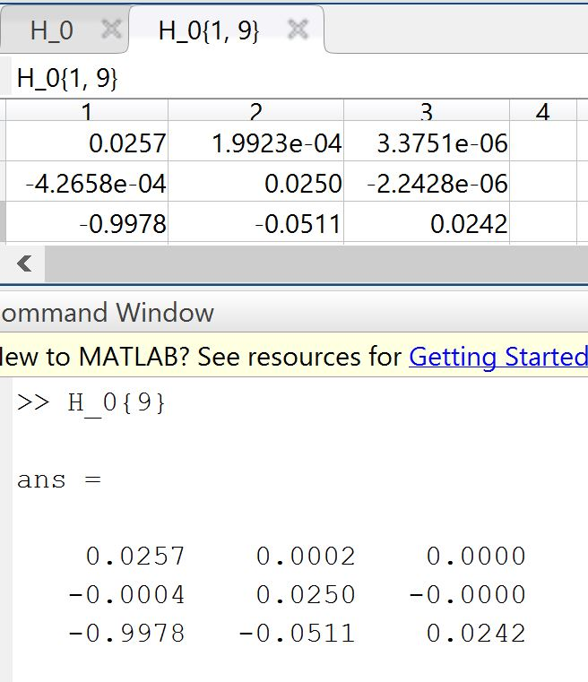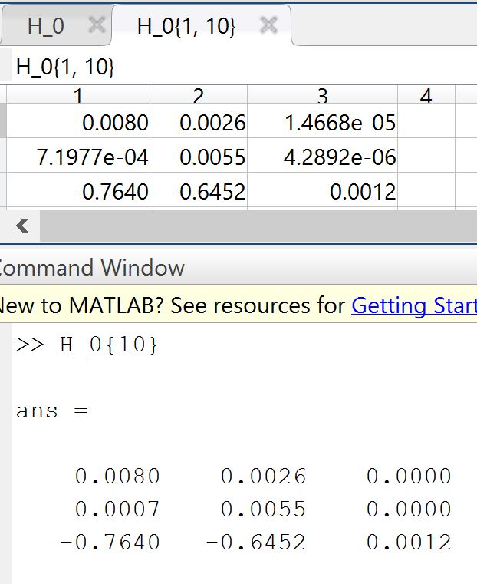

*Part 2 – 10 Homography Matrices H*

Image 1 – Plane 1: Image 1 – Plane 2:

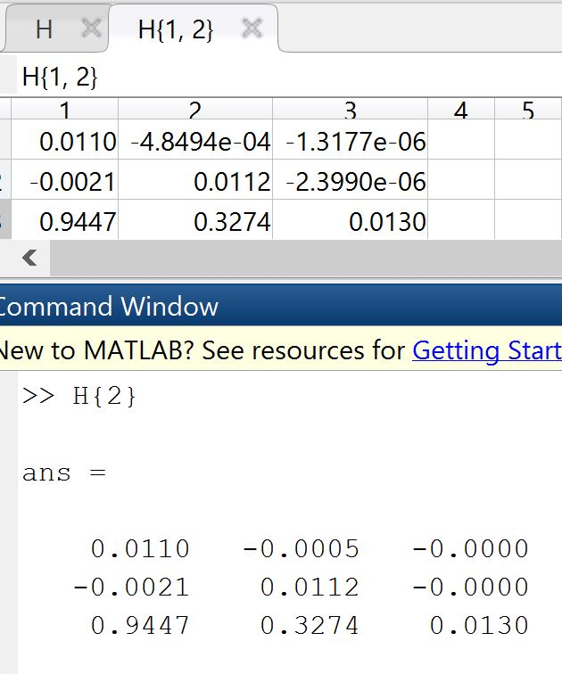

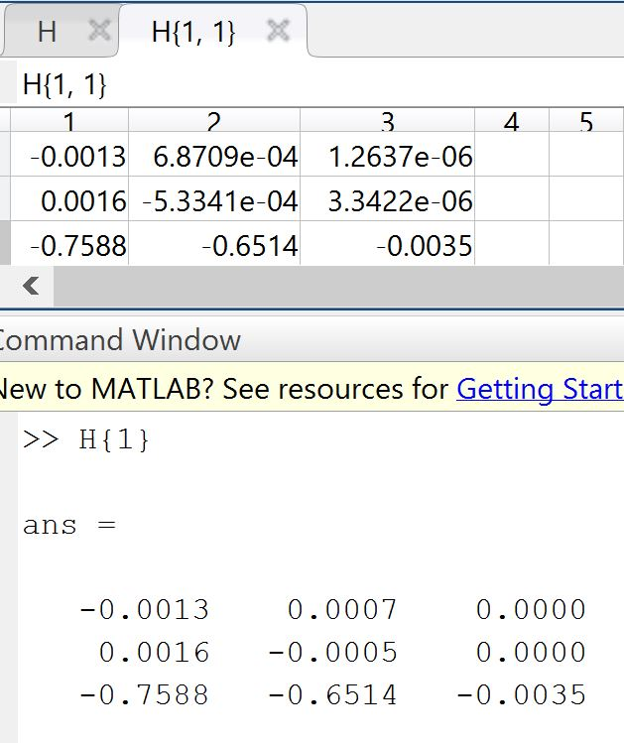

Image 2 – Plane 1: Image 2 – Plane 2:

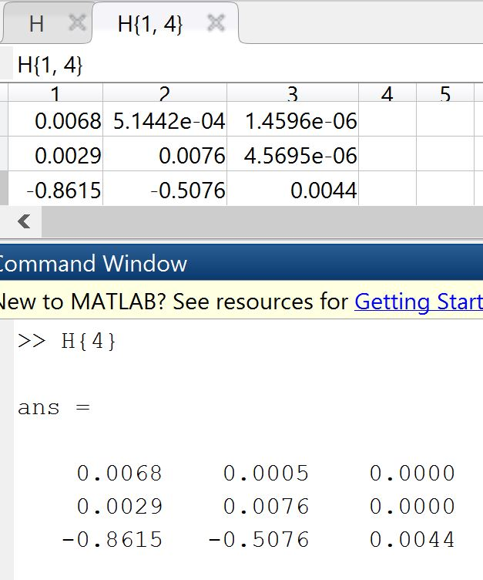

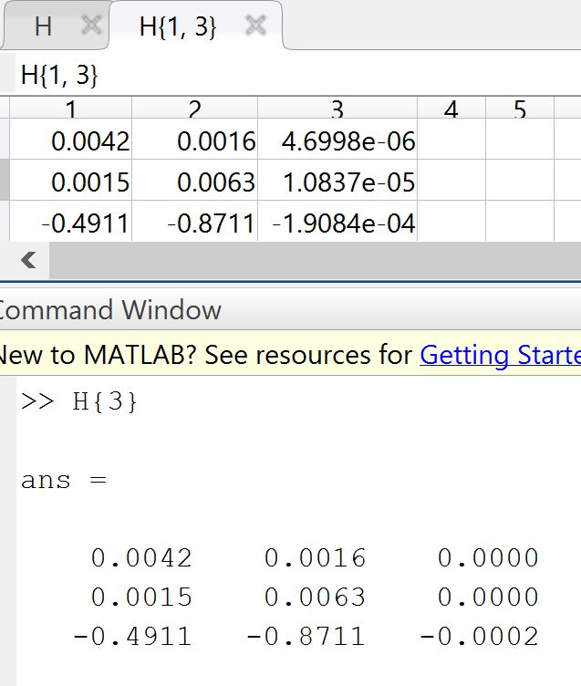

Image 3 – Plane 1: Image 3 – Plane 2:

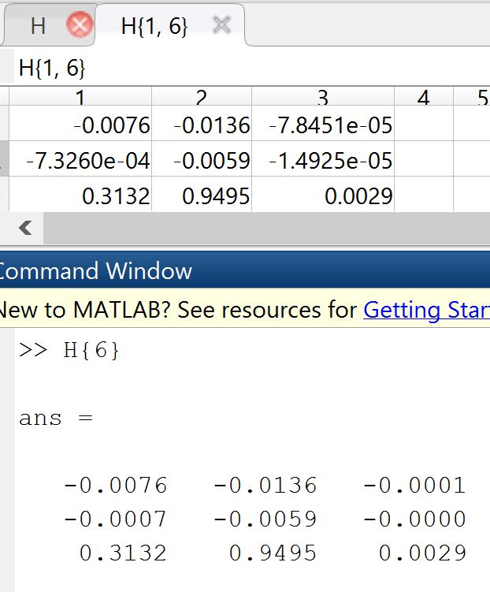

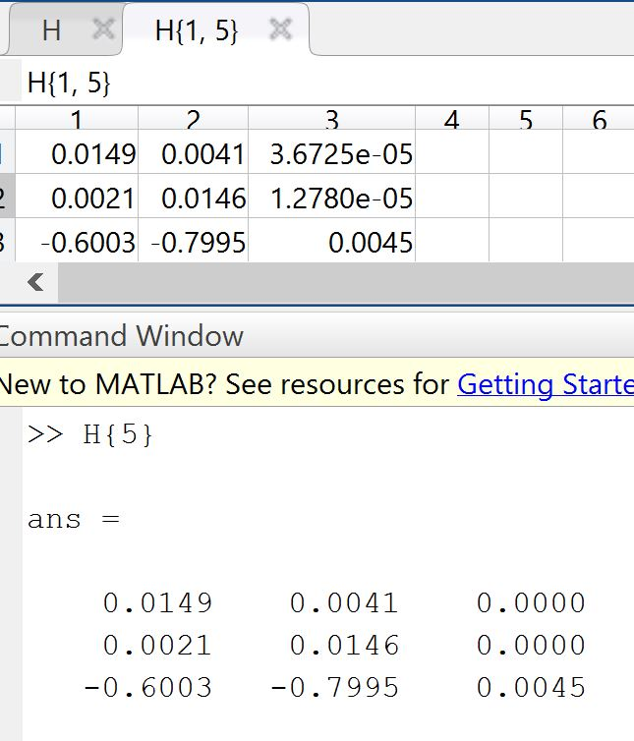

Image 4 – Plane 1: Image 4 – Plane 2:

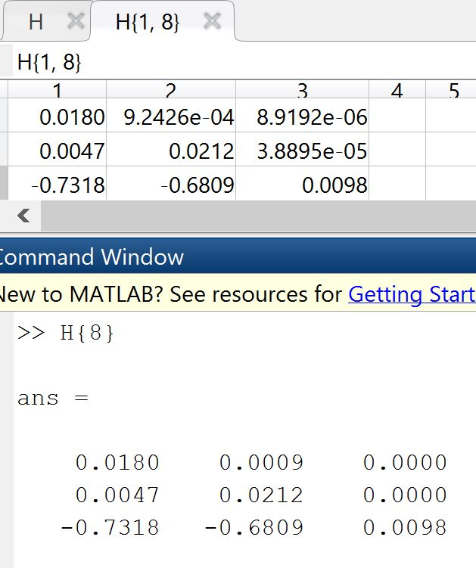

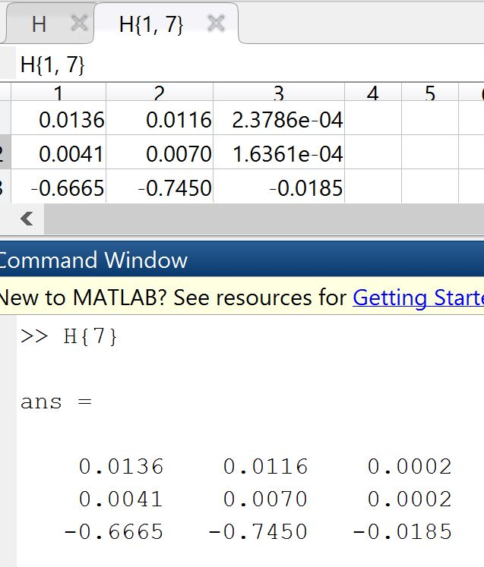

Image 5 – Plane 1: Image 5 – Plane 2:

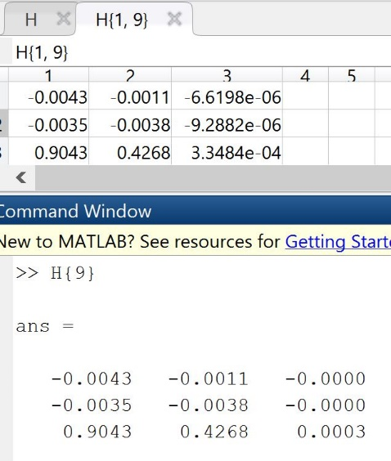

*Part 3 – New Many-to-many Matching Formulation:*

Where is the similarity vector calculated in the Homework 3.

where is the fundamental matrix calculated in the Homework 3.

and is the SURF points in image 1 and image 2.

and

Where and are the homography matrices calculated from previous steps.

and are the each two of SURF points in image 1 and image 2.

and

Where and

is the new binary vector indicating matches.

*Part 4 – New Zs and Comparison:*

The new Zs are still vectors, and they are impossible to print here in the report. However, the number of matchings chould be shown here:

Image 1: 544 Image 2: 169 image 3: 594 image 4: 39 Image 5: 7394

To compare with the old z vector, they both detect some same matches. The indices of these matchings will be shown here:

Image 1: 202 6257 7154 7395 9354

Image 2: 9243

Image 3: 89 122 740 1411 1523 1536 1711 1912 6022 6225 7123 9596

Image 4: 7396 9981

Image 5: 37 59 65 80 186 360 606 610 667 705 874 894 1037 1059 1065 1080 1109 1116 1121 1278 1315 1323 1353 1376 1378 1515 1523 1553 1576 1578 1642 1812 1887 1907 1918 2011 2112 2187 2223 2433 2440 2853 2869 2876 2981 3000 3381 3400 3414 3452 3697 3883 3928 4097 4262 4291 4515 4523 4578 4787 4928 5162 5191 5467 5489 5653 5676 5724 5759 5765 5827 5837 5859 6028 6245 6246 6281 6300 6335 6372 6558 6587 6590 6685 6709 6716 6870 7103 7138 7168 7488 7675 8034 8097 8478 8531 8579 8585 8594 8643 8713 9052 9067 9089 9114 9184 9370 9484 9503 9525 9527 9637 9659 9665 9979

*Part 5 – Printout of Software:*

Matlab