GlassFish v3 Installation

Installing SGE

1.
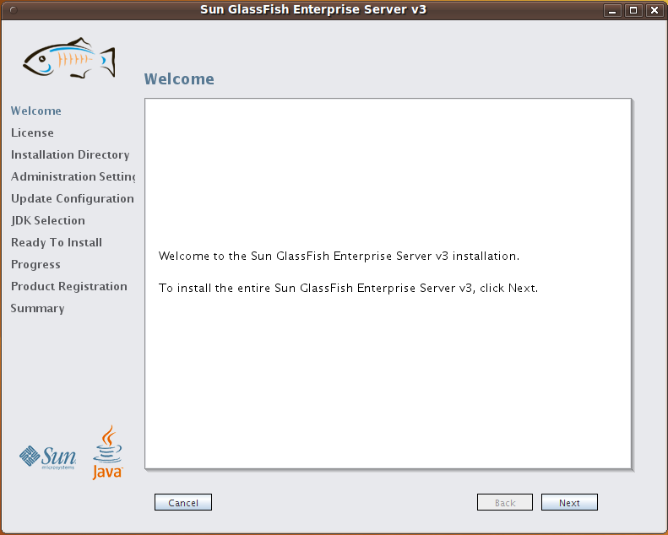

2.
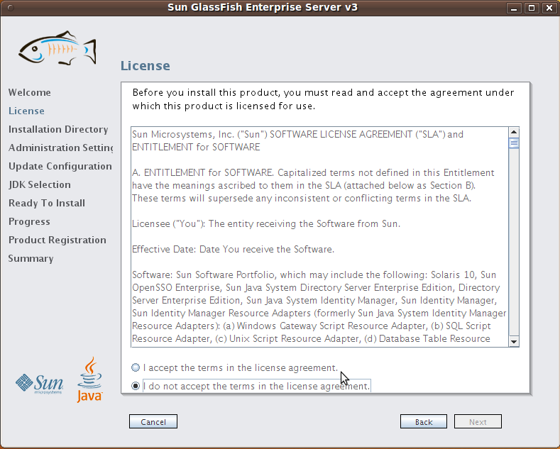
Not accepting license aggreement: “Next” grayed out
Agree: “Next” is available

3.
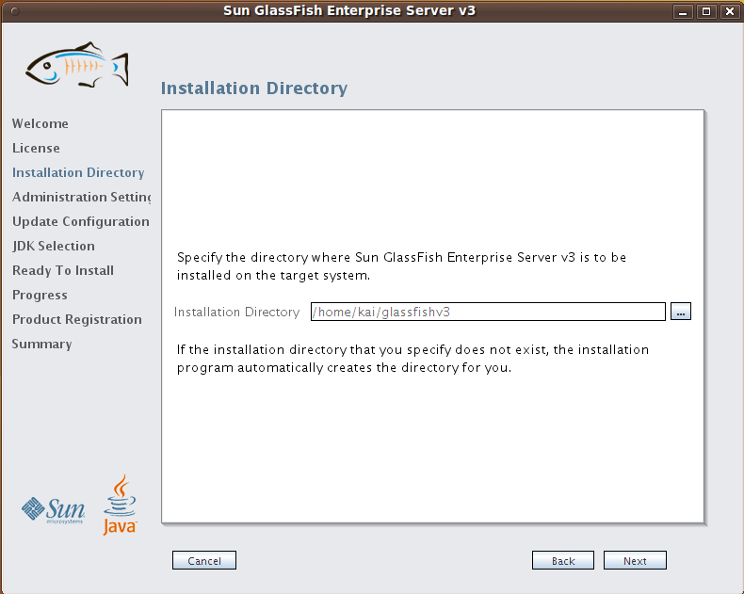
Input: Installation Directory (above - default)

4.
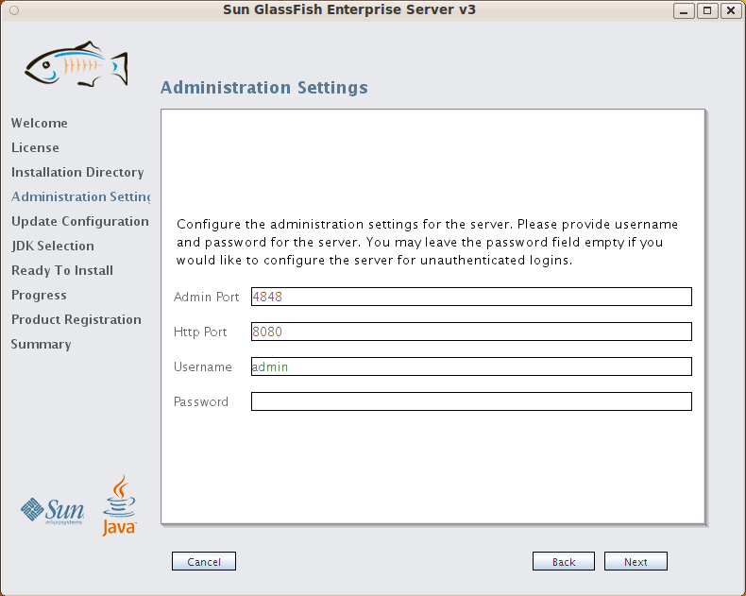Input: admin port, http port, username, password textfield (above all default)

5. Configuring Update Tool
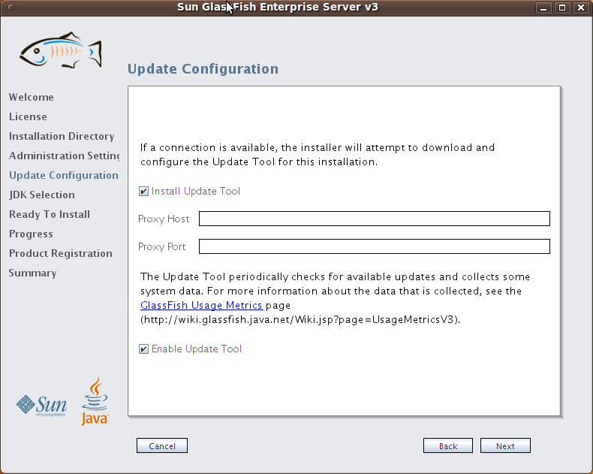

6. JDK Selection
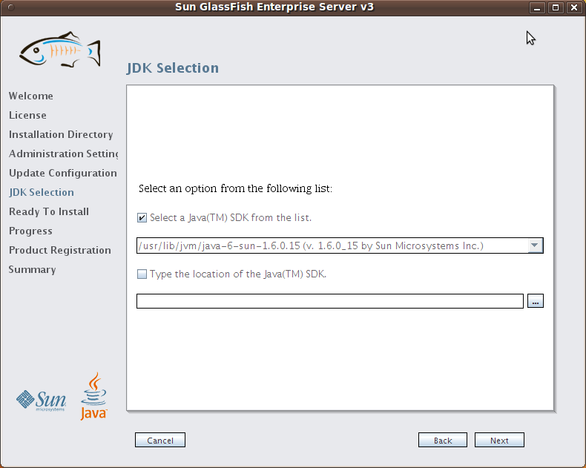
Selecting JDK Selection, above show default setting.

7.
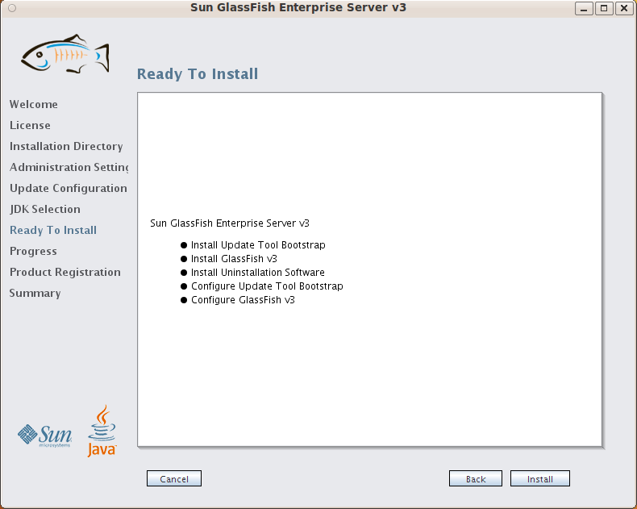

- During Installation
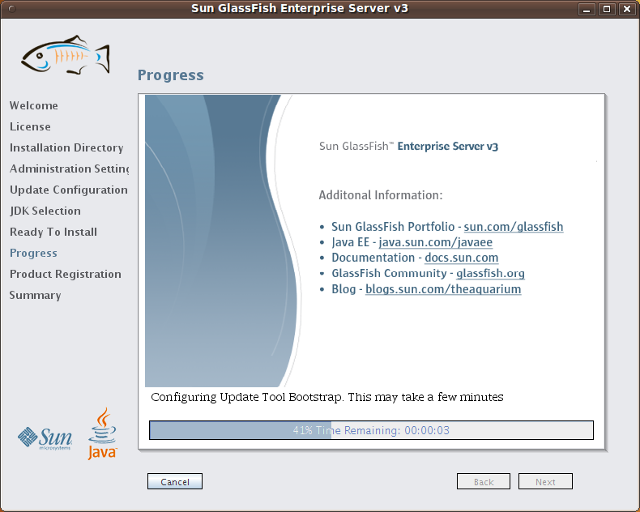

- Product Registration

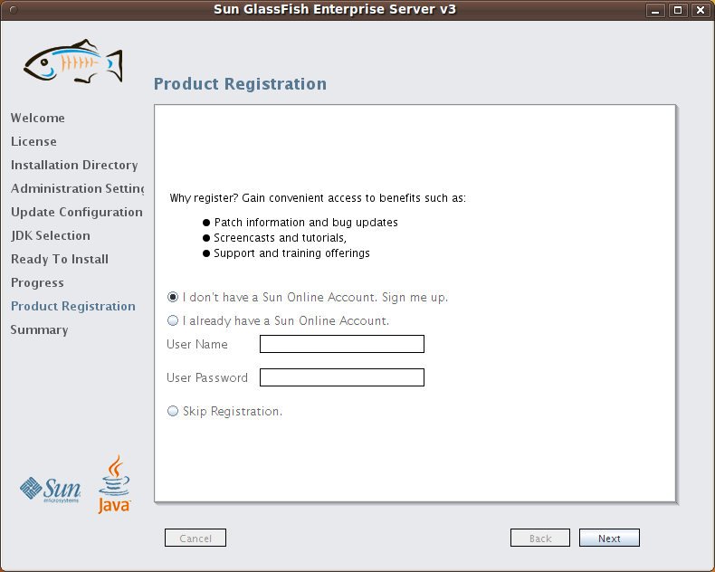

- Summary
