Cognizant - UpGrad Training Program
-------------------------------------------------------------------
WEEKLY CODING SUBMISSION
-------------------------------------------------------------------
Name : MD Kaif Khan
Week : Week 7
Batch : B1_Python
Trainer : Kunal

Question – 1
Program.cs
using Microsoft.Extensions.DependencyInjection;
using Microsoft.Extensions.Hosting;

// Create Host (recommended for DI in console apps)
var host = Host.CreateDefaultBuilder(args)
.ConfigureServices((context, services) =>
{
// Register Notification Strategies
services.AddScoped<INotification, EmailNotification>();
services.AddScoped<INotification, SmsNotification>();
services.AddScoped<INotification, PushNotification>();

// Register Factory & Service
services.AddSingleton<NotificationFactory>();
services.AddScoped<NotificationService>();
})
.Build();

// Resolve service
var notificationService = host.Services.GetRequiredService<NotificationService>();

// Sample Bulk Requests
var requests = new List<NotificationRequest>
{
new NotificationRequest { Type = "Email", Recipient = "user1@example.com", Message = "Hello Email" },
new NotificationRequest { Type = "SMS", Recipient = "9952614946", Message = "Hello SMS" },
new NotificationRequest { Type = "Push", Recipient = "Device123", Message = "Hello Push" }
};

// Execute
await notificationService.SendBulkAsync(requests);

Console.WriteLine("Done...");

EmailNotification.cs
public class EmailNotification : INotification
{
public string Type => "Email";

public async Task SendAsync(NotificationRequest request)
{
await Task.Delay(200);
Console.WriteLine($"Email sent to {request.Recipient}");
}
}

PushNotification.cs
public class PushNotification : INotification
{
public string Type => "Push";

public async Task SendAsync(NotificationRequest request)
{
await Task.Delay(200);
Console.WriteLine("Push sent");
}
}

SmsNotification.cs
public class SmsNotification : INotification
{
public string Type => "SMS";

public async Task SendAsync(NotificationRequest request)
{
await Task.Delay(200);
Console.WriteLine($"SMS sent to {request.Recipient}");
}
}

INotification.cs
public interface INotification
{
Task SendAsync(NotificationRequest request);
string Type { get; }
}

NotificationFactory.cs
public class NotificationFactory
{
private readonly Dictionary<string, INotification> _map;

public NotificationFactory(IEnumerable<INotification> notifications)
{
_map = notifications.ToDictionary(x => x.Type, x => x);
}

public INotification Get(string type)
{
if (!_map.ContainsKey(type))
throw new Exception("Invalid type");

return _map[type];
}
}

NotificationRequest.cs
public class NotificationRequest
{
public string Type { get; set; }
public string Message { get; set; }
public string Recipient { get; set; }
}

NotificationService.cs
public class NotificationService
{
private readonly NotificationFactory _factory;

public NotificationService(NotificationFactory factory)
{
_factory = factory;
}

public async Task SendBulkAsync(List<NotificationRequest> requests)
{
var tasks = requests.Select(async req =>
{
var strategy = _factory.Get(req.Type);

try
{
await strategy.SendAsync(req);
}
catch
{
try
{
await strategy.SendAsync(req);
}
catch (Exception ex)
{
Console.WriteLine($"FAILED: {req.Type} - {ex.Message}");
}
}
});

await Task.WhenAll(tasks);
}
}

Program.cs
using Microsoft.Extensions.DependencyInjection;
using Microsoft.Extensions.Hosting;

// Create Host (recommended for DI in console apps)
var host = Host.CreateDefaultBuilder(args)
.ConfigureServices((context, services) =>
{
// Register Notification Strategies
services.AddScoped<INotification, EmailNotification>();
services.AddScoped<INotification, SmsNotification>();
services.AddScoped<INotification, PushNotification>();

// Register Factory & Service
services.AddSingleton<NotificationFactory>();
services.AddScoped<NotificationService>();
})
.Build();

// Resolve service
var notificationService = host.Services.GetRequiredService<NotificationService>();

// Sample Bulk Requests
var requests = new List<NotificationRequest>
{
new NotificationRequest { Type = "Email", Recipient = "user1@example.com", Message = "Hello Email" },
new NotificationRequest { Type = "SMS", Recipient = "9952614946", Message = "Hello SMS" },
new NotificationRequest { Type = "Push", Recipient = "Device123", Message = "Hello Push" }
};

// Execute
await notificationService.SendBulkAsync(requests);

Console.WriteLine("Done...");

Question – 2
CacheItem.cs
public class CacheItem
{
public object Value { get; set; }
public DateTime Expiry { get; set; }
}

MemoryCacheService.cs
using System.Collections.Concurrent;

public class MemoryCacheService
{
private readonly ConcurrentDictionary<string, CacheItem> _cache = new();

public void Set(string key, object value, TimeSpan expiry)
{
_cache[key] = new CacheItem
{
Value = value,
Expiry = DateTime.UtcNow.Add(expiry)
};
}

public object Get(string key)
{
if (_cache.TryGetValue(key, out var item))
{
if (item.Expiry > DateTime.UtcNow)
return item.Value;

_cache.TryRemove(key, out _);
}

return null;
}
}

Program.cs
var cache = new MemoryCacheService();

cache.Set("name", "Kaif", TimeSpan.FromSeconds(5));

Console.WriteLine("name : " + cache.Get("name"));
Console.WriteLine("Value will be vanished after 6 seconds");
await Task.Delay(6000);

Console.WriteLine("name : " + cache.Get("name")); // null after expiry

Question – 3
Program.cs
using Microsoft.AspNetCore.Authentication.JwtBearer;
using Microsoft.IdentityModel.Tokens;
using System.Text;

var builder = WebApplication.CreateBuilder(args);

// Register JwtService
builder.Services.AddSingleton<JwtService>();

// Add authentication
builder.Services.AddAuthentication(JwtBearerDefaults.AuthenticationScheme)
.AddJwtBearer(options =>
{
options.TokenValidationParameters = new TokenValidationParameters
{
ValidateIssuer = false,
ValidateAudience = false,
ValidateLifetime = true,
ValidateIssuerSigningKey = true,
IssuerSigningKey = new SymmetricSecurityKey(
Encoding.UTF8.GetBytes("THIS_IS_A_VERY_SECURE_SECRET_KEY_12345"))
};
});

builder.Services.AddAuthorization();

var app = builder.Build();

app.UseAuthentication();
app.UseAuthorization();

// Public endpoint to get token
app.MapPost("/login", (string userId, string role, JwtService jwtService) =>
{
var token = jwtService.GenerateToken(userId, role);
return Results.Ok(new { Token = token });
});

// Protected endpoint
app.MapGet("/secret", () => "This is protected")
.RequireAuthorization();

app.Run();

JwtService.cs
using System.IdentityModel.Tokens.Jwt;
using System.Security.Claims;
using System.Text;
using Microsoft.IdentityModel.Tokens;

public class JwtService
{
private const string SecretKey = "THIS_IS_A_VERY_SECURE_SECRET_KEY_12345";

public string GenerateToken(string userId, string role)
{
var claims = new[]
{
new Claim(ClaimTypes.NameIdentifier, userId),
new Claim(ClaimTypes.Role, role)
};

var key = new SymmetricSecurityKey(Encoding.UTF8.GetBytes(SecretKey));
var creds = new SigningCredentials(key, SecurityAlgorithms.HmacSha256);

var token = new JwtSecurityToken(
claims: claims,
expires: DateTime.UtcNow.AddMinutes(15),
signingCredentials: creds
);

return new JwtSecurityTokenHandler().WriteToken(token);
}
}

Question – 4
RateLimiter.cs
using System.Collections.Concurrent;

public class RateLimiter
{
private readonly ConcurrentDictionary<string, List<DateTime>> _store = new();

public bool Allow(string key)
{
var now = DateTime.UtcNow;
var list = _store.GetOrAdd(key, _ => new List<DateTime>());

lock (list)
{
list.RemoveAll(x => x < now.AddSeconds(-10));

if (list.Count >= 5)
return false;

list.Add(now);
return true;
}
}
}

Program.cs
var limiter = new RateLimiter();

for (int i = 0; i < 10; i++)
{
Console.WriteLine(limiter.Allow("user1"));
}

Question – 5
DeadlockDemo.cs
public class DeadlockDemo
{
private readonly object lock1 = new();
private readonly object lock2 = new();

public void CreateDeadlock()
{
Task.Run(() =>
{
lock (lock1)
{
Console.WriteLine("Thread 1 acquired lock1");
Thread.Sleep(500);

Console.WriteLine("Thread 1 waiting for lock2...");
lock (lock2)
{
Console.WriteLine("Thread 1 acquired lock2");
}
}
});

Task.Run(() =>
{
lock (lock2)
{
Console.WriteLine("Thread 2 acquired lock2");
Thread.Sleep(500);

Console.WriteLine("Thread 2 waiting for lock1...");
lock (lock1)
{
Console.WriteLine("Thread 2 acquired lock1");
}
}
});
}

public void PreventDeadlock()
{
Task.Run(() => SafeMethod());
Task.Run(() => SafeMethod());

Thread.Sleep(1000);
}

private void SafeMethod()
{
lock (lock1)
{
Console.WriteLine("Safe: acquired lock1");

lock (lock2)
{
Console.WriteLine("Safe: acquired lock2");
}
}
}
public async Task TimeoutSolution()
{
await Task.Run(() =>
{
bool gotLock1 = false;
bool gotLock2 = false;

try
{
gotLock1 = Monitor.TryEnter(lock1, 1000);

if (!gotLock1)
{
Console.WriteLine("Timeout acquiring lock1");
return;
}

Console.WriteLine("Acquired lock1");

Thread.Sleep(300);

gotLock2 = Monitor.TryEnter(lock2, 1000);

if (!gotLock2)
{
Console.WriteLine("Timeout acquiring lock2 → avoiding deadlock");
return;
}

Console.WriteLine("Acquired lock2");
}
finally
{
if (gotLock2) Monitor.Exit(lock2);
if (gotLock1) Monitor.Exit(lock1);
}
});
}
}

Program.cs
var demo = new DeadlockDemo();

Console.WriteLine("1. Creating Deadlock...");
demo.CreateDeadlock();

await Task.Delay(2000);

Console.WriteLine("\n2. Running Safe Version...");
demo.PreventDeadlock();

Console.WriteLine("\n3. Running Timeout Version...");
await demo.TimeoutSolution();

Question – 6
MyHashMap.cs
public class MyHashMap<K, V>
{
private List<(K key, V value)>[] buckets = new List<(K, V)>[16];

private int GetIndex(K key)
=> Math.Abs(key.GetHashCode()) % buckets.Length;

public void Add(K key, V value)
{
int index = GetIndex(key);

buckets[index] ??= new List<(K, V)>();
buckets[index].Add((key, value));
}

public V Get(K key)
{
int index = GetIndex(key);

if (buckets[index] != null)
{
foreach (var item in buckets[index])
if (item.key.Equals(key))
return item.value;
}

return default;
}
}

Program.cs
var map = new MyHashMap<string, int>();

map.Add("a", 1);
map.Add("b", 2);

Console.WriteLine(map.Get("b"));

PROJECT – 1

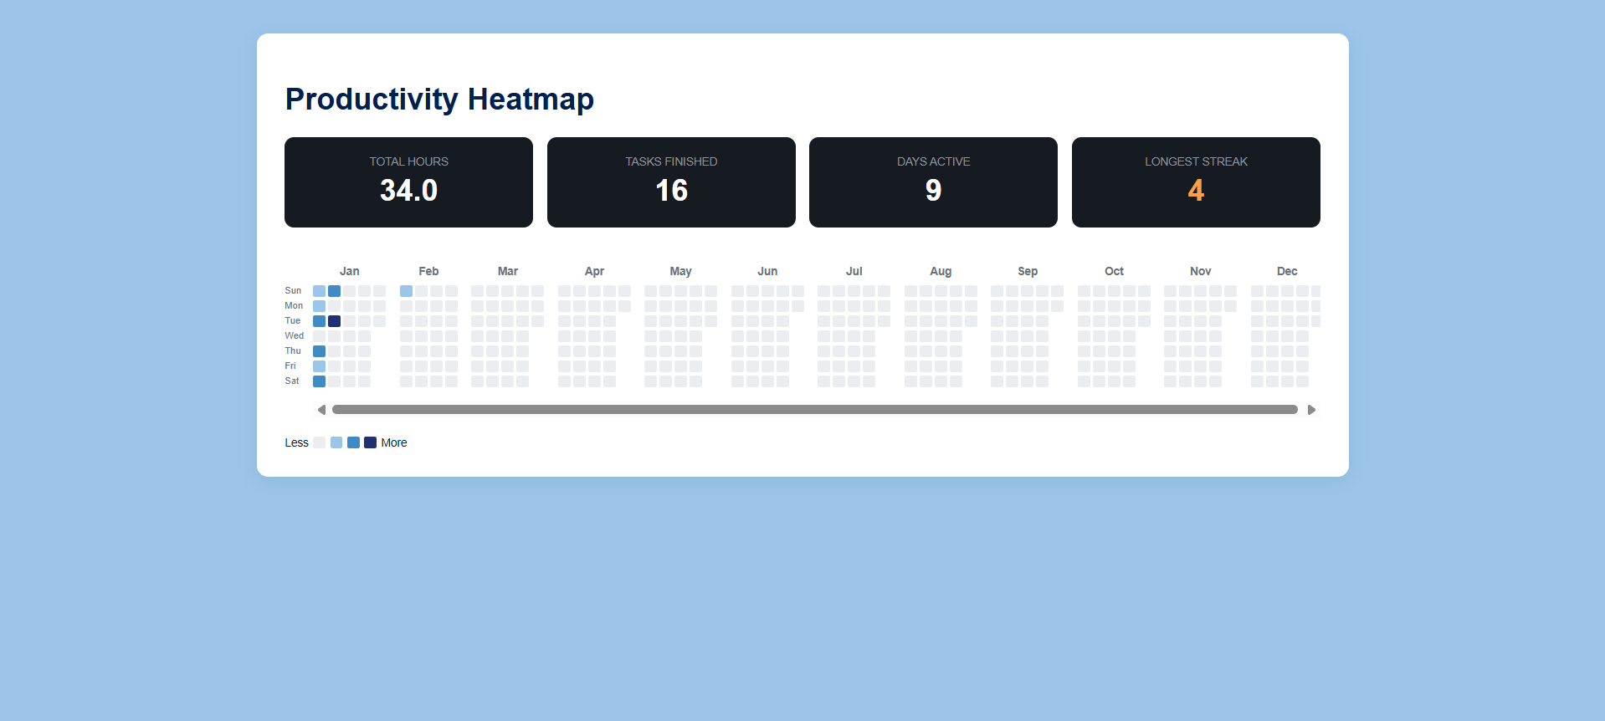

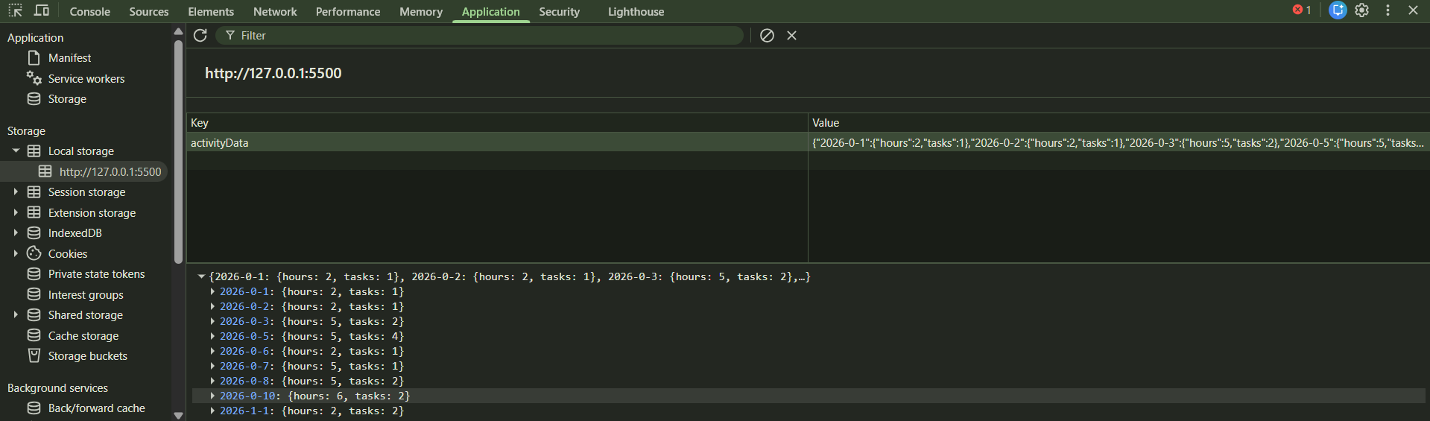

PROJECT – 2

