CYBERSECURITY UMBRELLA
DevOps Internship — Project Report

PROJECT REPORT
Full-Stack Web Application Deployment on AWS EC2
React.js • ASP.NET Web API • PostgreSQL • IIS • AWS EC2 • Swagger

Submitted By | Kaif Dudhwala
Designation | DevOps Intern
Organization | CyberSecurity Umbrella
Date of Submission | 21 August 2026

1. Objective

The objective of this project is to design, deploy, and host a fully functional full-stack web application on an AWS EC2 instance. The deployment demonstrates an end-to-end production-style workflow in which a React.js frontend, an ASP.NET (.NET) Web API backend, and a PostgreSQL database are integrated and served through Internet Information Services (IIS) on a single cloud-hosted virtual machine, with the API layer independently verifiable through Swagger.

2. Technology Stack
Layer | Technology
Frontend | React.js
Backend | ASP.NET / .NET Web API
Database | PostgreSQL
Web Server | Internet Information Services (IIS)
Cloud Platform | AWS EC2
API Testing / Documentation | Swagger

3. Architecture Overview

The application follows a standard three-tier client-server architecture, with all tiers hosted on a single AWS EC2 instance and IIS acting as the entry point and reverse proxy for both the static frontend and the backend API.

User → React Frontend (IIS) → .NET Web API → PostgreSQL Database

All components — the IIS-hosted frontend, the Kestrel/IIS-hosted .NET Web API, and the PostgreSQL server — reside on EC2 instance 13.202.3.15 and communicate over the ports.

4. Frontend Deployment (React.js on IIS)

4.1 Steps Performed
- Developed the React.js application and verified it locally before deployment.
- Generated a production build using "npm run build", producing static, optimized HTML/CSS/JS assets.
- Updated the frontend environment configuration (.env / config file) so all API calls point to the deployed backend at http://13.202.3.15:5001/api instead of localhost.
- Copied the contents of the build folder to the IIS web root directory on the EC2 instance.
- Installed the IIS URL Rewrite module and added rewrite rules so that client-side routes resolve correctly on page refresh, instead of returning IIS 404 errors.
- Created and configured a dedicated IIS site/application bound to port 80, pointing to the deployed build folder.
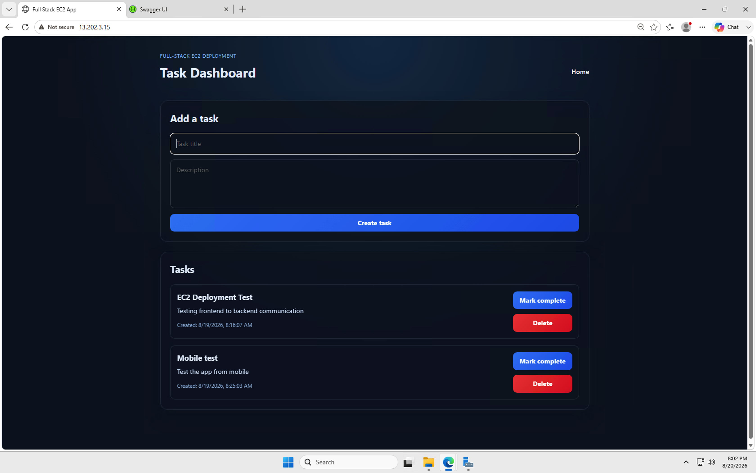
- Verified that all frontend routes and pages load correctly via the public IP after deployment.

FiG 1: Running React application

5. Backend Deployment (.NET Web API)

5.1 Steps Performed
- Published the ASP.NET / .NET Web API project in Release configuration using "dotnet publish".
- Copied the published output to a dedicated folder on the EC2 instance.
- Installed the .NET Hosting Bundle on the EC2 instance so IIS could host the ASP.NET Core application via the ASP.NET Core Module (ANCM).
- Configured the connection string and environment-specific settings in appsettings.Production.json, including the PostgreSQL connection details.
- Set the ASPNETCORE_ENVIRONMENT variable to "Production" for the deployed application pool.
- Created a separate IIS site/application bound to port 5001 for the backend API, with its own Application Pool set to "No Managed Code" (required for .NET Core).
- Confirmed the API responded correctly when accessed from the EC2 public IP rather than only from localhost.

6. Database Setup (PostgreSQL)

6.1 Steps Performed
- Installed PostgreSQL on the EC2 instance and configured it to accept connections on the default port 5432.
- Created a dedicated application database and database user (myapp_user) with the required privileges.
- Updated postgresql.conf and pg_hba.conf to allow connections from the application (and, where required, remote administration access).
- Configured the connection string in the .NET Web API's appsettings.Production.json to point to the PostgreSQL instance.
- Ran Entity Framework Core migrations to build the database schema.
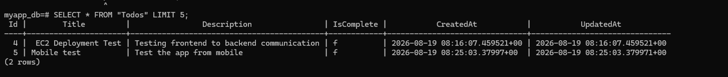
- Verified successful connectivity between the backend API and PostgreSQL, and confirmed that Create, Read, Update, and Delete (CRUD) operations work as expected.
Fig 2: Postgresql/ Database connection

7. IIS Configuration

7.1 Sites and Bindings
- Frontend site: bound to port 80, serving the React production build.
- Backend site: bound to port 5001, hosting the .NET Web API via the ASP.NET Core Module.
- Swagger UI exposed on port 5001, accessible at /swagger/index.html on the backend service.

7.2 Firewall / Security Group Rules

The following inbound rules were added to the EC2 instance's Security Group to allow external access:
- Port 80 (HTTP) — Frontend access
- Port 5001 (HTTP) — Backend API access
- Port 5001 (HTTP) — Swagger UI access
- Port 5432 (PostgreSQL) — restricted to application/internal access only
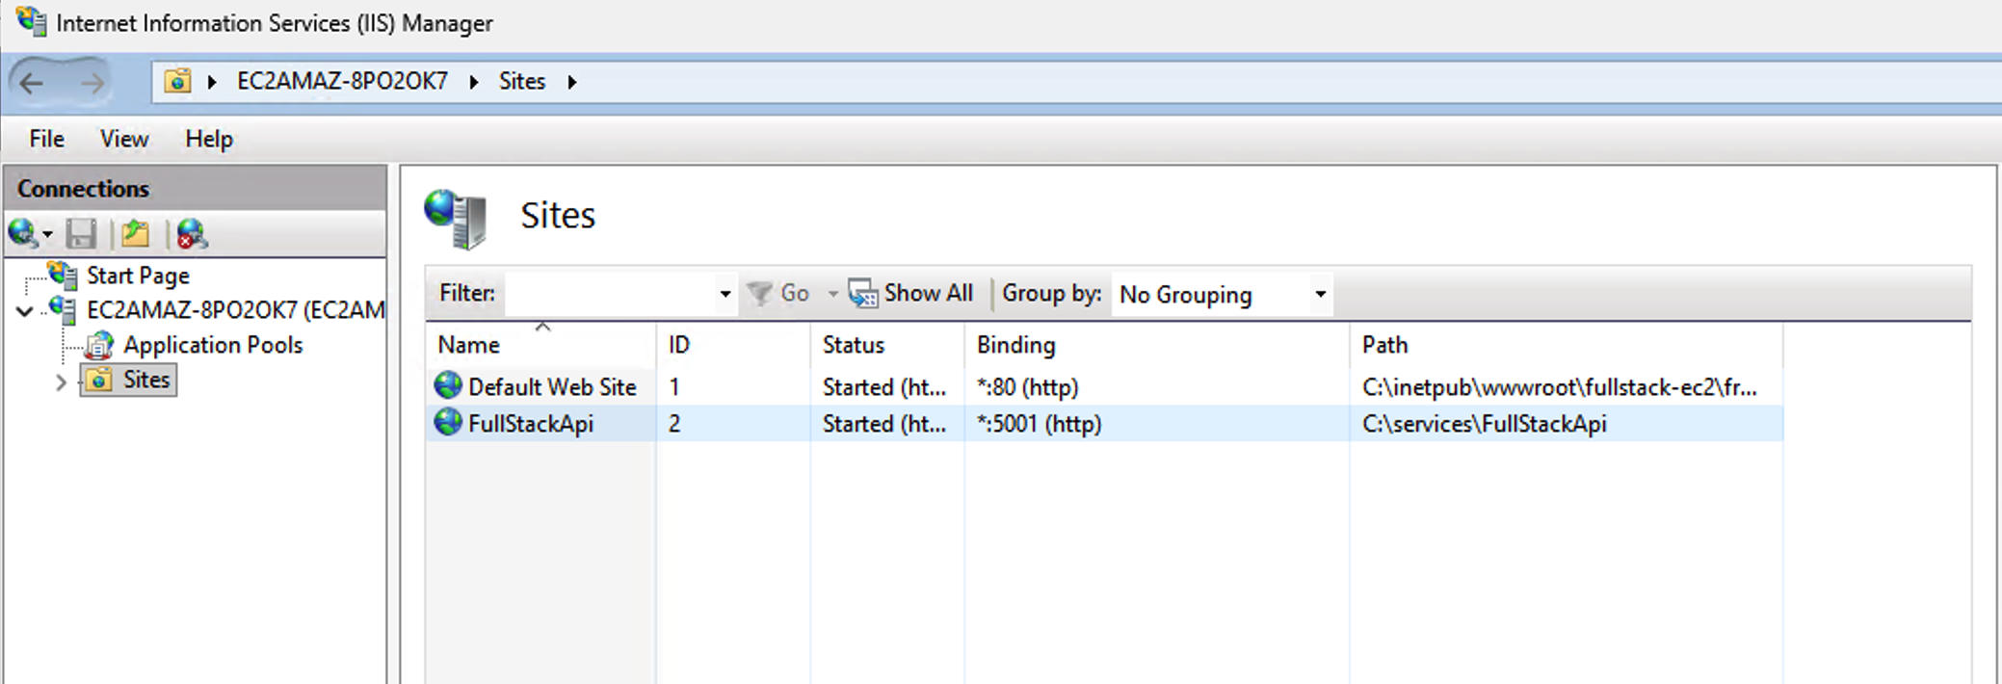
- Port 3389 (RDP) — restricted to the administrator's IP for remote management

fig 3: IIS configuration
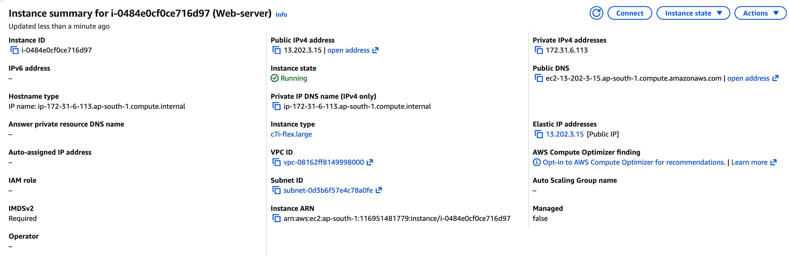
Fig 4: ec2 instance running

8. API Verification via Swagger

The deployed .NET Web API was verified using Swagger UI, accessible at:

http://13.202.3.15:5001/swagger/index.html

All major endpoints were tested directly through Swagger to confirm correct behavior:
- GET — Retrieved existing records and confirmed a 200 OK response with the expected JSON payload.
- POST — Created new records and confirmed a 201 Created response with the new resource returned.
- PUT / PATCH — Updated existing records and confirmed a 200 OK / 204 No Content response as applicable.
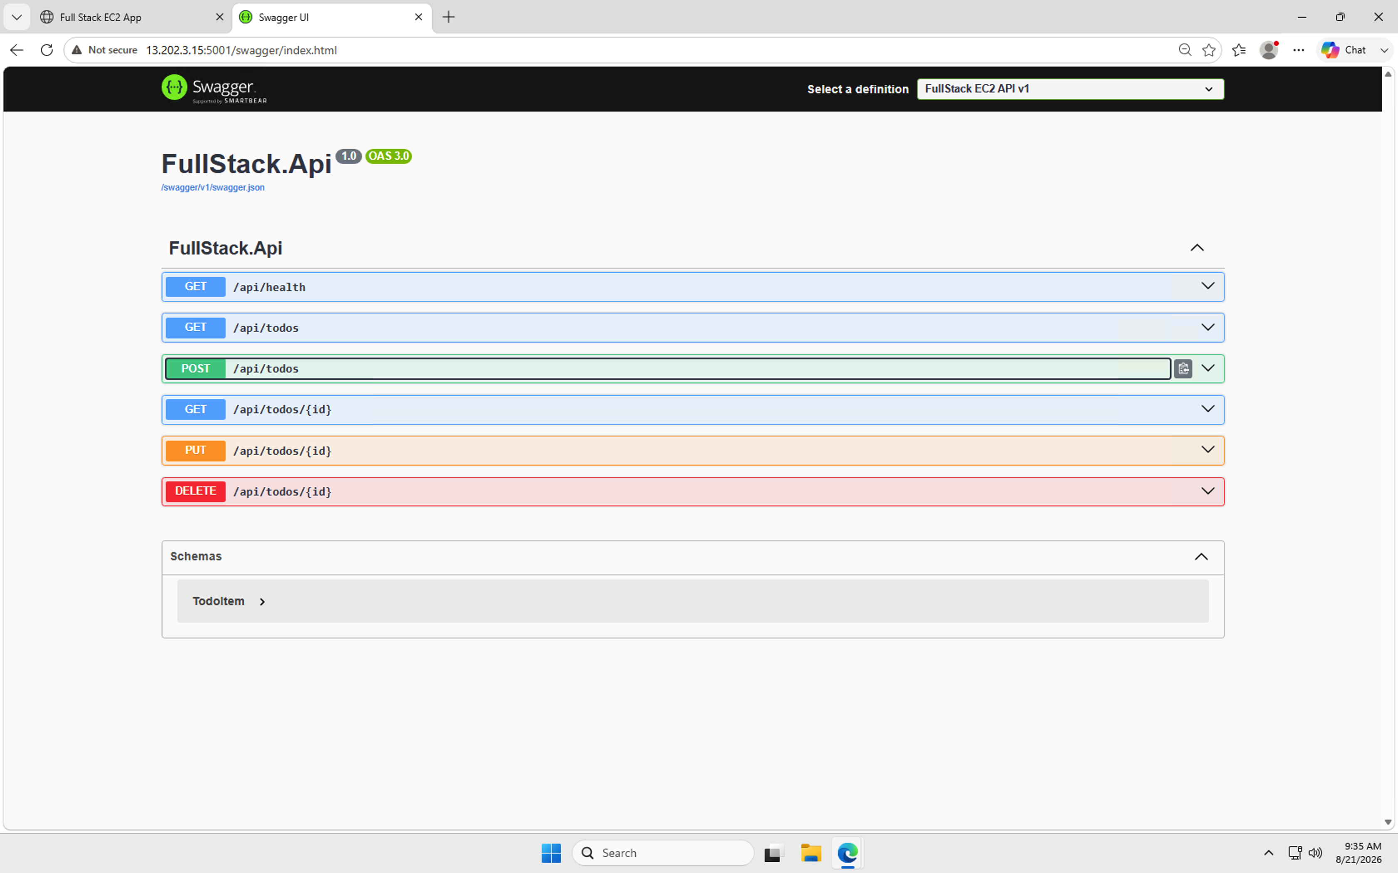
- DELETE — Removed records and confirmed a 200 OK / 204 No Content response, with the record no longer retrievable afterwards.

Fig 5: swagger

9. Frontend–Backend Integration & End-to-End Testing

With both tiers deployed, the complete application flow was tested end-to-end:
- Loaded the live frontend at http://13.202.3.15/ and navigated through all major pages/routes.
- Performed create, update, and delete actions from the UI and confirmed the corresponding API calls succeeded (verified via browser dev tools / network tab).
- Confirmed that data submitted from the React frontend was correctly persisted in the PostgreSQL database.
- Refreshed and revisited pages to confirm that data retrieved on load matched what was stored in the database, validating that the full path — User → React Frontend (IIS) → .NET Web API → PostgreSQL — works correctly.

10. Final Deliverables
Deliverable | Details
EC2 Public IP / Domain | 13.202.3.15
Live Frontend URL | http://13.202.3.15/ (port 80, served via IIS)
Backend API Base URL | http://13.202.3.15:5001/api
Swagger API URL | http://13.202.3.15:5001/swagger/index.html
GitHub Repository | https://github.com/kaif2104/full-stack-ec2.git
Database Name | myapp_user
Database Port | 5432 (default PostgreSQL port)
Database Password | •••••••• (masked for security)

11. Conclusion

The full-stack application comprising a React.js frontend, an ASP.NET / .NET Web API backend, and a PostgreSQL database was successfully deployed and hosted on an AWS EC2 instance using IIS. All components were verified to be reachable via the EC2 public IP, the API was fully tested through Swagger across GET, POST, PUT/PATCH, and DELETE operations, and end-to-end data flow between the frontend, backend, and database was confirmed to be working correctly. This deployment demonstrates a complete, production-style hosting setup on AWS.

12. Appendix: Screenshot Checklist

The following screenshots are required to complete this report. Each has been marked with a highlighted placeholder at the relevant section above:
- Fig 1 — Running React application (Section 4)
- Fig 2 — PostgreSQL / database connection (Section 6)
- Fig 3 — IIS configuration showing both sites (Section 7)
- Fig 4 — EC2 instance in Running state (Section 7)
- Fig 5 — Swagger showing successful API requests (Section 8)

