TECHNICAL PROJECT REPORT
StockMaster Pro: Inventory Management System
Angular Framework | Enterprise Resource Planning Simulation

1. Project Aim & Objectives
The StockMaster Pro is a comprehensive inventory management system built with Angular. It aims to simulate a real-world warehouse environment where administrators can track stock levels, issue items, and restock hardware components in real-time.

Technical Objectives:
- Implementation of Interpolation for real-time status updates and timestamps.
- Use of Property & Event Binding to control UI visibility and stock levels.
- Employment of Structural Directives (*ngIf, *ngFor) for dynamic data rendering.
- Integration of Built-in Pipes (Currency, Date, Uppercase) for professional data formatting.
- Application of ngClass for visual status indicators based on inventory count.

2. Development CLI Summary
Action | CLI Command | Purpose
Setup | ng new angular-almi | Create the standalone workspace.
Serve | ng serve | Start development server.
Build | ng build | Compile for production.

3. Code Implementation: Logic Layer

3.1 Component Logic (app.ts)
Handles the inventory data model and business logic for issuing/restocking items.
import { Component } from '@angular/core'; import { CommonModule } from '@angular/common'; @Component({ selector: 'app-root', standalone: true, imports: [CommonModule], templateUrl: './app.html', styleUrls: ['./app.css'] }) export class AppComponent { appName = 'StockMaster Pro'; systemStatus = 'Online'; lastUpdated = new Date(); inventory = [ { id: 'ITM-001', name: 'Dell Wireless Mouse', price: 750, stock: 45, category: 'Hardware' }, { id: 'ITM-002', name: 'Mechanical Keyboard', price: 2500, stock: 5, category: 'Hardware' }, { id: 'ITM-003', name: 'USB-C Adapters', price: 499, stock: 0, category: 'Accessories' }, { id: 'ITM-004', name: '27" IPS Monitor', price: 12500, stock: 12, category: 'Displays' } ]; isTableVisible = true; toggleTable() { this.isTableVisible = !this.isTableVisible; } issueItem(item: any) { if (item.stock > 0) { item.stock--; this.lastUpdated = new Date(); } } restockItem(item: any) { item.stock += 10; this.lastUpdated = new Date(); } }

3.2 Template Implementation (app.html)
This file defines the UI structure using Angular-specific syntax for data manipulation.
<nav class="top-nav"> <h1>{{ appName }}</h1> <span>{{ lastUpdated | date:'mediumTime' }}</span> </nav> <main> <button (click)="toggleTable()">Toggle View</button> <section *ngIf="isTableVisible"> <table> <tr *ngFor="let item of inventory"> <td>{{ item.name | uppercase }}</td> <td>{{ item.price | currency:'INR' }}</td> <td> <span [ngClass]="{'stock-low': item.stock <= 5}"> {{ item.stock }} units </span> </td> <td> <button [disabled]="item.stock === 0" (click)="issueItem(item)">Issue</button> <button (click)="restockItem(item)">Restock</button> </td> </tr> </table> </section> </main>

4. Visual Project Output
The following screenshots demonstrate the application's responsiveness and real-time data updates.

4.1 Main Inventory Dashboard
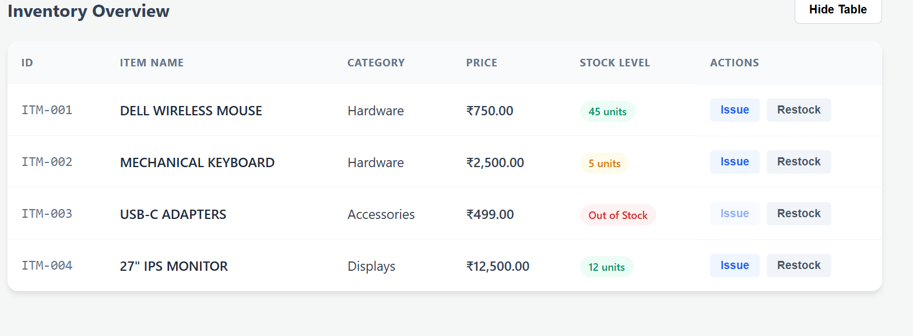

4.2 Real-time Stock Updates (Issue/Restock)

4.3 View Toggling (Structural Directive)
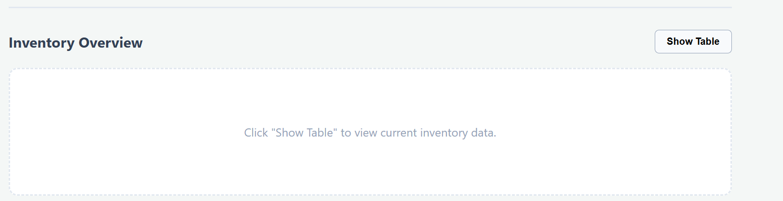

4.4 Status Indicators (ngClass & Out of Stock)
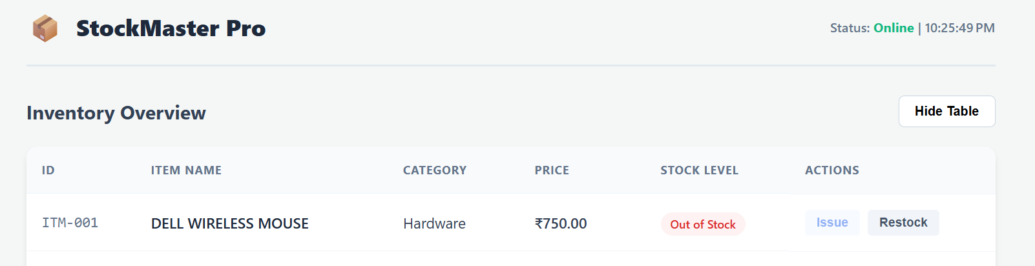

5. Conclusion
The StockMaster Pro project successfully integrated multiple Angular concepts into a cohesive enterprise solution. By utilizing advanced binding techniques and built-in pipes, we created a tool that is both functional and easy to maintain. The standalone component approach ensures the application remains modular and scalable for future enhancements.

