- Create Databse/use database
- Create table with syntax
- Datatypes, Signed & Unsigned Data Types
- Types of SQL commands
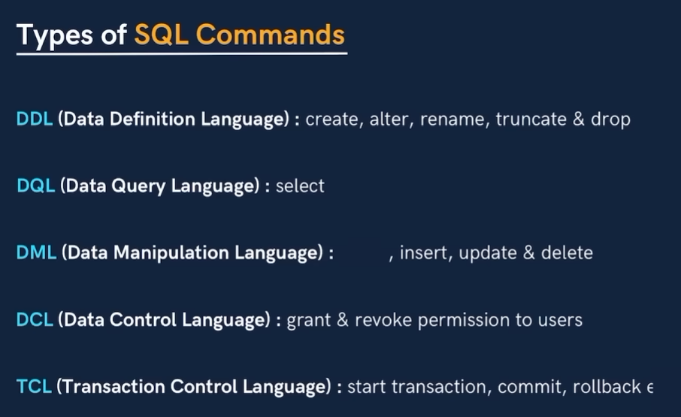
- Databse related queries
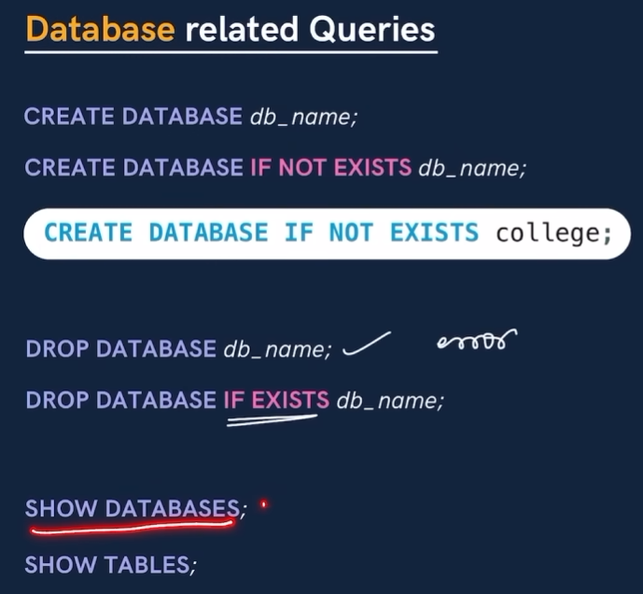
- Table Related Queries
  - Create
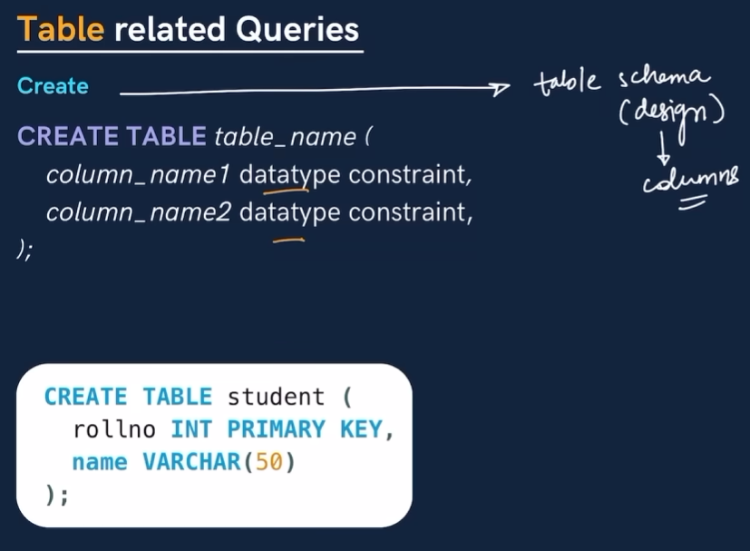
  - Select and View ALL columns

  - Insert
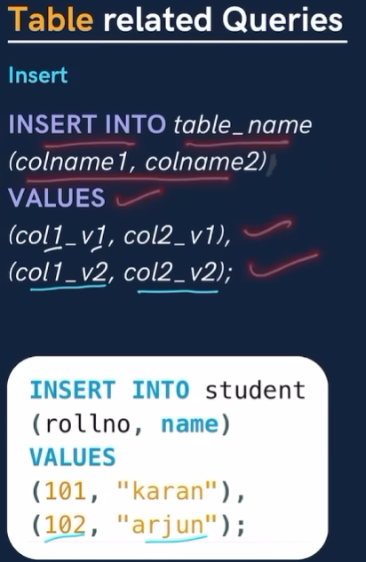

- Question 1
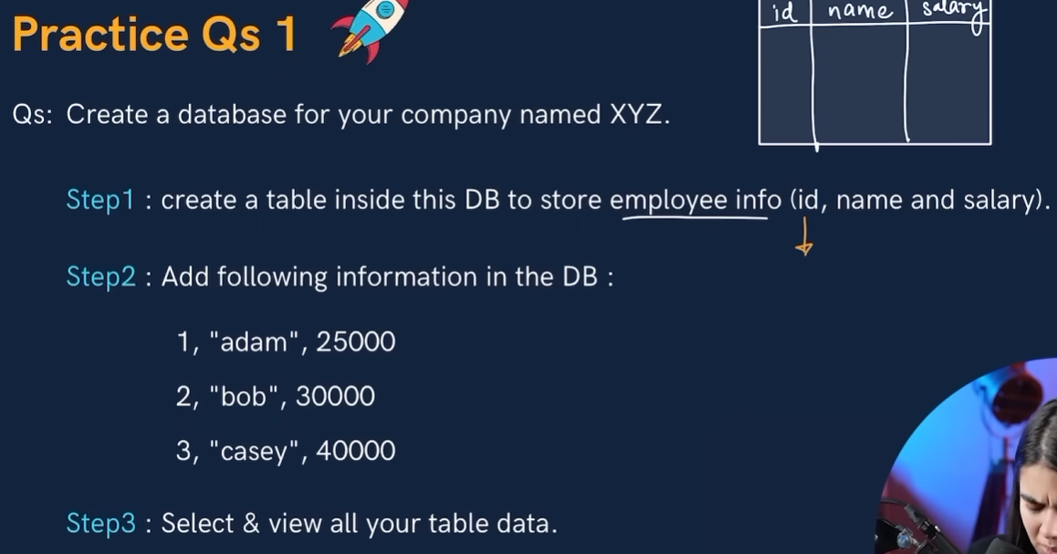
- Primary & Foreign Key
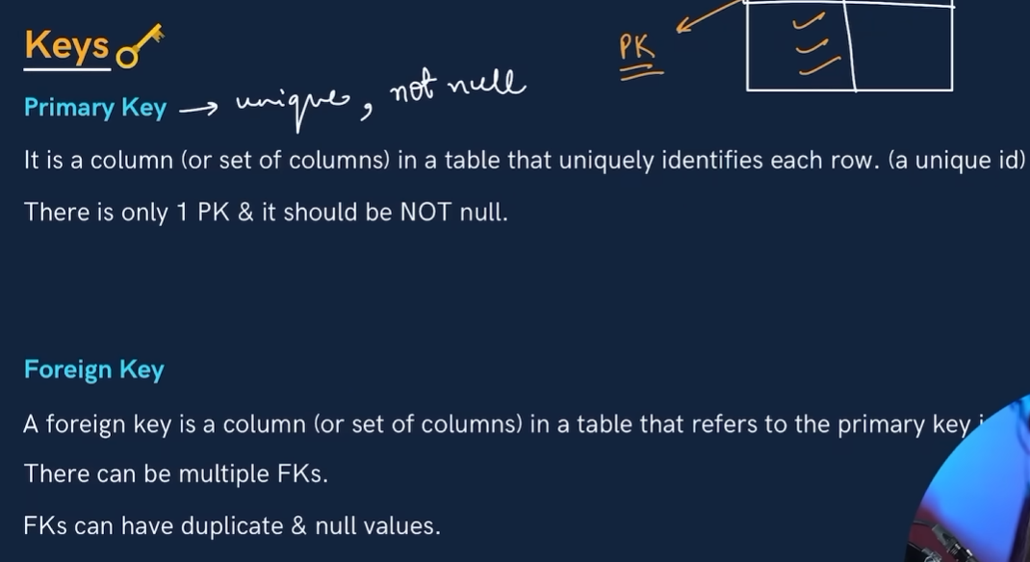
- Constraints
  - Primary key, UNIQUE, NOT NULL
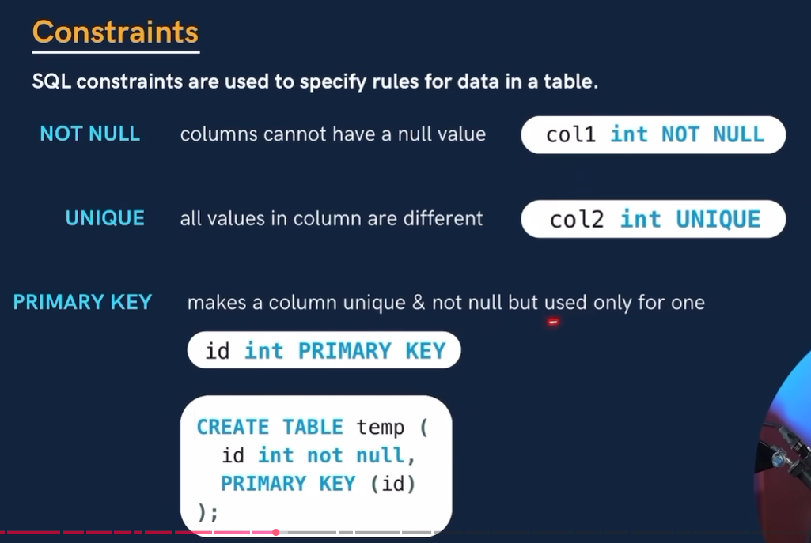
  - Foreign key & default
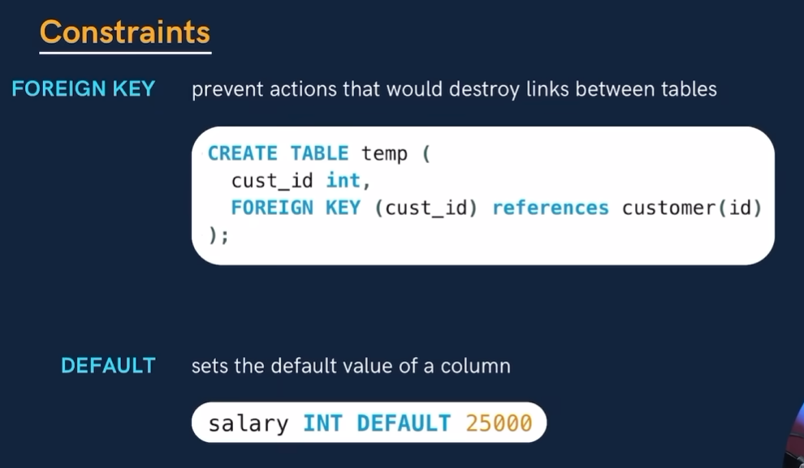
  - CHECK
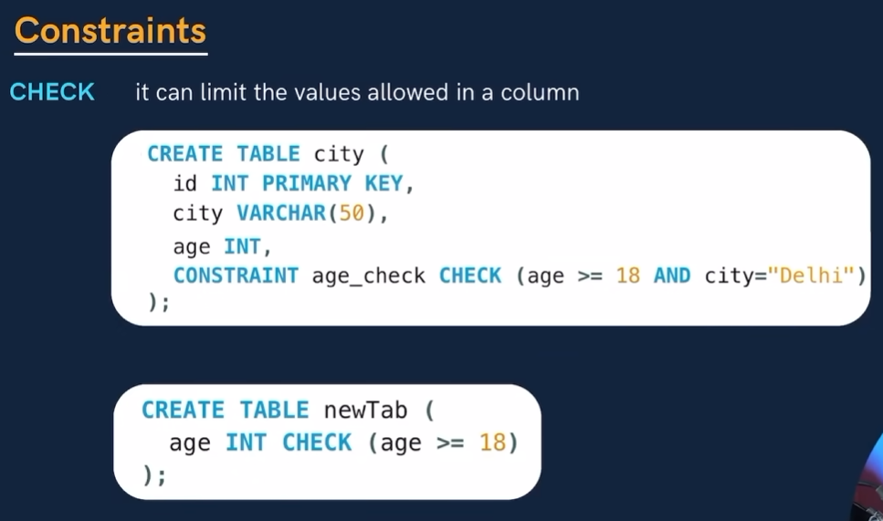
- SELECT Clause
  - Basic Syntax and To Select All
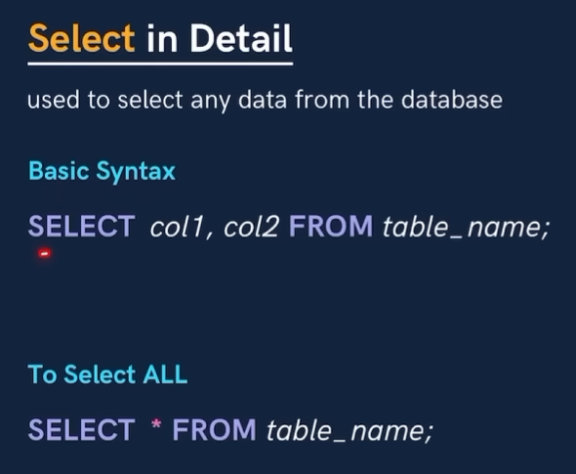
SELECT name, city from student;
SELECT * FROM student;

  - Distinct Keyword
SELECT DISTINCT city FROM student;
- Where Clause
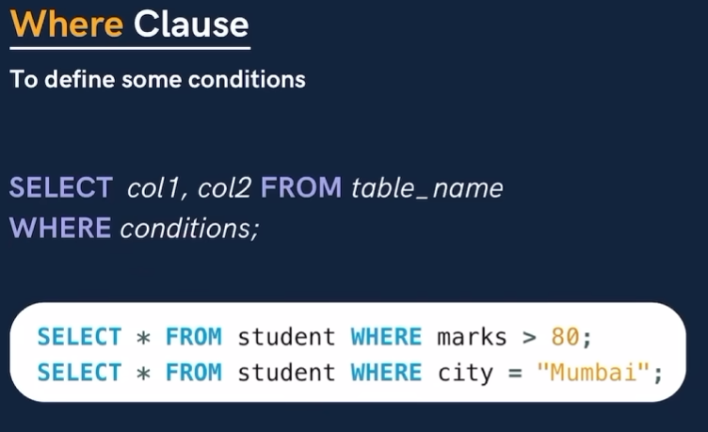
SELECT * FROM STUDENT WHERE marks > 80;
SELECT * FROM STUDENT WHERE city = "Delhi";
SELECT * FROM STUDENT WHERE marks > 80 AND city = "Mumbai";

  - Using Operators in WHERE
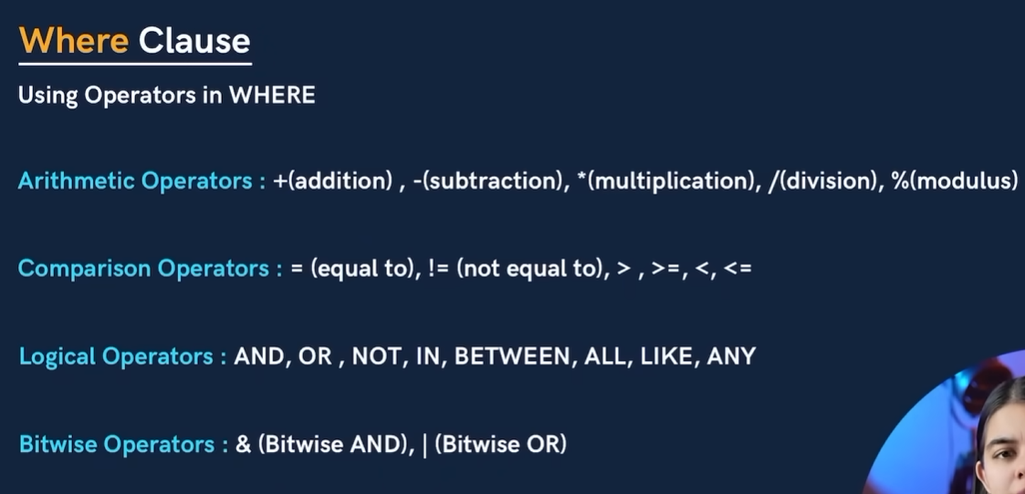
  - AND & OR
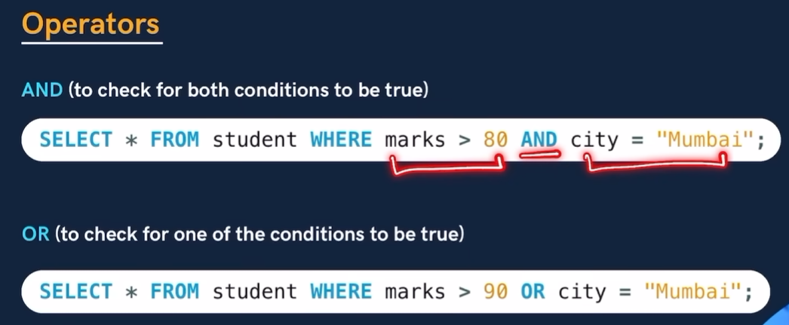
  - BETWEEN, In, NOT
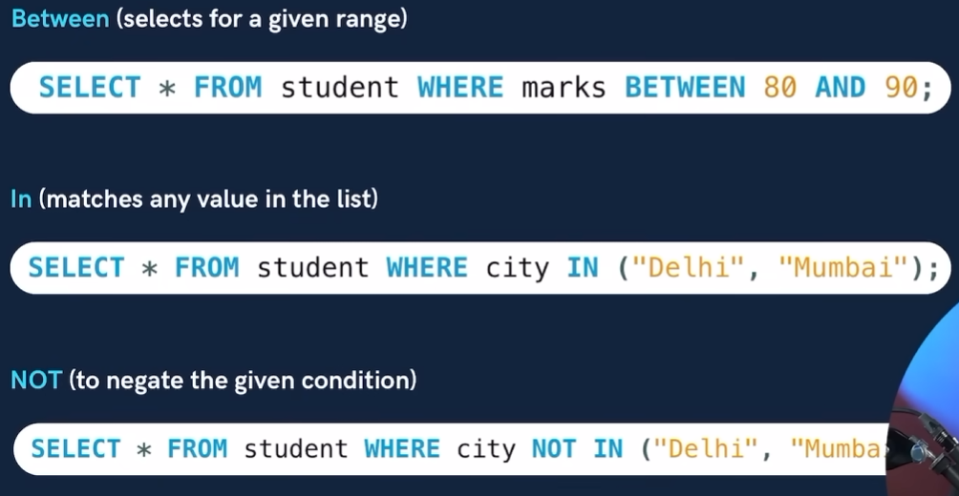
  - LIMIT
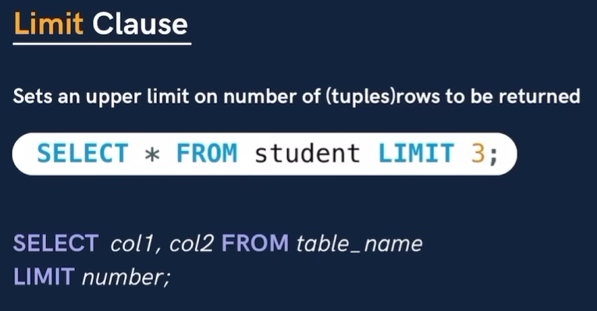
SELECT name FROM student WHERE marks > 70 LIMIT 3;
  - ORDER BY Clause
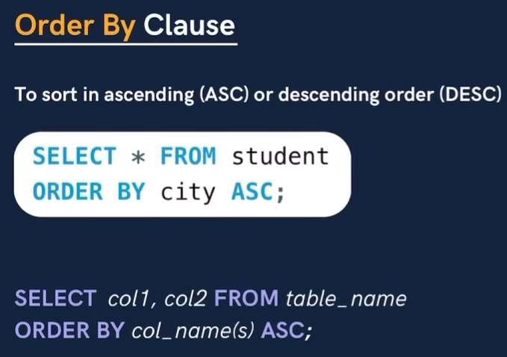
SELECT name, city FROM student ORDER BY marks ASC;
SELECT name, city FROM student ORDER BY marks ASC LIMIT 3;
- Aggregate Functions
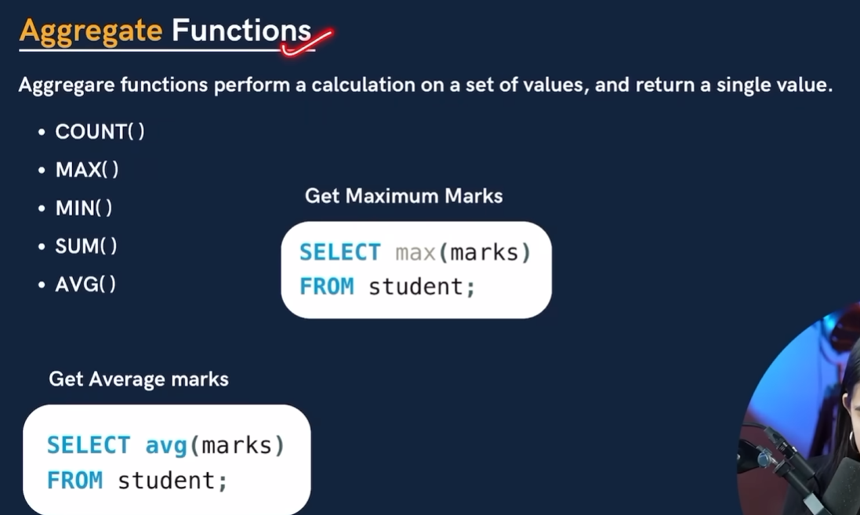
select MAX(marks) FROM student;
select MIN(marks) FROM student;
select count(marks) FROM student;
select SUM(marks) FROM student;

- GROUP BY
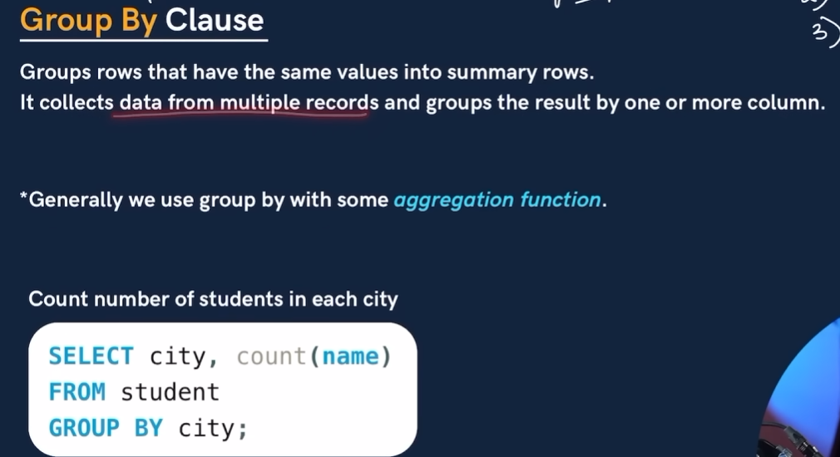
SELECT city, COUNT(name) AS total_students
FROM student
GROUP BY city
ORDER BY total_students ASC;

SELECT city, AVG(marks) as AVERAGE_MARKS
FROM student
GROUP BY city;

SELECT grade, COUNT(name) AS TOTAL_STUDENTS
FROM student
GROUP BY grade;

SELECT grade, MAX(marks) AS highest_marks
FROM student
GROUP BY grade;

- HAVING CLAUSE
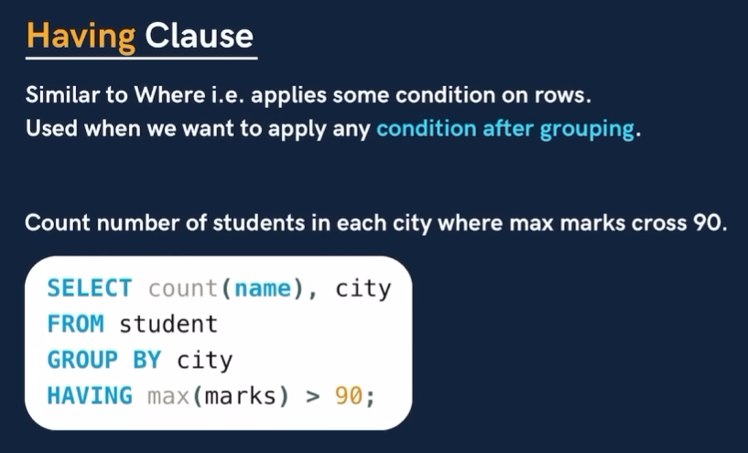
SELECT city, COUNT(rollno)
FROM student
GROUP BY city
HAVING MAX(marks) > 90;

SELECT city, COUNT(*) AS total_student
FROM student
GROUP BY city
HAVING COUNT(*) > 1;

- Sequence of CLAUSE to be used
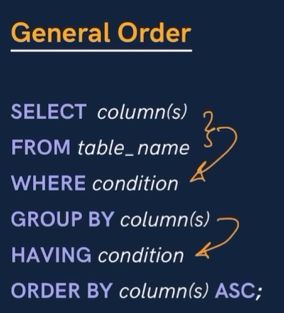
SELECT city
FROM student
WHERE GRADE = "A"
GROUP BY city
HAVING MAX(marks) > 90
ORDER BY city ASC;
- Table Related Queries
  - Update
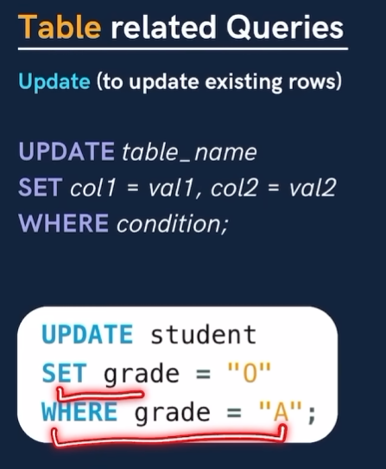
SET SQL_SAFE_UPDATES = 0;

UPDATE student
SET grade = "O"
WHERE grade = "A";

select * from STUDENT;

UPDATE student
SET marks = 82
WHERE rollno = 105;

UPDATE student
SET grade = "B"
WHERE marks BETWEEN 80 AND 90;

UPDATE student
SET marks = marks + 1;

  - DELETE

DELETE FROM student
WHERE marks <33;
- Revisiting FOREIGN KEYS
- The tables whose Primary key is used as FOREIGN KEY is the Parent table
- The table in whiohc the Foreign key is used is the Child Table
Visualizing the Tables
USE college;

CREATE TABLE dept(
ID INT PRIMARY KEY,
name VARCHAR(50)
);

CREATE TABLE teacher(
id INT PRIMARY KEY,
name VARCHAR(50),
dep_id INT,
FOREIGN KEY(dep_id) REFERENCES dept(id)
);
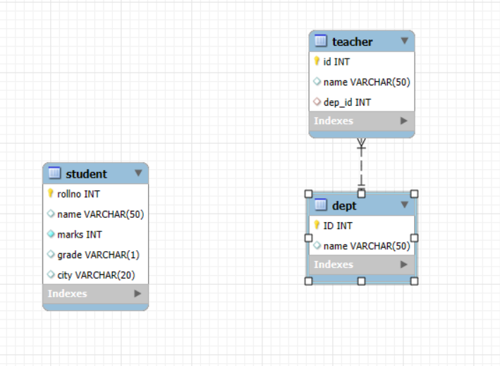

- CASCADING in FK
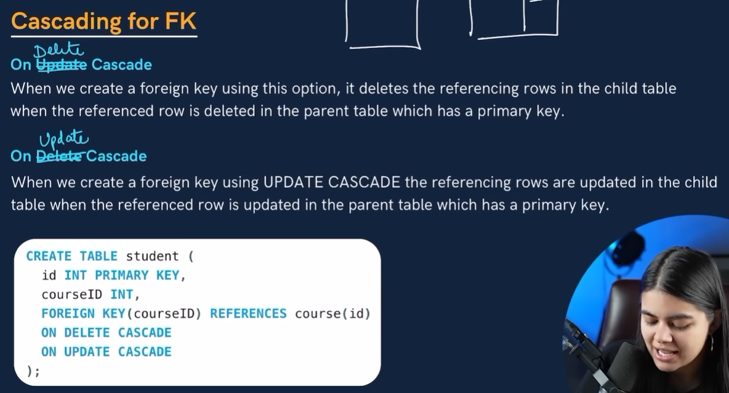
CREATE TABLE dept(
ID INT PRIMARY KEY,
name VARCHAR(50)
);
INSERT INTO dept VALUES(101, "english"), (102, "IT");

CREATE TABLE teacher(
id INT PRIMARY KEY,
name VARCHAR(50),
dep_id INT,
FOREIGN KEY(dep_id) REFERENCES dept(id)
ON UPDATE CASCADE
ON DELETE CASCADE
);

INSERT INTO teacher VALUES(101, "Adam", 101), (102, "Eve", 102);

SELECT * FROM teacher;
SELECT * FROM dept;

DROP TABLE teacher;

UPDATE dept
SET id = 103
WHERE ID = 102;

UPDATE dept
SET id = 111
WHERE ID = 101;
  - Alter
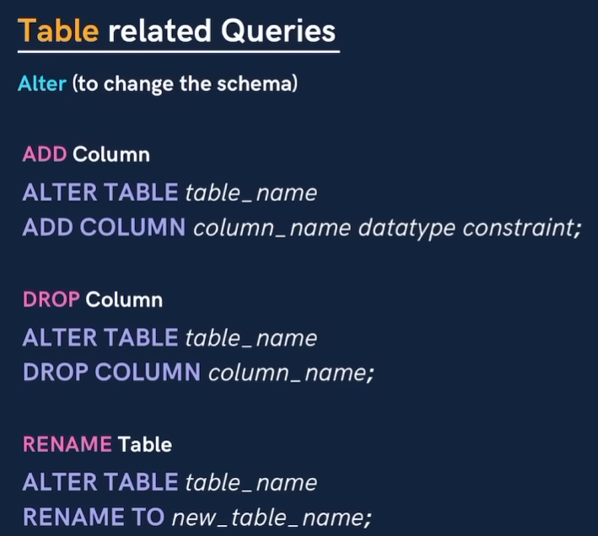
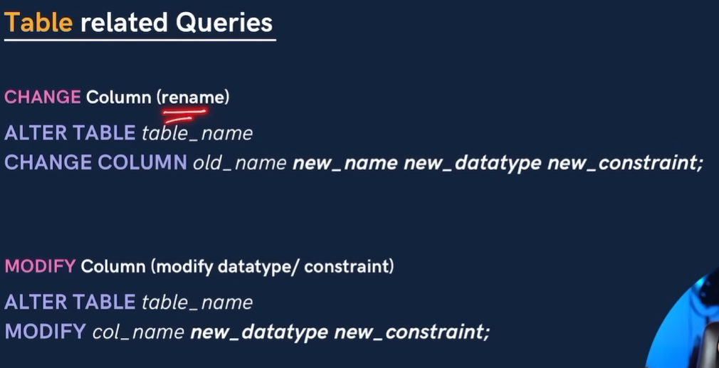
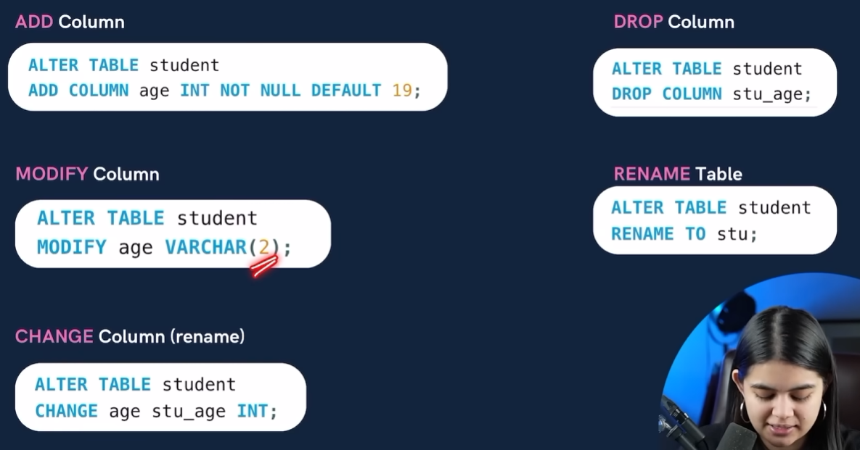
  - TRUNCATE
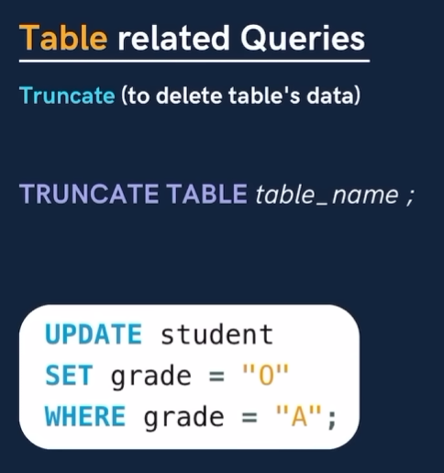
- Joins
Inner Join
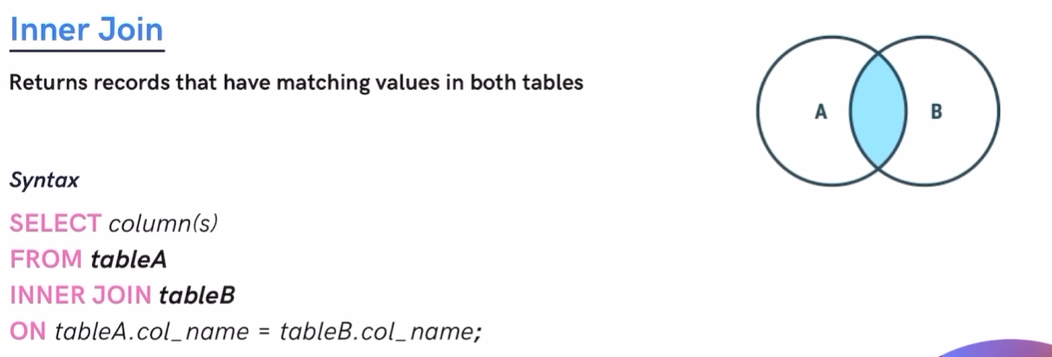
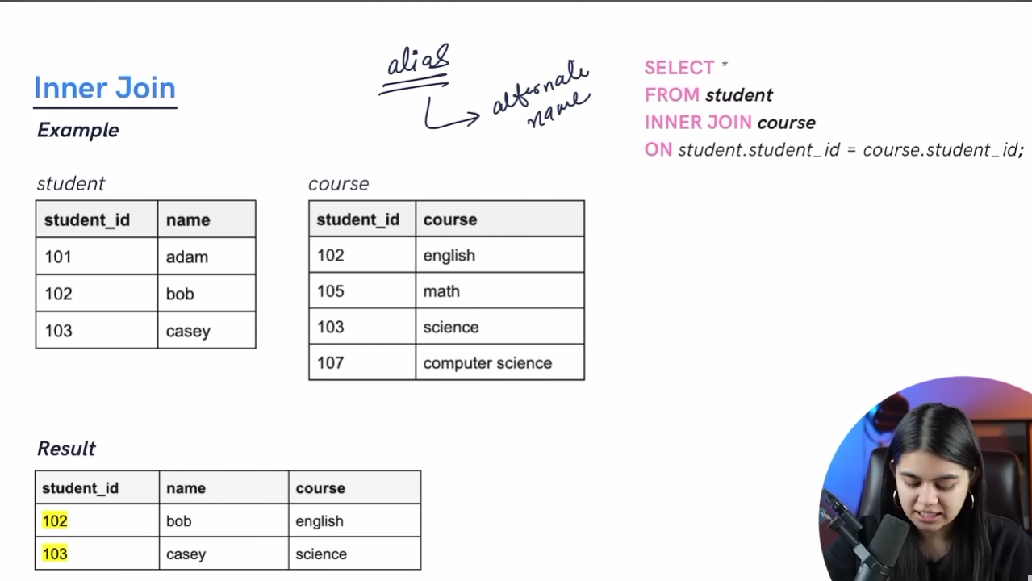
CREATE TABLE student1(
id INT PRIMARY KEY,
name VARCHAR(50)
);

INSERT INTO student1(id, name) VALUES
(101, "adam"),
(102, "bob"),
(103, "casey");

CREATE TABLE course1(
id INT PRIMARY KEY,
courses VARCHAR(50)
);
INSERT INTO course1 (id, courses) VALUES
(102, "english"),
(105, "math"),
(103, "science"),
(107, "computer science");

SELECT * FROM student1;
SELECT * FROM course1;

SELECT *
FROM student1
INNER JOIN course1
ON student1.id = course1.id;

SELECT student1.name, course1.courses
FROM student1
INNER JOIN course1
ON student1.id = course1.id;

SELECT S.name, C.courses
FROM student1 AS S
INNER JOIN course1 AS C
ON S.id = C.id;

- LEFT JOIN
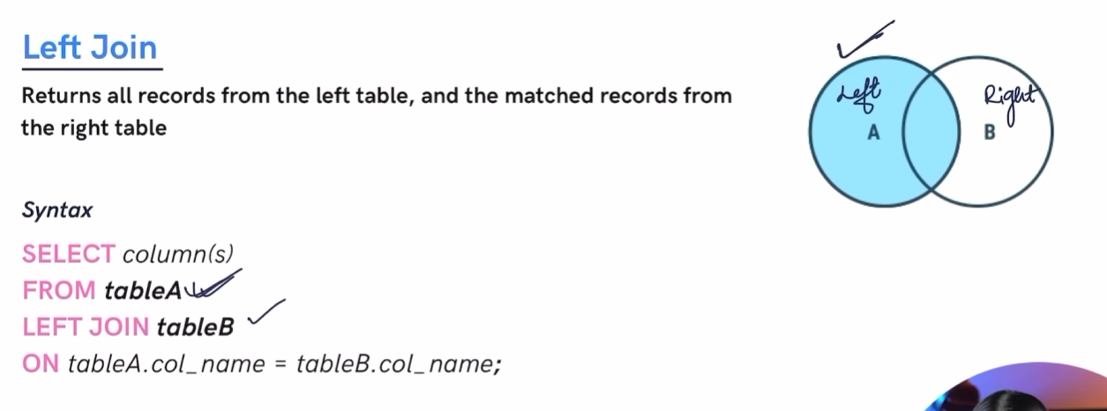
select *
FROM student1
LEFT JOIN course1
ON student1.id = course1.id;

- RIGHT JOIN
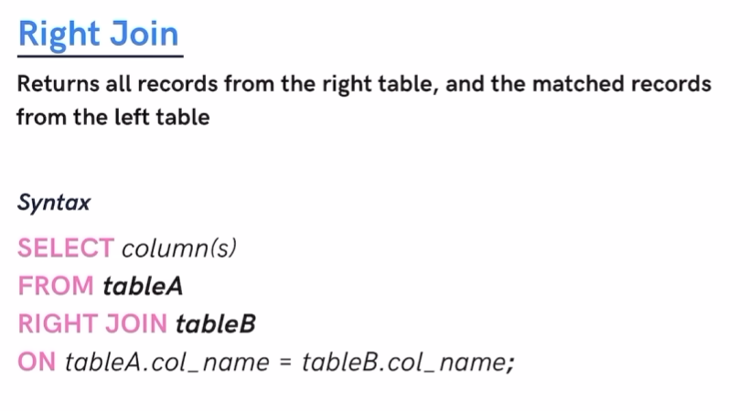
select *
FROM student1
RIGHT JOIN course1
ON student1.id = course1.id;
- FULL JOIN
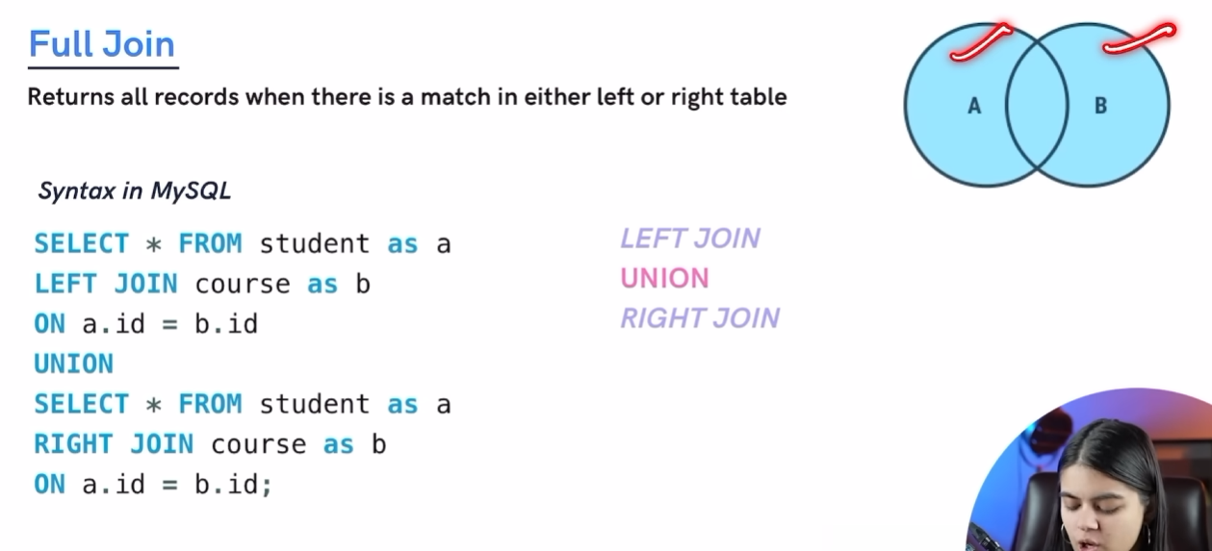
- LEFT EXCLUSIVE JOIN & RIGHT EXCLUSIVE JOIN
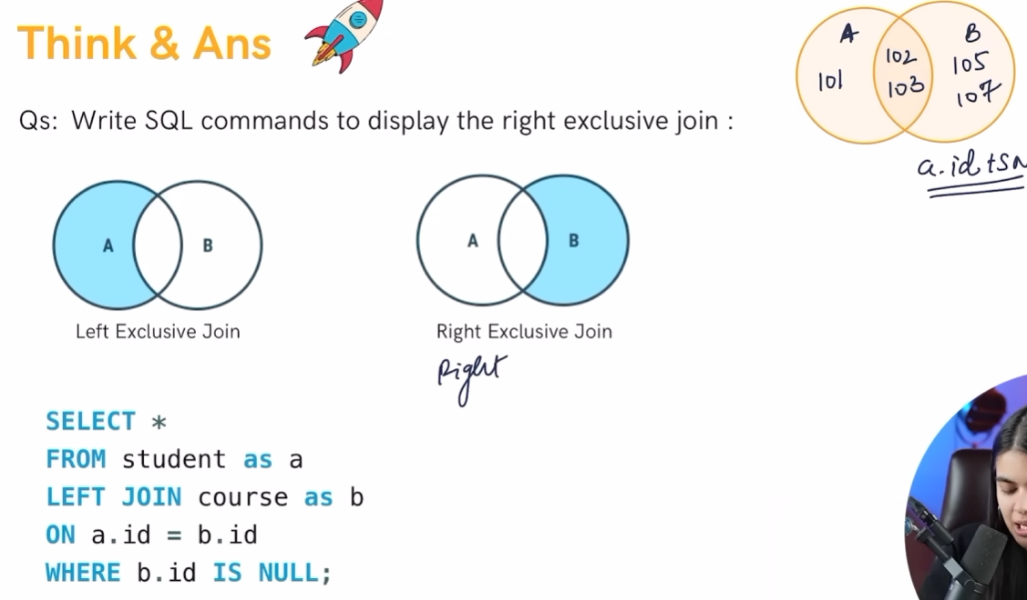
SELECT *
FROM student1
LEFT JOIN course1
ON student1.id = course1.id
WHERE course1.id IS NULL;

SELECT *
FROM course1
RIGHT JOIN student1
ON student1.id = course1.id
WHERE course1.id IS NULL;

- SELF JOIN
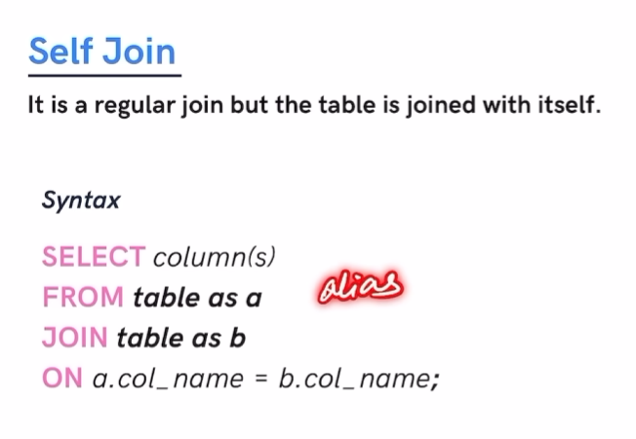
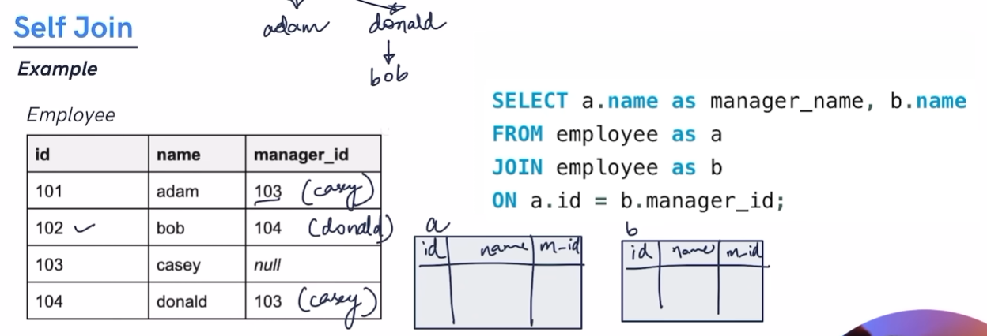
- UNION IN SQL and UNION ALL
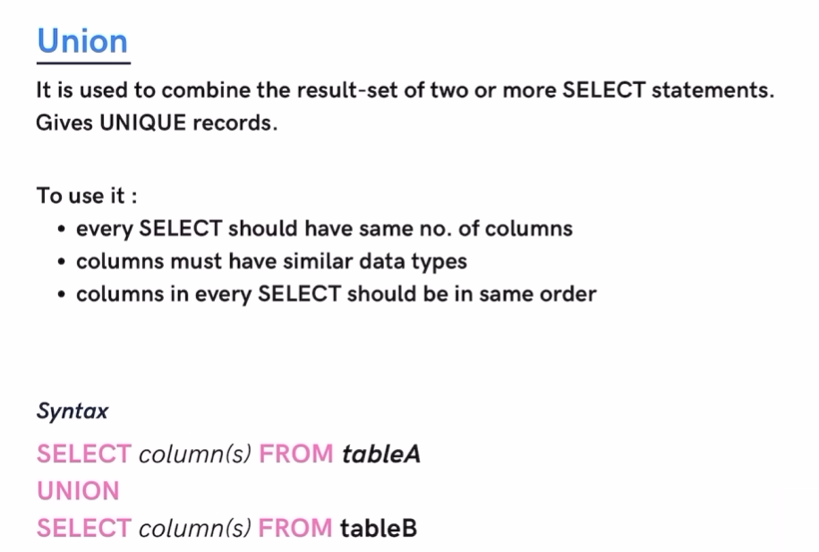

- SUB QUERY


SELECT name, marks
from student
WHERE marks > (
SELECT AVG(marks)
FROM student
);

SELECT name
from student
WHERE rollno IN (
SELECT rollno
from student
where rollno % 2 = 0
);

SELECT name
from student
WHERE city = "delhi"
AND marks = (
SELECT MAX(marks)
FROM student
WHERE city = "Delhi"
);

SELECT name
from student
WHERE city = "delhi"
AND marks = (
SELECT MAX(marks)
FROM student
WHERE city = "Delhi"
);

SELECT name
from student
WHERE city = "Delhi"
AND marks = (
SELECT MIn(marks)
FROM student
WHERE city = "Delhi"
);

