# Analysis on Wide Use of

# Electric Vehicles

## Abstract

In the face of dwindling fossil fuel and the contaminative substance brought about by fuel-burning vehicles, people are considering promoting electric vehicles widely. In order to analyze comprehensive impacts of widespread use of electric vehicles, we pay attention on four aspects – environment, society, economy and health, which are considered to be most representative perspectives. We develop one model for every part. In each of these four models, we pick several significant factors and quantify them. Then we get the relationship between electric vehicles number and any of these factors from many valid and warranted references. After that, we use Analytic Hierarchy Process (AHP) to analyze and calculate the importance of promoting  electric vehicles. To make use of these models, we introduce many well-founded data into them, and get some conclusion about the optimized number of electric vehicles in terms of each the four aspects. Finally, we use sensitivity analysis to seek out the most significantly influencing parameter, which will be realistic and sound suggestions to governments and manufacturers while they are planning to promote electric vehicles.

Based on those models, we calculate the amount of fossil fuel save if electric vehicles are widespread used. The result shows that we can save  petroleum but need more natural gas and more coal if we widely use electric vehicles.

Furthermore, we develop models of amount and type of electricity generation based on the former models. We focus on four aspects – environment, society, business and individuals. For each aspect, we also have some significant factors and all these factors are determined by some parameters, including the amount and type of electricity generation. Given some conclusion of former models, we can get the equations set with different amount and type of electricity generation as variables. Then we get a multivariable optimization problem whose solution is the optimizing result of arranging electricity generation.

## 1 Introduction

As fossil fuel resource of our earth running out, and meanwhile the waste gas emitted by fossil fuel-burning vehicles continuously contaminating and warming our world, many governments are considering promoting electric vehicles to be pervasive. But there are still a bunch of concerns of widespread use of electric vehicles. Considering the huge impact of widely changing the type of vehicles, governments need circumspectly make decisions.

In order to discuss whether and how to put electric vehicles into widespread use, we focus mainly on four aspects - environment, society, economy and health. Every aspect has several significant factors. And every factor is determined by several parameters. These components make up a hierarchy structure. Then we use theory of Analytic Hierarchy Process (AHP) to analyze this structure and calculate the importance of widespread use of electric vehicles in all the four aspects.

Based on these models, we develop the models of amount and type of electricity generation. These models also have four aspects - environment, society, business and individuals. Every aspect has several main factors and every factor is determined by several parameters. So we have a comprehensive judgment on the benefits of widely using electric vehicles and properly distributing electricity generation.

## 2 Problem Description

### 2.1 The impacts of widespread use of electric vehicles

In order to analyze the impacts after widely using electric vehicles, we should consider some aspects of consequence in the whole world. Given this, we choose environment, society, economy and health to focus on. And as we are supposed to give sound advice about promoting electric vehicles, we should seek out the factors that most significantly influence those aspects, which will help government and manufacturers to make decision and choose the focus of their future work. Furthermore, some proper and warranted data should be adopted to prove the correctness and validity of our model.

### 2.2 Oil Saved by widely using electric vehicles

To see the benefit/damage brought out by widely using electric vehicles, we are supposed to calculate the amount of oil (fossil fuels) saved/wasted. The goal of this problem is to numerically see the oil perspective of impacts.

### 2.3 Model of electricity generation

As we have the models of impacts by widely using electric vehicles, we can provide some effective and realistic advice about promoting electric vehicles. After this, we are supposed to develop the model of assigning electricity generation depend on the amount and type of electric vehicles that we suggest according to our models. The goal of this problem is to build model and give advice about the amount and type of electricity generation that can optimize the benefits to environment, society, business and individuals.

## 3 Problem Analysis

### 3.1 The impacts of widespread use of electric vehicles

To analyze and discuss the widespread use of electric vehicles, we put our attention on four aspects - environment, society, economy and health. Firstly the main influencing factors of them will be considered and quantified. Then the relationship between these factors and the number of electric vehicles will be formulized. After that, we can use AHP (Analytic Hierarchy Process) to analyze the impacts of widespread use of electric vehicles on those four aspects. Finally, proper and well-founded data will be employed to validate our models.

### 3.2 Oil Saved by widely using electric vehicles

Based on the model we constructed at first step, we can get the relationship between the oil (fossil fuels) expensed on transportation and the number of electric vehicles. In light of this relationship and some data that indicates the amount of worldwide vehicles, we can easily calculate the saved oil by widely use electric vehicles.

### 3.3 Model of electricity generation

We are supposed to give model of the amount and type of electricity generation aiming at optimizing the benefits by using predicted amount and type of electric vehicles on environment, society, business and individuals. We need get the factors that mainly influence these four parts. Then we need to get the relationship between these factors and the amount and type of electricity generation, some of which are conclusions of former models. Then we get the equations sets indicating the relationship between the amount and type of electricity generation and each of these four aspects. So this problem becomes the optimization problem based on these equations sets.

## 4 Assumptions

* The total amount of vehicles is constant
* There is no electric vehicle at the beginning
* The speed of transferring renewable and nuclear energy into electricity is constant.
* The contamination of manufacturing fossil fuel-burning vehicles and electric vehicles are same

## 5 Model Development

### 5.1 The impacts of widespread use of electric vehicles

#### 5.1.1 Environment

**5.1.1.1 Model Building**

Because the fuel and batteries can be the most contamination of environment, the “environment” part is principally determined by following factors:

1. The amount of petroleum used for transportation, denoted by
2. The amount of natural gas used for transportation, denoted by
3. The amount of coal used for transportation, denoted by
4. The amount of batteries used for electric vehicles, denoted by

To calculate those factors, we need those following parameters:

1. The reduced number of fuel-burning vehicles, denoted by 
2. The total number of vehicles, denoted by 
3. Energy consumption per fuel-burning or electric vehicle per unit of time, denoted by  and ,respectively
4. Energy transformation ratio of petroleum, natural gas and coal, denoted by , , , respectively
5. Amount of batteries per electric vehicle, denoted by 
6. The percentage of petroleum, natural gas, coal, renewable energy and nuclear energy used in the energy resources of transportation, denoted by , ,
7. The percentage of petroleum, natural gas, coal, renewable energy and nuclear energy used in the energy resources of electric power, denoted by , ,,and 

As we assumed,is constant, which will lead to more electric vehicles. And we also have the assumption that the speed of transferring renewable and nuclear energy into electricity are constant.

Then, the total amount of petroleum, natural gas and coal used for transportation are calculated by







On the other hand, the amount of electric vehicles’ batteries is



To analyze the impact on environment, we have Figure 1 - Hierarchy Structure of Environment.

Figure 1 - Hierarchy Structure of Environment

Environment

Petroleum

Natural Gas

Coal

Battery

No Electric

Vehicle

Electric

Vehicles

Let , , , respectively denote the importance of petroleum, natural gas, coal and battery. And we normalize the importance of “No Electric Vehicle”, written , and “ Electric Vehicle”, written , as following formula













is a monotonic function indicating the value of any kind of factors that influence environment, society, economy and health. So the formula of  and  can be applied to the following discussion.

According the theory of Analytic Hierarchy Process, we can get the importance of “No Electric Vehicle” to environment by



and the importance of “ Electric Vehicle” to environment by



We use 2-orderbecause as contamination amount increase, the harm to environment will increase at high-order speed, which we suppose as 2-order.

Based on Analytic Hierarchy Process, our target is to find out x that maximizes or minimizes . And this purpose is the same in following discussion.

**5.1.1.2 Model Results**

In order to get some results from our models, we simulate the model in Wolfram Mathematica 6.0, using .

Table 1 – Values of Parameters of Environment

|  |  |  |  |
| --- | --- | --- | --- |
|  | 250844644 |  | 0.01 |
|  | 2.651*106 J/kM |  | 0.18 |
|  | 5.4*105 J/kM |  | 0.48 |
|  | 0.3 |  | 0.11 |
|  | 0.5 |  | 0.22 |
|  | 0.4 |  | 0.4 |
|  | 0.5 |  | 0.1 |
|  | 0.94 |  | 0.3 |
|  | 0.03 |  | 0.2 |
|  | 0 |  |  |

Most of the values are referred from

* [3] BP Global. www.bp.com
* [4] U.S. Energy Information Administration. www.eia.doe.gov/iea
* from reference .

Others can be estimated by some statistic data. All the data we used in rest discussion is the same.

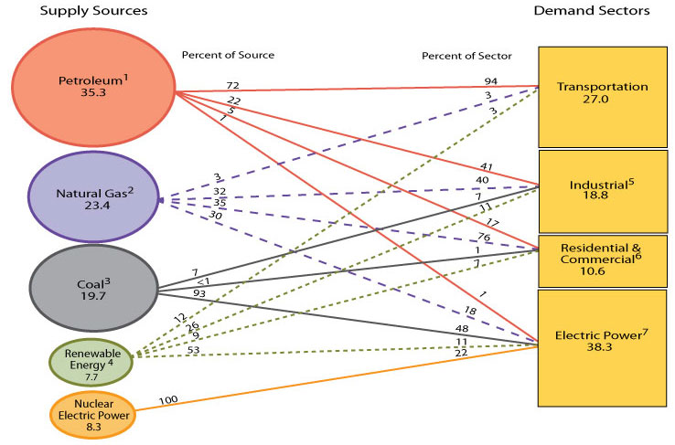

Figure 2 - U.S. Primary Energy Flow by Source and Sector

Based on the data above, Mathematica delineates the curve of  in Figure 3 -  Curve.

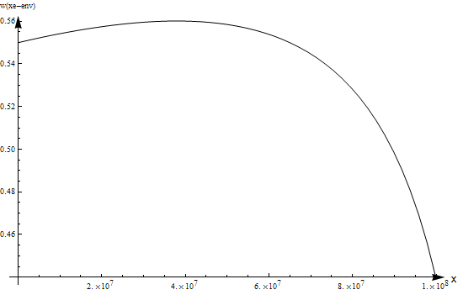

Figure 3 -  Curve of Environment

The culmination occurs at and values 0.560148, which indicates that it would be best for the environment to replace about 15.13% fuel-burning vehicles by electric vehicles.

**5.1.1.3 Model Performance**

We can do sensitivity analysis on this model and seek out those parameters that most significantly influence our environment. For example, when  increase 5%, using the data in , the number of electric vehicles under optimizing circumstance will increase 0.0011%, which means  is not a significant parameter to the number of electric vehicles . So, the governments and manufacturers can neglect  when they are making decisions.

#### 5.1.2 Society

**5.1.2.1 Model Building**

The society has very strong relation with the time spent on transportation and expenditure of government. So the “society” part is principally determined by following factors:

1. Total time spent on transportation of the whole society, denoted by 
2. Total expenditure for promoting electric vehicles, , denoted by 

To calculate those factors, we need those following parameters:

1. The total number of electric vehicles, denoted by 
2. The total number of vehicles, denoted by 
3. The average distance per unit of time per vehicle, denoted by 
4. The average speed of fuel-burning and electric vehicles, denoted by  and , respectively
5. The time wasted on charging batteries per unit of time per electric vehicle, denoted by 
6. The government save on waste gas treatment per electric vehicle, denoted by 
7. The government expenditure per battery station, denoted by 
8. The amount of battery stations, calculated by , which contains two parameters -  and 

Time spent on transportation of whole society is



The expenditure for promoting electric vehicles is mainly consists of environmental protection and battery station construction investment, sois



To analyze the impact on society, we have Figure 4 - Hierarchy Structure of Society.

Society

Time spent

Expenditure

No Electric

Vehicle

Electric

Vehicles

Figure 4 - Hierarchy Structure of Society

Let ,  respectively denote the importance of time spent and expenditure.

According the theory of Analytic Hierarchy Process, we can get the importance of “No Electric Vehicle” to environment by



and the importance of “ Electric Vehicle” to environment by



**5.1.2.2 Model Results**

Similarly, we run our model on Mathematica and analyze the curve of , using the data in .

Table 2 - Values of Parameters of Society

|  |  |  |  |
| --- | --- | --- | --- |
|  | 50 km |  | 0.5 |
|  | 100 km/h |  | 3 |
|  | 50 km/h |  | 758500 Dollars |
|  | 1 hour |  | 0.3 |
|  | 1517 Dollars |  | 0.7 |

The curve of  is shown in , where  reaches its maximum value 0.847377 at , which is 2.3% of all vehicles.

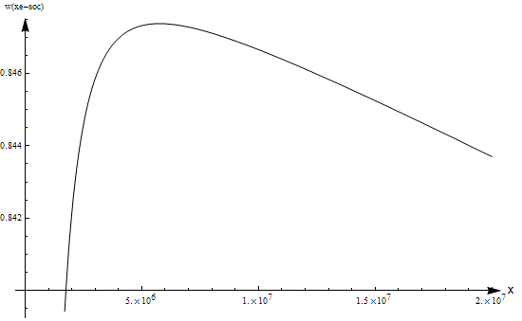

Figure 5 -  Curve of Society

**5.1.2.3 Model Performance**

We can also do sensitivity analysis to find out most significantly influencing parameters on society. For instance, when  increase 5%, using the data in Table 2 - Values of Parameters of Society, the number of electric vehicles under optimizing circumstance will decrease 0.0026%, which means  is not a significant parameter to the number of electric vehicles . Under the same condition, when  increase 5%, the number of electric vehicles will decrease 1.6%, which means the important of  is normal. So, the governments and manufacturers can neglect  but cannot ignore . They should pay more attention on reducing  than reducing .

#### 5.1.3 Economy

**5.1.3.1 Model Building**

The expense of using vehicles and the production capability are two main influences on economy, so the “economy” part is principally determined by following factors:

1. Total expense of using vehicles, denoted by 
2. Total wasted production capability, denoted by 

To calculate those factors, we need those following parameters:

1. The reduced number of fuel-burning vehicles, denoted by 
2. The life time of fuel-burning vehicles, denoted by 
3. The life time of electric vehicles, denoted by 
4. The price of unit of petroleum at the beginning, denoted by 
5. The price of unit of electricity at the beginning, denoted by 
6. Energy consumption per fuel-burning and electric vehicle per day, denoted by  and  , respectively
7. The price of fuel-burning vehicles, denoted by 
8. The price of electric vehicles, denoted by 
9. The production per unit of time, denoted by 

The price of unit of petroleum is



And the price of unit of electricity is



So the total expense of using vehicles is



Besides, the total wasted production capability is



To analyze the impact on society, we have Figure 6 - Hierarchy Structure of Economy.

Figure 6 - Hierarchy Structure of Economy

Economy

Expense

Wasted Prod

No Electric

Vehicle

Electric

Vehicles

Let ,  respectively denote the importance of expense and wasted production capability.

According the theory of Analytic Hierarchy Process, we can get the importance of “No Electric Vehicle” to environment by



and the importance of “ Electric Vehicle” to environment by



**5.1.3.2 Model Results**

The results model is calculated using .

Table 3 - Values of Parameters of Economy

|  |  |  |  |
| --- | --- | --- | --- |
|  | 10 years |  | 7142 dollars |
|  | 3 years |  | 14285 dollars |
|  | 1 dollar |  | 130 dollars/person*hour |
|  | 2.651*106 J/kM |  | 0.7 |
|  | 5.4*105 J/kM |  | 0.3 |

As it shows in , the peak of the curve locates at , which is 86.30% of all vehicles, with value 0.719347.

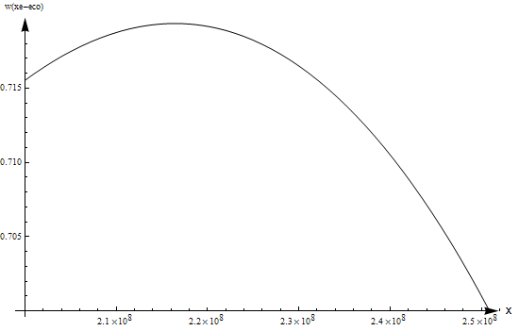

Figure 7 -  Curve of Economy

**5.1.3.3 Model Performance**

We can also do sensitivity analysis and find out those parameters that most significantly influence our economy. For example, when  increase 5%, using the data in Table 3 - Values of Parameters of Economy, the number of electric vehicles under optimizing circumstance will decrease 7.3%, which means  is a significant parameter to the number of electric vehicles . So, the governments and manufacturers should pay enough attention on reducing . The government can give some subsidies to decrease the price, and the manufacturers can work on new technologies which can reduce the cost of electric vehicles.

#### 5.1.4 Health

**5.1.4.1 Model Building**

Health is mostly influenced by noise, deleterious gas and radiation. The “health” part is principally determined by following factors:

1. Total noise, denoted by 
2. Total deleterious gas, denoted by 
3. Total radiation, denoted by 

To calculate those factors, we need those following parameters:

1. The reduced number of fuel-burning vehicles, denoted by 
2. The average speed of fuel-burning and electric vehicles, denoted by  and , respectively
3. The deleterious gas emitted per fuel-burning/electric vehicles, denoted by and  respectively
4. The radiation emitted per fuel-burning/electric vehicles, denoted by and  respectively

According to , we have the noise of vehicles formula



Given those, the total noise after reducing  fuel-burning vehicles is



where



and



And the total gas



And the total radiation is suppose to be



To analyze the impact on health, we have Figure 8 - Hierarchy Structure of Health.

Figure 8 - Hierarchy Structure of Health

Health

Noise

Radiation

No Electric

Vehicle

Electric

Vehicles

Deleterious Gas

Let , ,  respectively denote the importance of noise, deleterious gas and radiation.

According the theory of Analytic Hierarchy Process, we can get the importance of “No Electric Vehicle” to environment by



And the importance of “ Electric Vehicle” to environment by



**5.1.4.2 Model Results**

The parameters are set as in Table 4 - Values of Parameters of Health, and the result figure is shown in .

Table 4 - Values of Parameters of Health

|  |  |  |  |
| --- | --- | --- | --- |
|  | 100 km/h |  | 500 |
|  | 50 km/h |  | 0.4 |
|  | 220 g/km |  | 0.5 |
|  | 0 |  | 0.1 |
|  | 0 |  |  |

#### curve1

Figure 9 -  Curve of Economy

The acme of the function is 0.549925 at, i.e. about 50% of the fuel-burning vehicles are supposed to be replaced into electric vehicles.

**5.1.3.3 Model Performance**

As declared before, we can also do sensitivity analysis on this model and seek out those parameters that most significantly influence our economy.

#### 5.1.5 Strengths and Weaknesses

**Strengths**

* Valid theory support
* Consider a bunch of parameters, which means the models are more flexible

**Weakness**

* The relationships between factors and parameters need more consideration, any of these relationships can be a complex model

### 5.2 Oil Saved by widely using electric vehicles

As we discussed in , we have equations , and , which provides us the method to measure how much petroleum used for transportation. Therefore, we can use it to estimate the amount of fossil fuels the world would save by widely using electric vehicles. In , we simulated our model to get the *x* enlarging the environmental benefits most, whose value is . So we introduce  into equations , , and calculate the amount of fossil fuels saved, via transforming it into mass or volume and comparing with the situation with *x =* 0. We have







Therefore, we can save petroleum thanks to widely usage of electric vehicles. But we need more natural gas as well as more coal.

### 5.3 Model of electricity generation

To get the model of the amount and type of electricity generation, we discuss separately on four aspects – environment, society, business and individuals. The following parameters are common for them:

1. The percentage of energy used for transportation created by petroleum, denoted by 
2. The percentage of energy used for transportation created by natural gas, denoted by
3. The percentage of energy used for transportation created by coal, denoted by
4. The percentage of energy used for transportation created by renewable energy, denoted by
5. The percentage of energy used for transportation created by nuclear energy, denoted by

Then we build models one by one.

#### 5.3.1 Environment

The weighted amount of every kind of energy used for transportation, written , indicates the contamination to environment. The weights are those factors:

1. Contamination weight of petroleum, denoted by 
2. Contamination weight of natural gas, denoted by 
3. Contamination weight of coal, denoted by 
4. Contamination weight of renewable energy, denoted by 
5. Contamination weight of nuclear energy, denoted by 

Then we have



#### 5.3.2 Society

The expenditure on reducing contamination from electricity generation for transportation, denoted by,is the main factor influencing society. To calculate this factor, we need following parameters:

1. The contaminative substance produced by unit of petroleum, natural gas, coal, renewable energy and nuclear energy per unit of time, denoted by , , ,  and , respectively
2. The expenditure of reducing contaminative substance, calculated by , where  is the amount of contaminative substance and 

So we can get



where ,  and  can be calculated by , and , and ,  can be calculated by





#### 5.3.3 Business

The cost of constructing electricity generation equipment, written , and the cost of generating electricity, written , are the main factors of business. To calculate them, we need these parameters:

1. Cost per unit of electricity generation equipment of petroleum, natural gas, coal, renewable energy and nuclear energy, denoted by, , ,  and , respectively
2. Cost per unit of petroleum, natural gas, coal, renewable energy and nuclear energy, denoted by , , ,  and , respectively

Then we have





#### 5.3.4 Individuals

The price of electricity, written , and health, written , are main factors of individuals.

We can have



and



#### 5.3.5 Optimization of electricity generation

Obviously, the optimization of electricity generation is a multivariable optimization problem with the constraint that , so there are four variables because *pne* can be represented by the other four. Our target here is to minimize the measure functions mentioned above. For each measure function *f*, we have differential equations , where *i* is *p, ng, c* or *re*. Then we get all the extreme points and the boundary points to find out the minimum of them. The corresponding solution vector should be the optimal solution, i.e., the optimization of electricity generation.

#### 5.3.6 Strengths and Weaknesses

**Strengths**

* Consider comprehensive factors, which will make the models more realistic and flexible

**Weaknesses**

* Need more proper metric or method to integrate those factors, like Analytic Hierarchy Process

## 6 Discussion

Our models are mainly based on Analytic Hierarchy Process and optimization modeling with comprehensive and effective analyses on enough aspects. The methods and some ideas can be easily applied on other modeling situations. These models, however, also can be improved if some other factors could be included in the models. The most considerable factor that affects a lot should be time. It is very possible for us to turn the models into dynamic models via consider time as a variable or parameter. Nevertheless, our models are inclusive enough to meet the requirements of the problem and works very well to make optimal decision and prediction on it. If time were considered in our model, more cases and possibilities must be included, leading to higher complicacy and larger model size, which may be undesirable for people. Therefore, our models meet the requirements appropriately while avoiding high complicacy and huge size.

## 7 Conclusion

We developed four models on four aspects – environment, society, economy and health, indicating the impacts on these aspects of widespread use of electric vehicles. We calculate the percentage of all vehicles that should be replaced by electric vehicles in terms of these four perspectives. To optimize the environment condition, we should change 20% vehicles to electric vehicles. And changing 2.3% of all vehicles will mostly benefits society. And changing 86.3% will mostly benefits economy. Finally, changing 50% of all vehicles will optimize the impacts on health.

In order to give governments and manufacturers some key factors they should pay attention on, we use sensitivity analysis to get some result. For example, the price of electric vehicles should not be too high, so the government should limit the price of it and the manufacturers should focus on reducing the cost of electric vehicles.

As for the amount of fossil fuel save after widespread use of electric vehicles. We get conclusion that we can save  petroleum, but meanwhile, we need  more natural gas and more coal if we widely use electric vehicles.

Finally, we also build the models of amount and types of electricity generation on four aspects - environment, society, economy and individuals. We provided one method to calculate the optimization of electricity generation on these aspects, which can be considered as multivariable optimization problem.

## Reference

[1] U.S. Primary Energy Flow by Source and Sector, 2009.

http://www.eia.doe.gov/aer/pecss_diagram.html

[2] Florentina Farcaş. “Road Traffic Noise”.

ISRN:LIU-IDA/FFK-UP-A--08/015—SE

[3] BP Global. www.bp.com

[4] U.S. Energy Information Administration. www.eia.doe.gov/iea

[5] Energy Statistics Yearbook

[6] U.S. Census Bureau, Statistical Abstract of the United States: 2010

[7] Department of Energy. http://www.energy.gov/

[8] Michael H. Westbrook, The Electric Car: Development and Future of Battery, Hybrid and Fuel-Cell Cars.

[9] Curtis D. Anderson, Judy Anderson. Electric and Hybrid Cars: A History.

[10] Mark M. Meerschaert. Mathematical Modeling, 3rd Edition.

[11] Thomas L. Saaty, Luis G. Vargas. Models, Methods, Concepts & Applications of the Analytic Hierarchy Process.

[12] Kevin Coombes, Brian Hunt, et al.. The Mathematica Primer.

[13] Gilbert Strang. Introduction to Linear Algebra, 4th Edition, 2009.

[14] International Organization of Motor Vehicle Manufacturers. http://www.oica.net/.

[15] Electric Drive Transportation Association, http://www.electricdrive.org/.