**DOCUMENT of Multi-task FEFF calculation**

1. **The required files**

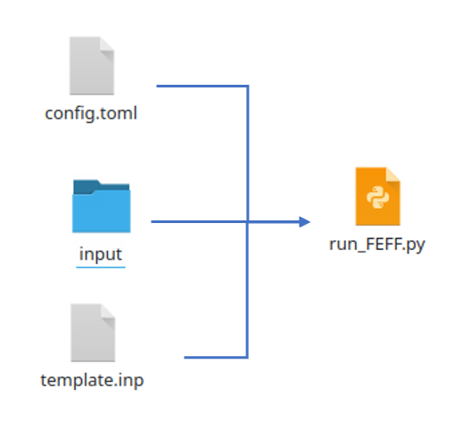

Config.toml contains the configurations of this calculation.

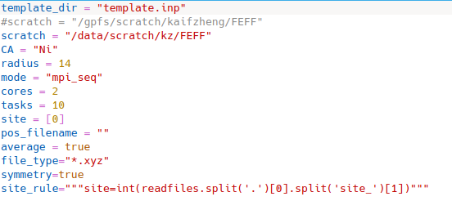

**Template_dir:** the location of feff.inp template

**Scratch:** the location of scratch folder

**CA:** absorbing atom

**Radius:** the size of particle for calculating spectrum. For non-periodic samples(nanoparticles), the value requires to be large enough to cover all atoms of the particle or the distance where is enough to calculate stable spectrum.

**Mode:** the calculation mode, there are 4 different modes: mpi_seq,mpi_multi,seq_seq, and seq_multi. **The _seq** means the program will calculate spectrum for different site or sample one by one. _multi means the program will calculate the spectrum in a batch, the size of batch is defined by tasks.

**Cores:** the number of cpus for mpirun

**Tasks:** number of tasks run simultaneously.

**Site:** the site we are trying to calculate(still under developed)

**File_type:** the input file type, can be *.xyz,*.POSCAR, *.cif

**Symmetry:** True means the calculation will find inequivalent sites by point group(only work for molecule—xyz file)

**Site_rule:** This is a paragraph of python program to define how to get the site index, which will execute in the python program by exec(). For example, if you want to use site in config.toml, you can write: site_rule=”””site=site[0]”””(I delete it for now, it may come later.)

1. **How to run**
   1. **use module**

**cd /home/ames/module**

**module use FEFF10**

**module load 10**

Then, you can run feff: **feffmpi** 8 #8 cores

Or: **feff** #seq run

* 1. **write input files**

Go to /home/ames/kzheng/FEFF_works/test



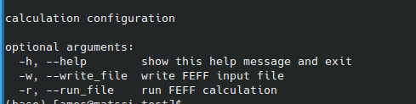

The python script has two arguments: -w and -r

If run python run_FEFF.py -w, the program will write feff input files(if symmetry=True, it will write input files for inequivalent sites) automatically to a new folder called FEFF_inp.

* 1. **run FEFF**

To run FEFF correctly, first needs to check template.inp, and then check config.toml. Then run it python  run_FEFF.py -r

The results will be stored in json file separately in output folder.

1. **A small test on 55-atom Ni particle**

(/home/ames/kzheng/FEFF_works/test)

For multi-task computing, I used 2 cores for mpi, and the maximum number of tasks can be submitted is 10, but we only have 5 tasks in this case, so it will submit all tasks simutanously.

In this case, it takes



For single-task computing(one by one)

The value of tasks is not matter.



It takes 9 minutes for all 5 tasks finished.

