Customer Shopping Behavior Analysis — Business Report
Prepared by Md Kaif | Data: 3,900 customers | Tools: Python, Pandas, SQL, Power BI
1. Executive Summary
This report analyzes the shopping behavior of 3,900 customers to find out who buys, what sells, and where the business can grow. The dataset covers 25 products across 4 categories, with total revenue of $233,081 and an average purchase of $59.76.
- Clothing drives 45% of all revenue ($104,264) — it is the backbone of the business.
- Men are 68% of customers and bring 68% of revenue, but women and men spend almost the same per purchase — growth can come from attracting more female shoppers.
- Only 27% of customers are subscribers, and subscribers do not spend more than non-subscribers. Repeat buyers (average 25 past purchases) mostly stay unsubscribed — the subscription offer is not convincing.
- Discounts are used in 43% of purchases, but discount buyers spend slightly less on average. Half of hat and sneaker purchases happen on discount.
- Shipping type, payment method, season, and location show almost no difference in spending — the customer base is very even across these.
- Top-rated products are Gloves (3.86), Sandals (3.84) and Boots (3.82) out of 5.
2. About the Data
The raw dataset was cleaned with Python and Pandas: duplicate records and missing values were checked, missing review ratings were filled with the median rating of the product category, columns were renamed to snake_case, an age_group column was created, purchase frequency was converted to days, and a redundant promo-code column was removed. The final dataset has 3,900 rows and 19 columns with zero missing values and zero duplicates. Business questions were then answered with SQL, and a Power BI dashboard was built for visual analysis.
- Age groups: Young Adult (18-31, 1,028 customers), Adult (32-44, 942), Middle-aged (45-57, 986), Senior (58-70, 944).
- Customers buy on average once every 89 days and have 25 past purchases on average.
- Purchase amounts range from $20 to $100.
3. Key Findings
3.1 Revenue overview
Metric | Value
Total customers | 3,900
Total revenue | $233,081
Average purchase | $59.76
Average review rating | 3.75 / 5
Avg. purchase frequency | Every 89 days

Revenue by product category:
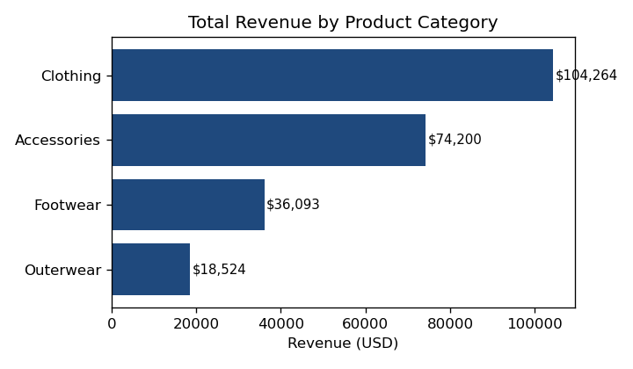

- Clothing: $104,264 (44.7%) — the clear leader.
- Accessories: $74,200 (31.8%).
- Footwear: $36,093 (15.5%).
- Outerwear: $18,524 (8.0%) — smallest category and lowest average spend ($57.17 vs ~$60 for others).
3.2 Who spends: gender and age
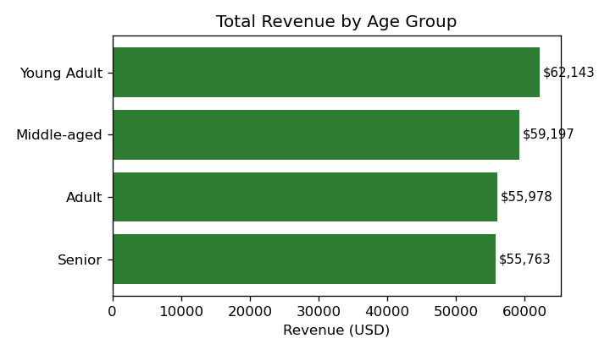

- Male customers (2,652) generate $157,890 and female customers (1,248) generate $75,191. The gap comes from customer count, not behavior — average spend per purchase is nearly identical ($59.54 for men, $60.25 for women).
- Young Adults (18-31) are the biggest group and bring the most revenue ($62,143). The other three age groups are close ($55,763-$59,197). No age group is being left behind.
3.3 What sells: products and ratings
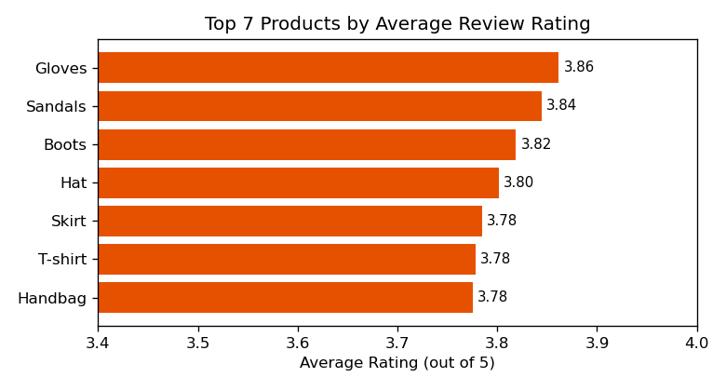

- Top-rated products: Gloves (3.86), Sandals (3.84), Boots (3.82), Hat (3.80), Handbag (3.78).
- Highest revenue items: Blouse ($10,410), Shirt ($10,332), Dress ($10,320), Pants ($10,090), Jewelry ($10,010).
- Most ratings are 4 stars (1,730 customers) and 3 stars (1,412); 692 gave 5 stars. Overall sentiment is positive but there is room to push more 5-star experiences.
3.4 Discounts
- 43% of purchases (1,677) used a discount. Discount buyers spend slightly less on average ($59.28 vs $60.13).
- 839 discount buyers still spent above the average purchase amount — discounts do not only attract bargain hunters.
- Products with the highest share of discounted purchases: Hat (50%), Sneakers (49.7%), Coat (49.1%), Sweater (48.2%), Pants (47.4%). Discounts are concentrated in clothing and footwear.
3.5 Subscriptions and loyalty
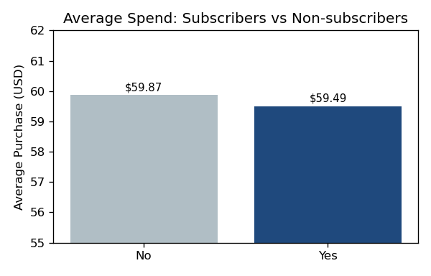

- Only 27% of customers (1,053) are subscribers. Subscribers spend $59.49 on average — slightly LESS than non-subscribers ($59.87). The subscription is not driving higher spending.
- Among repeat buyers with more than 5 past purchases, 2,518 are not subscribed vs 958 subscribed. Loyal customers are not converting into subscribers.
- Past purchase count has almost no link with purchase amount (correlation 0.008) — loyal customers buy often, but not bigger baskets.
3.6 Shipping, payment, season, location
- Shipping: all 6 shipping types have about 650 customers each, and average spend is nearly identical ($58.5-$60.7). Shipping choice does not change spending.
- Payment: all 6 payment methods are evenly used; Credit Card leads revenue slightly ($40,310). No method stands out.
- Season: Fall leads ($60,018) and Summer is lowest ($55,777) — only a 7% gap. Sales are stable all year.
- Location: revenue is spread evenly across states; Montana ($5,784) tops the list by a small margin.
4. Business Recommendations
- 1. Fix the subscription value proposition. Loyal repeat buyers are not subscribing and subscribers do not spend more. Offer subscriber-only perks (early access, free express shipping, members pricing) and test whether subscription lifts basket size.
- 2. Grow the female customer base. Women spend the same per purchase as men but are only 32% of customers. Targeted campaigns for women could grow revenue without changing pricing.
- 3. Protect the Clothing category and push Accessories. Together they are 76% of revenue. Feature top-rated items (Gloves, Sandals, Boots) in marketing since ratings drive trust.
- 4. Review the discount strategy on Hats and Sneakers. Half of these sales happen on discount — check whether full-price demand exists or whether discounts are simply expected now.
- 5. Lift Outerwear. It is the smallest category with the lowest average spend. Bundle outerwear with best-selling clothing items or run seasonal promotions.
- 6. Turn 4-star ratings into 5 stars. With 1,412 ratings at 3 stars and 1,730 at 4, small improvements in product quality or service could lift the 3.75 average and drive repeat buying.
- 7. Keep shipping and payment options as they are. No option is underperforming, so investment here will not move revenue — focus effort on the points above.
5. Methodology Note
Data processing was done in Python (Pandas) in Google Colab, business questions were answered with 8 SQL queries against the processed table, and results were visualized in a Power BI dashboard (Customer_Behavior_Dashboard.pbix). All figures in this report were computed directly from customer_shopping_behavior_processed.csv (3,900 records, no missing values, no duplicates).

